

spl@sh

Version 3.0

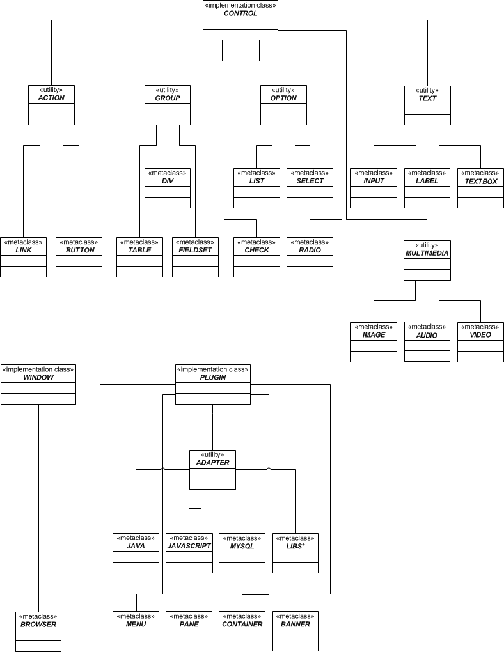

Server side, class based approach to HTML elements
Technical Details

The spl@sh extension provides a way to create and manage HTML elements on the server side with fine control on their attributes and events. spl@sh also give you control over server-side customized events just like ASP.NET.

The spl@sh extension provides a set of classes divided and categorized in groups. The three main classes or implementation classes are:

- WINDOW (defines general features of a window)
- CONTROL (defines general features of controls)
- PLUGIN (defines general features of plugins)

The utilities are intermediate classes that group related meta-classes. The utilities classes are:

- ACTION (classes of objects that cause an event)
- GROUP (classes that handle objects that group other objects)
- OPTION (classes that handle objects that offer options)
- TEXT (classes that handle text)
- MULTIMEDIA (classes that handle images or video)
- ADAPTER (classes that bridge different languages or libraries)

Meta-classes are classes which were extended by utility classes. They inherit common options but differ in object specific options.

