An HPSDR application for Linux

linHPSDR

by

John Melton g0orx/n6lyt

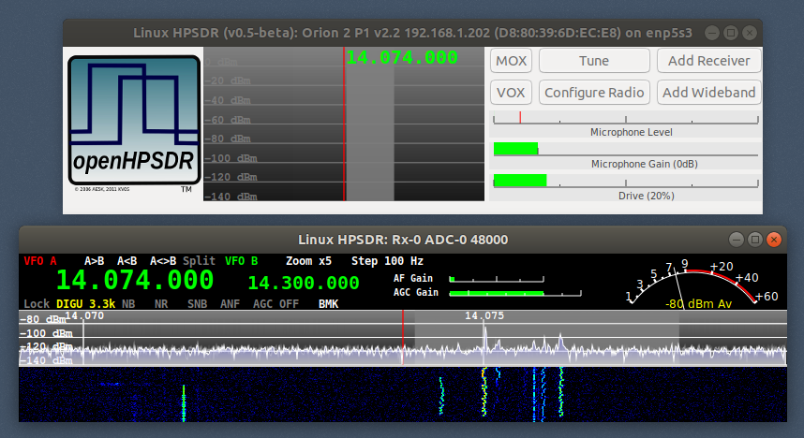

Warning: linHPSDR has been developed on Ubuntu 17.10. Currently it has not been tested on any other versions or distribution of Linux.

Installation.

This software requires the the fftw3 and pulse audio packages to be installed.

sudo apt-get install libfftw3-3 libpulse0

A Debian package, linhpsdr.deb, can be downloaded from:

https://drive.google.com/open?id=1de8E3Y6AiBcQxIoScf7JfuVET0YKlaps

Download the file into your home directory and then run the commands:

dpkg -i linhpsdr.deb

A desktop shortcut will be install that can be used to start the application by clciking on the icon. You can also start the application from a command line using the command:

linhpsdr

The first time it is run the wisdom file for FFTW3 will be created. This may take some time to complete. The file wdspWisdom will be created in the directory:

~/.local/share/linhpsdr

Once completed the application will try to discover any HPSDR devices on the network.

Discovery.

When started the application will try to discover any HPSDR devices on the network.

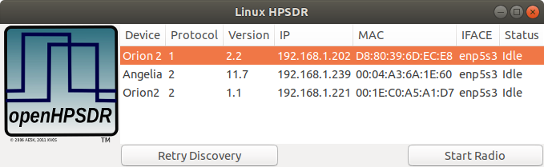

To start a radio select the entry from the list that you want to start and the click on the Start Radio button. Note that this application supports firmware for Protocol 1 and Protocol 2.

You will see 2 windows appear.

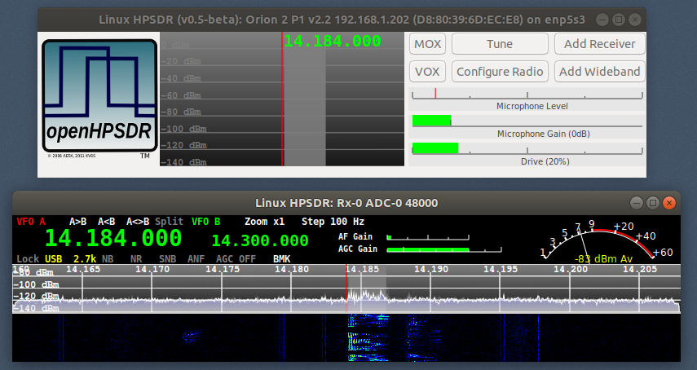

The top window is the Main window and is used to control the transmitter and to add additional receivers.

The bottom window is a receiver window.
Receivers.

When started there will be one receiver (RX-0) displayed. You can start additional receivers by clicking on the Add Receiver button on the main window. This button will be grayed out when the maximum number of receivers for the firmware are displayed.

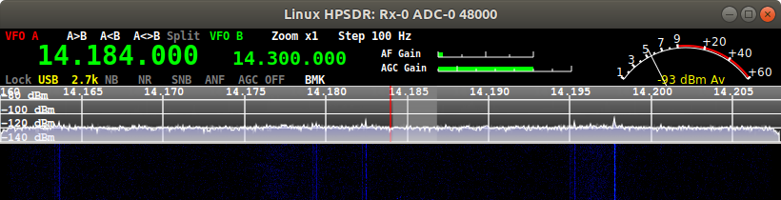
Note that the display is sensitive to the position of the cursor. Moving the cursor over the A<B button and clicking the left mouse botton will perforrm that function.

Each receiver has a VFO A and VFO B. VFO B can be used as a place to save a frequency, however when Split is enabled it is used as the transmit frequency. There are 3 buttons, A>B which transfers the frequency from VFO A to VFOB, A<B which transfers the frequency from VFO B to VFO A, and A<>B which swaps the frequencies between VFO A and VFO B.

Note that the display is sensitive to the position of the cursor. Moving the cursor over the A<B button and clicking the left mouse botton will perforrm that function.

The Split button will enable/disable Split mode. The VFO being used for transmit will be in red.

The Lock button will lock the VFO and not allow the frequency to be changed.

The current mode is displayed and can be changed by clicking on it and selecting another mode.

The current filter is displayed and can be changed by clicking on it and selecting another filter.

NB can be enabled/disabled by clicking on it and selection either OFF, NB or NB2.

NR can be enabled/disabled by clicking on it and selection either OFF, NR or NR2.

SNB can be enabled/disabled by clicking on it.

ANF can be enabled/disabled by clicking on it.

AGC can be enabled/disabled by clicking on it and selection either OFF, LONG, SLOW, MEDIUM or FAST.

The AF Gain can be adjusted by putting the mouse cursor over the slider and using the scroll wheel to move up or down.

The AGC Gain can be adjusted by putting the mouse cursor over the slider and using the scroll wheel to move up or down.

The step size for frequency increments can be set by clicking on the Step button and selecting the step size from the popup menu.

The Panadapter/Waterfall can be zoomed in by ckicking on the Zoom button and selecting x1, x3, x5 or x7. It currently is only display centered on the VFO frequency.

The BMK button lets to add or select a bookmark. Right clicking on the button will bring up a dialog with the frequency, mode and filter settings setup and the name defaulted to the frequency. You can change the Name and then clicking on the Add Bookmark button will save it. Clicking on the x button on the title bar will exit without saving the bookmark.

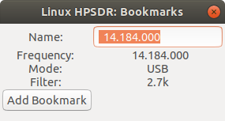

A left click on the BMK button brings up a dialog with the list of bookmarks.

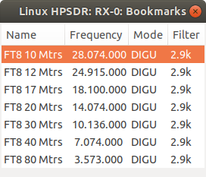

Double click on a bookmark to set the current receiver to the frequency, mode and filter. A single click will select a bookmark and then a right click will popup a menu to Edit or Delete the bookmark. Currently Edit is not implemented yet.

A mouse click on the S-Meter will pop up a menu to select either Peak or Average.

To change frequency you can:

Use the scroll wheel to increment/decrement the frequency by the current step size.
Click on a frequency to move to that frequency.
Click and drag to increment/decrement the frequency.
With the cursor over a VFO A frequency digit you can scroll up/down.

The receiver window can be resized (there is a minimum size). When resized the VFO bar remains the same height and the Panadapter/Waterfall will be increased in width and height. If the height is increased the additional height is split between the Panadapter and waterfall. The panadapter and waterfall size ratio can be changed by dragging the divider between them.

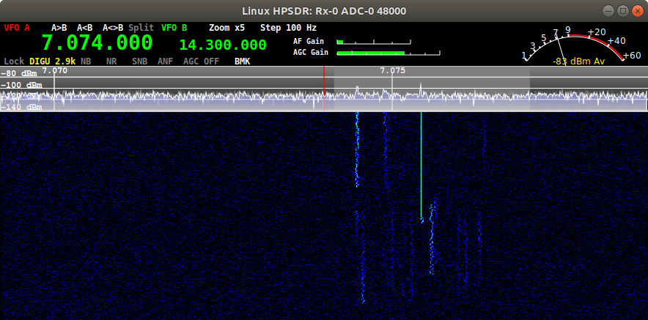

Configure Dialog

The Configue Dialog is displayed by clicking on the Configure Radio button of the main window.

There are tabs at the top of the window to selection specfiic configuration options. By right clicking on the transmitter panadapter display in the main window the configure dialog will be displayed with the TX tab selected. By right clicking on a receiver panadapter display the configure dialog will be displayed with the RX tab selected for that receiver.

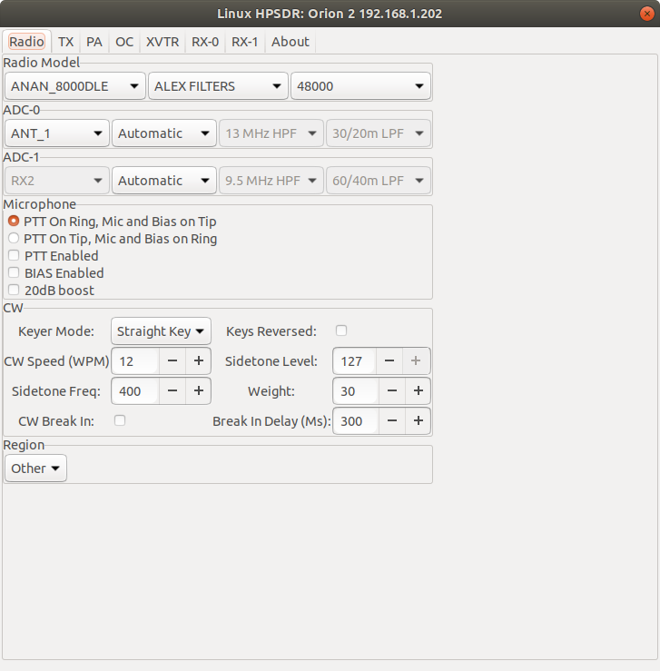

Radio Model

Select the specific radio model, the filter board type being ALEX or APOLLO. If the radio is running Protocol 1 firmware you can set the sample rate for all receivers. If running Protocol 2 firmware the sample rate is on an individual receiver and can be set in the receiver tab of the Configure Dialog.

ADC-0

Select the antenna source and filters to use for ADC-0. If you set the HPF and LPF filter selection to Automatic Either the software or the firmware will make the selection based on the frequency. The selection can be set to Manual and the HPF and LPF filter can manually be selected or you can BYPASS the filters.

ADC-1

This will be displayed if the radio supports 2 ADC’s and has a second filter board.

Microphone

This will be displayed if the radio microphone settings can be configured by software (currently Algelia, Orion and Orion 2 boards.

CW

Setting to control the firmware CW keyer.

TX tab

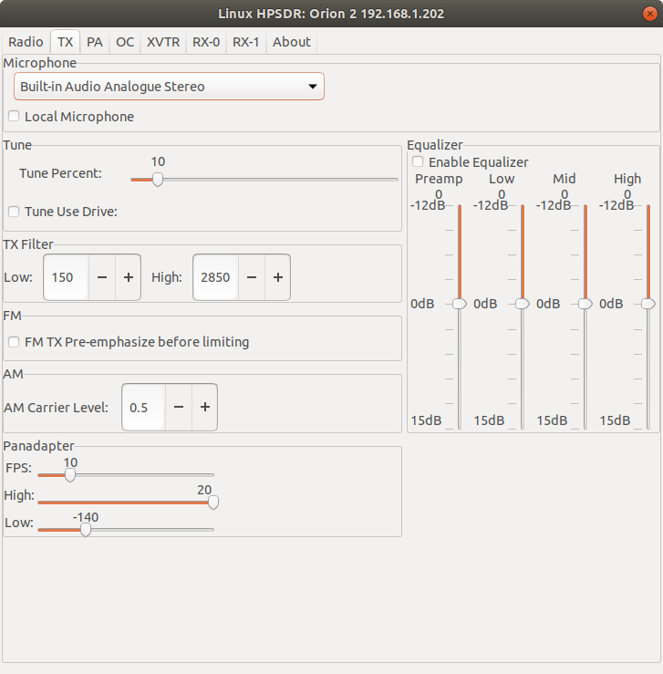
Microphone

By defaul the microphone input on the radio is used but you can select a local microphone input on the computer and then check Local Microphone to use it.

Tune

Select the tune power level as a percentage of the drive level.

Check Tune Use Drive to use the full drive level for tune.

TX Filter

Select the high and low values for the tranmit filter.
FM

Check FM TX Pre-emphasize before limiting to enable.

AM

Set the AM carrier level in the range 0..1.

Pandapter

Set the update rate (FPS).

Set the High and Low dBm values displayed.

Equalizer

Enable the transmitter equalizer and ajdust the Preamp, Low, Mid and High levels.

PA tab

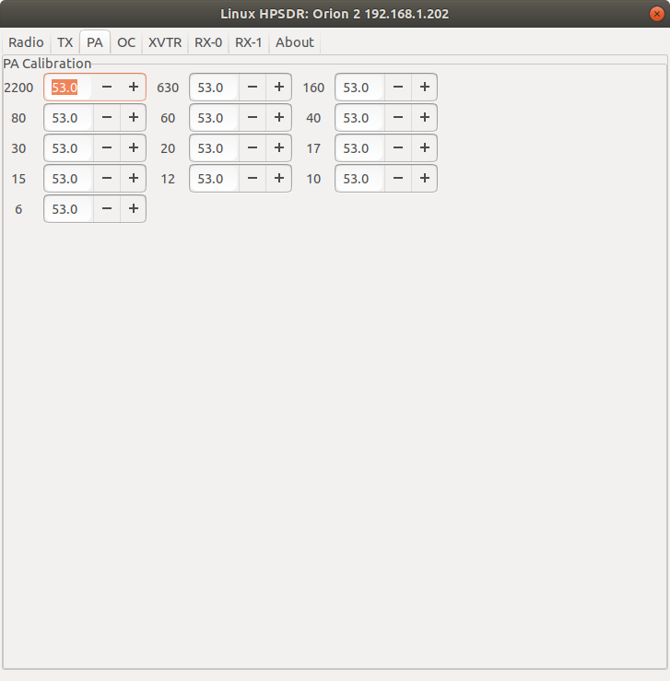
PA Calibration

Adjust the drive level for each band. Decreasing the value will increase the drive level.

OC tab

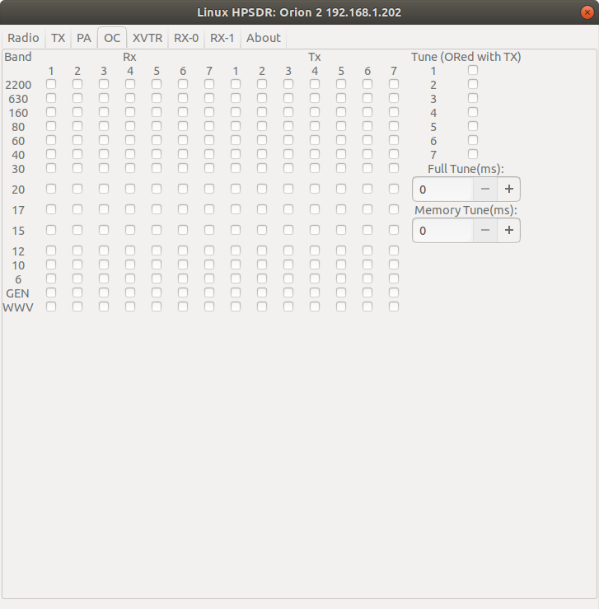
Set the Open Collector outputs for Rx and Tx for each band.

Set the Open Collector outut when Tune is active.

XVTR

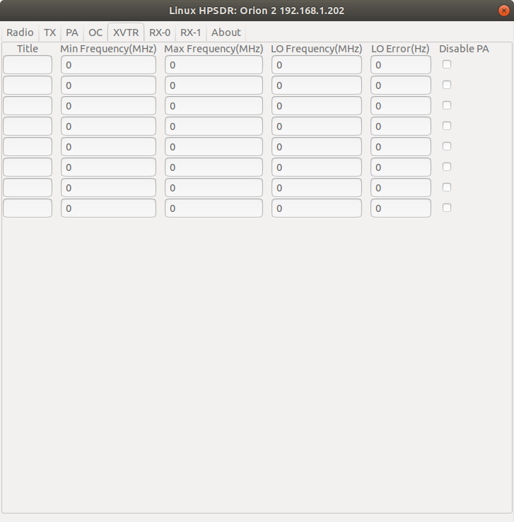

Configure transverters.

RX-x

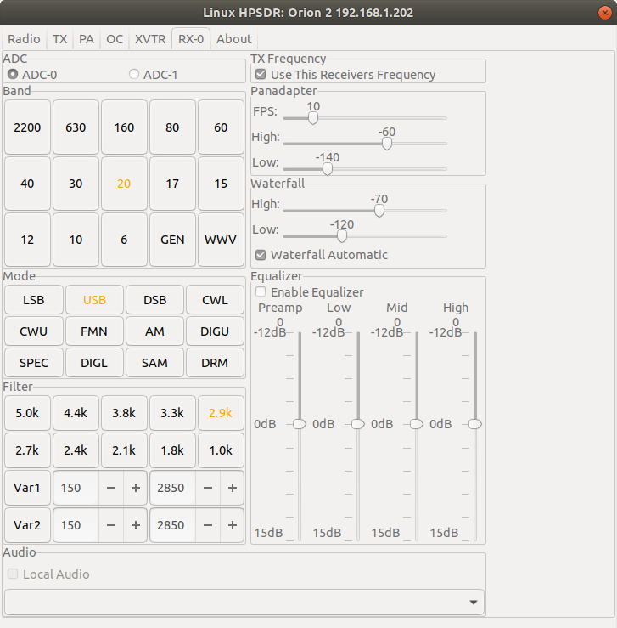
There will be one tab for each active receiver.

ADC

If the radio supports multiple ADC’s you can select which ADC the receiver is connected to.

Band

Selecting a band will change the receiver’s VFO A frequency to the one selected.

Mode

Selecting a mode will change the receiver’s VFO A mode to the one selected.

Filter

selecting a Filter will change the receiver’s VFO A filter to the one selected.

Panadapter

Set the FPS update frequency (also used fo the waterfall).

Set the High and Low values to adjust the dispplay.

Waterfall

Set the High and Low values to adjust the color range.

Equalizer

Enable the receiver equalizer an ajdust the Preamp, Low, Mid and High levels.

Audio

Select audio to be sent to the radio or to send the audio to a local device from the dopdown list on the computer.

