Configuring linHPSDR to work with WSJT-X.

LinHPSDR uses PulseAudio as its audio infrastructure. WSJT-X also has an option to use PulseAudio. PulseAudio allows the connection of the audio input and output streams between the applications without using physical cables.

So as not to use the sound card(s) in the computer you can configure pseudo devices that allow you to connect the audio out and microphone input of linHPSDR to WSJT-X.

Adding the pseudo devices.

To add the pseudo devices the file ~/.config/pulse/default.pa must be edited or created if it does not exist.

Add the following lines and then save the file:

.include /etc/pulse/default.pa
### linHPSDR
load-module module-null-sink sink_name=linHPSDR sink_properties="device.description='RX0 Audio'"
load-module module-null-sink sink_name=linHPSDR sink_properties="device.description='TX Audio'"

Note that you could add multiple receiver sinks for RX0 to RX6.

PulseAuido must to be restarted to load the pseudo devices using the following command:

pulseaudio -k

PulseAudio volume control.

Start the PulseAudio volume control pavucontrol.

If you look in the Output Devices tab you should now see RX0 Audio and TX Audio.

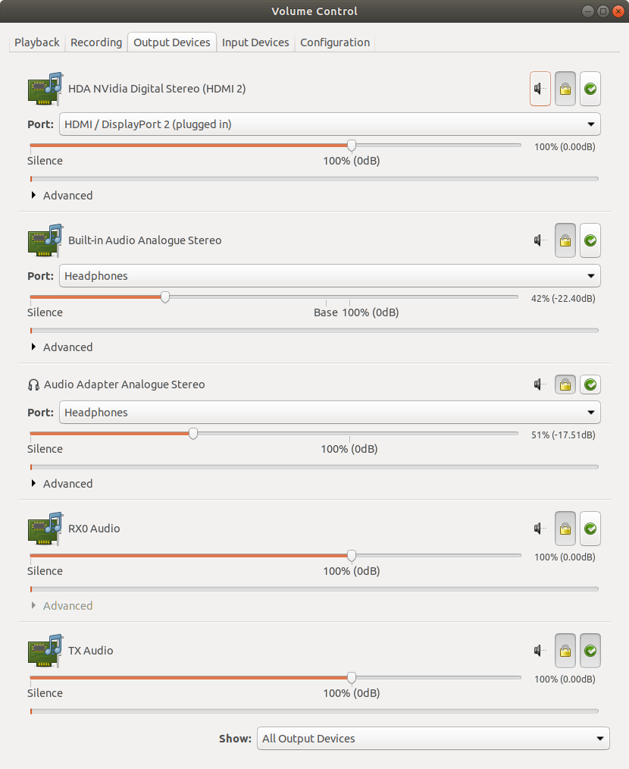

Configure linHPSDR.

To configure the audio ouput, right click on the receiver and the receiver dialog will be displayed. In the Audio frame select RX0 Audio and enable Local Audio.

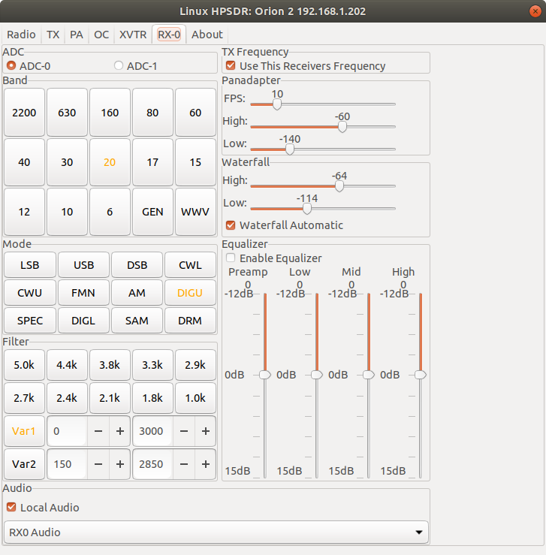
To configure the transmit audio for linHPSDR click on the Configure button on the radio window and in the Microphone frame select Monitor of TX Audio and enable Local Microphone.

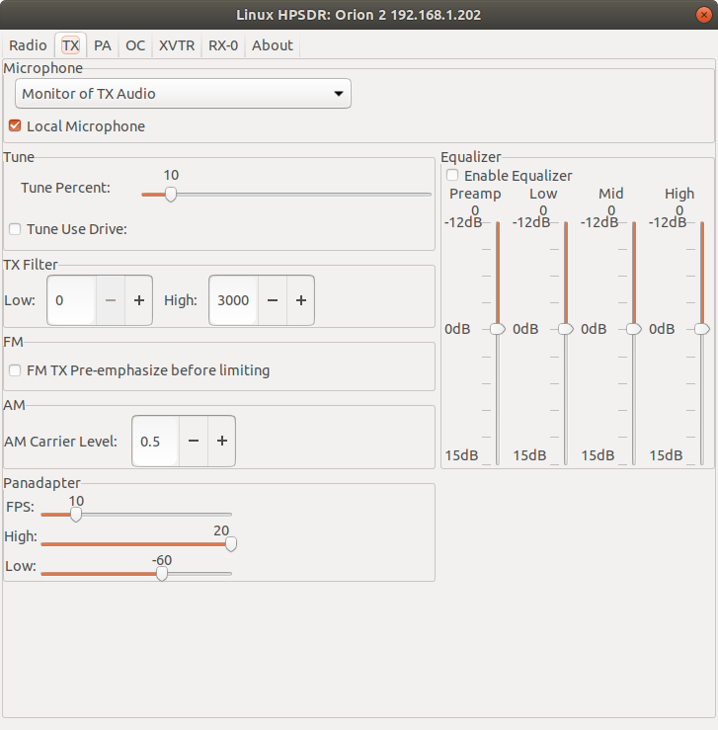

If you look in the Playback and Recording tabs of pavucontrol you will now see the linHPSDR connections.

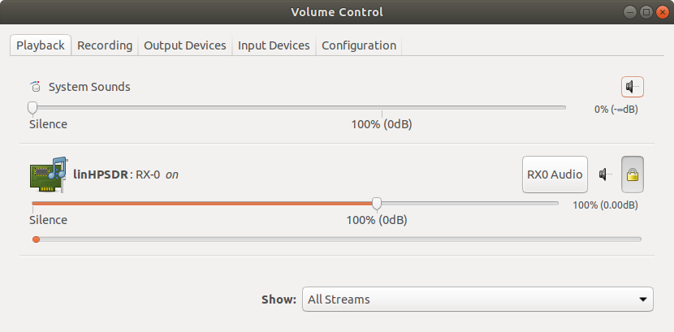

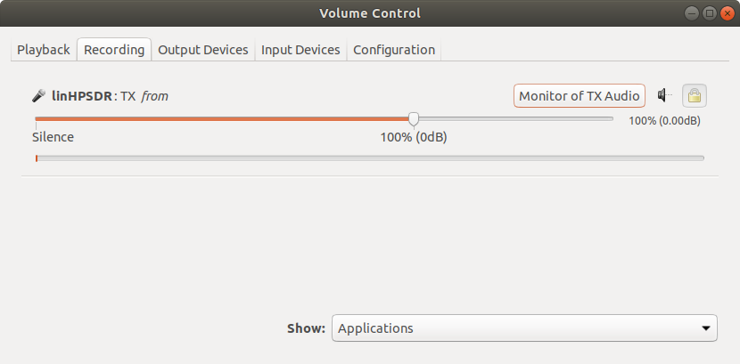
Configure WSJT-X.

Click on File→Settings menu and the Settings dialog will be displayed. Select the Audio tab and in the Soundcard frame select Input and Ouput to be pulse.

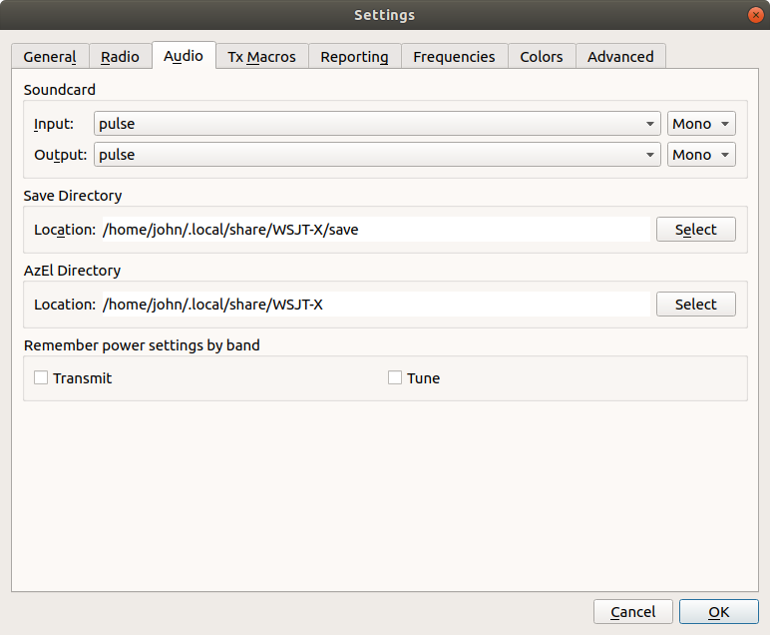

In pavucontrol in the Recording tab you should now see the wsjt-x stream to capture audio. Select Monitor of RX0 Audio. You should now see data in the the WSJT-X Wide Graph.

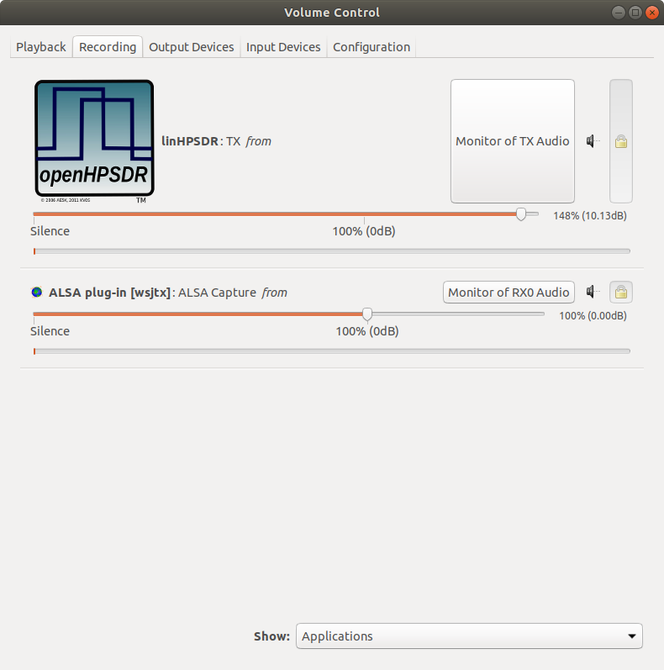

The Playback tab will not show the stream for the transmit audio from WSJT-X unless it is transmitting. Press the Tune button on the WSJT-X window and the wsjt-x Playback strteam will appear. Select TX Audio.

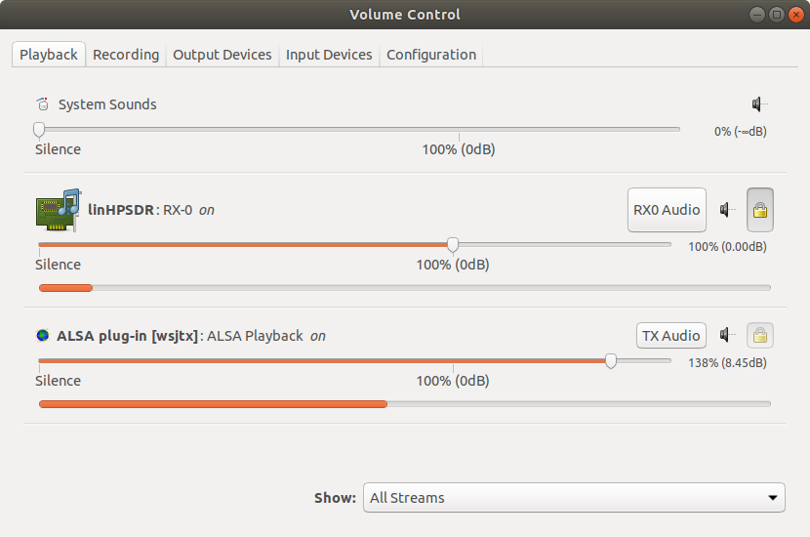
These setting will be remembered so it is only necessary to perform this configuration once unless something changes.

CAT inteface;

Currently linHPSDR has sufficient CAT commands implemented to allow WSJT-X to interface to it. It only works with RX-0 currently.

To configure WSJT-X to use the CAT interface select the Radio tab in the File→Settings dialog. Select OpenHPSDR PiHPSDR as the Rig and set the Network Server to localhost:19090 and set the PTT Method to CAT.
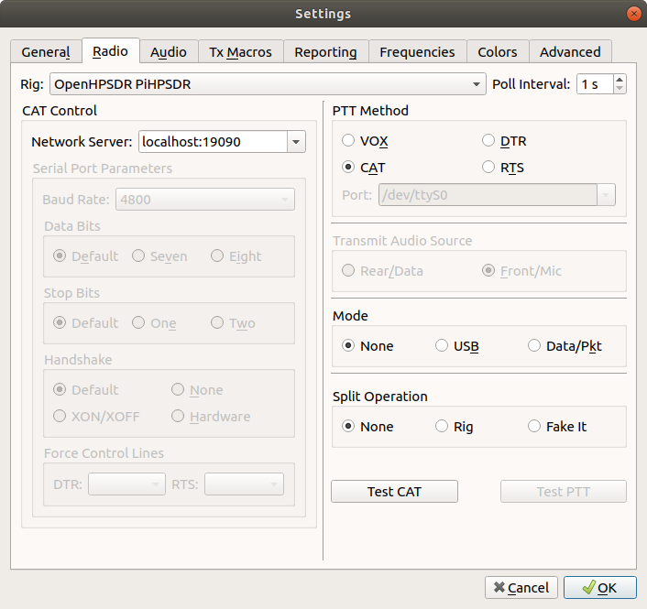
When connected the CAT logo should be illumintaed in RX-0.
