Apache Labs LLC
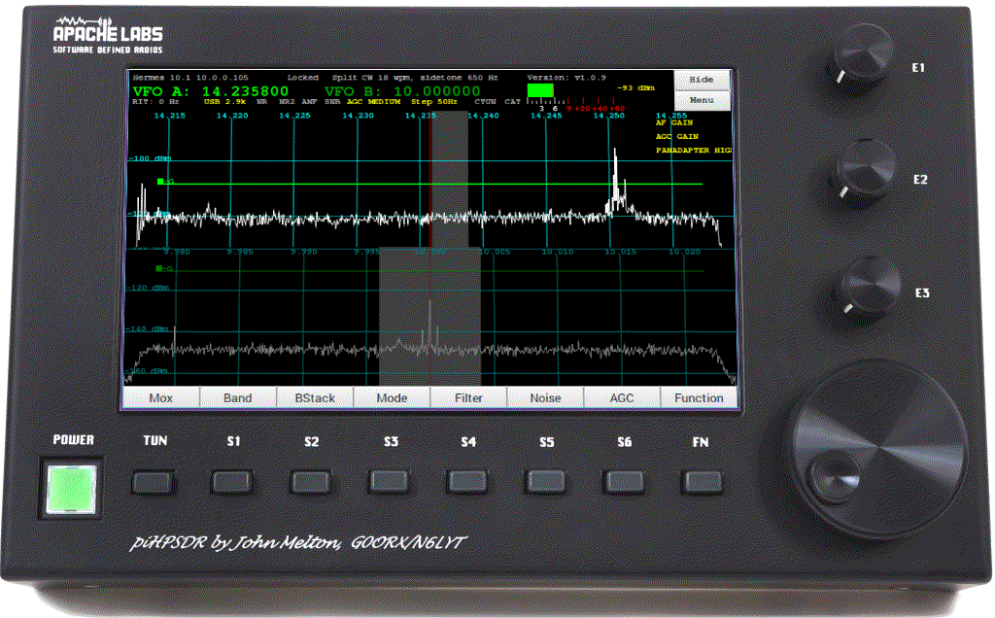
pihpsdr showing two receivers (40M LSB + WWV) + waterfalls + on screen sliders + menu toolbar
TWO
RECEIVER
Version
piHPSDR Controller
Users Guide
by
John Melton GØORX/N6LYT

This document contains references to the Apache Labs Transceiver products
http://www.apache-labs.com

In cooperation with VK6PH, NRØV, W5WC, K5SO
and the OpenHPSDR Hardware and Software Projects
http://openhpsdr.org

all images and manufacturer data is copied here with permission of the owner

Contents - piHPSDR Controller Users Guide

1. Introduction 5
Introduction by John Melton GØORX/N6LYT 5

2. Controller connection requirements 6
Network LAN Connection 6
Controller Hardware requirements 6
Controller software requirements: 7

3. Front panel controls 8
Default assignments of switches and rotary encoders 8
Power ON/OFF – switches external 12vdc 2A power to the Controller 8
TUN – MOX/TUNE 8
S1 – Band 8
S2 – Band Stack 8
S3 – Mode 8
S4 – Filter 8
S5 – Noise Blanker 8
S6 – AGC 8
FN – Function switch to toggle 8 on screen touch buttons such as TUNE or MOX 8
E1 – push encoder knob for selection from Encoder Assignment menu of 11 functions 8
E2 – push encoder knob for selection from Encoder Assignment menu of 11 functions 8
E3 – push encoder knob for selection from Encoder Assignment menu of 11 functions 8
E4 – VFO – main tuning knob 8

4. Front Panel Display 9

5. Side panel connections 10

6. Quick Start Instructions 11
Hardware Setup 11
Software Setup 11

7. Discovery Menu 12
Discover Ethernet Connections to RPi 12
Pihpsdr program START button 13

8. Main Menu 14
Menu → Exit piHPSDR 15
Menu → Radio 16
Menu → Rx 17
Menu → Sample Rate for new protocol 18
Menu → TX 19
Menu → PA Gain by Band 20
Menu → CW 21
Weight – sets the dot/dash weighting. 21
Menu → ANT 22
Menu → DSP 23
Menu → OC Open Collector Aux I/O connectors 24
Menu → Display 25
Menu → Display (continued) 26
Menu → XVTR 27
Menu → Equalizers 28
Menu → Step 29
Menu → Meter 30
Menu → VOX 31

9. On-Screen Controls and toolbar Buttons 32
Touch selection of VFO-A (Rx0) 32
Touch selection of VFO-B (Rx1) 32
Touch Direct Frequency Entry 33
Toolbar – Function button 34
Four Toolbar menus – select with Function button or front panel switch 34
Toolbar – MOX 35
Toolbar – Band selection 35
Toolbar - Bandstack 36
Toolbar – Mode 37
Toolbar – Filter 37
Toolbar – NOISE 38
Toolbar – AGC 38
Toolbar – Function button 39
Toolbar VFO Lock 40
40
Toolbar CTUN – Click Tuning 41
41
Toolbar A>B A<B A<>B 42
Toolbar SPLIT 43
Toolbar FREQ 44
Toolbar MEM 45
Toolbox VOX 46
Toolbar RIT 47
RIT – Receiver Incremental Tuning 47
Tapping on the RIT+ (plus) or RIT- (minus) button will enable RIT 47
AF Gain Slider 49
MIC Gain Slider 49
PA Drive Slider 50
Tune Drive Slider 50
AGC Gain Slider 51
Receive Attenuation Slider 51
Main screen HIDE 52
Menu or Toolbar → Meter 53

10. Tuning 54
VFO Encoder 54
Touch Screen 54
Mouse 54

11. TUNE/SWR/FWD Power 54
TUNE/SWR/FWD power 54

12. Appendix 55
Encoders and Switches 55
5Switch or Encoder 55
Power ON/OFF 55
TUN – TUNE button 55
MOX – MOX button 55
S1 – Band 55
S2 – Mode 55
S3 – Filter 55
S4 – Noise 55
S5 – AGC 55
FN – Function 55
22 55
E1 -- 55
E2 – 55
E3 – 55
E4 – VFO Main tuning knob 55
GPIO pin Assignments (RaspberryPi) 57

13. Reference materials 57
G0ORX Friedrichshaven pdf and video 57

14. Steve Wilson KA6S special addition for Fldigi 58
Using PiHPSDR with other applications: 58
Mapping a Serial Port to TCP/IP port in Linux 58
Example: Set up GRIG to talk to PiHPSDR 59
Example: Connect FLDIGI to PiHPSDR 59
Also – check the PTT via CAT button in the lower left corner. 60
Now Choose Config/Setup/TCPIP 61
Setting up rigctld 62
Multi-Client Support 62
Running applications with the latest version of Hamlib 64
KA6S Summary 65

15. Supported CAT Commands 66

16. Apache Support 71
Apache Labs International Support 71
Apache Yahoo Support Group 71
OpenHPSDR Group 71

17. Apache Service and Repair 71

Early prototypes by John Melton G0ORX (circa: 2015) 72

1. Introduction

Introduction by John Melton GØORX/N6LYT
Thu Aug 5, 2016 12:52 am (PDT) .
Posted by: "John Melton" g0orx
I think it is time to answer some of the questions about the controller.
Some background ...
I presented a paper at DCC last year on how to build a CAT controller using an Arduino and some buttons and encoders, even one with an LCD screen showing the mode, frequency and an S meter. The idea of this was to try to get people building them.
When I returned I started looking at what a Raspberry Pi (model 2 at the time) could do as a standalone controller. I had already ported WDSP to Linux so had a good starting point. Very soon after I received
an email from LA2NI, Kjell Karlsen asking if my Android code would run on the Raspberry Pi as he wanted to try to build a standalone system with a touch screen. I told him about my early development work on the Raspberry Pi and that started a project that is still on going today.
The idea was not to build an all singing/dancing copy of PowerSDR but to build something that could be used with a small portable system. Kjell has since gone on to build a very nice system using a Hermes and Apollo all built into a small case with the Raspberry Pi (now a model 3).
Abhi (Apache Labs) got interested in the project and wanted to build a controller initially without the built in Hermes/Apollo. Hopefully we will see a complete portable system sometime from Apache Labs.
So, that is what we have today. The software is still in development and new features are being added as well as bugs being fixed. It is designed to use with the radio, not as a remote console. The RPi does not have any audio input but does have audio output. It is currently possible to output the audio locally on the RPi but to connect a microphone you will need to plug a USB audio card into the device. I will be adding support for connecting a microphone to the this as well.
The RPi will work over WiFi using the built in controller. The signal quality will determine what sample rate it will run at. The RPi does not have GigE so cannot connect directly to a radio running the new Ethernet protocol, but will work through a switch or over WiFi. However, it has been tested using a USB to GigE dongle and that does work. Just remember this will not run at the higher sample rates.
I have looked at several other more powerful single board computers, but always I have run into problems with their implementation of the GPIO, which is used to interface the buttons and encoders.
We are using the Raspberry Pi official 7 inch touch screen. This has a resolution of 800x480 so we are struggling with screen real estate.
There is work in progress to also use the controller remotely across the Internet. This will require a server running at the radio that is connected to by a thin client running on the controller. This will stream the audio and spectrum information with all the DSP work being done on the server. It is not based on my ghpsdr3 project but of course that was a good starting point for the design.
Finally, all the software is open source. It will run on a Raspberry Pi without the buttons/encoders. It will also run on other Linux systems and I have even built it and had it running on Mac OS X. I have not
tried to build it on Windows as I do not have a Windows system.
-- John g0orx/n6lyt

Note: This Note: this document assumes familiarity with the Apache Transceiver and standard software such as PowerSDR or Thetis. The Apache Transceiver Users Guides are located here: https://apache-labs.com/al-downloads/1001/ANAN-USER-GUIDES.html

2. Controller connection requirements

Network LAN Connection

Auto-negotiation of a the RaspberryPi 100BT Ethernet connection allows operation of the Controller at the 48000, 96000, and 192Ksps sample rates.
Apache Transceiver
APIPA
crossover cable not required
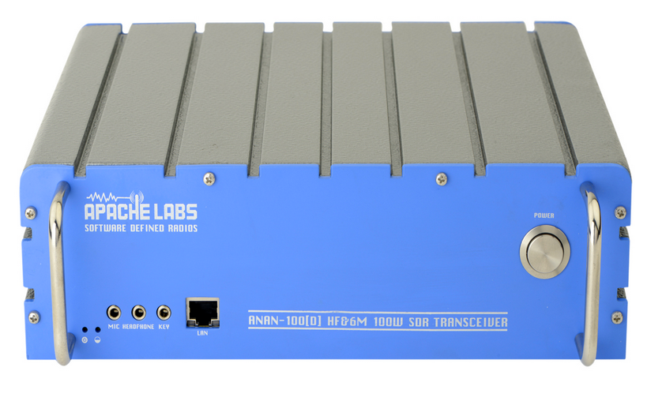
piHPSDR Controller
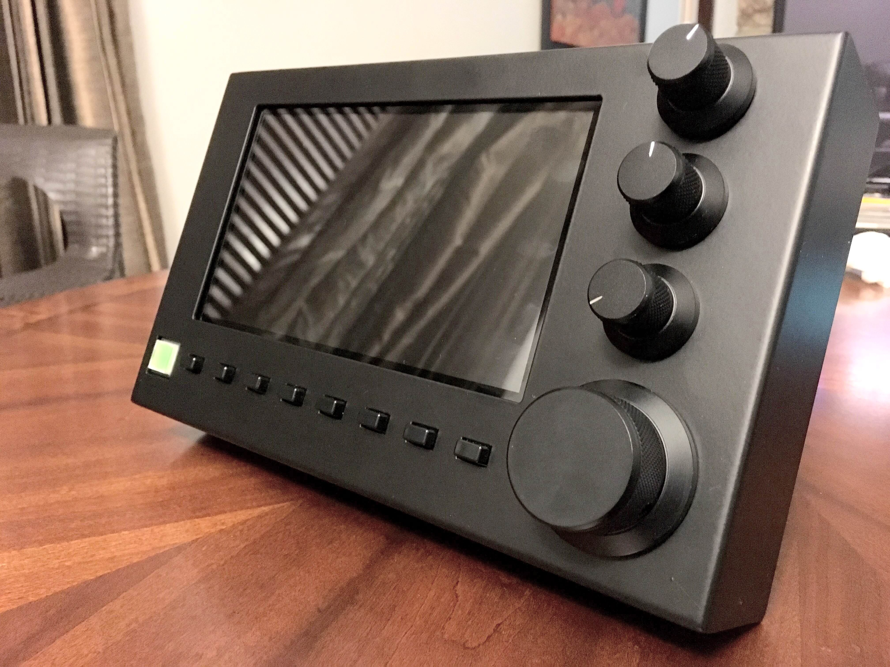
The new piHPSDR-Controller can be connected directly to your ANAN Transceiver and each unit will make use of the APIPA assignment for an IP address.

Apache Transceiver
piHPSDR Controller
Home Network

1000BT
(Gigabit)
Switch

CAT-5 or CAT-6 shielded cables are recommended for connection to the LAN

Controller Hardware requirements
- 13.8vdc 2.5A (minimum 12vdc 2A) Power connection
- 100BT LAN connection to your Apache Transceiver

Note: when running the dual receiver version of pihpsdr, you may need to place passive heatsinks on the CPU and LAN chip on the RaspberryPi-3b. Be mindful of the temperature alarm shown on the right side of the display screen.
Heatsinks like these:
- https://www.modmypi.com/blog/how-to-install-heat-sinks-on-the-raspberry-pi

- https://www.element14.com/community/community/raspberry-pi/raspberrypi_projects/blog/2016/03/03/raspberry-pi-3-cooling-heat-sink-ideas

- https://www.amazon.com/Addicore-Raspberry-Heatsink-Aluminum-Sinks/dp/B00HPQGTI4/ref=pd_lpo_147_bs_t_2?_encoding=UTF8&psc=1&refRID=6D4ND9MW55Y93DD05V26

Controller software requirements:

- Pihpsdr Controller Operating System and application program are factory installed on an SDHC card.

- If you have purchased the piHPSDR-Controller KIT, you will need to create and install an SDHC card with the RaspberryPi operating system and pihpsdr application.

- Instructions for Installation of Rpi software are detailed in the Install pdf document that is available at:
https://github.com/g0orx/pihpsdr/raw/master/release/documentation/pihpsdr-install.pdf

- If you wish to get the latest version of pihpsdr source code, executable binaries, and documentation the instructions are available at:
https://github.com/g0orx/pihpsdr/raw/master/release/documentation/pihpsdr-build.pdf

Note: it is a good idea to make a backup of your Operating System and piHPSDR software. Use the RaspberryPi Menu → Accessories → SD Card Copier utility. Use a new SDHC card of the same capacity as the original.

This is easily done using a USB – SDHC card reader/writer dongle plugged into one of the RPi USB ports on the left side of the piHPSDR Controller.

A pdf document reader is included in the standard RaspberryPi operating system distribution.

3. Front panel controls
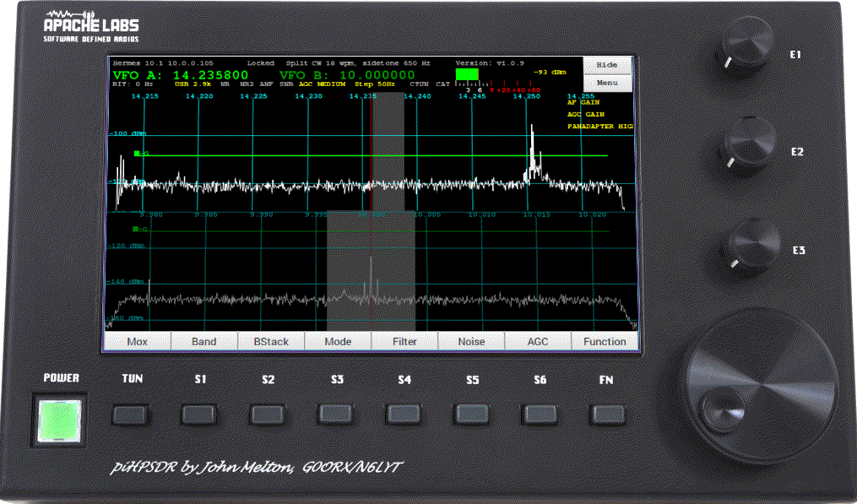
Switches
Encoders

Default assignments of switches and rotary encoders
- Power ON/OFF – switches external 12vdc 2A power to the Controller
- TUN – MOX/TUNE
- S1 – Band
- S2 – Band Stack
- S3 – Mode
- S4 – Filter
- S5 – Noise Blanker
- S6 – AGC
- FN – Function switch to toggle 8 on screen touch buttons such as TUNE or MOX
- E1 – push encoder knob for selection from Encoder Assignment menu of 11 functions
- E2 – push encoder knob for selection from Encoder Assignment menu of 11 functions
- E3 – push encoder knob for selection from Encoder Assignment menu of 11 functions
- E4 – VFO – main tuning knob
Note: Appendix page 56 has a table showing the Switch, Encoder, and Touch Screen activation details.
Note: if you are not using a touch sensitive display panel, you may wish to operate pihpsdr from your favorite Linux system. You can use either the RealVNC connection or connect a mouse/keyboard for easy access.

4. Front Panel Display
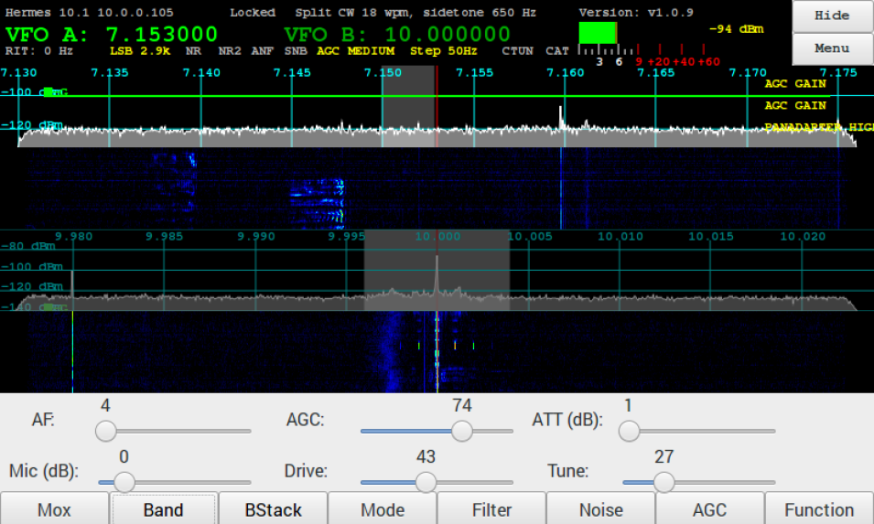
VFO-B Receiver Rx1
VFO-A Receiver Rx0
Status Lines above and below VFO frequency
Meter displays S-Meter and ALC displays
Main MENU on screen control
1
2
1
2
3
3
4
4
5
5
Panadapter display Rx0
6
6
7
Waterfall Rx0
7
8
8
Panadapter display Rx1
8
9
9
6 Slider controls
10
Function Menu activation
10

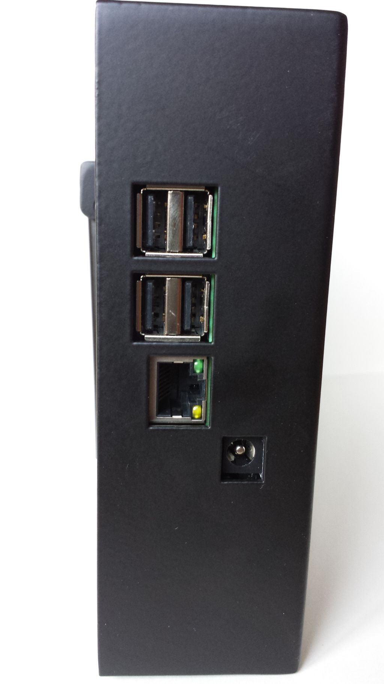
5. Side panel connections
LAN
USB
USB
12vdc
(center positive)
Power connection

6. Quick Start Instructions
please refer to front and back panel illustrations

Hardware Setup

- Carefully unpack the piHPSDR Controller.

- Connect a CAT 5/6 Ethernet cable between the rear panel LAN jack with proper access to your Apache Transceiver, Gigabit switch, or suitable router. Please see Network LAN connection page 9.

- Connect the supplied piHPSDR Controller power cable to a fused 12vdc typical (13.8vdc) Amateur Radio station power supply.

- Apache Transceiver connections to MIC, KEY, Headphones

Software Setup

The piHPSDR Controller software is pre-formatted on the Operating System SDHC card inserted in the RaspberryPi.
- Alternative software configurations are not provided by Apache Labs.
- A person familiar with the Raspbian operating system may wish to modify or update the contents of the SDHC card using appropriate Linux tools. Please refer to page 10.
Note: pihpsdr is OpenSource. If you would like to compile the program on a Linux system, the source, binaries, and documentation are located at https://github.com/g0orx/pihpsdr/tree/master/release/documentation

7. Discovery Menu

Discover Ethernet Connections to RPi
- When first started, piHPSDR will try to discover all the HPSDR compatible radios on the network. It will look for devices running both the original (old) and the new Ethernet (new) protocol.
- If one or more Transceiver interfaces are found they will be identified by the device type, the software version, the IP address and the MAC address of the device.
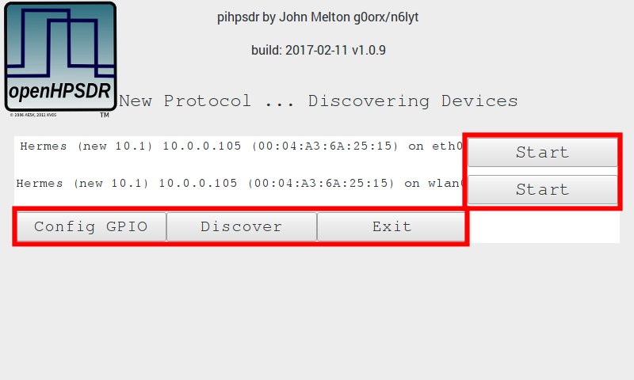
- If no devices are found you should check connectivity between the radio and the network that piHPSDR is connected to. Tapping on OK will try discovery again. Tapping on Cancel will exit piHPSDR back to the Raspberry Pi desktop.
- The Discover protocol will allow a device to see and respond even if they are not on the same subnet. If this is the case, the Start button will be disabled and the text replaced with Subnet The most common cause of this problem is usually that the radio has not been able to get a DHCP address and has defaulted to the Self Assigned IP Address, or the device has a static IP address that is not on the same subnet as the piHPSDR.

Pihpsdr program START button
- Tapping on the Start button will start the radio – on the selected Ethernet interface.
- In this example you see both the Rpi Wireless and Ethernet connections are active and were discovered properly.
- Depending on your particular WLAN and LAN setup, either will work well with pihpsdr 10Mbps network requirement. Both the Rpi and your Apache Transceiver must be on the same subnet.
- Configuration of the GPIO default connections are shown on page 57

8. Main Menu

Tapping the Menu button brings up the menu dialog.
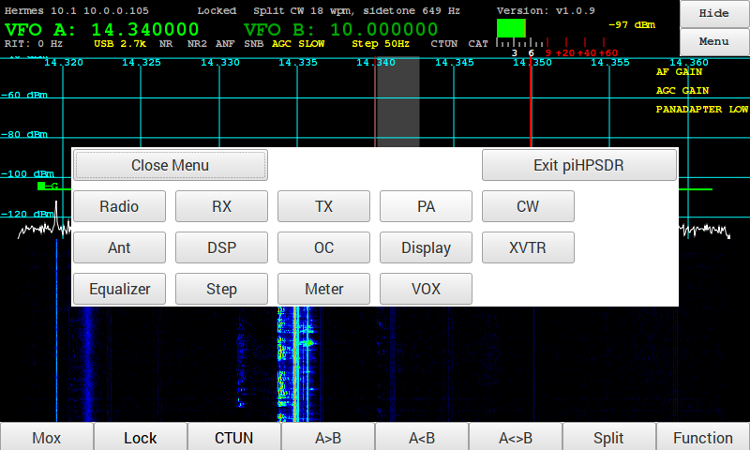
- You can close the menu by tapping on the Close Menu button or by tapping on the Menu button again.

Menu → Exit piHPSDR

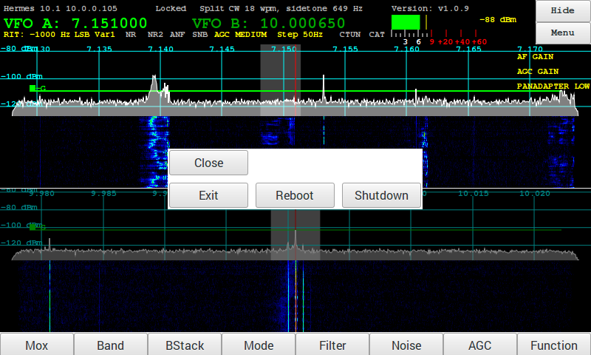
The Exit piHPSDR button will bring up a sub-dialog allowing you to end the piHPSDR application in a number of ways:
- Close – close this dialog box
- Exit – exit piHPSDR back to the Raspberry Pi Desktop
- Reboot – reboot the Raspberry Pi
- Shutdown – Shutdown the Raspberry Pi - (note the Controller power button remains lighted)
You can also tap the Menu button again to close the Exit Menu and bring up the Menu selection.

Menu → Radio

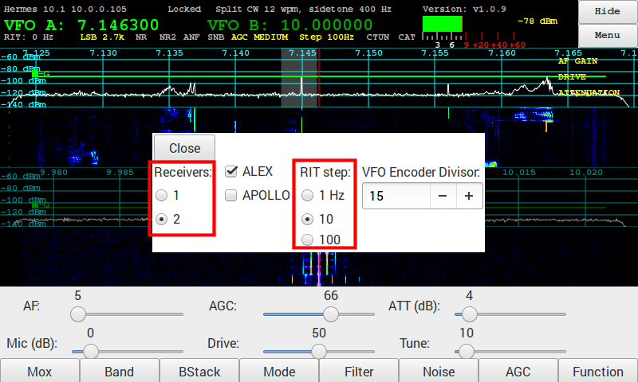

- Receivers - changing pihpsdr to 1 or 2 receiversl.
- RIT Step size – This value is the increment or step size for the RIT control and mouse wheel tuning.

Menu → Rx

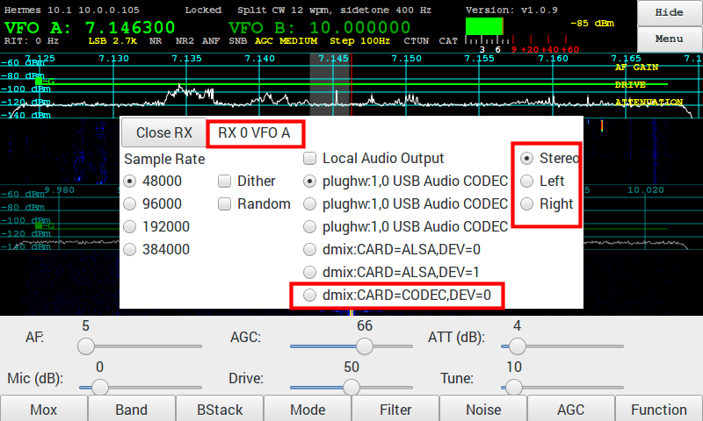
(individual receiver settings)
When you touch or select either PANADAPTER you change to that VFO and the RX menu changes from Rx0 to Rx1.

- Sample Rate - The Sample Rate selection selects the width of the Panadapter displayed on the piHPSDR Controller screen. This is the rate which pihpsdr uses to decode a portion of the 60Mhz spectrum data from the Apache Transceiver.
Note: Original Protocol sample rate for both receivers shown in the Menu → Radio
“New Ethernet Protocol” in beta test shows two receivers with individual sample rates.
If your Apache Transceiver has been updated to the 2017 firmware, you can change the sample rate of each receiver independently. This is a feature of the “New Ethernet Protocol” firmware. Independent Receiver sample rates have been implemented in the February 2017 pihpsdr software release.
Note: 768k and 1.536K are not available on Rpi.
- Dither - Dither is a built-in electronic feature of the Linear Technologies LTC-2208 Analog to Digital Conv’erter chip inside each Apache Software Defined Radio Transceiver.
- Random - Ramdom is a built-in electronic feature of the Linear Technologies LTC-2208 Analog to Digital Converter chip inside each Apache Software Defined Radio Transceiver.
- Local Audio Output – This column identifies all the audio output connections that pihpsdr recognizes when it starts. The entries with “bcm2835 ALSA” are associated with the audio chip on the Rpi. Entries with “USB” indicate external audio devices that you have plugged into the Rpi. Entries with “dmix” have been added in the February pihpsdr in order to facilitate TEXT FROM JOHN

Menu → Sample Rate for new protocol
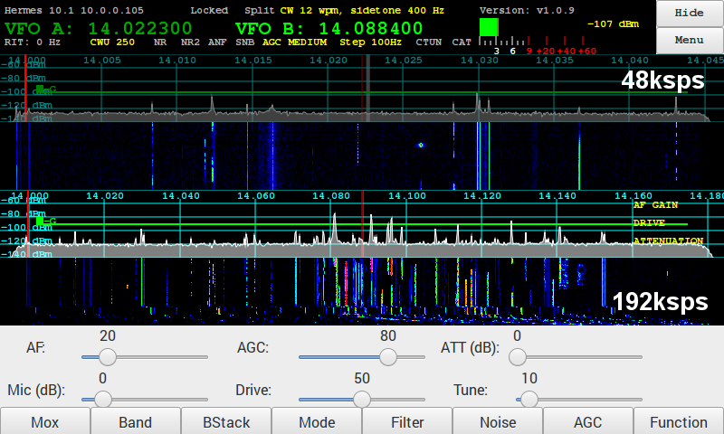

Note: Original Protocol sample rate for both receivers shown in the Menu → Radio
“New Ethernet Protocol” in beta test shows two receivers with individual sample rates.

Menu → TX
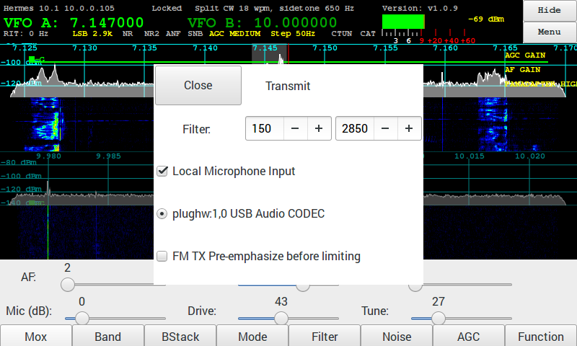
- Local Microphone Input – Local Audio refers to the front panel MIC connection on an Apache Transceiver.
- Filter indicates the upper and lower frequencies for the Transmit bandwidth.
- Audio CODEC shown here is an external USB Audio INPUT device connected to the Rpi.
- FM TX Pre-Emphasis may be required for normal voice quality communications by the FM Server you are connecting to.

Menu → PA Gain by Band

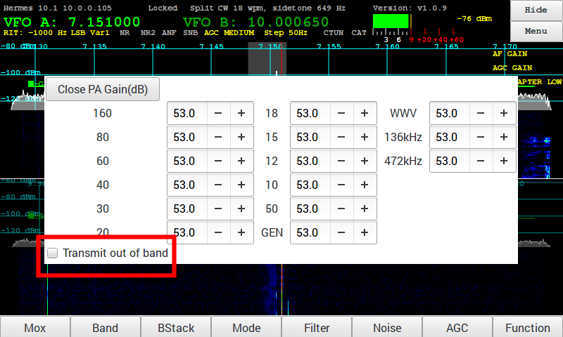
- Sets the PA gain for each band by adjusting the drive level. Note that as the setting are increased the drive level is decreased. This adjustment is set for minimum drive to protect the PA Final Amplifier.
- Note: Transmit out of band – enables transmit outside of ham bands. Default disabled.

Menu → CW

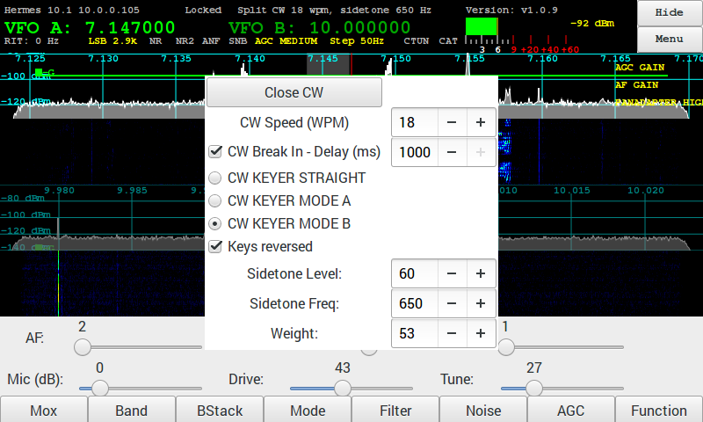
Controls the firmware CW Keyer.
- CW Speed (WPM) – sets speed of dot/dash generator when in Mode A or Mode B.
- CW Break In – when enabled sets the delay time in milliseconds to switching to receive.
- CW KEYER STRAIGHT – selects the key connected will be a straight key.
- CW KEYER MODE A – selects a paddle key running in Mode A
- CW KEYER MODE B – selects a paddle key running in Mode B
- Keys reversed – when enabled the dot/dash paddles are reversed.
- Sidetone Level – sets the audio level of the sidetone.
- Sidetone Freq – set the frequency of the sidetone.
- Weight – sets the dot/dash weighting.

Menu → ANT

The Ant menu selects which antenna is used for receive and transmit on each band.
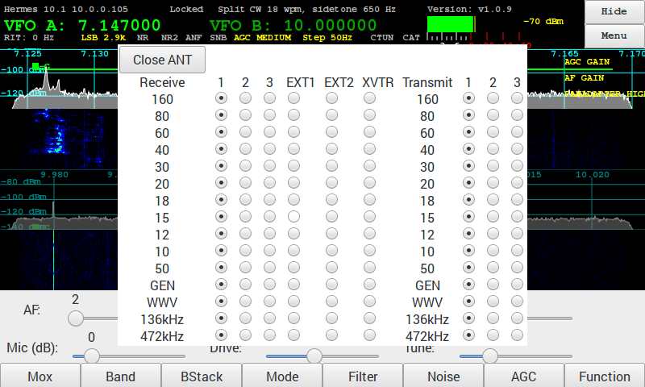

Menu → DSP

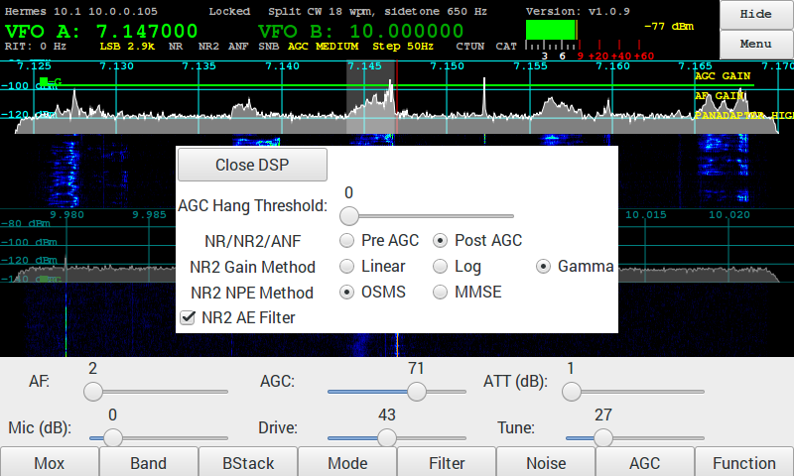
The DSP has options for the DSP functions.

- AGC Hang Threshold – sets the HangThreshold for the AGC.

- NR/NR2/ANF – selects where in the DSP processing the noise reduction functions are performed/ The default id Pre AGC processing.
Pre AGC – perform noise reduction pre AGC
Post AGC – perform noise reduction post AGC

- NR2 Gain Method – selects the method used for the gain processing. The default is Gamma.
Linear - Gaussian speech distribution, linear amplitude scale
Log - Gaussian speech distribution, log amplitude scale
Gamma - Gamma speech distribution

- NR2 NPE Method – selects the Noise-Power-Estimation method. The default is OSMS.
OSMS - Optimal Smoothing Minimum Statistics
MMSE - Minimum Mean -Square Error

- NR2 AE Filter - Enable Artifact elimination. Default enabled.

Menu → OC Open Collector Aux I/O connectors

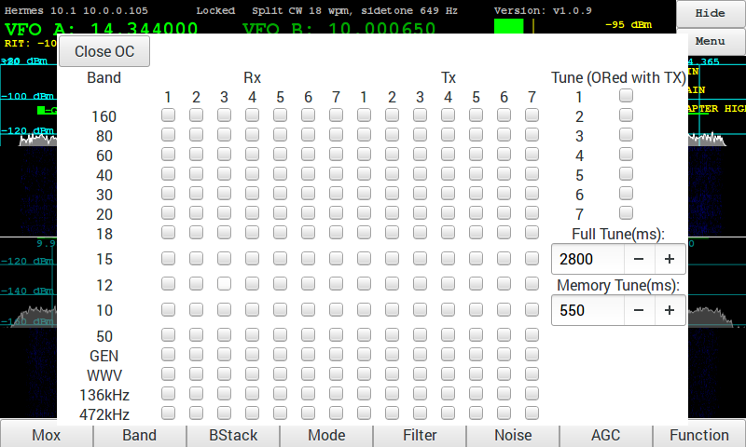
Configure the Open Collector outputs for each band. These can be used to control an external bandpass or antenna filter when not using the Apache Labs filters or the Alex filters. The default is none are enabled.
When an external ATU is used the Tune option can be used to signal to the ATU to start its tune function. The default is none are enabled.
- Tune – configure an OC to be turned on when Tx is enabled.
- Full Tune milliseconds – specifies the time the OC is enabled when the Tuning.
- Memory Tune milliseconds – keydown time for TUNE when using an external Automatic Antenna Tuner

Menu → Display

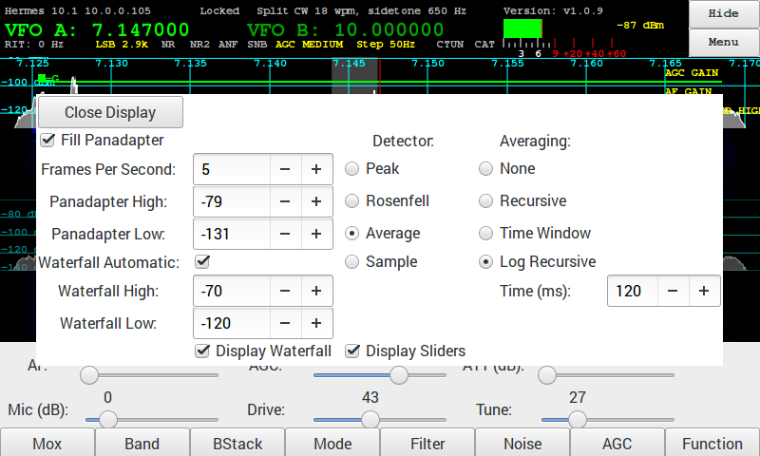
- Fill Panadapter – when enabled the panadapter graph will be filled. When not enabled it will be drawn as a line. Default enabled.

- Frames Per Second – Update rate of Panadapter and Waterfall

- Panadapter High - Maximum signal level displayed in Panadapter
Note: now included as a sub-menu selection for E1, E2, E3 Encoder function assignment

- Panadapter Low – Minimum signal level displayed in Panadapter
Note: now included as a sub-menu selection for E1, E2, E3 Encoder function assignment

- Waterfall Automatic – When enabled the Waterfall High and Waterfall Low are adjusted automatically.

- Waterfall High – Manual control to set the maximum signal used in the waterfall.

- Waterfall Low – Manual control to set set the minimum signal used in the waterfall.

Menu → Display (continued)
- Detector – Selects Peak, Rosenfell, Average or Sample for the Panadapter display.

- Averaging – Selects the method for averaging the Panadapter display.

- Display Panadapter – when selected the Panadapter is displayed on the main screen.

- Display Waterfall – when selected the Waterfall display is displayed on the main screen.

- Display Sliders – when selected the slider controls are displayed on the main screen.

Menu → XVTR

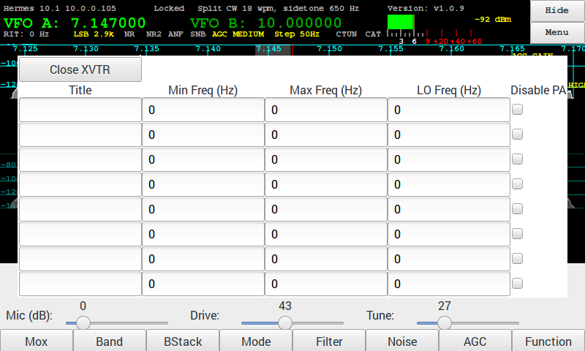
Configure up to 8 transverters.
- Title – the name as it appears in the Band, Ant and OC menus.
- Min Feq – The minimum frequency in Hz.
- Max Feq – The maximum frequency in Hz.
- LO Feq – The Local Oscillator frequency in Hz.
- Disable PA – When checked the Transceiver power amplifier will be disabled on transmit.
Note that the frequency the radio is tuned to is the selected frequency minus the LO frequency. In the example above the 144MHz to 146MHz Transverter frequency will be tuned to 28MHz to 30MHz on the radio.
When one or more Transverters are configured they will appear in the band selection dialog and also in the ANT selection menu and the PA Gain menu.

Menu → Equalizers

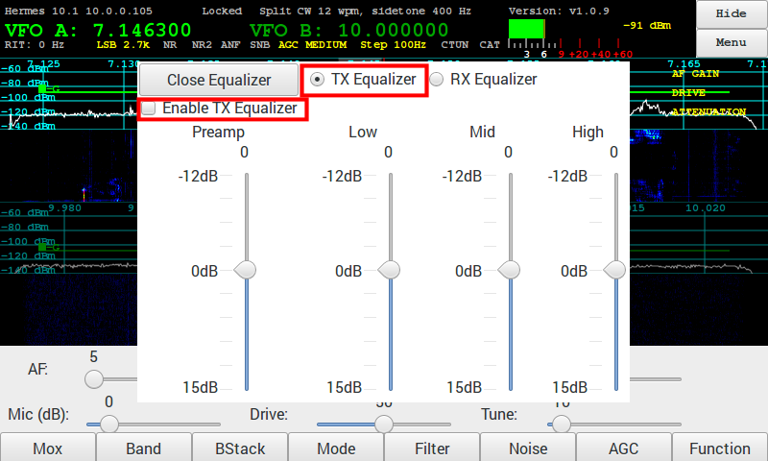
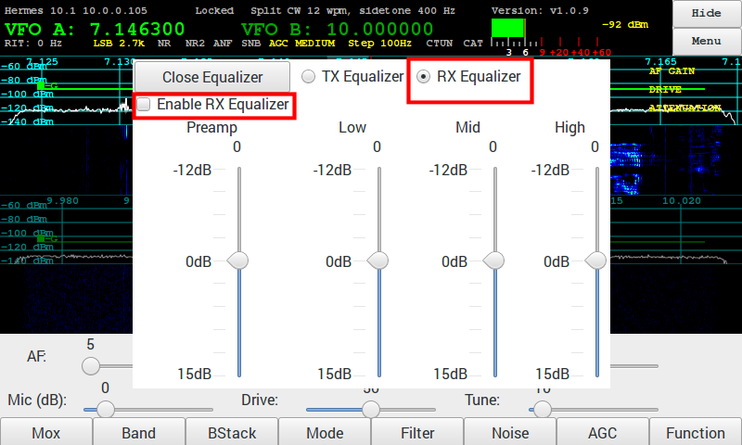
A 3 band graphic equalizer is implemented for both Transmit and Receive:
- Preamp
- Low – 0-400 Hz slider dB
- Mid – 400-1500 Hz slider dB
- High – 1500-6000 Hz slider dB

The radio buttons TX Equalizer and RX Equalizer select which values are displayed.
The equalizers can be enabled by the checkbox Enable TX Equalizer or Enable Rx Equalizer.

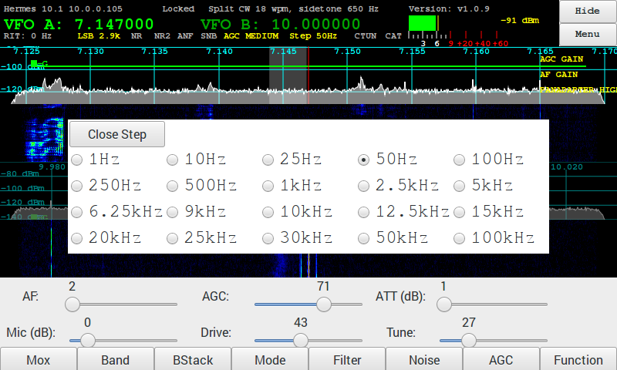
Menu → Step

- Step sets the incremen for VFO Tuning rate via Touch, E4 Encoder, and Mouse Wheel.

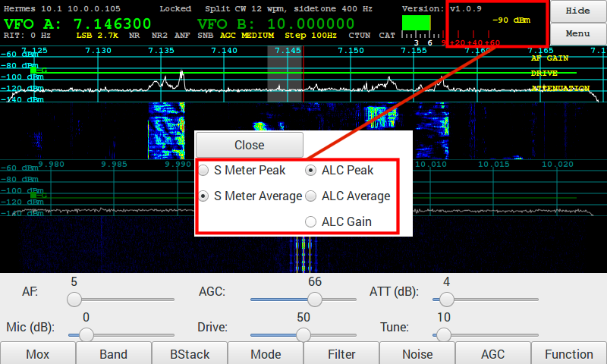
Menu → Meter

- S-Meter Peak and Average
- ALC Peak Average or GAIN
- Meter values appear in the upper right hand corner of the display.

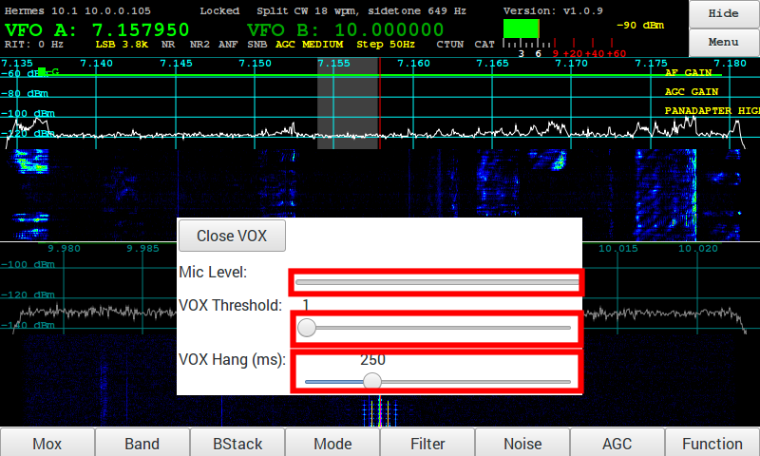
Menu → VOX

- Highlighted box indicates Microphone Level as you speak to adjust Threshold and Hang

- Threshold for VOX activation

- Hang for how long to hold VOX between words while speaking

9. On-Screen Controls and toolbar Buttons

Touch selection of VFO-A (Rx0)
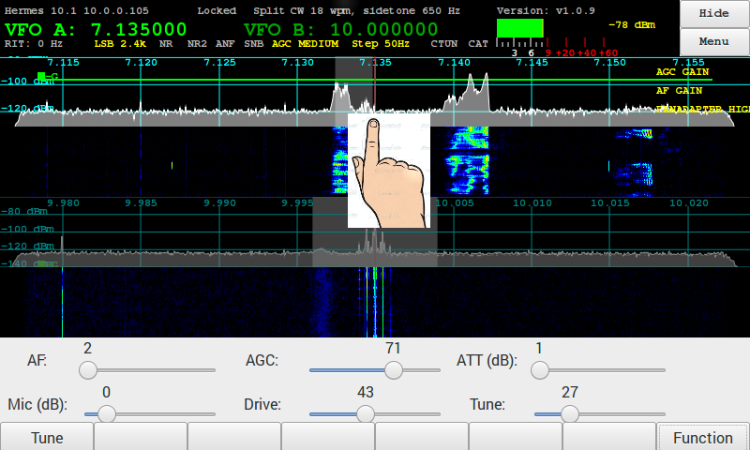

Touch selection of VFO-B (Rx1)
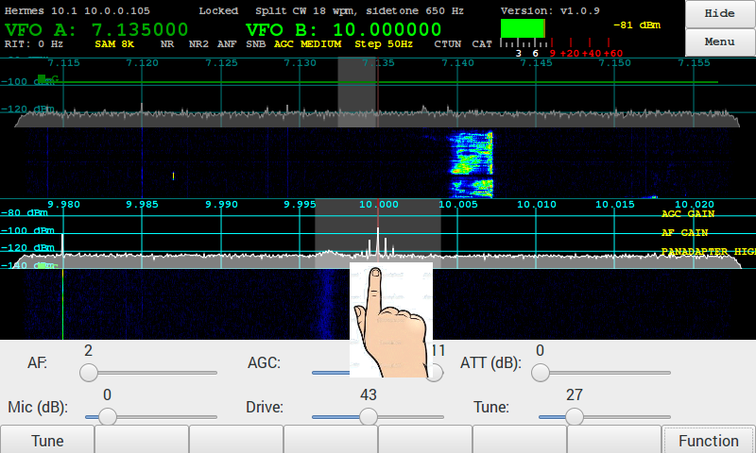

Touch Direct Frequency Entry

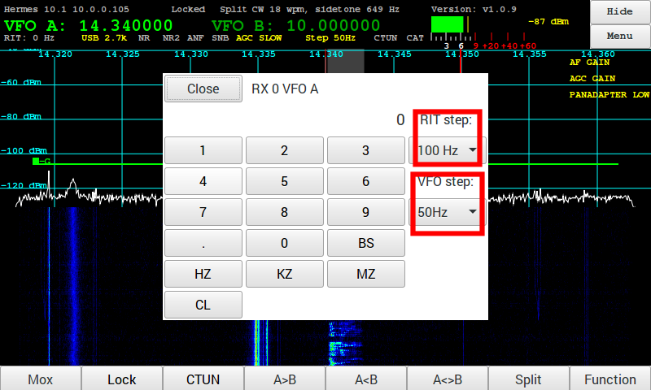
  - Touch or Mouse on VFO-A or VFO-B digits to bring up Direct Frequency Entry menu
(example touch 1-4-3-2-0-KZ = 14.320Mhz 20M)
Note: there is a separate direct Freq entry for each VFO

  - RIT Step
  - VFO Step

Toolbar – Function button

There are 4 Toolbars. Each one is selected by using the Function button or on-panel switch FN Switch to repeatedly cycle through the 4 toolbars.
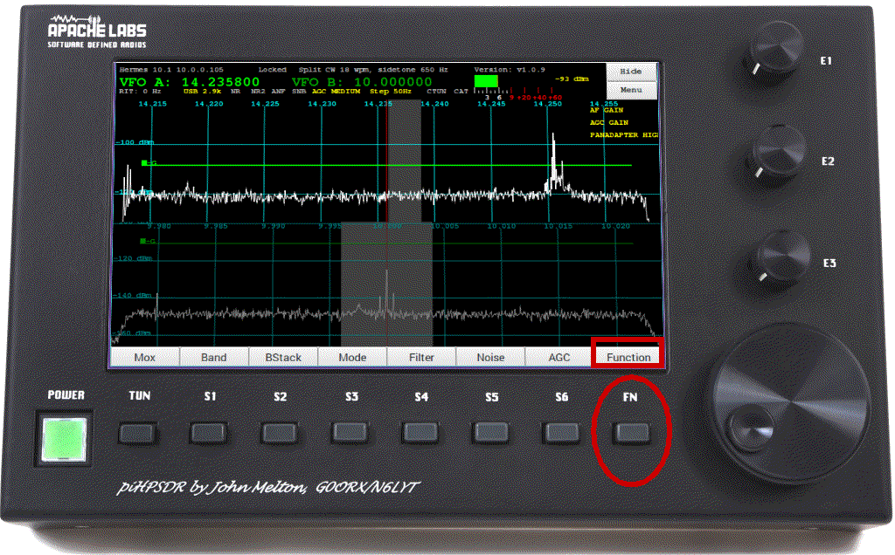
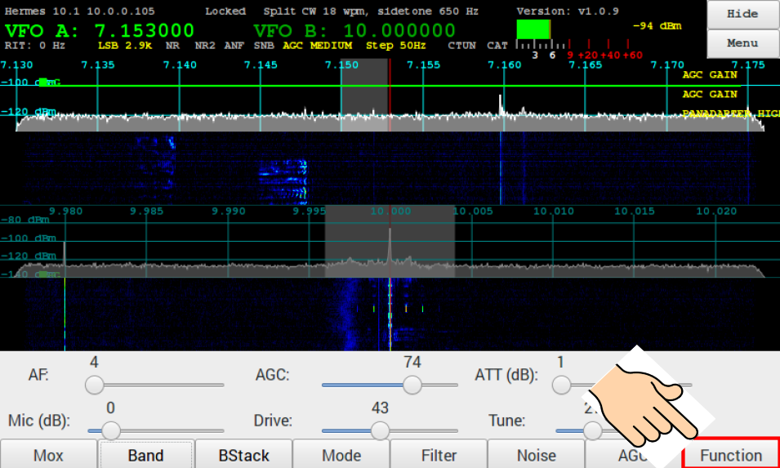
On-Screen
Function
Button
Physical Function
“FN” Button
The function touch screen button or physical button enable the 4 functions buttons and encoders.

Four Toolbar menus – select with Function button or front panel switch
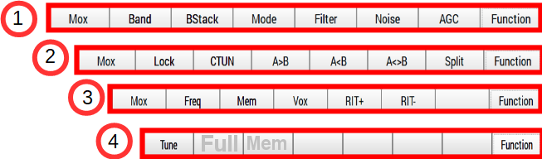

Toolbar – MOX
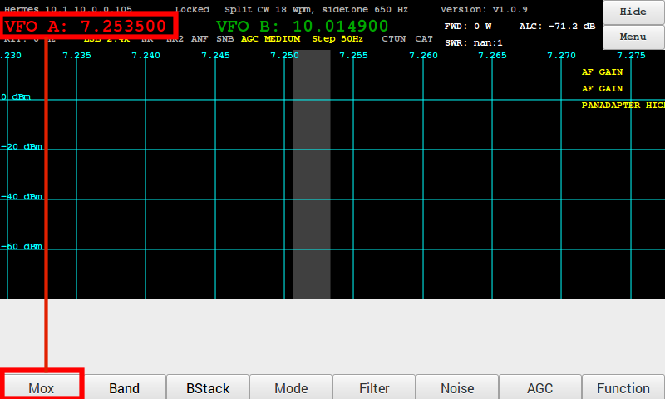

Toolbar – Band selection
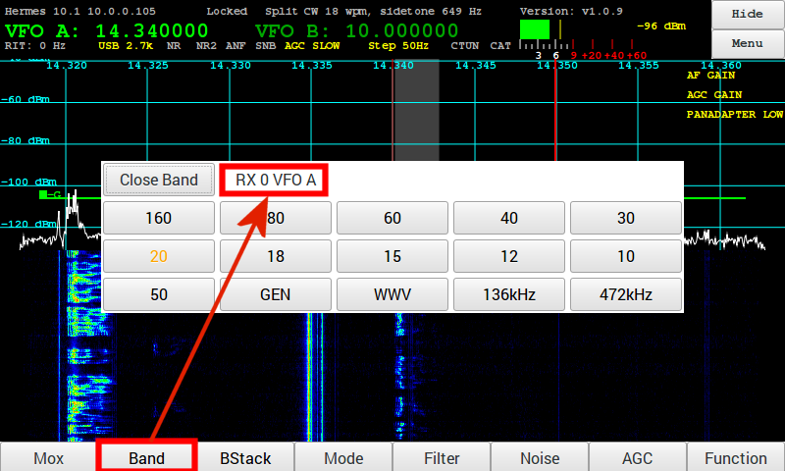

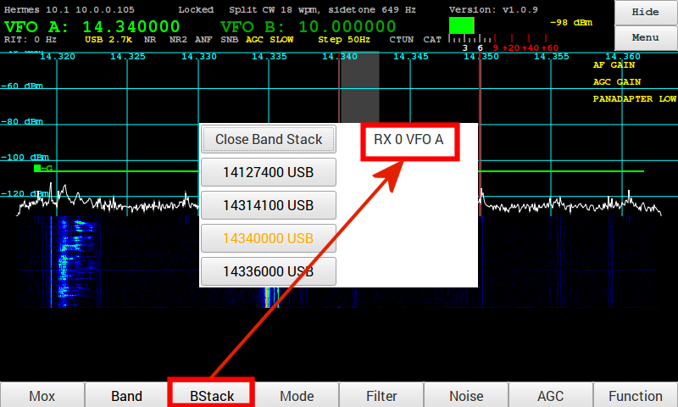
Toolbar - Bandstack

Toolbar – Mode
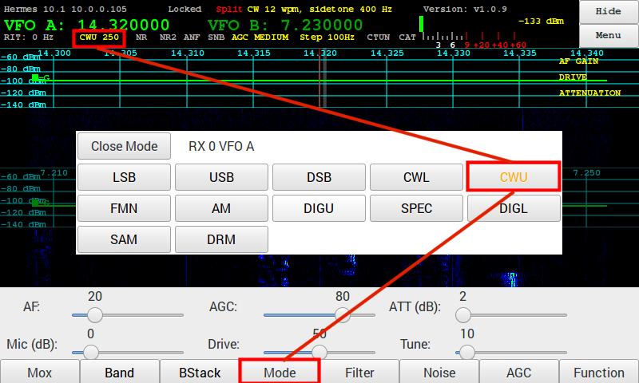

Toolbar – Filter
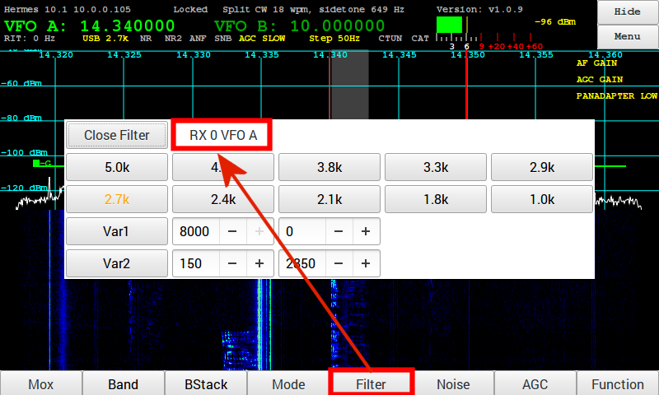

Toolbar – NOISE
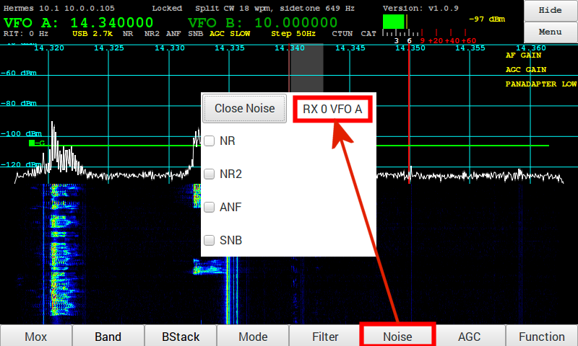

Toolbar – AGC
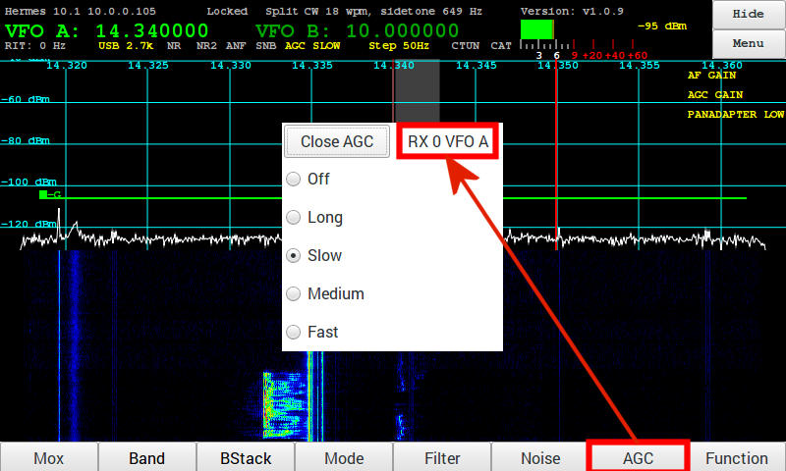

Toolbar – Function button

The function touch screen button or physical button enable the optional functions of some of the buttons and encoders.

Four Function Toolbar menus – select with Function button or front panel switch
Note: the 4th Function Menu will include the Full Time and Mem Time from the Open Collector Menu

Toolbar VFO Lock

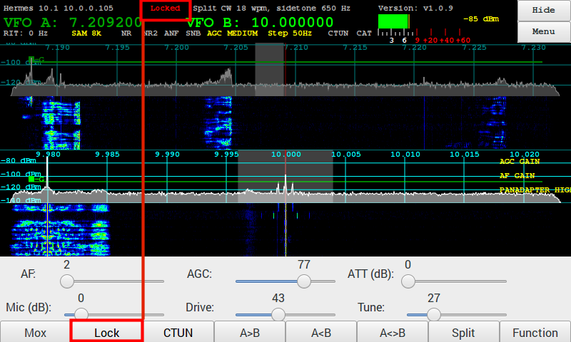
- The VFO can be locked by pressing the button on the AF Gain encoder or by tapping on the left side of the VFO display. To unlock press the AF Gain encoder button again or tap on the left side of the VFO display.
- When locked the text will be displayed in Red on the VFO.

Toolbar CTUN – Click Tuning
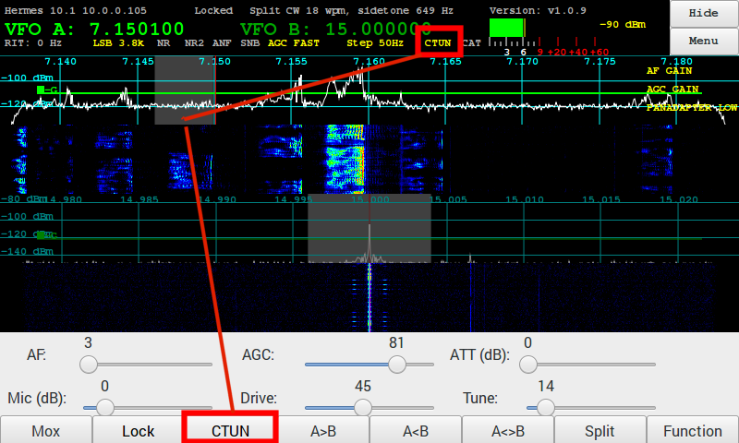
Note: how filter is Tuned to a new frequency and CTUNE is announced in the status bar in Yellow
- Tapping on the CTUN button will enable or disable the click tuning function. When the function is enabled the CTUN button text will be red.
- When CTUN is enabled tuning is restricted to be within the passband currently being received. The tuned frequency and filter moves withing the current passband without scrolling the panadapter or waterfall left or right.

Toolbar A>B A<B A<>B
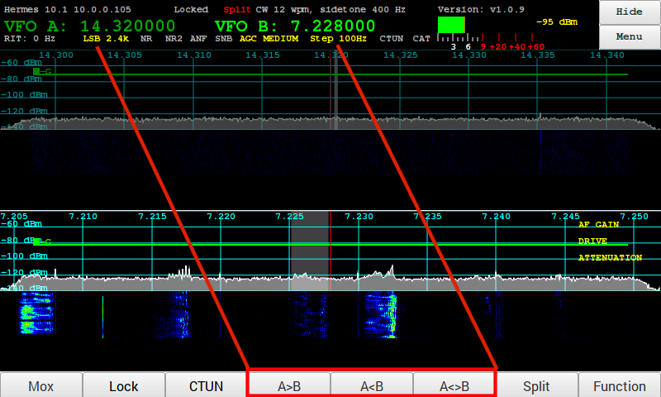
The toolbar allows you to copy the VFO frequency:
VFO-A into VFO-B ( A>B )
VFO-B into VFO-A ( A<B )
VFO-A swap VFO-B ( A<>B )

Toolbar SPLIT
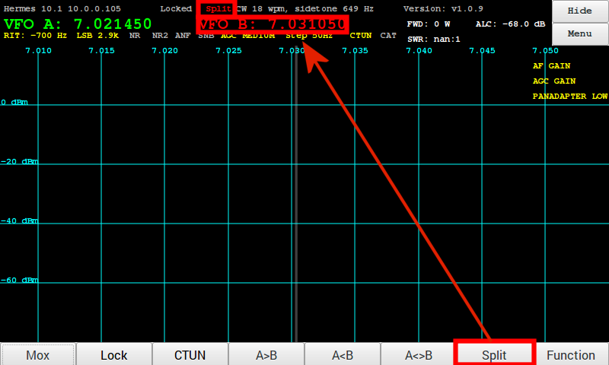
- The Split function allows you to select VFO-A for Receive and VFO-B for Transmit. This is a common practice when working Contests, DX, or Crossband.

Toolbar FREQ
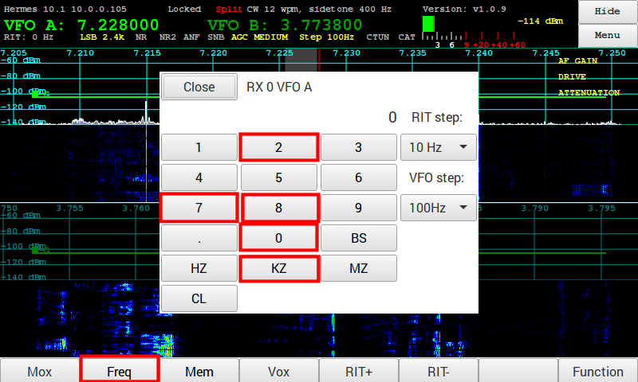
- Direct frequency entry using the touchpad is easily done by first selecting the VFO you wish to change, and then punching in the frequency in kHz or mHz. This illustration shows selection of 7.228 LSB on 40M.

Toolbar MEM

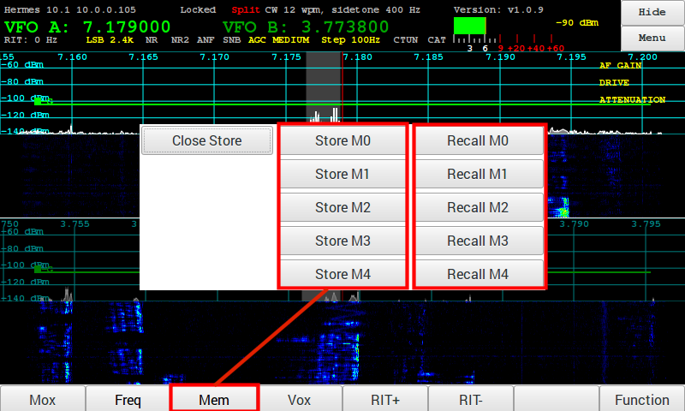
- Convenient storage and recall of four favorite frequencies

Toolbox VOX
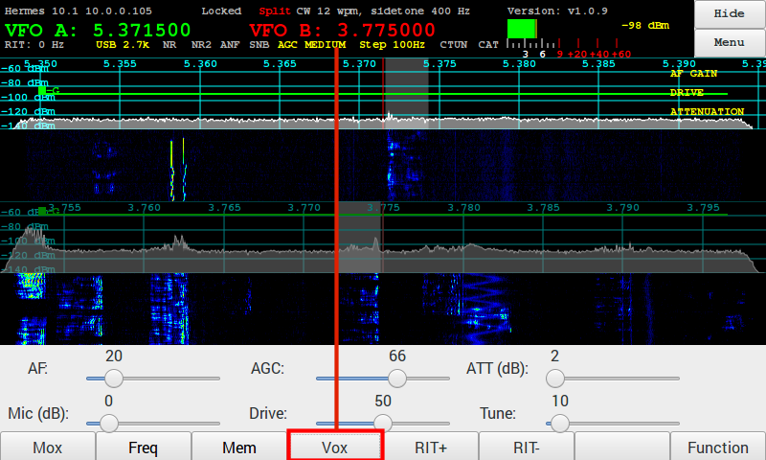
- Using the Toolbar VOX allows you to key PTT for VOX level adjustments (Menu)

Toolbar RIT

RIT – Receiver Incremental Tuning
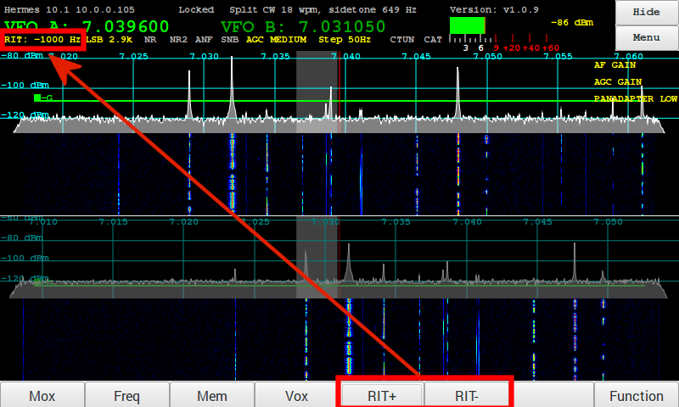
- Tapping on the RIT+ (plus) or RIT- (minus) button will enable RIT
This page reserved for future additions of
Open Collector Full Tune and Memory Tune times (ms)

AF Gain Slider
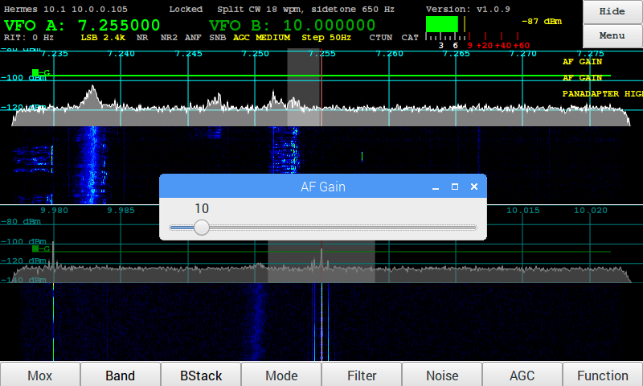
AF Gain Slider is displayed using Function key to select one of the two uses for Encoder E1

MIC Gain Slider
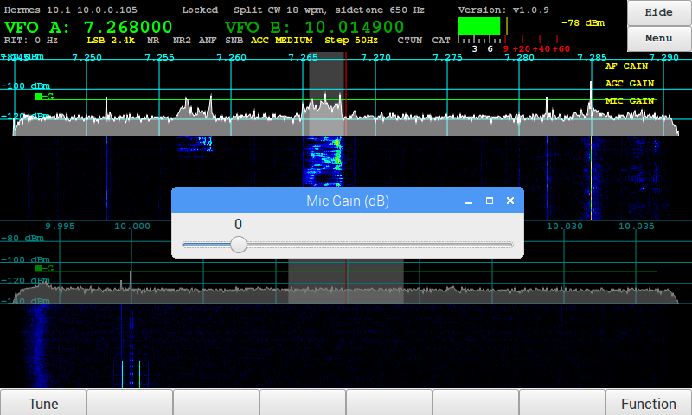
MIC Gain Slider is displayed using Function key to select one of the two uses for Encoder E1

PA Drive Slider
PA Drive Slider is displayed using Function key to select one of the two uses for Encoder E1
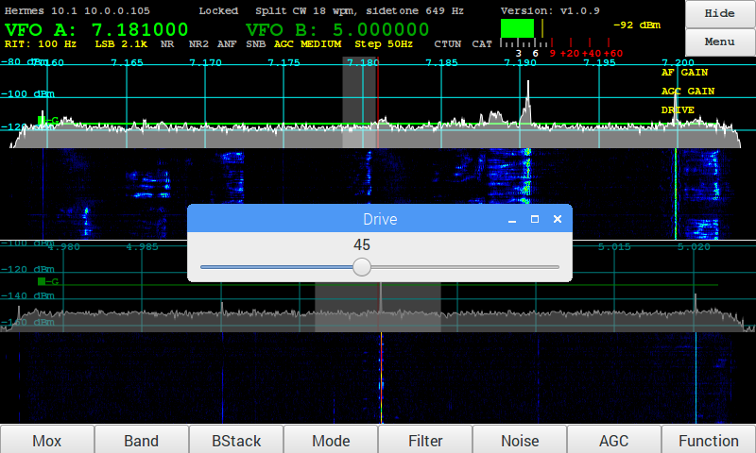

Tune Drive Slider
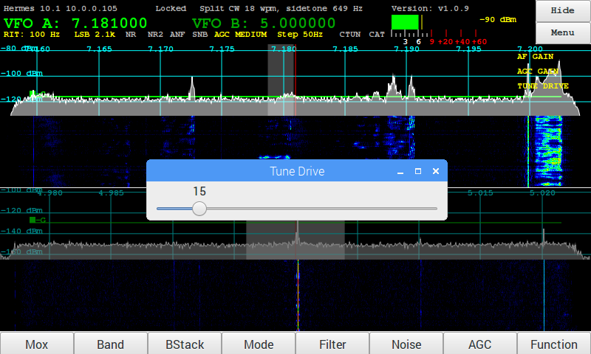
TUNE Drive Slider is displayed using Function key to select one of the two uses for Encoder E2

AGC Gain Slider
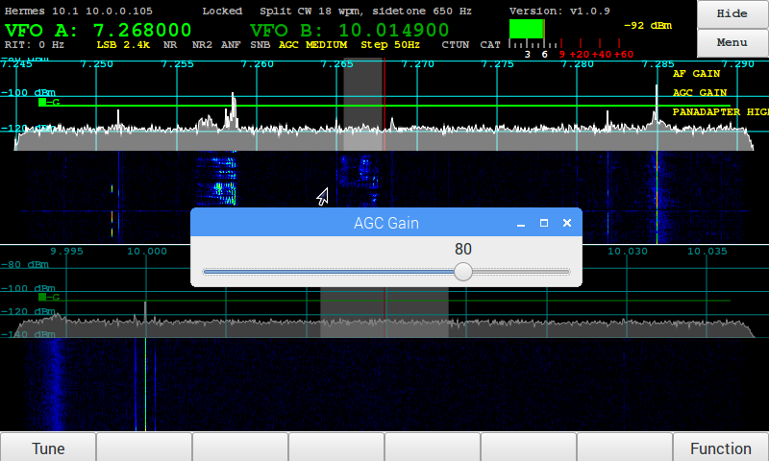
AGC Gain Slider is selected using the Function Key and then rotating E3

Receive Attenuation Slider
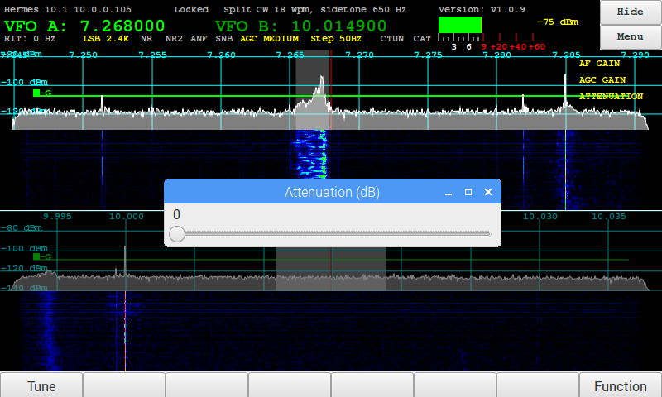
Receive Attenuation Slider is selected using the Function Key and then rotating E3

Main screen HIDE

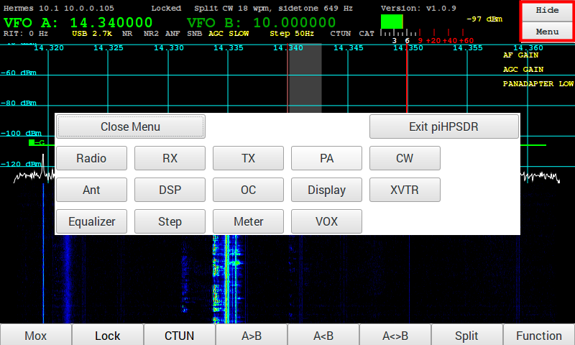
- The purpose of the HIDE option is to minimize the pihpsdr application window and to then provide easy access to the RaspberryPi operating system and secondary applications such as Fldigi.

Menu or Toolbar → Meter

- Tapping on the Meter will display a list of options for updating the meter.

10. Tuning

VFO Encoder
The VFO encoder knob is used to tune the radio. By turning the encoder clockwise and anticlockwise the frequency will increment or decrement by the amount of the step value.
The General Menu has a field to set the resolution of the encoder.

Touch Screen
Touching and dragging on the panadapter or waterfall will move the frequency up or down. Note that it will move in step increments.
Tapping a frequency on the panadapter or waterfall will move to that frequency.

Mouse
Left down and holding then dragging while on the panadapter or waterfall will move the frequency up or down.
Left clicking will move to the selected frequency.
Moving the scroll wheel will increment or decrement the frequency by the step value.

11. TUNE/SWR/FWD Power

TUNE/SWR/FWD power
When the Function button is selected, it toggles the TUNE/MOX button on the far left. FWD power and SWR can then be read in the top of the pihpsdr window.
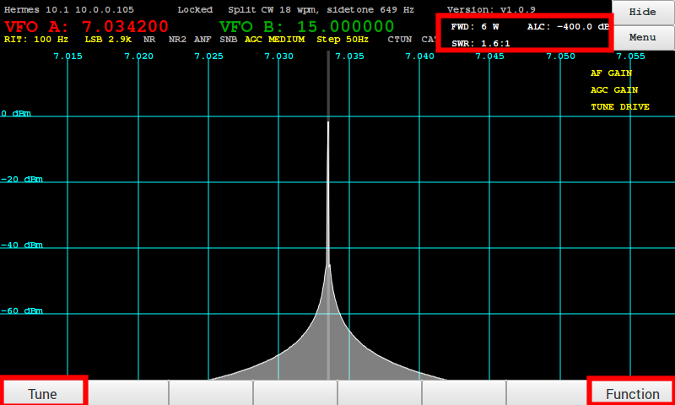

12. Appendix

Encoders and Switches

Factory Switch/Encoder/Touch activation
5Switch or Encoder | Function | Touch Screen | GPIO  A | GPIO  B
Power ON/OFF | Controller power on/off | Controller power on/off
TUN – TUNE button | generates a carrier with Tune power selection slider | generates a carrier with Tune power selection slider
MOX – MOX button | Space bar toggle for PTT  or MOX button | Space bar toggle for PTT  or MOX button | 27
S1 – Band | 10 HF Bands + General Coverage + WWV + LF + XVRT | 10 HF Bands + General Coverage + WWV + LF + XVRT | 13
S2 – Mode | LSB USB DSB CWL CWU FMN AM DRM FreeDV PSK | LSB USB DSB CWL CWU FMN AM DRM FreeDV PSK | 6
S3 – Filter | 10 IF Filter widths | 10 IF Filter widths | 5
S4 – Noise | 5 Noise Reduction modes | 5 Noise Reduction modes | 24
S5 – AGC | 5 AGC Decay settings | 5 AGC Decay settings | 4
FN – Function | Function switch to toggle TUNE or MOX button displayed on the bottom left of the screen | Function switch to toggle TUNE or MOX and the action of E1, E2, E3 knobs | 22
E1 -- | two functions AF Gain / MIC Gain | two functions AF Gain / MIC Gain | 20 | 26
E2 – | two function RF Drive / TUNE Drive | two function RF Drive / TUNE Drive | 16 | 19
E3 – | two function AGC Gain / Rx ATTEN | two function AGC Gain / Rx ATTEN | 4 | 21
E4 – VFO Main tuning knob | ------- | ------- | 17 | 18
Menu | ------- | Main piHPSDR Menu
Menu → Band |  | Select band
Menu → Band Stack | 3 to 5 level quick freq change | 3 to 5 level quick freq change | 13
Menu → Mode | Mode | Mode | 6
Menu → Filter | IF Filter width | IF Filter Width | 5
Menu → Noise | Noise Blanker mode | Noise Blanker Mode | 24
Menu → AGC | Automatic Gain | Automatic Gain | 4 | 21
Locked | Right click on VFO Frequency to toggle Frequency Lock | Touch VFO Frequency to toggle Frequency Lock
Meter | Right click on S-Meter for S-Meter and ALC peak/average | Touch S-Meter for S-Meter and ALC peak/average

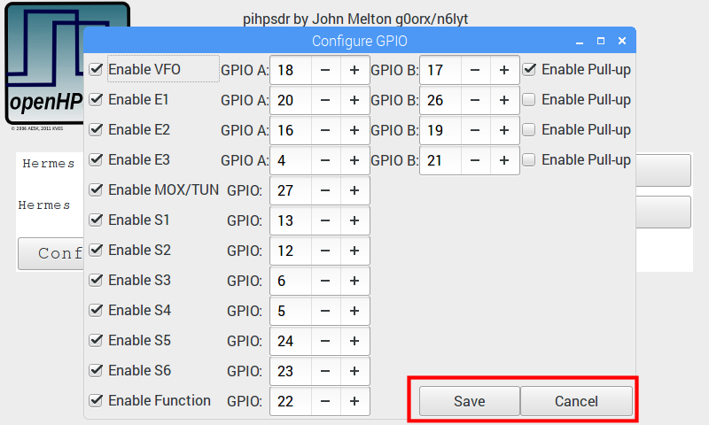
GPIO Default assignments

GPIO pin Assignments (RaspberryPi)

Note: You may wish to reverse the direction of Tuning on the VFO Encoder. The GIPIO table shown at the START of pihpsdr allows convenient text entry. For example, the VFO direction of TUNING can easily be changed by swapping GPIO-A from 17 to 18, and GPIO-B from 18 to 17.
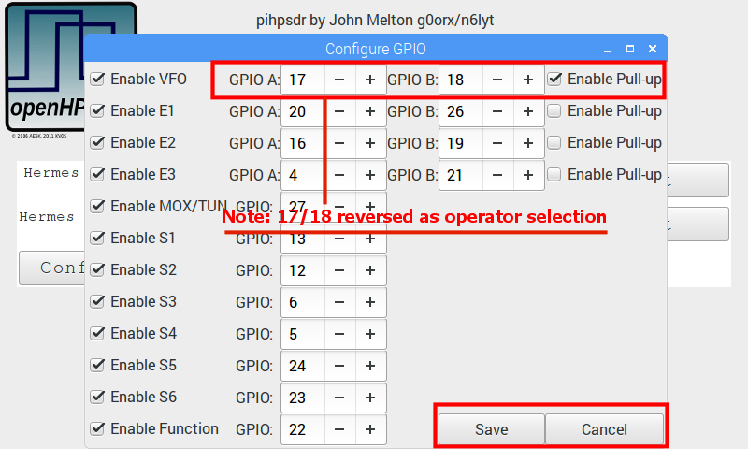

13. Reference materials

G0ORX Friedrichshaven pdf and video
Friedrichshafen 2016 publication
https://www.dropbox.com/sh/fva5d5mi93c93tq/AAD6dU-eBMR0cVK-E95hJC5Ia?dl=0
Jacinto Rebelo CU2ED for his Homebrew of a pihpsdr Controller
Kjell Lasen LA2NI for his complete RPi-e System

Scott WU2O Homebrew Controller http://wu2o.dyndns.org/wu2o_pi_4.html
F'Hafen video on YouTube:
https://www.youtube.com/watch?v=U7QfP28YjCw

14. Steve Wilson KA6S special addition for Fldigi

Using PiHPSDR with other applications:

PiHPSDR emulates several commands available in the CAT control found in the TS-2000. However, it receives commands over TCP/IP instead of through an RS-232 connection. For some applications this is trivial – for others some internet plumbing is required.

The Basics
PiHPSDR listens on Ports 19090-19092 for TCP/IP connections. It interprets TS-2000 protocol commands and will respond appropriately. It is NOT a full implementation. Some things don't make sense, i.e. they are features not shared between the TS-2000 and PiHPSDR. Others are still to be implemented.
Note: The latest version of Hamlib has a radio definition for the PiHPSDR, thus any application that uses Hamlib will be able to talk to PiHPSDR in its native manner, i.e. directly through TCP/IP without using the serial port. (Thanks to Jae, K5JAE for the hamlib port!) The serial port methodology is presented here for older iterations of Hamlib. To get access to to native support you will need to compile Hamlib from source and install it. That is beyond the scope of this manual.

Raspberry PI
Linux/Windows
Application
Use the Raspberry PI TCP/IP Address
And set for Port 19090
PiHPSDR

Ethernet

Mapping a Serial Port to TCP/IP port in Linux
Perhaps the easiest way to do this is via the utility “socat” available in most Linux distributions. This utility is sort of a swiss army knife for interconnectivity, and one its abilities is to map Linux Serial ports to TCP/IP ports.

To obtain “socat” and install it on an Ubuntu system type:

sudo apt-get install socat

To use it – first start PiPHSDR. You need to know the TCP/IP address of your Raspberry Pi. This will be a 32 bit number formated as XX.XX.XX.XX. I'll use 192.168.1.73 in my examples – since that happens to be what I have my Raspberry Pi set too.

To run it – type:
socat pty,link=/tmp/vtty,raw tcp:192.168.1.73:19090&
This will do two things. It creates a fake serial port called /tmp/vtty that can be opened by most applications and acts just like a serial port.

The next step is to point your application at /tmp/vtty where you would normally choose a serial port and set it to talk to a TS-2000. It really is that simple!

This allows applications that are built to use Hamlib to talk to PiHPSDR.

Example: Set up GRIG to talk to PiHPSDR

grig –-model=214 –-rig-file=/tmp/vtty *

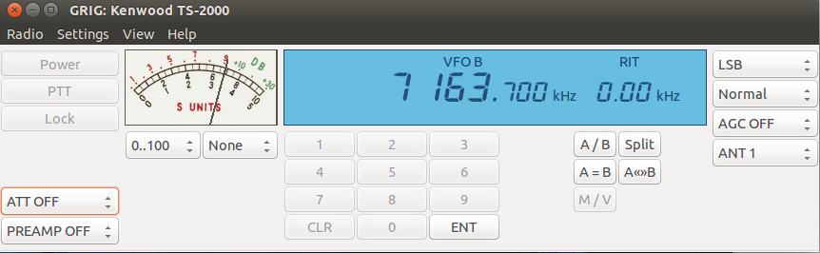

/tmp/vtty is a temporary file – it disappears as soon as socat ends.

Grig is built around the Hamlib radio access library. The TS-2000 is model 214 in Hamlib. Any application that uses Hamlib should be able to communicate with PiHPSDR by using /dev/vtty and choosing model 214 as the radio.

Something else to realize is that only one application can talk to PIHPSDR at a time on a given port. PiHPSDR can use any of 19090-19092 as the CAT port, and supports 3 simultaneous connections.

If you have the latest version of Hamlib that supports PiHPSDR natively – the command to start grig would be:

grig –model=240 –rig-file=192.168.1.73:19090 &

Example: Connect FLDIGI to PiHPSDR
FLDIGI can be connected to PiHPSDR using the native PiHPSDR interface built into the latest version of Hamlib. However, it polls PiHPSDR way to fast.

Have no fear – FLRIG is here. FLRIG is a companion application to FLDIGI that can act as a server for FLDIGI.

You can install FLRIG on with:
sudo apt-get install flrig

You can install FLDIGI with:
sudo apt-get install fldigi

Start FLRIG first with

flrig

No need to start it with sudo since it talks directly to PiHPSDR.

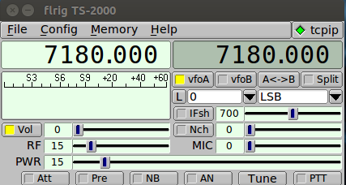

To set up FLRIG – Hit the Config button on the top of the application and Choose Config/Setup/Transceiver – the Window below will pop up.

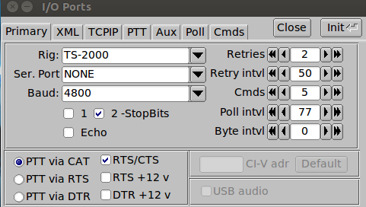

Use the arrow to the right of the Rig: box and slide it to TS-2000.

Also – check the PTT via CAT button in the lower left corner.

Hit Close

Now Choose Config/Setup/TCPIP

The window below will pop up.

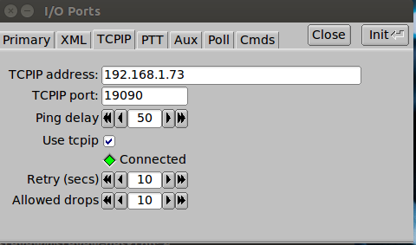

Select the TCPIP tab. Enter the TCPIP address of your Raspberry Pi – in our example you see 192.168.1.73. Type in the TCPIP box 19090 and that should do it. Hit the “Use tcpip” button. If the connected light isn't green – hit the Init button in the upper right portion of the window.

Hit Close and you should have FLRIG up and controlling your PiHPSDR.

The Frequency should work by using the scroll wheel over the digit you want to change.

The volume, RF, PWR, and MIC sliders should all work.

The PTT should cause the radio to transmit.

The S Meter should register.

Now get FLDIGI running.

Type:

fldigi

Choose Configure/Rig Control

Hit the flrig tab and the window below will pop up.

Hit the “Enable flrig xcvr control with fldigi as client” button.
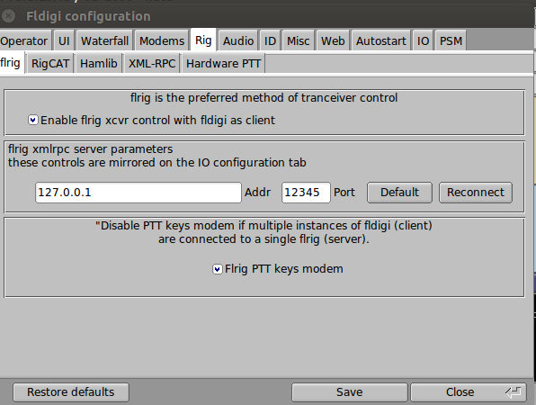

Note that the TCP/IP address is 127.0.0.1 – which is the same as the machine you are running flrig and fldigi on. The TCP/IP port 12345 should already be configured.

Also hit the “Flrig PTT keys modem”

That is it.

You need to use actual audio cables from the Radio to your Linux computer for the audio as of now – but this should be all that is necessary for FLDIGI to talk to your radio!

Setting up rigctld
The Hamlib system must be installed to use some packages – specifically to run the rigctld daemon.

On Ubuntu:

sudo apt-get install libhamlib-utils
sudo apt-get install libhamlib2

Note: These packages don't yet have PiHPSDR supported natively. It is necessary to compile the latest version from source and that is beyond the scope of this manual.

Multi-Client Support

PiHPSDR can communicate with up to 3 independent clients simultaneously. An example of this might be running FLRIG/FLDIGI with the logging program CQLOG.
First – make sure you have CQLOG installed.

On Ubuntu:
sudo apt-get install CQLOG

We need do three things to get cqrlog running.
1) Create a virtual terminal – see the instructions above about running cqrlog. There is one change here. We're going to aim the virtual serial port /tmp/vtty at TCP/IP port 19091 instead of 19090.
2) Start up the hamlib rigctld – this is a “daemon” in Unix parlance that is responsible for interfacing between applications and the virtual terminal using the internal hamlib protocol. Note that SOME applications have the hamlib software built in, while others use the daemon – cqrlog uses the daemon. The rigctld must be started using “sudo”
3) Start up cqrlog. Specifically do NOT use “sudo” for this command.

In a single xterm – you can start up both socat AND the rigctld daemon. Note again the use of “sudo” prior to the command AND note that the first program can be put into the background safely. Rigctld doesn't work if you do that..

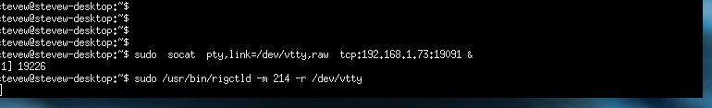
In another xterm – start up cqrlog

Enter: cqrlog &

This will start up cqrlog talking the PiHPSDR radio using port 19091. Note that this can be safely put into the background using the ampersand operator.

Configure cqrlog as shown in the picture below:
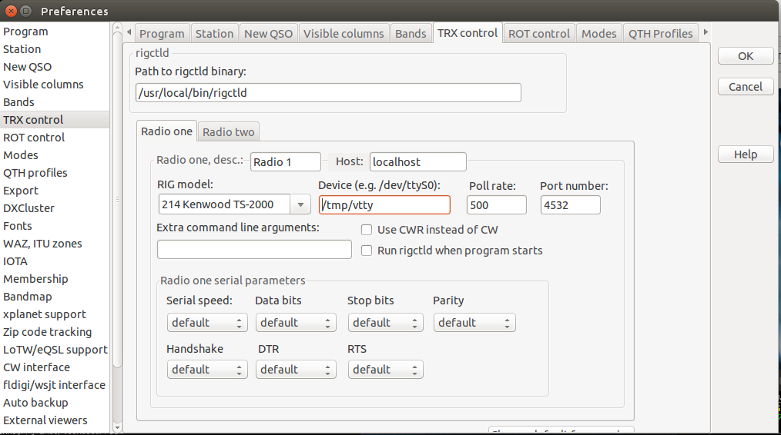
Note that we are choosing to NOT launch rigctld when the program starts – but rather starting it by hand.

Next – start up flrig as you have previously using port 19090. It should be configured correctly from the first time you used it. Since cqrlog spouts messages – you may need to use another xterm…

% flrig &

And this you can start up FLDIGI using the same xterm..

%fldigi

The picture below shows all applications running – using the two TCP/IP ports.

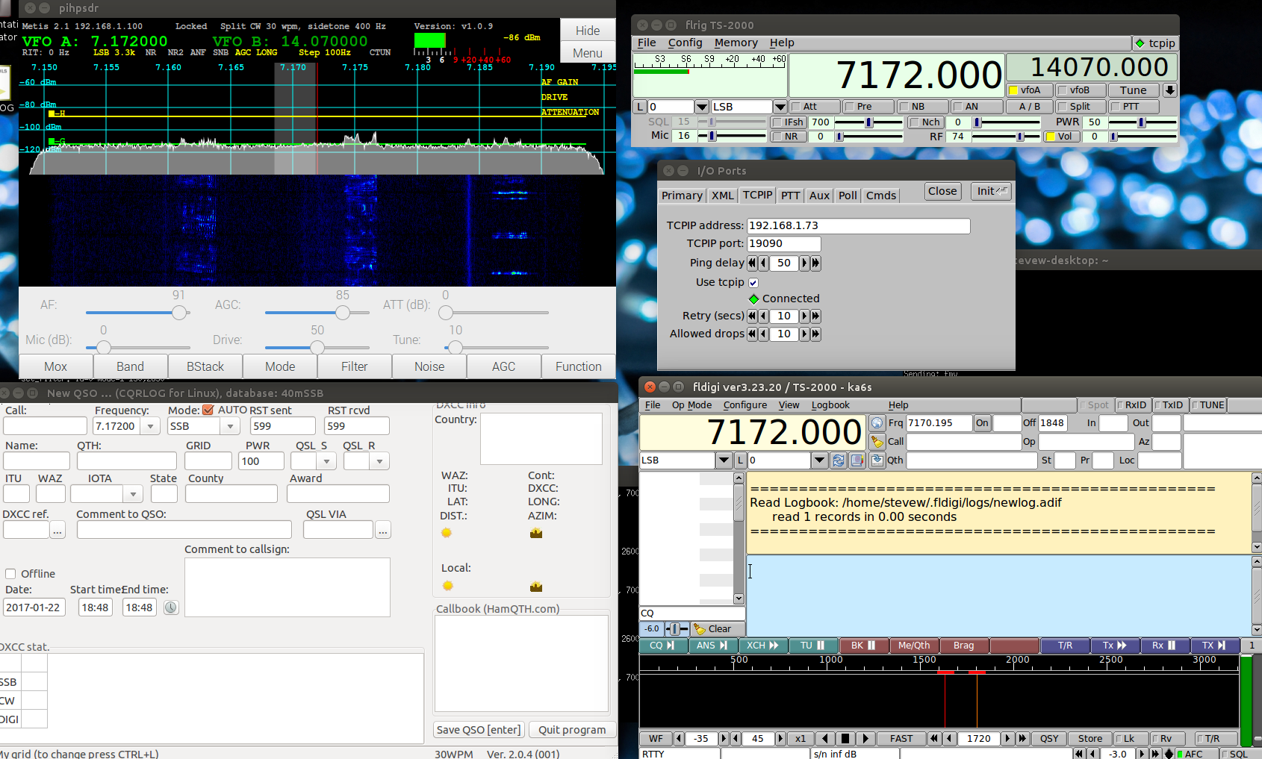

Running applications with the latest version of Hamlib

The biggest advantage of running applications through latest version of Hamlib is that the whole virtual terminal concept is removed! Applications can talk directly to PiHPSDR without any middleware. I'll use CQRLOG to illustrate the setup.

The first trick is to make rigctld runnable without being root. THIS IS A SECURITY HOLE – Proceed at your own risk! The following command allows rigctld to be run without being root…

sudo chown pi /usr/local/bin/rigctld

This makes the user “pi” owner of the rigctld daemon.

Next – start up cqrlog and set up its preferences as shown in the next picture.

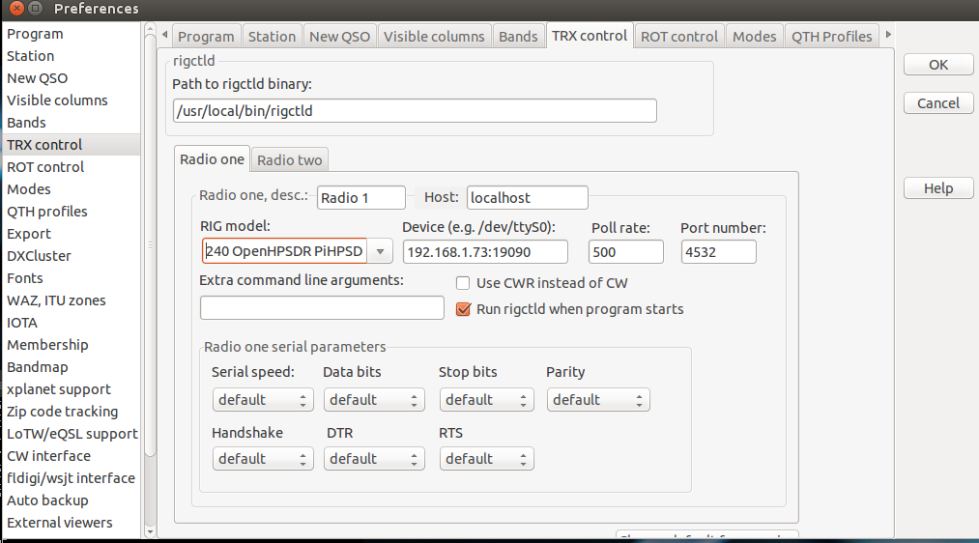
Things to note:
Rig Model is OpenHPSDR PiHPSDR – radio model 240.
Device: Use the TCP/IP/Port number – so 192.168.1.73:19090
The “Run rigctld when program starts” is checked – since we don't have to root to run rigctld.

It is also possible to start cqrlog on OTHER than the Raspberry Pi. The settings would be the SAME since the device entry is what actually aims the communications at the PiHPSDR TCP/IP port. Rigctld can be started on another machine and it will be able to communicate via TCP/IP directly to the PiHPSDR application.

KA6S Summary
PiHPSDR provides 3 separate TCP/IP channels on ports 19090, 19091, and 19092 which can communicate with other applications using an emulation of the TS-2000 command set.

Some applications require a virtual serial port – use the socat command run to create the virtual serial port.

The very latest version of Hamlib supports PiHPSDR natively. Radio model is 240, and uses TCPIP Address/Port Number instead of the serial port.

Other applications require the hamlib rigctld to be present – start /usr/bin/rigctld with sudo.

To run FLDIGI – use FLRIG as the server for FLDIGI since FLDIGI has issues talking to the virtual serial port.

15. Supported CAT Commands

16. Apache Support

Apache Labs International Support
Technical support for ANAN-10 from the factory is available via the Apache Labs Yahoo Group http://groups.yahoo.com/group/apache-labs/
or directly via email <support@apache-labs.com>

Apache Yahoo Support Group
http://groups.yahoo.com/group/apache-labs/

OpenHPSDR Group
Instructions relating to joining the OpenHPSDR Group reflector are here:
http://lists.openhpsdr.org/listinfo.cgi/hpsdr-openhpsdr.org

The OpenHPSDR archives may also be searched here:
http://lists.openhpsdr.org/mmsearch.cgi/hpsdr-openhpsdr.org

The latest version of the OpenHPSDR User Manual can be obtained from
http://openhpsdr.org/documents.php Author Phil Harman VK6PH

17. Apache Service and Repair
1023 Tower B4, Spaze I-Tech Park
Sector - 49, Sohna Road
Gurgaon - 122001
Haryana, India
Tel: 91-0124-4245173/4/5 (10AM - 6PM IST]
Email: support@apache-labs.com
Website: http://www.apache-labs.com

Early prototypes by John Melton G0ORX (circa: 2015)
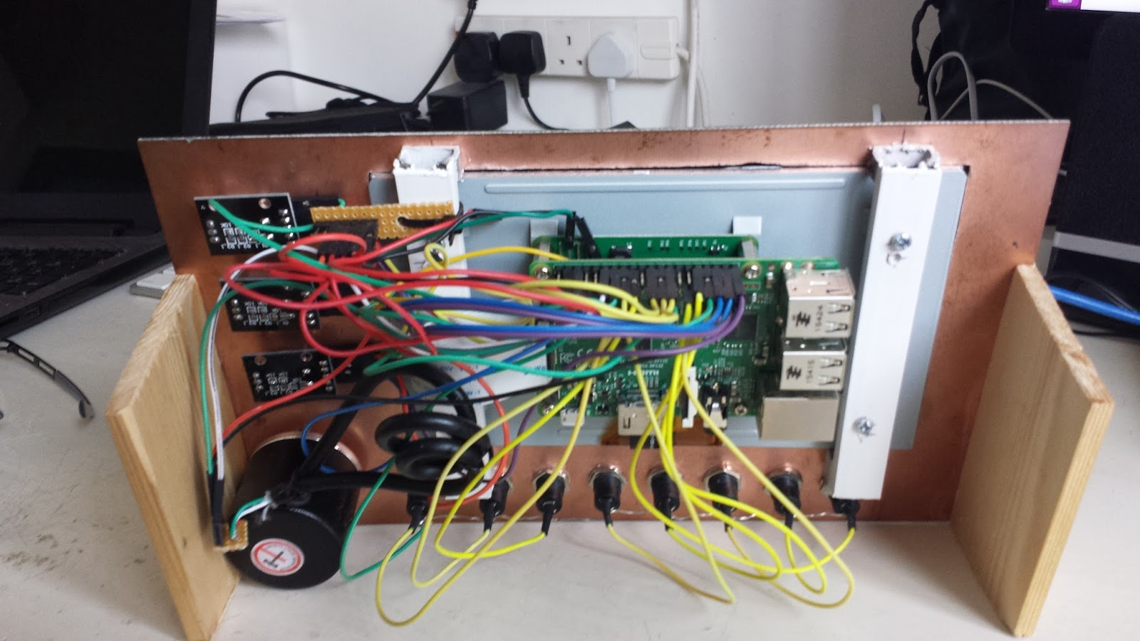
Note: pihpsdr is OpenSource. If you would like to run the program on a Linux system, the source, binaries, and documentation are located here: http://g0orx.blogspot.com/
NOTES

____________________________________________________________________________________________________________________________________________________________________________________________________________________________________________________________________________________________________________________________________________________________________________________________________________________________________________________________________________________________________________________________________________________________________________________________________________________________________________________________________________________________________________________________________________________________________________________________________________________________________________________________________________________________________________________________________________________________________________________________________________________________________________________________________________________________________________________________________________________________________________________________________________________________________________________________________________________________________________________________________________________________________________________________________________________________________________________________________________________________________

Alphabetical Index
1. Introduction 5
10. Tuning 54
100BT 6
100BT LAN connection 6
11. TUNE/SWR/FWD Power 54
12. Appendix 55
12. Appendix 55
13. Reference materials 57
13.8vdc 2.5A 6
16. Apache Support 71
17. Apache Service and Repair 71
3 band graphic equalizer 28
3. Front panel controls 8
4 Toolbars. 34
5. Side panel connections 10
5Switch or Encoder 55
6. Quick Start Instructions 11
7. Discovery Menu 12
8. Main Menu 14
9. On-Screen Controls and toolbar Buttons 32
AF Gain Slider 49
AGC Gain Slider 51
AGC Hang Threshold 23
ALC Peak Average or GAIN 30
Apache Labs International Support 71
Apache Labs LLC 1
Apache Service and Repair 71
Apache Support 71
Apache Yahoo Support Group 71
APIPA 6
Appendix 55
Audio CODEC 19
Automatic Antenna Tuner 24
Averaging 26
backup of your Operating System 7
binaries 11
CAT 5/6 Ethernet cable 11
change the sample rate 17
Close 15
Close Menu button 14
close this dialog box 15
compile 11
Config/Setup/TCPIP 61
Configure up to 8 transverters 27
Connect FLDIGI to PiHPSDR 59
Controller software requirements: 7
CQLOG 62p.
CW Break In 21
CW Keyer 21
CW KEYER MODE A 21
CW KEYER MODE B 21
CW KEYER STRAIGHT 21
CW Speed 21
Default assignments of switches and rotary encoders 8
Detector 26
direct Freq entry for each VFO 33
Direct frequency entry 44
Direct Frequency Entry menu 33
Disable PA 27
Discover 12
Discover Ethernet Connections to RPi 12
Discover protocol 12
Discovery Menu 12
Display Panadapter 26
Display Sliders 26
Display Waterfall 26
Dither 17
documentation 7, 11
E1 8
E2 8
E3 8
E4 8
Early prototypes 72
Encoders and Switches 55
equalizers can be enabled 28
executable binaries 7
Exit 15
exit piHPSDR back to the Raspberry Pi Desktop 15
Exit piHPSDR button 15
Factory Switch/Encoder/Touch activation 55
Fill Panadapter 25
Filter 19
FLDIGI – use FLRIG as the server 65
FLRIG 60
FM TX Pre-Emphasis 19
FN 8
FN Switch 34
Four Function Toolbar menu 39
Frames Per Second 25
Front Panel Display 9
Full Time and Mem Time 39
Full Tune milliseconds 24
Function 55
Function button 39
function touch screen 34
fused 12vdc 11
G0ORX Friedrichshaven pdf and video 57
Gamma 23
GPIO 55
GPIO Default assignments 56
GPIO default connections 13
GPIO pin Assignments (RaspberryPi) 57
grig 59
Hamlib 58
Hang 31
Hardware Setup 11
HIDE 52
High 28
holding then dragging 54
Install pdf document 7
John Melton GØORX/N6LYT 1
K5SO 1
KA6S Summary 65
Keys reversed 21
latest version of pihpsdr source code 7
Linear 23
Linux 11
LO Feq 27
Local Audio Output 17
Local Microphone Input 19
Log 23
Low 28
Main screen HIDE 52
Mapping a Serial Port to TCP/IP port in Linux 58
Max Feq 27
Memory Tune milliseconds 24
Menu → 19
Menu → ANT 22
Menu → CW 21
Menu → Display 25
Menu → DSP 23
Menu → Equalizers 28
Menu → Exit piHPSDR 15
Menu → Meter 30
Menu → OC 24
Menu → PA Gain by Band 20
Menu → R 16
Menu → Radio 16
Menu → Rx 17
Menu → Sample Rate for new protocol 18
Menu → Step 29
Menu → TX 19
Menu → VOX 31
Menu → XVTR 27
Menu button 14
Menu or Toolbar → Meter 53
Meter values appear in the upper right hand corner of the display. 30
MIC Gain Slider 49
Microphone Level 31
Mid 28
Min Feq 27
minimize the pihpsdr application window 52
minimum 12vdc 2A 6
MMSE 23
Mouse 54
mouse/keyboard for easy access 8
Moving the scroll wheel 54
MOX 54
Multi-Client Support 62
New Ethernet Protocol 17p.
NOTES 73
NR/NR2/ANF 23
NR2 AE Filter 23
NR2 Gain Method 23
NR2 NPE Method 23
NRØV 1
on-panel switch 34
On-Screen Controls 32
Open Collector Aux I/O connectors 24
Open Collector Menu 39
Open Collector outputs 24
OpenHPSDR archives 71
OpenHPSDR Group 71
OpenHPSDR Hardware and Software Projects 1
OpenSource 11
Original Protocol 18
OSMS 23
PA Drive Slider 50
Panadapter High 25
Panadapter Low 25
piHPSDR Controller 1
PiHPSDR listens on Ports 19090-19092 for TCP/IP connections 58
Pihpsdr program START button 13
Post AGC 23
Power 8
Pre AGC 23
Preamp 28
PTT via CAT button 60
Quick Start Instructions 11
Random 17
RealVNC connection 8
Reboot 15
reboot the Raspberry Pi 15
Receive Attenuation Slider 51
Receiver Incremental Tuning 47
reverse the direction of Tuning on the VFO 57
RIT 47
RIT Step 33
Running applications with the latest version of Hamlib 64
S-Meter Peak and Average 30
S1 8
S2 8
S3 8
S4 8
S5 8
S6 8
Sample Rate 17
Set up GRIG to talk to PiHPSDR 59
Setting up rigctld 62
Shutdown 15
Shutdown the Raspberry Pi 15
Sidetone Freq 21
Sidetone Level 21
socat 58
Software Setup 11
source 11
Start button will start the radio 13
Start button will start the radio – on the selected Ethernet interface 13
Step 29
Steve Wilson KA6S special addition for 58
Steve Wilson KA6S special addition for Fldigi 58
Subnet 12
sudo apt-get install fldigi 60
sudo apt-get install flrig 60
sudo apt-get install socat 58
The VFO encoder knob 54
Threshold 31
Title 27
Toolbar VFO Lock 40
Toolbar - Bandstack 36
Toolbar – AGC 38
Toolbar – Band selection 35
Toolbar – Filter 37
Toolbar – Function button 34, 39
Toolbar – Mode 37
Toolbar – MOX 35
Toolbar – NOISE 38
Toolbar A>B A<B A<>B 42
Toolbar CTUN 41
Toolbar CTUN – Click Tuning 41
Toolbar FREQ 44
Toolbar MEM 45
Toolbar SPLIT 43
Toolbox VOX 46
Touch 33
Touch Direct Frequency Entry 33
Touch Screen 54p.
Touch selection of VFO-A (Rx0) 32
Touch selection of VFO-B (Rx1) 32
Touching and dragging on the panadapter 54
Transceiver interfaces 12
Transmit bandwidth 19
Transmit out of band 20
TS-2000 protocol 58
TUN 8
TUNE 24, 54
Tune Drive Slider 50
TUNE/SWR/FWD power 54
two receivers with individual sample rates. 18
TX Equalizer and RX Equalizer 28
unction button 34
upper and lower frequencies 19
USB Audio INPUT device 19
Users Guide 1
Using PiHPSDR with other applications: 58
VFO Encoder 54
VFO Step 33
VFO Tuning rate 29
VFO-A 33
VFO-B 33
VK6PH 1
W5WC 1
Waterfall Automatic 25
Waterfall High 25
Waterfall Low 25
Weight 21
Weight – sets the dot/dash weighting. 21
Wireless and Ethernet connections 13
17p., 40p., 47
(individual receiver settings 17
Buttons 32
February 2017 pihpsdr software release. 17
Menu button 14
, 57
“New Ethernet Protocol” in beta test shows two receivers with individual sample rates. 18



