Apache Labs LLC
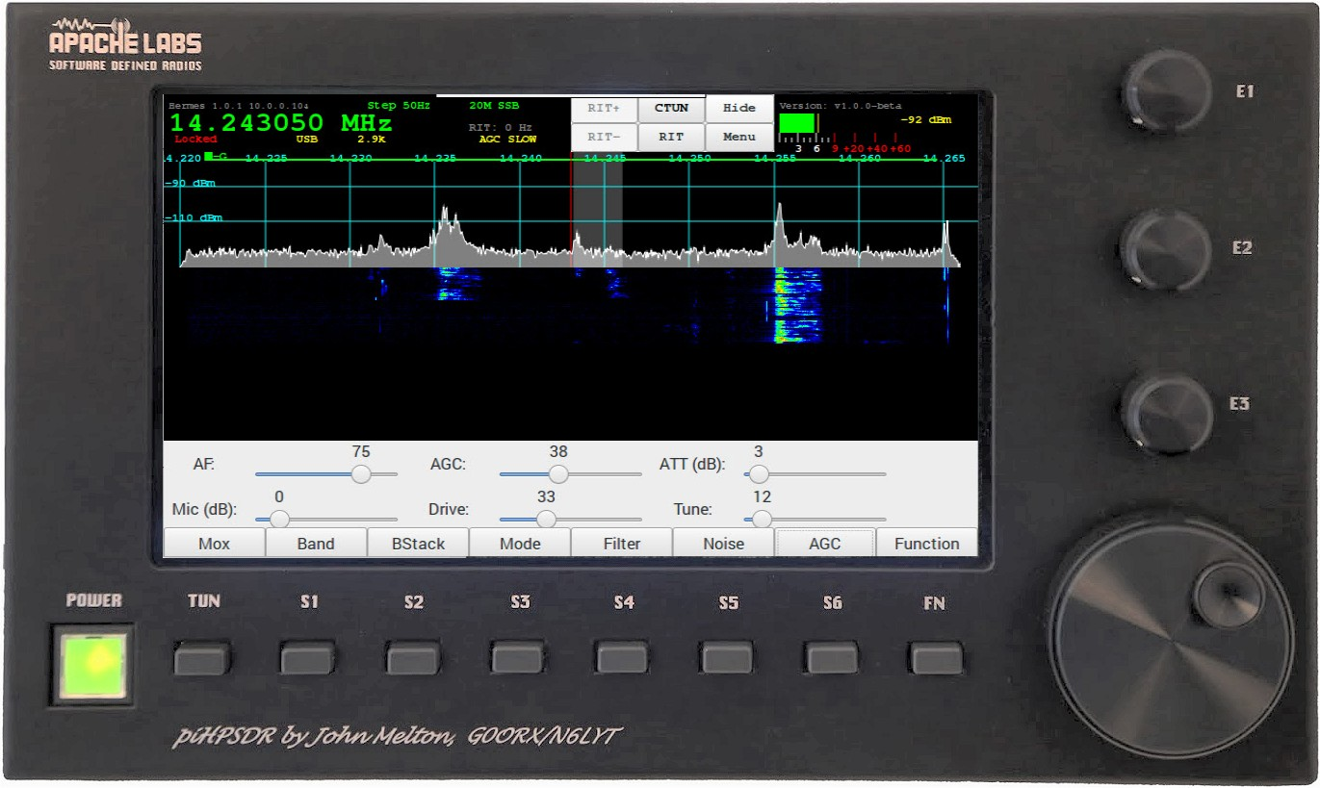
piHPSDR Controller
Users Guide
by
John Melton GØORX/N6LYT

This document contains references to the Apache Labs Transceiver products
http://www.apache-labs.com

In cooperation with VK6PH, NRØV, W5WC, K5SO
and the OpenHPSDR Hardware and Software Projects
http://openhpsdr.org

all images and manufacturer data is copied here with permission of the owner

Contents - piHPSDR Controller Users Guide

Introduction 5
Introduction by John Melton GØORX/N6LYT 5

1. Front panel controls 6
Default assignments of switches and rotary encoders 6
Power ON/OFF – switches external 12vdc 2A power to the Controller 6
TUN – MOX/TUNE 6
S1 - Band 6
S2 – Band Stack 6
S3 - Mode 6
S4 – Filter 6
S5 – Noise Blanker 6
S6 - AGC 6
FN – Function switch to toggle TUNE or MOX button and E1, E2, E3 6
E1 -- two functions AF Gain / MIC Gain 6
E2 – two function RF Drive / TUNE Drive 6
E3 – two function AGC Gain / Rx Attenuation 6
E4 VFO – main tuning knob 6
Appendix page 52 has a table showing the Switch, Encoder, and Touch Screen activation details. 6
Network LAN connection 7
Controller Hardware requirements 7
Controller software requirements: 8
PiHPSDR Controller - side panel 9

2. Quick Start Instructions 10
Hardware Setup 10
Software Setup 10

3. Discovery 11
Discovery → Start 13

4. Menu 14
Menu → Exit piHPSDR 15
Menu → General 16
Menu → Audio 17
Menu → ANT 18
Menu → Display 19
Menu → DSP 21
Menu → PA Gain by Band 22
Menu → CW 23
Menu → OC Open Collector Aux I/O connectors 24
Menu → FreeDV 25
Menu → XVTR 26
Menu → Equalizer 27
Menu → FM 28
Menu → Step 29
Menu → Meter 30
Menu → VOX 31
Menu → Diversity 32
Menu → Direct Frequency Entry 33

5. Screen Controls and Push Buttons 34
Function 34
AF Gain Slider 35
MIC Gain Slider 35
PA Drive Slider 36
Tune Drive Slider 36
AGC Gain Slider 37
Receive Attenuation Slider 37
Menu → Band Selection 38
Menu → Band Stack 39
Menu → Mode 40
Menu → Filter 41
Menu → Noise 42
NR - Noise Reduction 42
NR2 - New NR0V algorithm 42
ANF - Automatic Notch Filter 42
SNB - Spectral Noise Blanker 42
Menu → AGC 43
Off – AGC disabled 43
Long - Hangtime = 2000 ms. Decay_time_constant = 2000 ms. 43
Slow - Hangtime = 1000 ms. Decay_time_constant = 500 ms 43
Medium - Hang is turned OFF. Decay_time_constant = 250 ms 43
Fast - Hang is turned OFF. Decay_time_constant = 50 ms 43
The AGC Gain levels are adjusted using the AGC encoder (or the AGC Slider if no encoders). 43
VFO Lock 44
VFO Step 45
Meter 46

6. Tuning 47
VFO Encoder 47
Touch Screen 47
Mouse 47
CTUN – Click Tuning 48
RIT – Receiver Incremental Tuning 49

7. Mode PSK31 – Receive 50
TUNE/SWR/FWD power 50

8. Appendix 51
Encoders and Switches 51
Switch or Encoder 51
Power ON/OFF 51
TUN – TUNE button 51
S1 - Band 51
S2 - Mode 51
S3 - Filter 51
S4 - Noise 51
S5 -AGC 51
S6 - MOX 51
FN – Function 51
22 51
E1 -- 51
E2 – 51
E3 – 51
E4 VFO – Main tuning knob 51
GPIO pin Assignments (RaspberryPi) 53
RaspberryPi-3b TRRS connector 53
MIC Input is easily done with an inexpensive USB adapter 54

9. Reference materials 55
G0ORX Friedrichshaven pdf and video 55

10. Volunteer Programmers can help with ideas 55
PureSignal 55
SPLIT for DX 55
PSK31 Transmit encoding 55
RTTY receive decoding 55
Thin Pipe Remote Audio/Video 55
Panadapter color selection 55
IF-shift, Hi-Cut, Low-Cut 55

Apache Support 56
Apache Labs International Support 56
Apache Yahoo Support Group 56
OpenHPSDR Group 56

Apache Service and Repair 56

Early prototypes by John Melton G0ORX 57

Introduction

Introduction by John Melton GØORX/N6LYT
Thu Aug 5, 2016 12:52 am (PDT) .
Posted by: "John Melton" g0orx
I think it is time to answer some of the questions about the controller.
Some background ...
I presented a paper at DCC last year on how to build a CAT controller using an Arduino and some buttons and encoders, even one with an LCD screen showing the mode, frequency and an S meter. The idea of this was to try to get people building them.
When I returned I started looking at what a Raspberry Pi (model 2 at the time) could do as a standalone controller. I had already ported WDSP to Linux so had a good starting point. Very soon after I received
an email from LA2NI, Kjell Karlsen asking if my Android code would run on the Raspberry Pi as he wanted to try to build a standalone system with a touch screen. I told him about my early development work on the Raspberry Pi and that started a project that is still on going today.
The idea was not to build an all singing/dancing copy of PowerSDR but to build something that could be used with a small portable system. Kjell has since gone on to build a very nice system using a Hermes and Apollo all built into a small case with the Raspberry Pi (now a model 3).
Abhi (Apache Labs) got interested in the project and wanted to build a controller initially without the built in Hermes/Apollo. Hopefully we will see a complete portable system sometime from Apache Labs.
So, that is what we have today. The software is still in development and new features are being added as well as bugs being fixed. It is designed to use with the radio, not as a remote console. The RPi does not have any audio input but does have audio output. It is currently possible to output the audio locally on the RPi but to connect a microphone you will need to plug a USB audio card into the device. I will be adding support for connecting a microphone to the this as well.
The RPi will work over WiFi using the built in controller. The signal quality will determine what sample rate it will run at. The RPi does not have GigE so cannot connect directly to a radio running the new Ethernet protocol, but will work through a switch or over WiFi. However, it has been tested using a USB to GigE dongle and that does work. Just remember this will not run at the higher sample rates.
I have looked at several other more powerful single board computers, but always I have run into problems with their implementation of the GPIO, which is used to interface the buttons and encoders.
We are using the Raspberry Pi official 7 inch touch screen. This has a resolution of 800x480 so we are struggling with screen real estate.
There is work in progress to also use the controller remotely across the Internet. This will require a server running at the radio that is connected to by a thin client running on the controller. This will stream the audio and spectrum information with all the DSP work being done on the server. It is not based on my ghpsdr3 project but of course that was a good starting point for the design.
Finally, all the software is open source. It will run on a Raspberry Pi without the buttons/encoders. It will also run on other Linux systems and I have even built it and had it running on Mac OS X. I have not
tried to build it on Windows as I do not have a Windows system.
-- John g0orx/n6lyt

Note: This Note: this document assumes familiarity with the Apache Transceiver and standard software such as PowerSDR or Thetis. The Apache Transceiver Users Guides are located here: https://apache-labs.com/al-downloads/1001/ANAN-USER-GUIDES.html

1. Front panel controls
Switches
Encoders

Default assignments of switches and rotary encoders
- Power ON/OFF – switches external 12vdc 2A power to the Controller
- TUN – MOX/TUNE
- S1 - Band
- S2 – Band Stack
- S3 - Mode
- S4 – Filter
- S5 – Noise Blanker
- S6 - AGC
- FN – Function switch to toggle TUNE or MOX button and E1, E2, E3
- E1 -- two functions AF Gain / MIC Gain
- E2 – two function RF Drive / TUNE Drive
- E3 – two function AGC Gain / Rx Attenuation
- E4 VFO – main tuning knob

Appendix page 52 has a table showing the Switch, Encoder, and Touch Screen activation details.

Network LAN connection

Auto-negotiation of a the RaspberryPi 100BT Ethernet connection allows operation of the Controller at the 48000, 96000, and 192Ksps sample rates.
Transceiver
crossover cable not required
APIPA
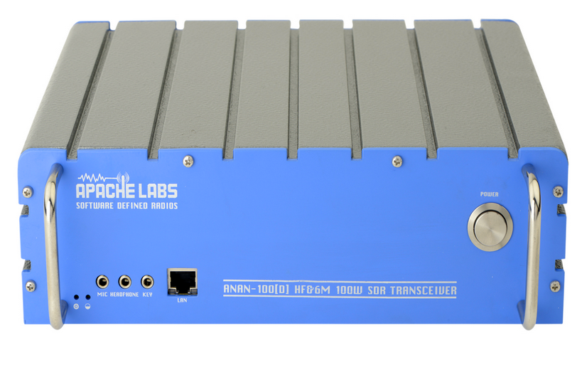
piHPSDR Controller
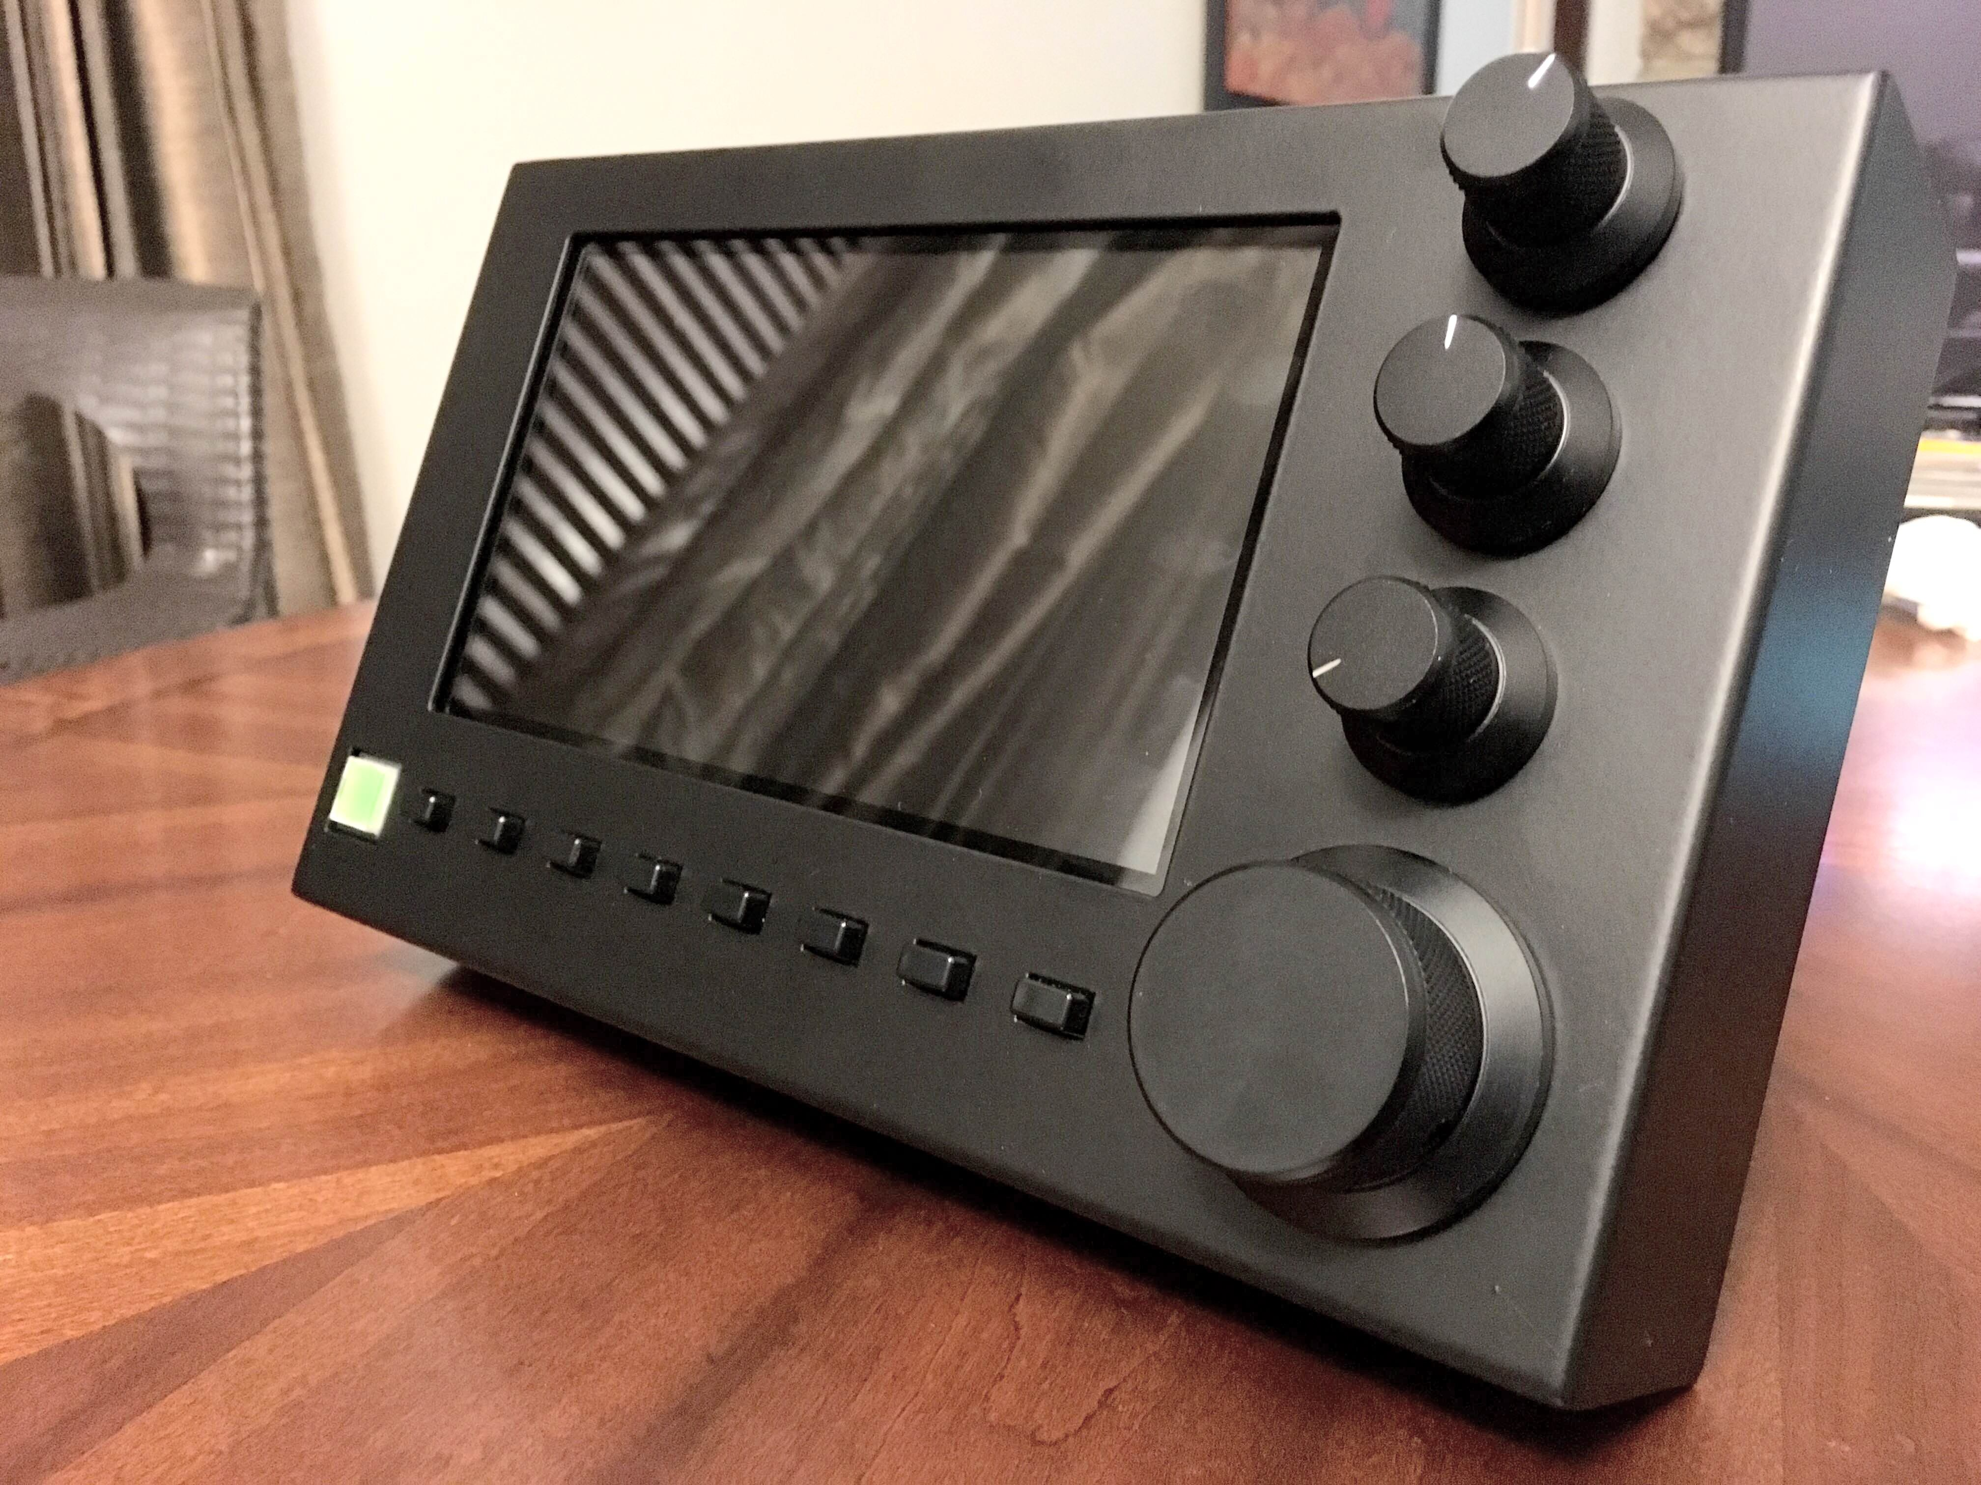
The new piHPSDR-Controller can be connected directly to your ANAN Transceiver and each unit will make use of the APIPA assignment for an IP address.

Home Network

1000BT
(Gigabit)
Switch

CAT-5 or CAT-6 shielded cables are recommended for connection of the Controller

Controller Hardware requirements
- 13.8vdc 2.5A (minimum 12vdc 2A) Power connection
- 100BT LAN connection to your Apache Transceiver

Controller software requirements:

- Pihpsdr Controller Raspbian Operating System and application program are factory installed on an SDHC card.

If you have purchased the piHPSDR-Controller KIT, you will need to create and install an SDHC card with the RaspberryPi operating system and pihpsdr application.

Instructions for Installation are detailed in the Install pdf document that is available at:

https://github.com/g0orx/pihpsdr/raw/master/release/documentation/pihpsdr-install.pdf

- If you wish to get the latest version of pihpsdr source code, executable binaries, and documentation the instructions are available at:

https://github.com/g0orx/pihpsdr/raw/master/release/documentation/pihpsdr-build.pdf

Note: it is a good idea to make a backup of your Operating System and piHPSDR software. Use the RaspberryPi Menu → Accessories → SD Card Copier” utility. Use a new SDHC card of the same capacity as the original.

This is easily done using a USB – SDHC card reader/writer dongle plugged into one of the RPi USB ports on the left side of the piHPSDR Controller.

A pdf document reader is included in the standard RaspberryPi operating system distribution.

PiHPSDR Controller - side panel

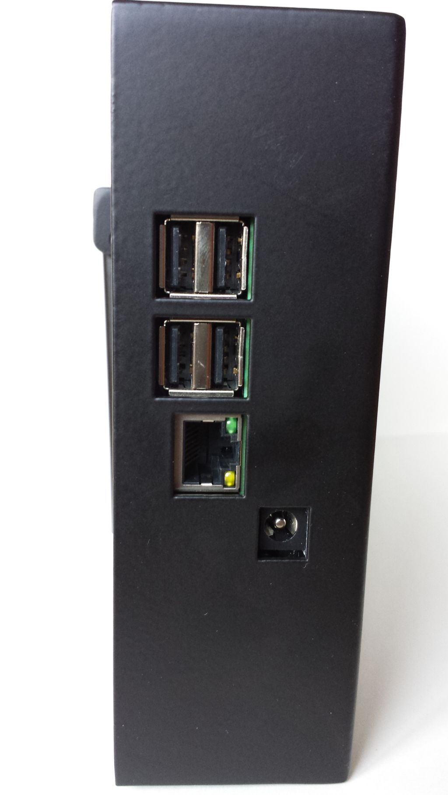
LAN Connection
USB
USB
12vdc
(center positive)
Power connection

2. Quick Start Instructions
please refer to front and back panel illustrations

Hardware Setup

- Carefully unpack the piHPSDR Controller.

- Connect a CAT 5/6 Ethernet cable between the rear panel LAN jack with proper access to your Apache Transceiver, Gigabit switch, or suitable router. Please see Network LAN connection page 9.

- Connect the supplied piHPSDR Controller power cable to a fused 12vdc typical Amateur Radio power supply.

Software Setup

The piHPSDR Controller software is pre-formatted on the Operating System SDHC card inserted in the RaspberryPi.
Alternative software configurations are not provided by Apache Labs.
A person familiar with the Raspbian operating system may wish to modify or update the contents of the SDHC card using appropriate Linux tools. Please refer to page 10.
Note: pihpsdr is OpenSource. If you would like to compile the program on a Linux system, the source, binaries, and documentation are located at https://github.com/g0orx/pihpsdr/tree/master/release/documentation

3. Discovery

When first started, piHPSDR will try to discover all the HPSDR compatible radios on the network. It will look for devices running both the original (old) and the new Ethernet (new) protocol.
If one or more Transceiver interfaces are found they will be identified by the device type, the software version, the IP address and the MAC address of the device.
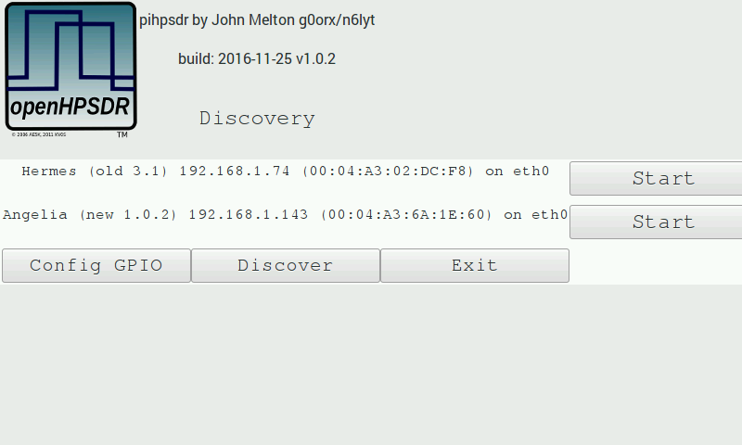
If no devices are found you should check connectivity between the radio and the network that piHPSDR is connected to. Tapping on OK will try discovery again. Tapping on Cancel will exit piHPSDR back to the Raspberry Pi desktop.

The discovery protocol will allow a device to see and respond even if they are not on the same subnet. If this is the case, the Start button will be disabled and the text replaced with Subnet The most common cause of this problem is usually that the radio has not been able to get a DHCP address and has defaulted to the Self Assigned IP Address, or the device has a static IP address that is not on the same subnet as the piHPSDR.
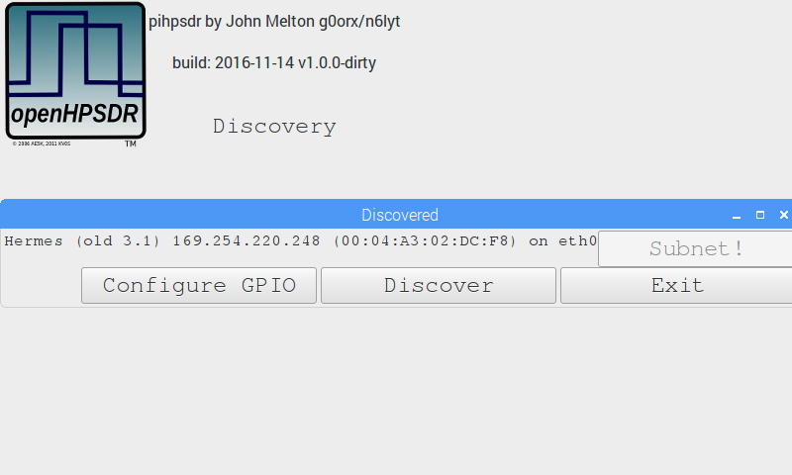

Discovery → Start

Tapping on the Start button will start the radio – on the selected Ethernet interface.

4. Menu

Tapping the Menu button brings up the menu dialog.
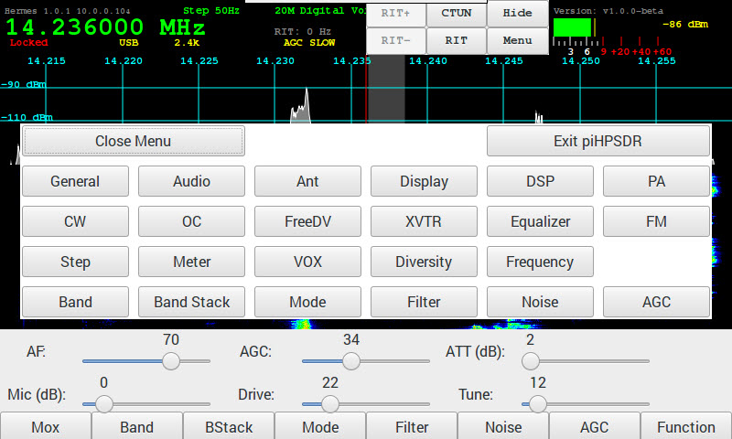
The menu dialog lets you select the different menu options for configuring the radio.
You can close the menu by tapping on the Close Menu button or by tapping on the Menu button again.

Menu → Exit piHPSDR

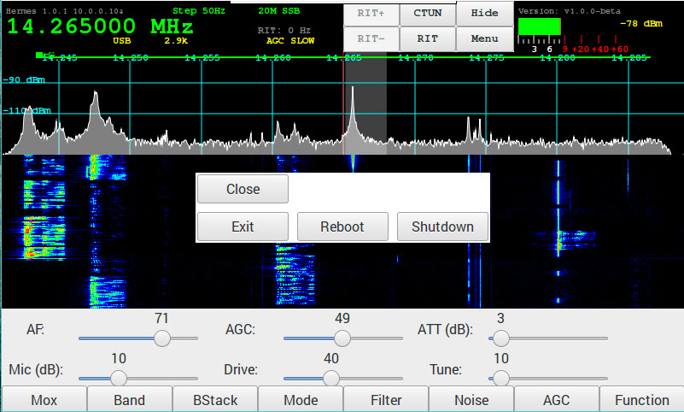
The Exit piHPSDR button will bring up another dialog allowing you to end the piHPSDR application in a number of ways:
- Close – close this dialog box
- Exit – exit piHPSDR back to the Raspberry Pi Desktop
- Reboot – reboot the Raspberry Pi
- Shutdown – Shutdown the Raspberry Pi - (note the Controller power button remains lighted)

You can also tap the Menu button again to close the Exit Menu and bring up the Menu selection.

Menu → General

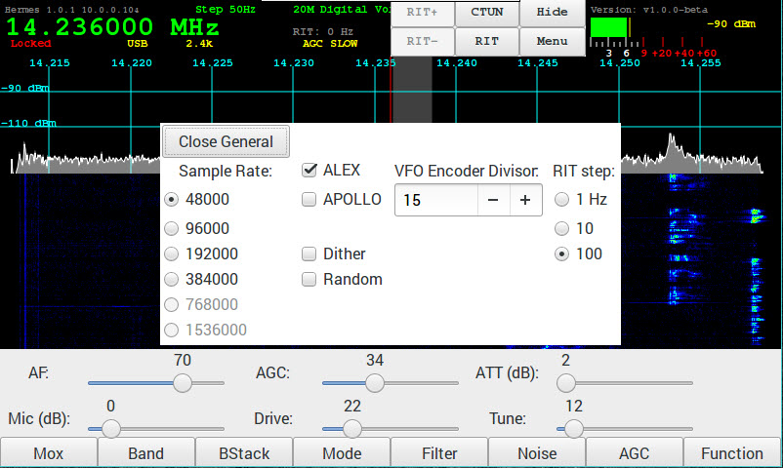

- Sample Rate - The Sample Rate selection selects the width of the Panadapter displayed on the piHPSDR Controller screen. This is the rate which pihpsdr uses to decode a portion of the 30Mhz spectrum data from the Apache Transceiver.
Note: 768k and 1.536K are not available on Rpi.
- ALEX – selects the automatic LPF/BPF filters selected inside each Apache Transceiver
- APOLLO – refers to the Linear Amplifier and filters designed by Kjell LA2NI.
- Dither - Dither is a built-in electronic feature of the Linear Technologies LTC-2208 Analog to Digital Converter chip inside each Apache Software Defined Radio Transceiver.
- Random - Ramdom is a built-in electronic feature of the Linear Technologies LTC-2208 Analog to Digital Converter chip inside each Apache Software Defined Radio Transceiver.
- VFO Encoder Divisor - The VFO Encoder Divisor lets you adjust the sensitivity of the VFO encoder. The value specifies the number of encoder steps required to step the VFO up or down.
- RIT Step size – This value will be used to increment Receiver Incremental Tuning when it is selected

Menu → Audio

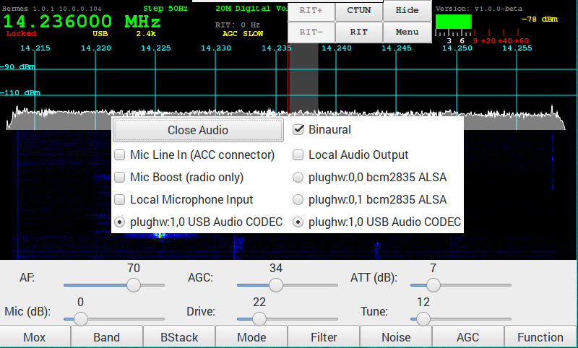

- Mic Line In – When enabled the audio from the radio will come from Line In rather than the microphone socket.
- Mic Boost - is a 20db boost of the MIC connected to your Apache Transceiver.

The Raspberry Pi has both TRRS Jack and external USB Audio input capability.
- Local Audio – When enabled selects the selected audio interface on the Raspberry Pi to output sound.
- Local Microphone Input – When enabled selects the TRRS audio interface on the Raspberry Pi for the microphone input.
- Lcocal Audio Output - When enabled selects the TRRS audio interface on the Raspberry Pi for the audio output.

Menu → ANT

The Ant menu selects which antenna is used for receive and transmit on each band.
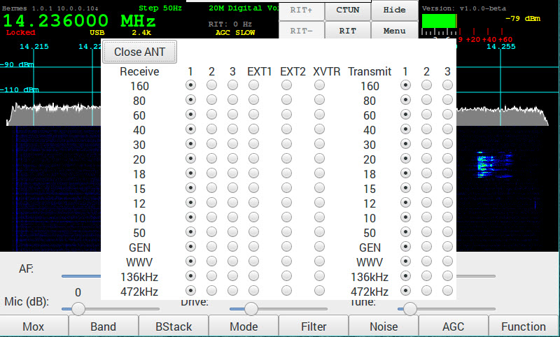

Menu → Display

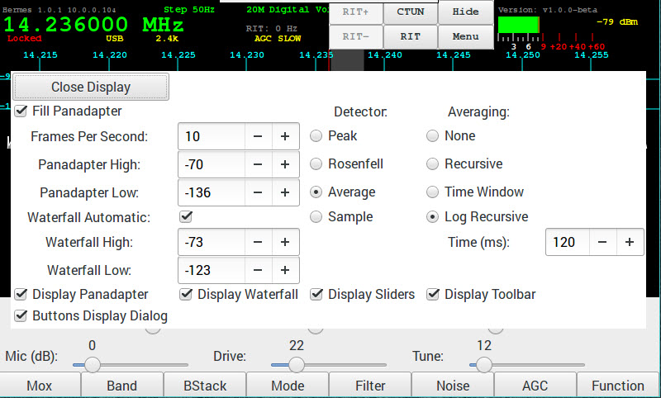
- Fill Panadapter – when enabled the panadapter graph will be filled. When not enabled it will be drawn as a line.

- Frames Per Second – Update rate of Panadapter and Waterfall

- Panadapter High - Maximum signal level displayed in Panadapter

- Panadapter Low – Minimum signal level displayed in Panadapter

- Waterfall Automatic – When enabled the Waterfall High and Waterfall Low are adjusted automatically.

- Waterfall High – When Automatic is not set this will set the maximum signal used in the waterfall.

- Waterfall Low - When Automatic is not set this will set the minimum signal used in the waterfall.

- Detector – Selects Peak, Rosenfell, Average or Sample for the Panadapter display.

- Averaging – Selects the method for averaging the Panadapter display.

- Display Panadapter – when selected the Panadapter is displayed on the main screen.

- Display Waterfall – when selected the Waterfall display is displayed on the main screen.

- Display Sliders – when selected the slider controls are displayed on the main screen. When the sliders are not displayed the specific slider for the Encoder being adjusted will pop up and will stay visible for 2 seconds after the last adjustment.

- Display Toolbar – when selected the toolbar is displayed on the main screen.

- Buttons Display Dialog – when selected the presses on the toolbar or the physical buttons displays a dialog to select the options. When not set the button steps forward or reverse (if Function is enabled) through the options.

Menu → DSP

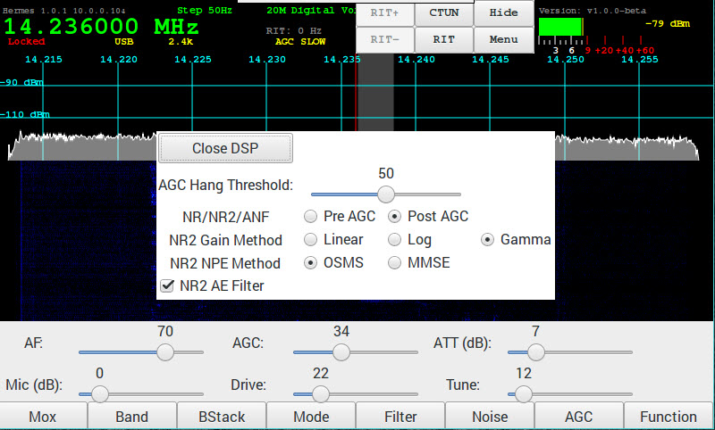
The DSP has options for the DSP functions.

- AGC Hang Threshold – sets the HangThreshold for the AGC when enabled.

- NR/NR2/ANF – selects where in the DSP processing the noise reduction functions are performed/ The default id Pre AGC processing.
Pre AGC – perform noise reduction pre AGC
Post AGC – perform noise reduction post AGC

- NR2 Gain Method – selects the method used for the gain processing. The default is Gamma.
Linear - Gaussian speech distribution, linear amplitude scale
Log - Gaussian speech distribution, log amplitude scale
Gamma - Gamma speech distribution

- NR2 NPE Method – selects the Noise-Power-Estimation method. The default is OSMS.
OSMS - Optimal Smoothing Minimum Statistics
MMSE - Minimum Mean -Square Error

- NR2 AE Filter - Enable Artifact elimination. Default enabled.

Menu → PA Gain by Band

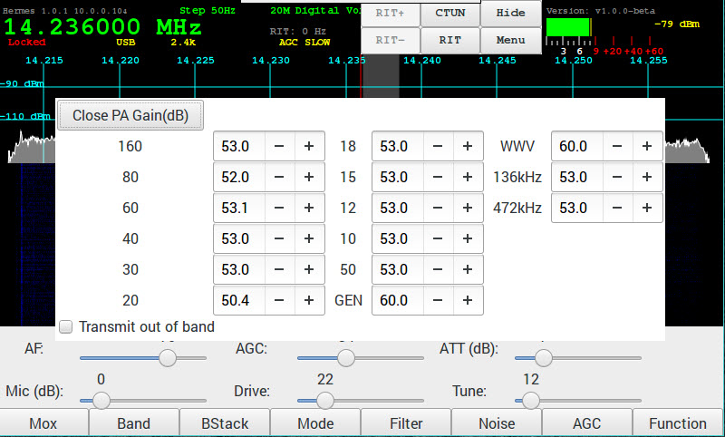
Sets the gain for each band to set the maximum drive level. Note that as the setting are increased the drive level is decreased.

- Note: Transmit out of band – enables transmit outside of ham bands. Default disabled.

Menu → CW

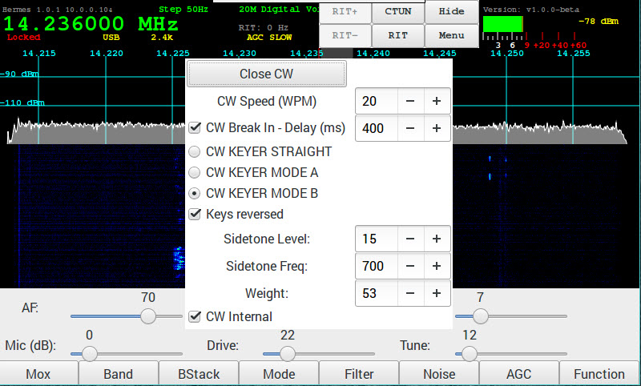
Controls the firmware CW Keyer.

- CW Speed (WPM) – sets speed of dot/dash generator when in Mode A or Mode B.
- CW Break In – when enabled sets the delay time in milliseconds to switching to receive.
- CW KEYER STRAIGHT – selects the key connected will be a straight key.
- CW KEYER MODE A – selects a paddle key running in Mode A
- CW KEYER MODE B – selects a paddle key running in Mode B
- Keys reversed – when enabled the dot/dash paddles are reversed.
- Sidetone Level – sets the audio level of the sidetone.
- Sidetone Freq – set the frequency of the sidetone.
- Weight – sets the dot/dash weighting.

Menu → OC Open Collector Aux I/O connectors

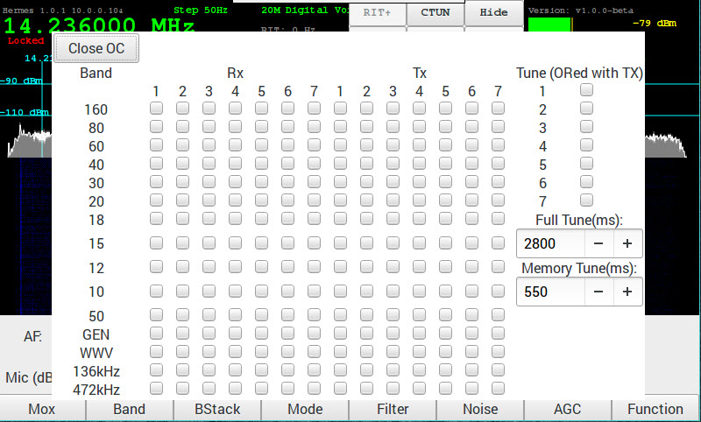
Configure the Open Collector outputs for each band. These can be used to control an external filter when not using the Apache Labs filters or the Alex filters. The default is none are enabled.

When an external ATU is used the Tune option can be used to signal to the ATU to start its tune function. The default is none are enabled.

- Tune – configure an OC to be turned on when Tune is enabled. Currently only the Full Tune is implemented.
- Full Tune – specifies the time the OC is enabled when the Tuning.

Menu → FreeDV

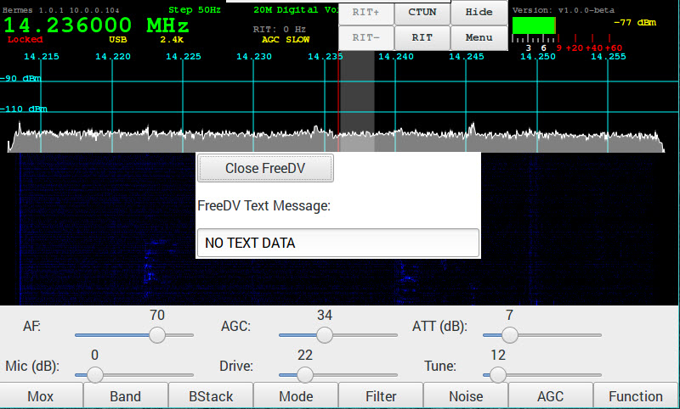
Enter the FreeDV Text Message that is send along with the digitized voice.

Menu → XVTR

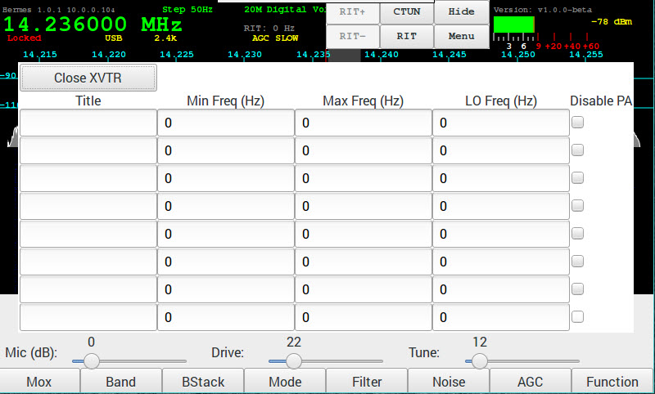
Configure up to 8 transverters.

- Title – the name as it appears in the Band, Ant and OC menus.
- Min Feq – The minimum frequency in Hz.
- Max Feq – The maximum frequency in Hz.
- LO Feq – The Local Oscillator frequency in Hz.
- Disable PA – When checked the PA will be disabled on transmit.
Note that the frequency the radio is tuned to is the selected frequency minus the LO frequency. In the example above the 144MHz to 146MHz Transverter frequency will be tuned to 28MHz to 30MHz on the radio.
When one or more Transverters are configured they will appear in the band selection dialog and also in the ANT selection menu and the PA Gain menu.

Menu → Equalizer

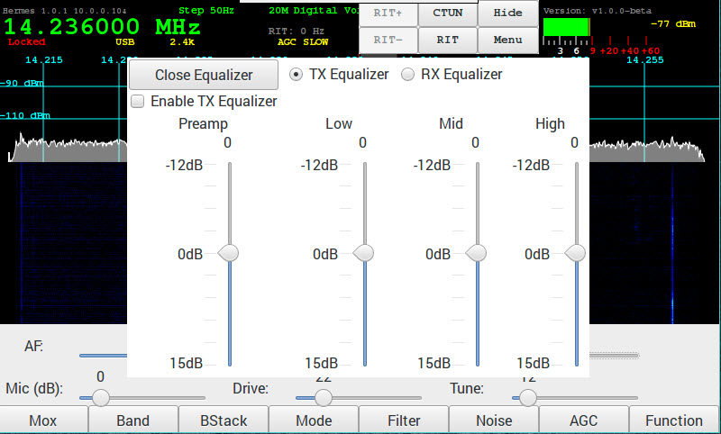
A 3 band graphic equalizer is implemented for both Transmit and Receive:
- Low – 0-400 Hz
- Mid – 400-1500 Hz
- High – 1500-6000 Hz

The radio buttons TX Equalizer and RX Equalizer select which values are displayed.
The equalizers can be enabled by the checkbox Enable TX Equalizer or Enable Rx Equalizer.

Menu → FM

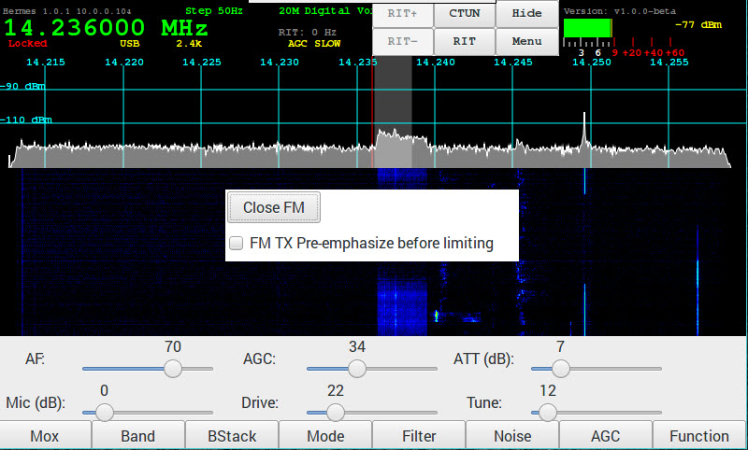

Menu → Step
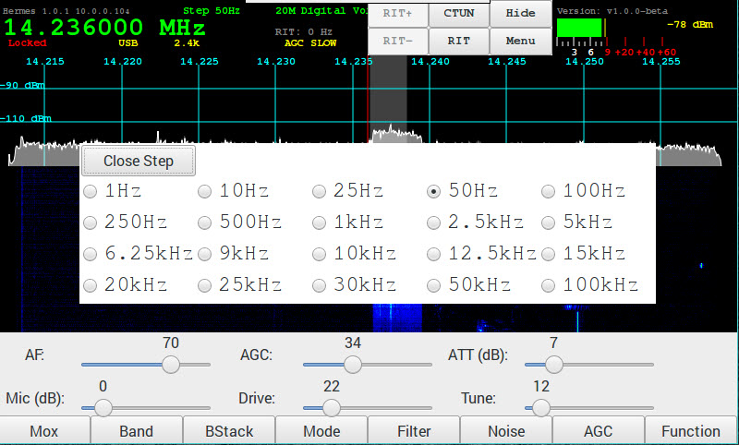

Menu → Meter
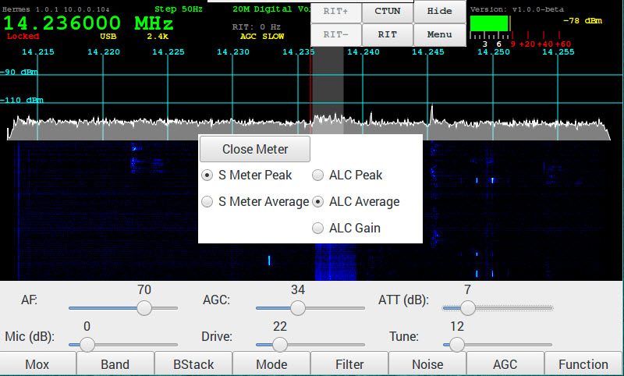

Menu → VOX
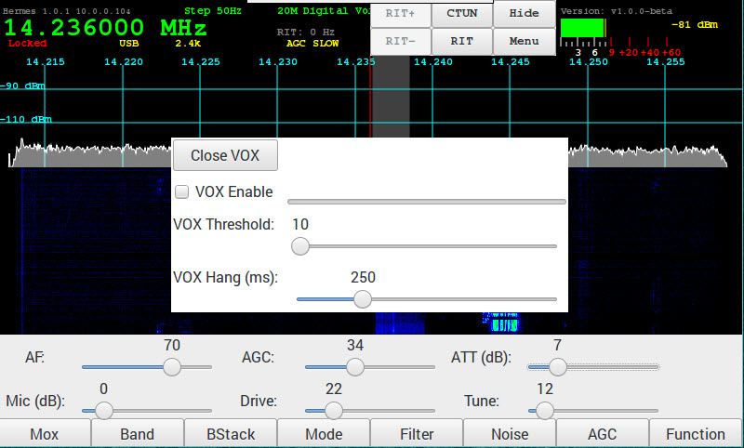

Menu → Diversity
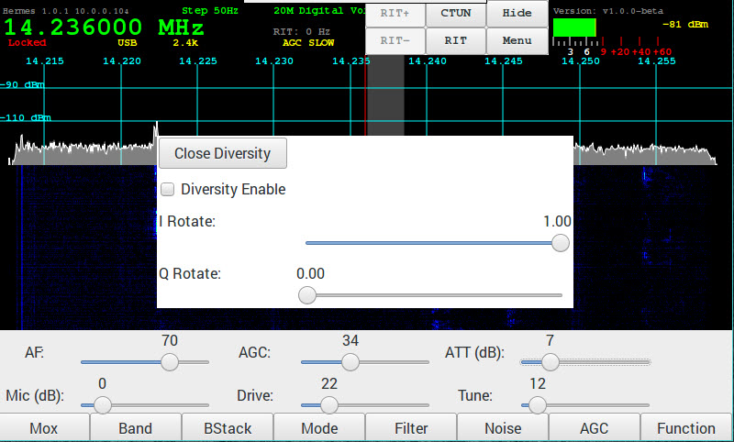

Menu → Direct Frequency Entry

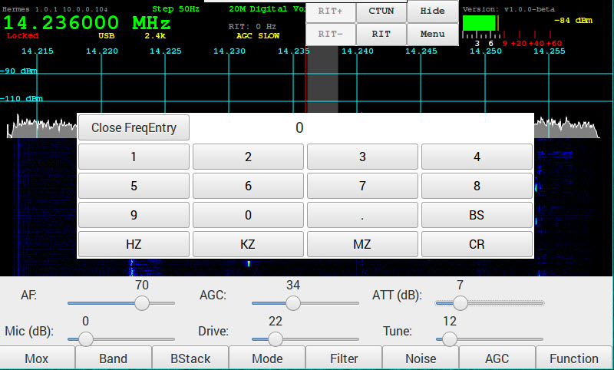
The Direct Frequency Entry allows you to enter a frequency directly using the keypad. The HZ button will take the current value and assume it is Hz and use that value. The KZ button will take the current value and assume it is Khz and use that value. The MZ button will take the current value and assume it is MHz and use that value. If the frequency entered is within the current band then it will just update the frequency. If the frequency is outside of the current band it will select the correct band and will use the last used Band Stack entry for that band. If XVTRs have been configured the frequency search will also include them.

BS – backspace
CR – Clear

5. Screen Controls and Push Buttons

Function

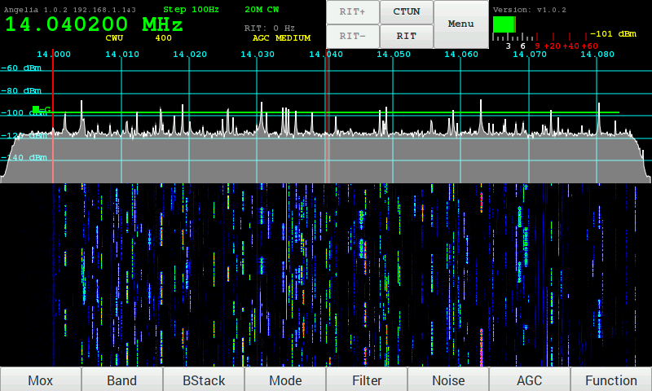

The function touch screen button or physical button enable the optional functions of some of the buttons and encoders.

When enabled the Function text appears in the VFO panel and the Mox button changes to Tune.
In addition the 3 encoders change function:
- The E1 encoders selects AF Gain or Mic Gain (when Function enabled)

- The E2 encoder selects PA Drive Level or Tune Drive Level (when Function enabled)

- The E3 encoder selects AGC Gain or Rx Attenuation (when Function enabled)

AF Gain Slider
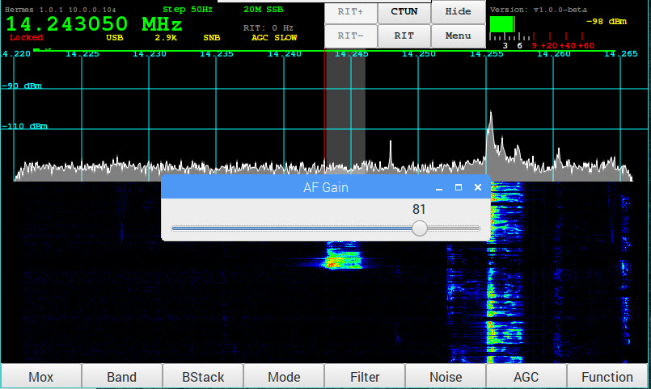

The AF Gain Slider is displayed when the AF Gain encoder (E1) is adjusted and the sliders are not displayed. It will remain for 2 seconds after the last adjustment or will be replaced if an other encoder adjusted or menu selected.

MIC Gain Slider

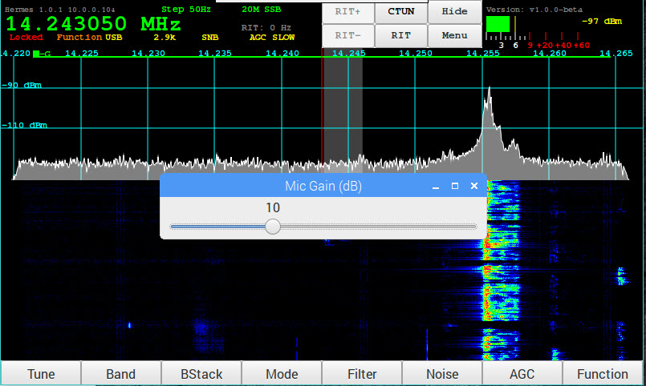
The MIC Gain Slider is displayed when the MIC Gain encoder (E1 and Function or when transmitting) is adjusted and the sliders are not displayed. It will remain for 2 seconds after the last adjustment or will be replaced if an other encoder adjusted or menu selected

PA Drive Slider

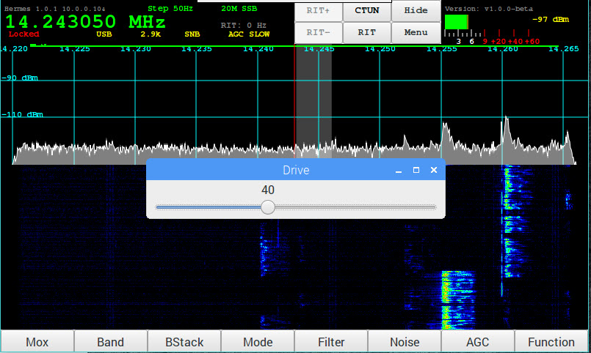
The PA Drive Slider is displayed when the PA Drive encoder (E2) is adjusted and the sliders are not displayed. It will remain for 2 seconds after the last adjustment or will be replaced if an other encoder adjusted or menu selected.

Tune Drive Slider

The Tune Drive Slider is displayed when the Tune Drive encoder (E2 and Function or when tuning) is adjusted and the sliders are not displayed. It will remain for 2 seconds after the last adjustment or will be replaced if an other encoder adjusted or menu selected.

AGC Gain Slider

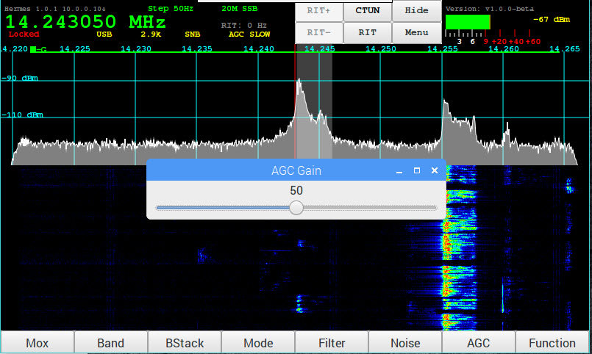
The AGC Gain Slider is displayed when the AGC Gain encoder (E3) is adjusted and the sliders are not displayed. It will remain for 2 seconds after the last adjustment or will be replaced if an other encoder adjusted or menu selected.

Receive Attenuation Slider

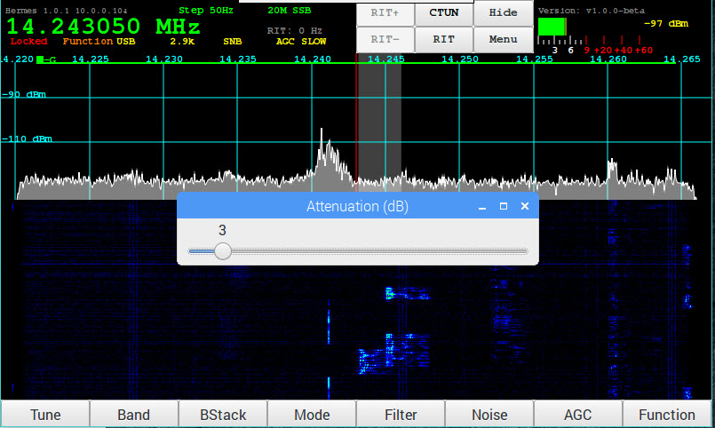
The Attenuation Slider is displayed when the Attenuation encoder (E3) is adjusted and the sliders are not displayed. It will remain for 2 seconds after the last adjustment or will be replaced if an other encoder adjusted or menu selected.

Menu or Toolbar → Band Selection
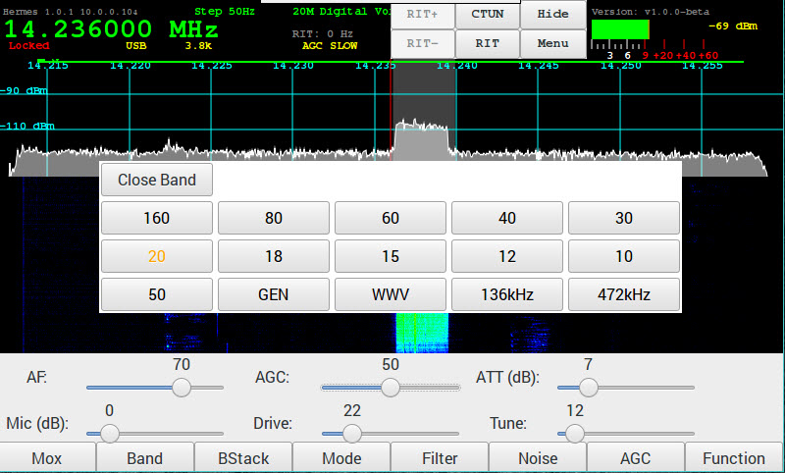
Tapping the Band touch screen button or pressing the physical button will display the list of bands with the current band highlighted in orange.
Tapping the current band will step through the band stack for that band. Tapping on any other band will switch to that band and the last used band stack entry.

Tapping on Close will close the menu.

Menu or Toolbar → Band Stack

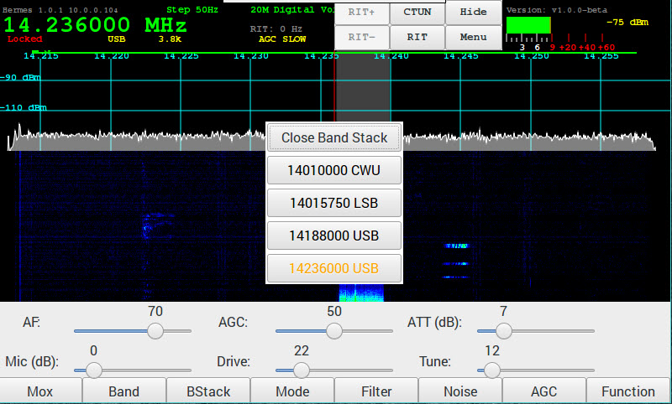
Tapping the BStack touch screen button or the physical button will display the list of Band Stack entries for the current band with the current selection highlighted in orange.
Tapping on an entry will switch to that entry.
Tapping on close will Close the menu.

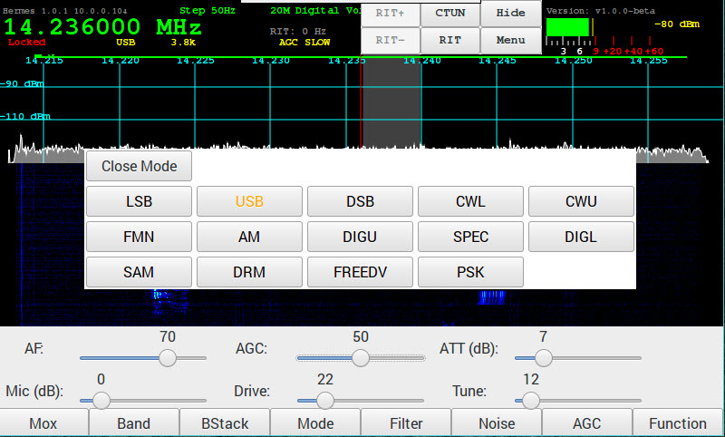
Menu or Toolbar → Mode

Tapping the Mode touch screen button or pressing the physical button will display the list of modes with the current mode highlighted in orange.
Tapping a mode will switch to the selected mode.
Tapping on Close will close the menu.

Menu or Toolbar → Filter

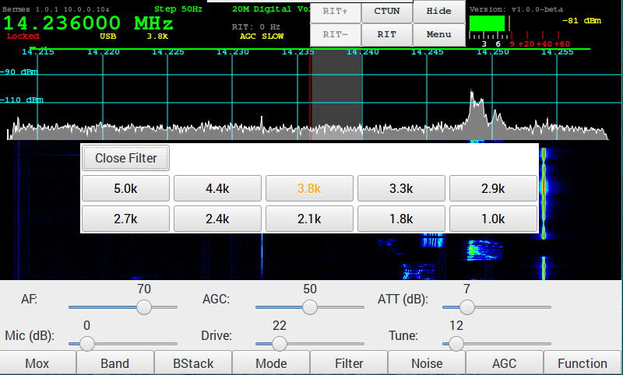

Tapping the Filter touch screen button or pressing the physical button will display the list of filters with the current filter highlighted in orange.

Tapping a filter will switch to the selected filter width.

Tapping on Close will close the menu.

Menu Toolbar → Noise

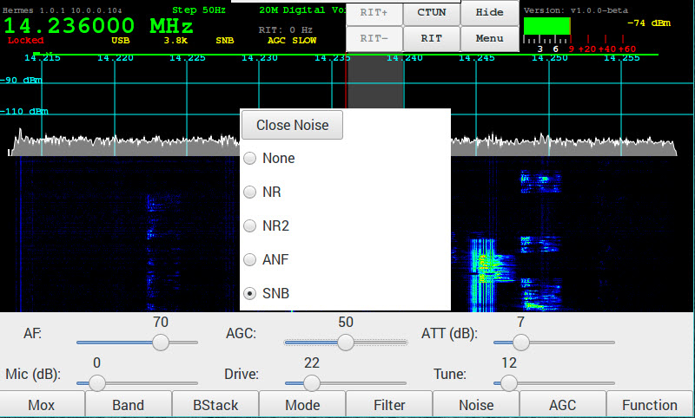
Tapping the Noise touch screen button or physical button will display the list of noise reduction modes are available.
You can select one of the following functions:

- NR - Noise Reduction

- NR2 - New NR0V algorithm

- ANF - Automatic Notch Filter

- SNB - Spectral Noise Blanker

Menu Toolbar → AGC

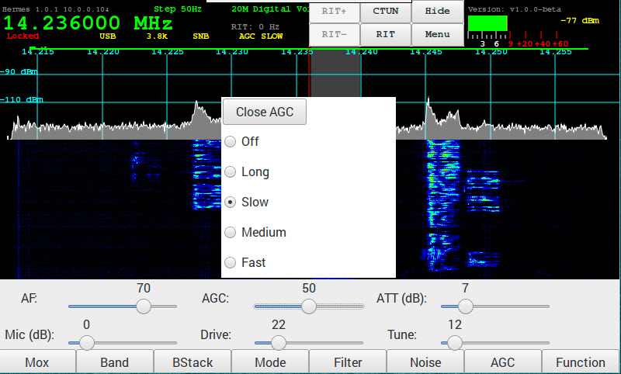

Tapping the AGC touch screen button or physical button will display the list of AGC options.

- Off – AGC disabled

- Long - Hangtime = 2000 ms. Decay_time_constant = 2000 ms.

- Slow - Hangtime = 1000 ms. Decay_time_constant = 500 ms

- Medium - Hang is turned OFF. Decay_time_constant = 250 ms

- Fast - Hang is turned OFF. Decay_time_constant = 50 ms

The AGC Gain levels are adjusted using the AGC encoder (or the AGC Slider if no encoders).

Main screen HIDE

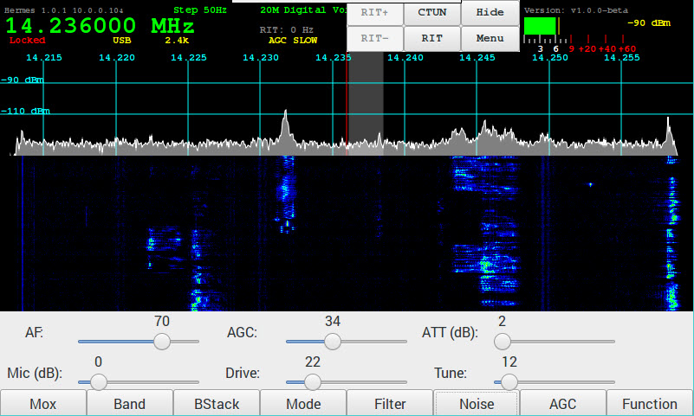
The purpose of the HIDE option is to minimize the pihpsdr application window and to then provide easy access to the RaspberryPi operating system and secondary applications such as Fldigi.

Touch VFO Lock

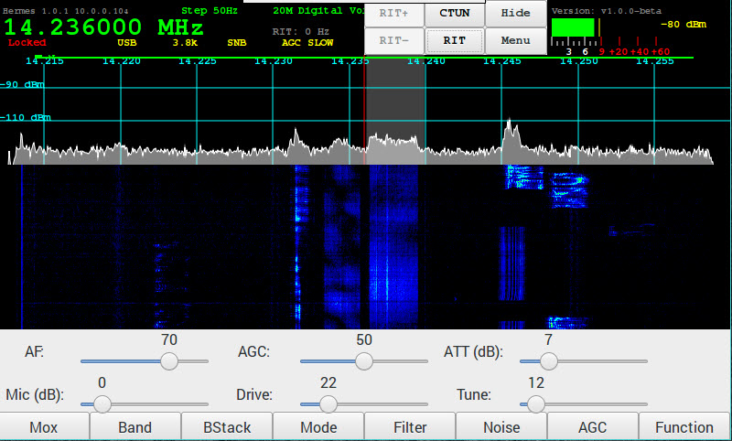
The VFO can be locked by pressing the button on the AF Gain encoder or by tapping on the left side of the VFO display. To unlock press the AF Gain encoder button again or tap on the left side of the VFO display.
When locked the text will be displayed in Red on the VFO.

Menu or Touch → VFO Step

By tapping on the right side of the VFO the menu to select the step rate can be selected.
This will set the stepping rate when using the VFO encoder, dragging the panadapter or waterfall or using a mouse wheel

Menu or Touch → Meter

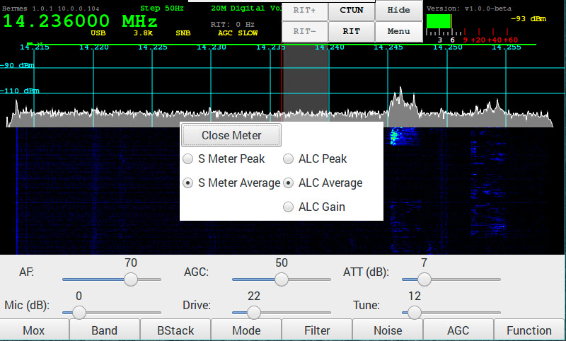
Tapping on the Meter will display a list of options for updating the meter.

6. Tuning

VFO Encoder

The VFO encoder can is used to tune the radio. By turning the encoder clockwise and anticlockwise the frequency will increment or decrement by the amount of the step value.
The General Menu has a field to set the resolution of the encoder.

Touch Screen

Touching and dragging on the panadapter or waterfall will move the frequency up or down. Note that it will move in step increments.
Tapping a frequency on the panadapter or waterfall will move to that frequency.

Mouse

Left down and holding then dragging while on the panadapter or waterfall will move the frequency up or down.
Left clicking will move to the selected frequency.
Moving the scroll wheel will increment or decrement the frequency by the step value.

CTUN – Click Tuning

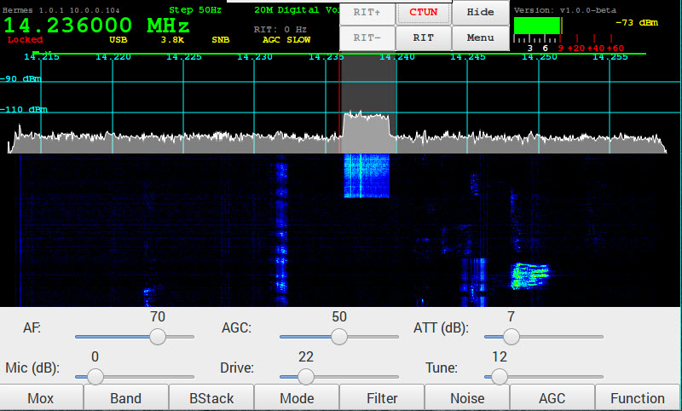
Tapping on the CTUN button will enable or disable the click tuning function. When the function is enabled the CTUN button text will be red.
When CTUN is enabled tuning is restricted to be within the passband currently being received. The tuned frequency and filter moves withing the current passband without scrolling the panadapter or waterfall left or right.

RIT – Receiver Incremental Tuning
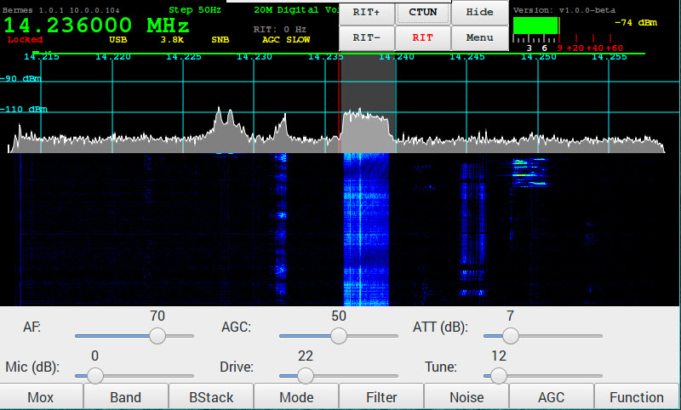
Tapping on the RIT button will enable RIT. The RIT+ and RIT- buttons can be tapped or held to increment decrement the RIT frequency in Hz.

7. Mode PSK31 – Receive

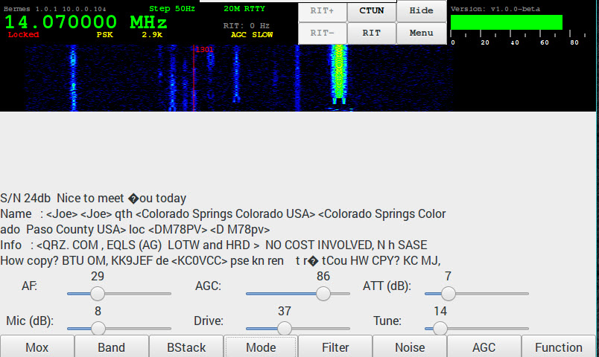

TUNE/SWR/FWD power
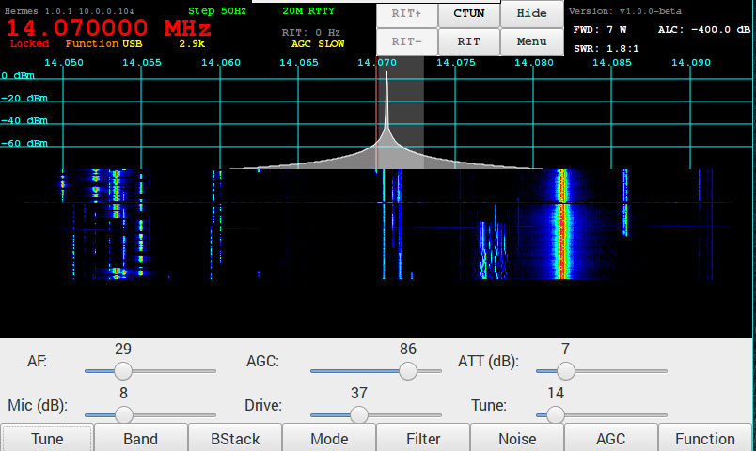
When the Function button is selected, it toggles the TUNE/MOX button on the far left. FWD power and SWR can then be read in the top of the pihpsdr window.

MOX Button
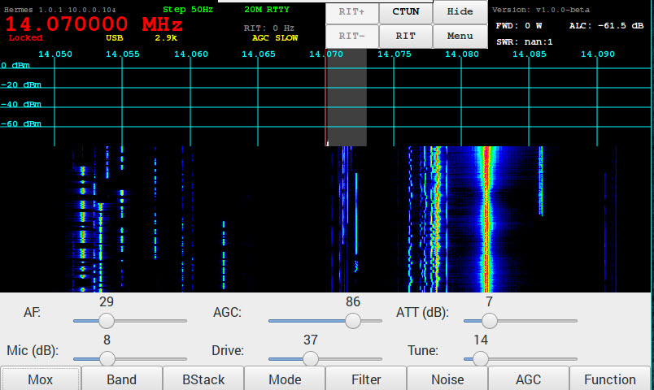

8. Appendix

Encoders and Switches

Factory Switch/Encoder/Touch activation
Switch or Encoder | Function | Touch Screen | GPIO  A | GPIO  B
- Power ON/OFF | Controller power on/off | Controller power on/off
- TUN – TUNE button | generates a carrier with Tune power selection slider | generates a carrier with Tune power selection slider
- S1 - Band | 10 HF Bands + General Coverage + WWV + LF + XVRT | 10 HF Bands + General Coverage + WWV + LF + XVRT | 13
- S2 - Mode | LSB USB DSB CWL CWU FMN AM DRM FreeDV PSK | LSB USB DSB CWL CWU FMN AM DRM FreeDV PSK | 6
- S3 - Filter | 10 IF Filter widths | 10 IF Filter widths | 5
- S4 - Noise | 5 Noise Reduction modes | 5 Noise Reduction modes | 24
- S5 -AGC | 5 AGC Decay settings | 5 AGC Decay settings | 4
- S6 - MOX | Space bar toggle for PTT  or MOX button | Space bar toggle for PTT  or MOX button | 27
- FN – Function | Function switch to toggle TUNE or MOX button displayed on the bottom left of the screen | Function switch to toggle TUNE or MOX and the action of E1, E2, E3 knobs | 22
- E1 -- | two functions AF Gain / MIC Gain | two functions AF Gain / MIC Gain | 20 | 26
- E2 – | two function RF Drive / TUNE Drive | two function RF Drive / TUNE Drive | 16 | 19
- E3 – | two function AGC Gain / Rx ATTEN | two function AGC Gain / Rx ATTEN | 4 | 21
- E4 VFO – Main tuning knob | ------- | ------- | 17 | 18
Menu | ------- | Main piHPSDR Menu
Menu → Band |  | Select band
Menu → Band Stack | 3 to 5 level quick freq change | 3 to 5 level quick freq change | 13
Menu → Mode | Mode | Mode | 6
Menu → Filter | IF Filter width | IF Filter Width | 5
Menu → Noise | Noise Blanker mode | Noise Blanker Mode | 24
Menu → AGC | Automatic Gain | Automatic Gain | 4 | 21
Locked | Right click on VFO Frequency to toggle Frequency Lock | Touch VFO Frequency to toggle Frequency Lock
Meter | Right click on S-Meter for S-Meter and ALC peak/average | Touch S-Meter for S-Meter and ALC peak/average

GPIO pin Assignments (RaspberryPi)
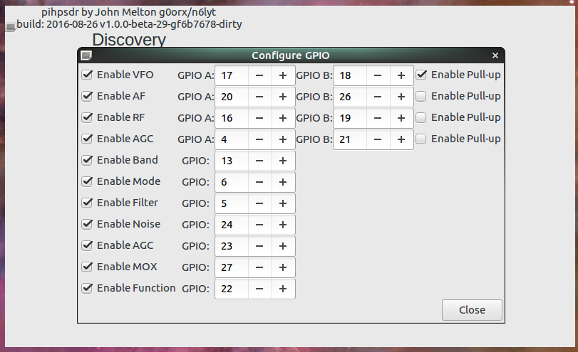

RaspberryPi-3b TRRS connector
The four wire TRRS audio/video connector on the RaspBerryPi-3b should be use carefully. The Video output may connect incorrectly on a standard 3-pin Stereo plug.
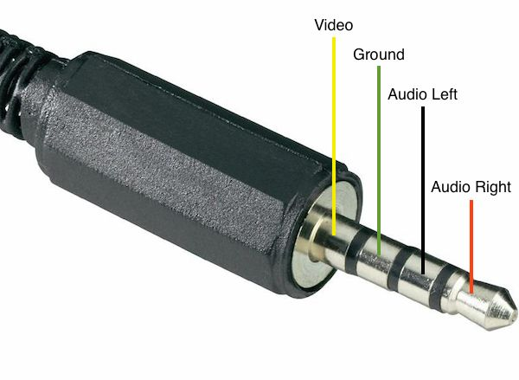
Adafruit has an adapter that may be helpful for experimenters:
<URL: https://www.adafruit.com/products/2914 >
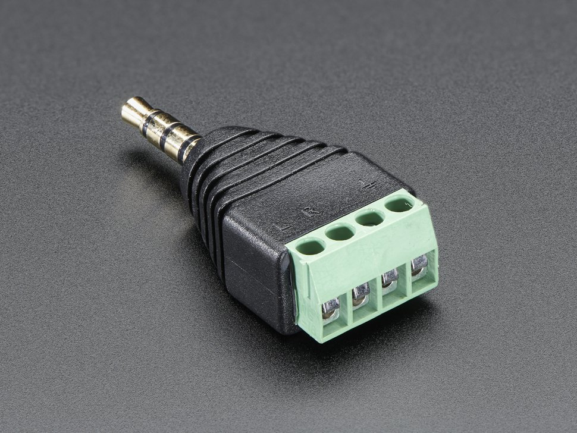

SparkFun has an open wire plug and cable
<URL: https://www.sparkfun.com/products/11580 >
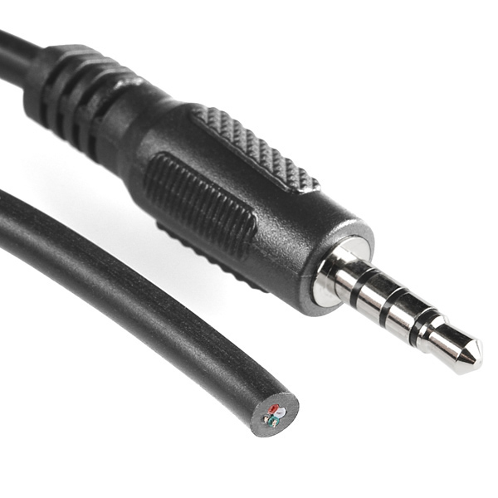

MIC Input is easily done with an inexpensive USB adapter

<URL: https://www.adafruit.com/product/1475>
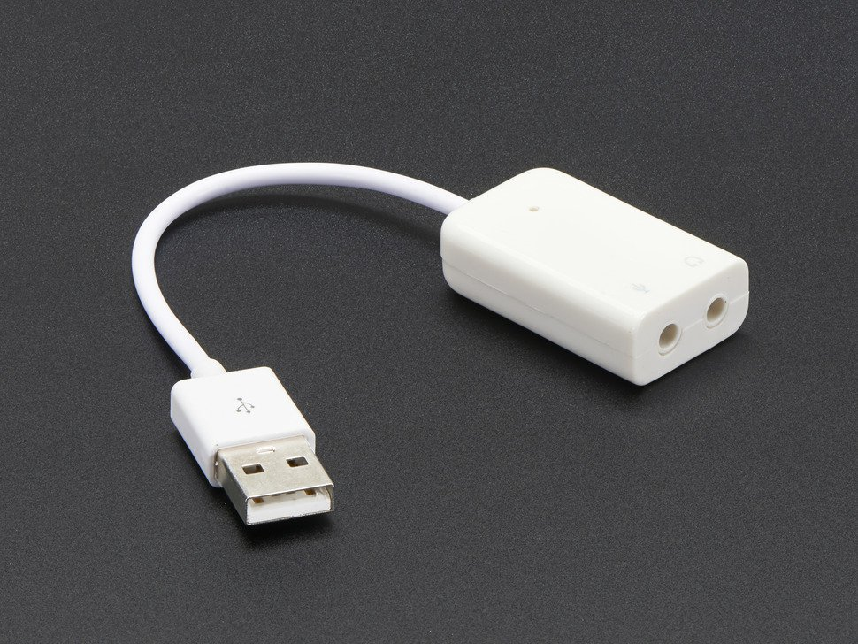

9. Reference materials

G0ORX Friedrichshaven pdf and video
Friedrichshafen 2016 publication
https://www.dropbox.com/sh/fva5d5mi93c93tq/AAD6dU-eBMR0cVK-E95hJC5Ia?dl=0
Jacinto Rebelo CU2ED for his Homebrew of a pihpsdr Controller
Kjell Lasen LA2NI for his complete RPi-e System
F'Hafen video on YouTube:
https://www.youtube.com/watch?v=U7QfP28YjCw

10. Volunteer Programmers can help with ideas

PureSignal

SPLIT for DX

PSK31 Transmit encoding

RTTY receive decoding

Thin Pipe Remote Audio/Video

Panadapter color selection

IF-shift, Hi-Cut, Low-Cut

Apache Support

Apache Labs International Support
Technical support for ANAN-10 from the factory is available via the Apache Labs Yahoo Group http://groups.yahoo.com/group/apache-labs/
or directly via email <support@apache-labs.com>

Apache Yahoo Support Group
http://groups.yahoo.com/group/apache-labs/

OpenHPSDR Group
Instructions relating to joining the OpenHPSDR Group reflector are here:
http://lists.openhpsdr.org/listinfo.cgi/hpsdr-openhpsdr.org

The OpenHPSDR archives may also be searched here:
http://lists.openhpsdr.org/mmsearch.cgi/hpsdr-openhpsdr.org

The latest version of the OpenHPSDR User Manual can be obtained from
http://openhpsdr.org/documents.php Author Phil Harman VK6PH

Apache Service and Repair
1023 Tower B4, Spaze I-Tech Park
Sector - 49, Sohna Road
Gurgaon - 122001
Haryana, India
Tel: 91-0124-4245173/4/5 (10AM - 6PM IST]
Email: support@apache-labs.com
Website: http://www.apache-labs.com

Early prototypes by John Melton G0ORX
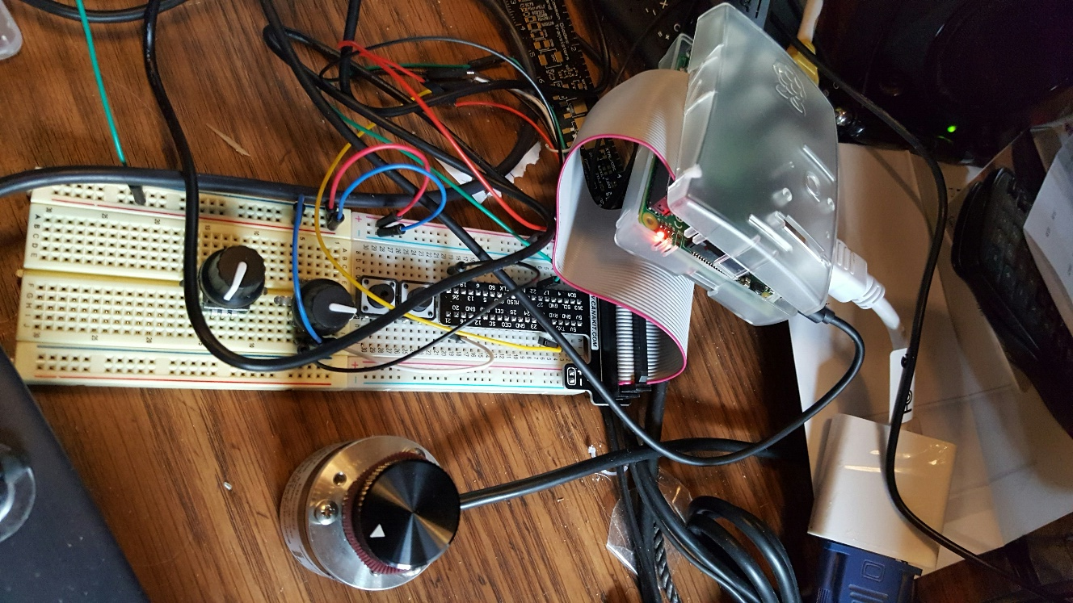
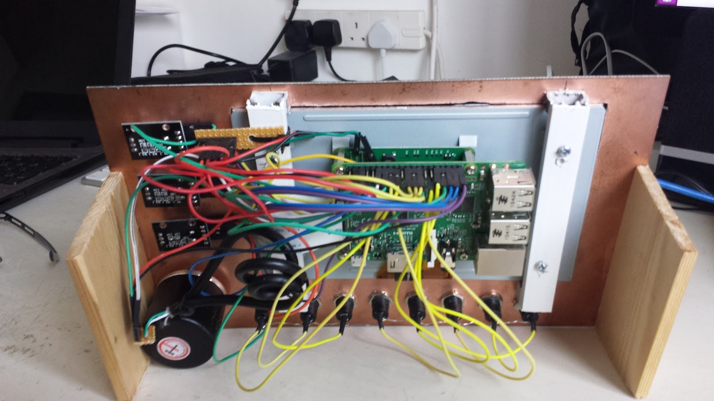
Note: pihpsdr is OpenSource. If you would like to run the program on a Linux system, the source, binaries, and documentation are located here: http://g0orx.blogspot.com/
NOTES

____________________________________________________________________________________________________________________________________________________________________________________________________________________________________________________________________________________________________________________________________________________________________________________________________________________________________________________________________________________________________________________________________________________________________________________________________________________________________________________________________________________________________________________________________________________________________________________________________________________________________________________________________________________________________________________________________________________________________________________________________________________________________________________________________________________________________________________________________________________________________________________________________________________________________________________________________________________________________________________________________________________________________________________________________________________________________________________________________________________________________

Alphabetical Index
1. Front panel controls 6
100BT 7
100BT LAN connection 7
13.8vdc 2.5A 7
2. Quick Start Instructions 10
3. Discovery 11
4. Menu 14
5. Screen Controls and Push Buttons 34
6. Tuning 48
7. Mode PSK31 – Receive 51
8. Appendix 53
8. Appendix 53
9. Reference materials 57
Adafruit 55
AF Gain Slider 35
AGC disabled 43
AGC Gain Slider 37
ANF 42
Apache Labs International Support 58
Apache Labs LLC 1
Apache Service and Repair 58
Apache Support 58
Apache Yahoo Support Group 58
APIPA 7
Appendix 53
backup of your Operating System 8
binaries 10
CAT 5/6 Ethernet cable 10
Close Menu button 14
compile 10
Controller software requirements: 8
CTUN 49
CTUN – Click Tuning 49
Default assignments of switches and rotary encoders 6
Discovery 11
Discovery → Start 13
documentation 8, 10
E1 6
E1 encoders selects AF Gain or Mic Gain 34
E2 6
E2 encoder selects PA Drive Level or Tune Drive Level 34
E3 6
E3 encoder selects AGC Gain or Rx Attenuation 34
E4 6
Early prototypes 59
Encoders and Switches 53
executable binaries 8
Fast 43
FN 6
FreeDV Text Message 25
Front panel controls 6
Function 34
fused 12vdc 10
G0ORX Friedrichshaven pdf and video 57
GPIO pin Assignments (RaspberryPi) 55
Hardware Setup 10
IF-shift, Hi-Cut, Low-Cut 57
Install pdf document 8
Introduction 5
John Melton GØORX/N6LYT 1
K5SO 1
latest version of pihpsdr source code 8
Lcocal Audio Output 17
Linux 10
Local Audio 17
Local Microphone Input 17
Long - Hangtime 43
Main screen HIDE 44
Medium 43
Menu → ANT 18
Menu → Audio 17
Menu → CW 23
Menu → Direct Frequency Entry 33
Menu → Display 19
Menu → Diversity 32
Menu → DSP 21
Menu → Equalizer 27
Menu → Exit piHPSDR 15
Menu → FM 28
Menu → FreeDV 25
Menu → General 16
Menu → Meter 30
Menu → OC 24
Menu → PA Gain by Band 22
Menu → Step 29
Menu → VOX 31
Menu → XVTR 26
Menu button 14
menu dialog 14
Menu or Toolbar → Band Selection 38
Menu or Toolbar → Band Stack 39
Menu or Toolbar → Filter 41
Menu or Toolbar → Mode 40
Menu or Touch → Meter 47
Menu or Touch → VFO Step 46
Menu Toolbar → AGC 43
Menu Toolbar → Noise 42
Mic Boost 17
MIC Gain Slider 35
MIC Input 56
Mic Line In 17
minimize the pihpsdr application window 44
minimum 12vdc 2A 7
Mouse 48
MOX 52
MOX Button 52
Network LAN connection 7
NOTES 60
NR 42
NR2 42
NRØV 1
OpenHPSDR archives 58
OpenHPSDR Group 58
OpenSource 10
PA Drive Slider 36
Panadapter color selection 57
piHPSDR Controller 1
PiHPSDR Controller - side panel 9
Power 6
PSK31 Transmit encoding 57
PureSignal 57
Quick Start Instructions 10
RaspberryPi-3b TRRS connector 55
Raspbian 8
Receive Attenuation Slider 37
Receiver Incremental Tuning 50
RIT 50
RTTY receive decoding 57
S1 6
S2 6
S3 6
S4 6
S5 6
S6 6
Slow - Hangtime 43
SNB 42
Software Setup 10
source 10
SparkFun 56
SPLIT for DX 57
Start button will start the radio 13
Start button will start the radio – on the selected Ethernet interface 13
Subnet 12
Thin Pipe Remote Audio/Video 57
Touch Screen 48
Touch VFO Lock 45
Transceiver interfaces 11
TUN 6
TUNE 52
Tune Drive Slider 36
TUNE/SWR/FWD power 52
TX Equalizer and RX Equalizer 27
Users Guide 1
VFO Encoder 48
VK6PH 1
W5WC 1
35pp.



