Dan Scarafoni
ID- 27435144
Project 3
CSC242- Introduction to AI

Inference in Bayesian Networks in Java

Introduction
In variables in which relationships and outcomes are uncertain, predicting future events is a difficult endeavor. Relationships between variables can be complicated to the point of intractability in sufficiently large worlds. This is problematic because real world situations almost always involve degrees of improbability and unpredictability. Developing algorithms to help solve problems of this nature is essential to creating AI that can hope to function in real-world scenarios. Our classwork with Bayesian networks provides a framework for representing the sample space of a given problem which features probabilistic relationships between a set of variables. Within a Bayesian network, several key algorithms (including enumeration-ask and gibbs sampling) can be used to predict the potential values of a variable given observed phenomena in an environment.

Algorithms
A Bayesian network is a directed graph depicting the causal relationships between variables. The nodes of the graph are variables in the problem which can have one of several potential values (known as random variables). The connection in the graph are directed, and a connection between from node A to node B represents that node A's state influences the state of node B (the two variables are said to be conditionally dependent). Figure 1 illustrates a simple Bayesian network used in experimentation for this project.

Figure 1- a Bayesian network
Note that Figure 1 also contains the conditional probability tables (CPT) for each variable; these represent the probable values of each node given the state of parent nodes.
The project required that queries to a given Bayesian network be calculated and answered. The notation to be used for these queries will be the same as used in the text book, repeated in Figure 2.

Figure 2: the probability of each value of variable X given evidence E
A number of techniques were usable in order to solve queries of this nature. The first to be implemented was enumeration-ask, which is shown in Figure 3.
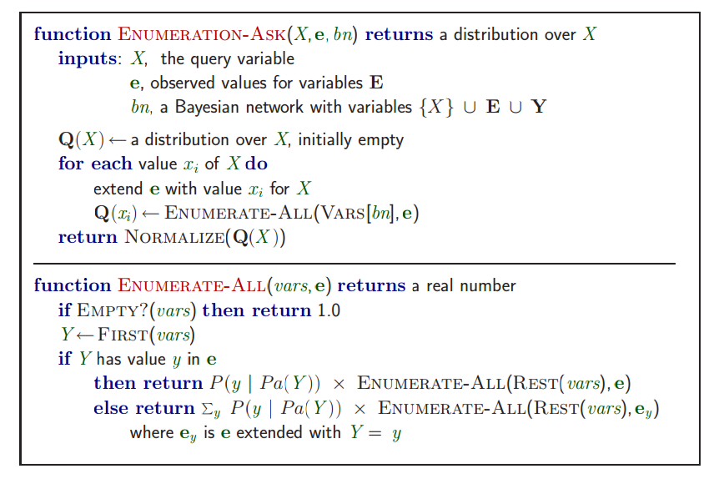
Figure 3: enumeration-ask
This algorithm solves the problem by enumerating through all unused (non-evidence and non-query) variables, enumerating all possible worlds (given the evidence). In each world, the program calculates the probability of that world's existence (full-joint distribution). The possibilities of each full-joint distribution are summed. This is repeated for all possible values of the query variable. The probability vector is then normalized such that the total probability of all variables sums to 1. Mathematically, the probability of a given variable can be represented a series of sums of products of network probabilities. This is represented in Figure 4.
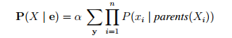

This algorithm guarantees that an exact probability inference is found; however, the algorithm is complex to the point of intractability, running in . This is simply unacceptable, particularly considering that the entire goal of probabilistic inference is to aid in solving real-world situations. As such, a trade off of accuracy in exchange for improved run-time would be acceptable.
Approximate inference algorithms provide this trade-off. The first algorithm looked at was Gibbs sampling. This algorithm, the pseudo-code of which is outlined in figure 5,
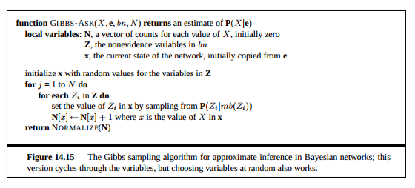
Figure 5- Gibbs-Ask algorith
This algorithm is a Markov Chain Monte Carlo algorithm (MCMC), and is a form of local search not dissimilar to the hill-climbing algorithm sometimes implemented to solve the n-queens problem. The algorithm essentially assigns all non-evidence variables to arbitrary values, and then reassigns variables one at a time based on which value is most likely given the state of it's Markov blanket (to be explained soon). In effect, the algorithm “wanders” through state space, with a probability of transitioning from one state space to another determined by the probability of the next state. If the values of the query variable are noted on each step, the ratio of each of the observed values will closely match the expected probability of each state (thus giving a consistent answer). The sampling algorithm described above determines the probability of selecting the next assignment for a variable based on the probability of that variable (given it's parents) multiplied by the probability of each of its children multiplied by their respective parents.
Though not as sophisticated as gibbs-sampling, rejection sampling and the slightly more complicated likelihood-weighting algorithms were also used in order to asses their advantages, disadvantages, and overall utility when compared to gibbs-sampling and exact inference.
Rejection sort works by reading in all nodes in a Bayesian network in topological order and assigning a value to each one based on the probability of each assignment given the parents (much like in gibbs-sampling). If this world produces a state that contradicts the evidence, it is rejected. Otherwise, the value of the query variable is noted and another full-disjoint is chosen. At the end of a number of iterations, the vector which held the number of occurrences of each value of the query variable is normalized and returned.
This algorithm was simple to implement and did not require much code. However, it is very inefficient in that is rejects a very large number of samples. The program would create hundreds of enumerations only to throw out the results produced, and it would throw out even more as more evidence was added to the network.
Likelihood-weighting reduced this problem. Like rejection sampling, the algorithm enumerated possible worlds via sampling. However, it only enumerated possibilities which were consistent with the evidence, and assigned a weight to each result based on the evidence.

Implementation
Java was selected as the language of choice for this project. This program made use of many complex data structures (most notably array lists) for which java has a myriad of built-in classes. This allowed for easy implementation of the various methods and classes needed.
Although sample code was given for the problem, only the parsing class (for parsing in Bayesian networks written in xml format) was utilized. A heavily edited topolocial sort algorithm from the code was also utilized for rejection-sampling likelihood-weighting. All other code was built from scratch. Classes were programmed for the basic components the Bayesian networks- random variables had their own class. CPT's were represented as trees, each layer of which represented all the possible values of a given parent variable. The “leaves” of the tree were the probabilities the CPT's random variable given the value of parent nodes. The data structure is illustrated in Figure 6.
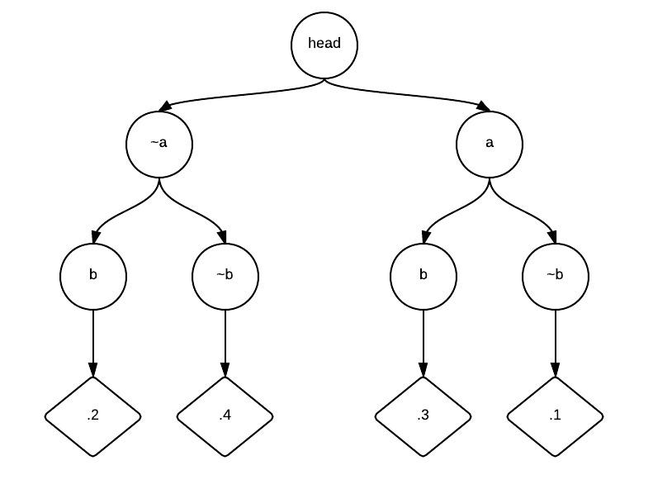
Figure 6: a CPT for a theoretical random variable A with parent B
A wrapper class for the random variable (which would contain the variables CPT and a list of parents) named Bnode was also implemented to safely house all important data to a given variable. A list of Bnodes was kept in the class BayesianNetwork. All driver programs would specify a query given evidence and an inference algorithm to be used. All driver programs were subclasses of Inference. Figure 7 shows the general class hierarchy for the project.
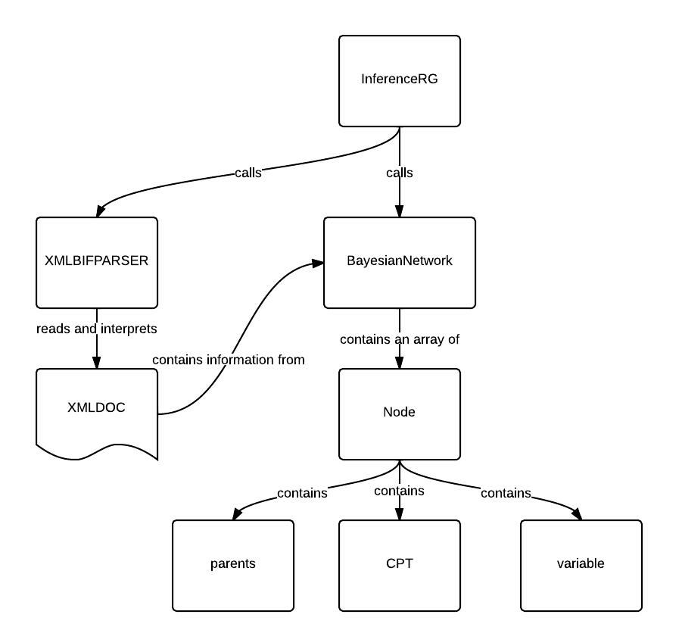

Figure 7
The exact Inference algorithm implemented utilized the pseudo-code found in the book (shown above in Figure 3). The arbitrary series of sums in the formula was implemented recursively using a tree, each layer of which represented the values of a given unused variable. Each leaf on the tree was a full disjoint of the problem. Full disjoints were calculated by multiplying the probability of each variable (which was found via the variable's CPT). This data implementatoin is not dissimilar to the implementation of the CPT tree, and as figure 8 (which represents a disjoint-tree) shows, the two share many common characteristics.
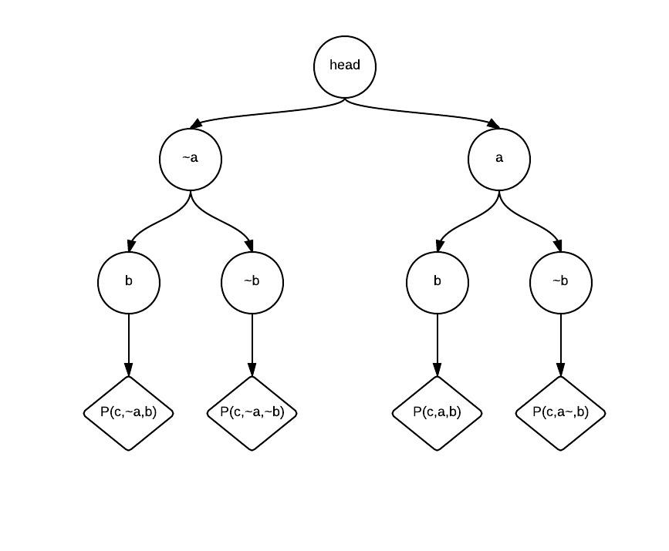
Figure 8- disjoint-tree for P(c) given no evidence
The Gibbs-Ask algorithm differed considerably. The algorithm first gathered all non-evidence variables, then iterated through each one individually. Each iteration sample a value for the variable given the Markov Blanket (as stated above). The value of the query variable was then noted in a vector which kept a running tally of the number of times each value was encountered. The ratio between the end values after a given number of iterations through all variables (typically 1000) was then normalized to give an approximation of the answer.
Rejection sampling used a much simpler implementation. No recursion was needed, only three methods were written. RejAsk was used to gather probabilistic values for the query based on worlds enumerated, and priorSample() was used to enumerate possible worlds. EvConsistent was also used in order to determine if an enumerated disjoint was consistent given the evidence. Figure 9 shows a screen capture of the source code.
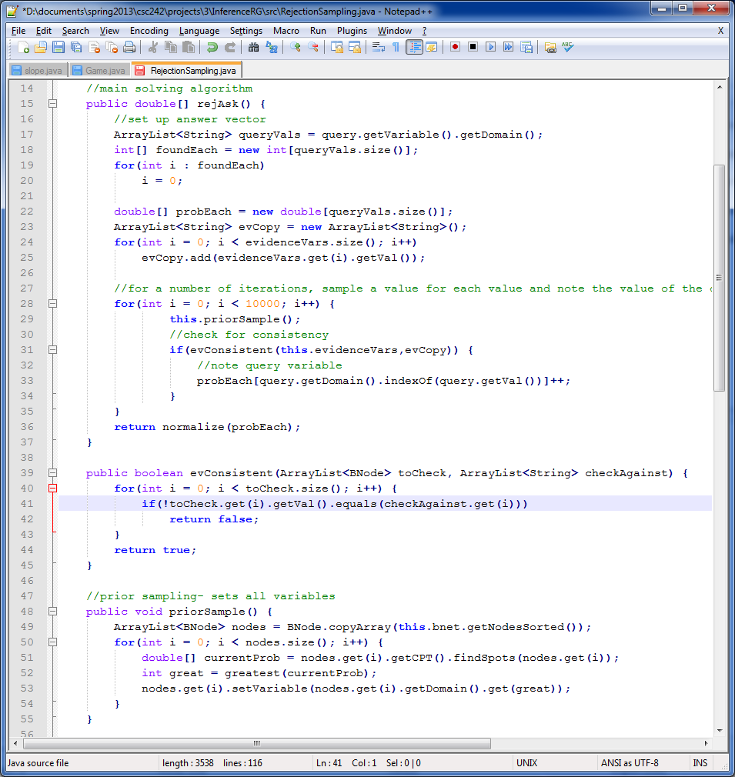
Figure 9
The algorithm for likelihood-weighting was constructed in a very similar manner, but without the evidence checking method (since no generated states were ruled out. Figure 10 shows the source code for this algorithm. The value for the weight of a variable was stored as a global variable which was initialized offscreen.
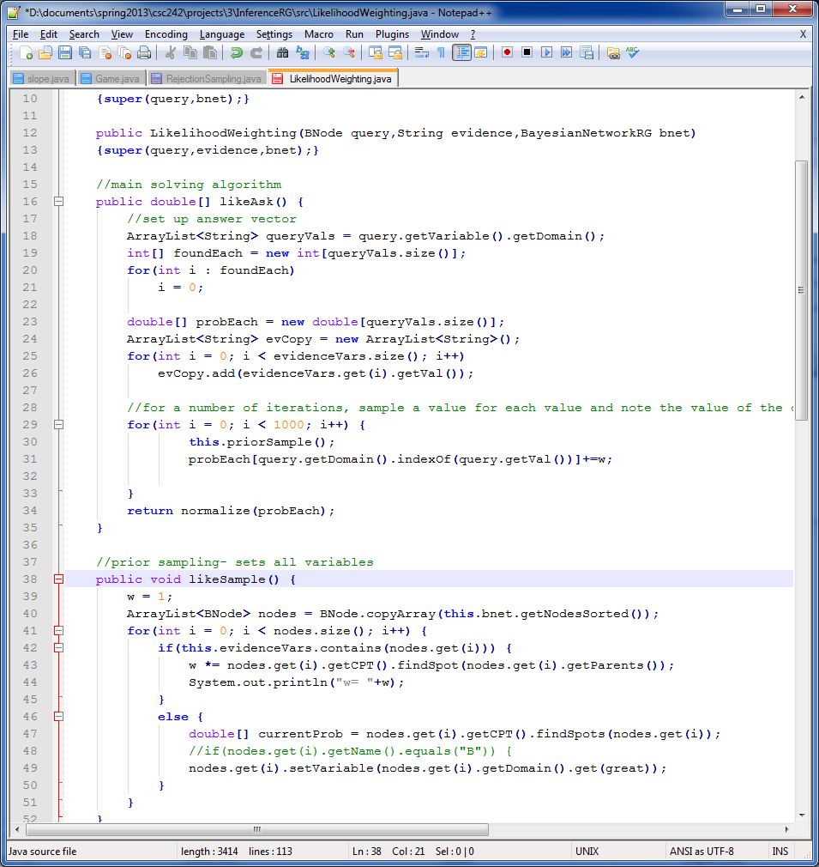
Figure 10
Results

