Below is the page you see when it’s started. Submission Id, Date and Address displayed.

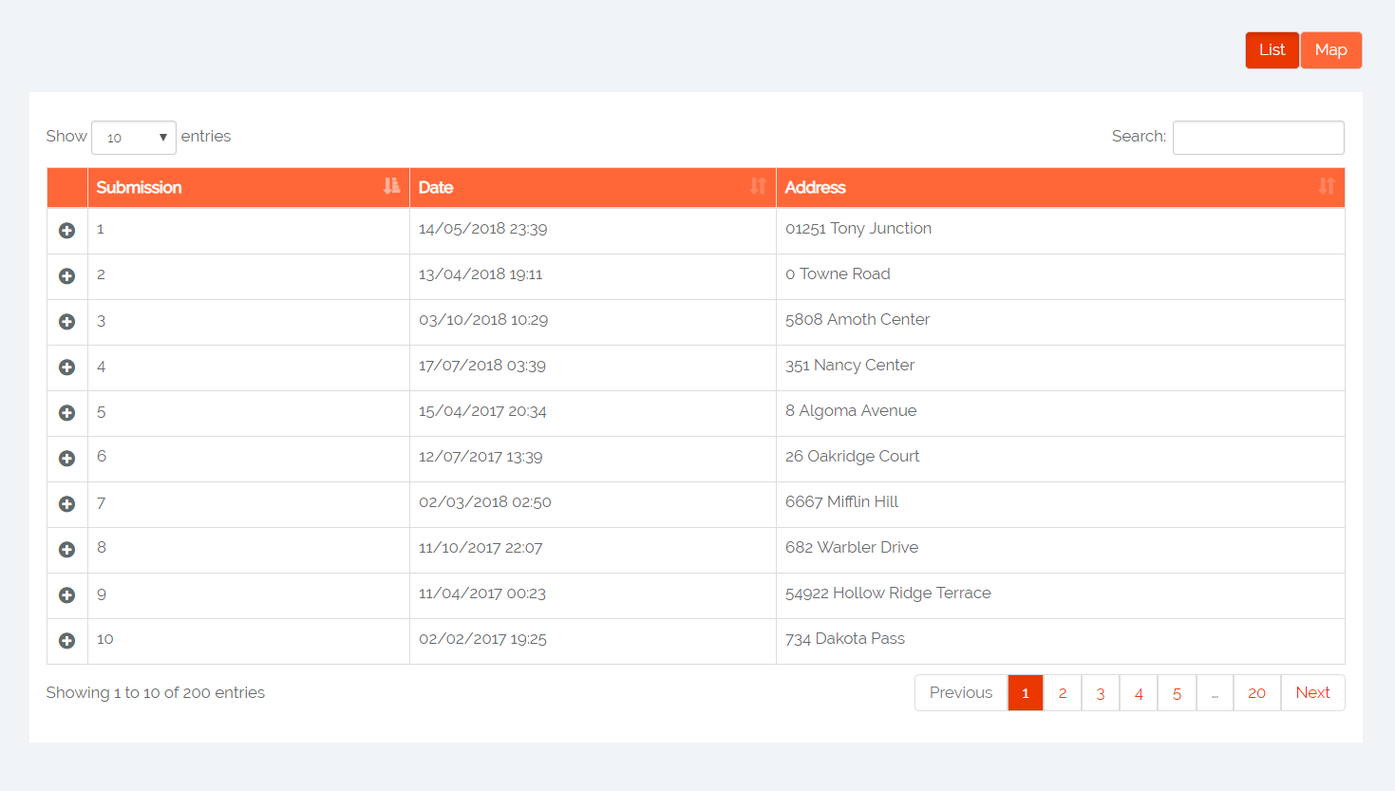

Click on the plus signs to see extra detail about the submissions, that is the answers given.

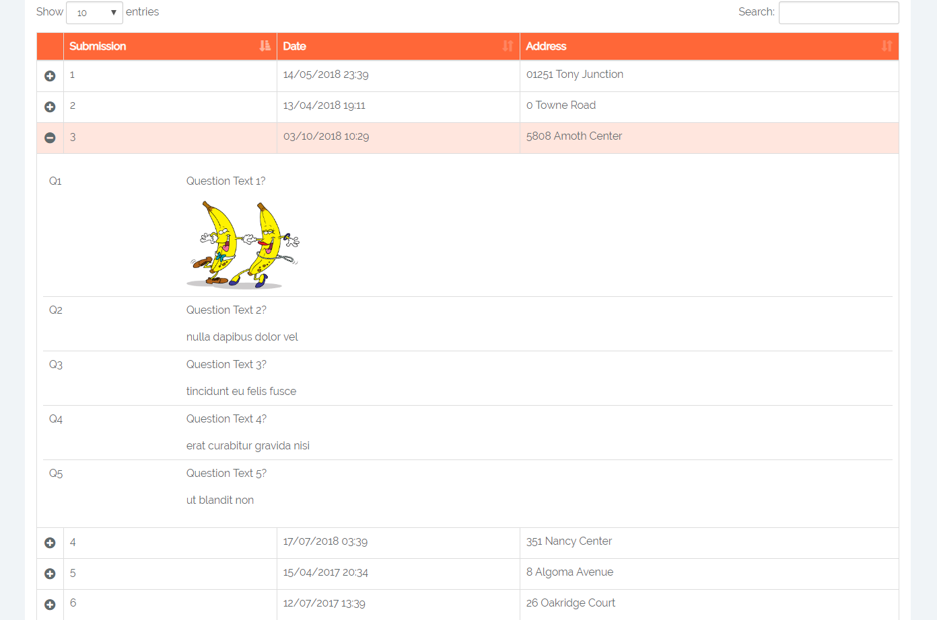

Click on the image to see it larger.

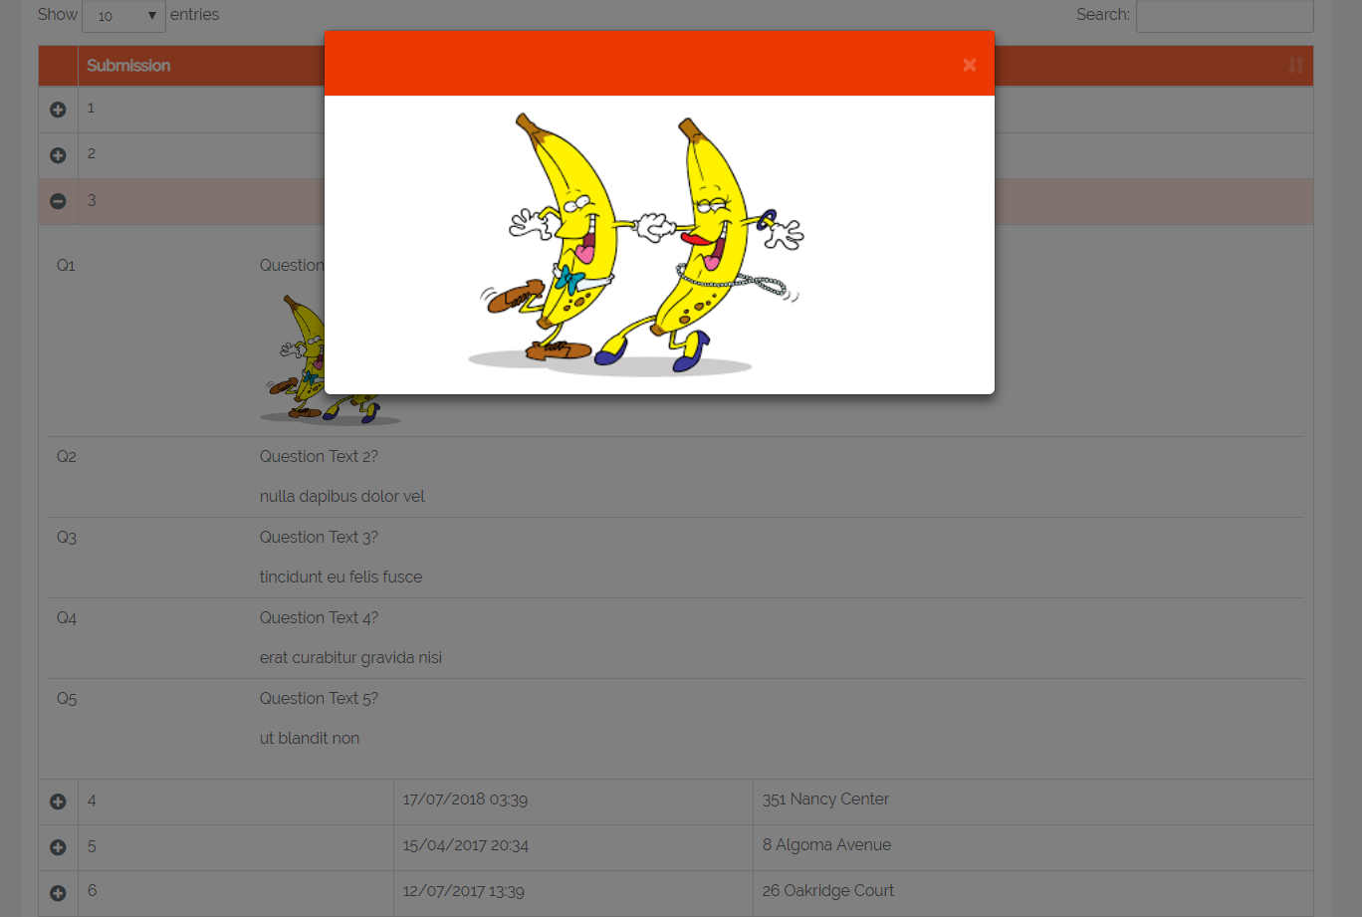

You can sort the submissions according to their ID, date or address. It is also possible to search for address/anything. Below is sorted according to the date:

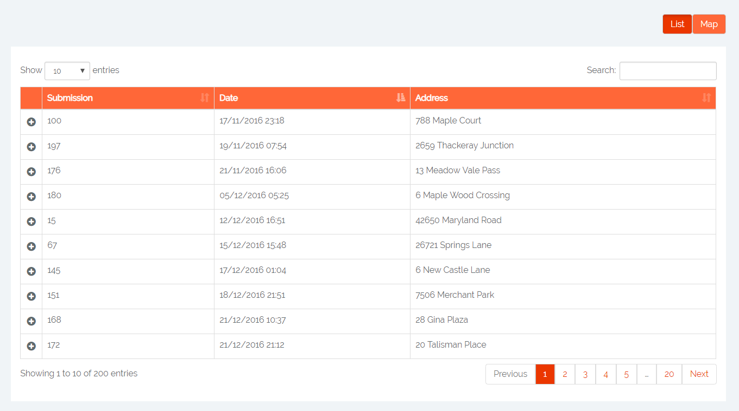

Click on the Map button to see the submissions on a map:

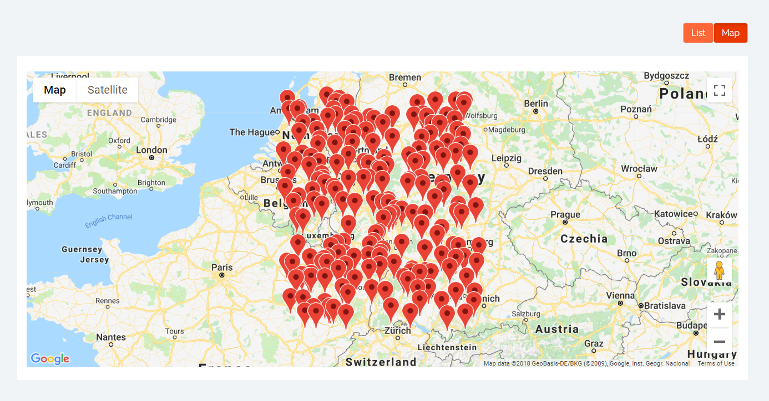

Once clicked on a pin, you see the detail about the submission on the map: Submission ID, date and address. Extra details, i.e. answers, are displayed below the map.

