MAISON LUMEN · ORACLE EPM PLANNING (EPBCS)

Solution Design Document
Lumen Plan: driver-based forecast and FY27 budget for the French sites
Project Oracle EPM rollout (Lumen Rollout) · Planning workstream
Document LR-DES-EPBCS-001 · version 1.0 · approved
Date 15 May 2026 (design sign-off)
Prepared by Gaurav Sharma, EPM consultant
Approved by Marc Dubois, CFO and project sponsor
Portfolio sample. Maison Lumen, its people and all figures are fictional. Oracle and EPBCS are trademarks of Oracle Corporation; this document is not affiliated with Oracle.

Document control
Document ID | LR-DES-EPBCS-001
Status | Approved at the design sign-off (steering committee, 15 May 2026)
Scope | Oracle EPM Planning application for Maison Lumen SAS: sites of Lyon, Paris and Lille
Related documents | Project Initiation Documentation (LR-PID-001) · FP&A workshop minutes (30 March to 24 April 2026) · Consolidation design (LR-DES-FCCS-001) · Project control workbook (UAT test plan)

Version history
Version | Date | Author | Changes
0.1 | 24 Apr 2026 | G. Sharma | First draft after the four FP&A design workshops
0.5 | 6 May 2026 | G. Sharma | Review comments from FP&A and IT; head-office allocation key changed from revenue to headcount (DD-03)
1.0 | 15 May 2026 | G. Sharma | Approved at the design sign-off (milestone M2)

Review and approval
Role | Name | Decision | Date
Paris site controller, FP&A key user | Claire Martin | Reviewed | 12 May 2026
Head-office controller, Lyon | Sophie Bernard | Reviewed | 12 May 2026
IT and ERP lead | Nicolas Petit | Reviewed | 13 May 2026
CFO, project sponsor | Marc Dubois | Approved | 15 May 2026

Contents
- 1. Introduction
- 2. Requirements and traceability
- 3. Solution overview
- 4. Application design
- 5. Forms and data entry
- 6. Business rules
- 7. Data integration
- 8. Workflow and approvals
- 9. Security
- 10. Reporting and analysis
- 11. Non-functional requirements
- 12. Design decisions

1. Introduction

1.1 Purpose
This document describes how Oracle EPM Planning is configured for the forecast and budget process of Maison Lumen SAS. It turns the requirements gathered in the FP&A workshops into a design that the build team configures and the key users test against. Once approved, any change to it goes through the project's change control.

1.2 Scope
In scope | Out of scope (phase 2 or another workstream)
Monthly rolling forecast of the current year (FY26) | Employee-level workforce planning (request CR-05, phase 2)
FY27 budget with submission and approval by site | Capital expenditure, balance sheet and cash-flow planning
Driver-based revenue and payroll, head-office cost allocation | Subsidiaries in the UK, the US and India (consolidated in FCCS)
Monthly load of actuals from the ERP | Integration with the payroll system
What-if simulation and variance analysis | Management reporting packs (Narrative Reporting)

1.3 Planning calendar
Cycle | Frequency | Horizon | Key dates
Rolling forecast | Monthly, after the ERP close | Current year: closed months as actual, the rest forecast (8+4 in September) | Actuals loaded on working day 3, forecast updated days 5 to 8, CFO review day 10
Budget FY27 | Yearly | 12 months of FY27 | Launch at the EPBCS go-live (2 November 2026), submission by 27 November, approval by 11 December

1.4 Glossary
Term | Meaning
Driver | An operational quantity (units, price, headcount, salary) from which amounts are calculated
Planning unit | A site's budget, which moves through the approval workflow as one block
Substitution variable | An application-wide value (for example the closed months) used by forms and rules
Business rule | A calculation script run on save or on demand (for example revenue = units × price)
Working / Final | The editable version of a plan, and its frozen copy once approved
Dense / sparse | Storage setting: dense dimensions are mostly filled (accounts, months), sparse ones are not

2. Requirements and traceability
The requirements come from four FP&A workshops held between 30 March and 24 April 2026. Each one is traced to the design section that answers it, and to the user acceptance test (UAT) case that proves it in the project control workbook.
ID | Requirement | Priority | Design | UAT
REQ-01 | Forecast the current year monthly, keeping closed months as actuals | Must | 4.4, 7.3 | U08
REQ-02 | Build revenue from units sold and the average selling price of each site | Must | 6 | U01, U02
REQ-03 | Calculate payroll from headcount and average salary, with the 13th month in December | Must | 6 | U03
REQ-04 | Allocate Lyon head-office costs to the Paris and Lille sites | Must | 6 | U04
REQ-05 | Enter an annual total and spread it over the months | Should | 5.2 | U05
REQ-06 | Submit and approve each site's budget, keeping a frozen approved version | Must | 8 | U06
REQ-07 | Simulate what-if scenarios without changing the plan | Should | 5.3 | U07
REQ-08 | Load monthly actuals from the ERP and reject unmapped accounts | Must | 7 | U16, U17
REQ-09 | Compare forecast, budget and actuals, with a price, volume and mix analysis | Must | 10 | U20
REQ-10 | Restrict each site controller to their own site | Must | 9 | U23, U24
REQ-11 | Keep an audit trail of changes and comments by cell | Should | 5.4 | U06
REQ-12 | Provide a CFO dashboard | Could | 10 | U22

Prioritisation
Priorities use MoSCoW: Must items are required for the go-live, Should items are expected but could move to a later release, Could items are included only if time allows.

3. Solution overview
One Oracle EPM Planning application holds actuals, the rolling forecast and the budget of the three French sites of Maison Lumen SAS. Actuals come from the ERP every month; site controllers plan drivers and costs in forms; business rules calculate revenue, payroll and the head-office allocation; the CFO approves each site's budget, which freezes a Final copy.
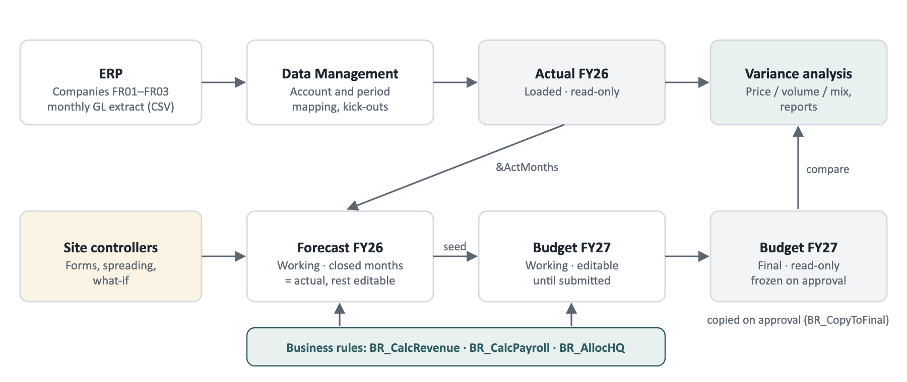
Figure 1. Data flow of the planning solution
- Actuals. The ERP's monthly general-ledger extract is mapped to planning accounts and loaded into Actual FY26.
- Forecast. Closed months of Forecast FY26 take the actuals (substitution variable &ActMonths); open months are planned.
- Budget. Budget FY27 Working is seeded from the forecast, planned by each site, then approved and copied to Final.
- Analysis. Variance analysis compares any two plans, with revenue split into price, volume and mix effects.

4. Application design

4.1 Dimensions
The application uses the six dimensions that every EPM Planning application requires, plus a Plan Element dimension that records where each amount comes from. The Currency dimension is not enabled: all three sites report in euros.
Dimension | Members (examples) | Storage | Notes
Account | UNITS, PRICE, 706, 607, MB, HC, SAL, 641, 645, 61, 62, 63, ALLOC, EBE, 681, REX | Dense | French chart-of-accounts codes; subtotals are dynamic calculations
Period | Jan to Dec, Q1 to Q4, YearTotal | Dense | Quarters and year total are dynamic calculations
Entity | Total entities > LYO, PAR, LIL | Sparse | Each site is a workflow planning unit
Years | FY26, FY27 | Sparse | Kept apart from Period so every year reuses the same months
Scenario | Actual, Budget, Forecast | Sparse | Actual is read-only, loaded from the ERP
Version | Working, Final | Sparse | Final is read-only and filled on approval
Plan Element | Loaded, Calculated, Input | Sparse | Loaded from the ERP, produced by rules, or entered in forms

4.2 Account structure
Code | Account | Type | Storage | Source or formula
UNITS | Units sold | Driver | Stored | Input by sales sites; whole number
PRICE | Average selling price (€) | Driver | Stored | Input; two decimals
706 | Revenue | Revenue | Stored | BR_CalcRevenue: UNITS × PRICE
607 | Cost of purchases | Expense | Stored | Input
MB | Gross margin | Revenue | Dynamic | 706 − 607
HC | Average headcount (FTE) | Driver | Stored | Input; one decimal
SAL | Average monthly gross salary (€) | Driver | Stored | Input
641 | Gross salaries | Expense | Stored | BR_CalcPayroll
645 | Social charges | Expense | Stored | BR_CalcPayroll: 641 × 42 %
61 | External services (rent, energy) | Expense | Stored | Input
62 | Other external services | Expense | Stored | Input
63 | Taxes and duties | Expense | Stored | Input
ALLOC | Head-office cost allocation | Expense | Stored | BR_AllocHQ
EBE | EBITDA | Revenue | Dynamic | MB − 641 − 645 − 61 − 62 − 63 − ALLOC
681 | Depreciation | Expense | Stored | Input
REX | Operating result | Revenue | Dynamic | EBE − 681

Expenses are entered as positive amounts; the account type decides whether a variance is favourable. The head office (LYO) has no sales, so its forms hide UNITS, PRICE, 706, 607 and MB.

4.3 Entities and planning units
Entity | ERP company | Role | Planner
LYO | FR01 | Lyon head office: cost centre, no sales; its costs are allocated to the sites | Sophie Bernard
PAR | FR02 | Paris: sales site | Claire Martin
LIL | FR03 | Lille: plant and sales site | Thomas Leroy

4.4 Scenarios and versions
Plan | Content | Access
Actual FY26 | Loaded from the ERP every month | Read-only
Budget FY26 | Approved last year; reference for FY26 variances | Read-only
Forecast FY26 · Working | Closed months equal to actual; open months planned | Open months editable
Budget FY27 · Working | Seeded from the forecast, planned by each site | Editable until submitted
Budget FY27 · Final | Frozen copy of each approved site | Read-only

4.5 Substitution variables
Variable | Meaning | Value at 25 Sep 2026 | Updated by
&ActMonths | Closed months of the current year | Jan to Aug | Month-close procedure
&FcstMonths | Open forecast months | Sep to Dec | Month-close procedure
&CurYr | Current year | FY26 | Administrator, once a year
&BudYr | Budget year | FY27 | Administrator, once a year

5. Forms and data entry

5.1 Forms
Form | Purpose | Layout | Editable cells
F01 Driver-based P&L | Enter forecast and budget drivers and costs | Rows: drivers then P&L lines · columns: months and year total | Input accounts in open months
F02 Top-down spreading | Spread an annual total over the open months | One account, total then months | The total
F03 What-if simulation | Test changes in volume, price, costs and salaries | Five levers against key results | The levers only
F04 Variance analysis | Compare two plans, with price, volume and mix | Accounts × current, reference, variance | None (read-only)
F05 Workflow dashboard | Status, blockers and approvals by site | One card per site | Actions by role

5.2 Spreading methods
- Seasonality of the reference plan (default): the total follows last year's monthly profile.
- Proportional: the total follows the current monthly values.
- Even: the same amount in every open month.
- Rounding differences go to the largest months, so the months always add up exactly to the total entered.

5.3 What-if simulation
Lever | Range | Effect
Units sold | −20 % to +20 % | Applied to volumes and to purchases
Selling prices | −10 % to +10 % | Applied to the average selling price
Unit purchase cost | −10 % to +15 % | Materials and components inflation
Average salaries | −5 % to +10 % | Social charges recalculated in turn
External services | −15 % to +15 % | Accounts 61 and 62 (rent, energy, fees)

A simulation never changes the plan by itself. The planner can publish it to the open months of the forecast, or to the budget of sites still in draft; the published changes then appear in the audit trail.

5.4 Validation rules and audit trail
Rule | Applies to | Severity | Message
V01 | All input cells | Error | Not a number
V02 | All input accounts | Error | Negative amounts are not allowed on this account
V03 | PRICE, SAL | Error | Value must be greater than zero
V04 | UNITS | Error | Units must be a whole number
V05 | All input accounts | Warning | Change of more than ±50 % against the reference plan for the same month

Errors block saving. Warnings are shown on the cell and can be justified with a cell comment. Every saved change is logged with its author, time, old and new value, and source (form, spreading, simulation or import).

6. Business rules
Rules run automatically when a form is saved (for the planning unit being edited) and can also be launched from the rules page. On the forecast they only touch open months; on the Working budget they cover the whole year.
Rule | Trigger | Scope | Logic
BR_CalcRevenue | On save; on demand | Sales sites (PAR, LIL) | 706 = round(UNITS × PRICE)
BR_CalcPayroll | On save; on demand | All sites | 641 = HC × SAL, doubled in December (13th month); 645 = 641 × 42 %
BR_AllocHQ | After payroll; on demand | LYO to PAR and LIL | Pool = LYO 61 + 62 + 63 + 641 + 645; PAR receives pool × HC(PAR) / (HC(PAR) + HC(LIL)); LIL the rest; LYO ALLOC = − pool
BR_CopyToFinal | On budget approval | The approved site, FY27 | Copy every stored account from Working to Final

Rule order and stale data
Revenue and payroll run before the allocation, because the allocation uses the head office's payroll. If a driver changes and a rule has not run since, the form shows the calculation as out of date and the site cannot submit its budget until the rules are run again.

7. Data integration

7.1 Source file
Each month the ERP produces one semicolon-separated file per company (FR01, FR02, FR03) with the columns company, account, label, period (YYYY-MM) and amount, using a decimal comma. Statistical accounts carry units sold and headcount.

7.2 Account mapping
ERP account | Description | Planning account | Sign
706* | Sales of finished goods | 706 | Reversed (credit)
607* | Purchases of goods | 607 | As loaded
606*, 613* | Energy and supplies; rent | 61 | As loaded
622*, 625*, 626* | Fees; travel; telecoms | 62 | As loaded
635* | Taxes (CFE) | 63 | As loaded
641* | Salaries and bonuses | 641 | As loaded
645* | Social security and pension | 645 | As loaded
681* | Depreciation | 681 | As loaded
STAT_UNITS | Statistic: units sold | UNITS | As loaded
STAT_HC | Statistic: FTE headcount | HC | As loaded

Accounts without a mapping are rejected (kick-outs) and listed for correction; the load is run again once the mapping is updated. The period column maps to the Period and Years dimensions.

7.3 Month-close procedure
1. Load the month's actuals and check that no line was rejected.
2. Reconcile the loaded totals with the ERP trial balance, company by company.
3. Close the month: its actuals replace the forecast, the month locks, and &ActMonths moves on one month (8+4 becomes 9+3).
4. Site controllers update the remaining forecast months before the CFO review.

8. Workflow and approvals
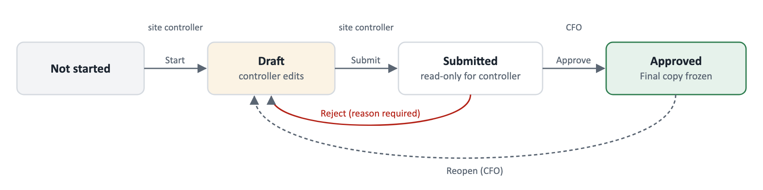
Figure 2. Budget approval workflow for each site (planning unit)
Each site's FY27 budget is a planning unit. The site controller starts it, plans and submits; the CFO approves it, or rejects it with a mandatory reason, which sends it back to draft. Approval runs BR_CopyToFinal and locks the site. Only the CFO can reopen an approved site.

Checks before submission
- No unsaved changes in the site's forms
- Revenue and payroll recalculated since the last driver change
- Head-office allocation run after the last payroll change
- No validation errors (V01 to V04)

9. Security
Role | Who | Access
Service administrator | EPM consultant during the project, then IT support | Full administration of the application
Power user | FP&A lead | All sites; runs rules, closes months, maintains substitution variables
Planner | Site controllers: Sophie Bernard (LYO), Claire Martin (PAR), Thomas Leroy (LIL) | Write access to their own site; read access to Total entities
Approver | CFO (Marc Dubois) | Read access to all sites; approves or rejects budgets
Viewer | Management committee | Read-only access to reports and variance analysis

Access is granted to groups (for example LP_Planner_PAR), never to named users, so a change of controller only means changing group membership. Security is tested in the test environment before production (UAT cases U23 and U24).

10. Reporting and analysis
Three comparisons are available: forecast FY26 against budget FY26, actual against budget FY26 (year to date), and budget FY27 against forecast FY26. Each is available by site or for the total, by quarter or for the year.
Effect | Formula (calculated by site, then added up)
Volume | (units in the plan − units in the reference) × reference price
Price | (price in the plan − reference price) × units in the plan
Mix | At total level: sum of the site volume effects − the total volume effect at the average reference price

A CFO dashboard with the main indicators by site completes the reporting (REQ-12).

11. Non-functional requirements
Area | Requirement
Performance | Forms open in under 3 seconds; rules for one site run in under 30 seconds
Oracle updates | Oracle updates test environments on the first Friday of each month and production on the third; regression tests run in between
Backup | Oracle's daily maintenance snapshot, plus an application snapshot before each release to production
Audit | Cell history and comments kept for the life of the application
Naming | Rules BR_*, forms F0x, security groups LP_<role>_<site>, variables &Name

12. Design decisions
ID | Decision | Rationale | Alternative rejected
DD-01 | Revenue = units × average price, by site | Matches how sales teams plan, and explains variances by volume and price | Revenue entered directly: no volume or price view
DD-02 | Payroll from average headcount and salary, 13th month in December | Accurate enough by site, with no personal data in the tool | Employee-level planning: moved to phase 2 (CR-05)
DD-03 | Head-office costs allocated by headcount | Simple, stable and agreed by the site controllers | Allocation by revenue: penalises growing sites
DD-04 | Final version filled by copy on approval | Keeps a frozen reference for variances and audit | Approval in place: no frozen copy
DD-05 | Forecast horizon moved by substitution variables | The same forms work every month, with no redesign | One form per month: heavy to maintain
DD-06 | Single currency (EUR), no Currency dimension | All three sites report in euros | Multi-currency: not needed here; subsidiaries are in FCCS

Sign-off
This design was approved by the steering committee on 15 May 2026 (milestone M2, decision log). Any change after sign-off goes through change control.

