MAISON LUMEN · ORACLE EPM ROLLOUT

Project Initiation Documentation
Lumen Rollout: deploying Oracle EPM Planning (EPBCS) and Financial Consolidation (FCCS)
Project Lumen Rollout · Maison Lumen Group
Document LR-PID-001 · version 1.0 · approved
Date 27 March 2026 (charter approval, milestone M1)
Prepared by Gaurav Sharma, project manager
Approved by Marc Dubois, CFO and project executive
Portfolio sample. Maison Lumen, its people and all figures are fictional. PRINCE2® is a registered trademark of PeopleCert; Oracle, EPBCS and FCCS are trademarks of Oracle Corporation. Not affiliated with either.

Document control
Document ID | LR-PID-001
Status | Approved by the steering committee on 27 March 2026 (decision DC1)
Purpose | Defines the project so the steering committee can authorise it and use it as the baseline for all later decisions
Related documents | Solution design documents (LR-DES-EPBCS-001, LR-DES-FCCS-001) · Project control workbook (RAID log, change log, UAT test plan, go/no-go checklist)

Version history
Version | Date | Author | Changes
0.1 | 13 Mar 2026 | G. Sharma | First draft after the kick-off
0.4 | 20 Mar 2026 | G. Sharma | Business case figures from finance; tolerances proposed
1.0 | 27 Mar 2026 | G. Sharma | Approved at the steering committee (milestone M1)

Approval
Project board role | Name | Position | Decision
Executive (sponsor) | Marc Dubois | Chief financial officer | Approved
Senior user, planning | Claire Martin | Paris site controller, FP&A key user | Reviewed
Senior user, consolidation | Sophie Bernard | Head-office and group controller | Reviewed
Senior supplier | Nicolas Petit | IT and ERP lead | Reviewed

Contents
- 1. Background
- 2. Project definition
- 3. Business case summary
- 4. Project approach
- 5. Organisation
- 6. Plan summary
- 7. Tolerances
- 8. Project controls
- 9. Risk management approach
- 10. Quality management approach
- 11. Communication plan

1. Background
Maison Lumen is a French lighting manufacturer with a head office in Lyon, a sales site in Paris, a plant in Lille and subsidiaries in the United Kingdom, the United States (80 % owned) and India. Its budget and forecast run on about forty linked Excel files, and the group consolidation on a spreadsheet model maintained by one person.
Last year the budget took ten weeks, the monthly forecast a full week, and the half-year consolidation closed at day 12 after two late intercompany corrections. The auditors asked for a traceable consolidation process. The CFO decided to replace both processes with Oracle EPM Cloud before the FY27 budget and the FY26 year-end close.

2. Project definition

2.1 Objectives
Objective | Measure | Target
Launch the FY27 budget in Oracle EPM Planning | EPBCS in production | 2 November 2026
Shorten the budget cycle | Weeks from launch to approval | 6 weeks (10 today)
Shorten the monthly forecast | Working days to update the forecast | 3 days (7 today)
Close the FY26 year-end consolidation in FCCS | FCCS in production | 8 January 2027
Close the consolidation faster | Working days after month end | Day 8 (day 12 today)
Deliver within budget | Cost at completion | 480 k€ (+5 % tolerance)

2.2 Scope
In scope | Out of scope
Oracle EPM Planning (EPBCS): forecast and budget of the French sites | Workforce planning by employee
Oracle FCCS: consolidation of the four group companies, IAS 21 translation, eliminations, NCI | Capital expenditure and cash-flow planning
Monthly ERP data flows for actuals and trial balances | Narrative Reporting (management packs)
Reports, security, testing, training and hypercare | ERP changes other than the extracts

2.3 Deliverables
Deliverable | Accepted by | Acceptance
Solution design documents (EPBCS, FCCS) | Senior users | Design sign-off (M2)
Configured EPBCS and FCCS applications | Senior users | UAT exit criteria met
ERP data flows with mapping and reconciliation | IT and ERP lead | Monthly load reconciled
Reports and security by entity | Senior users | UAT cases passed
User guides and training | Senior users | 90 % of users trained
Handover to support | IT and ERP lead | Support procedure tested

2.4 Constraints, assumptions and dependencies
- Constraint. EPBCS must be live before the FY27 budget launch; FCCS must be proven on a real close before the year end.
- Constraint. Key users are busy in October and November with the budget season.
- Assumption AS1. Key users give two half-days a week to testing.
- Assumption AS2. The group chart of accounts stays frozen until the FCCS go-live.
- Assumption AS3. Existing Oracle EPM licences cover 60 users at no extra cost.
- Assumption AS4. The 2024–2025 history can be extracted from the ERP without rework.
- Dependencies. ERP team for the data flows; Oracle's monthly updates; treasury for closing exchange rates.

3. Business case summary
Option | Description | Assessment
1. Do nothing | Keep the Excel models | Rejected: cycle times and audit findings remain
2. Improve Excel | Rebuild the models with controls and macros | Rejected: still manual, depends on key people
3. Oracle EPM Cloud | EPBCS for planning, FCCS for consolidation | Recommended: standard processes, audit trail, faster cycles

Item | Value
Project budget | 480 k€ (integrator and internal time), excluding licences already in the IT run budget
Contingency | 48 k€ (10 %), held by the sponsor and released through change control
Timescale | 2 March 2026 to 22 January 2027
Expected benefits | Budget in 6 weeks instead of 10; forecast in 3 days instead of 7; consolidation at day 8 instead of day 12; about 1.5 FTE of finance time freed for analysis
Main risks | Quality of ERP history (R1), key-user availability (R2), late ERP flows (R3)

Benefits review
The sponsor reviews the benefits after the first FY27 budget cycle and the first FCCS year-end close, using the measures in section 2.1.

4. Project approach
The project follows a hybrid approach, common for EPM implementations: sequential stages each closed by a steering committee decision, with the build delivered as three conference room pilots (CRPs) reviewed with key users. Configuration starts from Oracle's standard features and adds only what a documented requirement justifies.
- Environments. One test and one production environment per application; Oracle updates test on the first Friday of each month and production on the third, so regression tests run in between.
- Team. Integrator consultants build; internal key users design, test and become the application owners.
- Knowledge transfer. Every configuration is documented and paired with an internal owner (risk R6).

5. Organisation
Role | Name | Responsibilities
Project executive (sponsor) | Marc Dubois, CFO | Owns the business case; chairs the steering committee; releases contingency
Senior users | Claire Martin, Sophie Bernard | Represent planning and consolidation users; accept the deliverables
Senior supplier | Nicolas Petit, IT and ERP | Commits IT and integrator resources; owns the data flows
Project manager | Gaurav Sharma | Plans and runs the project day to day, within the tolerances set by the board
EPM consultants | Integrator team | Design, build, testing support, training
Key users | FP&A and consolidation teams | Workshops, test cases, UAT, champions in each entity
Auditors (consulted) | Statutory auditors | Review of consolidation rules before go-live

RACI for key activities
Activity | Sponsor | PM | Consultant | Key users | Consol. | IT | Auditors
Approve business case and charter | A | R | C | I | I | C
Run design workshops |  | A | R | C | C | I
Sign off the design | A | R | C | C | C | I
Build EPBCS and FCCS |  | A | R | C | C
Build the ERP data flows |  | A | C |  |  | R
Validate consolidation rules | C | I | R |  | A |  | C
Write and run test cases |  | A | C | R | R
Train users |  | A | R | C | C
Decide go/no-go | A | R | C | C | C | C | I

6. Plan summary
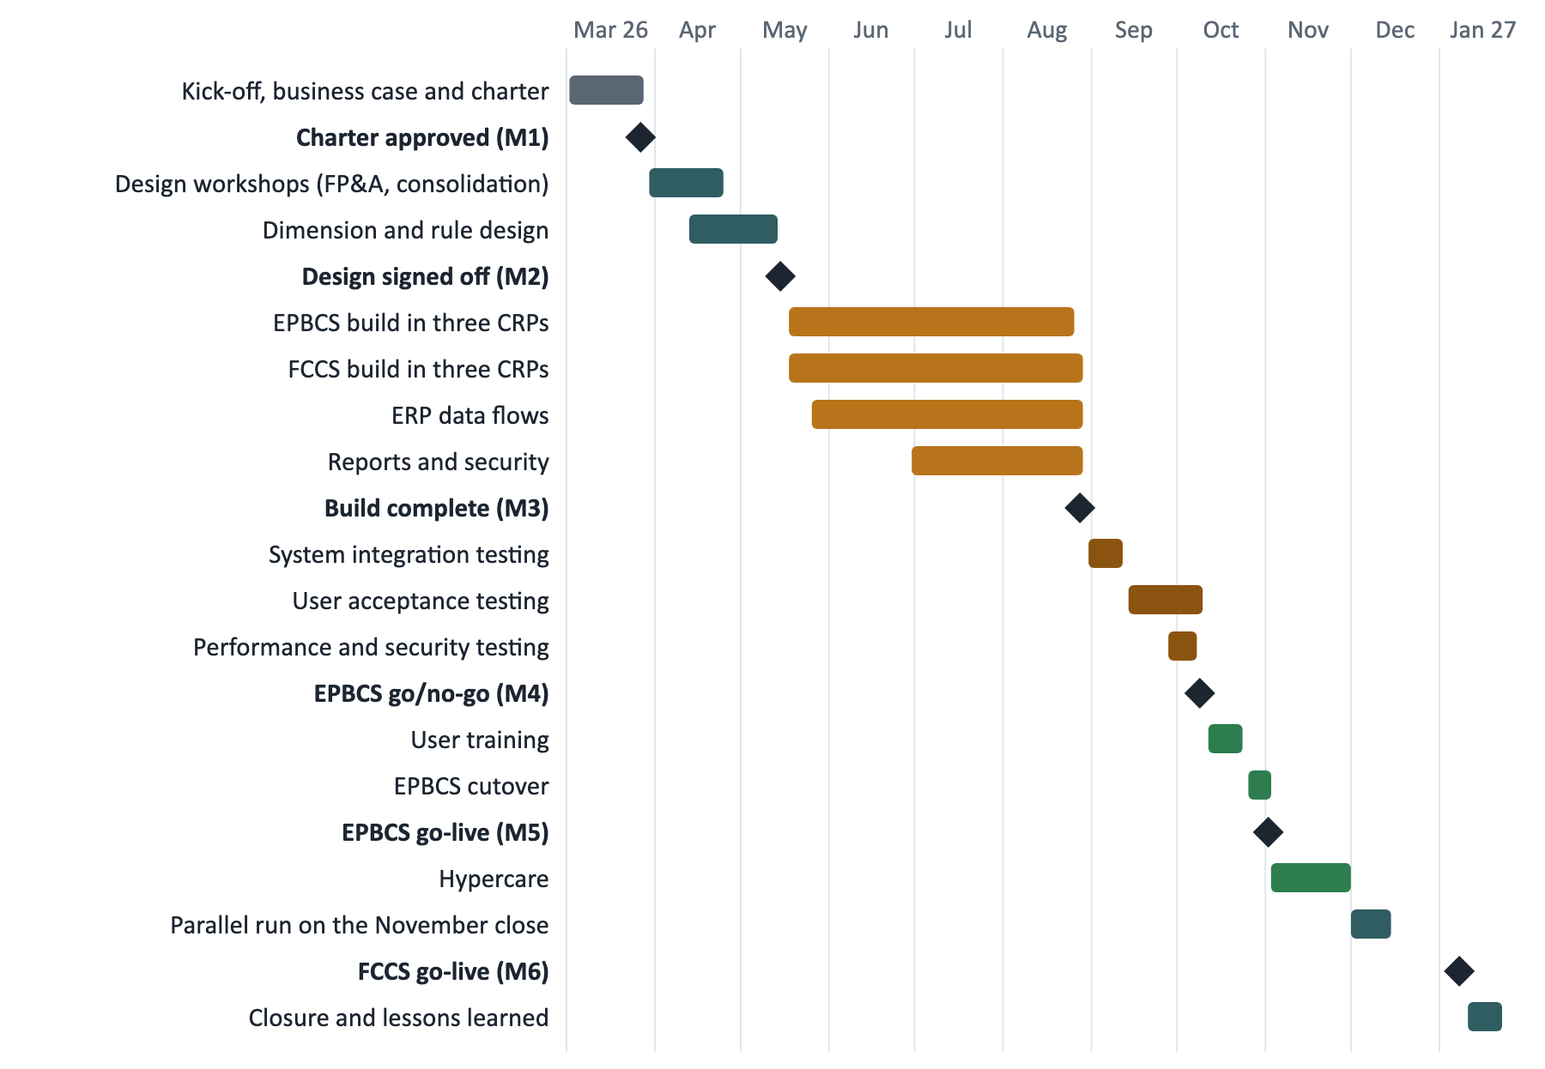
Figure 1. Baseline plan, in working days (weekends and French public holidays excluded)
Milestone | Baseline date | Decision
M1 Charter approved | 27 Mar 2026 | Initiation closed, design authorised
M2 Design signed off | 15 May 2026 | Build authorised
M3 Build complete | 28 Aug 2026 | Testing authorised
M4 EPBCS go/no-go | 9 Oct 2026 | Training and cutover authorised
M5 EPBCS go-live | 2 Nov 2026 | FY27 budget launched in EPBCS
M6 FCCS go-live | 8 Jan 2027 | Year-end close in FCCS

7. Tolerances
The steering committee delegates day-to-day management to the project manager within these tolerances. If a forecast goes beyond one of them, the project manager raises an exception report and the committee decides.
Area | Tolerance | Escalation
Time | ±10 working days on each go-live date | Exception report to the steering committee
Cost | +5 % of the authorised budget (about 24 k€ on 480 k€) | Exception report; contingency released only through a change request
Scope | All Must requirements delivered; Could items may be deferred by the board | Change request
Quality | UAT exit criteria (section 10) | No go-live without them, or a documented board decision
Risk | Any risk scoring 20 or more | Escalated to the sponsor within 48 hours

8. Project controls
Control | Frequency | Participants | Output
Steering committee | Monthly and at each stage end | Project board, project manager | Decisions, highlight report, end stage report
Project committee | Weekly | Project manager, leads, key users | Checkpoint, RAID review
Stand-up | Daily in build and testing | Project team | Blockers, defect triage
Exception report | When a tolerance is forecast to be exceeded | Project manager to the board | Options and recommendation

Change control
- Every request affecting scope, cost or dates is logged in the change log, costed and assessed.
- The project manager approves requests up to 10 k€ with no effect on a go-live date.
- Above that, or when a go-live moves, the steering committee decides.
- The 48 k€ contingency is released only through approved change requests; the authorised budget is updated accordingly.

9. Risk management approach
Score | Probability (P) | Impact (I)
1 | Rare (under 10 %) | Negligible: absorbed within the stage
2 | Unlikely (10 to 30 %) | Minor: a few days or under 5 k€
3 | Possible (30 to 50 %) | Moderate: a week, or 5 to 15 k€
4 | Likely (50 to 80 %) | Major: threatens a milestone or 15 to 30 k€
5 | Almost certain (over 80 %) | Severe: a go-live date or over 30 k€

The risk score is P × I. One scale applies to every report: low from 1 to 7, medium from 8 to 14, high from 15, and a score of 20 or more blocks a go-live. Each risk has an owner and one of the PRINCE2 responses: avoid, reduce, fallback, transfer, share or accept. The register is reviewed weekly and presented monthly to the steering committee.
ID | Initial risk | P | I | Score | Owner | Response
R1 | Poor quality of historical ERP data | 4 | 4 | 16 | IT | Reduce: cleansing, monthly reconciliation
R2 | Key users unavailable during testing (budget season) | 4 | 3 | 12 | Sponsor | Reduce: test calendar agreed by the CFO
R3 | Delay in the ERP data flows | 3 | 4 | 12 | IT | Fallback: manual file loads
R4 | Complex consolidation rules (NCI, FX) | 2 | 4 | 8 | Consol. | Reduce: dedicated tests, auditor review
R5 | Resistance to change (Excel habits) | 3 | 3 | 9 | PM | Reduce: champions, demos, hands-on training
R8 | Project budget overrun | 3 | 3 | 9 | PM | Reduce: monthly earned value, scope trade-offs

10. Quality management approach
Test stage | Who | Purpose
Configuration tests | Consultants | Each form, rule and report works as designed
System integration testing (SIT) | Consultants, IT | End-to-end flows from the ERP to the reports
User acceptance testing (UAT) | Key users | Real processes replayed in the tool, against the requirements
Performance and security | IT, consultants | Response times; access restricted by entity
Parallel run (FCCS) | Consolidation team | November close run in both Excel and FCCS, results reconciled
Regression | Key users | After each Oracle monthly update, before production

UAT exit criteria and defect severity
- 100 % of test cases executed; at least 95 % passed; 100 % of security tests passed.
- No critical defect open; no more than two major defects, each with a documented workaround.
- Critical: a process cannot be completed or figures are wrong, with no workaround.
- Major: a process is impaired but a workaround exists. Minor: cosmetic or low impact.

11. Communication plan
Audience | Message | Channel | Frequency | Owner
Project board | Status, decisions needed, tolerances | Steering committee | Monthly | Project manager
Finance teams | What changes, when, what is expected of them | Newsletter, demos | Each stage | Sponsor, PM
Key users | Test calendar, defects, training | Project committee | Weekly | Project manager
Subsidiary controllers | Consolidation packages and calendar | Webinar, user guides | Before each close | Consolidation team
IT and ERP team | Data flows, environments, Oracle updates | Technical meeting | Fortnightly | IT and ERP lead

Authorisation
The steering committee approved this document on 27 March 2026 (milestone M1, decision DC1). The initiation stage is closed and the design stage is authorised. This document is the baseline against which later changes are assessed.

