Grant McGovern

Dr. Pauca

CSC 222

1 April, 2015

**Lab #3 Report**

1. Exploring the Roots of Unity
   1. *The Nth roots of unity lie in the complex unity circle.*
      1. After writing the Complex number class and the method to generate complex numbers for a given value of N, I also wrote a method that graphed the complex roots of unity. In order to see a pattern of how the *Nth* root of unity appeared, I tested several different values for N: 2, 4, 8, 16, and 32, and obtained the following graphs. We can see from the range of the graphs that they the roots of unity are bounded by (-1, 1), which shows that they lie on the complex unit circle.

N = 2:

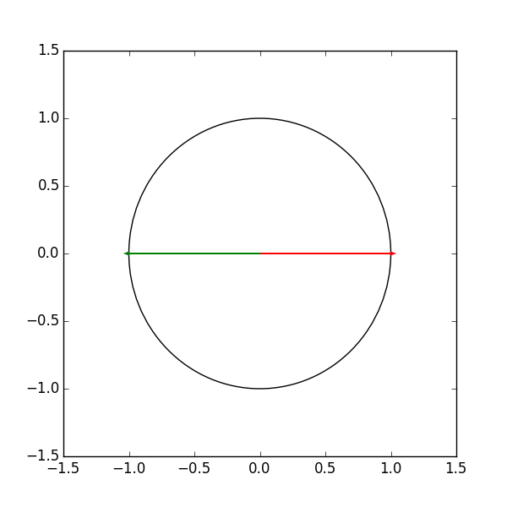

N = 4:

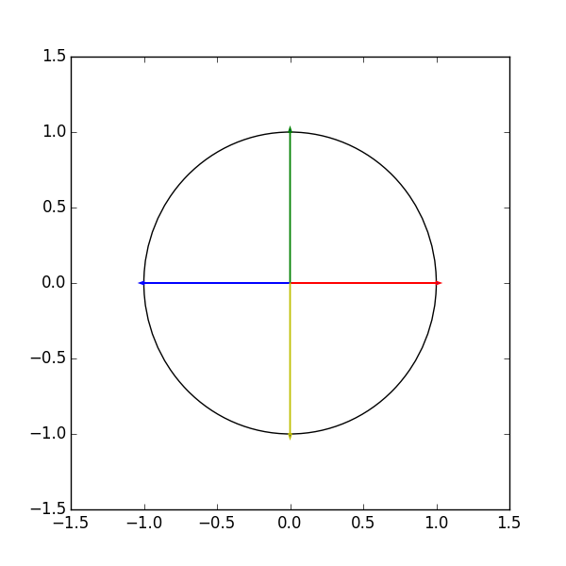

N = 8:

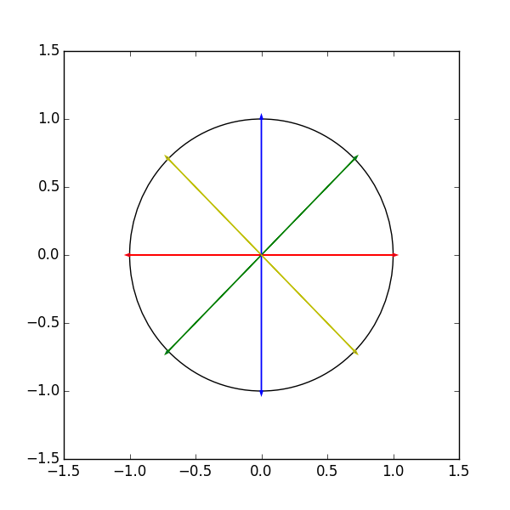

N = 16:

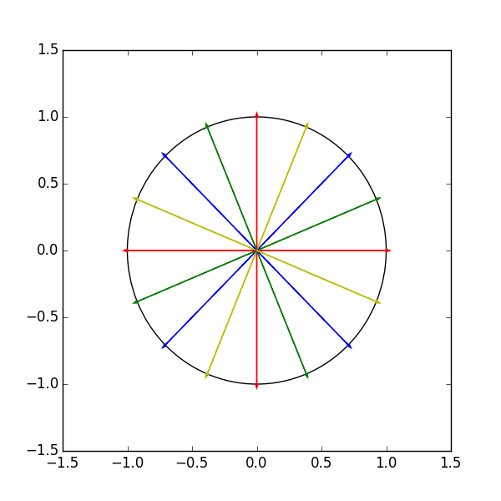

N = 32:

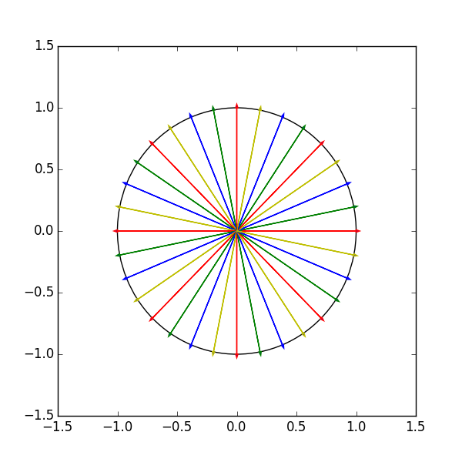

* 1. For each complex root in each output (N=2, N=4, N=8, etc…), we can clearly see that there exists both a positive and negative value for the same root. Below, I have attached my data, proving these results. The green denotes all of the positive values and the yellow denotes the corresponding negative values.

Roots 2:

1.00000 + 0.00000i

-1.00000 + 0.00000i

Roots 4:

1.00000 + 0.00000i

0.00000 + 1.00000i

-1.00000 + 0.00000i

-0.00000 + -1.00000i

Roots 8:

1.00000 + 0.00000i

0.70711 + 0.70711i

0.00000 + 1.00000i

-0.70711 + 0.70711i

-1.00000 + 0.00000i

-0.70711 + -0.70711i

-0.00000 + -1.00000i

0.70711 + -0.70711i

etc…

c. If you start at any number, and move forward 8 number of positions, then the previous 8 roots will be e

1. Exploring the discrete Fourier transform:
   1. When I ran my Fourier generation algorithm against inputs N=2, N=4, N=8, I obtained the following matrices. Although the formatting for the N=8 matrix is not as “pretty” as the others, this is because Python could not print it to the window size. However, the values are correct and were tested against octave.

F:2

[[ 1.+0.j 1.+0.j]

[ 1.+0.j -1.+0.j]]

F:4

[[ 1.+0.j 1.+0.j 1.+0.j 1.+0.j]

[ 1.+0.j 0.-1.j -1.+0.j 0.+1.j]

[ 1.+0.j -1.+0.j 1.+0.j -1.+0.j]

[ 1.+0.j 0.+1.j -1.+0.j 0.-1.j]]

F:8

[[ 1.00000000e+00+0.j 1.00000000e+00+0.j 1.00000000e+00+0.j

1.00000000e+00+0.j 1.00000000e+00+0.j 1.00000000e+00+0.j

1.00000000e+00+0.j 1.00000000e+00+0.j ]

[ 1.00000000e+00+0.j 7.07106781e-01-0.70710678j

0.00000000e+00-1.j -7.07106781e-01-0.70710678j

-1.00000000e+00+0.j -7.07106781e-01+0.70710678j

0.00000000e+00+1.j 7.07106781e-01+0.70710678j]

[ 1.00000000e+00+0.j -8.26946080e-16-1.j -1.00000000e+00+0.j

8.26946080e-16+1.j 1.00000000e+00+0.j -8.26946080e-16-1.j

-1.00000000e+00+0.j 8.26946080e-16+1.j ]

[ 1.00000000e+00+0.j -7.07106781e-01-0.70710678j

0.00000000e+00+1.j 7.07106781e-01-0.70710678j

-1.00000000e+00+0.j 7.07106781e-01+0.70710678j

0.00000000e+00-1.j -7.07106781e-01+0.70710678j]

[ 1.00000000e+00+0.j -1.00000000e+00+0.j 1.00000000e+00+0.j

-1.00000000e+00+0.j 1.00000000e+00+0.j -1.00000000e+00+0.j

1.00000000e+00+0.j -1.00000000e+00+0.j ]

[ 1.00000000e+00+0.j -7.07106781e-01+0.70710678j

0.00000000e+00-1.j 7.07106781e-01+0.70710678j

-1.00000000e+00+0.j 7.07106781e-01-0.70710678j

0.00000000e+00+1.j -7.07106781e-01-0.70710678j]

[ 1.00000000e+00+0.j 8.26946080e-16+1.j -1.00000000e+00+0.j

-8.26946080e-16-1.j 1.00000000e+00+0.j 8.26946080e-16+1.j

-1.00000000e+00+0.j -8.26946080e-16-1.j ]

[ 1.00000000e+00+0.j 7.07106781e-01+0.70710678j

0.00000000e+00+1.j -7.07106781e-01+0.70710678j

-1.00000000e+00+0.j -7.07106781e-01-0.70710678j

0.00000000e+00-1.j 7.07106781e-01-0.70710678j]]

Entire Bash Output:

(FourierTransformation)grantmcgovern@gMAC:~/Dropbox/Developer/Projects/CSC222/FourierTransformation(FourierTransformation)grantmcgovern@gMAC:~/Dropbox/Developer/Projects/CSC222/FourierTransformat$ python lab3.py

Roots 2:

1.00000 + 0.00000i

-1.00000 + 0.00000i

Roots 4:

1.00000 + 0.00000i

0.00000 + 1.00000i

-1.00000 + 0.00000i

-0.00000 + -1.00000i

Roots 8:

1.00000 + 0.00000i

0.70711 + 0.70711i

0.00000 + 1.00000i

-0.70711 + 0.70711i

-1.00000 + 0.00000i

-0.70711 + -0.70711i

-0.00000 + -1.00000i

0.70711 + -0.70711i

Roots 16:

1.00000 + 0.00000i

0.92388 + 0.38268i

0.70711 + 0.70711i

0.38268 + 0.92388i

0.00000 + 1.00000i

-0.38268 + 0.92388i

-0.70711 + 0.70711i

-0.92388 + 0.38268i

-1.00000 + 0.00000i

-0.92388 + -0.38268i

-0.70711 + -0.70711i

-0.38268 + -0.92388i

-0.00000 + -1.00000i

0.38268 + -0.92388i

0.70711 + -0.70711i

0.92388 + -0.38268i

Roots 32:

1.00000 + 0.00000i

0.98079 + 0.19509i

0.92388 + 0.38268i

0.83147 + 0.55557i

0.70711 + 0.70711i

0.55557 + 0.83147i

0.38268 + 0.92388i

0.19509 + 0.98079i

0.00000 + 1.00000i

-0.19509 + 0.98079i

-0.38268 + 0.92388i

-0.55557 + 0.83147i

-0.70711 + 0.70711i

-0.83147 + 0.55557i

-0.92388 + 0.38268i

-0.98079 + 0.19509i

-1.00000 + 0.00000i

-0.98079 + -0.19509i

-0.92388 + -0.38268i

-0.83147 + -0.55557i

-0.70711 + -0.70711i

-0.55557 + -0.83147i

-0.38268 + -0.92388i

-0.19509 + -0.98079i

-0.00000 + -1.00000i

0.19509 + -0.98079i

0.38268 + -0.92388i

0.55557 + -0.83147i

0.70711 + -0.70711i

0.83147 + -0.55557i

0.92388 + -0.38268i

0.98079 + -0.19509i

F:2

[[ 1.+0.j 1.+0.j]

[ 1.+0.j -1.+0.j]]

F:4

[[ 1.+0.j 1.+0.j 1.+0.j 1.+0.j]

[ 1.+0.j 0.-1.j -1.+0.j 0.+1.j]

[ 1.+0.j -1.+0.j 1.+0.j -1.+0.j]

[ 1.+0.j 0.+1.j -1.+0.j 0.-1.j]]

F:8

[[ 1.00000000e+00+0.j 1.00000000e+00+0.j 1.00000000e+00+0.j

1.00000000e+00+0.j 1.00000000e+00+0.j 1.00000000e+00+0.j

1.00000000e+00+0.j 1.00000000e+00+0.j ]

[ 1.00000000e+00+0.j 7.07106781e-01-0.70710678j

0.00000000e+00-1.j -7.07106781e-01-0.70710678j

-1.00000000e+00+0.j -7.07106781e-01+0.70710678j

0.00000000e+00+1.j 7.07106781e-01+0.70710678j]

[ 1.00000000e+00+0.j -8.26946080e-16-1.j -1.00000000e+00+0.j

8.26946080e-16+1.j 1.00000000e+00+0.j -8.26946080e-16-1.j

-1.00000000e+00+0.j 8.26946080e-16+1.j ]

[ 1.00000000e+00+0.j -7.07106781e-01-0.70710678j

0.00000000e+00+1.j 7.07106781e-01-0.70710678j

-1.00000000e+00+0.j 7.07106781e-01+0.70710678j

0.00000000e+00-1.j -7.07106781e-01+0.70710678j]

[ 1.00000000e+00+0.j -1.00000000e+00+0.j 1.00000000e+00+0.j

-1.00000000e+00+0.j 1.00000000e+00+0.j -1.00000000e+00+0.j

1.00000000e+00+0.j -1.00000000e+00+0.j ]

[ 1.00000000e+00+0.j -7.07106781e-01+0.70710678j

0.00000000e+00-1.j 7.07106781e-01+0.70710678j

-1.00000000e+00+0.j 7.07106781e-01-0.70710678j

0.00000000e+00+1.j -7.07106781e-01-0.70710678j]

[ 1.00000000e+00+0.j 8.26946080e-16+1.j -1.00000000e+00+0.j

-8.26946080e-16-1.j 1.00000000e+00+0.j 8.26946080e-16+1.j

-1.00000000e+00+0.j -8.26946080e-16-1.j ]

[ 1.00000000e+00+0.j 7.07106781e-01+0.70710678j

0.00000000e+00+1.j -7.07106781e-01+0.70710678j

-1.00000000e+00+0.j -7.07106781e-01-0.70710678j

0.00000000e+00-1.j 7.07106781e-01-0.70710678j]]

F^-1:

[[ 1.25000000e-01 +1.36487447e-18j 1.25000000e-01 +6.93889390e-17j

1.25000000e-01 +2.77555756e-17j 1.25000000e-01 +5.55111512e-17j

1.25000000e-01 +4.34913699e-17j 1.25000000e-01 -1.38777878e-16j

1.25000000e-01 -6.93889390e-17j 1.25000000e-01 +4.16333634e-17j]

[ 1.25000000e-01 -4.16333634e-17j 8.83883476e-02 +8.83883476e-02j

-6.93889390e-17 +1.25000000e-01j -8.83883476e-02 +8.83883476e-02j

-1.25000000e-01 -1.38777878e-17j -8.83883476e-02 -8.83883476e-02j

4.16333634e-17 -1.25000000e-01j 8.83883476e-02 -8.83883476e-02j]

[ 1.25000000e-01 +9.81307787e-18j -4.90653893e-18 +1.25000000e-01j

-1.25000000e-01 -1.96261557e-17j -7.35980840e-17 -1.25000000e-01j

1.25000000e-01 +4.90653893e-18j 4.90653893e-17 +1.25000000e-01j

-1.25000000e-01 +9.81307787e-18j 4.90653893e-18 -1.25000000e-01j]

[ 1.25000000e-01 +0.00000000e+00j -8.83883476e-02 +8.83883476e-02j

8.83177008e-17 -1.25000000e-01j 8.83883476e-02 +8.83883476e-02j

-1.25000000e-01 +0.00000000e+00j 8.83883476e-02 -8.83883476e-02j

-1.47196168e-16 +1.25000000e-01j -8.83883476e-02 -8.83883476e-02j]

[ 1.25000000e-01 +1.96261557e-17j -1.25000000e-01 +1.96261557e-17j

1.25000000e-01 +3.92523115e-17j -1.25000000e-01 -9.81307787e-18j

1.25000000e-01 -9.81307787e-18j -1.25000000e-01 -2.94392336e-17j

1.25000000e-01 +1.96261557e-17j -1.25000000e-01 -0.00000000e+00j]

[ 1.25000000e-01 +1.67519718e-17j -8.83883476e-02 -8.83883476e-02j

-1.25639788e-16 +1.25000000e-01j 8.83883476e-02 -8.83883476e-02j

-1.25000000e-01 -5.02559153e-17j 8.83883476e-02 +8.83883476e-02j

1.08887817e-16 -1.25000000e-01j -8.83883476e-02 +8.83883476e-02j]

[ 1.25000000e-01 -5.92271642e-18j -2.36908657e-17 -1.25000000e-01j

-1.25000000e-01 +1.77681493e-17j 2.96135821e-17 +1.25000000e-01j

1.25000000e-01 +5.92271642e-18j -5.92271642e-18 -1.25000000e-01j

-1.25000000e-01 -1.18454328e-17j -1.77681493e-17 +1.25000000e-01j]

[ 1.25000000e-01 +0.00000000e+00j 8.83883476e-02 -8.83883476e-02j

8.83177008e-17 -1.25000000e-01j -8.83883476e-02 -8.83883476e-02j

-1.25000000e-01 +1.96261557e-17j -8.83883476e-02 +8.83883476e-02j

-1.07943857e-16 +1.25000000e-01j 8.83883476e-02 +8.83883476e-02j]]

Identity Matrix Check

[[ 1.00000000e+00 +5.39260384e-33j -1.38777878e-17 +2.77555756e-17j

1.89287618e-17 +0.00000000e+00j 0.00000000e+00 +0.00000000e+00j

0.00000000e+00 +0.00000000e+00j 1.38777878e-17 +0.00000000e+00j

3.08340215e-17 +0.00000000e+00j 1.38777878e-17 +1.38777878e-17j]

[ 4.38400669e-17 -4.56681599e-17j 1.00000000e+00 +3.46944695e-17j

1.25129133e-17 +6.93889390e-18j 1.17961196e-16 +2.63677968e-16j

8.02181944e-17 +1.76172183e-16j -2.08166817e-17 -2.56739074e-16j

5.48436707e-17 -2.08166817e-17j 2.22044605e-16 +9.02056208e-17j]

[ -3.25354341e-17 +4.48562444e-17j 1.00486722e-16 +1.07318844e-16j

1.00000000e+00 +2.70569826e-17j 1.15635167e-16 +1.48952207e-16j

3.49164861e-17 -4.90653893e-18j -1.53619885e-17 -1.21196632e-16j

1.11022302e-16 -3.99185929e-17j 1.08441793e-16 +7.30923976e-17j]

[ -8.47760363e-17 +9.14559737e-18j 2.77555756e-17 +1.04083409e-16j

1.36487447e-18 -4.85722573e-17j 1.00000000e+00 -2.08166817e-17j

5.44949737e-17 +2.75812271e-17j 1.66533454e-16 -2.08166817e-17j

4.23008439e-17 -2.08166817e-17j 4.16333634e-17 +4.16333634e-17j]

[ -4.16333634e-17 +4.97627833e-17j 2.77555756e-17 +1.38777878e-16j

5.04601773e-17 +1.38777878e-16j 0.00000000e+00 -2.77555756e-17j

1.00000000e+00 +8.90150948e-17j 2.77555756e-17 -1.11022302e-16j

2.18966159e-16 -1.11022302e-16j 1.24900090e-16 +2.77555756e-17j]

[ 2.92648851e-17 +3.69011730e-17j 1.73472348e-16 +3.46944695e-17j

-2.63907011e-17 -6.93889390e-18j 0.00000000e+00 +5.55111512e-17j

2.87717531e-17 -1.74348493e-19j 1.00000000e+00 -8.32667268e-17j

5.61786317e-17 -1.45716772e-16j 9.71445147e-17 -3.46944695e-17j]

[ 3.25354341e-17 -1.06549069e-17j 5.79173120e-17 +8.69701854e-17j

1.11022302e-16 +1.10674805e-16j 1.16571213e-16 +7.30923976e-17j

1.87128119e-16 +5.06046123e-17j -1.11570457e-16 -4.61670456e-16j

1.00000000e+00 -5.55422637e-17j 1.07505747e-16 +7.95632683e-17j]

[ 8.10600234e-17 -7.34237355e-17j 0.00000000e+00 +2.08166817e-17j

1.09657428e-16 +4.85722573e-17j 0.00000000e+00 -4.85722573e-17j

5.85596837e-17 +9.63872937e-18j -2.01227923e-16 -7.63278329e-17j

-2.84230561e-17 -2.01227923e-16j 1.00000000e+00 +8.32667268e-17j]]

[ 1.67841000e+05 +0.j -1.96611299e+04+3761.75850266j

-6.27441742e+01+8612.04949857j ..., -1.26833947e+04 +156.98038805j

-6.27441742e+01-8612.04949857j -1.96611299e+04-3761.75850266j]

Displaying Frequency Graph...

Result:

Matrices Equivalent: True