30038637

smtafe

Practical-JavaTwo

# Activity 3

## o Keep record of debugging process as you develop this program.

## Provide a screenshot as an evidence of this process.

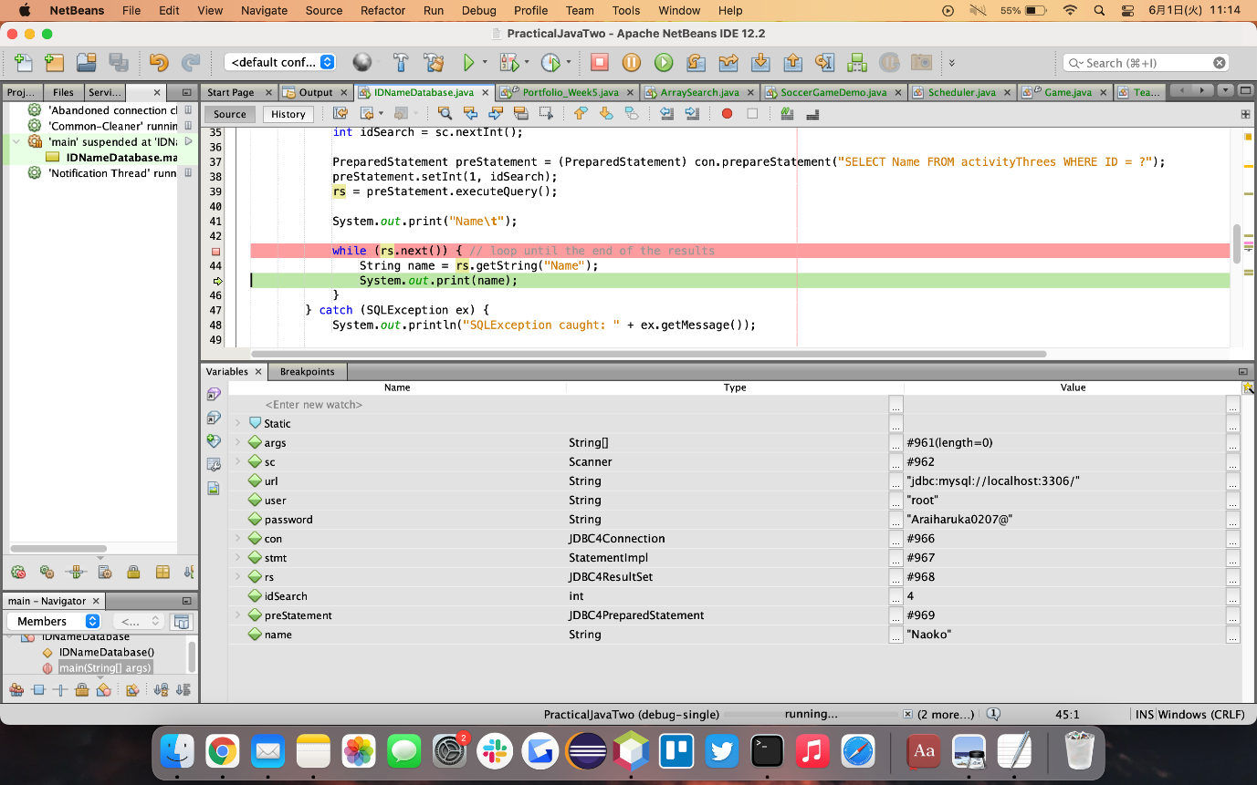

## o Write a test documentation of this program.

## Include sample user inputs and the results.

|  |  |  |  |
| --- | --- | --- | --- |
| # | Input to the question  (Enter an id for searching name from table activityThrees) | Actual output | Comment Fig |
| #1 | (ID = )3 | (Name = )Hideo | Fig1 |
| #2 | 6 | Shohei | Fig2 |
| #3 | 10 | Tanaka | Fig3 |
| #４ | 2 | Shota | Fig4 |

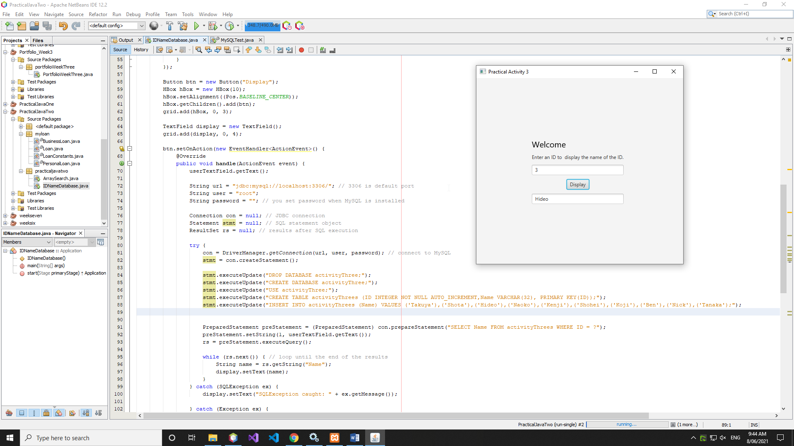

Figure

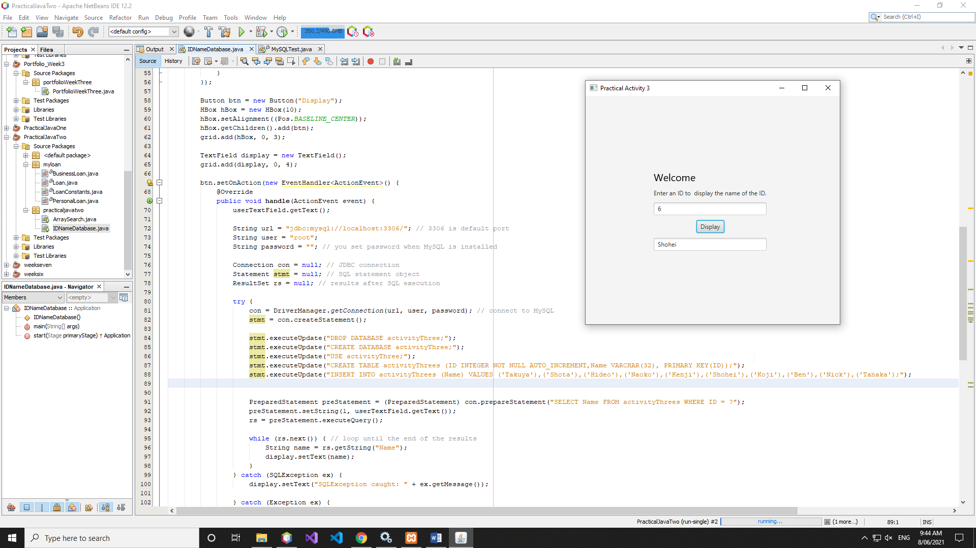

Figure

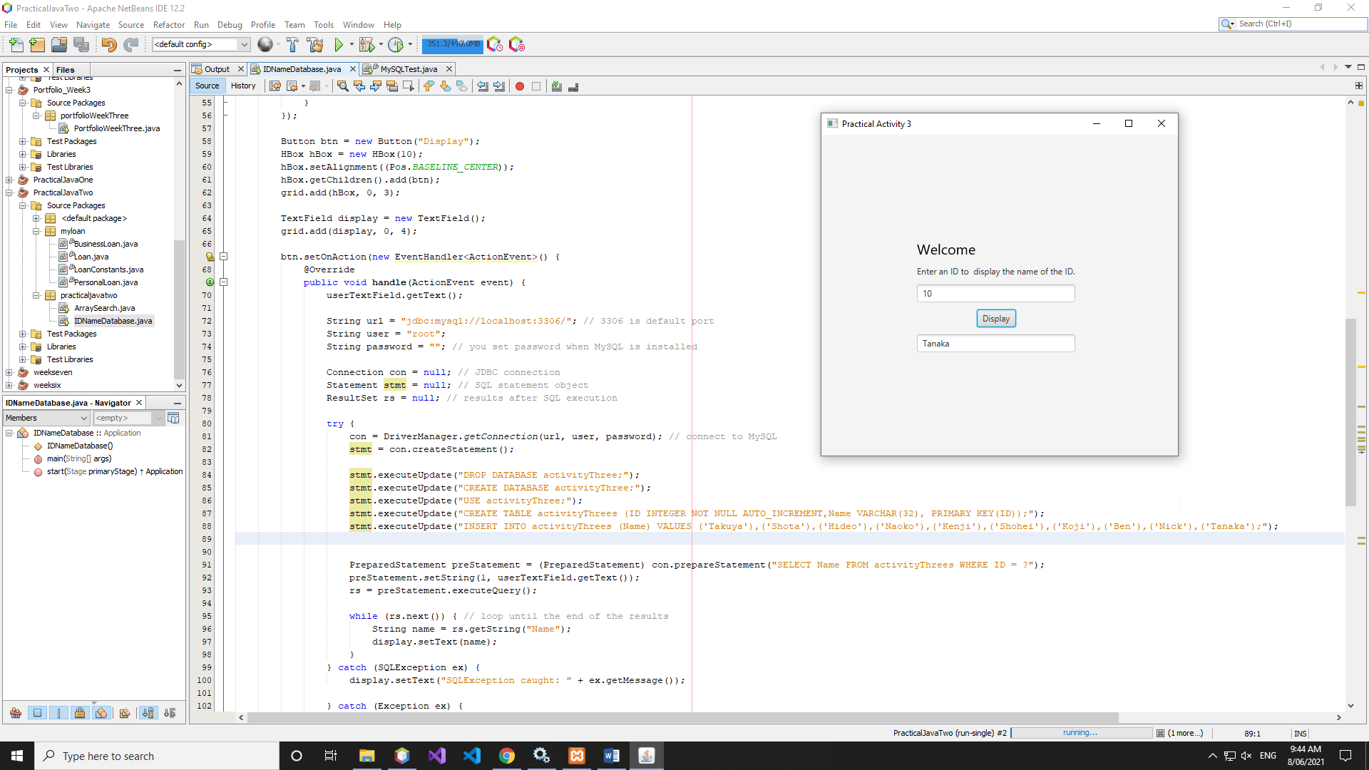

Figure

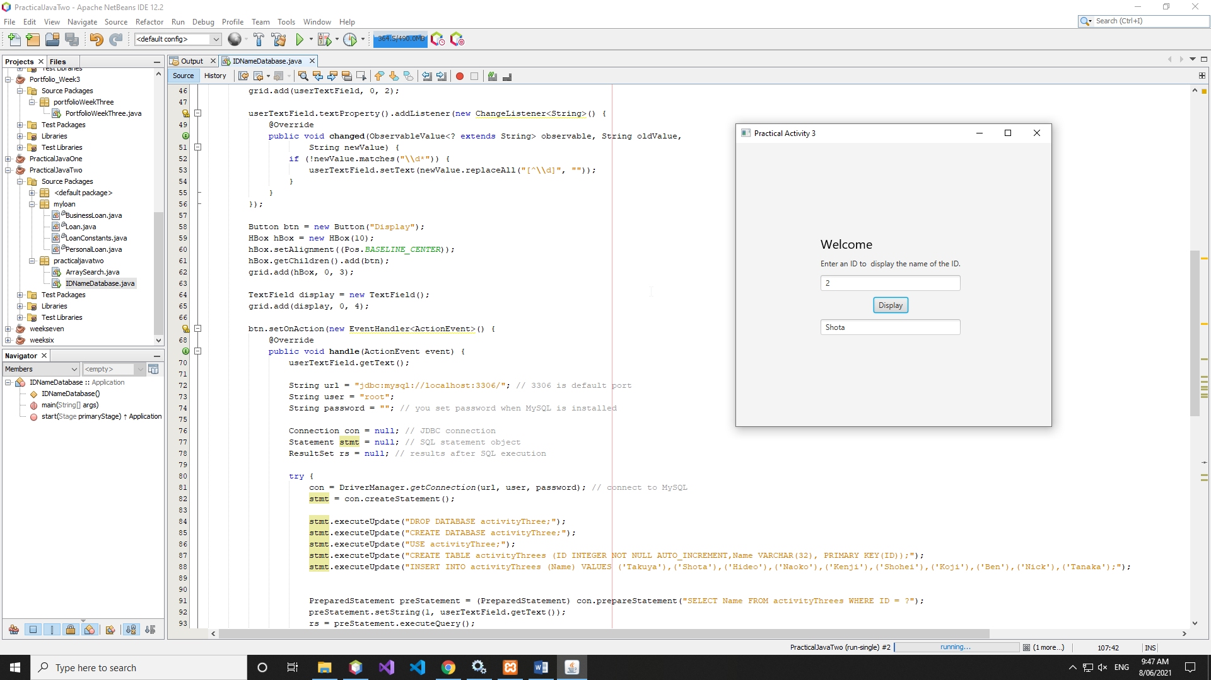

Figure

## o Assess the performance of your program with NetBeans Profiler.

## Provide a screenshot as an evidence of this process.

