Takuya Hasama, Koji Tanaka, Kin Tang
CITE Managed Services
Project Assessment Task Two
Sprint One-Three

Sprint One

Introduction
CITE Managed Services develops software for a range of clients and from time to time they will utilize external contractors when appropriate. Your team has been employed to implement a Movie Database for Acme Entertainment Pty Ltd. The team will be using a sprint workflow to develop each set of user requirements, your lecturer will act as the Product Owner and liaison Consultant for CITE Managed Services.
Team Name International
Scrum Master (1st team leader) Takuya Hasama
Team Member (#2) Koji Tanaka
Team Member (#3) Kin Tang

Software Development Testing Plan

Analysis Report

CITE business rules for software development

CITE Managed Services Quality Assurance

Acme Entertainment Pty Ltd development requirements

Multi-Platform Report

Sprint Two

Sprint Three

Source Control Snapshot
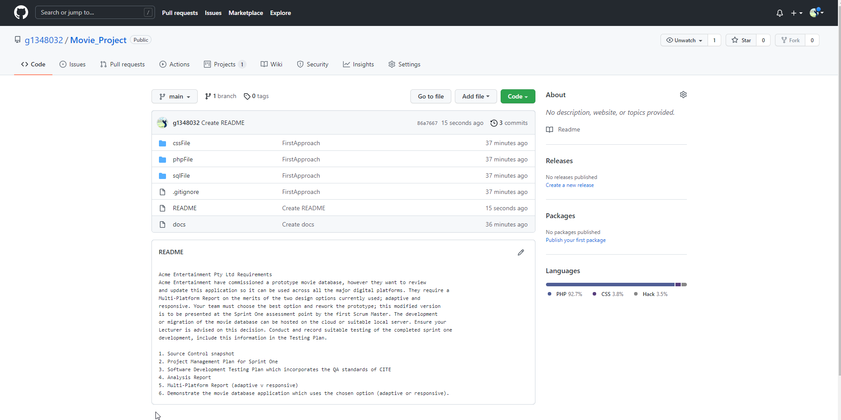

Project Management Plan
