Analysis documentation

CITE business rules for software development
Policy statement
All software developed in-house which runs on production systems must be developed according to the SDLC. This methodology ensures that the software will be adequately documented and tested before it is used for sensitive client information.
All enterprise-level project must adhere to coding standards and procedures documented CITE MS. There must be a separation between the production, development and test environments.
Where these distinctions have been established, development and test staff must not be permitted to have access to production systems.

Development Methodology
Agile for Distributed Development
Reasons why agile methodology is adopted by are as follows:
- The Agile framework maintains a customer focus and affirms that all remote teams will deliver the highest-priority features first.
- Sprint reviews ensure that the delivered features are reviewed and that feedback is shared.
- Continuous integration creates frequent integration points between all remote teams, facilitating problem resolution as issues arise.
- Test driven development supports the simplest design with good test coverage, and assures that no additional features are created which were not requested by the Product Owner.
- Refactoring strengthens evolutionary design and helps teams resolve the architectural issue.

Distributed Scrum Models
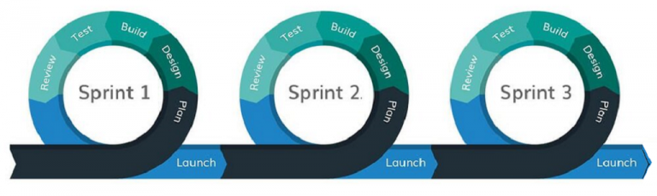

Isolated Scrums:
Overall, most teams are isolated across different locations.
Distributed Scrums of Scrums:
Cross-functional Scrum teams are isolated across locations and integrated by a Scrum of Scrums that meets.
Totally Integrated Scrums:
Scrum team members are distributed across locations.

Coding standard
All systems and projects will be covered by ISO/IEC/IEEE 12207:2017 Systems and software engineering — Software life cycle processes.
Basic standards of the coding standards are as follows:
- Naming conventions
- File Naming and Organization
- Formatting and Indentation
- Comments and documentation
- Classes, Functions and Interfaces
- Testing

User Interface Development
The user interface is one of the most important elements of making application, which can differentiate the product from competitors. The main goal of creating UX design is that creating solutions that are directly related to the business strategy which will create a holistic and optimized user experience for the user. In software development processes, following aspects need to be covered.
- Visibility of system status.
Users should always be informed of system operations with easy to understand and highly visible status displayed on the screen within a reasonable amount of time.

- Match between system and the real world.
Designers should endeavor to mirror the language and concepts users would find in the real world based on who their target users are. Presenting information in logical order and piggybacking on user’s expectations derived from their real-world experiences will reduce cognitive strain and make systems easier to use.

- User control and freedom.
Offer users a digital space where backward steps are possible, including undoing and redoing previous actions.

- Consistency and standards.
Interface designers should ensure that both the graphic elements and terminology are maintained across similar platforms. For example, an icon that represents one category or concept should not represent a different concept when used on a different screen.

- Error prevention.
Whenever possible, design systems so that potential errors are kept to a minimum. Users do not like being called upon to detect and remedy problems, which may on occasion be beyond their level of expertise. Eliminating or flagging actions that may result in errors are two possible means of achieving error prevention.

- Recognition rather than recall.
Minimize cognitive load by maintaining task-relevant information within the display while users explore the interface.

- Flexibility and efficiency of use.
With increased use comes the demand for less interactions that allow faster navigation. This can be achieved by using abbreviations, function keys, hidden commands and macro facilities. Users should be able to customize or tailor the interface to suit their needs so that frequent actions can be achieved through more convenient means.

- Aesthetic and minimalist design.
Keep clutter to a minimum. All unnecessary information competes for the user's limited attentional resources, which could inhibit user’s memory retrieval of relevant information. Therefore, the display must be reduced to only the necessary components for the current tasks, whilst providing clearly visible and unambiguous means of navigating to other content.

- Help users recognize, diagnose and recover from errors.
Designers should assume users are unable to understand technical terminology, therefore, error messages should almost always be expressed in plain language to ensure nothing gets lost in translation.

- Help and documentation.
Ideally, we want users to navigate the system without having to resort to documentation. However, depending on the type of solution, documentation may be necessary. When users require help, ensure it is easily located, specific to the task at hand and worded in a way that will guide them through the necessary steps towards a solution to the issue they are facing.

(Wong, 2020)

CITE Managed Services Quality Assurance
CITE Managed Services has implemented a Quality Management System (QMS) comprising a complex set of engineering and managerial activities.
There are four objectives on Quality Management System:
- Elaboration and implementation of procedures and regulations for software development process based on industry standards and best practices
- Product lifecycle monitoring to ensure compliance with established processes and guidelines
- Product quality verification and validation to ensure that it complies with clients’ business needs and expectations;
- Establishment of an effective collaboration between all project team members.

Comprehensive Approach to Quality
To secure the quality, three steps are implemented:
Quality planning
Quality plans are created, and it governs standards, regulations, procedure, guidelines and tools that are used in the life cycle.
Quality assurance
This assurance evaluates project performance that complies with customer requirements.
Quality control
Performance trends are measured to find defective pieces of code and correct them.

To improve the quality, QA department in the CITE Managed Service covers multiple aspects of the quality, and they implement following tests:
- Functional and Regression Testing;
- GUI and Usability Testing;
- Accessibility Testing;
- Compatibility Testing;
- Performance Testing;
- Installation / Configuration Testing;
- System / Integration Testing;
- Security Testing;
- Internationalization / Localization Testing;
- User Acceptance Testing (UAT).

Acme Entertainment Pty Ltd development requirements
Development requirements
Develop the application. The application must:
- Have a search form, searchable by the title, genre, rating and year. For example, Search movies by genre (Comedy or SciFi) with Rating (PG) in 1995 or search movies by title with genre, or search by title only.
- Display the full details of each movie found. If no movie is found, the application will display a user-friendly message.
- Have an option to display a chart image of top 10 most frequently searched movies.

