We talked about the dynamic interplay between planning and execution I the midst of motor learning. so the interesting findings are as follows:

1. **Finding**: Execution time is longer in smaller window sizes   
   **Meaning**: more information leads to better

**Question**: does this improvement happen in better planning or better execution

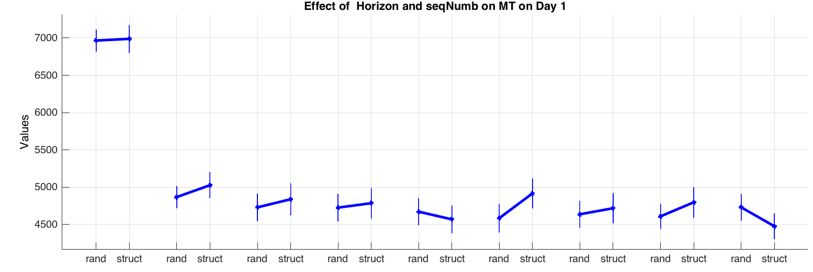

1. **Finding**: Towards begging where the effect of learning is minimal, this effective window size is 3 for both random and learnt sequences.   
   **Meaning**: seeing up to 3 digits ahead of the press position helps with better performance   
   **Question**: does this help with planning or execution (could be answered in 3)
2. **Finding**: Interestingly reaction time increases up to horizon size 3 on day 1  
   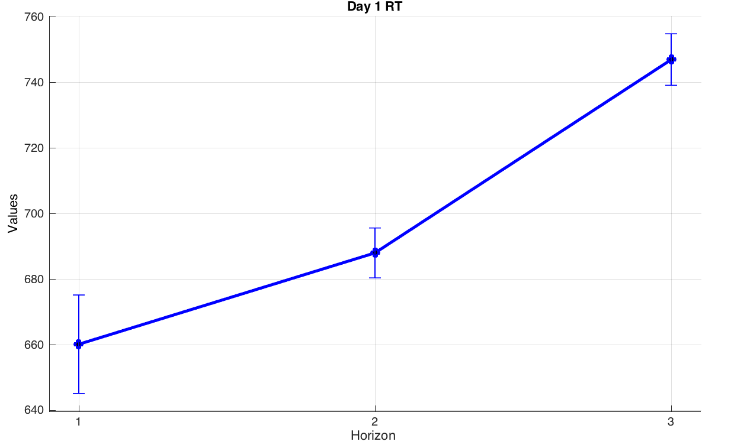

**Meaning** : they take time to plan up to 3 digits ahead

1. **Finding**: with learning movement becomes faster in both random and structured seqs. For Random sequences, this effect is significant in all horizon sizes, except 1. For structured it is significant even in horizon 1

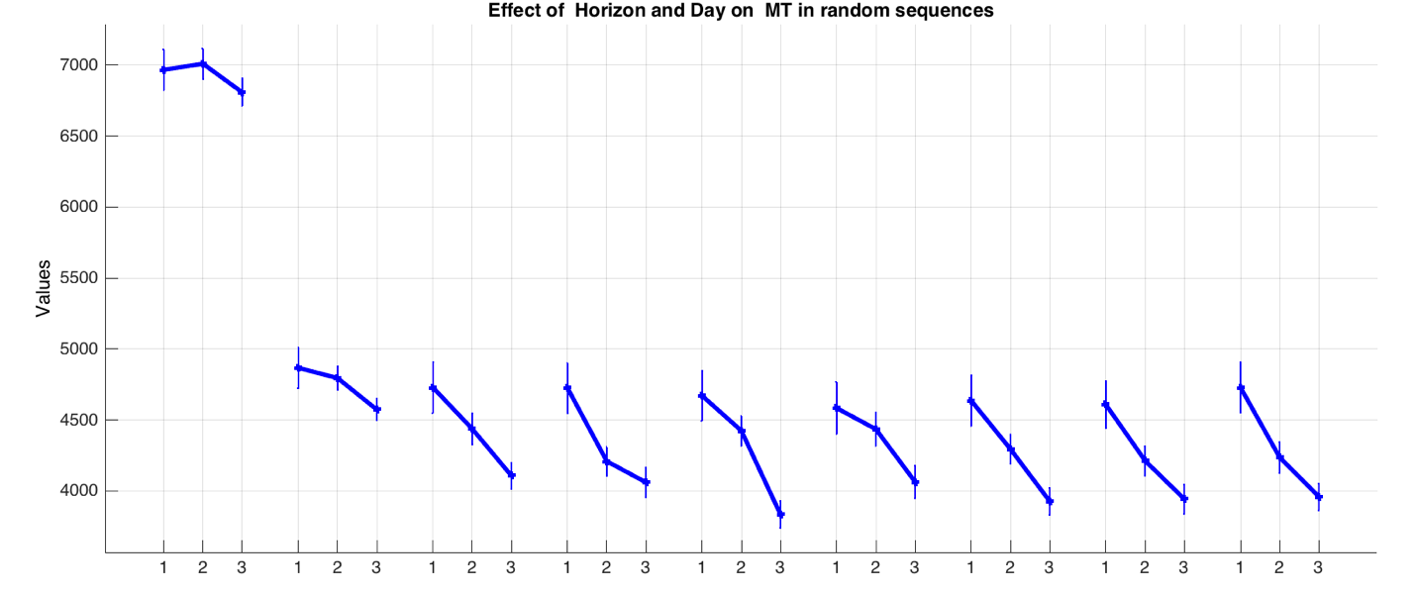  
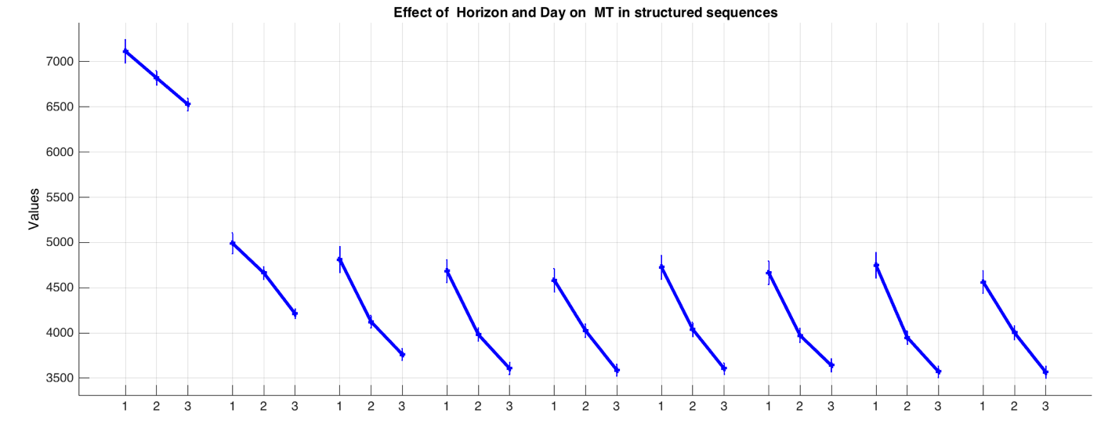

**Meaning**: Mapping learning is not simply what we think of as learning to map digits to numbers.

**Question**: what is the type of interaction between

1. **Finding**: with learning structured sequences become significantly faster than structured sequences except in horizon 1  
   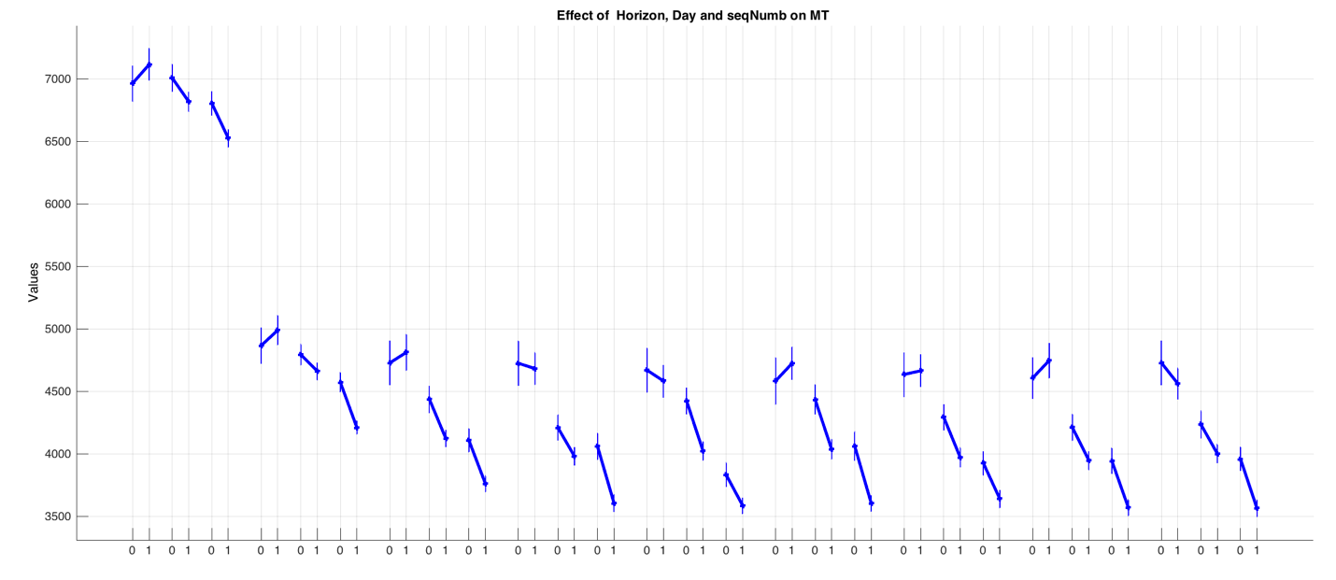  
     
   **Meaning**: sufficient information is necessary to benefit from learning
2. **Finding**: for random sequences the effective horizon size increases to 4 on days 4 5, whereas for structured sequences this number stays constant
3. **Finding**: interestingly the RT too keeps significantly increasing till horizon 4 on days 4 5 in random sequences
4. **Finding**: interestingly the RT too keeps significantly increasing till horizon 2 on days 4 5 in structured sequences
5. We decided to not talk about planning vs execution
6. The paper is going to be focused on random sequences
7. The model is going to be discussed to the extent that it helps explain the random sequences
8. For the trained sequences that data is going to be shown but without the modeling part
9. The training model + associative / chunking model is going to be another paper.
10. Regarding the first finding, in terms of the difference between H1 and H2, you cant make any inferences re: the difference in MT is due to planning. Or on the fact that the motor system plans more than one ahead. This is bcz you get discounted on at least visual processing time since the stimulus is in your foveal region regardless of whether you plan it or not. So even if you don’t plan it, you still see it.   
    so to make that point you need to show that the 2 and 3 are different.
11. RT is not a clear indication of planning time, bcz at some point they are going to make a decision to start the movement and not waist a lot of time on one trial. So they might start prematurely-prepared. But I think relatively speaking, it can be. So the argument about the RT is that up to H3, the amount of information is still worth it to take the time to plan.
12. We decided that there are two ways in which more information can effect performance. One is that when you plan more ahead, you are faster bcz assuming that there are shared resources for planning and execution, you plan more at the beginning, and then you are faster later.

Note – I made that argument and he agreed, but this would predict that you would only be faster at the beginning and during the steady state all horizons are the same. We see that this is not the case.

1. We decided to have two paragraphs talking about the effect of learning on the increased horizon size in random sequences. One, making it clear that that with training, the MT decreases for all horizon sizes except for H1. Two, making it clear that the effective horizon size increases with training, from H3 to H4 for random sequences and interestingly stays constant for trained sequences.
2. Make a case that in trained sequences the MT keeps decreasing even in H1.
3. Look at the within vs between intervals in H1 to see why it is that the MT keeps decreasing even in H1 for trained sequences but not for random.
4. Poster:

trained

Model

Result

design