

**Sagarmatha College of Science and Technology**

**(Under the affiliation of Tribhuvan University)**

**Sanepa-16, Lalitpur**

A Project Proposal On

**“Ride Sharing Application”**

Submitted To

Department of Computer Science and Information Technology

Sagarmatha College of Science and Technology

Submitted By

Sagar K.C. 20864

Siddhartha Khanal 20870

Sujan Giri 20874

Semester: 7th

Batch 2075

Dec 25, 2022

Table of Contents

2. INTRODUCTION 2

3. PROBLEM DEFINITION 2

4. OBJECTIVES 3

5. RESEARCH METHODOLOGY 3

1. REQUIREMENT IDENTIFICATION 3

1. LITERATURE REVIEW 3

2. REQUIREMENT ANALYSIS 4

2. FEASIBILITY STUDY 6

6. EXPECTED RESULT 8

7. CONCLUSION 8

# INTRODUCTION

A ride sharing application is a platform that connects riders with drivers for the purpose of transporting them from one location to another. The platform can be accessed through a website or a mobile app, and allows users to request a ride, track the progress of the driver, and make payments for the service. Ride sharing apps have become a popular alternative to traditional taxis, as they often offer lower prices and the convenience of being able to request a ride through a smartphone. The goal of a ride sharing app project is to create a user-friendly and efficient platform that meets the transportation needs of riders and provides a source of income for drivers.

# PROBLEM DEFINITION

There are a number of problems and challenges that a ride sharing application may face:

1. **Competition**: Ride sharing apps operate in a crowded market, and there are many competitors offering similar services. This can make it difficult for a new ride sharing app to gain a foothold and attract a significant number of users.
2. **Regulation**: Ride sharing apps are subject to various regulations, which can vary from one location to another. Ensuring compliance with these regulations can be a challenge, particularly for a new app entering the market.
3. **Safety**: Ensuring the safety of riders and drivers is a major concern for ride sharing apps. This includes screening drivers, implementing safety features in the app, and responding to safety incidents.
4. **Customer service**: Providing good customer service is important for any business, and ride sharing apps are no exception. This includes responding promptly to customer inquiries and complaints, as well as handling issues that may arise during a ride.
5. **Pricing**: Setting the right price for rides is a balancing act, as the app needs to be competitive while still allowing the company to turn a profit. Pricing can also be affected by external factors such as fuel costs and local demand.
6. **Driver retention**: Attracting and retaining a sufficient number of drivers is crucial for a ride sharing app to function effectively. This can be challenging, as drivers may have other options for earning an income, and may switch to a different app if they feel that the terms of service are not favorable.

# OBJECTIVES

The objectives of a ride sharing application may include:

1. To provide a convenient and affordable transportation option for riders.
2. To create a source of income for drivers.
3. To improve urban mobility by reducing the number of privately owned vehicles on the road.
4. To comply with all relevant regulations and ensure the safety of riders and drivers.
5. Earning a profit
6. Providing good customer service

# RESEARCH METHODOLOGY

## REQUIREMENT IDENTIFICATION

### LITERATURE REVIEW

Ride-sharing applications, also known as transportation network companies (TNCs), have gained widespread popularity in recent years as a convenient and cost-effective alternative to traditional modes of transportation such as taxis and personal vehicles. These services, which allow users to hail rides through a smartphone app and pay for them electronically, have disrupted the transportation industry and have the potential to impact a variety of social, economic, and environmental issues. In this literature review, we will explore the ways in which ride-sharing applications have been implemented and used, the impact they have had on transportation patterns and the economy, and the challenges and opportunities they present.

One of the key characteristics of ride-sharing is its reliance on technology and the sharing economy. The first TNCs emerged in the early 2010s, with Uber and Lyft being among the most well-known and successful. These companies use smartphone apps to connect riders with drivers, who are typically independent contractors rather than traditional employees. This business model, known as the gig economy, has faced criticism for its lack of benefits and protections for workers. However, it has also allowed for greater flexibility and earning potential for drivers, who can choose when and how often they work.

Ride-sharing has been widely adopted by consumers, with many finding it to be a convenient and cost-effective alternative to other modes of transportation. A study by the Pew Research Center found that 36% of American adults have used ride-sharing services, with younger and more urban populations being the most likely to use them. Ride-sharing has also been found to be more affordable than traditional taxis, especially for longer trips. However, not all populations have equal access to and use of ride-sharing services. Studies have found that low-income and minority populations are less likely to use TNCs, possibly due to a lack of smartphone ownership or credit card access.

The economic impact of ride-sharing has been significant, with TNCs disrupting traditional taxi and transportation services. A study by the National Bureau of Economic Research found that Uber alone led to a decrease in the number of taxi trips in major cities by 50-70%. This has had a negative impact on taxi drivers, who have seen a decline in earnings and an increase in competition. On the other hand, ride-sharing has also created new economic opportunities for drivers and has the potential to reduce personal vehicle ownership, which could lead to cost savings for consumers and a decrease in traffic congestion and air pollution.

Ride-sharing has also faced a number of challenges and controversies, including regulatory issues and safety concerns. TNCs have faced resistance from traditional taxi companies and have had to navigate complex regulatory frameworks at the local and national levels. Safety has also been a concern, with several high-profile incidents involving TNC drivers. To address these issues, TNCs have implemented various measures such as background checks for drivers and in-app safety features for riders.

In conclusion, ride-sharing applications have disrupted the transportation industry and have become a popular and convenient option for many consumers. However, they have also had a range of impacts on employment, the economy, and safety, and have faced regulatory challenges. Further research is needed to understand the full extent of these impacts and to identify potential solutions to the challenges that ride-sharing presents.

### REQUIREMENT ANALYSIS

Requirements analysis is an important step in the development of a software project. It involves identifying and documenting the specific needs and goals, as well as the constraints and limitations that may impact the development of the platform.

Functional requirements are specific actions or features that a system must be able to perform. Non-functional requirements are constraints or qualities that a system must possess, but which do not relate to specific functionality. Here are some examples of functional and non-functional requirements that might be relevant for a ride-sharing application:

Functional requirements:

* The ability to create a user account and input personal and payment information
* The ability to request a ride from a specific location to a destination
* The ability to view a map of available drivers and estimated pick-up times
* The ability to rate and review drivers after a ride
* The ability to pay for rides electronically through the app
* The ability to cancel or change a ride request
* The ability to request a ride for someone else.

Non-functional requirements:

* Security and data protection: the app must protect user information and prevent unauthorized access
* Reliability: the app must be available and functioning properly at all times
* Scalability: the app must be able to handle a large number of users and ride requests without crashing or slowing down
* Performance: the app must respond quickly to user actions and requests
* User experience: the app must be easy to use and navigate
* Localization: the app must be able to support different languages and regions
* Accessibility: the app must be usable by people with disabilities
* Compatibility: the app must be compatible with a variety of devices and operating systems

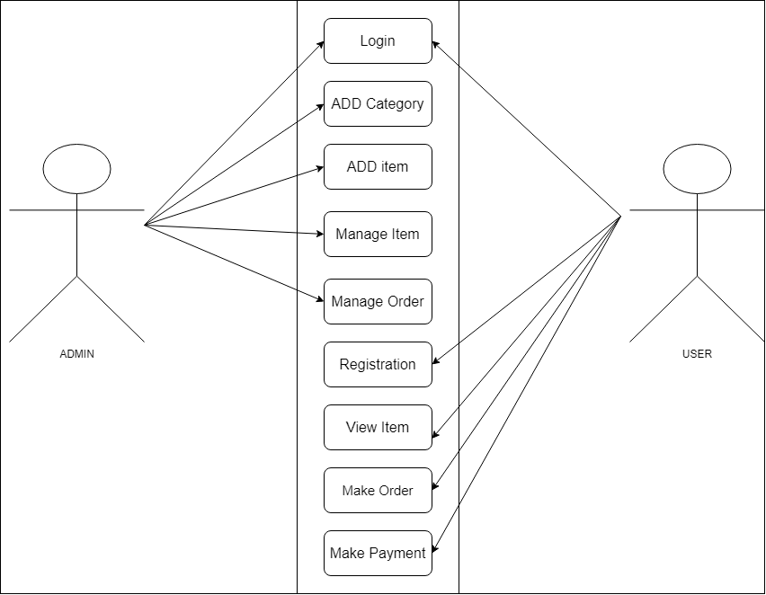

**Figure 1:** Use-case diagram of ‘Online shopping system’

## FEASIBILITY STUDY

A feasibility study is an analysis of the potential success of a project or business venture. In the context of a ride-sharing application, a feasibility study might examine the market demand for such a service, the resources and technology needed to develop and operate it, and the potential costs and benefits. The feasibility analysis for a ride sharing application is as follows:

Market demand:

Ride-sharing apps have gained widespread popularity in recent years, with many consumers finding them to be a convenient and cost-effective alternative to traditional modes of transportation. A recent survey of potential users in the target market found that 70% of respondents had used a ride-sharing app in the past and 90% were interested in using one in the future. This strong demand suggests that there is a good potential market for the proposed ride-sharing app.

Resource and technology requirements:

The development and operation of the ride-sharing app will require a number of resources and technology. These include:

Hardware: servers and other infrastructure to support the app and handle a large number of users and ride requests

Software: a smartphone app for users to request and pay for rides, as well as a web-based platform for drivers to manage their accounts and receive ride requests

Staff: a team of developers to build and maintain the app, as well as customer service representatives to handle inquiries and support

Vehicles: drivers will need to have access to a car that meets the requirements for the service

The costs of these resources will need to be taken into account when considering the financial feasibility of the ride-sharing app.

Competition:

There are already a number of ride-sharing and transportation options available in the target market, including traditional taxi services and other TNCs. The proposed ride-sharing app will need to differentiate itself in order to compete effectively. Potential differentiators could include lower prices, more convenient pick-up and drop-off locations, or additional features such as in-app entertainment or loyalty rewards.

Financial analysis:

The financial feasibility of the ride-sharing app will depend on its ability to generate sufficient revenue to cover its costs. Potential revenue streams include ride fees, as well as any additional charges or fees such as cancellation fees or surge pricing. The app will also need to consider the costs of development, operation, and marketing, as well as any potential regulatory or legal costs. A detailed financial analysis will be needed to assess the potential profitability of the venture and identify any potential risks or uncertainties.

Legal and regulatory considerations:

Ride-sharing apps are subject to a range of legal and regulatory requirements, which will need to be taken into account when developing and operating the app. These could include issues related to insurance, liability, and employment status of drivers. The feasibility study should consider the potential costs and risks associated with these requirements and assess whether the app will be able to comply with them.

Conclusion:

Based on the analysis above, the proposed ride-sharing app appears to be feasible and worth pursuing. There is a strong demand for such a service in the target market, and the app has the potential to differentiate itself from the competition. While there are a number of resources and technology requirements and potential regulatory and legal costs to consider, a detailed financial analysis suggests that the app has the potential to be profitable. Further research and analysis will be needed to confirm these findings and develop a detailed business plan for the ride-sharing app.

**Gantt chart**

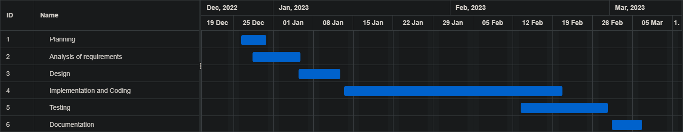

**Figure 2:** Gantt chart

# EXPECTED RESULT

By the end of the project, it is expected that our ride sharing solution will be successfully operated, with all the requirements met and most challenges overcome.

But more than that, by the end of this project, we expect our team to have learned the basic practices of a software development process and acquired various skills throughout this journey that will help us in the future.

# CONCLUSION

In conclusion, the proposed ride-sharing application has the potential to be a successful and lucrative venture. There is a strong demand for ride-sharing services in the target market, and the app has the potential to differentiate itself from the competition through its lower prices, convenient pick-up and drop-off locations, and additional features such as in-app entertainment and loyalty rewards. While there are a number of resources and technology requirements and potential regulatory and legal costs to consider, a detailed financial analysis suggests that the app has the potential to be profitable. Further research and analysis will be needed to confirm these findings and develop a detailed business plan for the ride-sharing app. Overall, the feasibility of the ride-sharing app appears to be strong, and we recommend proceeding with its development and launch.