

**Sagarmatha College of Science and Technology**

**(Under the affiliation of Tribhuvan University)**

**Sanepa-16, Lalitpur**

A Project Proposal On

**“Vivaan Collections”**

Submitted To

Department of Computer Science and Information Technology

Sagarmatha College of Science and Technology

Submitted By

Sagar K.C. 20864

Siddhartha Khanal 20870

Sujan Giri 20874

Semester: 7th

Batch 2075

Dec 25, 2022

Table of Contents

2. INTRODUCTION 2

3. PROBLEM DEFINITION 2

4. OBJECTIVES 3

5. RESEARCH METHODOLOGY 3

1. REQUIREMENT IDENTIFICATION 3

1. LITERATURE REVIEW 3

2. REQUIREMENT ANALYSIS 4

2. FEASIBILITY STUDY 6

6. EXPECTED RESULT 8

7. CONCLUSION 8

# INTRODUCTION

VIVAAN COLLECTION is a women’s wear wholesale store that provides the other shopkeeper to buy clothes like kurtas, Pants, and other items at a wholesale rate. We are located at NBTC Wholesale Complex Khasibazar, Kalanki.

Vivaan collection has been providing services for the last three years and has gotten good reviews from various customers as well.

Our project is an interactive e-commerce solution providing users with an opportunity to buy clothes at an affordable price. Users can select products from multiple renowned brands at the lowest cost possible. For the storage devices, we provide a wide variety in their capacity which enables users to select the appropriate amount that fulfills their needs. So overall users can select the best fit by comparing all the available options.

# PROBLEM DEFINITION

As E-commerce is a trend, there are a lot of websites on the internet which results in a lot of competition among the different e-commerce sites. Users always expect to find the product that they are looking for quickly and easily. There are several reasons hindering the consumer that are involved in online shopping because some of the consumers are not willing to take part in online purchases due to valid reasons such as low quality of products, not being durable, etc.

Some of the core problems are:

#### **Lack of visibility:** Many small e-commerce businesses struggle to get their products in front of potential customers. This problem can be addressed through search engine optimization, social media marketing, and other strategies that help increase visibility and drive traffic to the website.

#### **Competition:** E-commerce businesses must often compete with other companies offering similar products or services. This can be especially challenging for small businesses that may not have the resources or marketing budget of larger competitors.

#### **Customer acquisition**: Attracting and retaining customers is a key challenge for any e-commerce business. This can involve finding ways to differentiate the business from competitors, building a strong brand, and offering excellent customer service.

#### **Payment processing:** E-commerce businesses must have a secure and reliable payment processing system in place to handle transactions from customers. This can involve working with payment gateways, merchant account providers, and other partners to ensure smooth and secure payment processing.

#### **Fulfillment and logistics:** E-commerce businesses must also have a plan in place for fulfilling orders and delivering products to customers. This can involve managing inventory, selecting and working with fulfillment partners, and handling returns and exchanges.

# OBJECTIVES

The proposed system has the following objectives.

* Buying and selling clothes.
* To manage information on different types of items.
* Consistently update information on all the items.
* To manage the Database Efficiently.
* To sell genuine products on time.

# RESEARCH METHODOLOGY

## REQUIREMENT IDENTIFICATION

### LITERATURE REVIEW

E-commerce has rapidly evolved into a major force in the global economy, with online sales accounting for a significant portion of total retail sales in many countries. The history of e-commerce can be traced back to the early days of the internet, when online shopping was first introduced in the 1990s. Since then, the e-commerce industry has undergone significant changes, with the development of new technologies, such as mobile commerce and social media, leading to the growth of new business models and the emergence of new players in the market.

One of the key drivers of e-commerce has been the convenience it offers to consumers, who can shop online from the comfort of their own homes without the need to physically visit a store. In addition, online shopping allows consumers to easily compare prices and browse a wide range of products, which can lead to increased consumer satisfaction. However, concerns about security and privacy, as well as the risk of fraud, have been a barrier to the adoption of e-commerce for some consumers. To address these concerns, e-commerce businesses have implemented a range of security measures, such as encrypted payment systems and fraud detection systems, to protect the privacy and security of their customers.

Marketing and advertising have also played a crucial role in the growth of e-commerce. Online businesses have used a range of strategies, such as search engine optimization (SEO), social media marketing, and email marketing, to attract and retain customers. In addition, the use of data analytics has allowed e-commerce businesses to better understand their customers' needs and preferences and tailor their marketing efforts accordingly.

Despite the many opportunities that e-commerce offers, it also poses significant challenges for businesses. Competition can be intense, with a large number of players in the market vying for a share of the e-commerce pie. In addition, logistical challenges, such as the need for efficient and cost-effective delivery systems, can be a significant barrier to entry for new businesses. Finally, the regulatory environment for e-commerce can vary widely from one country to another, with different rules and regulations governing the sale of goods and services online.

Overall, the e-commerce industry is a rapidly evolving and dynamic sector, with many opportunities and challenges for businesses. Further research is needed to better understand the factors that drive consumer behavior in online shopping, as well as the strategies and tactics that are most effective for marketing and advertising in the digital environment. Additionally, ongoing efforts to address security and privacy concerns, as well as the development of new technologies and business models, will continue to shape the future of e-commerce.

### REQUIREMENT ANALYSIS

Requirements analysis is an important step in the development of an e-commerce business. It involves identifying and documenting the specific needs and goals of the business, as well as the constraints and limitations that may impact the development of the e-commerce platform.

Functional requirements are specific actions or tasks that a system should be able to perform. Non-functional requirements are constraints or qualities that a system should possess. Here are some examples of functional and non-functional requirements for an online shopping system:

Functional requirements:

* Customers should be able to browse and search for products.
* Customers should be able to view product details, including images and descriptions.
* Customers should be able to add items to their shopping cart.
* Customers should be able to view their shopping cart and make changes to the contents.
* Customers should be able to place an order and make a payment.
* Customers should be able to track the status of their orders.
* Customers should be able to rate and review products.
* The system should be able to generate reports on sales, customer behavior, and other relevant metrics.

Non-functional requirements:

* The system should be secure and protect customer data, such as credit card information.
* The system should be user-friendly and easy to navigate.
* The system should be responsive and work well on different devices and browsers.
* The system should be able to handle high traffic and large numbers of concurrent users.
* The system should be scalable and able to handle an increase in the number of products and customers.
* The system should be reliable and have a high uptime.
* The system should be maintainable and easy to update and modify.

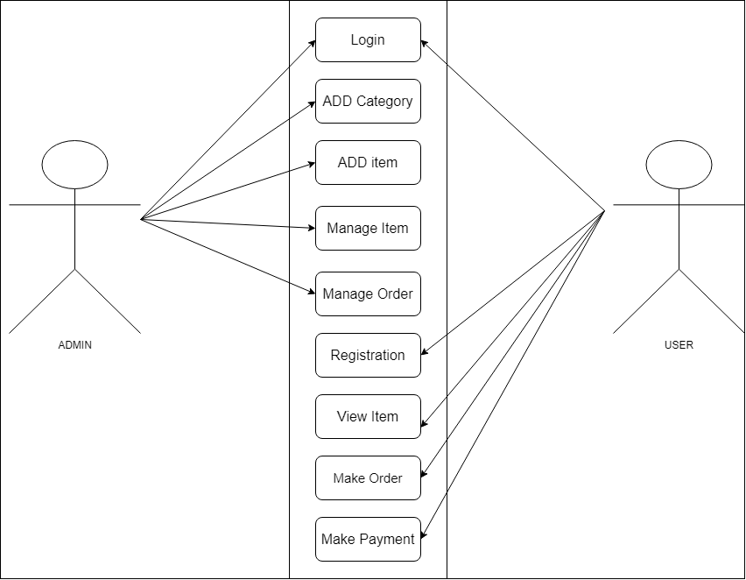

**Figure 1:** Use-case diagram of ‘Online shopping system’

## FEASIBILITY STUDY

A feasibility study is an important step in the development of an e-commerce business, as it helps to assess the viability and potential success of the business concept. A feasibility study can help identify any potential challenges or risks that may impact the development and operation of the e-commerce platform, as well as the resources and strategies needed to overcome them.

There are several key elements that should be considered during a feasibility study for an e-commerce business:

#### **Market analysis**: There is a clear demand for online shopping, with e-commerce sales accounting for a significant portion of total retail sales. A high level of interest suggests that there is a strong potential market for the proposed e-commerce platform.

#### **Technical feasibility**: This project delivers a simple and user-friendly interface to access the system using internet and it doesn’t require any special runtime environment for execution. Tools and technology required for this project are appropriate and available. Thus, this project is technically feasible.

#### **Financial feasibility**: Based on our financial analysis, this project appears to be financially feasible. This project requires small manpower and cost for development. After development, this system requires less maintenance.

#### **Legal feasibility**: E-commerce platforms are subject to a range of legal and regulatory requirements, which will need to be taken into account when developing and operating the platform. These could include issues related to consumer protection, privacy, and data security. The feasibility study should consider the potential costs and risks associated with these requirements and assess whether the platform will be able to comply with them.

#### **Conclusion:** Based on the analysis above, the proposed online shopping e-commerce platform appears to be feasible and worth pursuing. There is a strong demand for such a service in the target market, and the platform has the potential to differentiate itself from the competition through its wide selection of products, competitive pricing, and additional features. While there are a number of resources and technology requirements and potential regulatory and legal costs to consider, a detailed financial analysis suggests that the platform has the potential to be profitable. Further research and analysis will be needed to confirm

**Gantt chart**

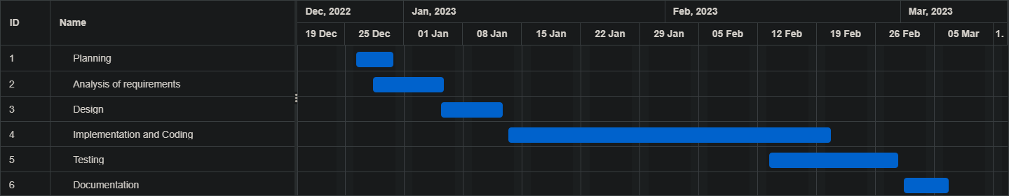

**Figure 2:** Gantt chart

# EXPECTED RESULT

By the end of the project, it is expected that our e-commerce solution will be successfully operated, with all the requirements met and most challenges overcome.

But more than that, by the end of this project, we expect our team to have learned the basic practices of a software development process and acquired various skills throughout this journey that will help us in the future.

# CONCLUSION

The system developed provides a buying clothes through the use of internet. It provides the facility of searching items, adding the items to cart and buying the items. Online Transaction is supported in this applicatoin through which user can pay online or cash on delivery. It also provides facility for users to login into the system through which users can add the products to the cart and make the purchase. Admin can login and provides the dashboard from where admin can visualize all the information regarding total product sale, total number of products, total number of order, total number of order dispatched and many more. Admin can handle everything in the website through the use of admin panel.

# REFERENCES

[1] "E-Commerce: The Role of the Internet in Business" by K.P. Padhy and S.S. Das. This book provides an overview of e-commerce and its impact on businesses.

[2] E-Commerce -Business Models. (2009, May 12). Tutorials Point. https://www.tutorialspoint.com/e_commerce/e_commerce_business_models.htm