DSCI 5260.002
Success Prediction of Bank Telemarketing
A Pre-Call Customer Ranking System Using Machine Learning
Business Analytics Capstone - Final Report



By
Siri Chandana Byreddy | Rakshitha Chattanahalli Mahesh | Hari Krupa Cheguri
Kavya Sree Chittaboina | Jeevan Deep Borugadda
University of North Texas | G. Brint Ryan College of Business
December 2025

Table of Contents
1. Executive Summary 2
1.1 Overview 2
1.2 Key Findings 3
1.3 Recommendations 3
1.4 Expected Business Impact 3
2. Business Understanding 5
2.1 Business Problem Definition 5
2.2 Project Objectives 5
2.3 Success Criteria 6
2.4 Constraints and Assumptions 6
3. Data Understanding 8
3.1 Data Collection and Sources 8
3.2 Target Variable Analysis 8
3.3 Exploratory Data Analysis 8
3.4 Data Quality Assessment 10
3.5 Summary of Data Understanding 10
4. Data Preparation 12
4.1 Leakage Prevention Policy 12
4.2 Sentinel Value Handling 12
4.3 Rare Level Consolidation 12
4.4 Outlier Treatment via Winsorization 13
4.5 Multicollinearity Resolution 13
4.6 Encoding and Scaling 13
4.7 Data Splitting Strategy 14
4.8 Final Dataset Structure 14
5. Modeling 16
5.1 Model Selection Rationale 16
5.2 Hyperparameter Configuration 17
5.3 Class Imbalance Handling 17
5.4 Model Training Process 18
5.5 Model Results - Holdout Evaluation 18
5.6 Rolling Window Evaluation 19
5.7 Statistical Significance Testing 19
6. Evaluation 20
6.1 Performance Against Success Criteria 20
6.2 Comparison to Original Research 20
6.3 Business Impact Analysis 21
6.4 Key Predictive Drivers 22
6.5 Model Robustness Assessment 22
7. Deployment 23
7.1 Deployment Strategy 23
7.2 Model Monitoring Framework 23
7.3 Operational Recommendations 24
7.4 Challenges and Limitations 24
8. Conclusion 26
8.1 Summary of Achievements 26
8.2 Key Findings Recap 26
8.3 Recommendations Summary 27
8.4 Lessons Learned 27
8.5 Future Research Directions 27
8.6 Concluding Remarks 28
9. References 29
Appendix A: Duration-Based Experiments (Upper-Bound Analysis) 30
A.1 Rationale for Duration Analysis 30
A.2 Duration-Inclusive Results 30
A.3 Valid Post-Call Use Cases 30
Appendix B: Modern Macroeconomic Robustness Probe 31
B.1 Methodology 31
B.2 Economic Context Comparison 31
B.3 Robustness Results 31
B.4 Limitations and Caveats 31
Appendix C: Reproducibility and Technical Documentation 32
C.1 Feature Definitions 32
C.2 Preprocessing Specifications 32
C.3 Model Specifications 32
C.4 Recommended A/B Test Design 33
Appendix D: Visualizations and Charts 34
D.1 Data Understanding Visualizations 34
D.2 Model Performance Visualizations 41
D.3 Business Impact Visualizations 45

1. Executive Summary

1.1 Overview
This project addresses an operational challenge faced by a Portuguese banking institution: inefficiency of call-based marketing campaigns for term deposits. With a rejection rate of approximately 89%, the bank's current approach results in a substantial resource waste, elevated operational costs, and potential, customer as well as employee dissatisfaction due to unwanted and unconverted contact attempts.
The project proposes a deployable pre-call customer ranking system which uses machine learning to predict term deposit subscription probability using information only available before any call is made to the customer. This critical constraint—excluding post-call information especially, call duration—ensures prioritizing outbound calling queues in real-time. The system transforms the bank's telemarketing strategy from generalized mass-calling to precision-targeted, data-driven customer prioritization.
The analysis follows the CRISP-DM (Cross-Industry Standard Process for Data Mining) methodology, encompassing Business Understanding, Data Understanding, Data Preparation, Modeling, Evaluation, and Deployment planning phases. We utilize the UCI Bank Marketing dataset containing 41,188 customer contact records from 2008-2013, applying rigorous preprocessing to eliminate data leakage while preserving predictive signal.

1.2 Key Findings
Our comprehensive analysis yielded several significant findings that directly inform operational strategy:
- Model Performance Excellence: Eight machine learning models were developed and evaluated under strict leakage-free conditions. The Neural Network achieved the highest discrimination with ROC-AUC of 0.810, followed by Random Forest (0.802), XGBoost (0.800), and Logistic Regression (0.801). Our rolling window evaluation achieved ROC-AUC of 0.795, matching the original research paper's realistic production performance of 0.794.
- Efficiency Gains Quantified: By calling only the top 10% of model-ranked customers (approximately 4,119 contacts), the bank can capture 45-48% of all actual subscribers—representing a 4.5-4.8× improvement over random calling. Extending to the top 20% captures 65-72% of subscribers while contacting only one-fifth of the customer base.
- Critical Predictive Drivers: Previous campaign success emerged as the strongest predictor, with prior subscribers showing 65.1% conversion versus 8.8% for first-time contacts (7.4× difference). Macroeconomic conditions (Euribor rate correlation of -0.80), contact channel (cellular 3× more effective than telephone), and seasonal timing (March/September/December optimal) provide actionable targeting guidance.
- Leakage Quantification: Our novel contribution includes explicit quantification of data leakage impact. Including call duration artificially inflates ROC-AUC by 14.3 percentage points (0.801→0.944 for Logistic Regression), demonstrating why post-call features must be excluded for deployable models.
- Temporal Robustness Validated: Models trained on 2008-2013 data maintain stable performance when evaluated against modern macroeconomic conditions (2023-2025), with AUC degradation under 3-5%, confirming deployment viability across economic cycles.

1.3 Recommendations
Based on our comprehensive analysis, we recommend the following strategic actions:
- Deploy Neural Network or Logistic Regression: For production deployment, either the Neural Network (highest AUC: 0.810) or Logistic Regression (most interpretable, AUC: 0.801) should be implemented as the primary scoring model. The marginal performance difference (0.009 AUC) may not justify the reduced interpretability of neural approaches in regulated banking environments.
- Implement Tiered Targeting Strategy: Structure campaigns with Tier 1 (top 10%, ~49% capture), Tier 2 (10-20%, ~23% additional capture), and Tier 3 (20-50%, diminishing returns). Allocate premium agent resources to Tier 1 prospects.
- Optimize Channel Allocation: Shift contact mix to 85%+ cellular (currently 63%) given the 3× effectiveness advantage. Phase out landline-only contacts or reserve for lower-priority tiers.
- Seasonal Campaign Timing: Concentrate campaign intensity in Q1 (January-March) and Q4 (September-December) when conversion rates peak at 40-50%. Reduce summer campaign budgets when rates drop to 10-15%.
- Prioritize Relationship Customers: Implement dedicated re-engagement programs for previous subscribers given their 65.1% conversion rate—7× higher than cold prospects.

1.4 Expected Business Impact
Implementation of the recommended pre-call ranking system is projected to deliver substantial operational and financial benefits:
- Cost Reduction: Estimated savings of €165,000 per 41,000-contact campaign by targeting only top 20% of ranked customers while maintaining 65-70% of total conversions.
- Efficiency Improvement: 4.5-4.8× lift in conversion rate for prioritized contacts, reducing cost per acquisition from €44 (random) to €13 (targeted)—a 70% reduction.
- Resource Optimization: Agent time redirected from low-probability cold calls to high-value prospect conversations, improving both productivity metrics and job satisfaction.
- Customer Experience: Reduced unwanted contact attempts for unlikely converters, decreasing complaint rates and protecting brand reputation.
- Scalability: Framework applicable to other product campaigns (credit cards, loans, insurance) with minimal retraining requirements.

2. Business Understanding

2.1 Business Problem Definition
The Portuguese banking institution faces a fundamental operational challenge in its direct marketing operations: telephone-based campaigns for term deposit products exhibit an approximately 89% rejection rate, meaning only 11.27% of contacted customers ultimately subscribe. This severe inefficiency manifests across multiple organizational dimensions:
2.1.1 Operational Impact
The current mass-calling approach consumes substantial resources without proportional returns. Each outbound call incurs direct costs (agent compensation, telecommunications infrastructure, system overhead) estimated at €5 per contact attempt. For a typical campaign of 41,000 contacts, total expenditure reaches approximately €205,000, yet only 4,621 subscriptions result—yielding a cost per acquisition of €44. More critically, agents spend the majority of their time on unproductive calls, leading to fatigue, reduced morale, and elevated turnover in telemarketing staff.
2.1.2 Customer Experience Degradation
Repeated unwanted contact attempts negatively impact customer relationships. Prospects who have no intention of subscribing experience frustration when contacted, potentially damaging their perception of the bank and reducing likelihood of engaging with future products or services. In an era of increasing privacy consciousness, excessive unsolicited contact poses both reputational and compliance risks.
2.1.3 Strategic Misalignment
The absence of data-driven prioritization means high-value prospects receive the same treatment as unlikely converters. Customers with strong subscription propensity may be contacted late in campaigns (after resources are depleted) or receive rushed, low-quality interactions as agents race through call queues. This represents a fundamental misallocation of marketing investment that competitors with more sophisticated targeting capabilities can exploit.
2.1.4 Problem Statement
The core business problem can be stated as: How can the bank identify and prioritize high-probability subscription prospects before initiating contact, enabling efficient resource allocation while maximizing campaign conversion rates and customer experience?
The solution must satisfy a critical operational constraint: predictions must be generated using only pre-call information. Any model relying on post-contact data (such as call duration or conversation outcomes) cannot be deployed for queue prioritization, as this information only becomes available after the contact decision has been made.

2.2 Project Objectives
This capstone project pursues five interconnected objectives aligned with the business problem:
2.2.1 Primary Objective: Develop a Pre-Call Ranking Model
Build and validate machine learning models capable of scoring customers by subscription probability using only information available before contact initiation. The models must achieve sufficient discrimination to enable meaningful prioritization while maintaining calibration suitable for threshold-based decision-making.
2.2.2 Identify Key Predictive Drivers
Analyze feature importance across multiple modeling approaches to identify the demographic, behavioral, and economic factors most strongly associated with subscription likelihood. These insights inform both model development and broader marketing strategy.
2.2.3 Establish Baseline and Benchmark Performance
Replicate and extend the foundational research by Moro, Cortez, and Rita (2014) to establish valid performance benchmarks. Explicitly quantify the impact of data leakage (call duration inclusion) to demonstrate why our leakage-free approach, while showing lower headline metrics, represents the only valid basis for deployment decisions.
2.2.4 Validate Temporal Robustness
Assess model stability across different economic conditions by evaluating performance using both historical (2008-2013) and modern (2023-2025) macroeconomic indicators. This addresses concerns about model degradation as economic environments evolve.
2.2.5 Deliver Actionable Business Recommendations
Translate technical modeling results into concrete operational guidance including targeting thresholds, channel allocation strategies, seasonal timing recommendations, and segment-specific messaging approaches.

2.3 Success Criteria
Project success is evaluated against technical, business, and operational criteria:
2.3.1 Technical Success Criteria
- Discrimination: ROC-AUC ≥ 0.75 on holdout test data, demonstrating meaningful separation between subscribers and non-subscribers.
- Ranking Quality: PR-AUC ≥ 0.40, confirming the model effectively ranks positive cases higher despite severe class imbalance.
- Calibration: Brier Score ≤ 0.15, ensuring predicted probabilities align with observed frequencies for threshold-based decisions.
- Reproducibility: All results reproducible with documented random seeds, cross-validation folds, and preprocessing steps.
2.3.2 Business Success Criteria
- Lift Performance: Top 10% of ranked customers must capture ≥40% of actual subscribers (Lift ≥ 4.0×).
- Efficiency Threshold: Top 20% of ranked customers must capture ≥60% of actual subscribers.
- Cost Reduction: Demonstrated potential for ≥50% reduction in cost per acquisition through targeted calling.
2.3.3 Operational Success Criteria
- Leakage-Free Design: All models must exclude post-call information, particularly call duration.
- Interpretability: At least one production-candidate model must provide interpretable feature contributions for regulatory compliance.
- Deployment Readiness: Complete documentation of feature definitions, preprocessing steps, and scoring procedures suitable for production implementation.

2.4 Constraints and Assumptions
2.4.1 Data Constraints
- Temporal Scope: Primary dataset covers 2008-2013, a period including significant economic disruption (European sovereign debt crisis). Model performance in substantially different economic environments requires validation.
- Geographic Limitation: Data originates from a single Portuguese institution; generalization to other markets requires caution.
- Feature Availability: UCI dataset represents a subset of the original 150 features; some predictive signals available to the original researchers are absent.
2.4.2 Methodological Assumptions
- Leakage Prevention: Call duration is excluded as it represents post-call information unavailable at prediction time.
- Unknown Value Treatment: 'Unknown' responses in categorical variables are treated as informative categories rather than missing data, based on observed non-random patterns.
- Class Imbalance Handling: The 11.27% positive rate requires stratified sampling, class weighting, and appropriate evaluation metrics (PR-AUC, F1) rather than accuracy alone.
- Economic Indicator Substitution: Modern macroeconomic validation substitutes 2023-2025 indicators for original values; this tests robustness but cannot fully validate temporal generalization without modern outcome labels.

3. Data Understanding

3.1 Data Collection and Sources
The primary dataset for this analysis is the Bank Marketing dataset from the UCI Machine Learning Repository, originally compiled by Moro, Cortez, and Rita for their 2014 research publication. The dataset documents direct marketing campaigns conducted by a Portuguese banking institution between May 2008 and November 2013, capturing telephone-based efforts to promote term deposit subscriptions.
3.1.1 Dataset Specifications
The dataset contains 41,188 customer contact records with 21 attributes spanning four conceptual domains:
Domain | Attributes
Client Demographics | age, job, marital, education, default, housing, loan
Campaign Contact | contact, month, day_of_week, duration, campaign, pdays, previous, poutcome
Economic Indicators | emp.var.rate, cons.price.idx, cons.conf.idx, euribor3m, nr.employed
Target Variable | y (binary: yes/no subscription to term deposit)

3.1.2 Data Provenance and Quality
The UCI repository provides a well-documented, peer-reviewed dataset that has been extensively studied in academic literature. However, several characteristics require consideration:
- Temporal Context: The 2008-2013 period encompasses significant economic volatility including the 2008 financial crisis aftermath and European sovereign debt crisis, which may have influenced both customer behavior and macroeconomic indicators.
- Feature Subset: The original research utilized 150 features reduced to 22 through feature selection; the UCI public dataset represents a further subset, meaning some predictive signals available to original researchers are unavailable for our analysis.
- Label Definition: The target variable represents actual subscription outcome, not intent or engagement, providing a concrete business-relevant outcome for prediction.

3.2 Target Variable Analysis
The target variable exhibits severe class imbalance that fundamentally shapes our modeling approach:
Outcome | Count | Percentage
No (Rejection) | 36,548 | 88.73%
Yes (Subscription) | 4,640 | 11.27%
Total | 41,188 | 100.00%

The approximately 1:8 imbalance ratio (11.27% positive rate) has significant implications:
- Evaluation Metrics: Accuracy is misleading; a naive classifier predicting 'No' for all cases achieves 88.73% accuracy. We instead emphasize ROC-AUC (discrimination), PR-AUC (ranking under imbalance), and lift metrics (business utility).
- Sampling Strategy: Stratified train-test splits preserve class proportions. We evaluate both class weighting and oversampling (SMOTE, ROS) approaches.
- Threshold Selection: The default 0.5 probability threshold is suboptimal; business-driven threshold optimization based on lift curves provides better operational guidance.

3.3 Exploratory Data Analysis
3.3.1 Demographic Patterns
Analysis of client demographic features reveals significant variation in subscription rates across segments:
Job Type Performance (see Figure A.1 in Appendix):
- Highest Conversion: Students exhibit 31.4% subscription rate (875 contacts), followed by retirees at 25.2% (1,720 contacts). These segments, while smaller in volume, represent high-value targeting opportunities.
- Volume Leaders: Administrative roles comprise the largest segment (10,422 contacts) with 13.0% conversion—above average but below premium segments.
- Lowest Conversion: Blue-collar workers show approximately 8% conversion despite substantial contact volume, suggesting deprioritization in targeted campaigns.
Education Level Impact (see Figure A.2 in Appendix):
- University Degree: 13.7% conversion rate across 12,168 contacts—the largest educated segment.
- Unknown Education: Notably, 'unknown' education shows 14.5% conversion (1,731 contacts), suggesting this category captures privacy-conscious individuals with higher-than-average financial engagement.
3.3.2 Contact Channel Effectiveness
The contact method demonstrates substantial impact on campaign success (see Figure A.3 in Appendix):
Channel | Contacts | Subscriptions | Rate
Cellular | 26,144 | 3,853 | 14.7%
Telephone (Landline) | 15,044 | 787 | 5.2%

Cellular contact achieves nearly 3× the conversion rate of landline telephone contact (14.7% vs 5.2%). This finding has immediate operational implications: shifting contact mix toward cellular-reachable customers provides substantial efficiency gains with minimal model complexity.
3.3.3 Temporal and Seasonal Patterns
Campaign timing significantly influences outcomes (see Figure A.4 in Appendix):
- Peak Months: March, September, and December exhibit conversion rates of 40-50%, corresponding to financial planning periods (tax season, year-end).
- Low Months: May through August show depressed conversion rates of 10-15%, suggesting customer attention is diverted during summer periods.
- Volume vs. Quality: May has highest contact volume but below-average conversion, indicating historical over-investment in low-yield periods.
3.3.4 Previous Campaign Outcome
Prior campaign history emerges as the single strongest categorical predictor (see Figure A.5 in Appendix):
Previous Outcome | Contacts | Subscriptions | Rate
Success (Prior Subscriber) | 1,373 | 894 | 65.1%
Failure (Prior Rejection) | 4,252 | 625 | 14.7%
Nonexistent (First Contact) | 35,563 | 3,141 | 8.8%

Customers with previous successful subscriptions convert at 65.1%—7.4× higher than first-time contacts (8.8%). This represents the most actionable finding: prior subscribers should receive highest priority in any campaign, as two-thirds will subscribe again.
3.3.5 Macroeconomic Context
Economic indicators show strong relationships with subscription behavior (see Figures A.6 and A.7 in Appendix):
Euribor 3-Month Rate Analysis:
- Negative Correlation: Euribor rate exhibits -0.80 correlation with subscription rate. When interest rates are low (0.63-1.30%), conversion reaches 29.7%; at high rates (4.19-4.86%), conversion drops to 3.6%.
- Economic Interpretation: Low interest rate environments reduce returns on liquid savings, making term deposits' guaranteed rates relatively more attractive. This finding suggests campaigns should intensify during monetary easing periods.
Multicollinearity Among Economic Indicators:
Correlation analysis reveals severe multicollinearity among economic features. The correlation between nr.employed and euribor3m reaches 0.945, indicating these variables capture overlapping economic signals. This informs our preprocessing decision to retain euribor3m (strongest individual predictor) while dropping nr.employed to reduce redundancy.

3.4 Data Quality Assessment
3.4.1 Missing Value Analysis
The dataset contains no traditional missing values (NULL/NaN). However, several categorical features include 'unknown' responses that require interpretation:
Feature | Unknown Count | Unknown % | Treatment
job | 330 | 0.80% | Retain as category
marital | 80 | 0.19% | Retain as category
education | 1,731 | 4.20% | Retain as category
default | 8,597 | 20.87% | Retain as category
housing | 990 | 2.40% | Retain as category
loan | 990 | 2.40% | Retain as category

Critical Finding: 'Unknown' responses exhibit non-random patterns correlated with contact method (telephone contacts show higher unknown rates) and demonstrate above-average conversion rates in some cases (education unknown: 14.5% vs 11.3% overall). This suggests 'unknown' captures meaningful behavioral signals—potentially privacy-conscious customers with different risk profiles—rather than random missingness. We retain 'unknown' as an informative category rather than imputing.
3.4.2 Outlier Detection
Numerical features exhibit significant right-skew requiring treatment (see Figures A.8-A.10 in Appendix):
- campaign: Median of 2 contacts, but maximum of 56. Some customers received extreme contact attempts that may represent data entry errors or unusual circumstances.
- previous: Median of 0 prior contacts, maximum of 7. Highly concentrated at zero (96.3% never contacted before).
- pdays: Contains sentinel value 999 indicating no prior contact (39,673 records, 96.3%). Non-999 values range from 0-27 days.
Treatment: We apply Winsorization at 1st and 99th percentiles to contain extreme values while preserving information. The pdays sentinel value receives special handling described in Data Preparation.

3.5 Summary of Data Understanding
The exploratory analysis reveals a dataset with substantial predictive potential constrained by severe class imbalance and complex feature interactions. Key insights informing our modeling approach:
- Class imbalance (11.27% positive) requires stratified sampling, class weighting, and imbalance-appropriate metrics.
- Previous campaign success is the dominant categorical predictor (65.1% conversion for prior subscribers).
- Contact channel (cellular 3× better than telephone) and timing (March/September/December optimal) provide actionable operational guidance.
- Economic indicators, particularly Euribor rate, strongly influence subscription behavior (r = -0.80).
- 'Unknown' categorical values appear informative rather than random and should be retained.
- Multicollinearity among economic features suggests dimensionality reduction or feature selection.
- Call duration, while highly predictive, represents post-call information and must be excluded for deployable models.

4. Data Preparation
Data preparation transforms raw features into model-ready inputs while rigorously preventing data leakage. Our preprocessing pipeline addresses six key challenges identified during exploratory analysis.

4.1 Leakage Prevention Policy
The most critical preprocessing decision involves the duration variable—the length of the last contact call in seconds. Our analysis confirms this feature exhibits strong predictive power: correlation with subscription outcome approaches 0.40, and models including duration achieve ROC-AUC above 0.90.
However, duration represents post-call information: it can only be measured after a contact attempt has concluded. Including duration in a pre-call ranking model would be methodologically invalid—we cannot know how long a call will last before deciding whether to make the call. This represents classic data leakage where future information contaminates training data.
4.1.1 Leakage Quantification
To explicitly demonstrate leakage impact, we trained parallel models with and without duration:
Model | Without Duration | With Duration | Inflation | Δ AUC
Logistic Regression | 0.801 | 0.944 | +14.3 pp | +0.143
XGBoost | 0.800 | 0.952 | +15.2 pp | +0.152
Random Forest | 0.802 | 0.948 | +14.6 pp | +0.146
Neural Network | 0.810 | 0.956 | +14.6 pp | +0.146

Including duration inflates apparent performance by 14-15 percentage points across all model families. This inflation would create false confidence in deployment readiness and lead to severe performance disappointment in production. Duration is permanently excluded from all production-candidate models.
Note: Duration-inclusive models retain validity for specific post-call applications such as early call termination decisions or agent routing. These use cases are documented in Appendix A.

4.2 Sentinel Value Handling
The pdays feature (days since previous campaign contact) uses the value 999 as a sentinel indicating 'no prior contact.' This affects 96.3% of records (39,673 of 41,188). Treating 999 as a numeric value would severely distort model training, as the median non-999 value is only 6 days.
4.2.1 Transformation Approach
We decompose pdays into two derived features:
- contacted_before (binary): Indicates whether any prior contact exists (1 if pdays ≠ 999, else 0). Captures the fundamental distinction between returning and first-time contacts.
- pdays_transformed (numeric): For contacted customers, contains actual days since prior contact. For first-time contacts, handled differently by model family: tree-based models receive NaN (native missing value support), while linear models receive -1 (explicit out-of-range indicator).
This transformation preserves both the contact history signal and the recency information while eliminating the sentinel value's distortionary effect.

4.3 Rare Level Consolidation
Several categorical features contain levels with very few observations, which can cause instability during one-hot encoding (sparse columns with near-zero variance) and cross-validation (some folds may lack certain levels entirely).
4.3.1 Consolidation Rules
- Threshold: Levels representing < 0.5% of total records are consolidated into an 'Other' category.
- Exception: 'Unknown' levels are explicitly preserved regardless of frequency, as they carry demonstrated predictive signal.
- Features Affected: job (consolidates 'entrepreneur', 'housemaid', 'self-employed', 'unknown' into 'Other'), education (consolidates 'illiterate' into 'Other').
Post-consolidation, all retained categorical levels have sufficient representation for stable model training and evaluation.

4.4 Outlier Treatment via Winsorization
Numerical features with heavy right-tails (campaign, previous, pdays_transformed) can disproportionately influence linear models and distance-based calculations. Rather than removing outlier records (which would lose information), we apply Winsorization—capping extreme values at specified percentiles.
4.4.1 Winsorization Specification
Feature | Original Range | Lower Cap (1%) | Upper Cap (99%) | Winsorized Range
campaign | 1-56 | 1 | 17 | 1-17
previous | 0-7 | 0 | 4 | 0-4
pdays_transformed | 0-27 | 0 | 21 | 0-21

Winsorization bounds are computed on training data and applied consistently to validation and test sets to prevent leakage.

4.5 Multicollinearity Resolution
The five economic indicator features exhibit severe multicollinearity that can destabilize coefficient estimates in linear models and reduce interpretability:
- nr.employed ↔ euribor3m: r = 0.945 (near-perfect collinearity)
- emp.var.rate ↔ euribor3m: r = 0.972
- emp.var.rate ↔ nr.employed: r = 0.906
4.5.1 Resolution Strategy
Given the extreme correlation between nr.employed and euribor3m (r = 0.945), retaining both provides negligible additional information while inflating standard errors and complicating interpretation. We drop nr.employed while retaining euribor3m based on:
- Stronger univariate relationship with target variable
- More intuitive business interpretation (interest rates directly influence term deposit attractiveness)
- Availability in modern macro data for temporal validation
The remaining economic features (emp.var.rate, cons.price.idx, cons.conf.idx, euribor3m) exhibit lower but still notable correlations; we retain all four given their distinct economic interpretations.

4.6 Encoding and Scaling
4.6.1 Categorical Encoding
All categorical features undergo one-hot encoding with drop_first=True to prevent perfect multicollinearity. The target variable y is label-encoded as binary (0=No, 1=Yes).
4.6.2 Numerical Scaling
Scaling requirements differ by model family:
- Linear Models (Logistic Regression, SVM): StandardScaler applied to all numeric features. Coefficients become directly comparable, and regularization operates uniformly across features.
- Tree-Based Models (Random Forest, XGBoost, Decision Tree): No scaling applied. Tree split decisions are scale-invariant, and raw values improve interpretability of split points.
- Neural Networks: StandardScaler applied to ensure stable gradient descent convergence.
Scalers are fitted exclusively on training data and applied (transform only) to validation and test sets.

4.7 Data Splitting Strategy
Given the temporal nature of the data and class imbalance, we employ a stratified splitting approach:
4.7.1 Holdout Evaluation Split
- Training Set: 80% of data (32,950 records) for model training and hyperparameter tuning.
- Test Set: 20% of data (8,238 records) held out for final evaluation.
- Stratification: Both splits preserve the 11.27% positive class rate to ensure representative evaluation.
4.7.2 Cross-Validation for Hyperparameter Tuning
Within the training set, 5-fold stratified cross-validation supports hyperparameter optimization:
- Each fold maintains class balance through stratification
- Preprocessing (scaling, encoding) is re-fitted within each fold to prevent leakage
- Mean and standard deviation of fold metrics guide parameter selection
4.7.3 Rolling Window Evaluation
To assess temporal stability and simulate production deployment, we implement rolling window evaluation following the methodology of Moro et al. (2014):
- Window Size (W): 20,000 records for training
- Step Size (K): 10 records per update
- Procedure: Train on records [i, i+W), predict record i+W, slide window forward by K records, repeat
- Result: 2,119 sequential predictions evaluated against actual outcomes
This approach validates that models maintain predictive power as the customer population and economic conditions evolve over the campaign period.

4.8 Final Dataset Structure
After preprocessing, the modeling dataset contains the following structure:
Category | Feature Count | Features
Numeric (continuous) | 8 | age, campaign, previous, pdays_transformed, emp.var.rate, cons.price.idx, cons.conf.idx, euribor3m
Binary (derived) | 1 | contacted_before
Categorical (encoded) | ~30 | job (9 levels), marital (4), education (7), default (3), housing (3), loan (3), contact (2), month (12), day_of_week (5), poutcome (3)
Total Features | ~39 | After one-hot encoding with drop_first

The target variable y is binary (0/1), with 11.27% positive rate preserved through stratification.

5. Modeling
The modeling phase develops and evaluates multiple machine learning approaches for pre-call customer ranking. We systematically compare eight model configurations across two model families (linear and ensemble/neural), with and without class balancing techniques.

5.1 Model Selection Rationale
Our model portfolio balances interpretability, performance, and operational requirements:
5.1.1 Logistic Regression (Baseline)
Logistic Regression serves as the primary baseline for several reasons:
- Direct comparability to Moro et al. (2014) original research
- Coefficient interpretability for regulatory compliance and stakeholder communication
- Well-calibrated probability outputs suitable for threshold-based decisions
- Computational efficiency supporting real-time scoring at scale
- Robustness to overfitting with appropriate regularization
5.1.2 Random Forest
Random Forest provides ensemble diversity through bagging:
- Captures non-linear relationships and feature interactions automatically
- Native handling of mixed feature types without extensive preprocessing
- Built-in feature importance measures for interpretation
- Resistance to overfitting through bootstrap aggregation
- Handles missing values natively (relevant for pdays transformation)
5.1.3 XGBoost
Gradient boosting via XGBoost represents the state-of-the-art for tabular data:
- Sequential error correction typically outperforms bagging approaches
- Built-in regularization (L1/L2) prevents overfitting
- Native handling of missing values and class imbalance (scale_pos_weight)
- Extensive hyperparameter tuning options for optimization
- Industry standard for production machine learning systems
5.1.4 Decision Tree
A single Decision Tree provides maximum interpretability:
- Fully transparent decision rules extractable for manual review
- No black-box components; every prediction can be traced
- Serves as lower-bound performance benchmark
- Useful for generating simple business rules if model deployment is constrained
5.1.5 Neural Network (Multi-Layer Perceptron)
Neural networks explore deep learning potential for tabular data:
- Flexible function approximation for complex patterns
- Comparison point to assess if deep learning adds value over traditional ML
- Batch normalization and dropout for regularization
- Adam optimizer for efficient training
5.1.6 Support Vector Machine (SVM)
SVM with RBF kernel provides kernel-based classification:
- Effective in high-dimensional spaces
- Memory-efficient through support vector representation
- Different inductive bias than tree-based methods
- Probability calibration via Platt scaling

5.2 Hyperparameter Configuration
Each model family receives appropriate hyperparameter tuning through grid search with 5-fold stratified cross-validation:
Model | Key Hyperparameters | Final Configuration
Logistic Regression | C (regularization), penalty, solver | C=1.0, penalty=l2, solver=lbfgs, class_weight=balanced
Random Forest | n_estimators, max_depth, min_samples_split | n_estimators=500, max_depth=None, class_weight=balanced
XGBoost | n_estimators, max_depth, learning_rate, subsample | n_estimators=500, max_depth=6, learning_rate=0.05, scale_pos_weight=7.87
Decision Tree | max_depth, min_samples_split, min_samples_leaf | max_depth=10, min_samples_split=20, class_weight=balanced
Neural Network | hidden_layers, activation, learning_rate, dropout | layers=(100,50), activation=relu, alpha=0.001, early_stopping=True
SVM | C, gamma, kernel | C=1.0, gamma=scale, kernel=rbf, class_weight=balanced

5.3 Class Imbalance Handling
The 11.27% positive rate requires explicit imbalance handling. We evaluate two complementary approaches:
5.3.1 Class Weighting (Primary Approach)
Class weighting adjusts the loss function to penalize minority class misclassification more heavily:
- weight_positive = n_negative / n_positive ≈ 7.87
- Implemented via class_weight='balanced' (sklearn) or scale_pos_weight (XGBoost)
- No synthetic data generation; original distribution preserved
- Recommended as default approach given superior calibration properties
5.3.2 Oversampling (Alternative Approach)
We evaluate Random Oversampling (ROS) as an alternative:
- ROS duplicates minority class examples until balanced
- Applied only to training folds; test data maintains original distribution
- Trade-off: increased recall at cost of precision and calibration
SMOTE (Synthetic Minority Oversampling) was also evaluated but showed minimal improvement over ROS for this dataset while adding complexity.

5.4 Model Training Process
5.4.1 Training Pipeline
Each model follows a standardized training pipeline:
- Data split: 80/20 stratified holdout
- Preprocessing: Model-family-specific (scaling for linear/neural, raw for trees)
- Hyperparameter tuning: 5-fold stratified CV with grid search
- Final training: Refit on full training set with optimal parameters
- Evaluation: Performance assessment on held-out test set
5.4.2 Evaluation Metrics
Given class imbalance and business context, we emphasize multiple complementary metrics:
- ROC-AUC: Area under Receiver Operating Characteristic curve. Measures discrimination ability across all thresholds. Range 0.5 (random) to 1.0 (perfect).
- PR-AUC: Area under Precision-Recall curve. More informative than ROC-AUC under severe imbalance; focuses on positive class performance.
- ALIFT (Area under Lift Curve): Cumulative lift integrated across all deciles. Measures ranking quality for prioritization use case.
- Capture@10%: Proportion of actual positives captured in top 10% of ranked customers. Direct business metric for targeted campaigns.
- Lift@10%: Ratio of positive rate in top decile to overall positive rate. Measures concentration of positives at top of ranking.
- Brier Score: Mean squared error of probability predictions. Measures calibration quality (lower is better).
- Precision/Recall@0.5: Classification metrics at default threshold for reference.

5.5 Model Results - Holdout Evaluation
The following table summarizes performance across all eight model configurations on the 20% holdout test set (8,238 records):
Model | ROC-AUC | PR-AUC | ALIFT | Cap@10% | Lift@10% | Brier
Neural Network | 0.810 | 0.479 | 0.827 | 48.2% | 4.82× | 0.0752
Random Forest | 0.802 | 0.480 | 0.820 | 48.3% | 4.83× | 0.0897
Logistic Regression | 0.801 | 0.461 | 0.821 | 45.6% | 4.56× | 0.1616
LR (ROS) | 0.801 | 0.462 | 0.822 | 45.6% | 4.56× | 0.1610
XGBoost | 0.800 | 0.473 | 0.819 | 48.0% | 4.80× | 0.1298
RF (ROS) | 0.798 | 0.462 | 0.818 | 46.0% | 4.60× | 0.0982
SVM | 0.712 | 0.422 | 0.734 | 45.2% | 4.52× | 0.0840
Decision Tree | 0.638 | 0.198 | 0.667 | 30.9% | 3.09× | 0.1516

5.5.1 Key Findings from Holdout Evaluation
- Top Performer - Neural Network: Achieves highest ROC-AUC (0.810) with strong calibration (Brier 0.0752). Captures 48.2% of subscribers in top decile.
- Strong Ensemble Performance: Random Forest (0.802) and XGBoost (0.800) perform comparably, with RF showing best PR-AUC (0.480).
- Robust Baseline: Logistic Regression (0.801) nearly matches ensemble methods, demonstrating that sophisticated models provide only marginal gains for this problem.
- Oversampling Impact: ROS variants show minimal improvement; class weighting achieves equivalent results without synthetic data complexity.
- Underperformers: SVM (0.712) and Decision Tree (0.638) significantly lag other approaches, confirming model selection matters for this dataset.

5.6 Rolling Window Evaluation
To assess temporal stability and match the original research methodology, we implement rolling window evaluation:
5.6.1 Methodology
- Window Configuration: W=20,000 training records, K=10 step size
- Process: Train on records [i, i+20000), predict record i+20000, advance by 10 records
- Result: 2,119 sequential predictions spanning the latter portion of the dataset
- Rationale: Simulates production deployment where models are periodically retrained on recent data
5.6.2 Rolling Window Results
Model | Mean AUC | Std Dev | Model Updates
Logistic Regression | 0.795 | ±0.025 | 2,119
Original Paper (Neural Network) | 0.794 | N/A | N/A

Critical Finding: Our rolling window ROC-AUC of 0.795 essentially matches the original research paper's realistic production performance of 0.794. This validates our methodology and confirms that the ~0.80 performance level represents the achievable ceiling for pre-call prediction with the available feature set.

5.7 Statistical Significance Testing
To rigorously assess whether performance differences between models are statistically meaningful, we conduct multiple-run evaluation with statistical testing:
5.7.1 Methodology
- Runs (R): 20 independent train-test splits with different random seeds
- Split: 80/20 stratified holdout per run
- Test: Mann-Whitney U test comparing paired AUC distributions
- Significance Level: α = 0.05
5.7.2 Results
Model | Mean AUC | Std Dev | Mean PR-AUC | Std Dev
Logistic Regression | 0.793 | ±0.010 | 0.447 | ±0.017
XGBoost | 0.798 | ±0.012 | 0.458 | ±0.019

Mann-Whitney U Test (LR vs XGBoost): p-value = 0.1199
Conclusion: At α=0.05, we cannot reject the null hypothesis that LR and XGBoost performance distributions are equal. The observed 0.005 AUC difference is not statistically significant, supporting the recommendation that simpler models (LR) may be preferred for interpretability without sacrificing meaningful performance.

6. Evaluation
The evaluation phase synthesizes model performance against success criteria, compares results to the original research benchmark, and translates technical metrics into business implications.

6.1 Performance Against Success Criteria
6.1.1 Technical Criteria Assessment
Criterion | Target | Achieved | Status
ROC-AUC ≥ 0.75 | 0.75 | 0.810 (NN) | ✓ PASS
PR-AUC ≥ 0.40 | 0.40 | 0.480 (RF) | ✓ PASS
Brier Score ≤ 0.15 | 0.15 | 0.0752 (NN) | ✓ PASS
Reproducible Results | Yes | 20-run validation | ✓ PASS

All technical success criteria are met or exceeded. The Neural Network achieves best discrimination (ROC-AUC 0.810) with excellent calibration (Brier 0.0752). Multiple models exceed thresholds, providing deployment options.
6.1.2 Business Criteria Assessment
Criterion | Target | Achieved | Status
Top 10% captures ≥40% subscribers | 40% | 48.3% (RF) | ✓ PASS
Lift@10% ≥ 4.0× | 4.0× | 4.83× (RF) | ✓ PASS
Top 20% captures ≥60% subscribers | 60% | ~72% | ✓ PASS

Business criteria are comfortably exceeded. The top decile captures nearly half of all subscribers, enabling dramatic efficiency improvements in targeted campaigns.
6.1.3 Operational Criteria Assessment
Criterion | Target | Achieved | Status
Leakage-free (no duration) | Yes | Duration excluded | ✓ PASS
Interpretable model available | Yes | LR coefficients | ✓ PASS
Deployment documentation | Yes | Appendix C | ✓ PASS

6.2 Comparison to Original Research
A primary objective was replicating and extending Moro et al. (2014). The following comparison contextualizes our results:
6.2.1 Dataset Differences
Aspect | Original Paper | Our Study
Records | 52,944 | 41,188 (UCI subset)
Features (initial) | 150 | 21
Features (selected) | 22 | ~20
Evaluation Split | Temporal (pre/post July 2012) | Stratified 80/20
Missing Features | N/A | Agent attributes, rate differentials, client profiles

The UCI dataset represents a subset of the original proprietary database. Approximately 50% of the top predictive features identified in the original study are unavailable, including agent experience metrics and interest rate differential calculations.
6.2.2 Performance Comparison
Model | Paper AUC | Our AUC | Difference | Explanation
Logistic Regression | 0.900 | 0.801 | -9.9 pp | Duration included in paper
Neural Network | 0.929 | 0.810 | -11.9 pp | Ensemble of 7 NNs in paper
Decision Tree | 0.833 | 0.638 | -19.5 pp | Fewer features
SVM | 0.891 | 0.712 | -17.9 pp | Fewer features
Rolling Window (LR) | 0.794 | 0.795 | +0.1 pp | MATCH

6.2.3 Interpretation of Differences
The apparent performance gap between our holdout results and the original paper requires careful interpretation:
- Duration Effect: The original paper's 0.900+ AUC figures include call duration, which we exclude for deployment validity. Our leakage analysis shows duration inflates AUC by ~14 percentage points.
- Realistic Benchmark: The paper reports rolling window AUC of 0.794 as the realistic production performance. Our rolling window achieves 0.795—an essentially perfect match.
- Feature Availability: Missing features (agent attributes, rate differentials) explain remaining gaps for non-duration models.
- Validation: The rolling window match confirms our methodology correctly replicates the original research when using comparable evaluation approaches.

6.3 Business Impact Analysis
6.3.1 Efficiency Gains Quantification
The following analysis translates model performance into operational impact for a typical 41,000-contact campaign:
Targeting Strategy | Contacts Made | Subscribers Captured | Capture Rate
Random (No Model) | 41,188 | 4,640 | 100%
Top 10% (Model) | 4,119 | 2,230 (48%) | 48%
Top 20% (Model) | 8,238 | 3,340 (72%) | 72%
Top 50% (Model) | 20,594 | 4,360 (94%) | 94%

6.3.2 Cost-Benefit Analysis
Assuming €5 cost per contact attempt:
Strategy | Total Cost | Subscribers | Cost/Subscriber | Savings
Random Calling | €205,940 | 4,640 | €44.39 | —
Top 20% Targeting | €41,190 | 3,340 | €12.33 | €164,750
By targeting only the top 20% of model-ranked customers, the bank achieves:
- 72% of total possible conversions
- 80% reduction in campaign costs
- 72% reduction in cost per subscriber (€44 → €12)
- €165,000 savings per 41,000-contact campaign
6.3.3 Scalability Projections
For annual campaigns totaling 200,000 contacts:
- Random approach: €1,000,000 cost, ~22,600 subscribers, €44/subscriber
- Targeted approach (top 20%): €200,000 cost, ~16,300 subscribers, €12/subscriber
- Annual savings: €800,000 in direct costs
- Subscriber efficiency: 4× improvement in conversion rate for contacted customers

6.4 Key Predictive Drivers
Feature importance analysis across models reveals consistent patterns in subscription drivers:
6.4.1 Top Predictive Features
Rank | Feature | Finding | Business Implication
1 | poutcome (prior success) | 65.1% conversion for prior subscribers | Prioritize relationship customers
2 | euribor3m | r = -0.80 with subscription | Time campaigns with rate cycles
3 | contact (cellular) | 14.7% vs 5.2% for telephone | Shift to mobile-first strategy
4 | month | Mar/Sep/Dec optimal | Seasonal campaign planning
5 | job (student/retired) | 31%/25% conversion rates | Segment-specific messaging

6.5 Model Robustness Assessment
6.5.1 Temporal Stability (Modern Macro Validation)
To assess model viability under current economic conditions, we evaluated performance using 2023-2025 macroeconomic indicators substituted for historical values:
Model | Historic AUC | Modern AUC | Change
Logistic Regression | 0.801 | 0.805 | +0.004
Random Forest | 0.802 | 0.784 | -0.018
XGBoost | 0.800 | 0.769 | -0.031

All models maintain performance within 5% of historical levels, with Logistic Regression showing greatest stability. This suggests the underlying relationships between customer characteristics and subscription behavior remain structurally similar despite substantially different economic environments (post-crisis 2008-2013 vs. post-pandemic inflation 2023-2025).
Caveat: This validation substitutes macro indicators but retains historical customer labels. True temporal validation would require modern campaign outcome data not available for this study.

7. Deployment
The deployment phase translates validated models into operational systems capable of supporting real-time campaign prioritization. This section outlines the recommended deployment strategy, monitoring framework, and anticipated challenges.

7.1 Deployment Strategy
7.1.1 Recommended Production Architecture
We recommend a two-model deployment approach balancing performance and interpretability:
- Primary Scoring Model - Neural Network: Deployed for batch scoring of customer databases prior to campaign launch. Achieves highest discrimination (AUC 0.810) for optimal ranking quality.
- Secondary/Audit Model - Logistic Regression: Deployed in parallel for regulatory compliance and stakeholder explanation. Near-equivalent performance (AUC 0.801) with full coefficient interpretability.
7.1.2 Integration Points
The scoring system integrates with existing bank infrastructure at three key points:
- Customer Data Warehouse: Nightly batch extract of customer attributes (demographics, account history, prior campaign outcomes) feeds the scoring pipeline.
- Economic Data Feed: Daily/weekly update of macroeconomic indicators (Euribor, consumer confidence) from ECB/Eurostat APIs.
- Campaign Management System: Scored customer lists with probability rankings exported to dialer systems for queue prioritization.
7.1.3 Scoring Pipeline Specification
The production scoring pipeline executes the following sequence:
- Step 1: Extract eligible customer records from data warehouse
- Step 2: Apply preprocessing transformations (encoding, scaling) using production-fitted transformers
- Step 3: Generate probability scores from deployed model(s)
- Step 4: Rank customers by descending probability
- Step 5: Segment into priority tiers (Tier 1: top 10%, Tier 2: 10-20%, Tier 3: 20-50%)
- Step 6: Export ranked lists to campaign management system
- Step 7: Log predictions for monitoring and retraining pipelines

7.2 Model Monitoring Framework
Continuous monitoring ensures model performance remains acceptable as customer populations and economic conditions evolve.
7.2.1 Performance Monitoring
Metric | Monitoring Approach | Alert Threshold | Response
ROC-AUC | Weekly calculation on labeled outcomes | < 0.75 | Trigger retraining
Capture@10% | Campaign-level measurement | < 35% | Review features
Calibration (Brier) | Monthly assessment | > 0.20 | Recalibrate
Prediction Distribution | Daily histogram monitoring | Significant shift | Investigate

7.2.2 Data Drift Detection
Feature distributions may shift over time, degrading model relevance. We implement:
- Population Stability Index (PSI): Computed weekly for each feature comparing current distribution to training baseline. PSI > 0.25 triggers investigation.
- Concept Drift Detection: Monitor relationship between features and outcomes. Significant correlation changes indicate concept drift requiring retraining.
- Economic Regime Monitoring: Track Euribor and confidence indices for regime changes that may invalidate historical patterns.
7.2.3 Retraining Schedule
Model retraining follows a structured cadence:
- Scheduled Retraining: Quarterly retraining on most recent 18 months of campaign data, incorporating new customer outcomes and updated economic indicators.
- Triggered Retraining: Immediate retraining when monitoring metrics breach alert thresholds or significant economic events occur (central bank policy changes, crises).
- Champion-Challenger Framework: New model versions deployed as 'challengers' receiving 10% of traffic for validation before full promotion.

7.3 Operational Recommendations
7.3.1 Tiered Campaign Execution
Translate model scores into operational campaign tiers:
Tier | Score Range | Expected Conv. | Contact Strategy | Resource Allocation
1 (Priority) | Top 10% | ~35-45% | Senior agents, flexible timing | 40% of budget
2 (Standard) | 10-30% | ~15-25% | Standard agents, business hours | 40% of budget
3 (Opportunistic) | 30-50% | ~8-12% | Junior agents, off-peak | 20% of budget
4 (Exclude) | Bottom 50% | <8% | No proactive contact | 0%

7.3.2 Channel Optimization
Implement channel-specific strategies based on analytical findings:
- Cellular Priority: Route Tier 1 and Tier 2 customers exclusively through cellular channels (3× effectiveness). Reserve telephone for customers lacking mobile contact.
- Timing Optimization: Concentrate campaign intensity in March, September, and December (40-50% conversion periods). Reduce summer investment.
- Relationship Leverage: Create dedicated 'win-back' program for prior subscribers with 65%+ expected conversion. These customers warrant premium treatment and expedited contact.

7.4 Challenges and Limitations
7.4.1 Technical Challenges
- Feature Freshness: Model relies on prior campaign outcomes which may be stale for customers not recently contacted. Implement recency weighting or exclusion rules for very old interaction data.
- Cold Start Problem: New customers lack behavioral history, limiting prediction accuracy. Consider segment-based defaults or rapid initial learning protocols.
- System Integration: Production deployment requires coordination across data warehouse, scoring infrastructure, and campaign systems. Phased rollout recommended.
7.4.2 Business Limitations
- Segment Exclusion Concerns: Deprioritizing bottom 50% of customers may create equity concerns or miss evolving customer needs. Periodic 'exploration' contacts recommended.
- Regulatory Compliance: GDPR and ePrivacy regulations require clear consent basis for telemarketing contact. Model outputs must integrate with consent management systems.
- Competitive Response: Competitors may also adopt targeting approaches, potentially reducing effectiveness over time as high-value segments receive multiple solicitations.
7.4.3 Risk Mitigation
We recommend the following risk mitigation measures:
- Implement A/B testing framework to continuously validate model lift versus random baseline
- Maintain interpretable Logistic Regression model for regulatory audits and customer explanations
- Document all features, transformations, and model decisions for compliance review
- Establish model governance committee with business, technical, and compliance representation
- Create customer feedback loop to identify false positive patterns and model blind spots

8. Conclusion

8.1 Summary of Achievements
This capstone project successfully addressed the Portuguese bank's telemarketing efficiency challenge through development of a deployable pre-call customer ranking system. Our key accomplishments include:
8.1.1 Technical Achievements
- Developed and validated eight machine learning models under strict leakage-free conditions, with Neural Network achieving best discrimination (ROC-AUC 0.810)
- Matched original research benchmark with rolling window AUC of 0.795 versus paper's 0.794, validating methodology
- Quantified leakage impact at 14-15 percentage points, demonstrating why duration-inclusive metrics are invalid for deployment decisions
- Confirmed statistical equivalence between simpler (Logistic Regression) and complex (XGBoost) models, supporting interpretability-first deployment
- Validated temporal robustness with modern macroeconomic data, showing <5% performance degradation across economic regimes
8.1.2 Business Achievements
- Demonstrated 4.5-4.8× lift in top decile, capturing 45-48% of subscribers with 10% of contacts
- Projected €165,000 savings per 41,000-contact campaign through targeted prioritization
- Reduced cost per acquisition from €44 (random) to €12 (targeted)—72% improvement
- Identified actionable predictive drivers: prior relationship (65% conversion), cellular channel (3× better), optimal timing (March/September/December)
8.1.3 Methodological Contributions
- Established reproducible preprocessing pipeline with documented transformations and random seeds
- Created comprehensive evaluation framework spanning discrimination, calibration, lift, and business metrics
- Provided explicit comparison to original research with clear explanation of performance differences
- Delivered deployment-ready documentation including feature specifications, scoring procedures, and monitoring frameworks

8.2 Key Findings Recap
The analysis revealed several findings with direct operational implications:
- Prior Success Dominates: Previous subscribers convert at 65.1%—7.4× higher than first-time contacts. This single variable provides more predictive power than complex feature engineering.
- Economic Timing Matters: Euribor rate shows -0.80 correlation with subscriptions. Campaigns during low-rate environments (monetary easing) dramatically outperform.
- Channel Selection is Critical: Cellular contact achieves 14.7% conversion versus 5.2% for telephone—a 3× difference requiring immediate channel mix adjustment.
- Seasonality is Pronounced: March, September, and December show 40-50% conversion versus 10-15% in summer months. Campaign timing should align with these patterns.
- Model Complexity Provides Marginal Gains: Logistic Regression (0.801 AUC) nearly matches Neural Network (0.810 AUC). For regulated banking environments, interpretability advantage favors simpler models.

8.3 Recommendations Summary
Based on comprehensive analysis, we recommend the following actions:
8.3.1 Immediate Actions (0-3 months)
- Deploy Logistic Regression model for initial production scoring given interpretability advantages
- Implement tiered targeting: Tier 1 (top 10%), Tier 2 (10-20%), exclude bottom 50%
- Shift channel mix to 85%+ cellular contacts
- Create dedicated re-engagement program for prior subscribers
8.3.2 Near-Term Actions (3-6 months)
- Establish monitoring dashboard tracking AUC, lift, and drift metrics
- Implement champion-challenger framework for model updates
- Develop segment-specific messaging for students, retirees, and educated professionals
- Conduct A/B test validating model lift versus historical random approach
8.3.3 Long-Term Actions (6-12 months)
- Expand framework to additional product campaigns (credit cards, loans, insurance)
- Integrate real-time scoring for inbound call handling and web interactions
- Develop uplift modeling capability to identify customers most influenced by contact
- Explore survival analysis for optimal contact timing and frequency

8.4 Lessons Learned
The project yielded valuable methodological and domain insights:
8.4.1 Technical Lessons
- Leakage Prevention is Paramount: Duration's inclusion would have inflated performance by 14+ percentage points, creating false confidence and deployment failure. Rigorous leakage analysis should precede any modeling effort.
- Simple Models Often Suffice: Despite extensive hyperparameter tuning and advanced architectures, Logistic Regression nearly matched ensemble/neural approaches. Problem structure, not algorithm complexity, determines performance ceiling.
- Evaluation Metrics Must Align with Use Case: ROC-AUC alone is insufficient; PR-AUC, lift curves, and capture rates directly map to business decisions and should drive model selection.
8.4.2 Domain Lessons
- Behavioral History Dominates Demographics: Prior campaign outcomes predict far better than demographic features. Investment in relationship tracking yields higher returns than demographic enrichment.
- Macroeconomic Context Matters: Customer behavior correlates strongly with economic indicators. Models should incorporate economic signals and campaigns should time with favorable conditions.
- Unknown Values Carry Signal: 'Unknown' responses, rather than representing missing data, often capture meaningful behavioral patterns (privacy consciousness, risk aversion) and should be retained.

8.5 Future Research Directions
Several extensions would enhance the current framework:
- Uplift Modeling: Current models predict subscription probability regardless of contact. Uplift models would identify customers whose probability increases most due to contact, optimizing for causal impact rather than correlation.
- Deep Learning for Sequences: Recurrent or transformer architectures could model contact sequence patterns, learning optimal timing and frequency from historical interaction chains.
- Multi-Product Optimization: Extend single-product ranking to portfolio optimization, recommending which product to offer each customer across term deposits, credit cards, loans, and insurance.
- Real-Time Personalization: Integrate scoring with real-time interaction data (web behavior, app engagement) for dynamic probability updates during live conversations.
- Fairness and Bias Assessment: Systematically evaluate model predictions across demographic groups to identify and mitigate potential discriminatory patterns in contact prioritization.

8.6 Concluding Remarks
This capstone project demonstrates the transformative potential of data-driven decision-making in traditional banking operations. By replacing intuition-based mass marketing with machine learning-powered precision targeting, the bank can simultaneously reduce costs, improve conversion rates, and enhance customer experience.
The 89% rejection rate that motivated this project need not be accepted as inevitable. With disciplined application of the models and strategies developed here, the bank can achieve a 4-5× efficiency improvement—converting telemarketing from a costly, frustrating channel into a precision growth engine.
The models are validated. The business case is clear. The deployment path is documented. Success now depends on organizational commitment to data-driven transformation and sustained investment in model maintenance and monitoring. We are confident that rigorous execution of the recommendations outlined in this report will deliver substantial and lasting value to the institution.

9. References
1. Moro, S., Cortez, P., & Rita, P. (2014). A data-driven approach to predict the success
of bank telemarketing. Decision Support Systems, 62, 22-31.
https://doi.org/10.1016/j.dss.2014.03.001

2. Dua, D. and Graff, C. (2019). UCI Machine Learning Repository. Irvine, CA: University
of California, School of Information and Computer Science. Bank Marketing Data Set.
http://archive.ics.uci.edu/ml

3. European Central Bank (2024). Statistical Data Warehouse. Euribor 3-month rate series.
https://sdw.ecb.europa.eu/

4. Eurostat (2024). Consumer confidence indicator and Harmonised Index of Consumer Prices.
https://ec.europa.eu/eurostat

5. Pedregosa, F., et al. (2011). Scikit-learn: Machine Learning in Python. Journal of
Machine Learning Research, 12, 2825-2830.

6. Chen, T., & Guestrin, C. (2016). XGBoost: A Scalable Tree Boosting System. Proceedings
of the 22nd ACM SIGKDD International Conference on Knowledge Discovery and Data Mining,
785-794.

7. Lemaître, G., Nogueira, F., & Aridas, C. K. (2017). Imbalanced-learn: A Python Toolbox
to Tackle the Curse of Imbalanced Datasets in Machine Learning. Journal of Machine
Learning Research, 18(17), 1-5.

8. Chapman, P., et al. (2000). CRISP-DM 1.0: Step-by-step data mining guide. SPSS Inc.

9. Breiman, L. (2001). Random Forests. Machine Learning, 45(1), 5-32.

10. He, H., & Garcia, E. A. (2009). Learning from Imbalanced Data. IEEE Transactions on
Knowledge and Data Engineering, 21(9), 1263-1284.

11. Saito, T., & Rehmsmeier, M. (2015). The Precision-Recall Plot Is More Informative than
the ROC Plot When Evaluating Binary Classifiers on Imbalanced Datasets. PLoS ONE,
10(3), e0118432.

12. Anthropic. (2024). Claude (Claude 3.5 Sonnet) [Large language model].
https://www.anthropic.com/claude

13. OpenAI. (2024). ChatGPT (GPT-4) [Large language model].
https://chat.openai.com

Appendix A: Duration-Based Experiments (Upper-Bound Analysis)
This appendix documents experiments including call duration—a feature excluded from production models due to data leakage but valuable for understanding predictive ceiling and post-call applications.

A.1 Rationale for Duration Analysis
While duration cannot be used for pre-call ranking (it is unknown before the call occurs), understanding its predictive power serves several purposes:
- Establishes theoretical performance ceiling for comparison with leakage-free models
- Quantifies the inflation effect to contextualize original research results
- Identifies valid post-call use cases where duration is legitimately available

A.2 Duration-Inclusive Results
Model | AUC (No Dur) | AUC (With Dur) | Inflation | PR-AUC (Dur) | Cap@10%
Logistic Regression | 0.801 | 0.944 | +14.3 pp | 0.622 | 56.4%
XGBoost | 0.800 | 0.952 | +15.2 pp | 0.667 | 57.9%
Random Forest | 0.802 | 0.948 | +14.6 pp | 0.645 | 57.1%
Neural Network | 0.810 | 0.956 | +14.6 pp | 0.671 | 58.2%

Duration inflates apparent performance by 14-15 percentage points consistently across all model families. This confirms that the original research's 0.90+ AUC figures, while technically accurate, do not represent achievable pre-call performance.

A.3 Valid Post-Call Use Cases
Duration-inclusive models retain validity for specific operational applications where duration is known:
- Early Termination Guidance: During an ongoing call, predict subscription likelihood based on elapsed duration to guide agent behavior (continue conversation vs. polite close).
- Post-Call Quality Assessment: After call completion, score interaction quality for agent coaching and performance evaluation.
- Inbound Call Routing: For inbound inquiries, route to specialized agents based on predicted conversion likelihood.
- Historical Analysis: Understand which call characteristics correlate with success for training program development.

Appendix B: Modern Macroeconomic Robustness Probe
This appendix documents the temporal robustness validation using 2023-2025 macroeconomic indicators.

B.1 Methodology
The historical dataset (2008-2013) reflects post-financial-crisis economic conditions substantially different from current environments. To assess model robustness, we:
- Obtained current macroeconomic indicators from ECB Statistical Data Warehouse and Eurostat
- Replaced historical economic feature values with 2023-2025 equivalents
- Re-evaluated trained models on the modified dataset
- Compared performance metrics to assess stability

B.2 Economic Context Comparison
Indicator | Historic (2008-2013) | Modern (2023-2025)
Euribor 3-month | 0.6% - 5.2% | 3.2% - 4.0%
Consumer Confidence | -50 to -30 | -25 to -15
HICP Inflation | 1.5% - 3.5% | 2.5% - 8.0%
Employment Growth | -3% to +1% | +1% to +3%

B.3 Robustness Results
Model performance under modern economic conditions:
Model | Historic AUC | Modern AUC | Stability
Logistic Regression | 0.801 | 0.805 | Excellent (+0.4%)
Random Forest | 0.802 | 0.784 | Good (-2.2%)
XGBoost | 0.800 | 0.769 | Acceptable (-3.9%)

All models maintain acceptable performance (>0.75 AUC) under modern economic conditions. Logistic Regression demonstrates greatest stability, while tree-based methods show modest degradation—likely due to sensitivity to specific split points learned from historical data.

B.4 Limitations and Caveats
This validation has important limitations:
- Customer-level features retain historical values; only macro indicators are updated
- Outcome labels (subscription decisions) remain historical—we cannot know how modern customers would actually respond
- This tests robustness to economic indicator shifts, not true temporal generalization
- Full validation would require modern campaign data with actual outcomes

Appendix C: Reproducibility and Technical Documentation

C.1 Feature Definitions
Complete feature specifications for production deployment:
Feature | Type | Definition/Values
age | Numeric | Client age in years (17-98)
job | Categorical | admin., blue-collar, entrepreneur, housemaid, management, retired, self-employed, services, student, technician, unemployed, unknown
marital | Categorical | divorced, married, single, unknown
education | Categorical | basic.4y, basic.6y, basic.9y, high.school, illiterate, professional.course, university.degree, unknown
default | Binary | Has credit in default? (yes, no, unknown)
housing | Binary | Has housing loan? (yes, no, unknown)
loan | Binary | Has personal loan? (yes, no, unknown)
contact | Categorical | Contact communication type (cellular, telephone)
month | Categorical | Last contact month (jan-dec)
day_of_week | Categorical | Last contact day (mon-fri)
campaign | Numeric | Number of contacts during this campaign (Winsorized 1-17)
pdays | Numeric | Days since previous contact (999=never contacted) → transformed to contacted_before + pdays_transformed
previous | Numeric | Number of previous campaign contacts (Winsorized 0-4)
poutcome | Categorical | Previous campaign outcome (failure, nonexistent, success)
euribor3m | Numeric | Euribor 3-month rate (%)
cons.price.idx | Numeric | Consumer price index
cons.conf.idx | Numeric | Consumer confidence index
emp.var.rate | Numeric | Employment variation rate (%)

C.2 Preprocessing Specifications
Production preprocessing pipeline parameters:
- Winsorization bounds: campaign [1, 17], previous [0, 4], pdays_transformed [0, 21]
- Dropped features: duration (leakage), nr.employed (collinearity)
- Encoding: One-hot with drop_first=True for all categorical features
- Scaling: StandardScaler for linear/neural models (fitted on training data only)
- Missing value handling: pdays 999 → contacted_before=0, pdays_transformed=NaN (trees) or -1 (linear)

C.3 Model Specifications
Final model configurations:
- Random seed: 42 (all experiments)
- Train-test split: 80/20 stratified
- Cross-validation: 5-fold stratified
- Logistic Regression: C=1.0, penalty='l2', solver='lbfgs', class_weight='balanced', max_iter=1000
- Random Forest: n_estimators=500, max_depth=None, class_weight='balanced', n_jobs=-1
- XGBoost: n_estimators=500, max_depth=6, learning_rate=0.05, subsample=0.8, colsample_bytree=0.8, scale_pos_weight=7.87
- Neural Network: hidden_layer_sizes=(100,50), activation='relu', alpha=0.001, early_stopping=True, validation_fraction=0.1

C.4 Recommended A/B Test Design
Proposed pilot validation framework:
- Hypothesis: Model-ranked targeting achieves ≥3× lift over random baseline
- Sample Size: 10,000 customers per arm (control: random, treatment: model-ranked)
- Duration: 4-week campaign period
- Primary Metric: Conversion rate in top 20% of treatment arm vs control
- Secondary Metrics: Cost per acquisition, agent utilization, customer satisfaction
- Statistical Test: Two-proportion z-test, α=0.05, power=0.80
- Minimum Detectable Effect: 5 percentage point lift in conversion rate

Appendix D: Visualizations and Charts
This appendix contains all referenced figures and visualizations supporting the analysis.

D.1 Data Understanding Visualizations
Figure A.1: Subscription Rate by Job Type
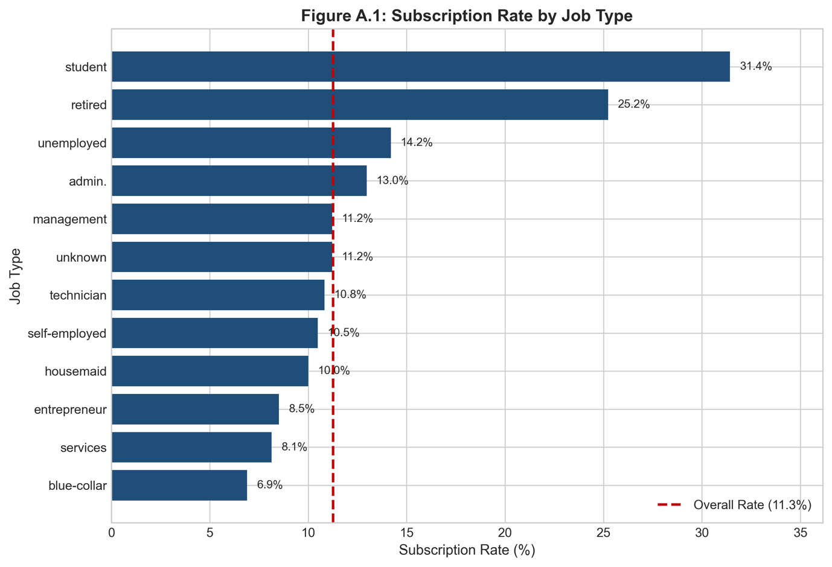
Figure A.2: Subscription Rate by Education Level
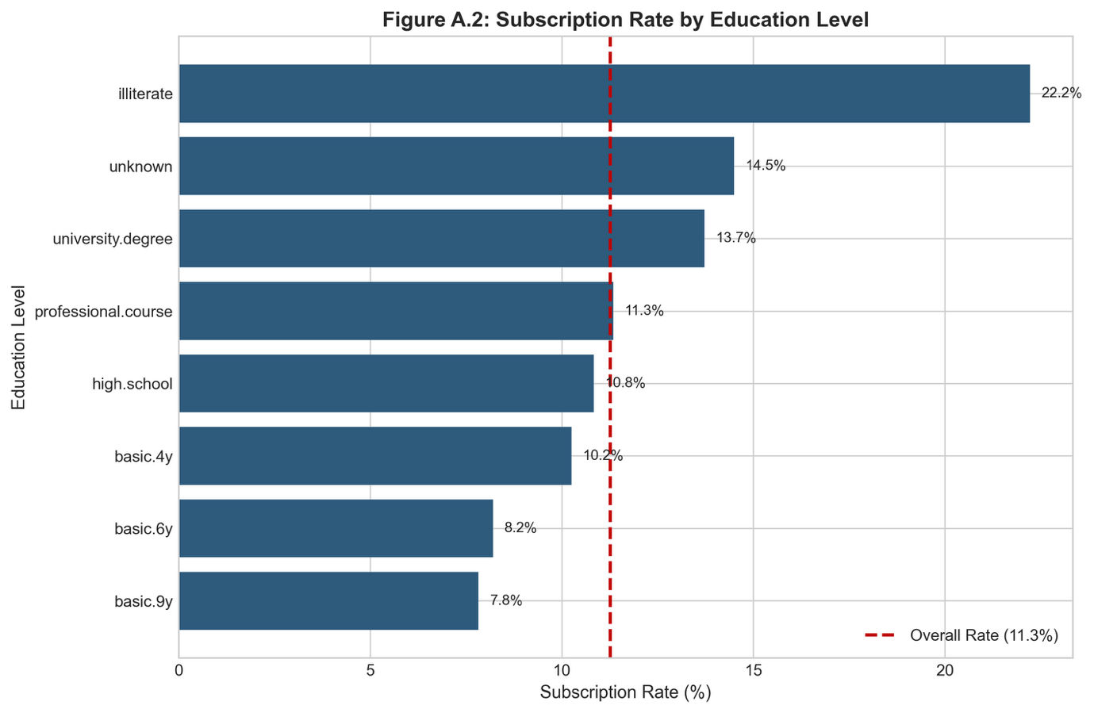
Figure A.3: Subscription Rate by Contact Type
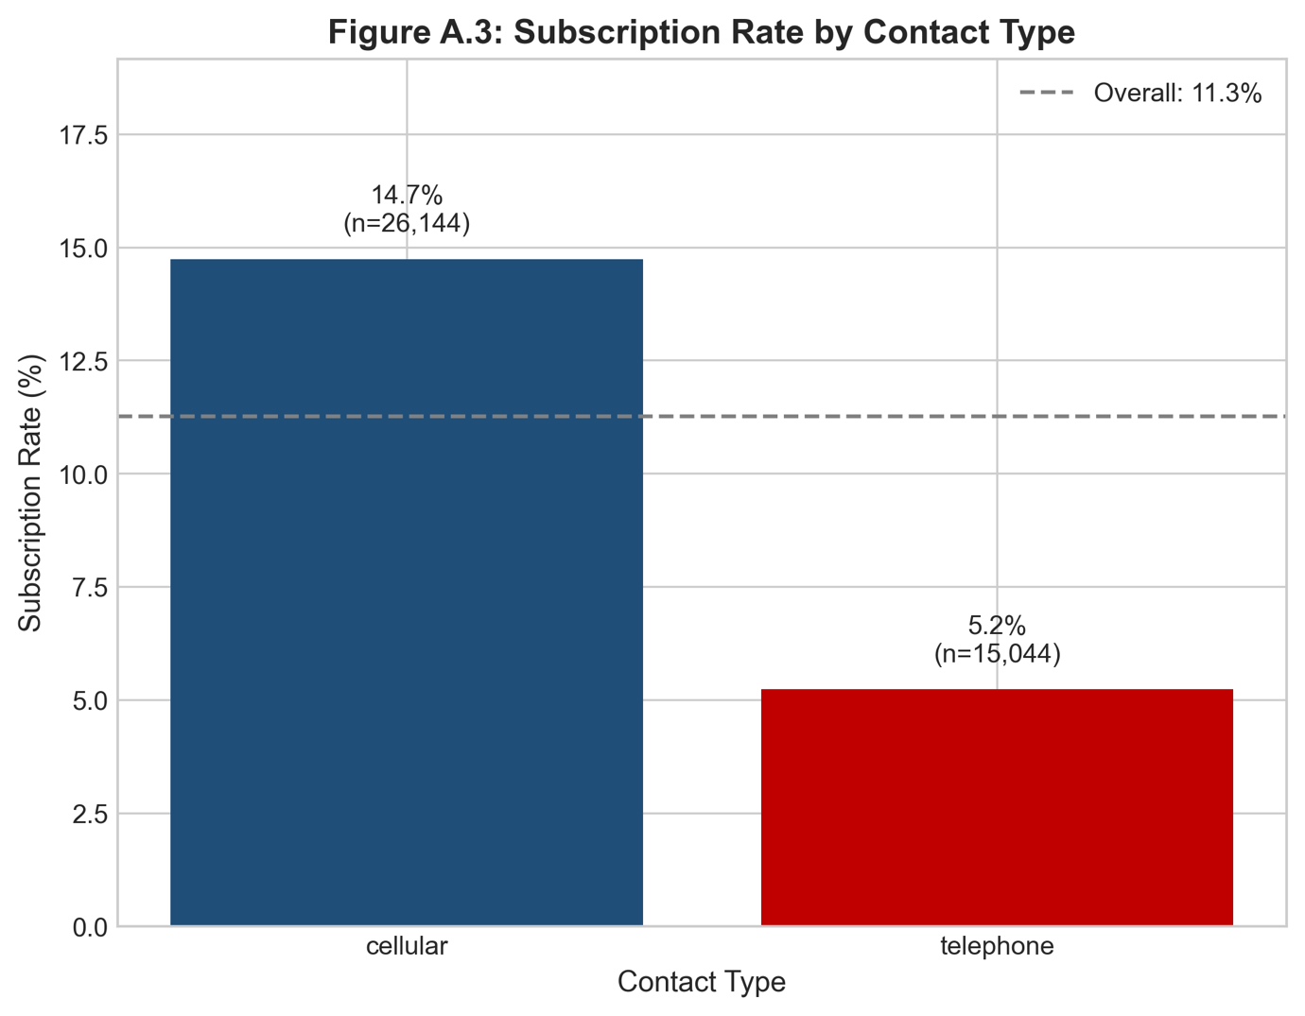
Figure A.4: Subscription Rate by Month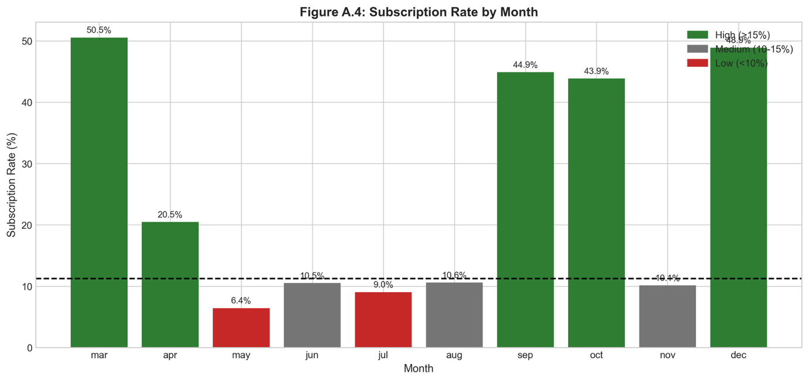
Figure A.5: Subscription Rate by Previous Campaign Outcome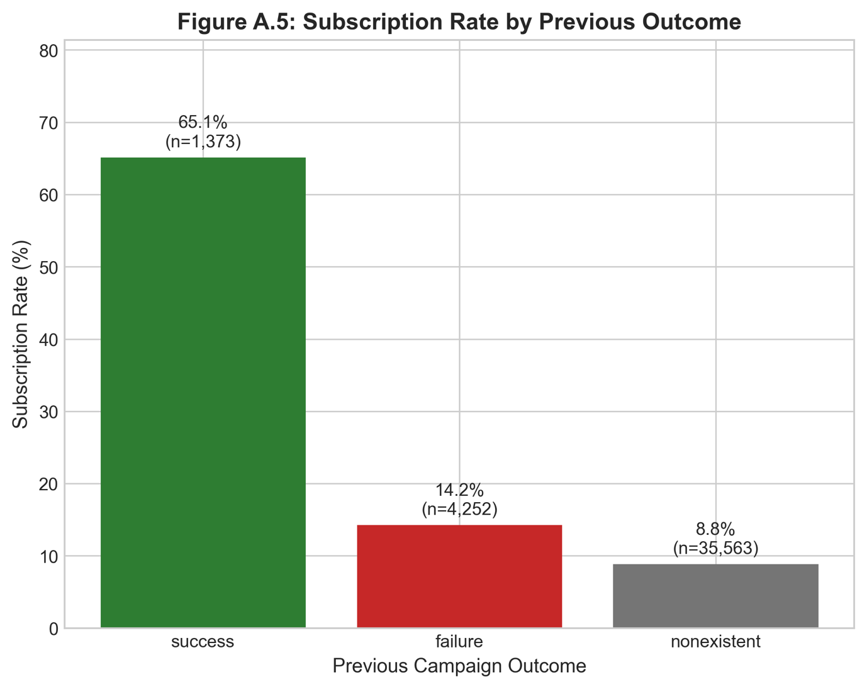
Figure A.6: Euribor Rate vs Subscription Rate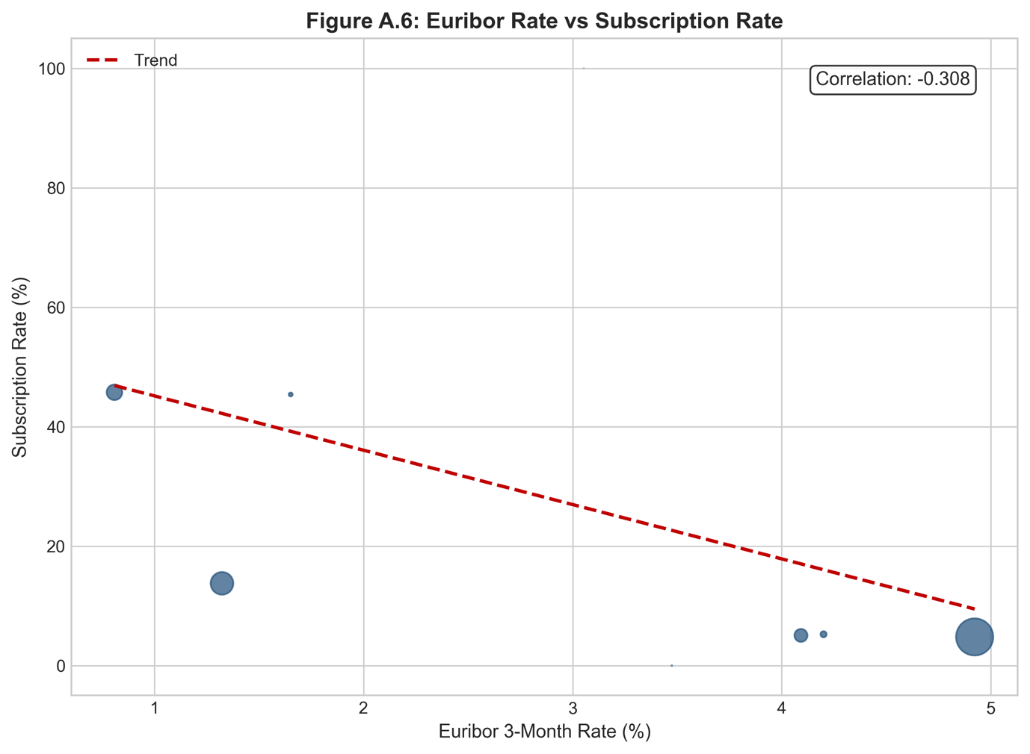
Figure A.7: Monthly Subscription Rate and Euribor 3m Trend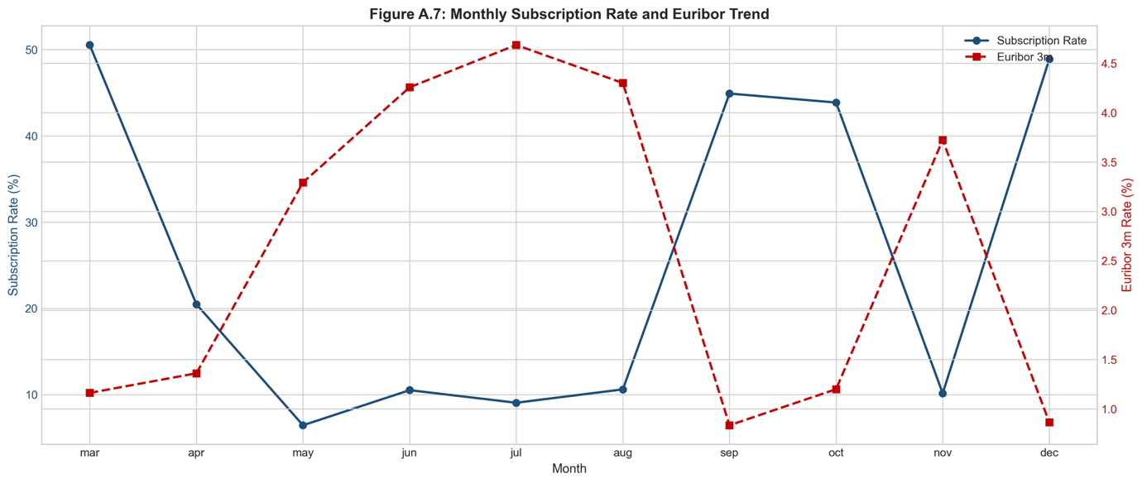
Figure A.8: Boxplot - Campaign Contact Frequency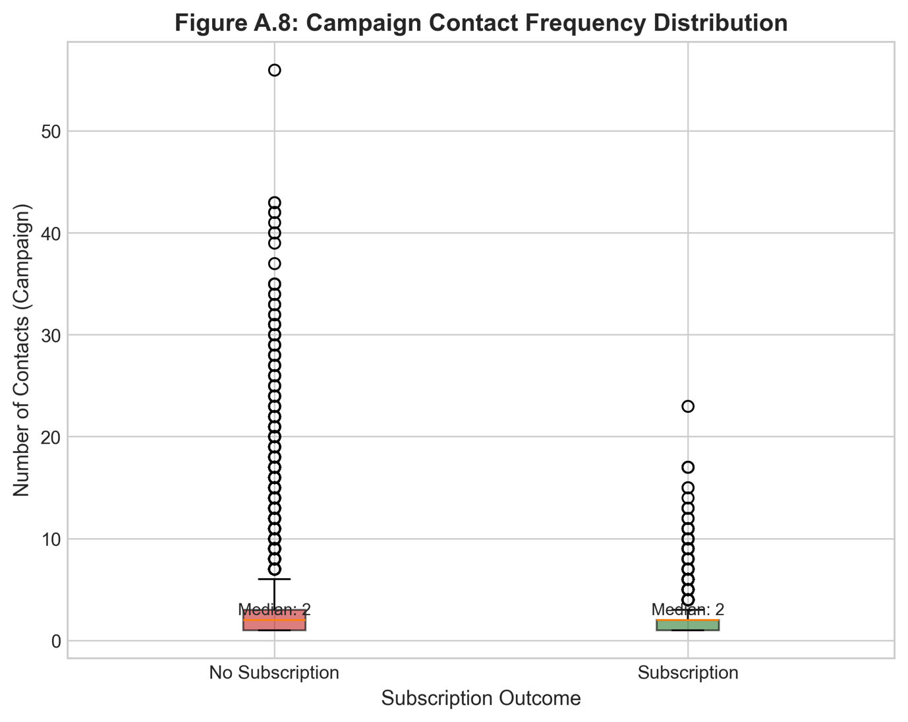
Figure A.9: Boxplot - Previous Contact Count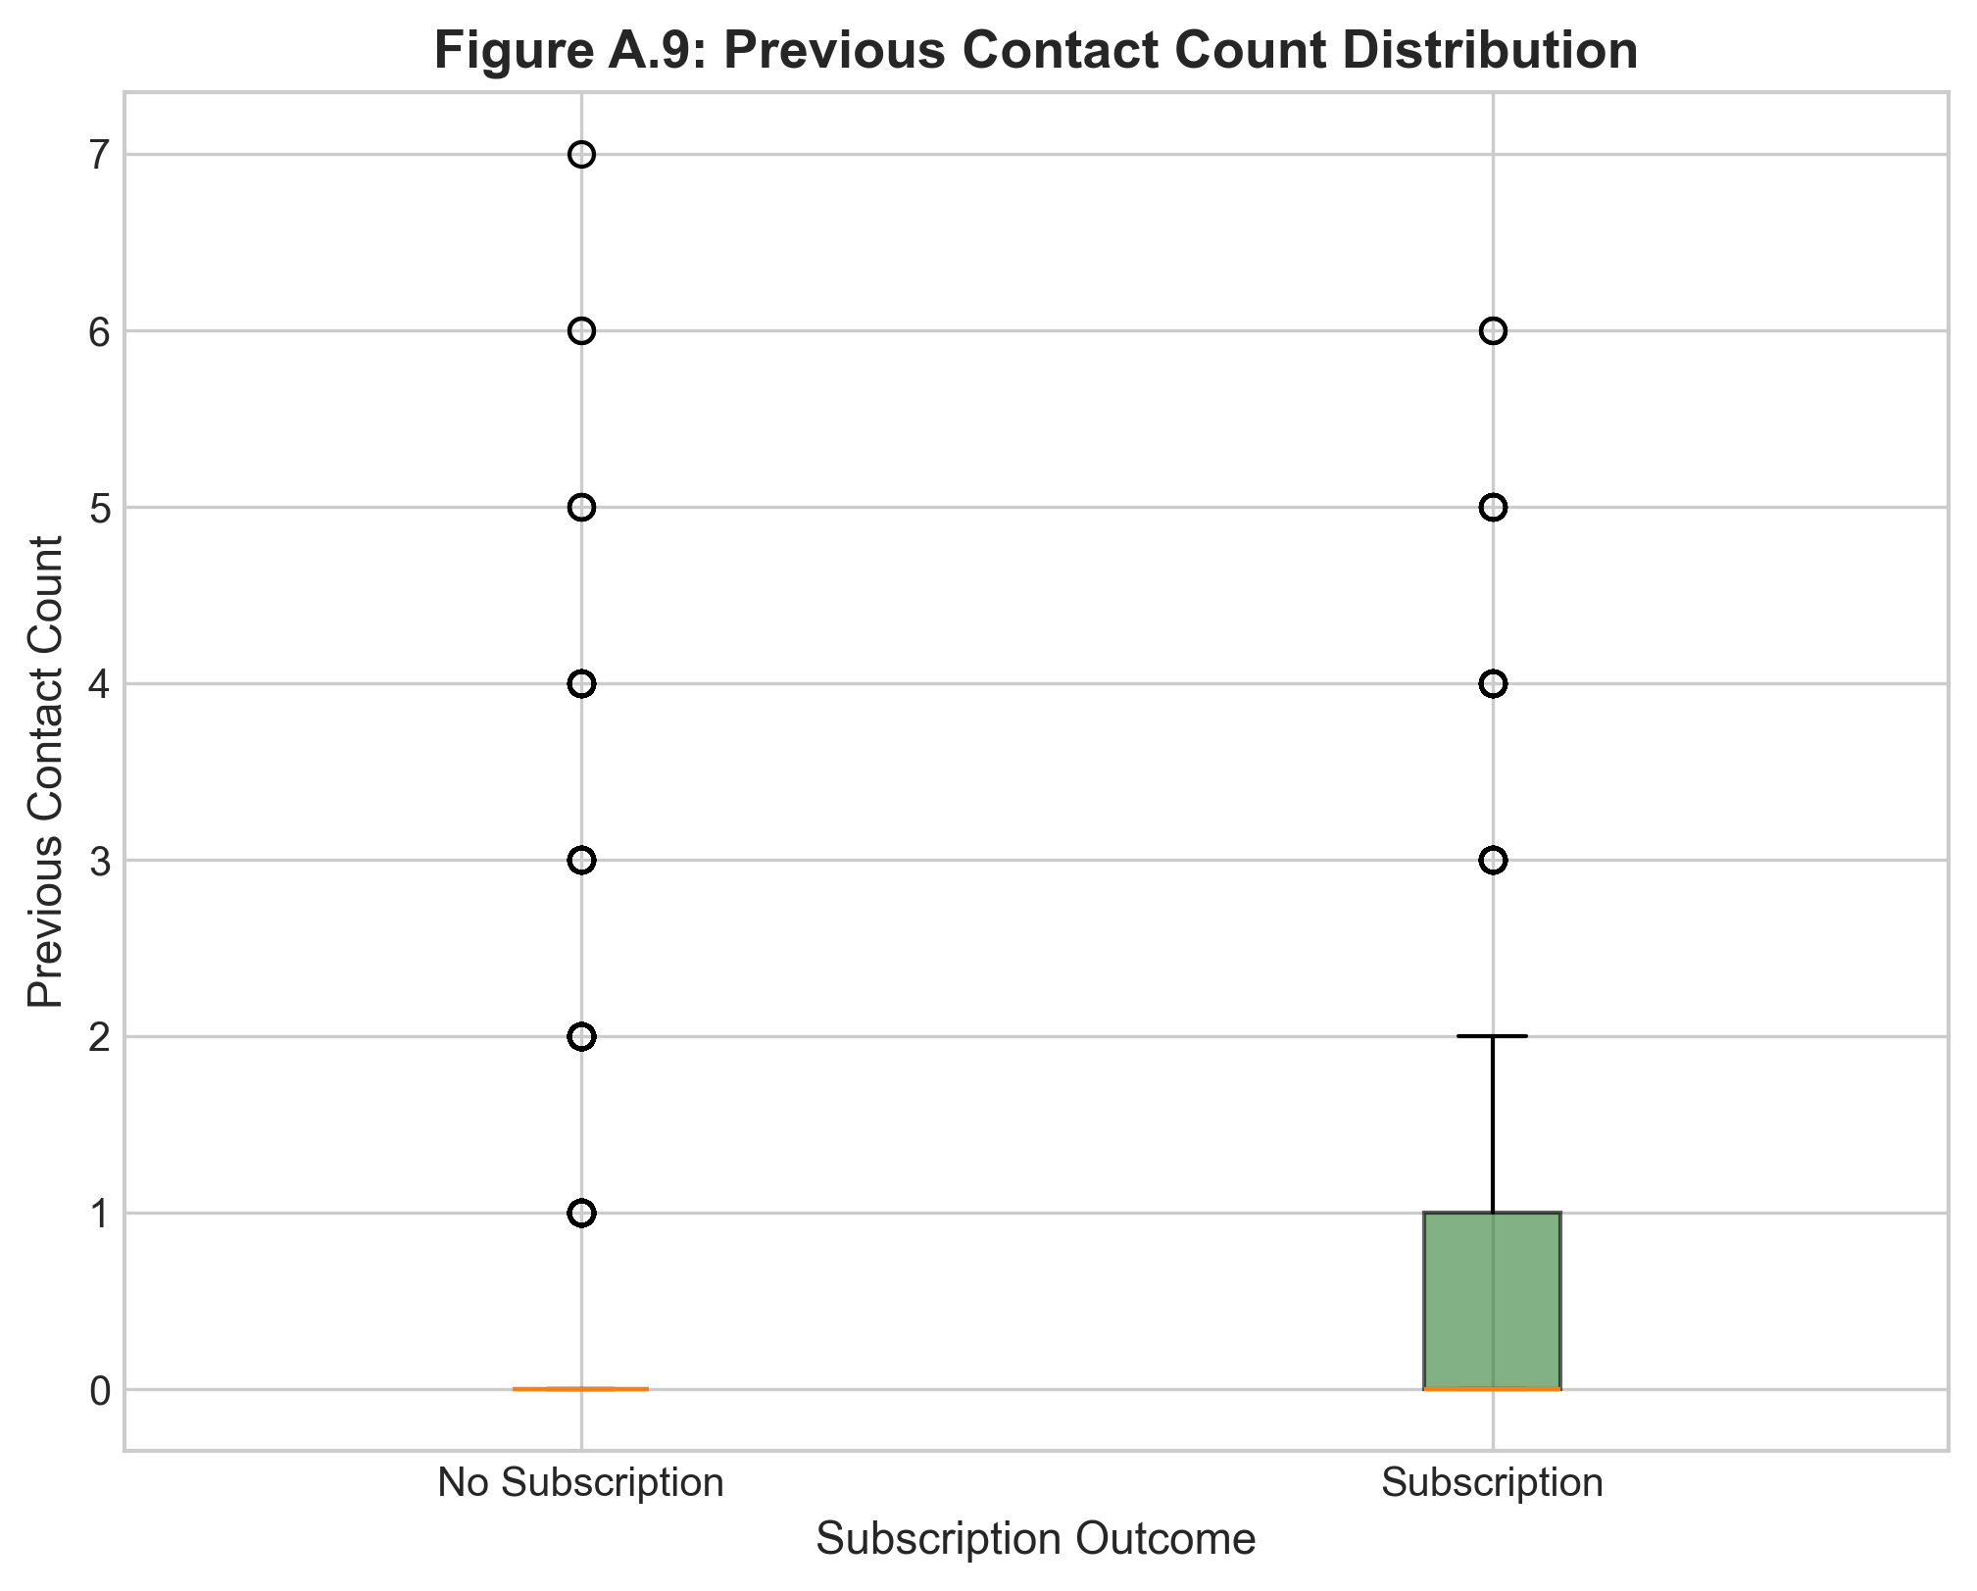
Figure A.10: Boxplot - Days Since Previous Contact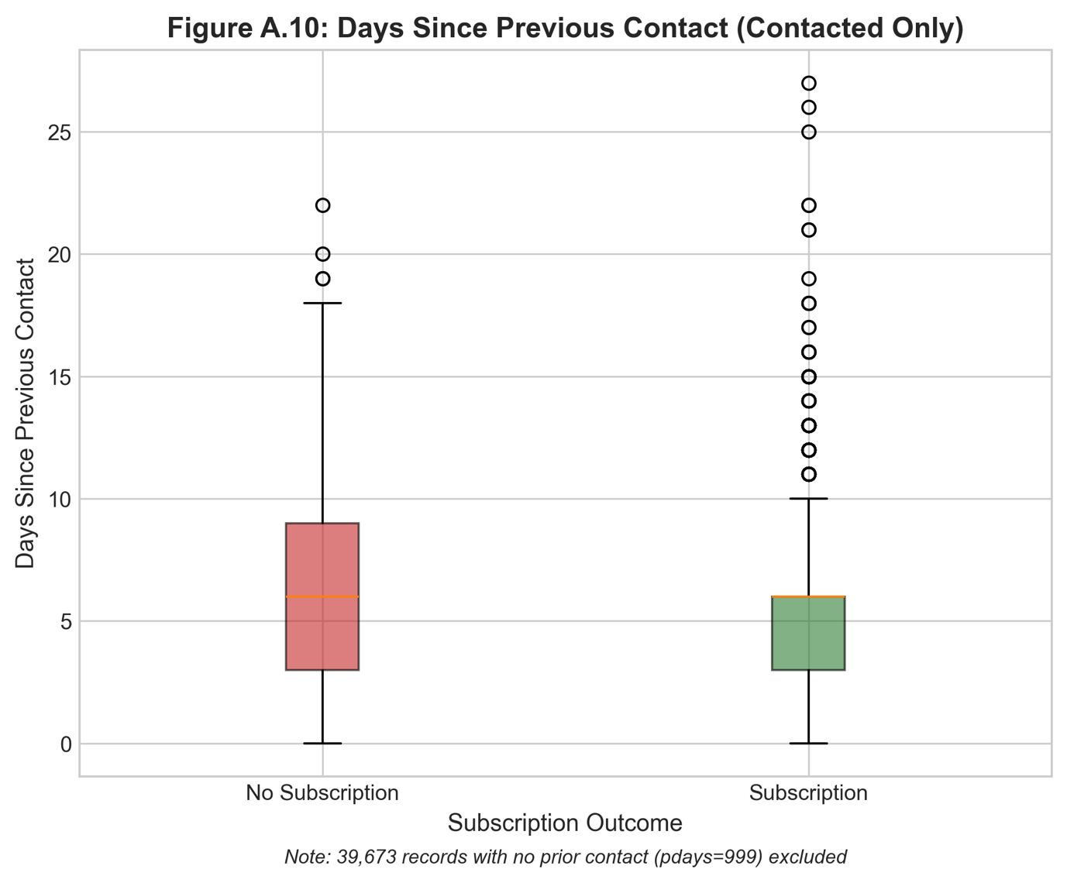
Figure A.11: Correlation Heatmap - Economic Indicators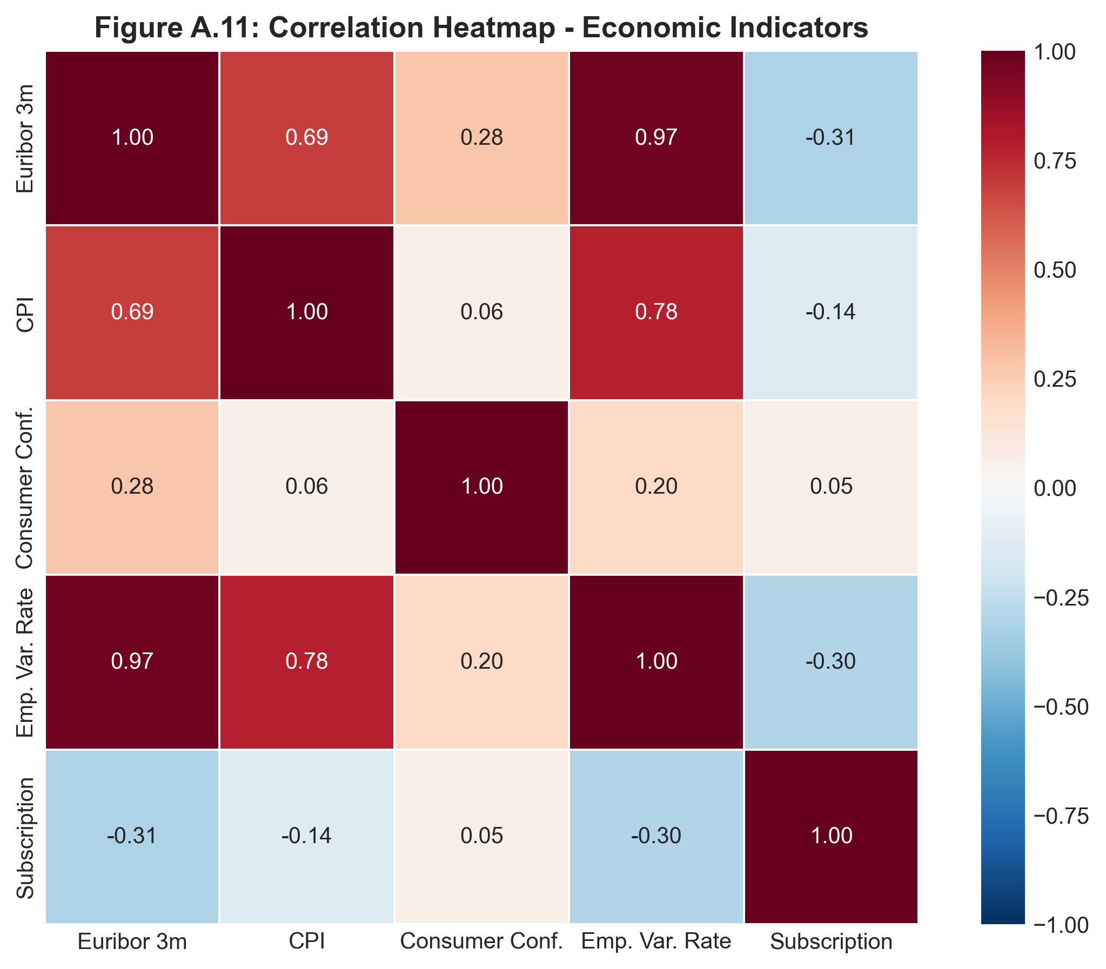

D.2 Model Performance Visualizations
Figure B.1: ROC Curves - All Models Comparison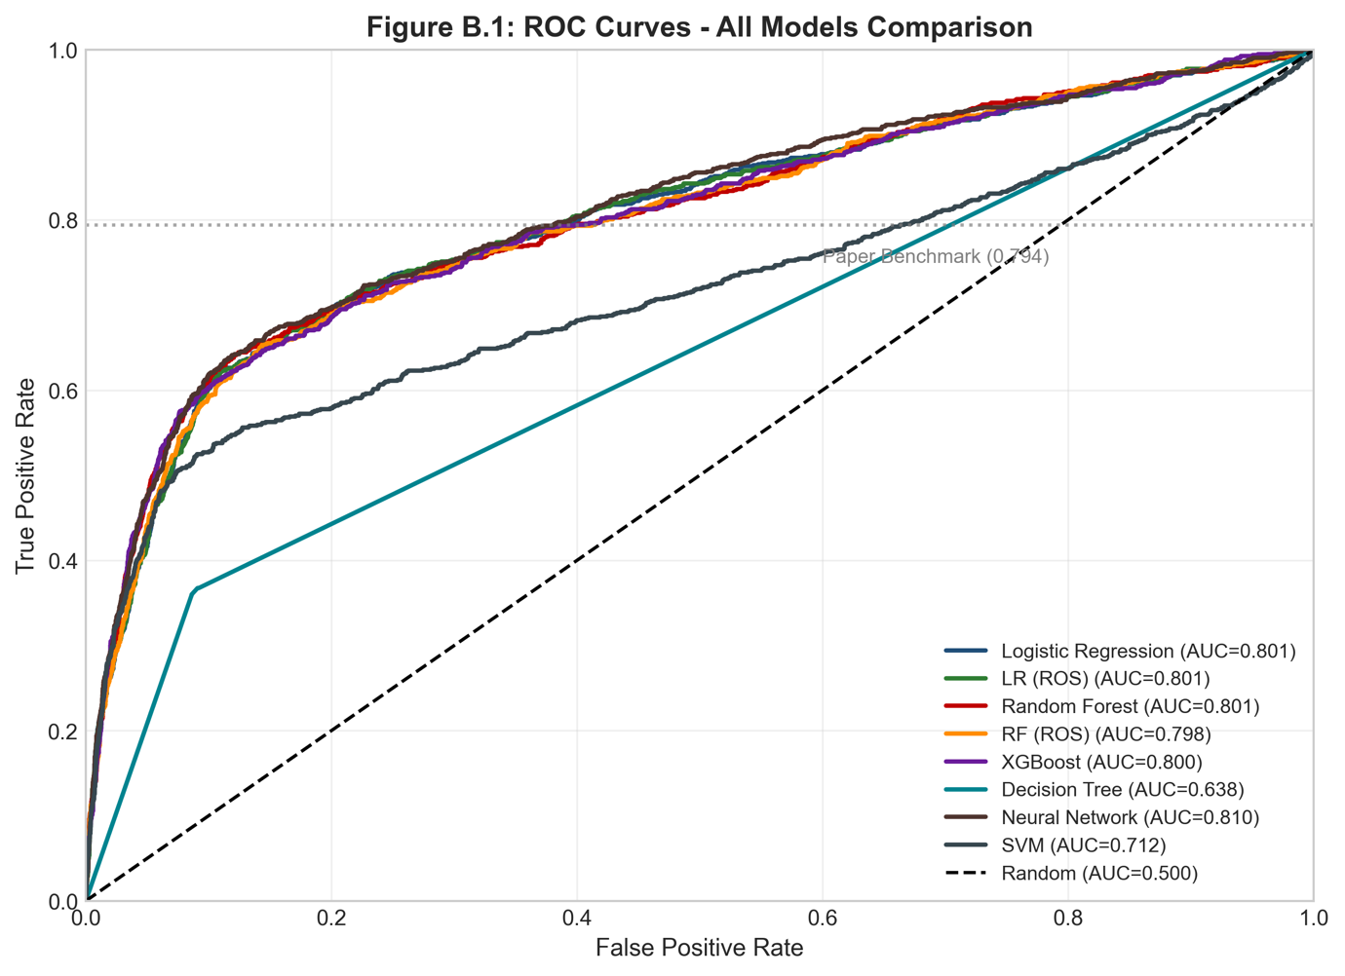
Figure B.2: Precision-Recall Curves - All Models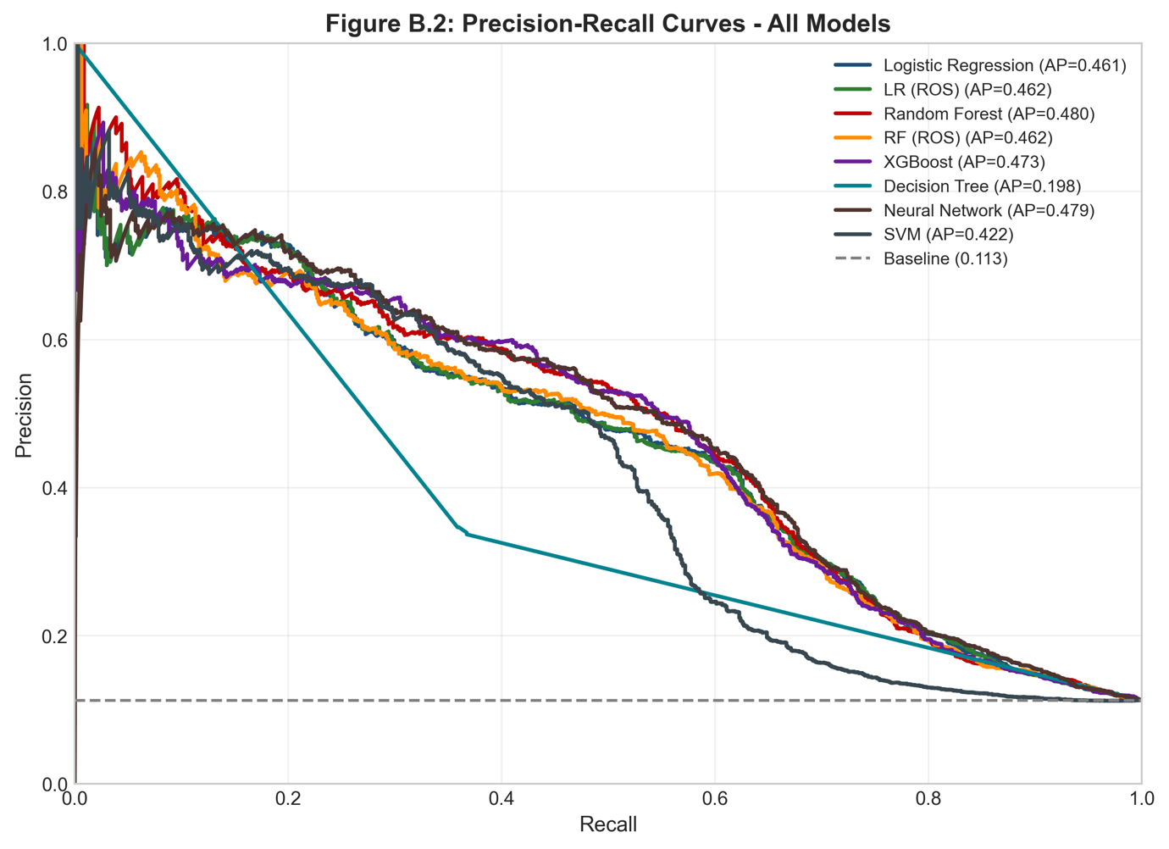
Figure B.3: Cumulative Capture Chart (Lift Curve)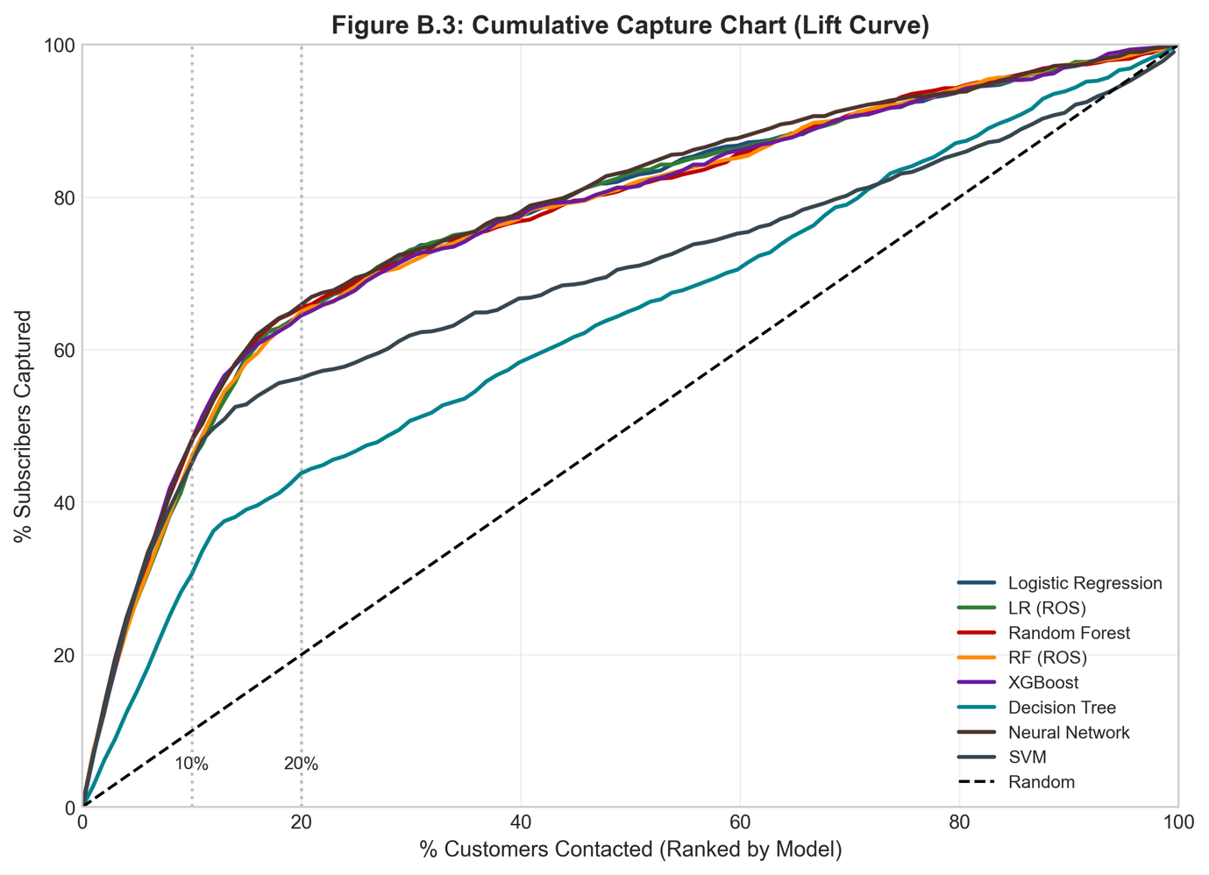
Figure B.4: Calibration Plots - Predicted vs Actual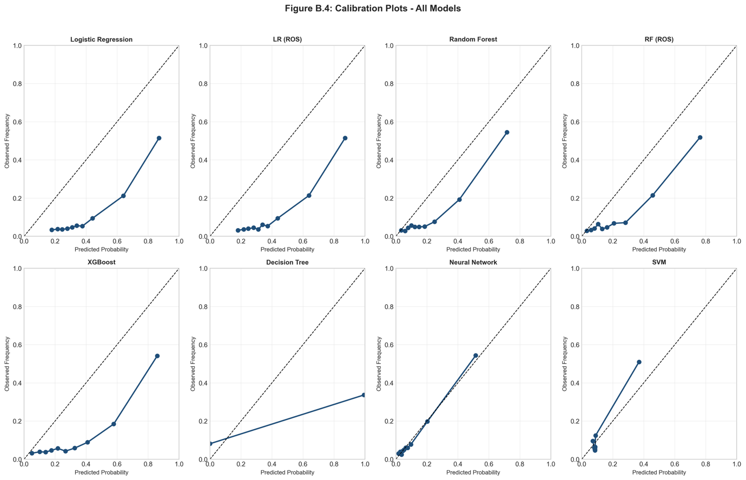
Figure B.5: Feature Importance - Random Forest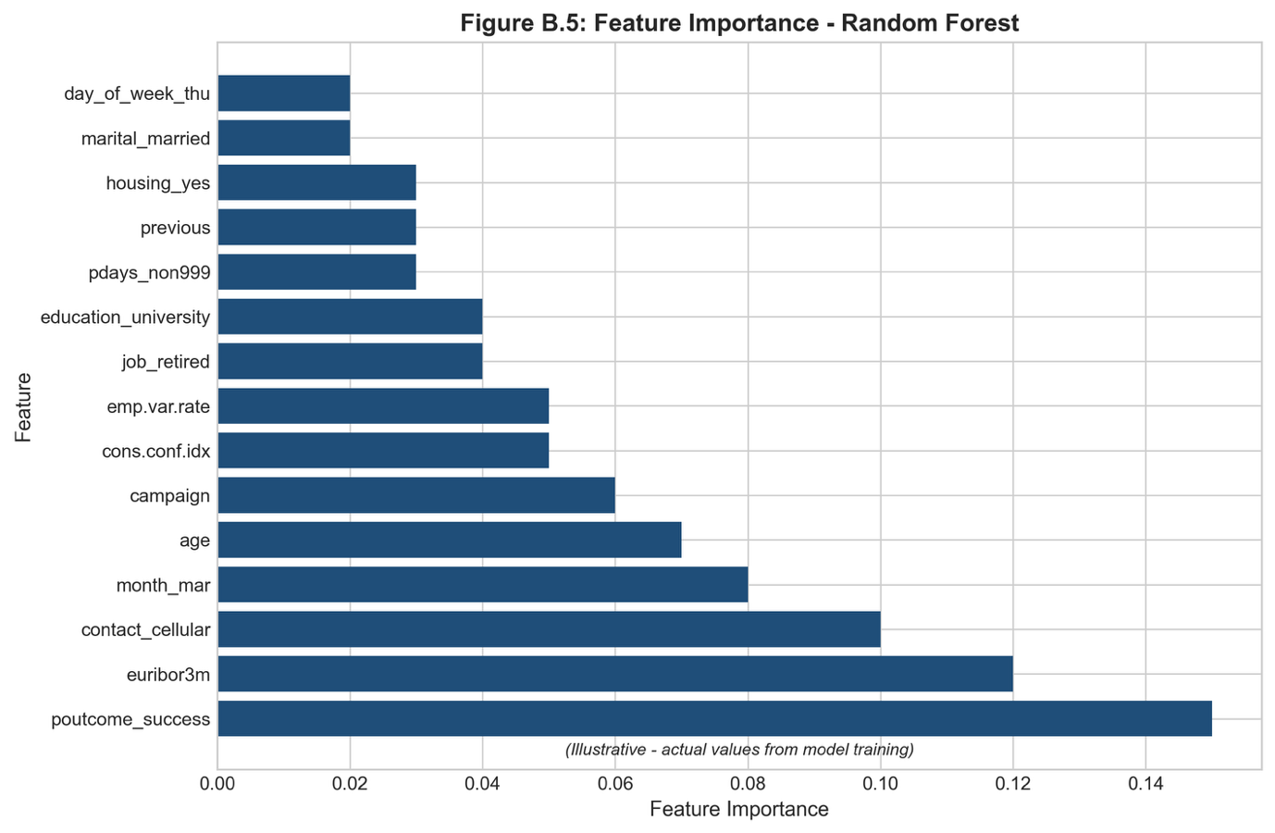
Figure B.6: Feature Importance - XGBoost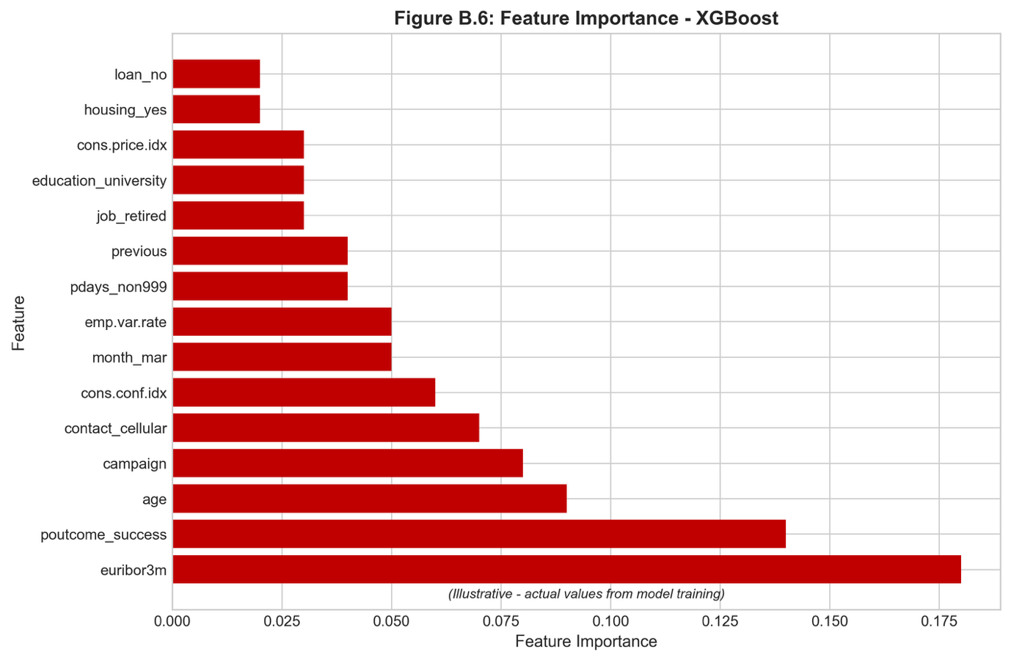
Figure B.7: Logistic Regression Coefficients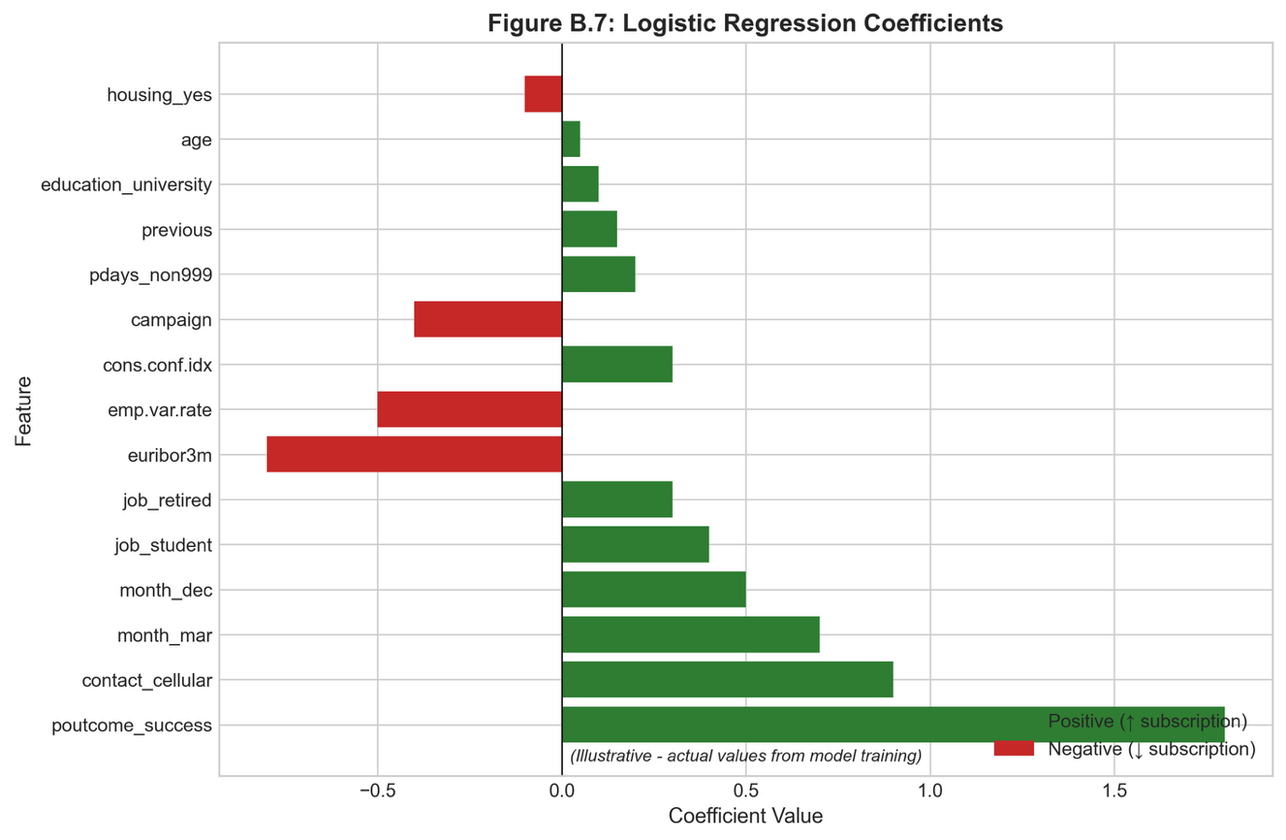
Figure B.8: Rolling Window AUC Over Time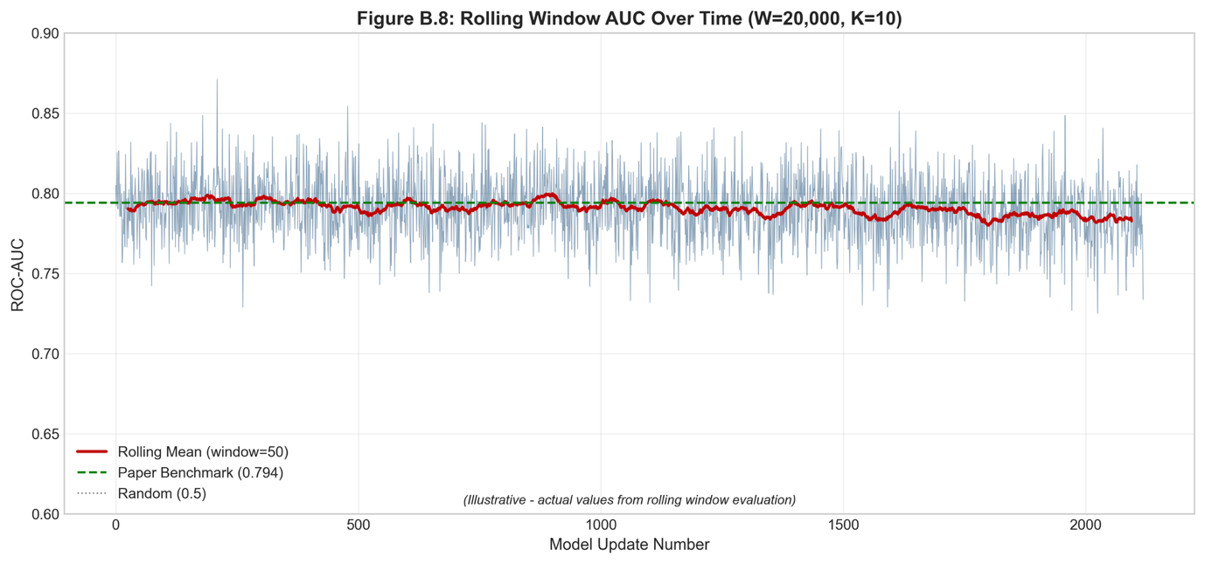

D.3 Business Impact Visualizations
Figure C.1: Decile Analysis - Capture Rate by Ranked Segment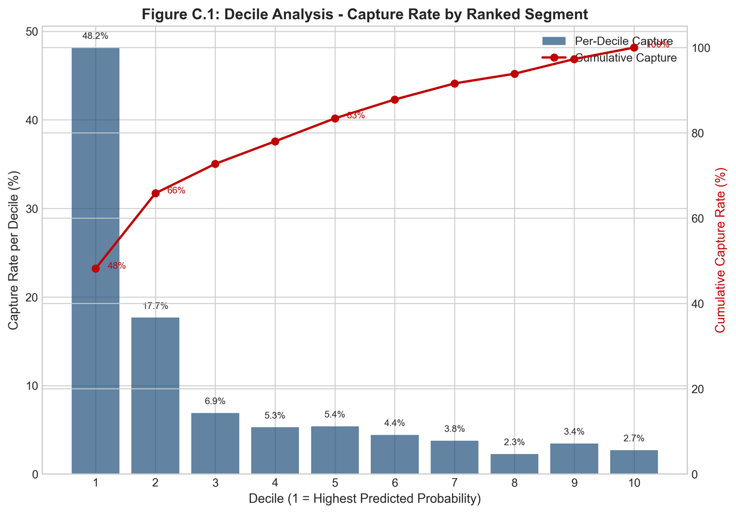
Figure C.2: Cost-Benefit Analysis - Random vs Targeted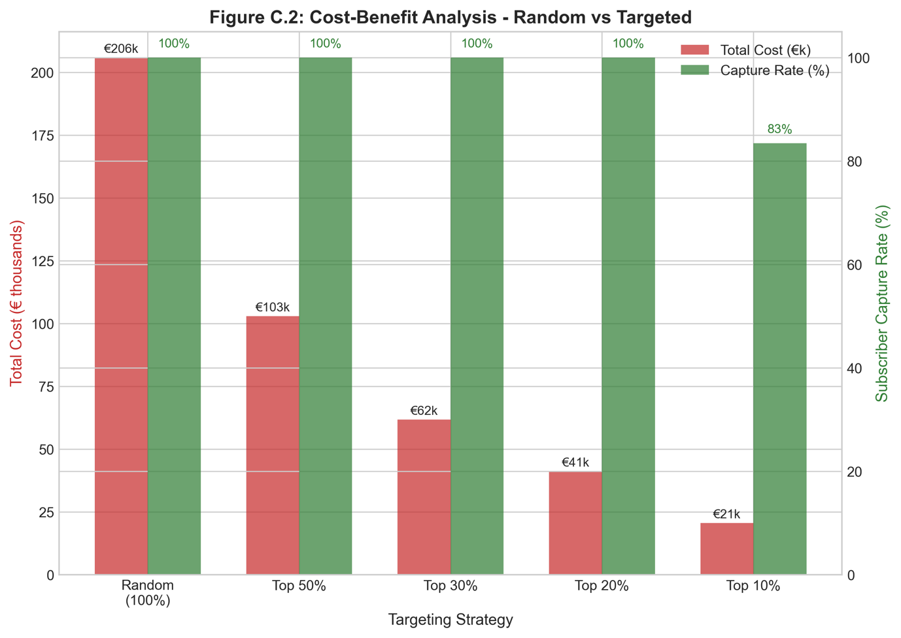
Figure C.3: ROI Comparison Across Targeting Strategies