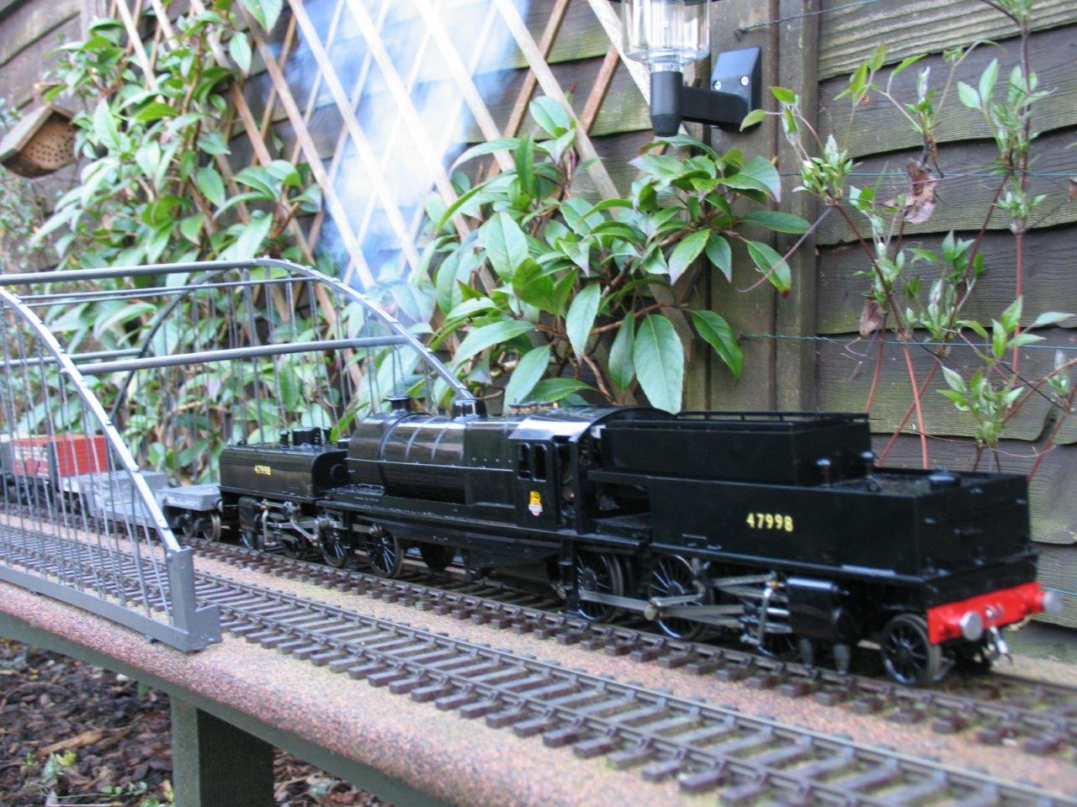
Chiltern Group
We are a long established, friendly group, drawing our membership from the counties of Buckinghamshire, Hertfordshire, Oxfordshire and Bedfordshire. We do not have a committee or officers, but Bob Carter is the person to contact if you would like further information.
We now have 5 outdoor tracks across the area offering a range of running experiences. A number of our members are experienced in outdoor track construction, and the building of locomotives and rolling stock, so plenty of advice and help is available to the newcomer to Gauge 1.
An annual programme of running dates is produced, usually beginning in April, and to which all members are invited. In the winter we hold afternoon meetings at member’s homes.
Contact: Bob Carter – Email: bob@sasrikal.myzen.co.uk or 01296 706587
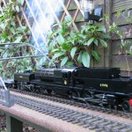
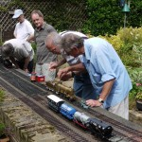
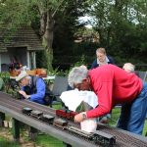

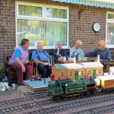
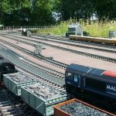

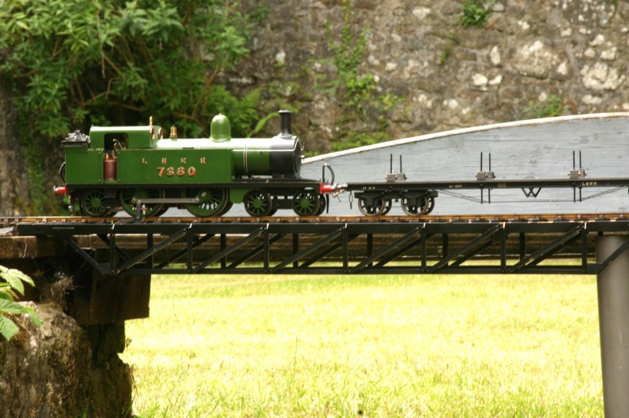Cornwall Group
Members of the Cornwall Group are spread throughout the county though there are fewer tracks available for GTGs than in past years. Never the less enthusiasm is still very strong and many members are active runners throughout the West Country and further afield.
Main running track action in the county takes place in Mid Cornwall particularly in the St Austell district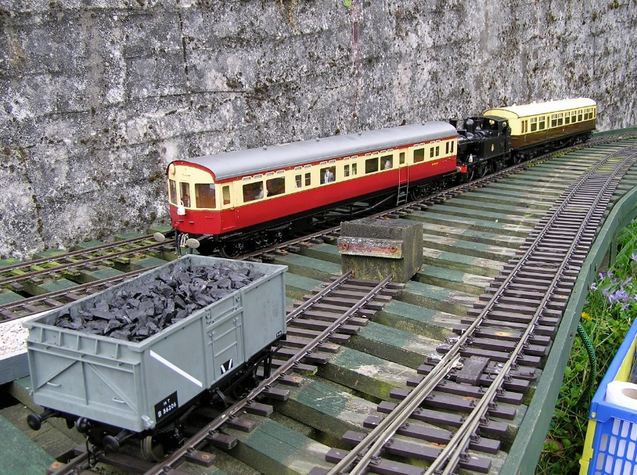, though there are a few private tracks where running may be available by invitation of the owners.
Currently, monthly meetings are held on the third Thursday of the month either at David Taylor’s home overlooking St Austell Bay or in St Austell at Group Co-ordinator Nick Wilder’s home. Folks visiting the area and wishing to join us for these meetings should first contact David or Nick by phone – phone numbers in the member’s list.
Contact: Nick Wilder or David Taylor
Contact details for these two are available in the Members Area.
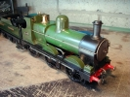
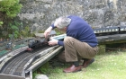
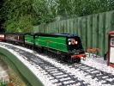
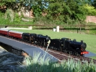


G1MRA – East Anglia Group
(updated April 2023)
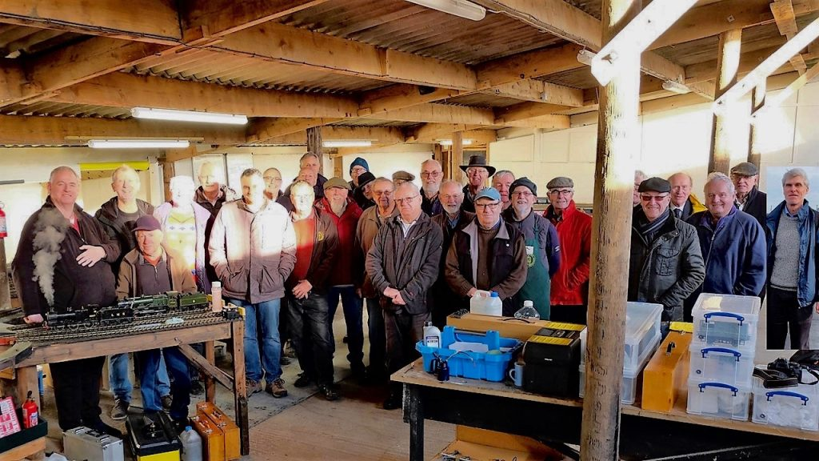
The East Anglia Group draws its membership from a large area, with members living in Essex, Suffolk, Norfolk, Cambridgeshire and Lincolnshire.
We have recently moved to our new premises at Stonham Aspal, where we have installed a permanent indoor layout 60 feet by 27 feet, with three main running lines and a number of loops and sidings, suitable for the operation of coal-fired, spirit-fired, gas-fired and battery-driven electric stock. The radius and spacing of the track permits the operation of large American outline locomotives and 16mm narrow gauge stock as well as 10mm and 1:32 scale models.
Please see our new website: www.angliaG1.com
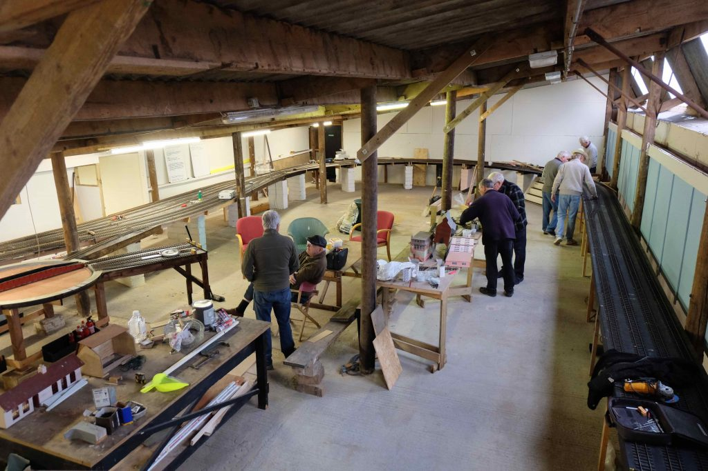
We currently meet regularly at Stonham Aspal on the second Wednesday and the last Sunday of each month. Members can use our facility – which includes a clubroom – at other times for their own get-togethers, and for the testing of locomotives.
We are fortunate to have ‘Anglia Roads’ as our portable exhibition layout. In the past Anglia Roads has appeared at G1MRA events – most recently at the AGM at Godmanchester in 2017 – and at a number of local shows, exhibitions and charity events, including Waveney MRC at Southwold, Chappel and Wakes Colne, and Felixstowe.
During the summer we also meet at members’ outdoor tracks, and visit other clubs for running days and get-togethers. We are pleased to extend invitations to clubs wishing to visit us to exercise themselves and their locomotives on our superb track, enjoy good conversation with like-minded people, and enjoy our Suffolk countryside.
Within our membership, which currently stands at 54, we have scratch and kit builders as well as runners of commercial offerings. The G1MRA East Anglia Area boiler tester is also a member, and boilers can be tested and certificated at the majority of our meetings throughout the year. We also have members who are well known traders within the hobby, and advice and help is always at hand.
It doesn’t matter if you are an old hand or a complete novice to Gauge One – you will find a warm welcome at our club. You are welcome to join us at any of our meetings to get a flavour of the group prior to any commitment, or just chat to us when we are out and about with Anglia Roads at shows, exhibitions and charity events.
If you would like more information, please contact our Chairman, Howard Hines email hineshe@btinternet.com telephone 01394 388069, or our Membership Secretary, Keith Plumb, on 01473 621697 or at g1mra3361@btinternet.com.
East Anglia on youtu.be (external link)
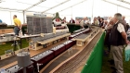
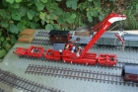
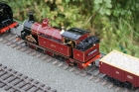
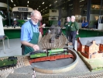

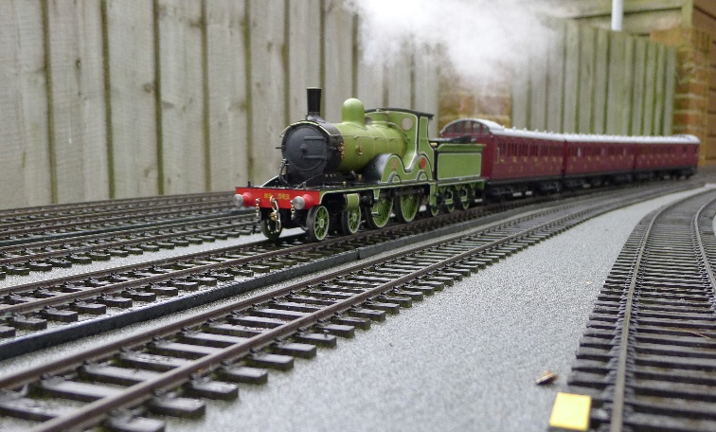East Dorset & New Forest Group
The East Dorset and New Forest Group was formed in the late 1980’s with about 8 members running on Don Gardiner’s line. It has now expanded to 70 members running on 8 lines, one having no less than 5 individual running tracks. Our membership extends from Dorchester in the west to Southampton in the east.
Meetings are held throughout the year normally on the second and fourth Saturday in the month, In the event of adverse weather we are very fortunate in being able to use the 200ft indoor line at The South Coast Model Railway Club, the branch terminus, Croyde was described in Newsletter No. 234.
Whilst all methods of propulsion can be seen, there has been a steady growth in the use of radio controlled gas fired locomotives. Locomotives range from the usual commercial models to exquisitely hand built and much admired models, the same applies to both coach and goods rolling stock.
Being in a holiday area we do see visiting members from other parts of the country giving us even more variety. We also have available a number of utube links to various past events, please contact Peter Armstrong for further information about our group.
Contact: Alan Seymour 01202 694576 email: alan.n.seymour@outlook.com and Robin Whiting email: robinwhiting251@gmail.com
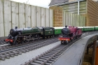
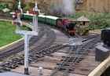
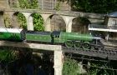
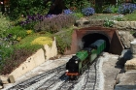

Hants & Sussex Group
The Hants & Sussex Group stretches along the SouthCoast from Southampton to Worthing a distance of 55 miles connected by the M27 and A27 South Coast road routes.
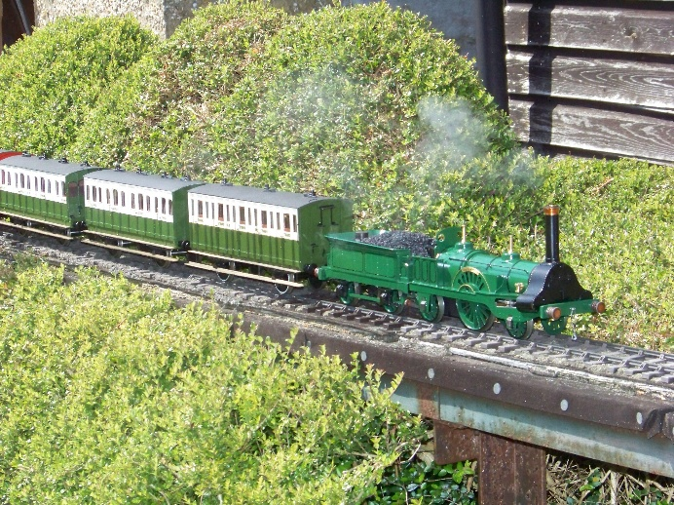Our meetings take place every Sunday during our running season of April to October. There are 9 main tracks that operate in the season from a published meetings calendar that is decided at our Winter Meeting in February each year. The Sunday meetings run from 10am until 3pm.
The group was formed in 1978 by 2 members, Roy Scott and John Patterson whose two layouts became the start of the then named ‘Sussex Group’. Over the next 35 years the group expanded in size to the current 66 G1MRA members and also geographically westward to include layouts in Hampshire – hence the renaming of the group to be ‘ The Hants & Sussex Group ‘
The group members operate all types of gauge 1 locomotives – from the original steam ( both scratch-built and commercially constructed ) locomotives to electric power. Manual and radio-control models of British Standard, Continental and American outline are all seen at our meetings together with the occasional interesting ‘ speciality’ locomotives.
The one thing that is guaranteed at our meetings is a friendly welcome and plenty of valuable advice for both new, old and visiting members – for further information please contact Bill Whiting, Martin Hughes or Dick Comber
Contact details are available in the Members Area.
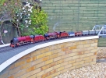
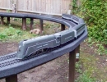
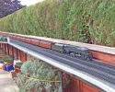
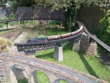

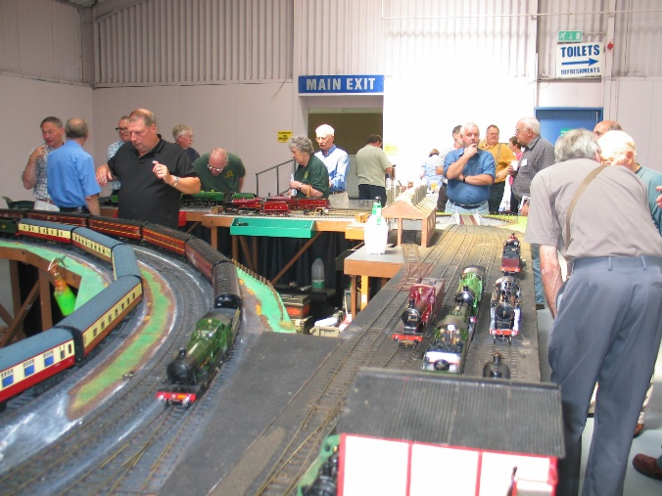Midland Group
The Midland Group caters for members who generally live in the Midlands area, however, all G1MRA Members are welcome to join. The group was initially set up in the early 1980’s to design and build a Gauge One exhibition layout called ‘Stanley Midland’.
See bottom of this page for their contact details.
Stanley Midland is the flag ship of the Midland Group and is ‘worked’ at all the major Model Engineering Exhibitions and Shows. A monumental layout, having two main running lines for both live steam and battery operation, a comprehensive steaming bay, shunting sidings, platforms and many other features, including an array of authentic railway buildings and figures. Being under constant improvement for the benefit of those who use it…..or just view it, all Members are invited to enjoy and share in the experience of being part of this unique heritage.
At exhibitions where floor space is limited, we have a static display stand with a video player to give the general public a flavour of ‘Gauge One’.
The highlight of the Midland Group calendar is the annual Midland Model Engineering Exhibition. The layout is organised and run by Midland Group Members, with assistance from G1MRA Members. Each year well over 50 operators, and more than 100 locomotives are in action over the duration of the show. In addition to this the Midland Group attends the Warley Exhibition at the NEC and the Large Scale Model Rail Exhibition held at the “Fosse” in Warwickshire.
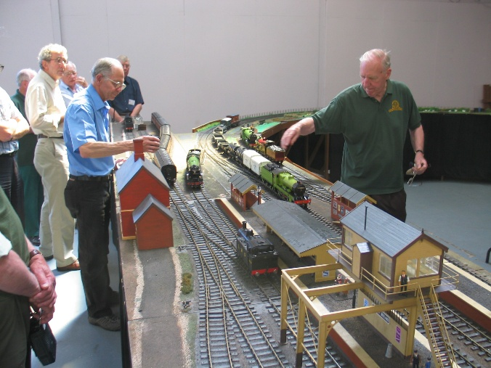
Summer events are held at various garden railways belonging to our Members, who kindly open their gardens and extend warm hospitality to all that attend. For members without a loco, the Midland Group offers two ways to get “hands on”. For electric propulsion fans, there is a radio controlled Bachmann Jinty. For those that want to try live steam, a Fowler 4F loco (The Project) was constructed by Midland Group members and is available to run at any event….it is there to be used! Advice and or tuition from experienced members is always available.
Although owned by the main association, the Midland Group also looks after a rake of BR MK 1 carmine and cream coaches, plus a train of freight wagons so there is something to haul at events.
There is a Committee, which sits four times a year to discuss matters relating to the Group, with an AGM held in February.
The AGM is combined with an indoor running session, where privately owned portable tracks are erected for the enjoyment of Members.
All Midland Members receive an invitation to the AGM and a ‘News Sheet’. Also enclosed is a ‘Diary Sheet’ detailing all the calendar events throughout the following 12 months. This allows every Member to plan their year around Gauge One………..after seeking permission of course! The ‘News Sheet’ reports on achievements and brings Members up to date on Stanley Midland and other topics of interest within the Group.
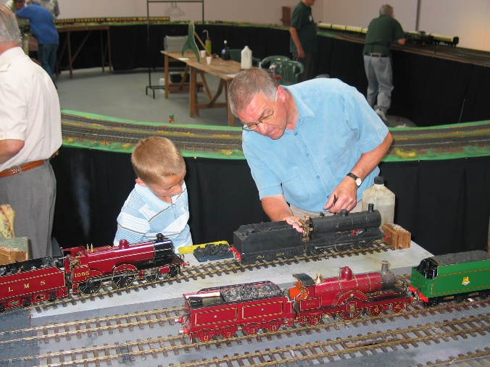There is a subscription of £3 payable on 1st January, which runs for the year, but you must be a member of G1MRA first.
You may well ask!……”Why do I need to pay a further subscription when I’ve just paid the G1MRA fee” ?……well, we have to cover the cost of postage, printing etc, plus expenses for maintenance, insurance and development of Stanley Midland.
Members are encouraged to help and get involved in setting up Stanley Midland and also in its maintenance. Even though its construction is of a robust nature, it does suffer the rigours of transportation and heavy usage.
Finally, there exists within the Group a wealth of knowledge and experience on all aspects of Gauge One, whether it involves machining, silver soldering, painting & lining, trouble shooting, problems when running, etc, etc………..rest assured, someone has ‘been there’ and are only too willing to help!
If you are interested in joining the ‘Midland Group’ (remember, you must be a Member of G1MRA first!) then please:
Contacts: Jamie Wilde – wilde917@outlook.com and Steve Andrews – sandrews55@outlook.com
Contact details for these people available in the Members Area.
Running Day
The next of our running days at Penkridge is on Sunday 30th October 22. For an Invitation, please contact Steve or Jamie, whose contact details are above. If you are attending, please remember to sign in, even if you are not running a loco, and please adhere to the new safety guidance during your visit (copies of the protocols will be in the hall). The hall-hire charge is £tba and Laura’s Lunchtime Litebites (bacon butties etc) will be available for a small additional charge.
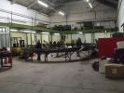
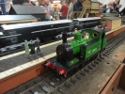
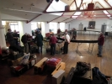
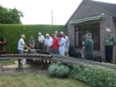

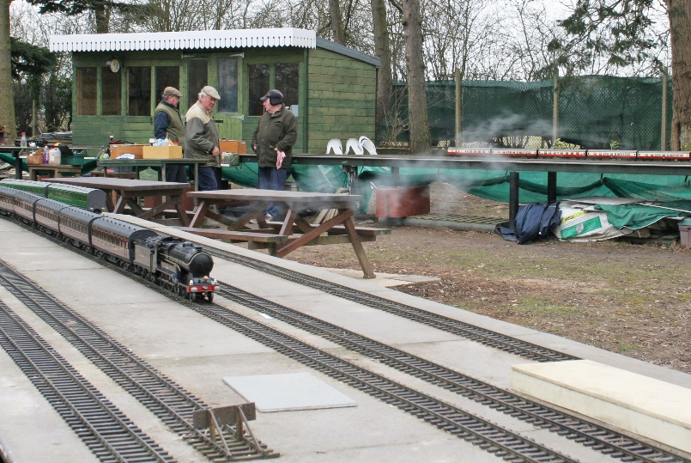North London SME Gauge One Group
The North London Society of Model Engineers “Gauge 1” section was originally formed in the late 1990s by members with an interest in gauge one. Our very active group currently numbers over 20 regular members. Most of us live in the Bucks, Herts and Essex area, as well as in north London. We have recently built a new large permanent outdoor track, which we believe is one of the largest in the country, to replace our first small track (which is now being used for narrow gauge prototypes running on 45 mm track).
We are located at the NLSME’s main site at Colney Heath, Hertfordshire, AL4 0NJ, which also boasts large 3½in, 5in and 7¼ in tracks, as well as a model boat lake. This secure, tree- studded landscaped site is pleasantly situated in the countryside and has ample safe car parking, room for children to play and comfortable picnic seating areas, some under cover.
Our superb new Gauge 1 facility comprises three main running lines, plus ample steaming bay areas (one for the inner and middle lines and a separate one for the outer). The inner and middle lines have been designed for gauge 1, while the outer line is also suited to US outline locos. There is plenty of under-track storage space and working tables, the track is fitted with ample stock sidings, and there are passing loops for each of the three lines, so that double running is safe and comfortable.
Nearly every Wednesday throughout the year we meet between 11am and 4pm at Colney Heath (weather permitting); exceptions occur from time to time as we visit other clubs or the home track of a Group member. We have recently completed the construction of a timber ‘bothy’ where we can sit inside and make ourselves hot drinks etc; this shelter is ideal for use in poor weather. As with all new tracks much work is still to be done, and starting spring 2013 we will be preparing an outside BBQ area containing protected seating, which will also offer a good view of the track. There are also other existing refreshment and full male/female toilet facilities on site.
Our friendly and enthusiastic members boast a large range of skills, including lathe work, casting and resin moulding, loco, coach and wagon building, track laying etc. Amongst our number we do have an accredited boiler tester. There are of course plenty of members who are only too happy to offer advice and give help with any construction project the newcomer to gauge one may be contemplating.
Visiting individuals or clubs are always welcome, whether they just want to enjoy a run on the track as our guests, or would like to join the NLSME on a permanent basis. We are only too pleased to provide membership application forms. Those intending to visit should contact Geoff Hammond phone: 01707 267939 – email: geoffrey.hammond@ntlworld.com
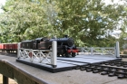
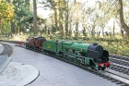
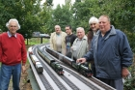
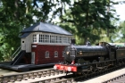

The North West Group
Our website is here.
The North West Group provides a contact point for those G1MRA members resident primarily in the North West, although we do have members from further afield. We currently have nearly sixty members, and our interests concentrate mainly on the railways of the UK, covering all regions and the whole spectrum from pre-grouping through to the present day. We produce nine or ten newsletters per year.
Our abilities range from ready-to-run, modified ready-to-run, kit construction, and building from scratch, of both live-steam and battery-electric steam and diesel outline locomotives. Some of our members have demonstrated particular skills in the application of radio control to live-steamers and battery-electrics, and one notable achievement a few years ago was the construction of a working diesel-electric loco. We will always be happy to share our skills and knowledge with new members.
Outdoor running sessions are held from March to November inclusive, some on a regular basis and others arranged at short notice. We hold evening meetings on the first Wednesday of each month at a community centre near Chorley, which take the form of talks, demonstrations, project night etc, and these have always been well supported. Topics in recent months have included a demonstration of 3D CAD, reversing slip-eccentric valve gear, painting weathering and lining, radio-control, casting in resin, the use of CAD and laser-cutting to produce valve-gear parts, and a survey of experimental steam locomotives.
The group commenced the construction of our portable track “Withnell Junction” back in 1999. It has appeared at numerous exhibition venues since that time and has undergone much development and refinement. The track appears regularly at the Woodvale Rally, the Padiham model railway exhibition, the Southport Model Railway Society’s exhibition and at two events at the East Lancashire Railway.
In the last few years, links have been developed with the Southport Model Engineering Club who had built a good-sized G1 track some years ago. North West Group members have recently helped to extend the track to a circuit of approximately 300 feet, and all members will be invited to run on it by arrangement.
Contact: John Lindars
Contact details for this person are available in the Members Area.
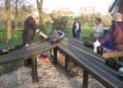
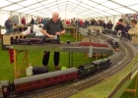
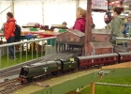
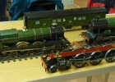

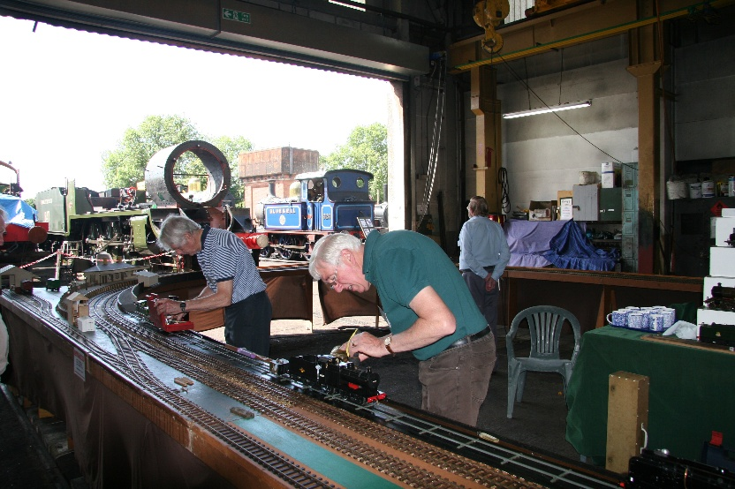North West Kent Group
The North West Kent Group provides activities for members in South East London and west of the Medway in Kent. In close cooperation with the South East Group the Group operates the Invicta portable track, which usually has three or four outings each year. Between September and May Group meetings are held on the second Friday of each month at Donnington Hall, Barretts Road, Dunton Green TN13 2UN, from 7.30 to 10.30 pm. These include talks, discussions and general chat. Members have a wide range of experience and expertise covering most aspects of Gauge 1 and many prototype interests.
Contact: John Harbourne
Contact details for this person are available in the Members Area.
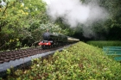
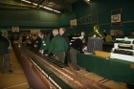
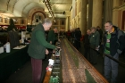
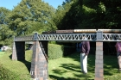

Scottish Group (North East)Meetings are held on the third Sunday of the month March to October, starting at 1.30 pm, weather permitting, either at Lochview Cottage by Forfar (June, September) or Mill House, Newmachar (other months). Contact Stuart Guthrie-Iveson 07973336139/stuguth@gmail.com (Forfar) or Martin Ford 01224 790052/maf.cairnie@gmail.com (Newmachar) for directions and confirmation running is going ahead.

Somerset Group – a small friendly group with get togethers throughout the summer at short notice when the weather is favourable. contact Martin Veasey, martinbathgauge1@gmail.com

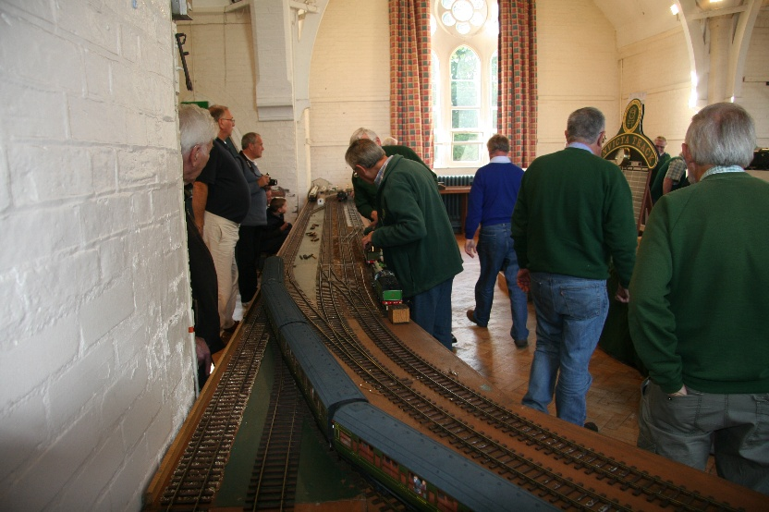
South East Group
The Southeast Group includes members from Kent, Sussex and Essex. There is no formal committee or officers but we work in conjunction with the North West Kent Group and support each other’s events. Running meetings take place, often on Wednesdays, and series of Friday evening talks, discussions and film showings are held from September to May. Other meetings are held throughout the year at the varied local tracks.
New members are always welcome whatever your area of gauge 1 interest whether it be Live Steam, Electric, British or Continental outline, Modern Image or Vintage Tinplate. If you wish to attend any of our meetings contact details are available in the members section.
We are fortunate to have many experienced model engineers and scratch builders among our number who are always happy to help those less experienced members. In addition to this there are several tracks in our area where get togethers are held- details are found in the Newsletter and Journal and on the website.
The Southeast Group use the ‘Invicta’ portable track for exhibition running. Our recent events include the The London Model Engineering Show at Alexandra Palace, the Staplehurst Model Railway Show, The Tenterden Model Show and the Model Weekend at The Bluebell Railway.
The Southeast Group has strong ties with some of our Swiss members and we have enjoyed their company both at home and in Switzerland.
The group members are informed by email of meetings. Contact Julian Barton
for details. julian.barton@hotmail.co.uk 01622 763069

South Oxfordshire Group – Contact Robert Dean Email: robdeanthecurator@outlook.com or Philip Johnson Email: sandylodge@icloud.com or David Eaves Email: davgrove@btinternet.com

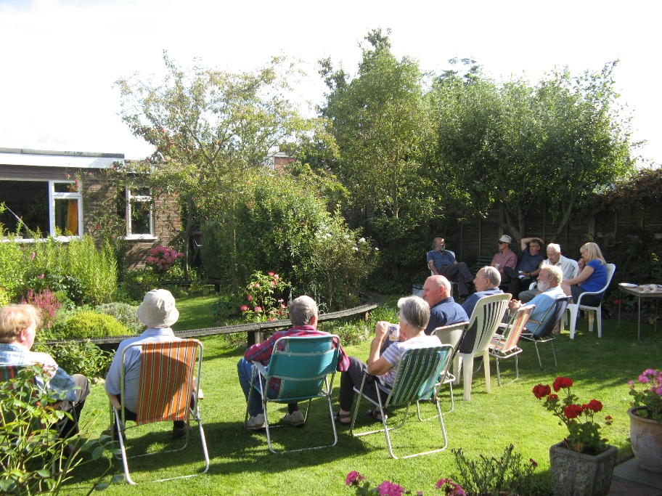Surrey Group
The Surrey Group was formed in 1998 by Alan England and now has around thirty regular attendees drawn from all over Surrey and the adjoining counties. We have access to eight garden tracks as well as the extensive facilities at Sutton Model Engineering Club (SMEC). Venues range from Sutton in the North West to Bansted and East Horsley in the south and Farnham in the South West; we also make an annual pilgrimage to Queen’s Park in west London.
We meet on the second Tuesday of the month throughout the year running in all weathers. Those of us who are SMEC members also join in with their second-Sunday and fourth-Thursday running days. Recently we have added occasional Friday afternoon and Saturday runs during the summer along with some evening runs for those that like to see fireboxes glowing in the dusk.
We are very informal in structure with no committee or officers. Adrian Johnstone organises the fixture list and sends out regular email reminders before meetings and Alan England looks after liaison with new members.
We are very fortunate to have some of the most experienced and knowledgeable members of the Association amongst our ranks with a broad range of interests. We have many live steam scratch builders as well as a good showing of members with kit-built and ready to run engines powered by coal, meths, gas, electricity and clockwork. Several members have tinplate collections, and we have even occasionally seen a few O-gauge interlopers on our dual gauge tracks.
You can read more about the group’s activities at http://www.cs.rhul.ac.uk/~adrian/steam/surreyG1MRA/index.html
If you live in the Surrey area and own or are thinking of acquiring Gauge 1 models then please do get in touch.
Contact: Adrian Johnstone a.johnstone@rhul.ac.uk
Contact details for these people are available in the Members Area.
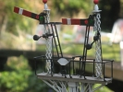
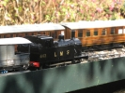
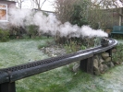
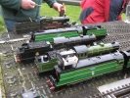

Vintage Tinplate Group operate working vintage train layouts at Model Railway Shows, Toy Fairs, Exhibitions etc. Forthcoming fixtures can be obtained by telephone from Dave Orchard 01527 874988 or Craig King 01622 851807

1:32 Finescale Group – See also their own page sub menu on this site (https://www.g1mra.com/joining-g1mra/local-groups/132-finescale-group/).
Contact: David Halfpenny at 1.32.finescale@gmail.com

The Gauge One 3D Circle
The Gauge One 3D circle is a discussion group for railway modellers working to a track gauge of 1 3/4 inches or 45mm who are interested in modern manufacturing technologies. You can find the group here.
The group aims are
(I) to share expertise in all forms of Computer Aided Design and Manufacturing as applied to Gauge 1 modelling,
(II) to create a series of freely available high quality parameterised 3D models of Gauge 1 items.
You may also be interested in our sub-group for control systems in Gauge 1 which you can find here. We meet over Zoom every Thursday, alternately at 16.00 and 19.00 London time to allow for folk in different time zones.

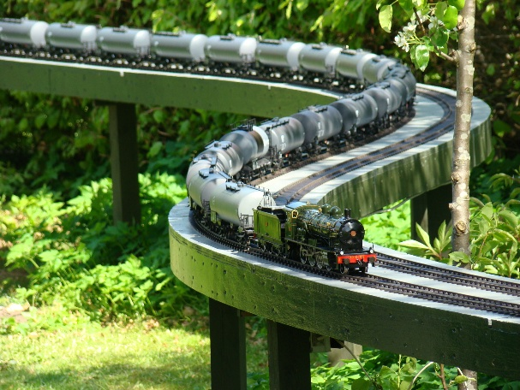
Danish Group
Members of the Danish Group are spread throughout the whole country. There are only a few tracks available for GTGs, and most of them are small. Never the less enthusiasm is very strong and we still attract new members. Plus we have the pleasure of having one of the best garden tracks available to our disposition: The Krogen Layout.
The Krogen Layout consists of a circle and a folded bone. Length of the folded bone is approx. 200 meters.
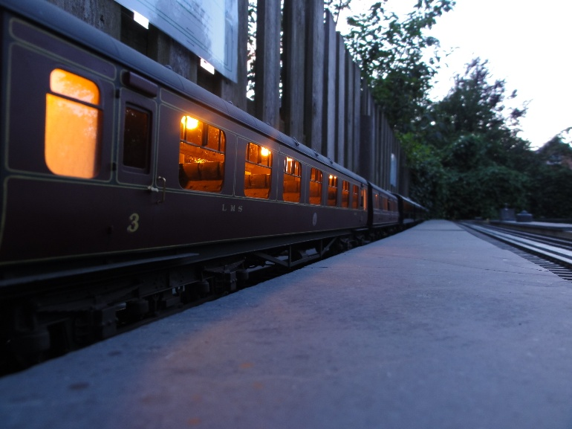
All in all there are more than 460 meters of track at the layout.
Main running track is therefore the Krogen Layout, located in the garden of Hotel Krogen, Aalborg.
Currently, monthly meetings are held on the first Sunday of the month (April to October) at the Krogen Layout, from 13.00-17.00. Folks visiting the area and wishing to join us for these meetings should first contact David or Aksel by phone or e-mail – phone numbers in the member’s list.
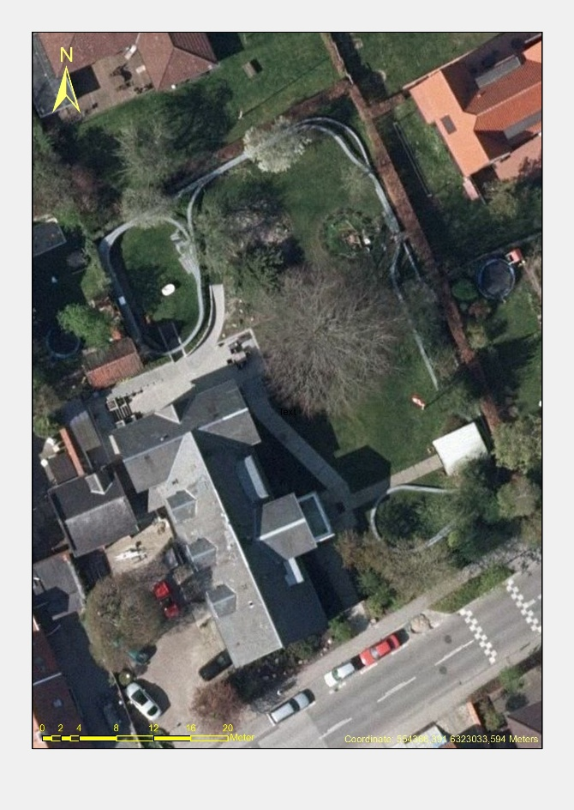
Contact: David Clement or Aksel Clement
Website (Danish Group, in Danish): www.havebane.dk
Website (hotel): www.krogen.dk
Contact details for these two are available in the Members Area.
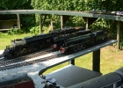
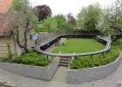
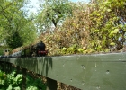
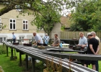

France, Longjumeau Group
In France, a country twice the size of the UK with roughly the same population, there are only about 45 G1MRA members. There are other G1 enthusiasts in France but for various reasons they don’t all belong to G1MRA, often because of the language barrier.
In late 2009 a small group of live steam enthusiasts founded the Essonne Vapeur Club 45. Essonne is the department or county, 45 is for the 45mm track. To attract members we opened the club to anybody running live steam on 45mm track. In the autumn of 2011 we were very fortunate to secure the support of the Longjumeau municipality (about 20
km 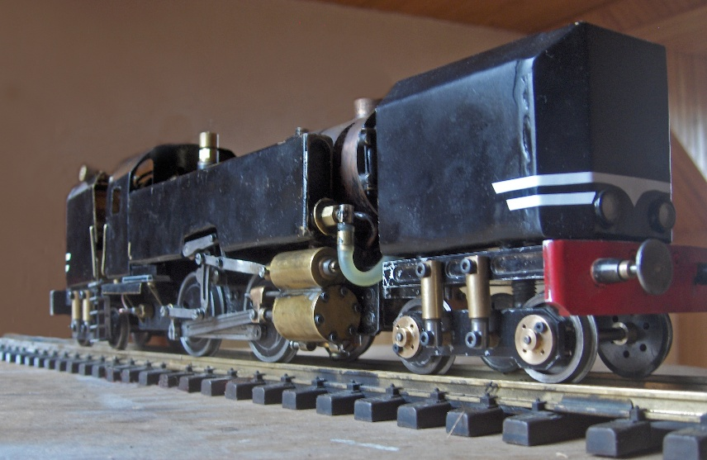south of Paris) who not only offered us the use of a gymnasium once a month but also modified an adjoining storage room to house our portable layouts – we had two by now. We were in business. Even in winter!
By the end of 2012 we had 30 members running a mix of G1 and 16mm. The seven G1MRA members make up the Longjumeau Group, France. None of us has a G1 garden layout. We meet monthly on a Saturday or a Sunday in the gymnasium and participate in exhibitions elsewhere in France.
Several members have built locos from scratch, and five members are currently looking into the possibility of building a batch of G1 Atlantics.
We are a very young club and are a long way from the beautifully matched trains we see in the N&J. Our aim is simply to run, so most of our trains will make a purist shudder. You can see what we get up to by typing EVC45 into Google. But be warned! If the sight of such things as a plucky Mamod pulling a gleaming J&M CIWL coach on lumpy track on a shiny baseboard makes you choke on your cornflakes DON’T WATCH.
But if you can bear it you are welcome to come along and join in the fun. Contact Jacques Cabeza or Hugh Hutchinson.
Contact details for this person are available in the Members Area.

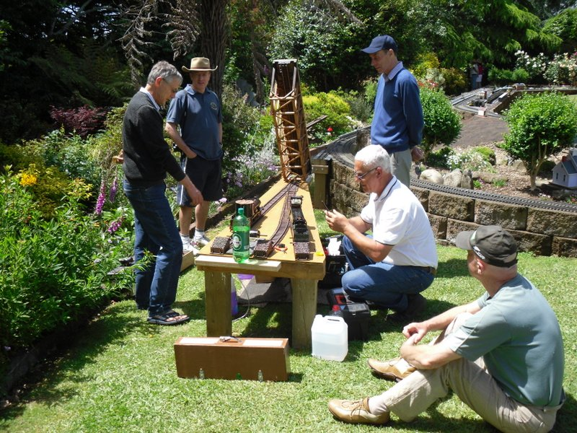New Zealand Group
The New Zealand Group of 16 members covers the whole of the North and South Islands (103,738 sq. miles) and doesn’t have any subgroups. Most members attend three of the four North Island tracks during the spring and summer months with informal meetings running from 11.00 am to 5.00 pm. The ladies usually provide lunch because of the large distances travelled.
Members mainly run UK and USA steam outline locomotives with some preferring to run track and battery powered models. One new attendee hasn’t powered any of his stunning NZ outline models because he didn’t know of any local tracks to run them on! His next model is definitely going to be track powered.
Non running get togethers are being planned for the autumn and winter months for education in model engineering construction techniques along with practical demonstrations.
We have two new tracks in the South Island and Group members have many locomotives, coaches and rollingstock under construction.
Advice is freely available at the meetings on how to maintain and run locomotives and assistance is given where possible to resolve any problems.
For more information please contact Geoff Hallam about the Group and running days. A warm welcome will be made to anyone wishing to join us.
Contact: Geoff Hallam
Contact details for this person are available in the Members Area.
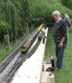
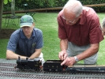
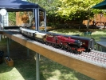
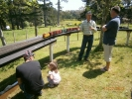

The Swiss Group does have its own website: www.g1mra.ch
Contact: Yves Rittener (1393), Trachterholzstrasse 11, CH-8708 Männedorf, Switzerland
Phone: +41796164013,
Email: yves.rittener@g1mra.ch or g1mraschweiz@gmail.com
Website: www.g1mra.ch

US, Puget Sound Live Steamers
The Puget Sound Live Steamers are a small but active group living in and around Seattle, in the Pacific Northwest of the USA. We have a hard core of around 20 regular members and 20 more occasional runners.
We meet on every second Saturday of the month at the Puget Sound Garden Railroad Society live steam portable layout (we are members of the PSGRS), and again every 4th Saturday at a members house, we have 9 to choose from. We also meet for breakfast at IKEA 2 times a month for our liars club get together where we exchange magazines, ogle at new acquisitions etc. Some of us also attend the PSGRS meet on the 3rd Saturday, so you can see we are pretty busy.
Our meets run from 10:00am to around 2:00pm, and as well as running trains we bring hot dogs, salads and drinks for a lunch party. Generally there are 2-3 trains out on the line at any one time with the rest of us looking on and enjoying the occasion.
We have a wide range of train interests. Some of us model US narrow gauge, and we have many 1:20.3 Accucraft locos such as the C-16, K-27 etc. There is a keen interest in US mainline with Aster Berks, Mikados, Daylights and GN S2’s pulling gargantuan trains at high speeds. There is a lot of interest in British mainline, mostly Asters, and British narrow gauge, represented by Roundhouse locos. Some folks also run French and German trains. Some members have built up quite a collection of vintage steam and clockwork trains from the 1910-1930 era, mostly UK, German and US models, and it’s a pleasure to watch the old tinplate rattling around.
Twice a year we up tracks and head off to Portland for the famous Staver locomotive convention, and we also participate at the local ‘Thomas the Tank” days where we show off our steam and electric trains to thousands of kids, and get a few of them interested in the hobby.
Contact: Pete Comley
Pete Comley
Sunset Valley Railroad LLC
(+1) 253 862 6748
www.svrronline.com
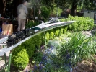
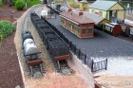
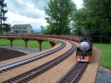
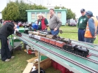

US, Southern Group

We are pleased to announce the formation of the G1MRA, US Southern Group.
Participation in the Southern Group activities is open to all G1MRA members,
but will mostly work to meet at tracks in South Carolina, North Carolina, and Georgia.

Formed by a 100 percent quorum of the G1MRA South Carolina membership,
the first formal gathering is scheduled in May 2014.
Many members initially queried about joining are live steamers,
and most likely, the G1MRA US Southern Group will meet at tracks which have no electrical power.

To join the mailing list, check on upcoming events, or to volunteer to host an event,
contact the Southern Group Chairman, Steve Baker, #4006.
Contact information is in the membership directory.
The group’s web presence is hosted by Jim Pitts, #1807 at
www.SouthernSteamTrains.com

Commoners in the colonies of the Carolinas and Georgia,
who are members of G1MRA UK, are invited to join with us.

