Welcome to

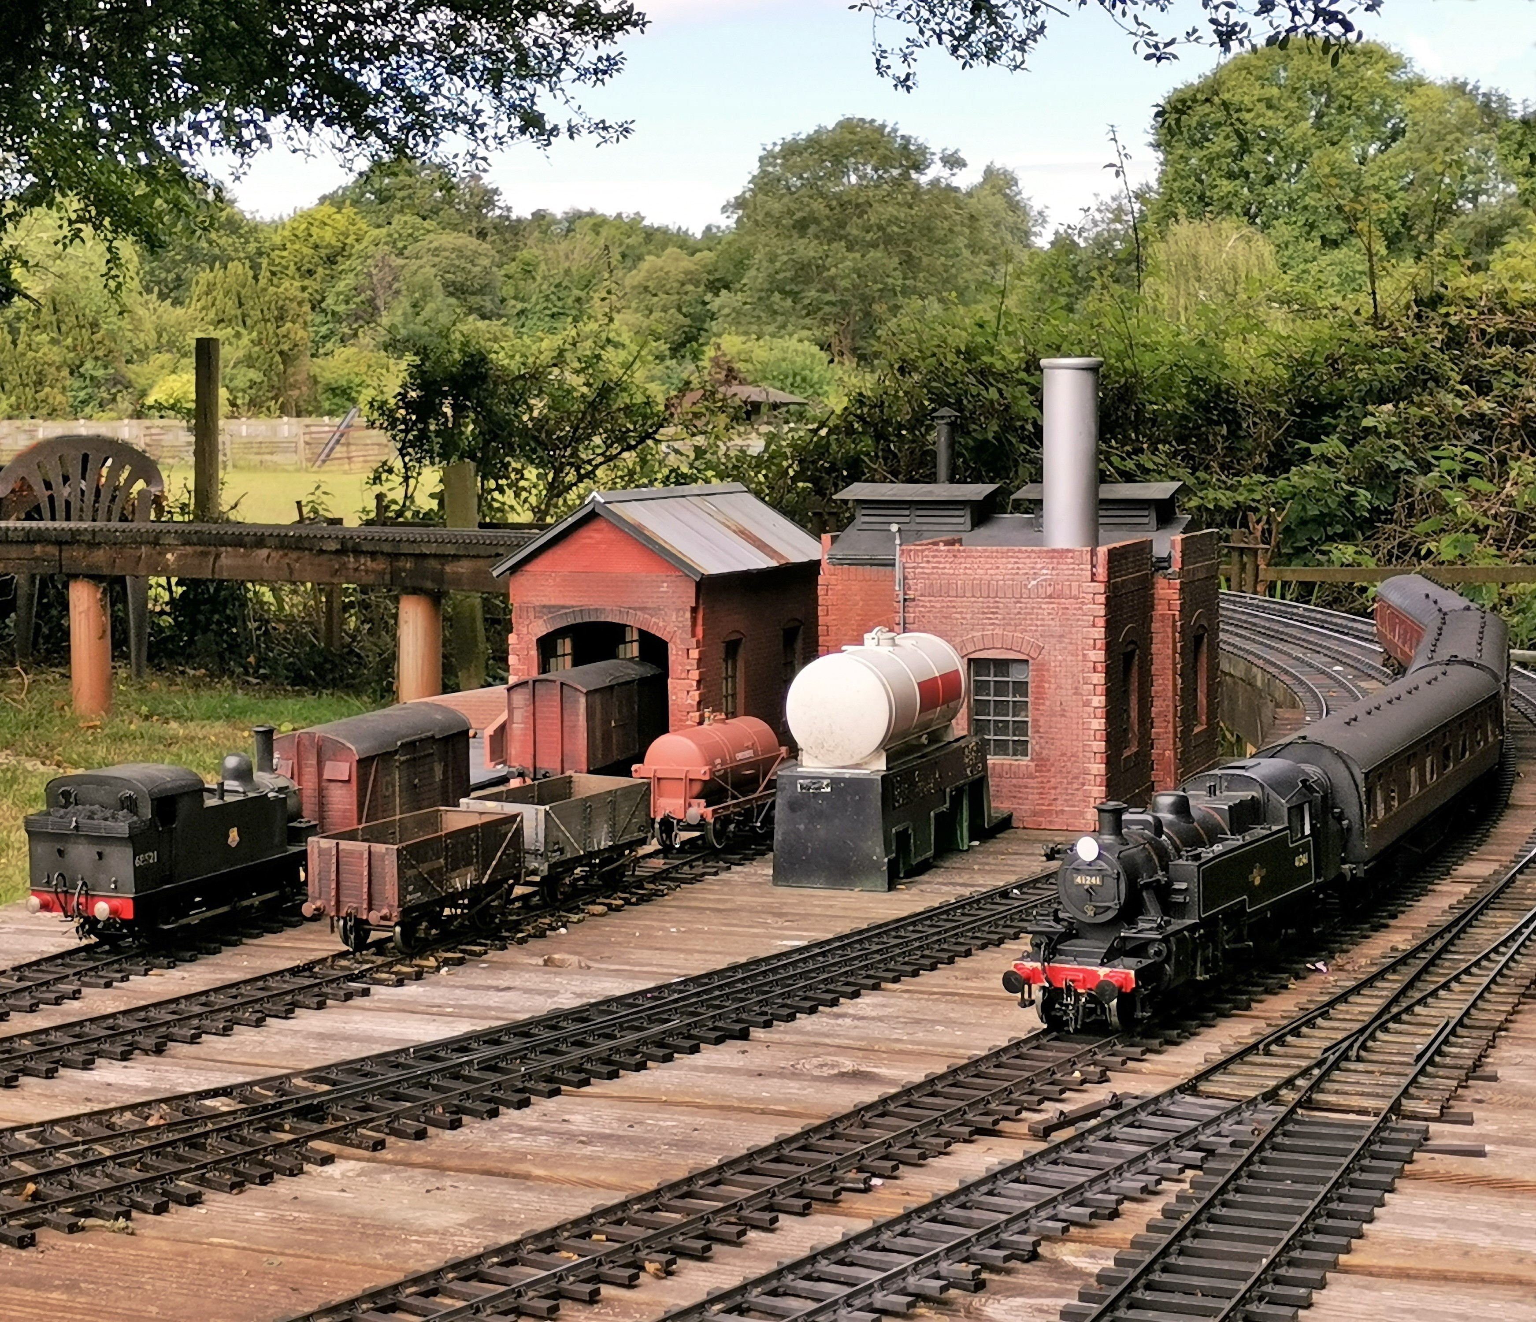
Gauge 1

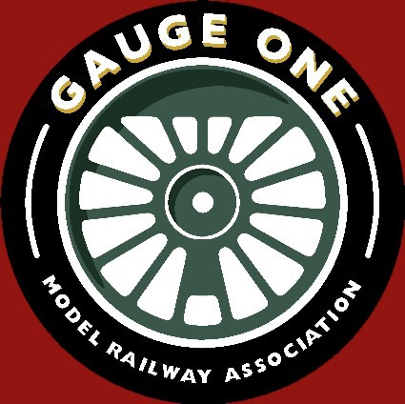
Starting in Gauge 1 with
The Gauge One Model Railway Association


Who we are

The Gauge One Model Railway Association
The Association was formed in Britain in 1947. Mem-bership has grown to over 2,000 in Australasia, Europe, North America, South Africa and the United Kingdom.
Meetings, Shows and Exhibitions
We organise a Spring Show, and a Show around the An-nual General Meeting in the Autumn. Local groups display at regional shows such as the Midland Garden Railway Show and GlMRA Yorkshire Group's Gauge One North, and have seasonal running at members' tracks. Winter activities in-clude indoor running, layout construction, films or speakers
Modelling aids
Paul Forsyth drawings for twenty live-steam British locomotives, of the 1900-1960 period.
Cast parts for tender, wagon and coach underframes. Wagon and coach wheelsets.
Track construction diagrams and cast chairs. Standard Dimensions for Gauge 1.
Publications
Our Journal is published quarterly in March, June, Sep-tember and December; ninety-six full-colour pages of news, articles and advertisements. We publish a selection of tech-nical books on modelling practical live-steam locomotives, coaching and freight stock.
Website
Our website www.glmra.com has public access to sam-ple copies of the Journal, and details of local groups. Mem-bers can access all issues of the Journal back to 1948, and profiles of other members with their interests and contact details. French and German texts are available under 'International'.
How to join
Joining is simple by mail, email, telephone, in person at exhibitions, or our website in minutes. Membership runs from 1 January to 31 December. You immediately get a membership directory, then quarterly copies of the Journal.

MY HOME ASSOOATIONBUSINE'SS., STANDAADS JOUII.NA.lli PHOTOS NEWS&EVENTS 7SEIIENT MEHllBI.OIR!CTCIRY MYPllOFl.E., GAUGEON:SCENE - 0. �
re�::;.,
1 1�
YEAIIS

mzm-�-...Oor ----ow:lt,1.1,1175 7w.-_.,--

_&,..,...115 ..,,.,,..,,,._ 1.15---U.OM-- .....,.., --Gt-.

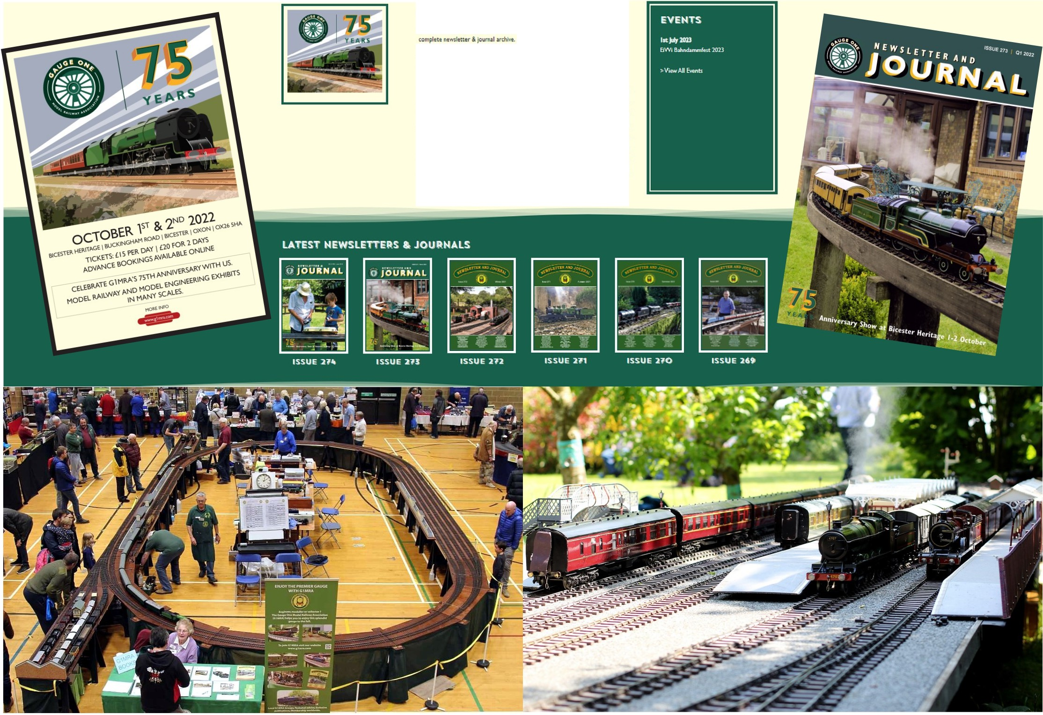
WELCOME ROD CLARKE
Au ,ubs<rib.d tMmb.r,you"°"" ful ><<•u to >I ,o ,,..,tl.o lit• ..Ch.di,,l tM

Yoo<-1,i1l,o?Ul>l,ohyo""owo ,.,.,...,,.,..1""'�"""lp>1tamdolurt;i,..;ih
e GIHMSHOP
Cover: Bicknacre Junction. Above: [clockwise] 75th Anniversary; Website; Journal; Garden track; Group indoor track.

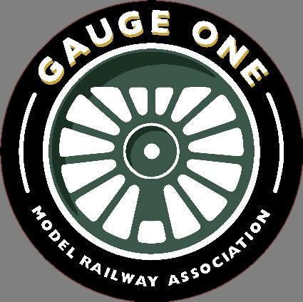

Something for Everyone

Getting Started in Gauge 1


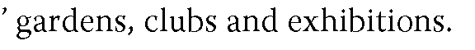
Where can I run my models?

How much does it cost?

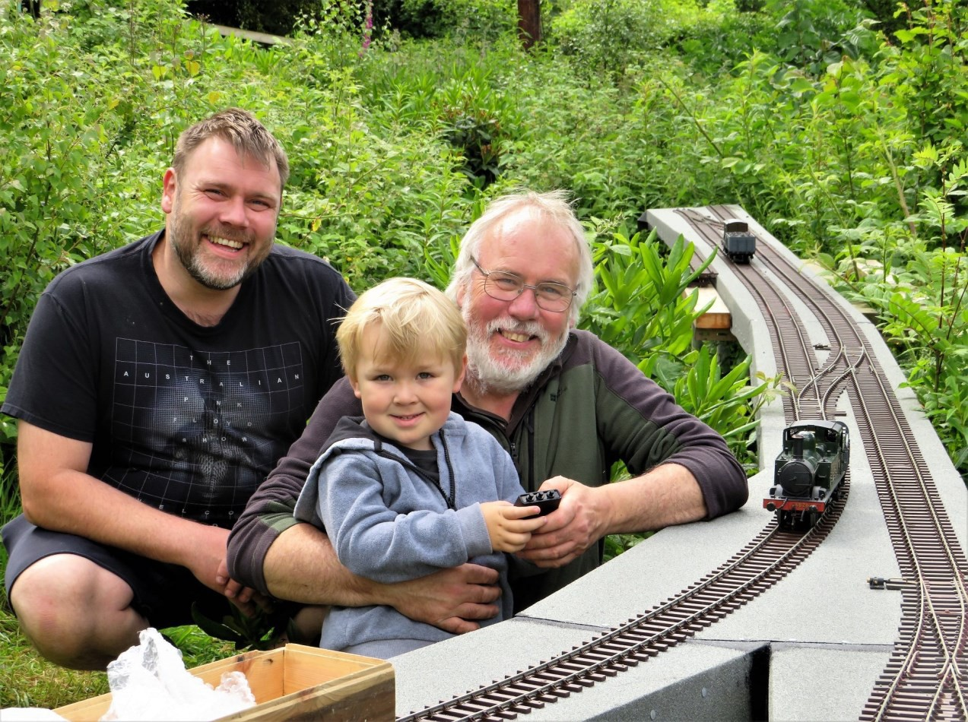

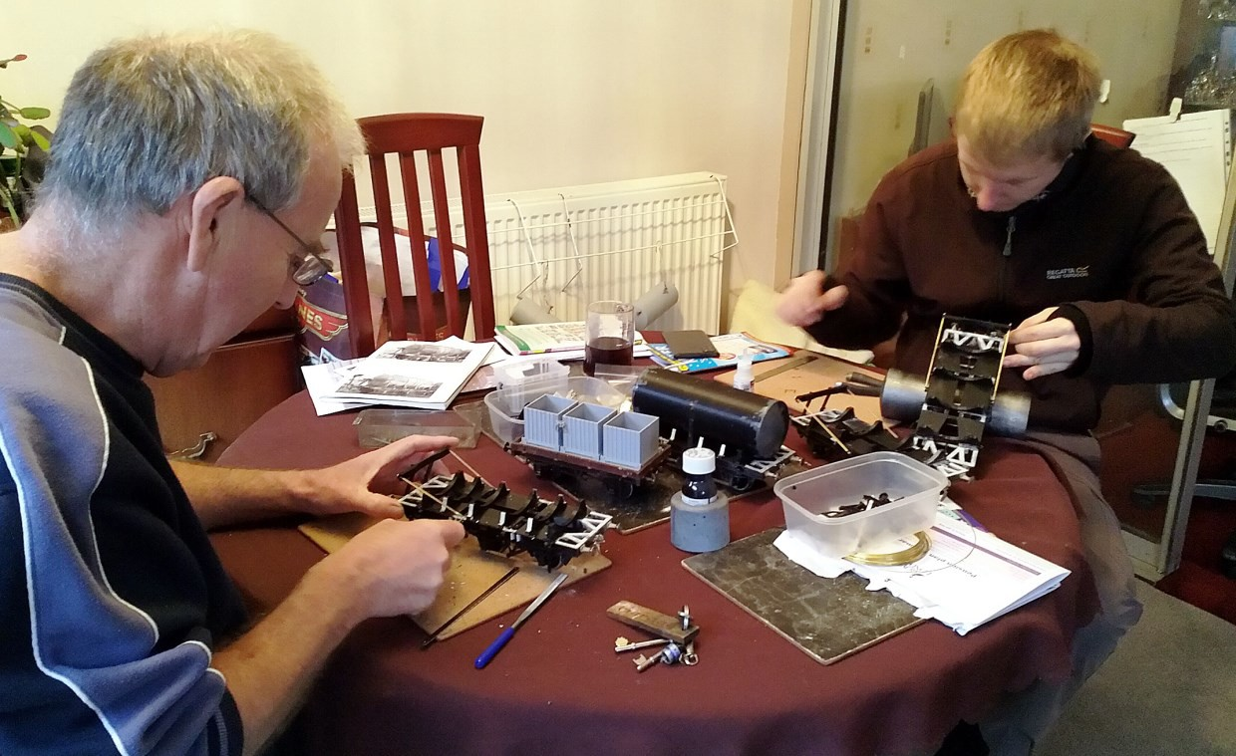



What can I model?

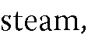

What are the layout options?



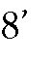
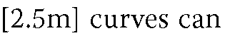
How much space do I need?

Learning more and meeting others
What scale should I model?

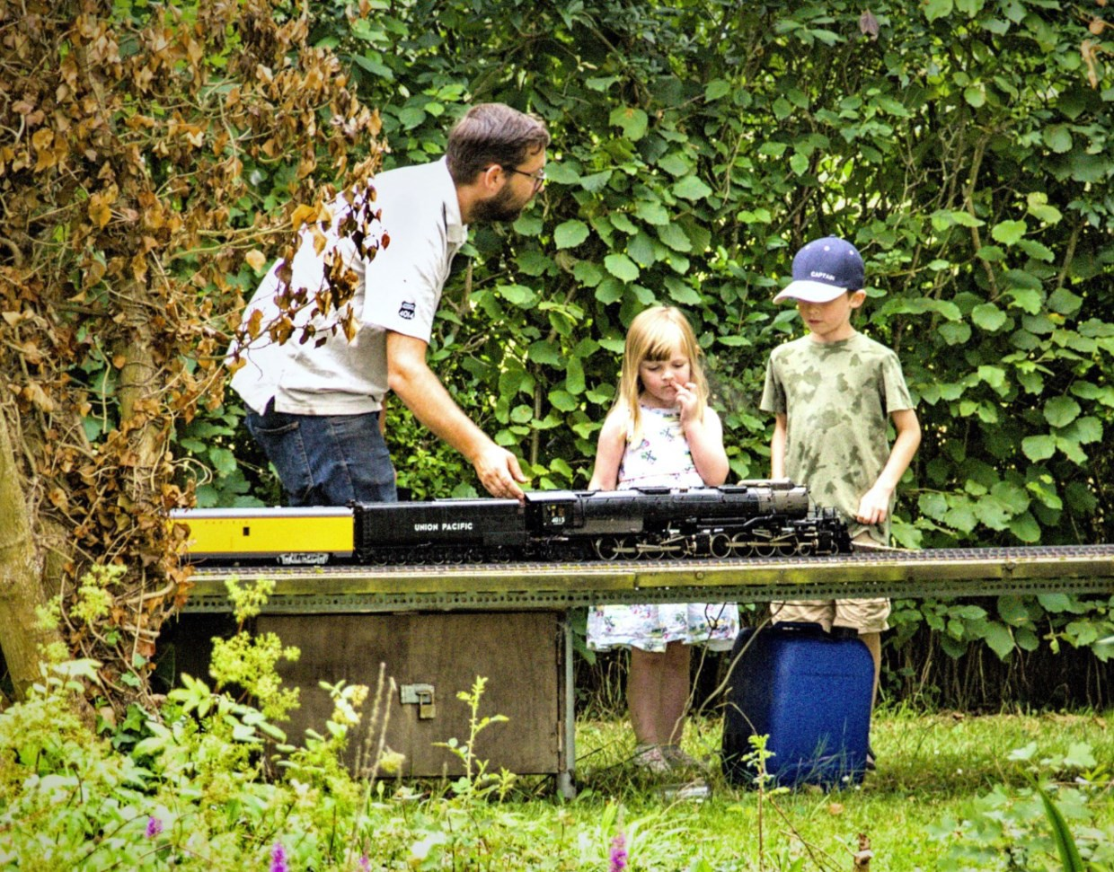
Will my stock run on Gauge 1 track?


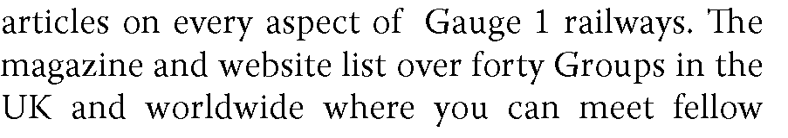

A great attraction of Gauge 1 is getting together to run trains
Local Groups




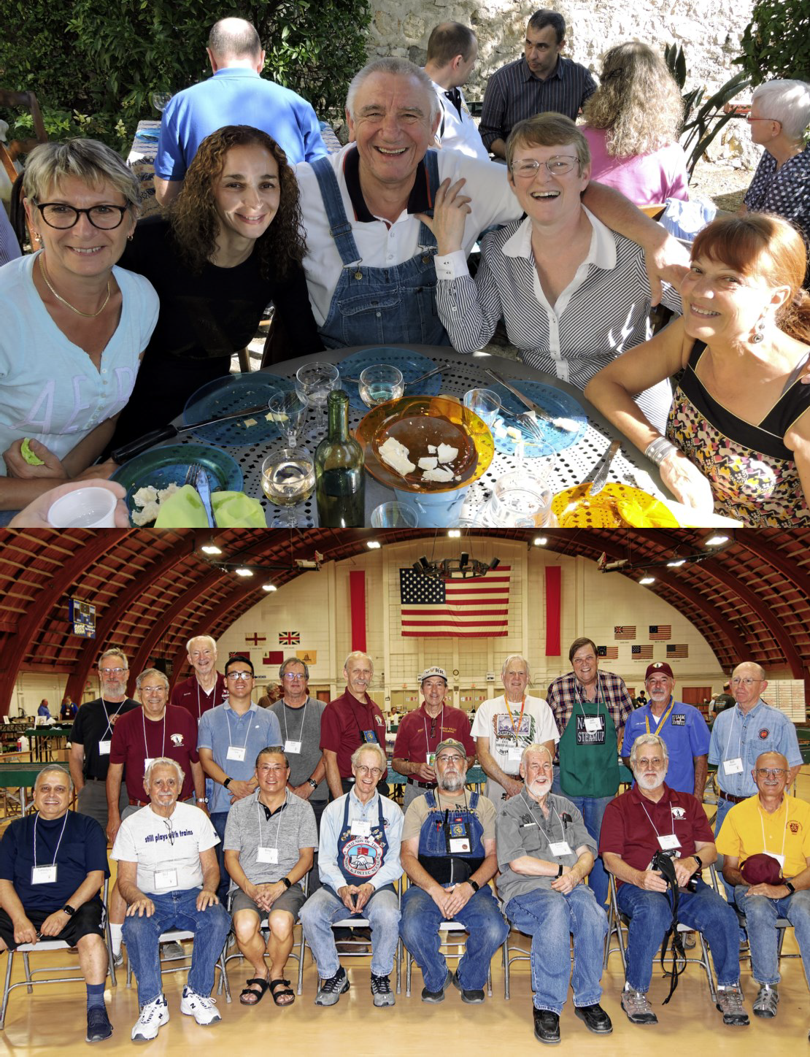
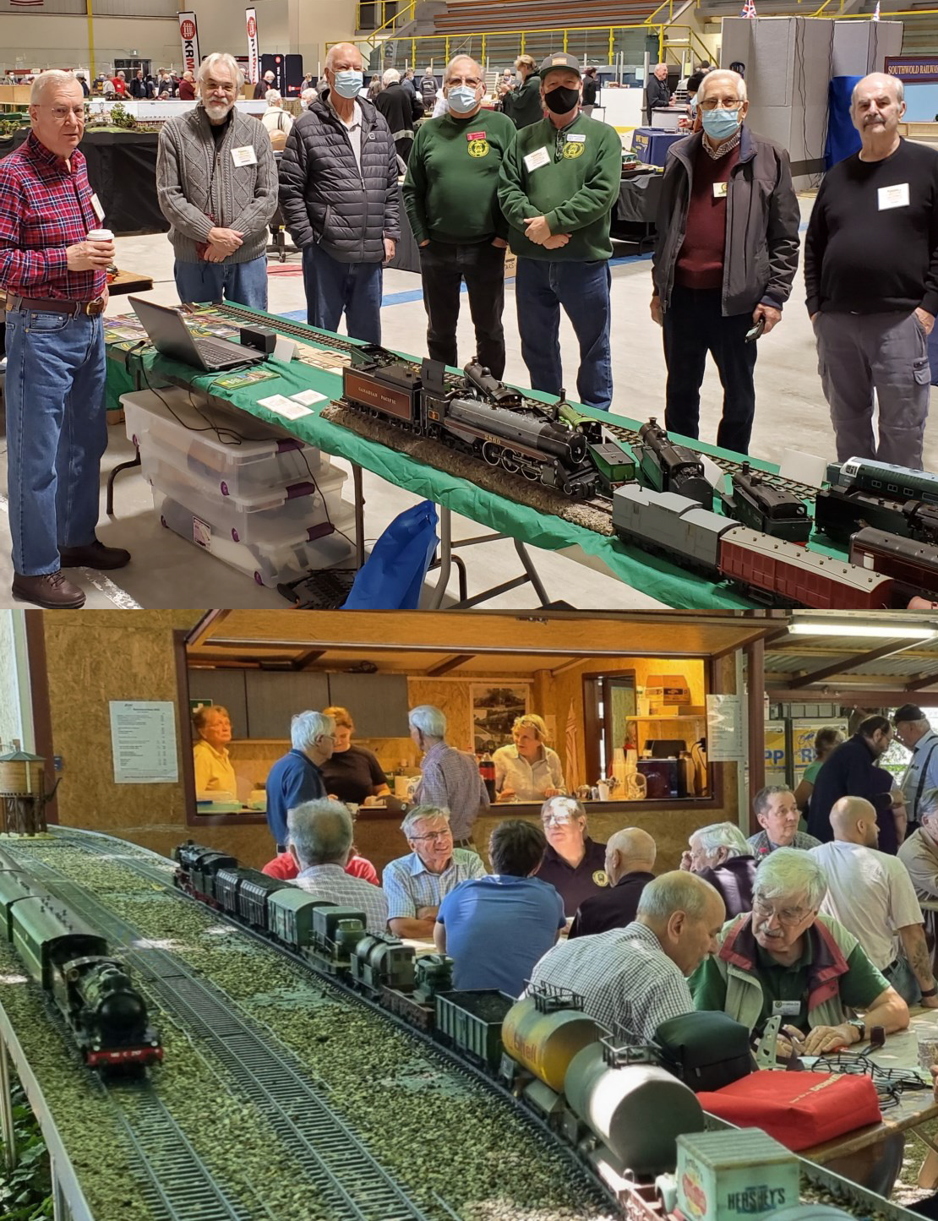
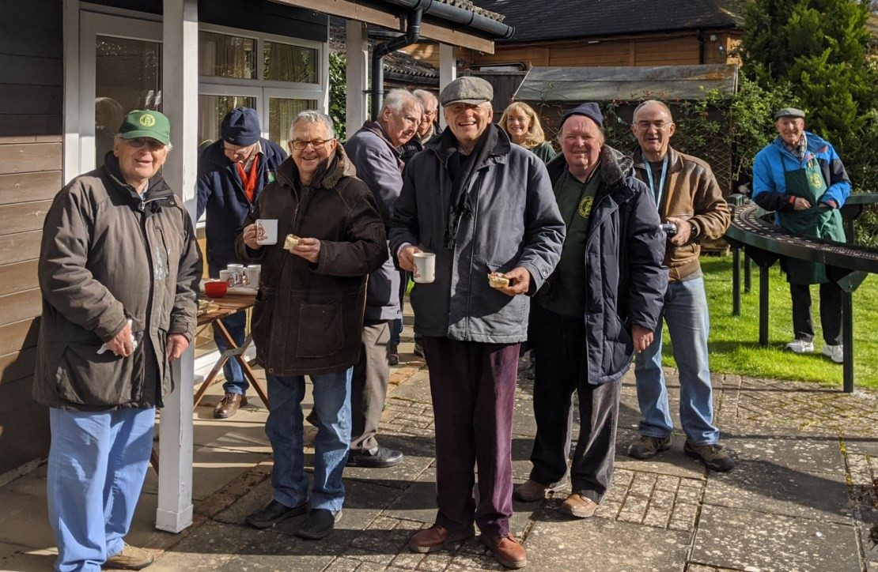
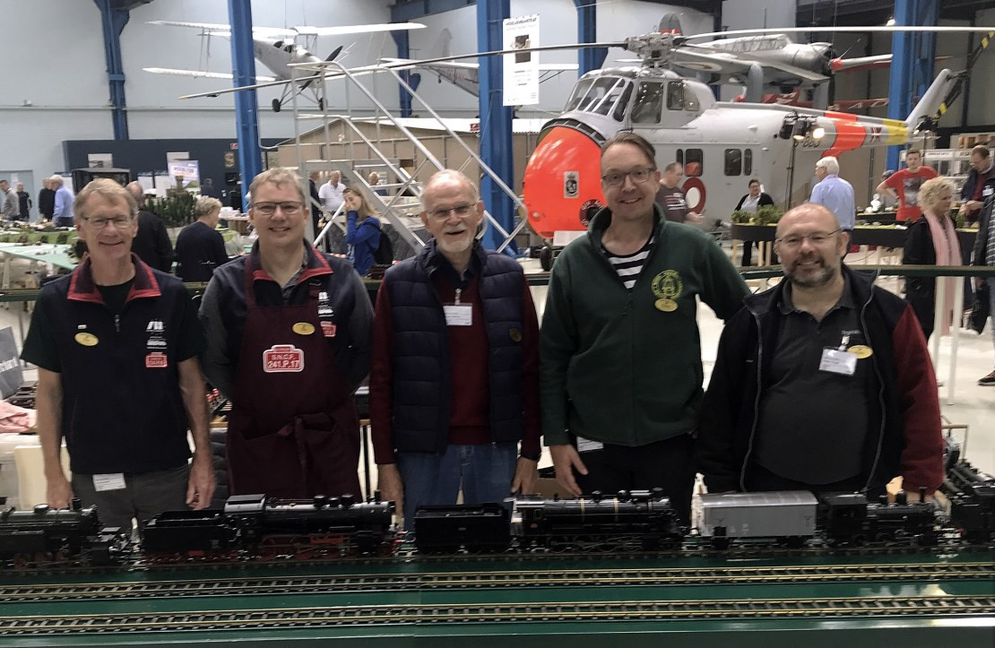


Rod Clarke [Canada] found Gauge 1 live-steam to be Just Like the Real Thing.
Live-steam

If you come to Gauge 1 from a smaller scale, as I did, you may be surprised at the popularity of live-steam models. This has much to do with our engines being the smallest which replicate all the prototypical features of water, fuel, firebox, multi-tube boiler, regulator, steam blower, valve gear, cylinders, pistons, safety valve, ex-haust jet and gauges. You become the designer, con-structor, maintainer, driver, and fireman all in one.
Early models were fuelled with alcohol, but butane gas-firing is now reliable and popular. Coal-firing is con-sidered the ultimate.
Fill the boiler and fuel tank, light the fire and watch the boiler pressure rise. Steam will move the engine in a few minutes.
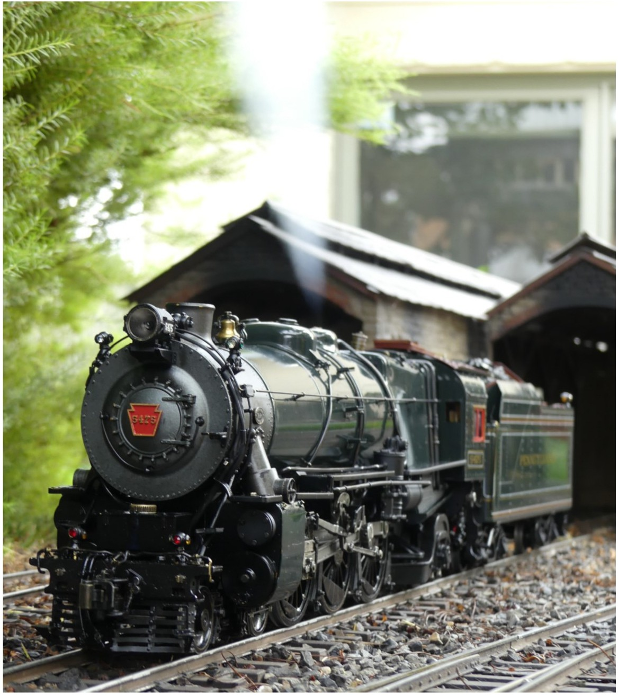
These engines are driven! So, you follow them closely, adjusting the speed to the load and gradient, and adding water and fuel as needed. Just like on the footplate!
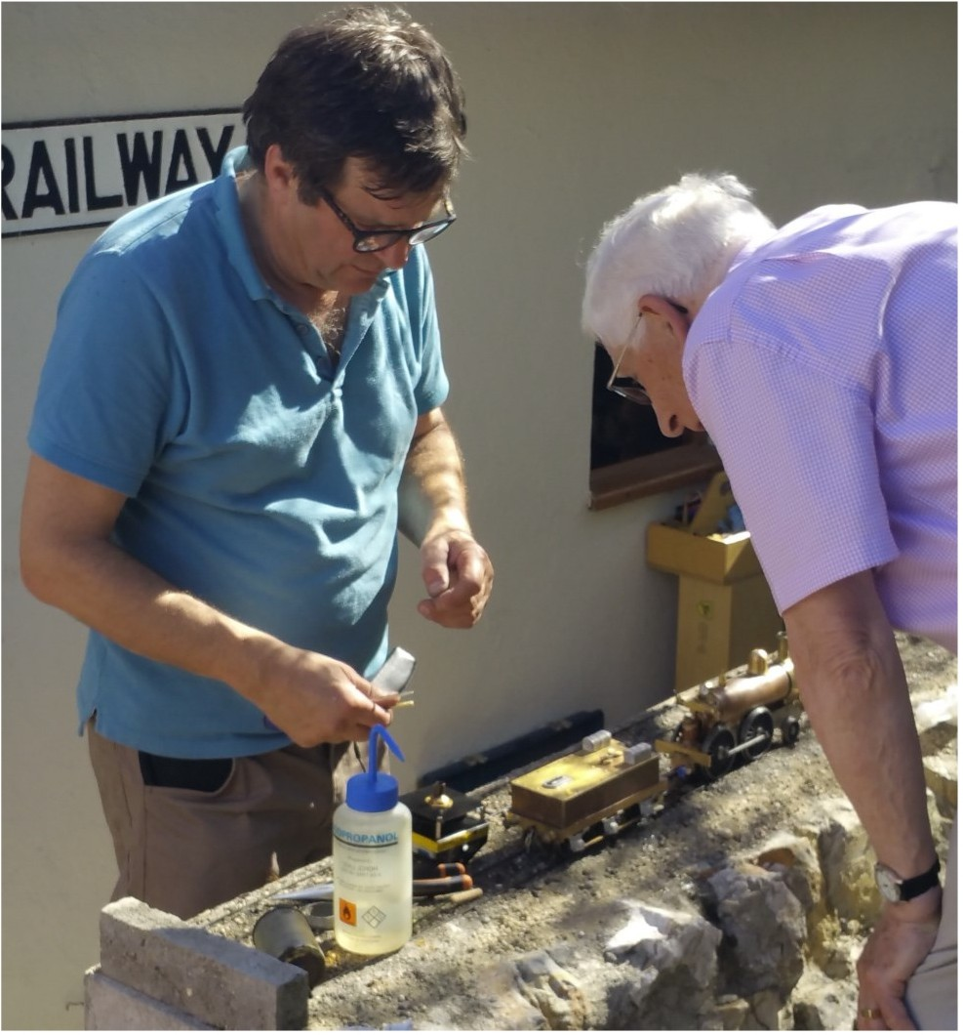

You will see individual models of an enormous range of prototypes, hand-built by enthusiasts. If you have mechanical aptitude and access to tools, such as a drill-ing machine and a small lathe, you can scratch-build an engine from raw materials.
GlMRA sells a wide range of locomotive design drawings from the Paul Forsyth collection, and several booklets on locomotive projects. A number of suppliers sell detail parts to help.

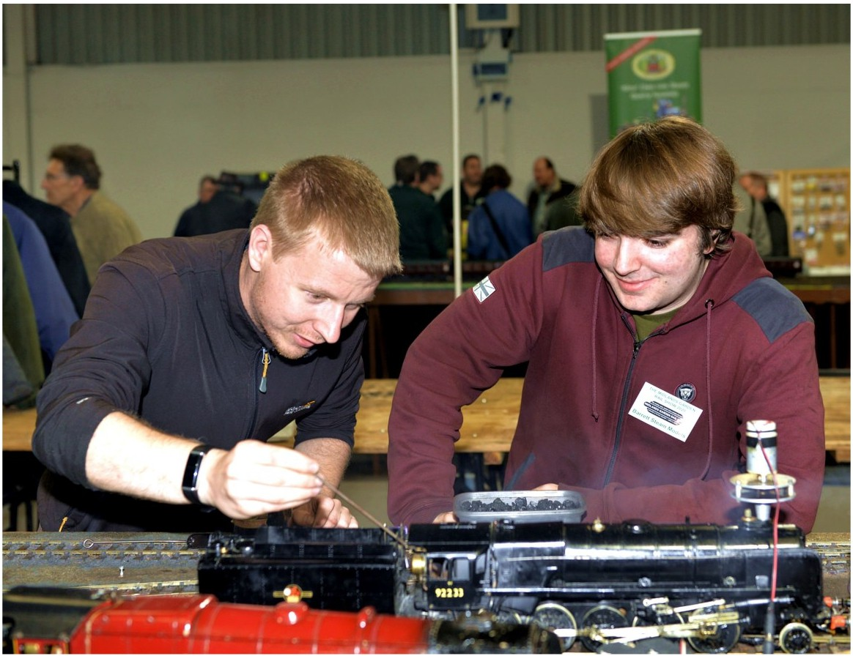

If you are a newcomer it's wise to start by purchasing a simple model. A practical start might be a small, moderately detailed, tank engine
Gauge 1 is a small market so the range of commercial models is more limited, but kits are available for locomotives of different sizes, complexity and cost. Commercial RTR engines are also available as kits for assembly with hand tools.




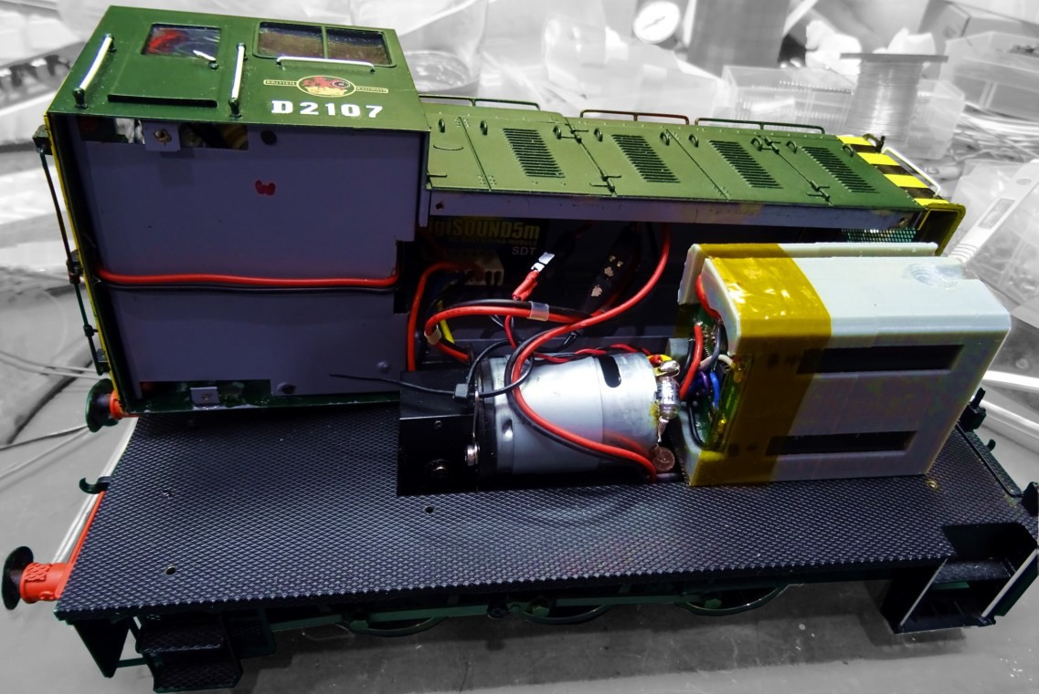


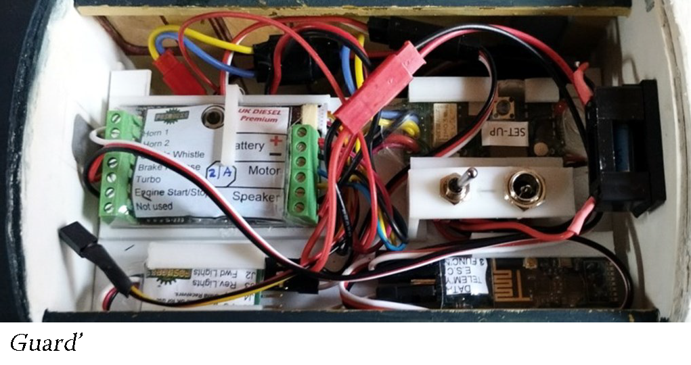


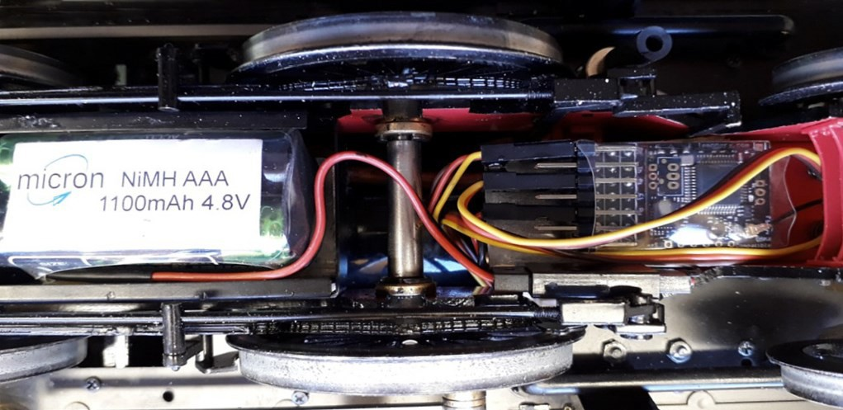
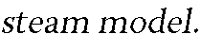
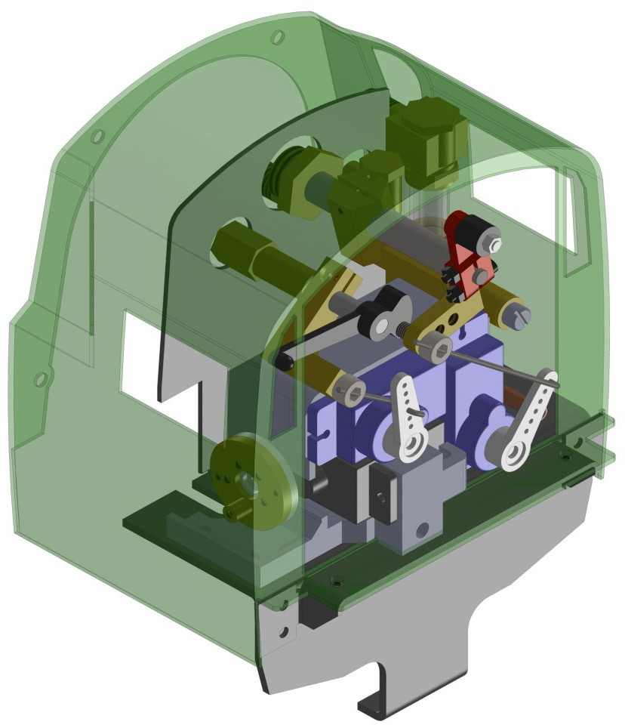

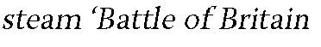
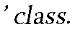





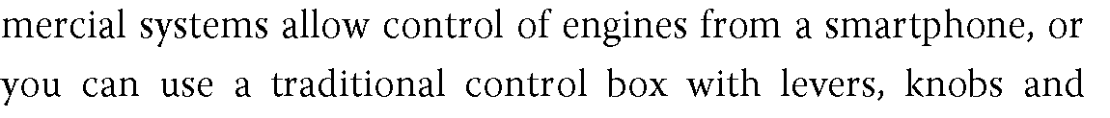

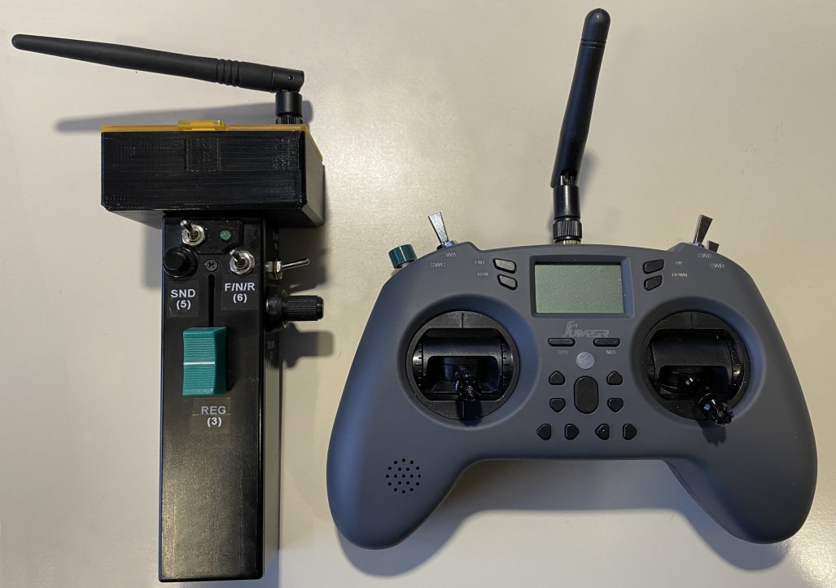
Peter Jackman and Peter Newbury, [UK] apply RC and electronics to Gauge 1.
Battery-electric, radio control and electronics



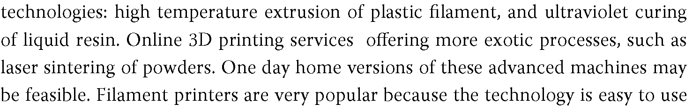





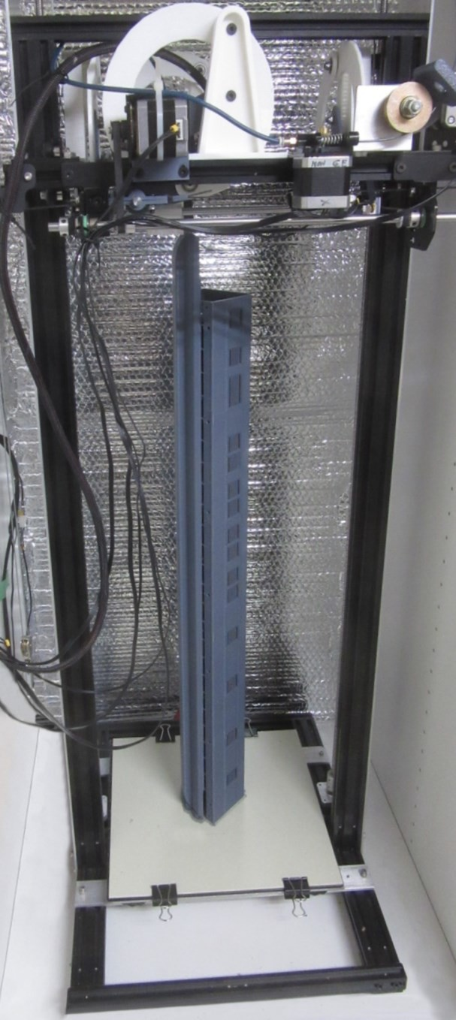

Adrian Johnstone [UK] and members invite you to the Gauge One 3D Circle.
3D Printing

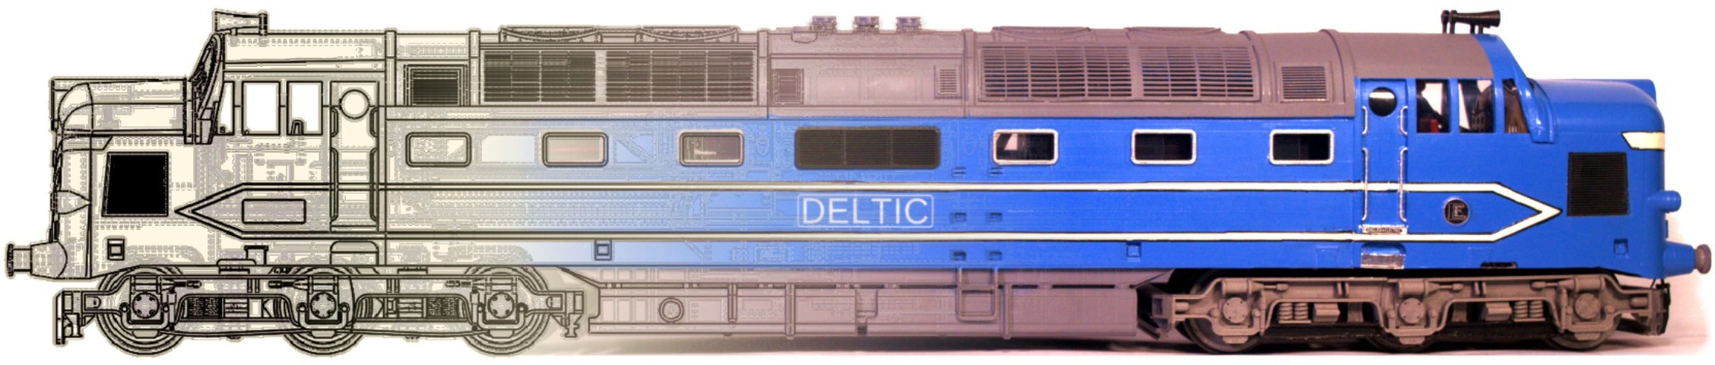

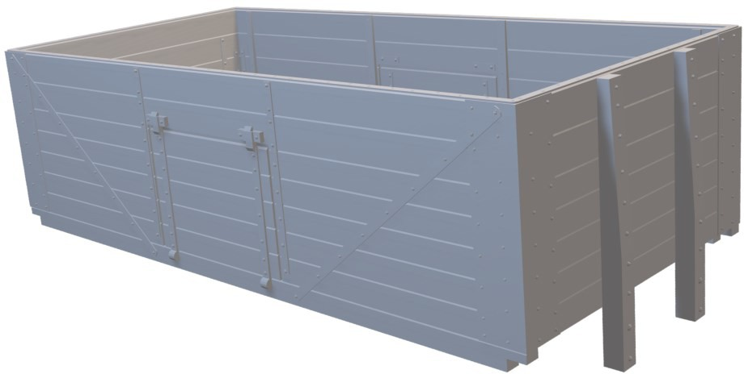
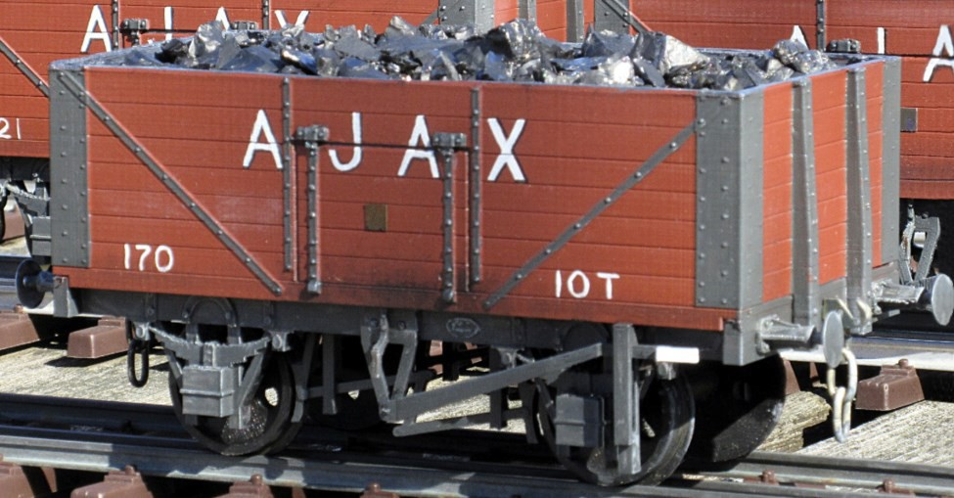


Rob Kuhlman [USA] found a Ruston 88DS kit ideal for a starter project.
Locomotive kit building

I've always been attracted to little internal combustion 'critters' and when a manufacturer introduced three very inex-pensive kits for four-wheel locomotives I ordered the Ruston 88 DS shunter. Ruston and Hornsby of Lincoln were best known for their little narrow-gauge engines, but they also produced small standard-gauge shunters for industry. The 88DS [Eighty-eight horsepower, Diesel Shunter] was introduced in 1938, and many examples continued operating well after Ruston sold its last loco-motive in 1970.
The kit is a combination of 3D-printed parts for complex shapes, and laser-cut acrylic pieces for flat panels. Assembly in-structions are provided on the maker's website for both the loco-motive and the motor assembly. I generally dislike using cy-anoacrylate adhesives because they seem to lose holding ability after several years, so I used two-part epoxy for the acrylic corn-
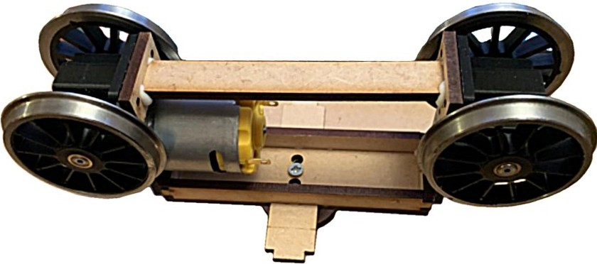
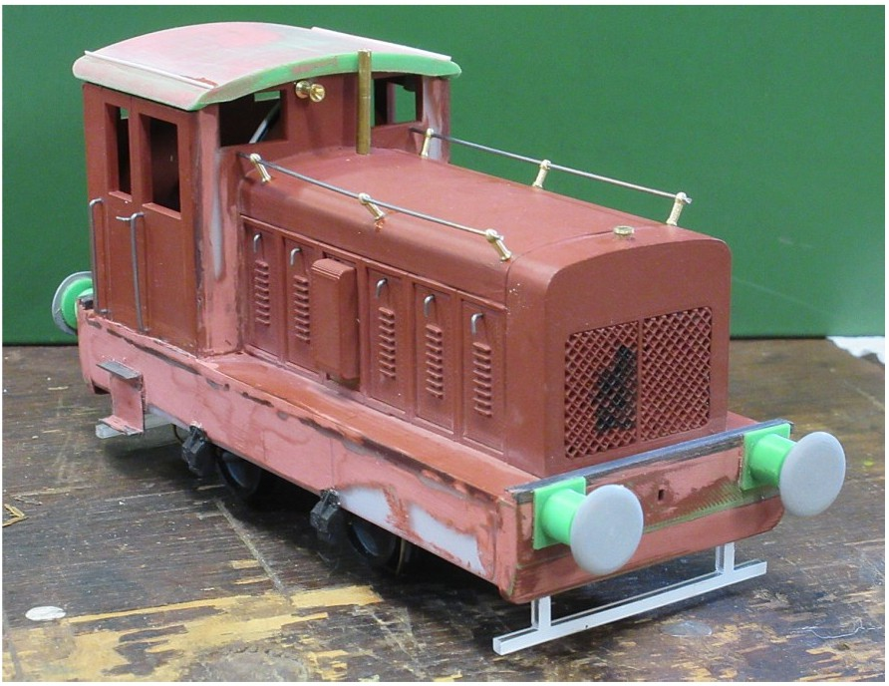
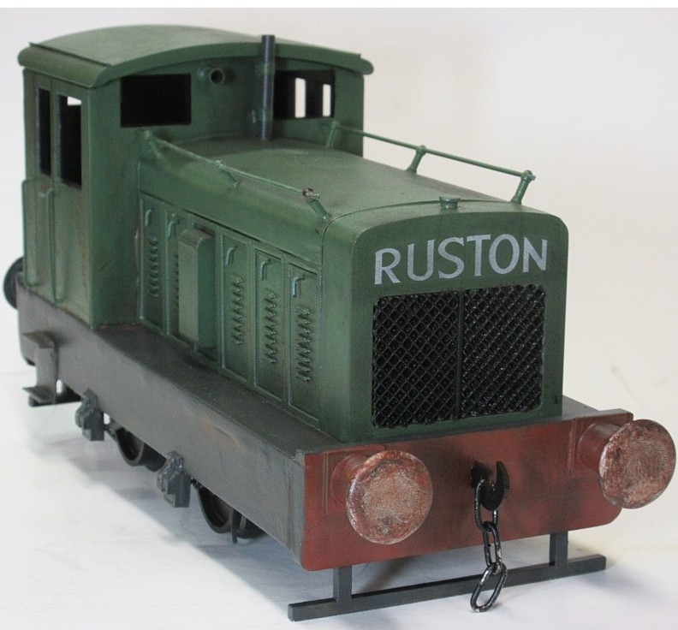

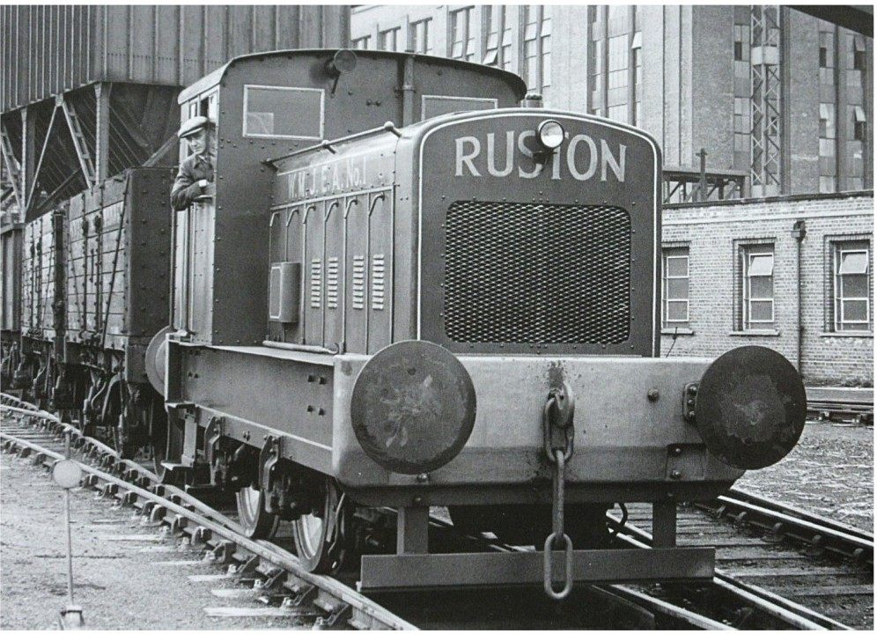
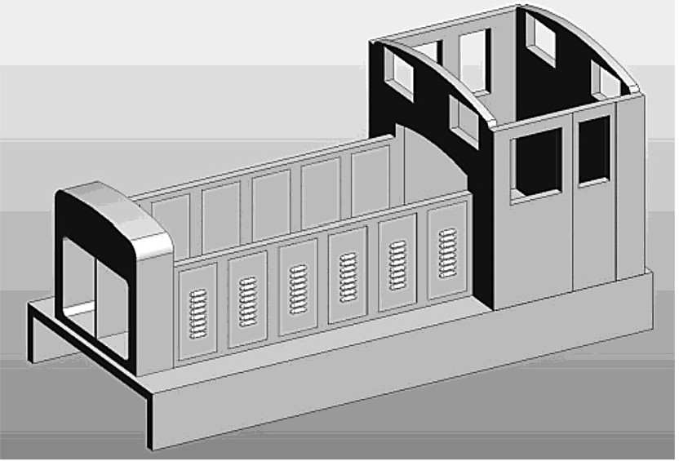
ponents. The frame, hood, and cab are assembled first, and several tab and slot joins assist with alignment.
The acrylic hood side panels are pre-cut to accept the 3D-printed louvred access doors. Make sure these prints fit com-fortably in the cutouts. The locomotive's body seems to sit too low on the motor block, partly hiding the wheels. So, I made a pair of 3mm tall spacers to fit between motor block and body, to raise the body and expose more of the wheels.
Construction yields a simple, sturdy engine for less than
£100 - a bargain. I tried to match the prototype appearance by making details from odds and ends. The noticeably large buffer heads were represented with styrene disc overlays. Styrene strips made gutters for the cab. I free-hand turned a brass horn, and added handrail stanchions for the top of the hood. I used music wire for the hood handrails, the cab ac-cess door latch handles, and the cab grab rails. The radiator cap was soldered from brass bits, and K&S brass tubing was used for the exhaust stack. Prototype photos show frame plate details, so I added axle boxes, snubbers brake shoes, and cab steps. Sand pipes were bent from music wire and inserted into lumps of plastic glued on the side frames.
I was guided by wonderful drawings and photographs in Andrew Neale's 'Ruston & Hornsby Diesel Locomotive Al-bum'. Thanks to Tom Eivers of Endon Valley for the 'Ruston' transfer on the radiator, and many more to the manufacturer for seeing a need for affordable entry-level locomotive kits.


Alan Leslie [UK] shows how he constructed a basic laser-cut van kit.
Vehicle kit building

I purchased this Southern Region four-wheel, long-wheelbase, Parcels and Miscella-neous [PMV] van as a kit. As I model mainly the BR-era Scottish Region, it might seem an odd choice, but I found pictures of similar vans as far north as Wick and Thurso.
I laid the kit components out for checking prior to assembly. The MDF parts went togeth-er easily using PVA glue, as did the detailed strapping. The kit has 3D-printed buffer bod-ies, and drawing pins for buffer heads, but I substituted Peter Korzilius sprung buffers.
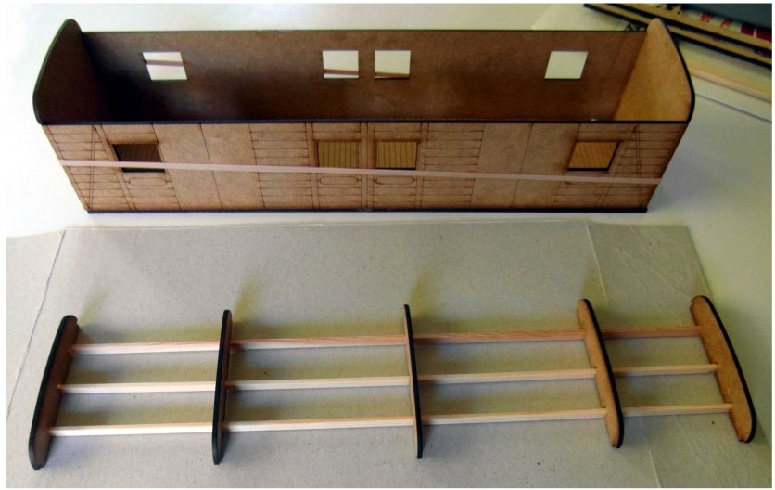

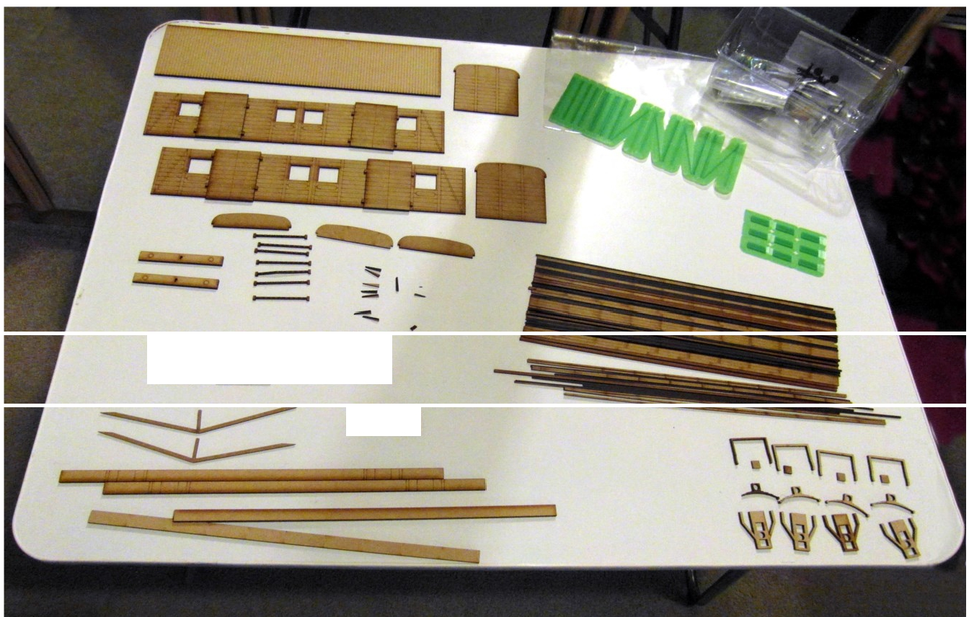
f-f...--II. .--II-..-.:z:::r.
- ■

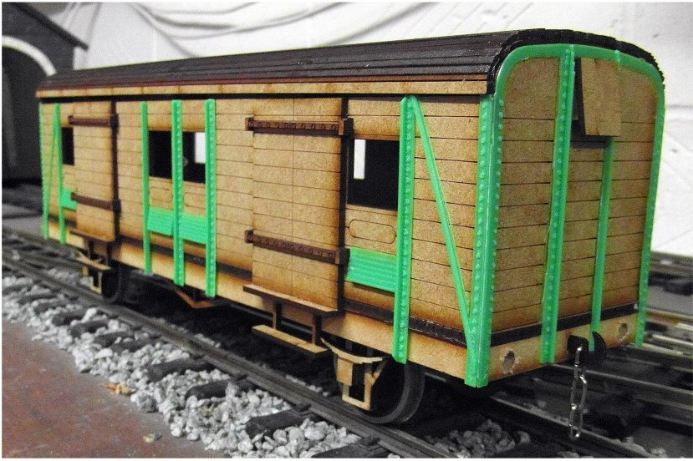
The roof construction was of long MDF slats of various widths, glued to the roof trusses and van ends. I wanted to make the van roof van removable for batteries and radio control gear, and the manufacturer kindly supplied me with some extra supports. The longitudinal trusses were strip wood. The roof slats were glued to the subframe with the narrowest slats at the edges to form the typical SR sharply curved edges.
I wanted to have bars across the windows so I used Plastruct round rod. To finish, I covered the roof with an old handkerchief and hand painted it Humbrol Matt Grey 145. The finished van was well detailed, had a proto-typical roof construction method and the profile looked correct for an SR van.

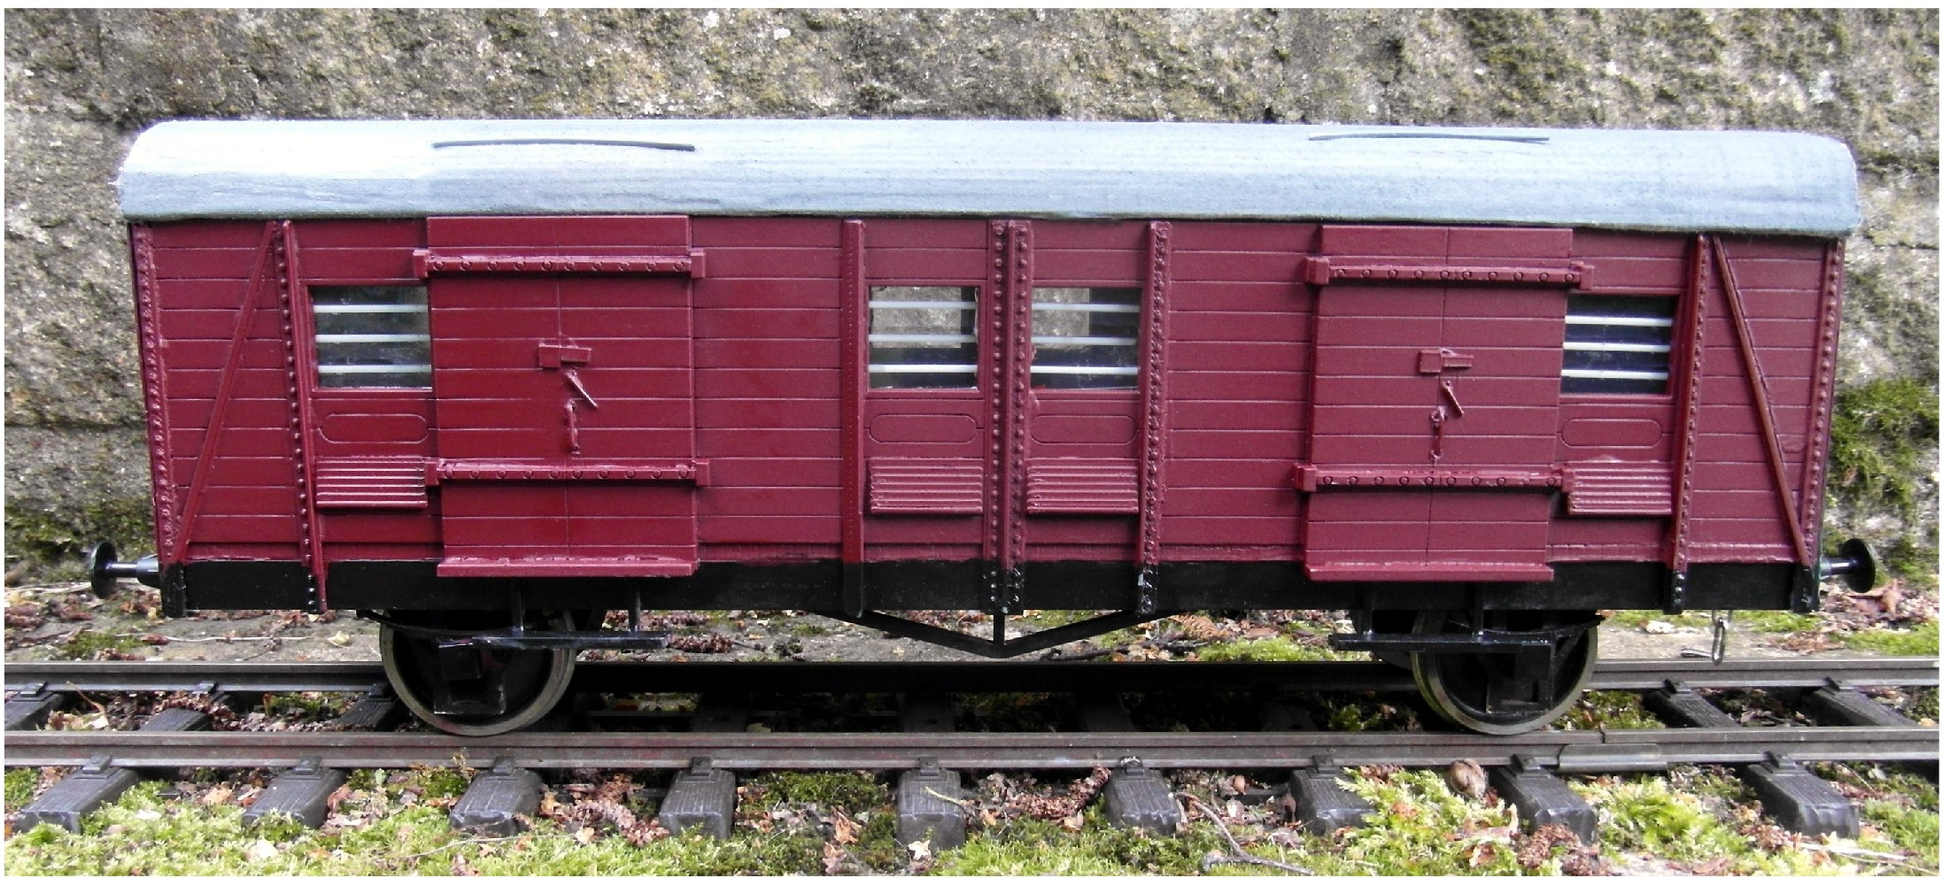


Steven Cook [UK] wanted a very basic circuit in the garden.
Outdoor layout

I believe that having any garden railway is better than none. I have a flat garden measuring 22' x 34 ', and a garage leaves an L-shaped space. My first line was L-shaped, very simple and for one glorious summer day everything worked fine. I never could get it to run that way afterwards, so I was content using wireless DCC control to run stock up and down.
With the arrival of an Aster 'Castle' kit, and a shift to live
-steam I thought of a simple circuit for continuous running, and a fire-up lane which would allow alternate running at geHogethers. Relocation of a garage drainpipe freed up an extra 4" of space. I sank 3" square posts into the ground, spaced at 40" centres on the straights, and 30° intervals round the curves, anchored in Postcrete. Short sections of 2" x 3" timber were screwed close to the top of the posts, to create a cross to support the horizontal framing.
The framing itself is ½" x 3" door jamb donated by a friend. The timbers were cut to length and notched to fit over the cross pieces, giving a tight fit which I secured with screws. Another friend offered wood that provided a stock-box storage shelf under the firing-up lane. The top of the framework was checked for level and thin sections of damp-course membrane were inserted between horizontal timbers and cross pieces to provide adjustment.
Filcris recycled plastic lawn edging planks form the run-ning surface. The layout is more test track than scenic, and tight curves would use a lot of material for a solid surface. Eleven 12' planks were cut to length. A simple trammel and jig kept them evenly spaced, and hid minor variations in post position. Four screws secure each plank, bracing the horizontal framework and stiffening the structure.
The track is 45.5mm widened gauge sleepers, and code 180 rail. Threading the rail through the chairs was easy, only taking about four hours. The rail was pre-curved using a home-made bender to make sure track was smooth and consistent. The trammel was modified to suit the larger track radius, and rails were carefully laid to it. Elevation wedges incline the outer rail 1mm above the inner.
A small deck was built in one corner to accommodate seating, and make it easier to step over the line. Gravel paths run inside and outside the line. The 'Castle' runs around with five coaches, although there is some slowing down on the curves. A friend bought over an Aster '9F', a 'Patriot' and electric 'Project'. All three locomotives were capable of run-ning around the curves. Next, the paintwork and track for the fire-up lane were installed. There is also a 32mm gauge third rail because my interests include 16mm and ½th' scale.
I'm not sure how much smaller one could go with a con-tinuous Gauge 1 run and support a good range of locomo-tives. I suspect that I'm very close to that edge. With the track surface at thirty inches off the ground, firing and run-ning locomotives is fairly comfortable while allowing step-over access to the decking. I'm pleased to find that it works and I can steam at home.

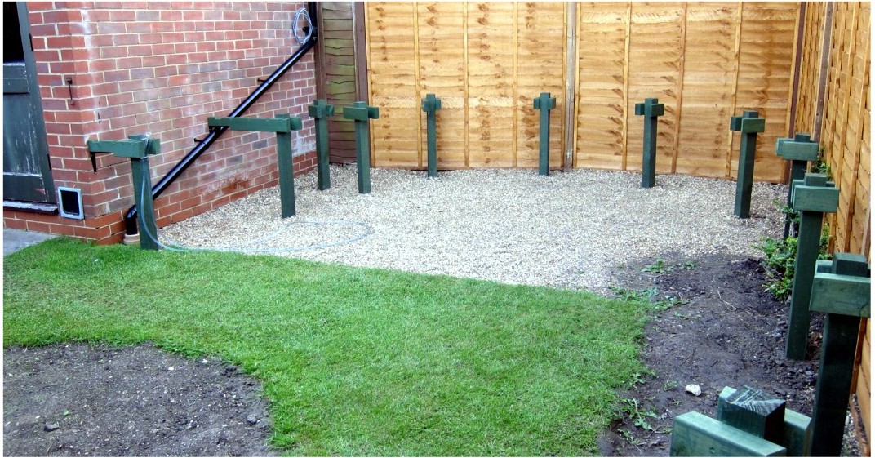
Cross pieces on posts, provide support for longitudinal timbers.
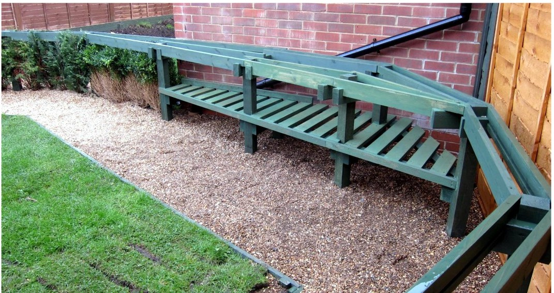
Storage shelf installed under the track.
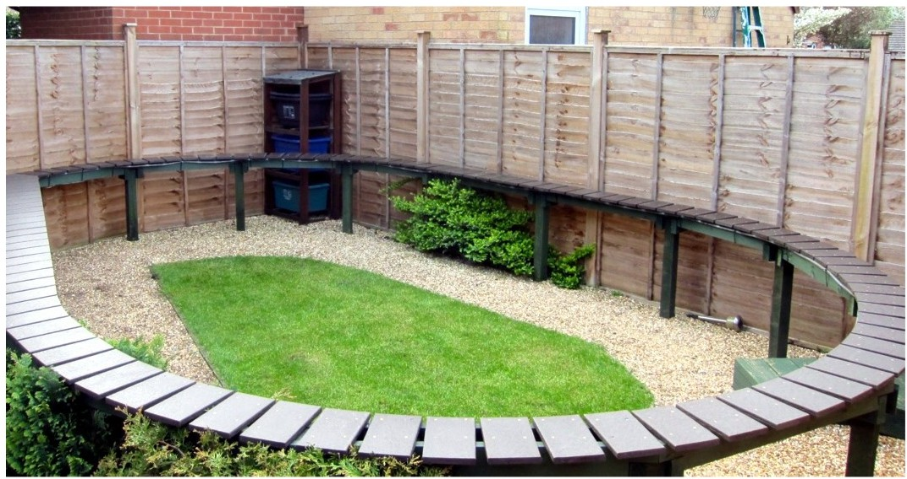
Basic framing and running surface complete.

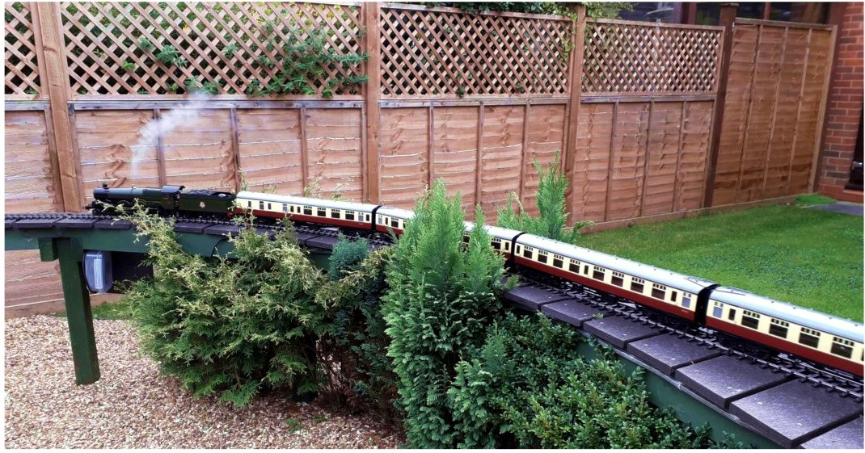
'Castle' and carriages on the line - what it was all about.

Indoor layout

Mike Palmer [UK] built Croft , a simple end to end layout, in his workshop.

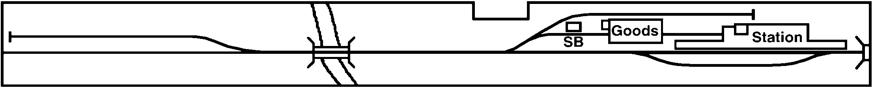
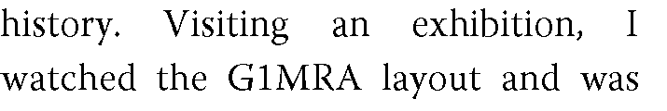




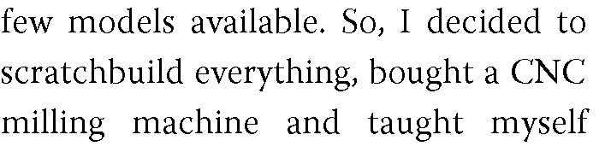

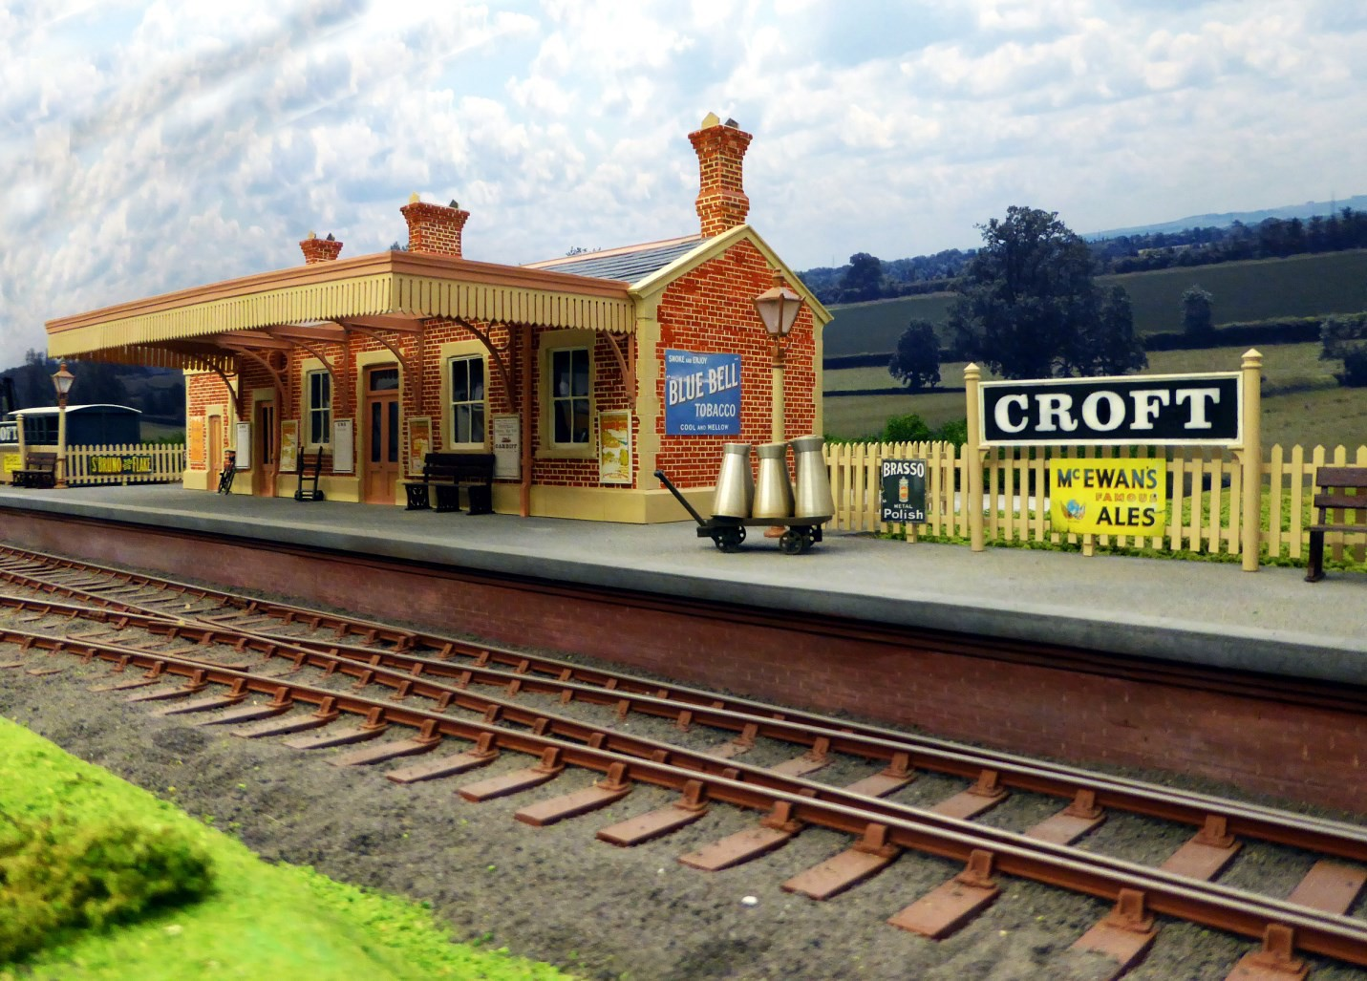
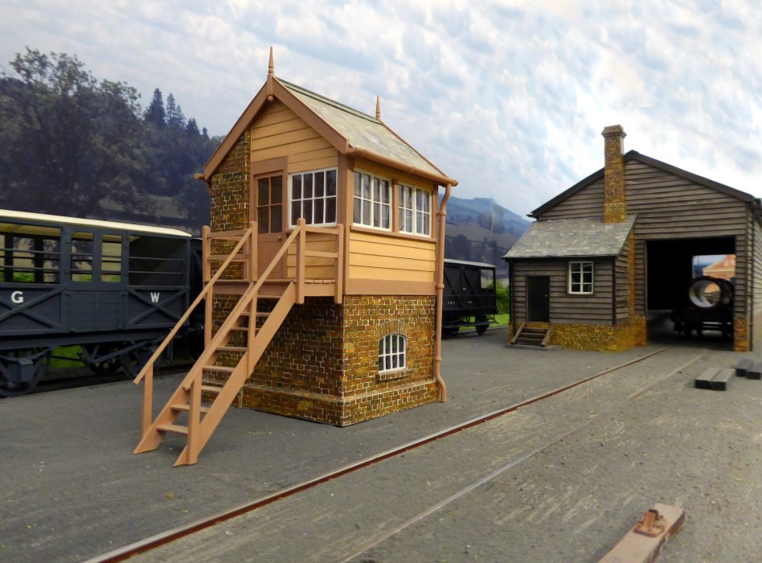


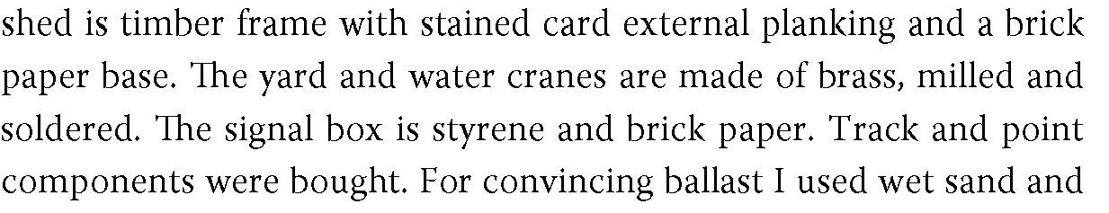


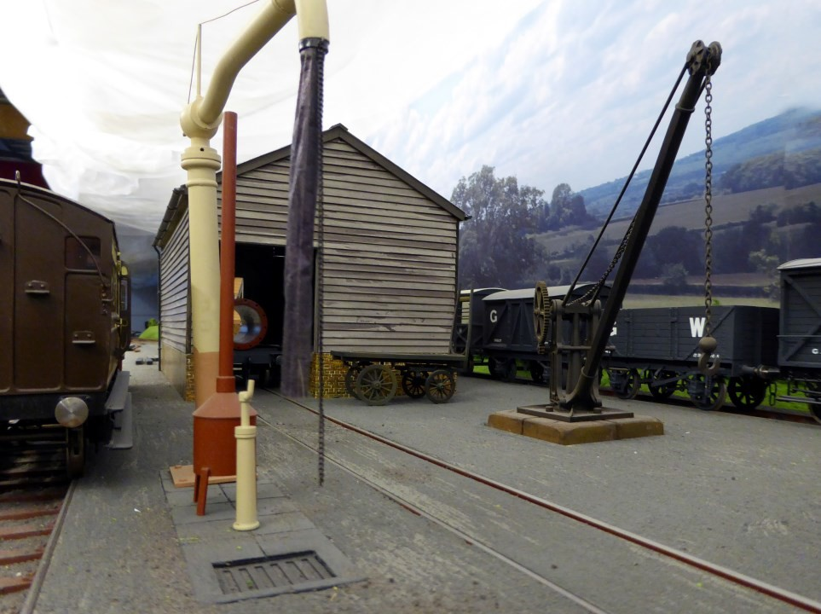

www.accucraft.uk.com info@accucraft.uk.com
Barrett Steam Models - 10mm scale live-steam locomotive kits. www.barrettsteammodels.co.uk info@barrettsteammodels.co.uk
Bowande Live Steam UK- 1:32 scale live-steam locomotives.
www.bowandelivesteamuk.com bowan-delivesteam@gmail.com
Bowaters Models - 1:32 and 10mm scale model locomotive and rolling stock kits. www.bowatersmodels.co.uk info@bowatersmodels.co.uk
Fred Phipps - Locomotive and rolling stock kits.
fphippsz@yahoo.co.uk
www.fosworks.co.uk
sales@fosworks.co.uk
Fosworks - RC, sound systems, axle motors.
Garden Railway Specialists - Track and RTR locomotives and rolling stock. www.grsuk.com
sales@grsuk.com
Rushford Barn Models - New and pre-owned locomotives and rolling stock. www.rushfordbarnmodels.co.uk rushfordbarnmode1s@gmail.com
Special Auction Services - Railway item auc-tioneers.
www.specialauctionservices.com mail@specialauctionservices.com
www.elstow-engineering.co.uk
Elstow Engineering - Model railway engineering.
and rolling stock. RTR and kits.
Accucraft UK - 1:32 scale live-steam locomotives
mail@fox--transfers.co.uk

info@elstow-engineering.co.uk
Fox Transfers -Transfers ofrailway insignia.
www.fox-transfers.co.uk
Railmodel - Laser-cut structure kits. www.railmodel.co.uk
Peter Rogers - Model coaches. www.roger-models.co.uk enquiries@rogers-models.co.uk

Brian Jones - Radio and electronic controls. www.brianjonesmodels.co.uk brian@brianjonesmodels.co.uk
Brunel Models - Model buildings and structures. www.brunelmodels.co.uk enquiries@brunelmodels.co.uk
Camden Miniature Steam Services - Books,
DVDs.
www.camdenmin.co.uk adamh@tantraweb.co.uk
Castle Steam Boilers - Model steam boilers. www.castleinstruments.co.uk info.castlesteam@gmail.com
Cliff Barker - Gauge 1 track and rolling stock. www.cliffbarker.me.uk
cliff@cliffbarker.me.uk
Cromford Designs - Painting and lining service. lizmarsden@cromforddesigns.co.uk
Custom Carriages - Rolling stock. www.customcarriages.co.uk custom carriages@aol.com
Diane Carney Nameplates - Custom nameplates. www.loco-nameplates.co.uk loco.nameplates@uwclub.net
Dreweatts - Transport model auctioneers. www.drewea Us.corn vbillington@dnfa.com
Ellis Oark Trains - Model purchase and sales. www.ellisclarktrains.com ellis@ellisclarktrains.com
GM Transport Books - Railway and other
gmtransportbooks@gmail.com
transport books.
KBW Kits - Laser-cut rolling stock kits.
westkev58@gmail.com
Model Engineers Laser - Laser cut parts.
sales@modelengineerslaser.co.uk
www.modelengineers laser.co.uk
Northern Fines Scale - 1:32 scale wagons and rolling stock.
UK: www.chrisarundell.com mail@chrisarundell.com
North America: gaugeonelines@yahoo.com
Steve Golding - Locomotive and rolling stock kits. www.stevegoldingmodels.com stevegoldingmode1s@outlook.com
Strikalite Batteries - Batteries and radio control. www.strikalite.co.uk
info@strikalite.co.uk
Tenmille Products -Track and rolling stock kits. www.tenmille.com
trains@tenmille.com
TMS Models - Locomotive and rolling stock sales service.
www.tmsmodels.biz terrysmith@tmsmodels.biz
Todmorden Model Supplies - Modelling tools and materials. www.todmordenmodelsupplies.co.uk info@todmordenmodelsupplies.co.uk
Tower Models -RTR brass locomotives and coaches.
www.tower-models.co.uk sales@tower--models.com
Vectis - Train and collectable auctioneers. www.vectis.co.uk
louise@vectis.co.uk
Wallis and Wallis - Specialist auctioneers. www.wallisandwallis.co.uk toys@wallisandwallis.co.uk
Walsall Model Industries - Castings and parts. www.walsallmodelindustries.co.uk info@walsallmodelindustries.co.uk
peter.korzilius@googlemail.com
Peter Korzilius - Wagon kits and parts.
alliott49@btintemet.com
and repair.
Peter Alliott - Locomotive construction, servicing
www.marcway.net
Marcway Paintwork- Track and track parts.
ken.jo.martin007@gmail.com
and rolling stock.
Ken Martin - Lost wax castings for locomotives
justtheticketeng@gmail.com
www.justtheticketsupplies.co.uk
locomotive kits.
Just the Ticket - Model engineering supplies and
Mike Danby - Locomotive builder. www.mikedanbylocomotives.co.uk m.danby34@btinternet.com

Contact our Membership Services Provider, Virginia Hauxwell by post, email or telephone at:
PO Box 363, Trimdon Station, TS29 6YU
Email: glmra.membershipofficer@gmail.com
Tel: 07547 804142
Or see www.glmra.com for more details, and instant joining.
Several membership categories are available:

Ordinary Membership: UK £30; Europe £32; Rest of the World £36
Family [one N&J per household] - Add £5
Junior under 18 in full time education [N&J but no voting rights] - £10

