Skip to content
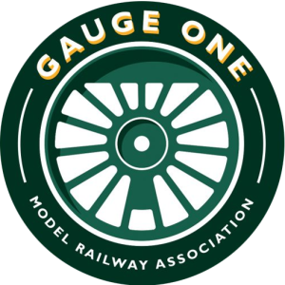
- HOME
- JOURNALS
- Local Groups
- STANDARDS
- PHOTOS
- NEWS & EVENTS
- MEMBERS AREA
- International

Search for:

JOIN US
Gauge 1 North 2026
- Home
- Homepage
- News Ticker
- Gauge 1 North 2026
Previous

Gauge 1 North 2026
Gauge 1 North is a public show that’s been running since 2010 at the Agricultural Business Centre in Bakewell, Derbyshire.
The next show will be on 11 July 2026!
The list of traders and exhibits will be updated as they are booked.
Exhibits:
- Ridings layout – Yorkshire Group’s flagship live steam layout
- Moordale – Yorkshire Group
- G1MRA
- Peak Railway Association
- Friends of Wensleydale Railway
- Gauge 3 Society

Traders attending: (updated 16 July 2025)
- Barrett Steam Models Ltd
- Black Cat Bridges
- Brunel Models
- Chris Devenish
- Claudia Carter
- Cromford Designs
- CUP Alloys
- Custom Carriages
- Jon Stewart-Milne (private sales)
- Mel’s Models (formerly Ken West Models)
- Metalsmith (Leeds) Ltd
- Model Engineers Nameplates
- Peter Korzilius
- RC Trains
- Slaters Plastikard
- SLR Models
- SM Models
- Squires Models
- Steve Golding Models
- Tenmille Products
- TMS Models
- Uncommon Kits (demonstration)
- Walsall Model Industries
Refreshments are available on site on Saturday at the cafe next to the show hall. Bakewell is also about 10 mins walk from the hall.
Parking is available on site – please make sure to follow any parking notices – the area to the front of the hall is reserved for coach drop off and blue badge holders.
+−
Leaflet | © OpenStreetMap
By Liz Marsden|9th April 2026|Homepage, News Ticker|Comments Off on Gauge 1 North 2026
Copyright 2022 | All Rights Reserved | Privacy Policy | Site designed by Footprint
FacebookEmail
Go to Top

