**Guide for How to run the code   
 Step 1**

On the project dir run:

* + python game.py

Note: When searching the UI will appear as Not responding, this is not the game crashing, it’s just the game taking time to do it handful searching job

Note: Sometime it’ll crash while auto running the result. Don’t worry, just start it again  
 **same as Ubuntu**

Step 2   
Title screen after start-up looks like this.

* Just press SPACEBAR or click on screen to proceed.

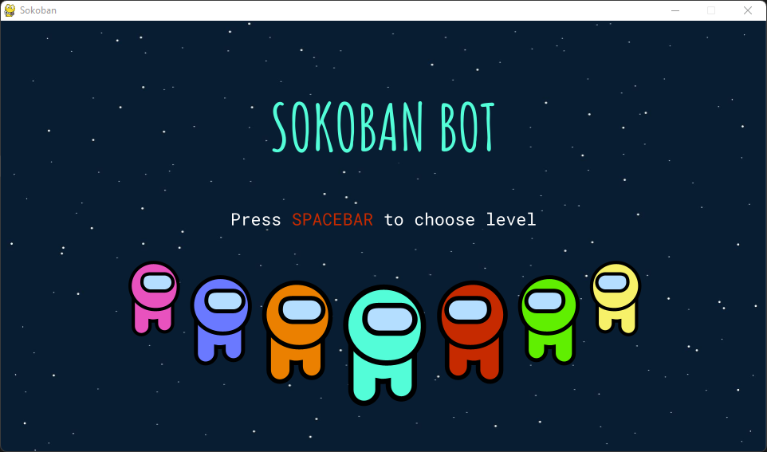

Step 3

* After that, it’s the level set choosing, between Mini Cosmos and Micro Cosmos
* Press either Arrow keys or click on 1 screen side to proceed.
* Or press/click on z to return to Title.

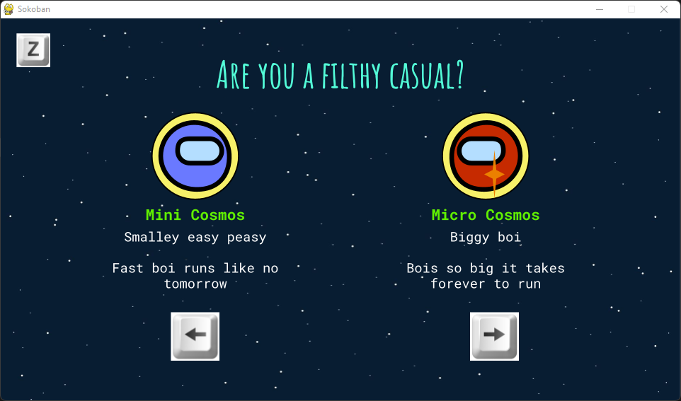

Step 4

* Choose the level 1 - 40
* Click on one of the number or type them

Ex: type 1 and 2 in order will choose 12.

* Press/click on z to return to set choosing

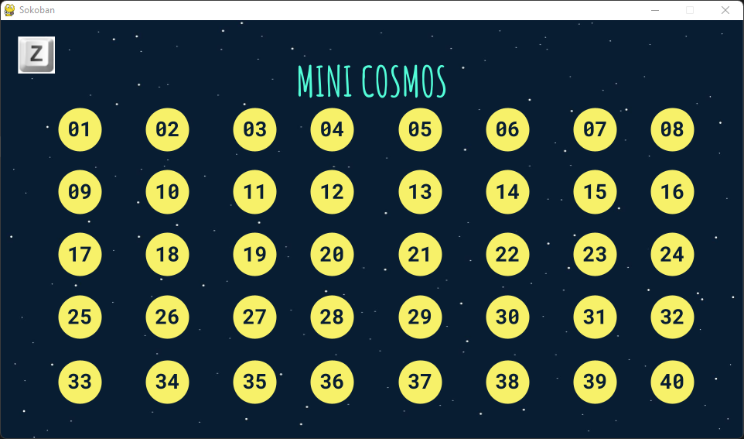

Step 5

* Choose the level 1 - 40
* Click on one of the number or type them

Ex: type 1 and 2 in order will choose 12.

* Press/click on z to return to set choosing

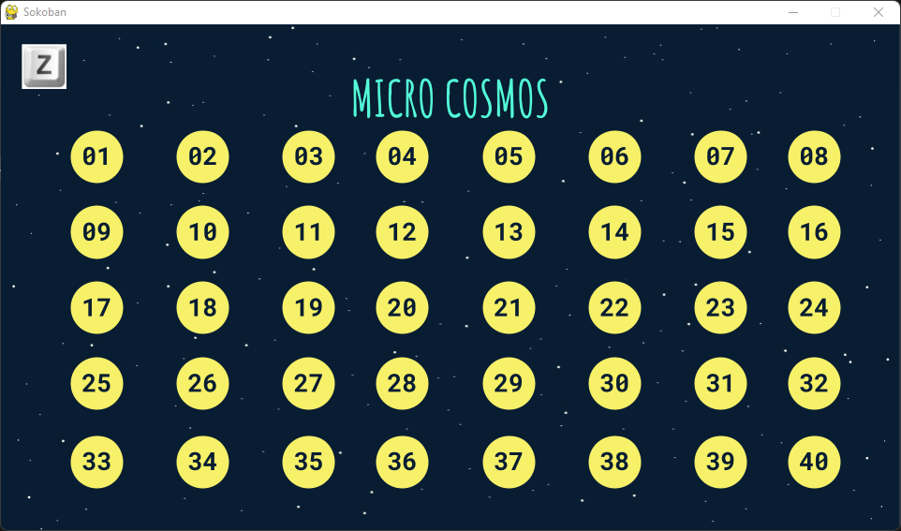

Step 6

* After that, it’s the search method choosing, between Breadth-first Search and A*
* Press either Arrow keys or click on 1 screen side to proceed.
* 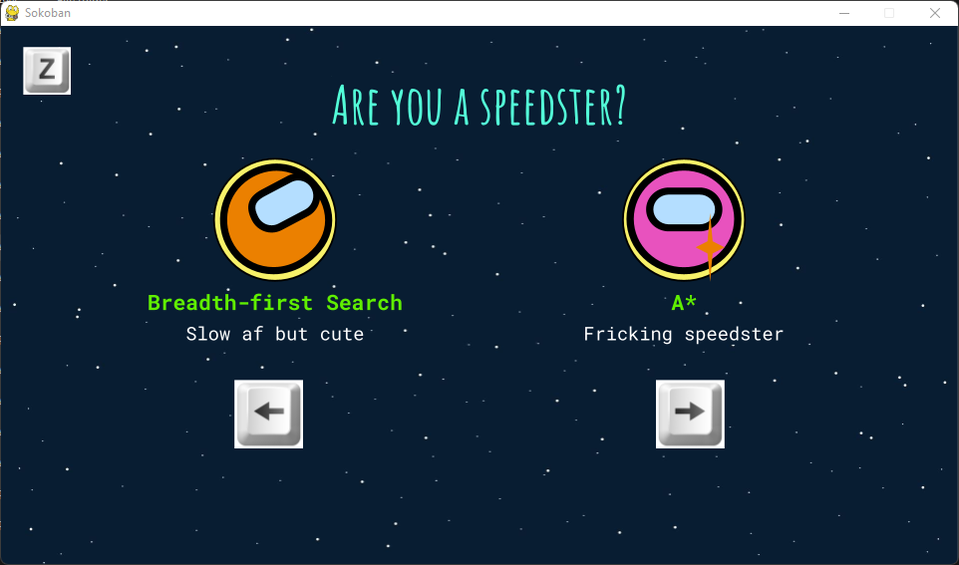Or press/click on z to return to Title.

Step 7

* Searching in progress
* Max runtime on our local machine is appx 1400s for one of the Micro Cosmos BFS algorithm
* Please be patient since the screen might look Not Responding

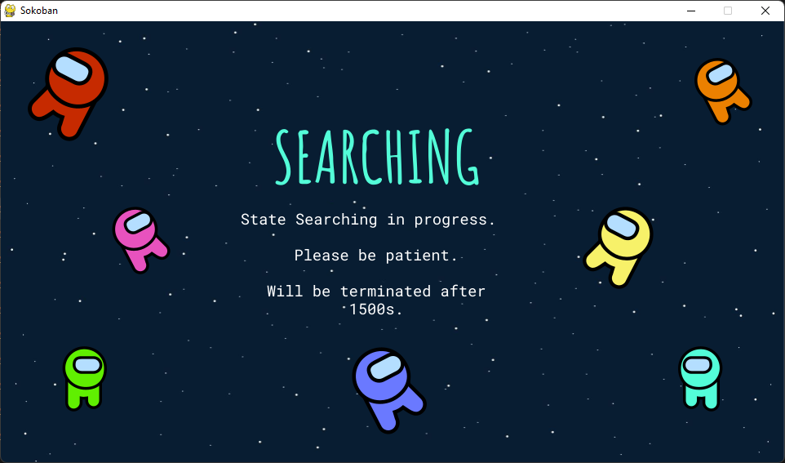

Step 8

Enjoy the game