|  |  |  |
| --- | --- | --- |
|  |  | GWU  Data Analytics Bootcamp  Homework week Two (VBA) |
| T K { KrAsh } This weeks’ class was great, I really liked this assignment, I way underestimated the power of VBA and Excel, I’m glad to have been wrong and found great value in this session! . |  | Assignment  1. The VBA of Wall Street    1. A screen shot for each year of your results on the Multi Year Stock Data.    2. VBA Scripts as separate files. |
| 2014 |  |  |

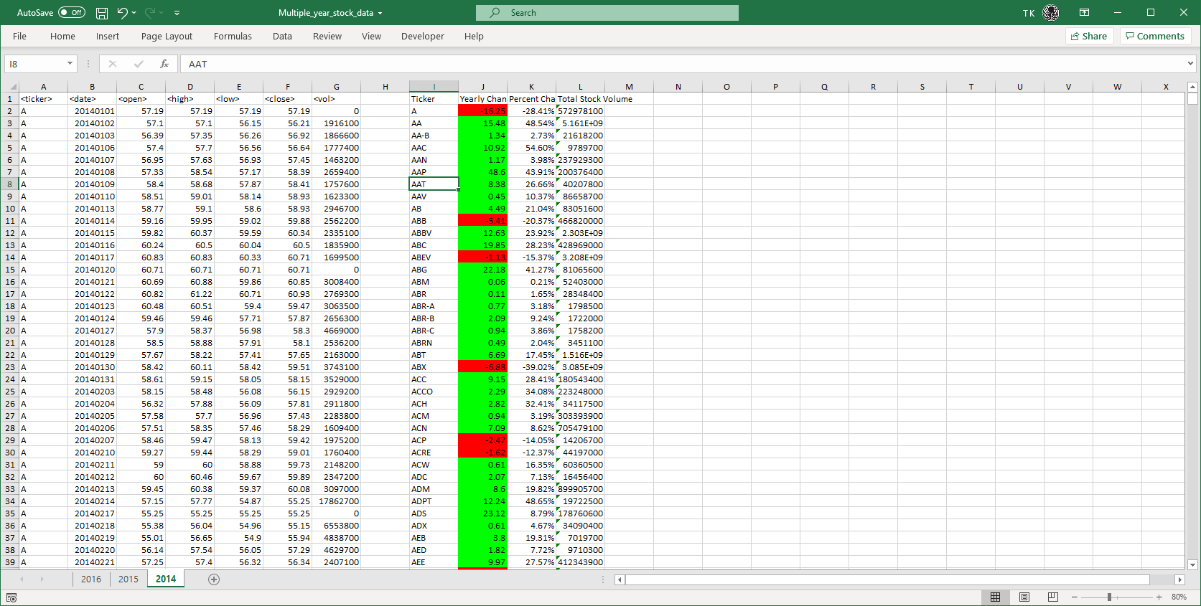

2015

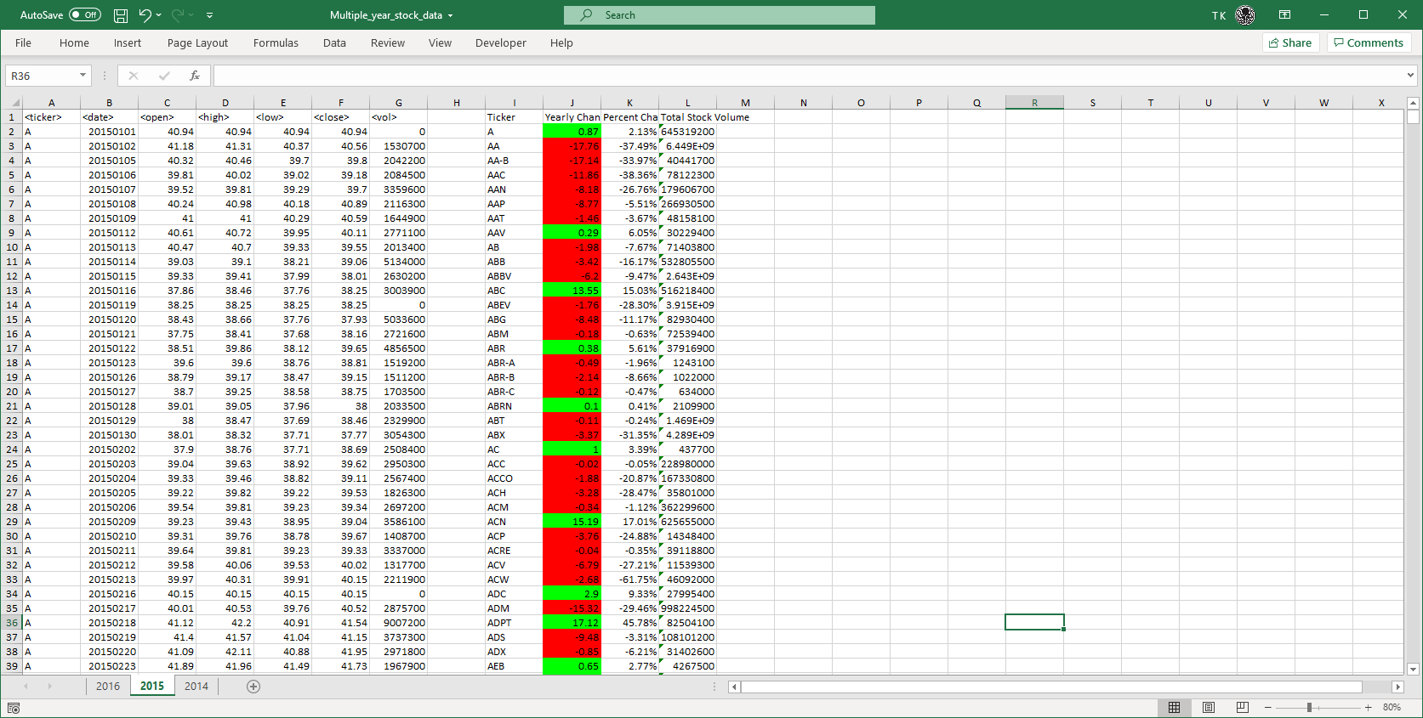

2016

