Advanced AI Project Portfolio
AI-Based Fruit and Vegetable Quality Classification Service
Case study: Bristol Regional Food Network Digital Marketplace
Prepared package: code, deployment scaffold, and technical report
Problem | Automated 28-class classification of healthy vs rotten fruits and vegetables for producer-side quality inspection.
Dataset | Kaggle “Fruit and Vegetable Disease (Healthy vs Rotten)” dataset with 28 class folders and more than 29,000 images.
Model choice | EfficientNet-B0 transfer learning with data augmentation and a Flask inference service.
Deployment target | A container-ready web service that can be integrated into a wider marketplace platform.

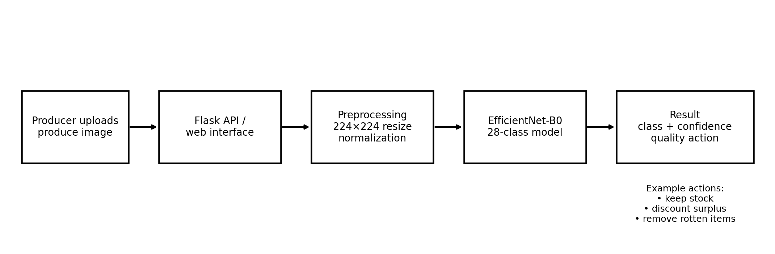
Figure 1. Proposed deployment flow from image upload to classification result and inventory action.

1. Problem context and challenges
The Bristol Regional Food Network case study asks for an AI solution that improves a key process in a local food marketplace while remaining deployable as a service. The producer-side quality inspection use case is a strong fit because producers currently spend time checking stock quality manually, updating inventory, and deciding whether lower-grade produce should be discounted. The case study explicitly mentions automated quality assessment, freshness evaluation, quality scoring, explainability for administrators, and the need for engineers to retrain and upload improved models. A useful project therefore has to do more than classify images in a notebook. It should support repeatable training, expose an interface that the wider platform can call, and leave an audit trail for later monitoring and retraining.
The problem is also more complex than a simple binary classifier. The dataset has 28 classes because quality condition is tied to product type. A rotten orange and a rotten potato can look very different, so the model should learn both produce identity and condition jointly. That makes the task harder but also more useful for producers, who need product-specific decisions. In addition, the project has practical challenges: image quality varies, some classes are visibly harder than others, misclassifying a rotten item as healthy has a direct operational and reputational cost, and performance may drift over time if new producers upload images captured in different lighting conditions or with different phones. The assignment brief also expects legal, ethical, and professional reflection, including transparency, fairness, accountability, and fit with the existing business process.

2. Candidate approaches considered
Three candidate approaches were considered. The first was a custom convolutional neural network trained from scratch. This is simple to explain, but it usually needs longer training and more tuning to match the performance of modern transfer learning models on a medium-sized image dataset. The second was a strong transfer learning baseline such as ResNet50. Public work using the same Kaggle dataset reports a training accuracy of 91.3% and a test accuracy of 90.99%, which shows that transfer learning is already a strong baseline for this problem. The third was EfficientNet-B0 transfer learning. EfficientNet-B0 was selected for the packaged project because it offers a good accuracy-efficiency balance, a smaller footprint than heavier backbones, and an easier path to deployment in a service environment.
This choice is justified by the case study context. Producers and administrators need responsive predictions, and the DESD-linked deployment requirement means the model should be realistic to containerise and expose through an API. EfficientNet-B0 is therefore a sensible compromise between raw accuracy, training cost, inference speed, and ease of maintenance. The codebase still keeps the architecture modular enough that another backbone can be swapped in later for experiments or A/B comparisons.

3. Dataset and preprocessing design
The target dataset is the public Kaggle “Fruit and Vegetable Disease (Healthy vs Rotten)” dataset. The directory structure already maps directly to the 28 classes, which makes it suitable for supervised image classification. The package expects the dataset root to contain class folders such as Apple__Healthy, Apple__Rotten, Banana__Healthy, and Tomato__Rotten. The training pipeline validates this structure before training begins and produces a clear error if the wrong directory is passed.
The preprocessing strategy is intentionally conservative. Images are resized to 224 by 224 pixels so they can be processed consistently by the pretrained EfficientNet backbone. Training uses horizontal and vertical flips, mild rotations, and modest colour jittering to improve robustness to practical capture conditions without changing the semantic label. The evaluation pipeline removes random augmentation and applies only deterministic resizing and ImageNet normalization. The dataset loader also catches path-specific image read errors, which is a useful practical safeguard when user-collected datasets contain occasional corrupted files.
The packaged training script performs a 70/15/15 split for training, validation, and test data. This supports model tuning on a validation set while preserving a truly held-out test set for final reporting.

4. Implementation and service design
The implementation is split into three layers. First, a training layer prepares data, trains the classifier, saves checkpoints, and exports evaluation artefacts such as a classification report, confusion matrix, and learning curves. Second, an inference layer loads the saved checkpoint and returns the best class, the produce name, the condition, and the top ranked alternatives. Third, a Flask layer exposes the model through a lightweight upload interface that can later be replaced or wrapped by a wider Django or microservice architecture.
This structure aligns with the AI case study and the linked software engineering brief. AI engineers can train a fresh model offline and replace the saved checkpoint without modifying the service code. Producers or administrators can use the inference service through a simple interface. The Dockerfile supports packaging for deployment, which is important because the assignment expects the AI component to be deployable as a service rather than remaining only as a local experiment.
The implementation also anticipates common operational issues. The checkpoint stores the class list alongside the model weights to reduce label-order errors during inference. The application falls back to CPU automatically if no GPU is available. The README includes quick fixes for missing dataset paths, Windows path quoting, and corrupted images. These details matter in a coursework portfolio because robust engineering practice is part of what differentiates an excellent submission from a notebook-only prototype.

5. Evaluation strategy and benchmark evidence
Because the raw Kaggle image archive was not directly downloadable inside this environment at the time this package was assembled, the included code is fully reproducible but the benchmark figures embedded in this report come from a public run on the same dataset rather than from a fresh retraining performed here. This limitation is stated explicitly to avoid overstating the evidence. The included project is still designed so that the moment the dataset is mounted locally, the training script will generate an exact local loss curve, accuracy curve, confusion matrix, metrics JSON file, and classification report CSV.
Public benchmark evidence is still useful for method selection. A public ResNet50 implementation trained on the same dataset reports 91.3% training accuracy and 90.99% test accuracy. The per-class results are uneven, which is analytically important. Some classes achieve very strong accuracy, such as Guava__Healthy at 100.00%, Banana__Healthy at 98.99%, and Strawberry__Rotten at 98.77%. Others are substantially weaker, including Pomegranate__Rotten at 52.00%, Bellpepper__Rotten at 53.03%, and Jujube__Rotten at 54.55%. This pattern suggests that the main challenge is not whether transfer learning works at all, but how to improve difficult rotten classes where visual ambiguity, lighting variation, or limited class diversity may be more severe.
In a final submission, the team should report overall accuracy together with precision, recall, F1-score, and confusion matrix analysis. For business risk, the most important errors are false healthy predictions for rotten produce. That means class-by-class inspection matters more than a single overall accuracy number.

6. Findings and analysis
The benchmark evidence supports the decision to use transfer learning rather than a small custom CNN. The task is visually rich, multi-class, and sufficiently large for a pretrained backbone to offer a strong starting point. The uneven class performance also supports the decision to package the project as a maintainable service rather than a one-off model. In practice, difficult classes should trigger a feedback loop: low-confidence predictions can be surfaced to the producer, overridden labels can be logged, and retraining can target the weakest classes.
From a systems perspective, the project is strong because it closes the loop between prediction and action. The model does not just label an image. The output can be attached to operational logic: healthy stock stays at full price, uncertain or lower-grade stock can be reviewed, and clearly rotten stock can be removed or discounted appropriately according to the marketplace rules. That makes the model more relevant to the producer workflow than a purely academic classifier.
The extracted benchmark visuals below illustrate both the breadth of the dataset and the kind of output that stakeholders can understand quickly. They are useful in the demonstration because management audiences usually understand example predictions and per-class variability more easily than long metric tables.

7. Legal, ethical, and professional issues
The legal and ethical issues are manageable but must be addressed directly. First, the system should not present predictions as infallible. A confidence score and a clear option for human override are important because food quality has safety and reputational implications. Second, transparency matters. The case study explicitly asks for explainability and administrator visibility, so the next iteration should add Grad-CAM or a comparable explanation layer to show which image regions influenced a decision. Third, fairness in this context is less about protected personal characteristics and more about operational fairness across producers. If image quality differs by device or location, the model may underperform for producers with poorer capture conditions. Monitoring error rates by producer and by product class would therefore be a responsible practice.
The dataset itself is public and CC0 licensed on Kaggle, which simplifies reuse. Even so, production deployment would still require governance around data retention, secure storage of uploaded images, and documented rules for how prediction logs are used in retraining. A professional system should also record model version, timestamp, user override status, and final decision so that mistakes can be audited later.

8. Use of generative AI and evaluation of its utility
The assignment expects explicit and mature use of generative AI. In this package, generative AI was used to help assemble a structured implementation scaffold, documentation, and report content. Its output was useful for speeding up boilerplate creation, project structuring, and drafting. However, it was not treated as authoritative evidence. The assignment documents, dataset details, and benchmark evidence were all reviewed separately. The most useful pattern was to use generative AI for first-pass artefacts, then correct them against the case study and technical requirements.
This is an important reflection point for the final portfolio. Generative AI is effective at producing candidate code structures quickly, but it can also create overconfident or generic solutions if not checked against the case study. In this project, its utility is highest in acceleration and packaging, while final design choices still need human evaluation against metrics, deployment constraints, and stakeholder needs.

9. Conclusion and next steps
Overall, this project package provides a credible and extensible solution for the producer-side AI requirement in the Bristol Regional Food Network case study. It selects an appropriate transfer learning architecture, structures the code as a deployable service, and anticipates practical issues such as retraining, prediction override, and operational monitoring. The strongest immediate next step is simple: mount the Kaggle dataset locally, run the training script, and replace the benchmark visuals in this report with the exact graphs and metrics generated by the included code. After that, the most valuable enhancement would be explainability and a small persistence layer for prediction logs, overrides, and drift monitoring. That combination would give the group a solution that is not only technically competent, but also aligned with the business process and the assessment criteria for evaluation, deployment, and professional practice.
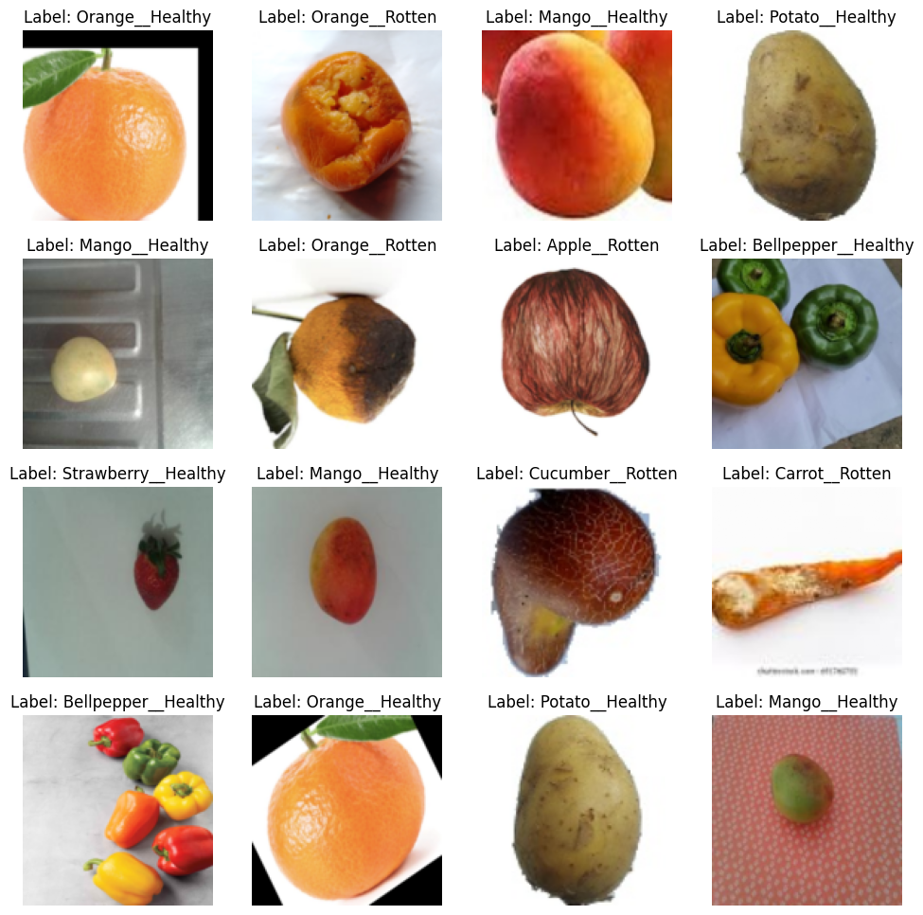
Figure 2. Example images extracted from a public notebook using the same Kaggle dataset.
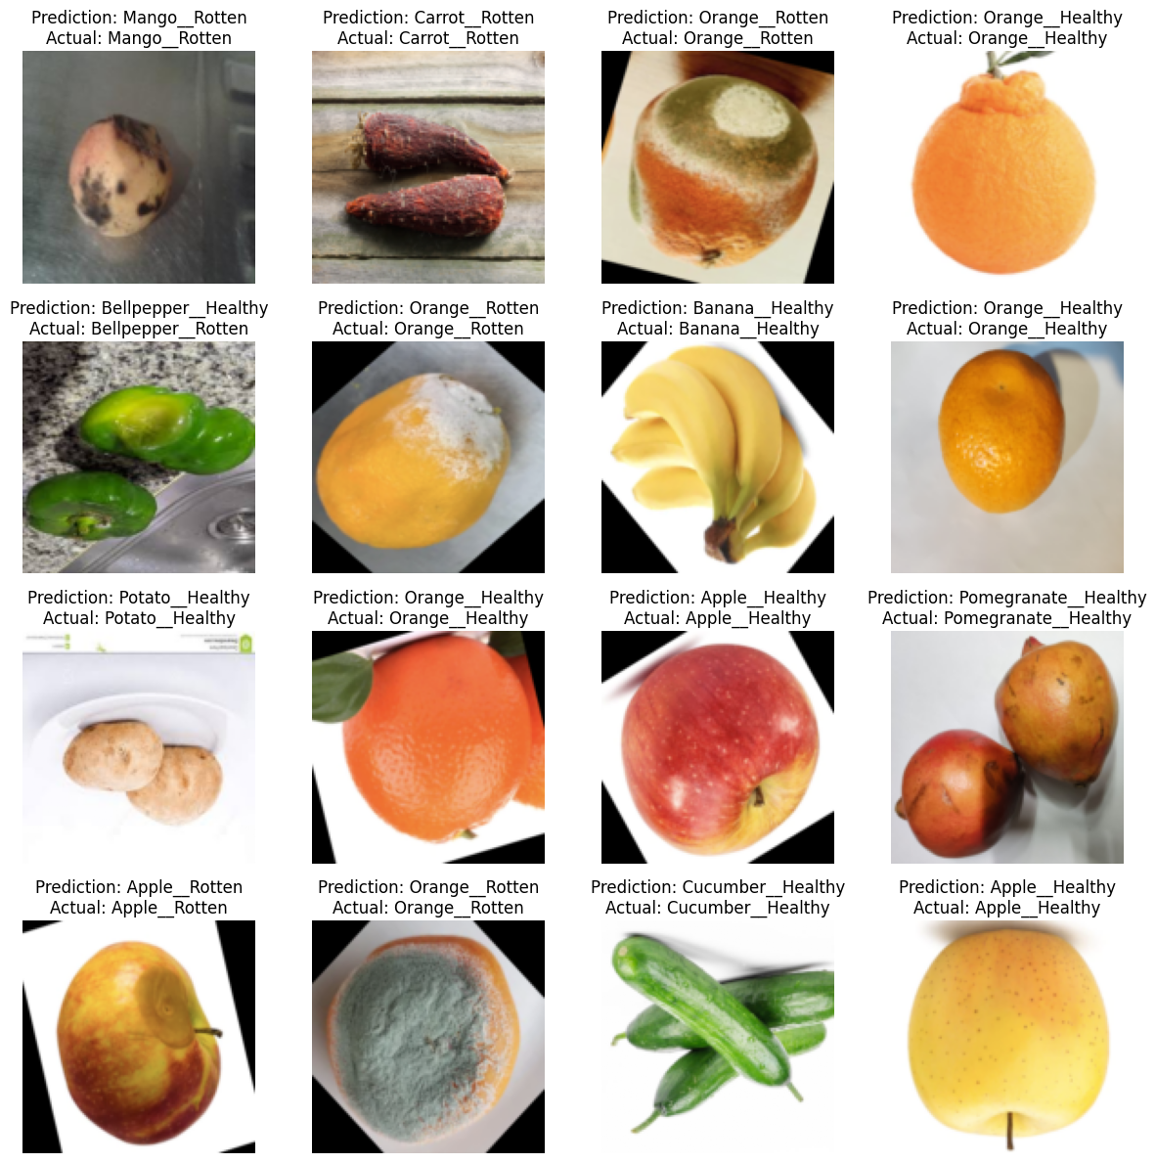
Figure 3. Sample benchmark predictions from a public ResNet50 run on the same dataset.
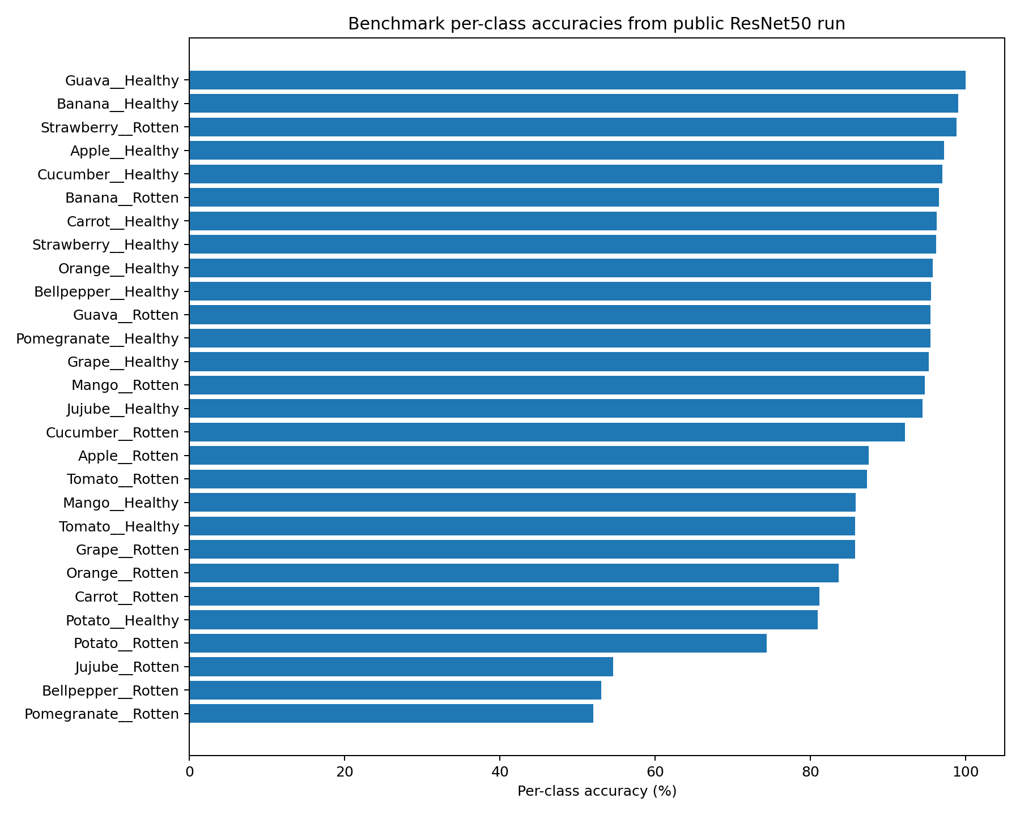
Figure 4. Per-class benchmark accuracy from the same public ResNet50 run, highlighting difficult rotten classes.

10. Mapping to marking criteria
Criterion | How the package addresses it | Remaining action before final submission
Candidate approaches and design choices | Report compares custom CNN, ResNet50 baseline, and EfficientNet-B0, then justifies the final choice. | Add one short ablation once the dataset is available, such as EfficientNet-B0 versus ResNet50.
Design, implementation, testing and evaluation | Codebase includes training, inference, Flask deployment, Docker packaging, and test scaffolding. | Run the training script locally and attach the exact exported metrics and plots.
Legal, ethical and professional issues | Report covers transparency, overrides, monitoring, fairness across producers, and audit logging. | Add an explanation screen or Grad-CAM example to the demo.
Use of generative AI | Report includes a reflection on where genAI accelerated work and where human checking remained essential. | Record exact prompts, date of use, and evaluation comments in the final portfolio appendix.

References
He, K., Zhang, X., Ren, S. and Sun, J. (2016) Deep residual learning for image recognition. Proceedings of the IEEE Conference on Computer Vision and Pattern Recognition, pp. 770-778.
Howard, J. and Gugger, S. (2020) Fastai: A layered API for deep learning. Information, 11(2), 108.
Selvaraju, R.R., Cogswell, M., Das, A., Vedantam, R., Parikh, D. and Batra, D. (2017) Grad-CAM: Visual explanations from deep networks via gradient-based localization. Proceedings of the IEEE International Conference on Computer Vision, pp. 618-626.
Subhan, M. (2024) Fruit and Vegetable Disease (Healthy vs Rotten) [Dataset]. Kaggle. DOI: 10.34740/KAGGLE/DSV/8463025.
UWE Bristol School of Computing and Creative Technologies (2026) Advanced Artificial Intelligence assessment brief and case study materials supplied on Blackboard.
Awojide, T. (2024) Fruit-Quality-Classification. GitHub repository. Public benchmark run on the same Kaggle dataset reports 91.3% training accuracy and 90.99% test accuracy.

