Advanced Technologies Task 3: 2D Procedural Tile Map Tool
Gundars Pelns (15014193)
Department of Computer Science and Creative Technologies
University of the West of England
Coldharbour Lane
Bristol, UK
Gundars2.Pelns@uwe.live.ac.uk

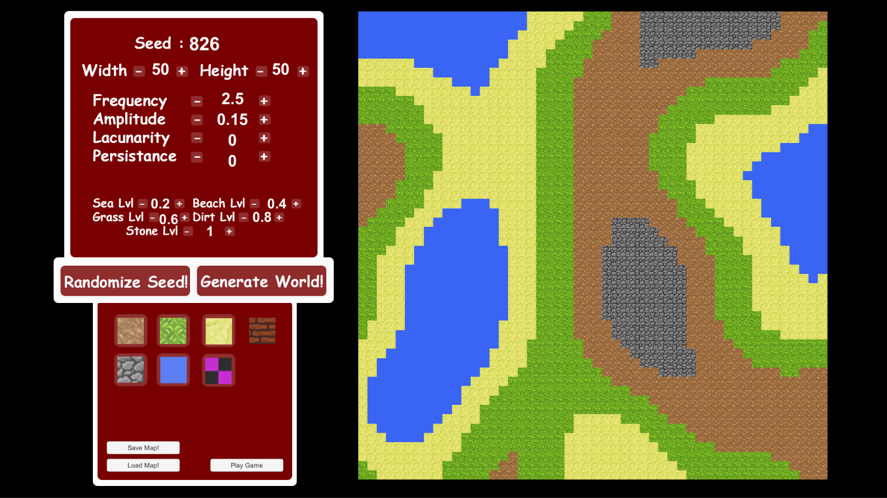

Introduction
Final task of this assignment was to develop a 2D procedural tile map tool that would allow the users to generate procedural levels in a 2D environment. It was also necessary that the generation of the terrain is editable. Allowing users to change specific values which then would create different types of 2D maps. However the requirements also suggested that the user should be able to edit the terrain manually as well as random generation. Another objective for this task was to implement saving and loading of the generated maps as well as a stretch goal of playability. By this it meant that the tool should then allow the user to play on this terrain, with the availability to complete this game as well as limit the user to the map, not allowing them to leave or enter prohibited areas.

Background Research
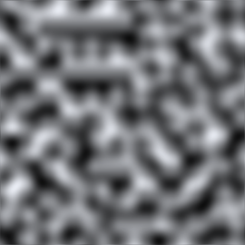
This task was very open, as in you were able to make any time of procedural tile map tool using any technique that appealed to the developer. There are quite a few ways of creating this sort of tool, one of them being the drunken walk, which was actually considered for the first prototype. What this algorithm or technique does is that it takes a point or tile of the world and marks it as the start. Once that is done it then randomly chooses a direction (Up, Down, Left or Right) and then creates or deletes a tile at the chosen direction. This step is then repeated until the desired amount of tiles has been placed or deleted from the tile map. As you’d expect this would look pretty messy, and very unpredictable, however it did create large caverns or rooms with corridors leading to them. So this did technically create dungeons that could then be playable or even editable. This sort of technique actually allowed for simple editing of the terrain as each of these tiles were individual objects with unique properties. On the other hand this seemed quite low level, and was better for a dungeon generator rather than a top down map.
Figure [1] – Perlin Noise example
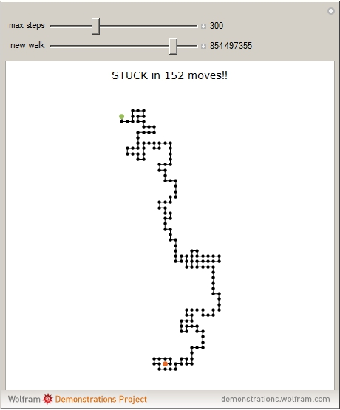
Thus more research had to be made as this did not accomplish all that was planned, and not long after a new technique was discovered. This technique was to create a mesh of a specified size on run time, which then applied unique properties in each of the tiles within the whole mesh. As a mesh is created from a large amount of squares (which are actually two triangles together to form a square) you are able to create custom sized meshes with the correct amount of titles within it. Much like in DirectX, you are required to create a mesh with vertices, triangles and UVs for texture mapping. Vertices being the 4 corner points of each tile of the mesh, triangles are a combination of 3 of these vertices which are then used to create the surface of the mesh. And finally UVs are applied to each of the tiles so that they have unique textures, allowing for more complex and generally interesting terrain.
The issue with this however was that the terrain had no flow, as in the value for each tile was created randomly, making very crazy patterns instead of smooth landscapes. This is why something called Perlin Noise had to be applied to this project. What Perlin noise does is that it checks what values are surrounding the set point and makes sure that it is within a set range of the surrounding tiles. This allows for smoother transactions between values that have a large scope. Thus allowing you to implement functionality that chooses a different type of terrain depending on the value of the tile, while checking the values of surrounding tiles and making it as similar as possible. On a map like environment this would create nice transactions between terrains such as water, sand, grass, dirt and potentially stone.
Figure [2] – Drunken Walk example

Outcomes
The first thing that was developed was a way to create a custom mesh on runtime. With the possibility to change its width and height before the program is ran. An in-depth explanation of this and more about perlin noise was discovered by an individual called Nintendo Examiner. He had created a multi part explanation of how to apply perlin noise onto a textured mesh. At first it was required to create a simple non textured mesh of a plane at a desired size. A way to accomplish this was to create a mesh using similar techniques that you use to create a VBO (Vertex Buffer Object) in DirectX.
As you can see by looking at the example, it is required to add the positions of the 4 corner points of the required square size to a vertices list. As well as that you need to create the triangles that will then form a single tile or square for the mesh. This is much easier to do in Unity as you can see, as it already has the lower level code within it, which figures out all of the vertex and index buffer calculations. Allowing us to simply tell it coordinates of the world space and let it calculate the more complex equations.
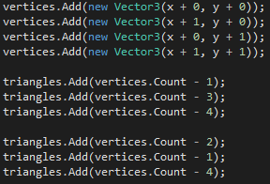
This then repeats depending on the selected width and height values, creating a simple pink mesh which then can be textured. However texturing is a bit more complex as we are creating the mesh on runtime with each square created individually. After further research it appeared that the same individual (Nintendo Examiner) had also explained about UVs and how they can be applied to a custom mesh. This was almost the same as creating the squares themselves, however it required something called a sprite sheet. This is usually a simple image of multiple smaller image samples. These smaller samples are then cut up and named appropriately so that when you come to use them, they have unique names allowing for a more robust program.
Figure [3] – Code snippet of creating custom tiles using triangles.
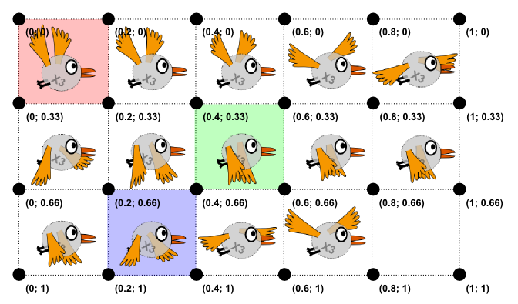
UVs require 4 values, same as vertices you could say, as it needs to know the exact place and size of the location for the texture. Once these 4 points have been calculated, it takes the corners of the selected image sample and places them accordingly to the 4 points of the UVs. This is simpler than it sounds, and once again Unity’s engine is pretty advanced at features like this. As it has many libraries that have the lower level code within them, calculating all of the buffers for you.
Once the UVs were implemented a reasonable map could be generated, as we had perlin noise implemented it was creating smooth and playable maps. However one of the requirements was to be able to then edit this map, so a menu system had to be implemented. This was not a hard task as this has been done before, and only requires design skills as there are buttons available for Unitys UI system. Once this was implemented the buttons however had no functionality, so listeners had to be added for them to be able to call out functions when clicked. One of these functions was to change what tile has been selected for the editor, the selection of tile was simple, whereas the actual changing of a tile once clicked was a bit more complex. This meant that it was required for the code to know which exact tile has been selected on the mesh, and then change its texture to the desired tile type. This also meant that the UVs of that specific tile had to be altered as it will need to change the texture. To simplify this, instead of updating the values of the exact tile and then updating the whole mesh, it was better to simply recreate the mesh with the new tile. This did not create any performance issues as it is a 2D mesh of a very computationally simplistic model.
Figure [4] – Sprite sheet with UV values.

Evaluation
This was one of the favorite tasks to do, meaning that a lot of self-learning was made. This meant that not many tutorials were actually used as for this task it was quite interesting to try and figure things out yourself. Most of the planned features had been applied correctly, including the possibility of saving and loading in saved maps.
Unfortunately there were 2 features that did not manage to be implemented by the end of the project. One was to be able to hold the mouse button when editing the map, as that would make the editing feel a lot smoother. The second was quite a big one, where the level had to be complete able, this also turned out to be a difficult task to achieve, especially because of the style of the map.

References
CaptainKraft. (2013, August 19th). Create a Procedurally Generated Dungeon Cave System. Retrieved from https://gamedevelopment.tutsplus.com/tutorials/create-a-procedurally-generated-dungeon-cave-system--gamedev-10099
Examiner, N. (2017, April 23rd). YouTube. Retrieved from https://www.youtube.com/watch?v=kkEBZT9Hrz8&list=PLQQnUdF0ry186ltzOuXdW_nxsImeZQVMG
Mann, S. (2016, January 1st). Napland Games. Retrieved from http://naplandgames.com/blog/2016/11/18/unity-3d-tutorial-procedural-map-generation-beginner-level/
Unity3D. (2017, January 1st). Unity Documentation - Perlin Noise. Retrieved from https://docs.unity3d.com/ScriptReference/Mathf.PerlinNoise.html

