Advanced Technologies Task 2: Huge Swarm AI
Gundars Pelns (15014193)
Department of Computer Science and Creative Technologies
University of the West of England
Coldharbour Lane
Bristol, UK
Gundars2.Pelns@uwe.live.ac.uk

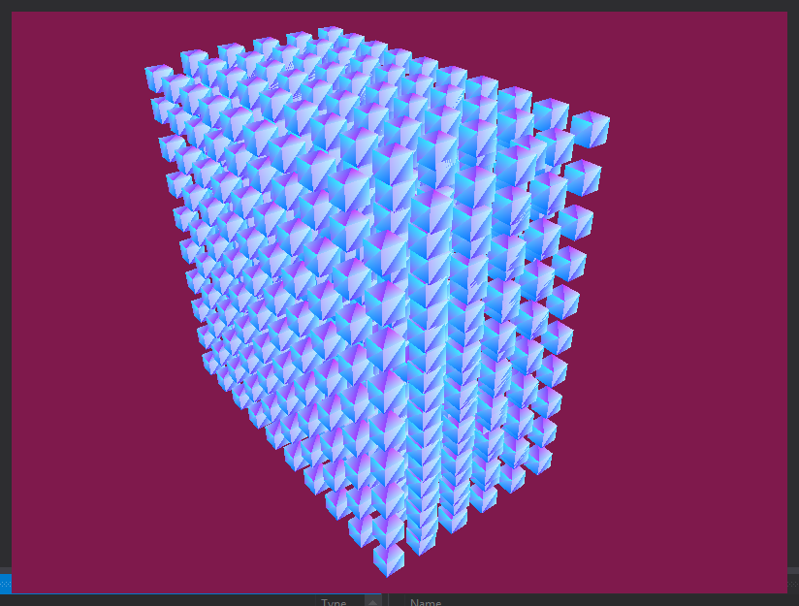

Introduction
This task required us to develop a huge swarm of objects, which then follow a set of rules to avoid each other as well as navigate to a point in the world. The main feature of the swarm was that it was required to be able to handle a large amount of these objects without much change in the CPUs performance. The task was set to be developed using DirectX 11 without using the DXTK, which contains a large amount of libraries that could assist this project.

Background Research
Initial research had to be made towards DirectX11 itself, this is because it was a new engine for everyone. Although there was no past experience in DirectX, it was understood that it is used a lot within the games industry. This is because it’s quite a robust engine that with the DXTK, even without to be truthful, has quite a lot of potential. As it allows you to create games or applications in a 2D and 3D environment. The main difference between DirectX and something like Unity is that you manually have to code the buffers and other low level features as such. Buffers are very important and quite complex to learn, there are 2 types of buffers, Vertex, Index and Pixel buffer.
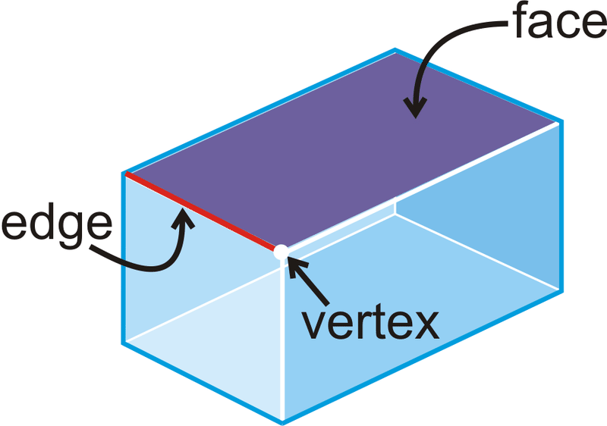

As you know, all objects or models that are created on the computer consist of hundreds or thousands of triangles, these triangles are created from three points in the world. Each of these points are called a Vertex, however to allow the model to be rendered we need to put all of these Vertex points into a special data array, called a Vertex buffer. The purpose for this is to then take the Vertex buffer that contains all of the desired vertex points, is then sent to the GPU for it to be rendered on the screen. However the vertex buffer is not the only buffer that you are required to implement for rendering models. It is also important to have the Index buffer set up as that works with the Vertex buffer to load information at a better rate. What the Index that is in the vertex buffer. The purpose for this is to allow the GPU to then quickly find specific vertices in the vertex array. This allows for much quicker calculations as it will know the exact location of the vertex you are looking for. The DirectX documentation also suggests that this improves the performance of the program, thus it is a very good idea to include both.
Figure [1] – Vertex point example
The next most important thing to research was shaders, and how these work in the DirectX environment. There are 2 types of shaders, first being the Vertex shader and second being the Pixel shader. These shaders are mostly used in 3D environments however, especially the vertex shader. They are both quite different actually, as both of them are in charge or different aspects of a model. The Vertex shader is the more technical one, this is because it consists of small programs that are in charge of transforming the vertices from the vertex buffer into 3D space. So these shaders are usually quite complex, and not only that, it is important to keep these shaders as optimized as possible. This is because the shader allows for complex calculations such as calculating the normals for each vertex. The vertex shader is called for all of the vertices in the vertex buffer to then calculate the normals for those vertices. So you can see that a big model with a lot of vertex points will need an efficient vertex shader.
Figure [2] – Simple HLSL model
The pixel shader on the other hand, is more graphical in the sense that it is in control of features such as, coloring, texturing, lighting and other effects as such. This should be used for most effects that you plan to apply to your polygon faces, as it is in control of graphical features. The pixel shader is actually quite a complex program, especially when it comes to writing efficient ones. This is because the pixel shader is run by the GPU for each visible pixel that will be drawn on the screen. This means that if you wanted to have an application with more complex models, which have multiple different graphical features. The shader would have to run for each pixel, so you can see how this could potentially affect frames per second causing the application to slow down.

Outcomes
Throughout researching, a lot of information was found about the DirectX engine. This included simple features such as creating a window for your application to then have models rendered on, to features like creating multiple instances of a single model. These all seemed overwhelming at first, but that was only because it was something new and unexperienced, so like with most things like that. It was all about trying anything that seemed to have potential, thus way it was possible to find the one thing that the works and allows for further development.
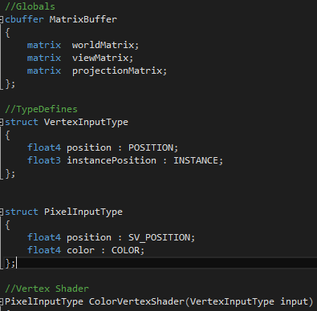
Thankfully DirectX has been available for years now, meaning that there were quite a lot of tutorials and examples available. Most of these being outdated sadly, but the logic still stood meaning that it was possible to implement this in the newer DirectX. The only problem then was that the code was not available, but debugging is a wonderful tool which helps with issues as such. So the first thing then was to get it all set up.
Figure [3] – Code snippet of Vertex Shader
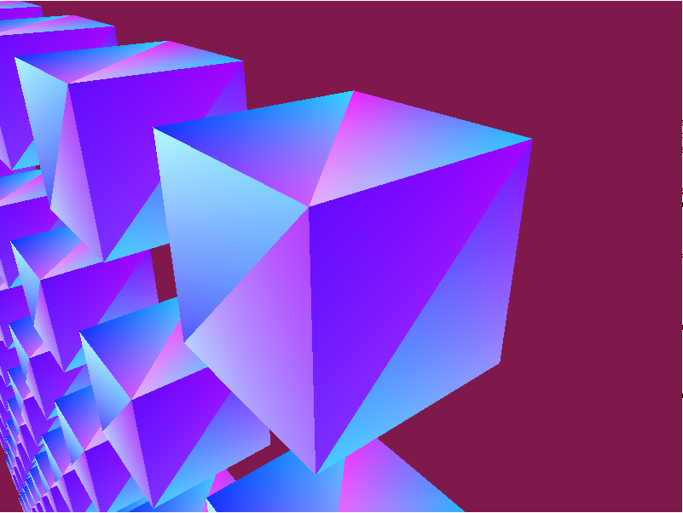
This required some changes in visual studio itself, as the version used for this task was Visual Studio 2015 this was not that complicated. You are required to create a new Win32 project with altering some settings before finishing the setup. As well as to remember to change the build from the default 32bit “x86” to the 64bit system “x64”. Once this is done the project is ready to use DirectX, however this needs to be set up within the code first. The way this was accomplished was by making a graphics class, which was in charge of initializing, running and shutting down of the DirectX class. The DirectX class on the other hand is in charge of a large amount of features, including the setting up of the buffers, such as the back buffer. The setting up is truly the most annoying part and takes up a lot of time, but once the DirectX class is set up you can start to implement more functionality.
Once this was set up, the next thing to do was to implement graphics, as this was for a swarm there was the choice to go either 2D or 3D. 3D seemed to be more intriguing so this option was chosen, although they are both pretty similar, 3D objects simply have a lot more vertex points. The way graphics are handled in the DirectX environment, is by using HLSL which is the language used to code small vertex and pixel shader programs. At first it seemed like it was going to be a whole new language, however after looking over some papers and examples it turned out to be pretty much identical to the C language used in DirectX. The only issue was that there still has been no experience in using these shaders, however this was not a massive issue as the examples from before carried on to explain these two shaders. They were different to a normal C script in the way that they mostly consisted of unique properties like, globals, typedefs and struct functions. Like mentioned before they both are in charge of different features, as you can see both of these shader typedefs require a position, however the pixel input has another unique value called “float 4 color”. This is because as mentioned before, the pixel shader is in charge of texturing, coloring and so on, whereas the vertex shader is more for positioning and instancing for example.
Figure [4] – Example of a 3D vertex cube

Evaluation
This was the most challenging task of the 3, proving that this takes a lot of time and effort to learn. Just like most thing correct, but this seemed to overwhelm with the new engine and the lack of code examples online.
This task required a lot more research causing time to disappear, if more could be done, more behaviors would be added. Such as cohesion alignment and separation, as at the moment in only has separation.

References
Hu, X. (2006, January 1st). PSO Tutorial. Retrieved from http://www.swarmintelligence.org/tutorials.php
Microsoft. (2016, January 1st). Optimizing HLSL Shaders. Retrieved from https://msdn.microsoft.com/en-us/library/windows/desktop/cc627119(v=vs.85).aspx
Microsoft. (2016, January 1st). Using Shaders in Direct3D 10. Retrieved from https://msdn.microsoft.com/en-us/library/windows/desktop/bb509703(v=vs.85).aspx
Microsoft. (2017, January 1st). Introduction to Buffers in Direct3D 11. Retrieved from https://msdn.microsoft.com/en-us/library/windows/desktop/ff476898(v=vs.85).aspx
Reynolds, C. (2001, September 29th). Boids. Retrieved from https://www.red3d.com/cwr/boids/
Tek, R. (2016, January 3rd). RasterTek. Retrieved from http://www.rastertek.com/

