Advanced Technologies Task 1: Water Simulation in Unity

Introduction
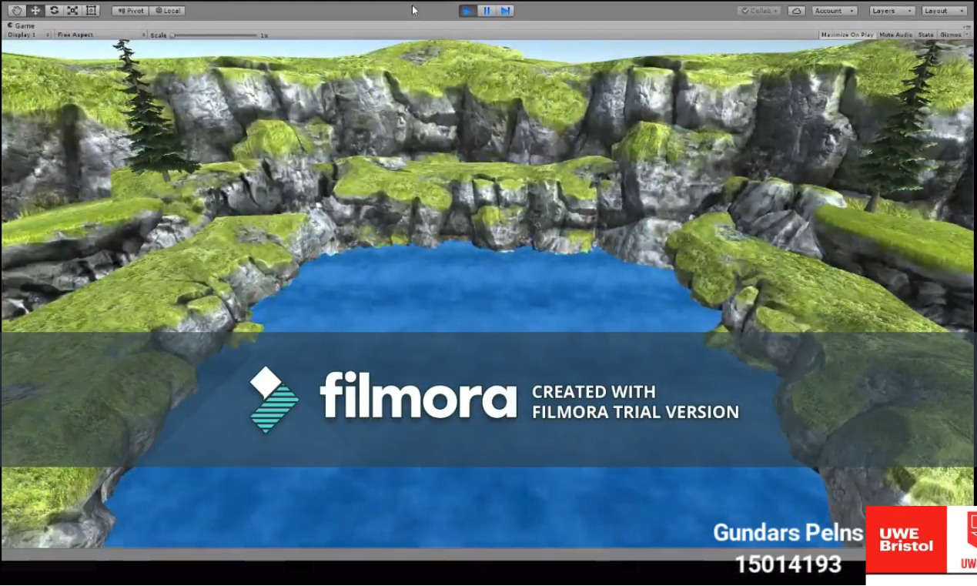
Gundars Pelns (15014193)
Department of Computer Science and Creative Technologies
University of the West of England
Coldharbour Lane
Bristol, UK
Gundars2.Pelns@uwe.live.ac.uk
The first task that was chosen by me to develop was a Water Simulation, the task was to develop a realistic simulation using the Unity engine. The main task was to create the simulation using shaders to improve performance as well as allow the user to alter different wave properties. These had to be the water type, wave direction and wind speed. However these could be slightly different and still count towards the project, for example instead of using wind speed, I was able to implemented features such as the wave scale, speed, frequency and amplitude. These features do the same however they are a bit more undefined, as they control the same values as wind speed for example, however you are required to know which one will do so.

Background Research & Outcomes
I began this project by looking at other peoples creations, however most of these individuals were using a free tool in unity called ‘cloth’. This simply takes a mesh, such as a plane, and then using perlin noise it creates a very realistic cloth like material for the object allowing all the verticies within the object to move around such as a cloth material would. So then if you move around the 4 corners of the plane, it will create a wave type motion all over the plane.
This looked super realistic and worked like a treat, however this did not teach me anything as it had all of the features already in the tool. It was also impossible to implement features such as wave strength to this tool, as it was pre made and was mostly meant for cloth like simulations which do not require the vertices to take any extra calculations. It was only able to create cloth animations when moved around or when an object was dropped on top of it. As the tool kept the mesh of the object, altering it with the movement of the vertices.
However the tool had quite a lot of good features that had the potential to be used within a different simulation, to be more specific there was a line of code which simply took the mesh of the plane and then altered each of the vertices on the object depending on the chosen values as well as taking in count what the values were for the other vertices around it. These being speed, scale and frequency of motion, although it was already looking like water with the possibility to change values on run time. It was not a shader, instead it was a C# script, this meant that it was not acceptable due to the fact that it was specified that it had to be a shader as this would be easier for the computer to then render. This also allows for more complex calculations as the shader will be rendered using the GPU, which will mostly focus on the rendering of the simulation, whereas the CPU has a lot of calculations before and after the rendering can occur.
Deep research then had to be made to figure out a way to program on a shader in Unity, this seemed quite difficult at first as there has been no past experience on this subject. However there appeared to be quite a lot of different techniques that achieved what was required for the simulation. Some of these not utilizing the shader however, there for it was important to then choose what type of technique was best and most simplistic for this task. As the task was a Wave Simulation, there is a technique using marching cubes, however this was not needed, as it just had to be the surface of the water. Water that is able to break and smash into objects was an extra task which did not seem necessary at the time being. This is why the research was more aimed at creating a simple shader that utilizes a plane (flat) object form unity. However it also meant that the waves would not be able to break nor have the ability to have these waves crashing into each other as that would need more than just a shader on a plane.
This allowed the research to be limited to a more basic shader that will simply alter the planes vertices. The creator of PeerPlay (Peer) had created a similar simulation in an older version of unity, his project was about dropping an object on top of a water plane. Which will then react to the object touching the plane and creates a ripple effect. The main interest was to see how Peer was able to alter the mesh of the plane using only a shader. Surprisingly it turned out to be more simplistic then expected, as shaders allow you to implement custom functions such as ‘surf’. Which stands for surface I believe, as the default code within it, is in charge of its surface appearance. However that was only the appearance of the object, the requirement was to have the mesh be altered to form a wave like simulation.
Although that would not be an issue as you are able to create more functions within the shader. Therefor a new function was created, called ‘vert’, which was in charge of gathering all of the vertices on the plane and altering their individual y-coordinates to create motion on the plane. Research was then made to see if a smoother motion amongst all of them was available, as it was not possible to use the default Mathf.PerlinNoise function within the shader environment. It was still possible however to apply sin and cos rules to the vertices on the plane, which created a wave formation starting from a set origin on the plane. These rules create a steady incline and decline for set values, which then forms a wave as the vertices follow each other up and down, but not at the same time. It starts from the origin of the plane, which is chosen within the code, and then a sin or cos wave is sent across the plane.
It was also possible to combine these rules to create more dynamic waves, such as a diagonal wave. As well as that, after research and multiple runs of trial and error, it was discovered that more than one origin could be applied. This allowed for multiple wave generations at the same time, for example you could now add a normal horizontal wave with a more advanced ripple effect creating even more realistic and random waves.
Although a dynamic wave can now be created, with the possibly of changing values of the wave in run time. It still had no perlin noise rule, which meant that vertices on the plane just had their own individual behaviors without checking if the vertices around it are at an acceptable range. In a normal C# script this could be set within the code, and its task is to keep surrounding vertices within that range, either above or below but no further than the value. As said before however, it was impossible to use the PerlinNoise function itself, there for a different approach had to be made. Gladly there is another technique that achieves the same as the PerlinNoise function, this being a noise texture instead. A noise texture or noise map even, is usually a black and white image of random spots across the image. With smooth transitions between these two colors as that has a lot of importance, this being that the darker the color, the more value that area has.
The purpose of the noise texture is to alter the mesh of a plane using just the difference in color of the texture. This would only work if the code within the shader is applied correctly however if it is, you can create custom terrain type meshes by using simple noise textures. This does not seem like it would be helpful for waves.
But after further research a technique called “scrolling noise map” was discovered, this takes the original noise texture or map and allows it to move around the plane in runtime. Changing the values of the verticies as it moves around the surface of the plane altering the whole mesh. This sounded a lot more useful as that could move over the plane slowly creating a more realistic and bumpy water mesh.

Evaluation
Evaluate your outcomes and your approach, suggest further improvements or dire

References
Evaluate your outcomes and your approach, suggest further improvements or dire

Research
Document this as-you-go, or at least keep notes of research you are carrying out.
Outcomes
What your investigations have found and what you have developed from those investigations

