As a group we decided to choose the University dataset as our theme, the dataset consists of three collections which are Students, Courses and Professors, we chose to work with the student’s collection. This collection consists of different fields with different data types. The fields are object id which is the id of a document inside the collection, and it is a string, a student id that is also a string, student name also a string, contact info which is an object with embedded documents, enrolled courses and advisors which are arrays.
To run the application, you need to create a virtual environment with faker and pymongo modules installed in it, then you would need to open visual studio code and connect to the virtual environment. This application has different functions which perform the CRUD operations. CRUD operations are the fundamental operations that are used to manage data in a document within a collection. These are operations are Create which is used to create a document within a collection, with this operation you can create a single document or many documents as shown in the picture below with the implemented functions.
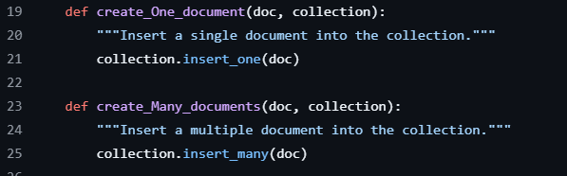
The Read operation is used to read documents from a document within a collection, with this operation you can read all documents in the collection, read one document, read a document by its id or read a document by a condition as shown in the picture below with the implemented functions.
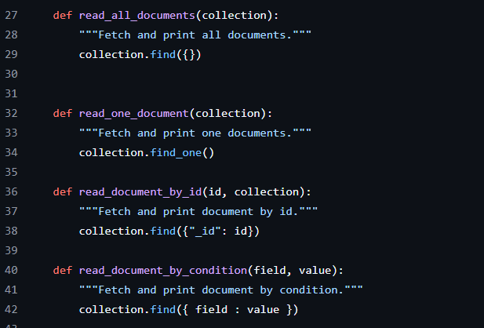
The Update operation is used to update documents within the collection, you can update one document or many documents in the collection, as implemented in picture below.
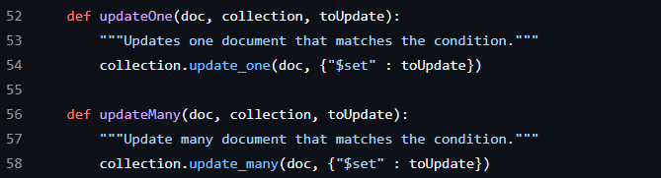
Lastly the Delete operation which is used to delete one document or many documents in the collection, as implemented in the picture below.
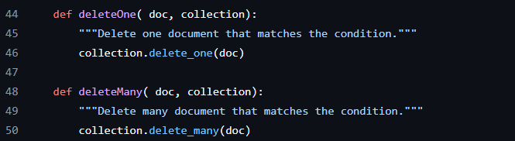

To interact with data in the document, the application provides users with a menu of choices to interact. Users will be prompted to select any choice they want after viewing the menu to interact with the data. When you run the application, the following menu will be provided on the terminal with a prompt to enter a choice.
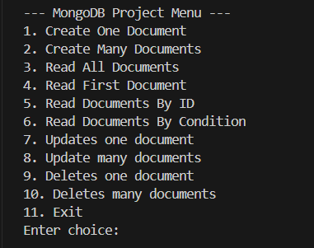
If the user selects choice number one, they will be creating a single document. By creating a single document, the user will be to prompt to enter the information of the student, which is the name of the student, student id, email, phone number, contact info. The user will also be prompted to enter course information of the single student being created, which is the course id, course code, semester, grade and status, the course information will be then appended to an array to create an embedded document. Lastly the user will be prompted to enter the number of advisors, the number of advisors will be used in a loop to add each advisor’s id. Then a single a student document will be created. This is shown by the picture below.
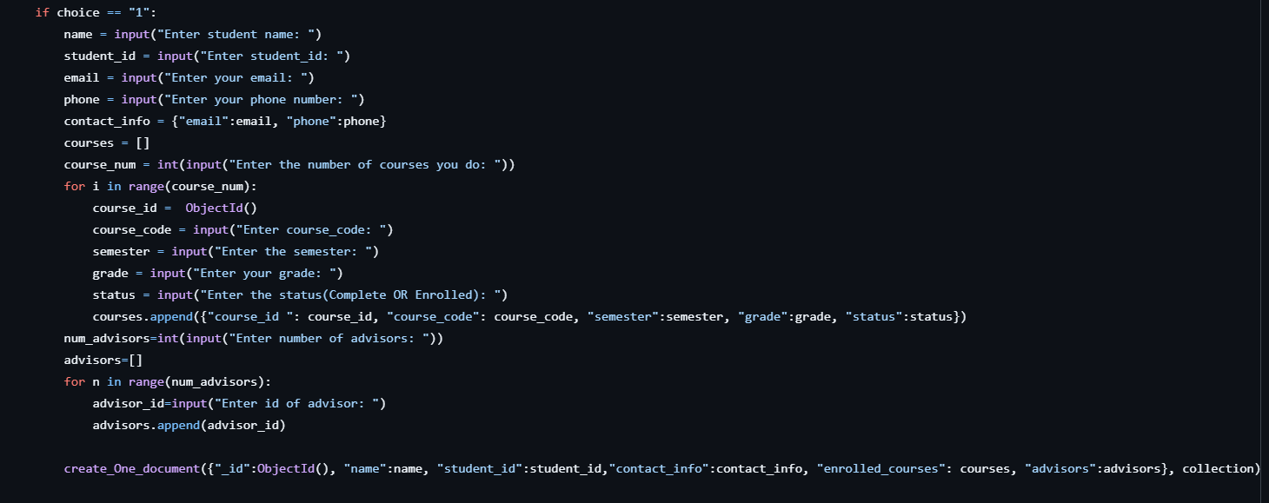
If the user selects option number two, this option prompts the user to create many documents of the students. This create many documents works just like the create a one document, but the main difference is that the user will be prompted to enter number of students that they want to create and then each student created is added into an array, as shown in the picture below.
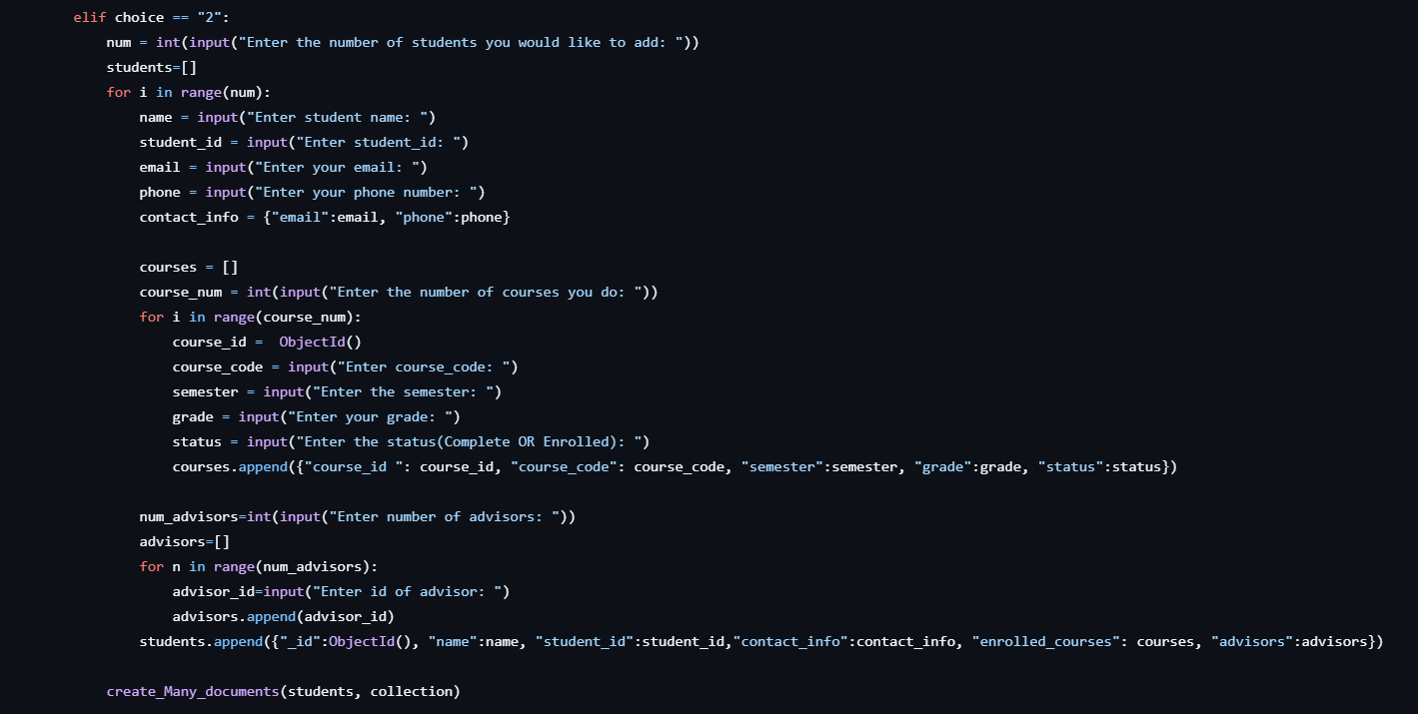
Option 3 to 6 are the read computations, where option 3 is reading all the documents within a collection. Option 4 allows the user to read only one document, option 5 prompts the user to enter the object id, then read a document by its id. Option 6 prompts the user to enter a field and a value to read a document by a condition. This is shown in the picture below.
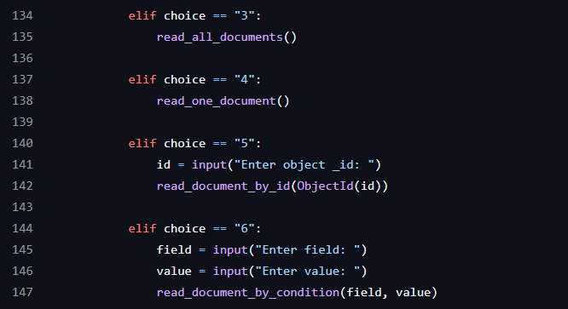
Option 7 and 8 allows the user to update documents, both options allow the user to enter a field, a value and a new value to update the document that matches the field provided by the user. The main difference between the options is that the option 7 allows the user to only update one document and option 8 allows the user to update many documents. Shown in the picture below.
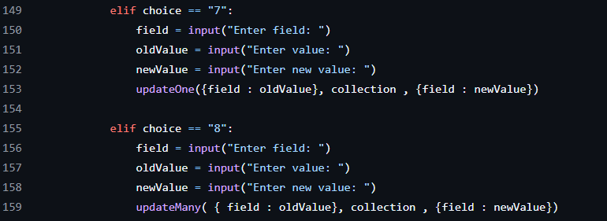
Option 9 and 10 allows the user to delete documents from the collection, both options prompts the user to enter a field and a value to be deleted from the collection, and the difference between the options is that option 9 allows the user to delete only one document and option 10 allows the user to delete many documents from the collection.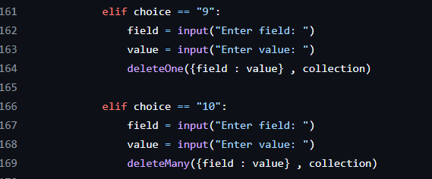
The last option which is option 11 allows the user to exit/quit the application if they are done interacting with the data of the document within a collection, and then an error message is returned to the user is neither of the choices/options are given.
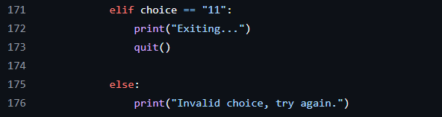
This is how the user can use the application to interact with the data in the document within a collection.

