Virtualization in cloud Computing
Assignment Document Work Report: --
Objective:
Create and configure multiple Virtual Machines (VMs) using VirtualBox, establish a network between them, and deploy a microservice-based application across the connected VMs.
Main steps:
- Step-by-Step Instructions for Implementation:
- Installation of VirtualBox and creation of multiple VMs.
- Configuration of network settings to connect the VMs.
Step:1 Downloaded the virtual box: --
Step:2 added 2 virtual machines of Linux Mint Operating system by using add the configuration
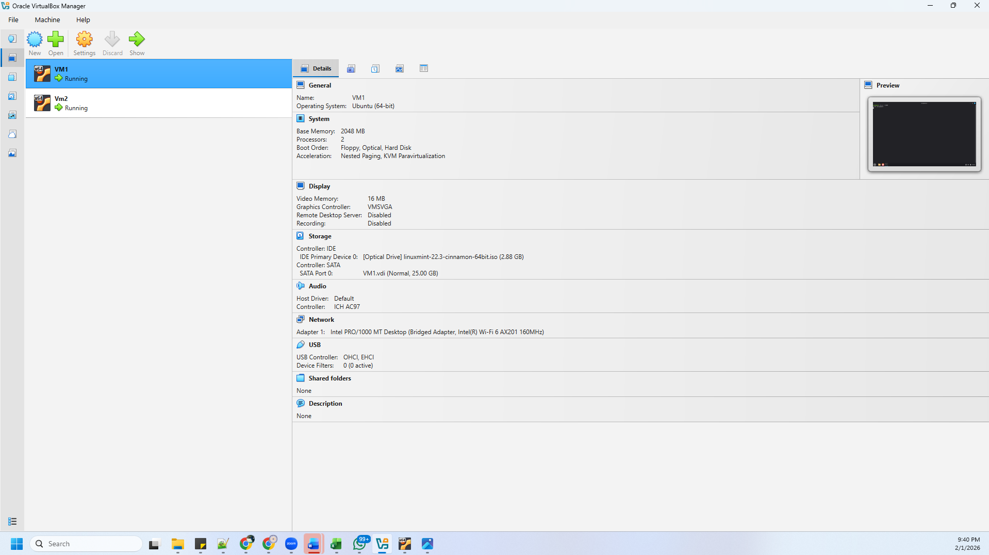
Step 3: once configured go to Settingsnetwork -bridged adapter for bring up the communications between the 2 virtual machines
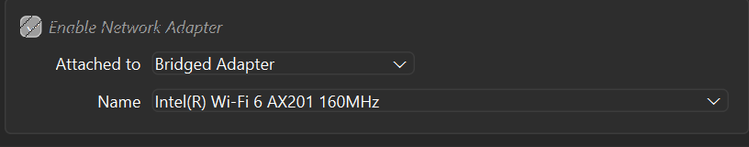
Step 4: once installed the os inside virtual box we have to know the of 2 Virtual machines by using ip addr here: VM 1 IP ADDRESS:192.162.29.90 and VM2 IP ADDRESS: 192.162.29.63
Step 5: We have to Use PING Packet internet Groper to confirm the reachability and connection checks between 2 hosts
Virtual machine 1 to VM 2 ping status
In terminal Nodes:
- VM1 (Sender): IP 192.168.29.90
- VM2 (Listener): IP 192.168.29.63
Step 6
Setting up the Listener (VM2) In the VM2 terminal, we opened a port to wait for incoming data: nc -l 5000
Step7: Initiating the Sender (VM1) In the VM1 terminal, we connected to VM2's IP and port: nc 192.168.29.63 5000
Data Transfer
- Action: Typed "Hi" in VM1 and pressed Enter.
Step 8: Result: The message appeared instantly on the VM2 terminal.
D.Deployment of a simple microservice application (e.g., a RESTful API or a Node.js-based service) across the VMs.
Step:1 The command sudo apt update was executed to refresh the local package index from the Linux Mint and Ubuntu repositories. This ensures that the system is aware of the latest available software versions and security updates.
After updating the package list, the command sudo apt install nodejs npm -y was used to install Node.js and npm. The output indicates that Node.js and npm were already installed and were at their latest available versions. Therefore, no new packages were installed, and no upgrades were required at this stage.
Sudo- Super User DO----- Allows a normal user to execute commands with administrator (root) privileges.
Apt Advanced Package Tool
Node.j runtime environment that allows execution of JavaScript code on the server side
Npm Node Package Manager-y “yes” to all installation prompts
This confirms that the system environment was already correctly configured for running Node.js-based microservice applications.
Step:2
- A second virtual machine (VM2) was used to verify application setup and execution.
- Node.js and npm were installed using the APT package manager.
- A project directory named inventory-service was created.
- An application file app.js was created using a text editor.
- The Node.js application was executed using the node app.js command.
- The service started successfully and listened on port 3000.
- This confirms that the Node.js runtime environment is properly configured.
Step:3
- mkdir gateway-service: To create a dedicated workspace and ensure the Gateway's source code is isolated from other system files.
- cd gateway-service: To move the terminal’s focus into the project directory so all subsequent commands and files stay contained within the project.
- npm init -y: To instantly generate a package.json file, which acts as the project's "ID card" and tracks all the external libraries (dependencies) the service will need to run.

- npm install express axios: To download and integrate the core libraries required for the service. Express is used to build the web server and handle API routing, while Axios is used to make HTTP requests to other microservices
Verification (npm init -y): To confirm that the dependencies were correctly registered in the package.json file. This ensures the project manifest reflects the current environment, showing axios (^1.13.4) and express (^5.2.1) under the "dependencies" section.
- Security & Integrity Audit: The command automatically triggers a security audit (showing 0 vulnerabilities), ensuring the installed packages are safe and stable for development.
Step:5 in virtual machine 2 we are making inventory report
Directory Navigation
- cd ~/inventory-service: Navigates into the specific microservice folder to ensure commands are executed within the correct isolated environment.
- We have used this code
const express = require('express');
const app = express();
const PORT = 3000;

// This is the data your microservice will provide
app.get('/api/inventory', (req, res) => {
res.json({
status: "Success",
message: "Hello from VM 2 Inventory Service",
items: ["Laptop", "Monitor", "Keyboard"],
timestamp: new Date()
});
});
app.listen(PORT, '0.0.0.0', () => {
console.log(`Inventory Service is active on port ${PORT}`);
});
. Service Execution
- node app.js: Launches the Node.js runtime for the Inventory Service, making it live and "active on port 3000" to listen for incoming data.
Step:6 In Virtual Machine 1 API Gateway Service Implementation
In this Overview phase, a Node.js application was developed to act as an API Gateway. This service serves as the single entry point for the system, routing requests to the appropriate backend services.
Environment & Execution
- Editor: The nano text editor was used to write and modify the app.js source code.
- Runtime: Node.js.
- Command to Start: node app.js.
- Active Port: The gateway is configured to listen on Port 8080.

VM1:
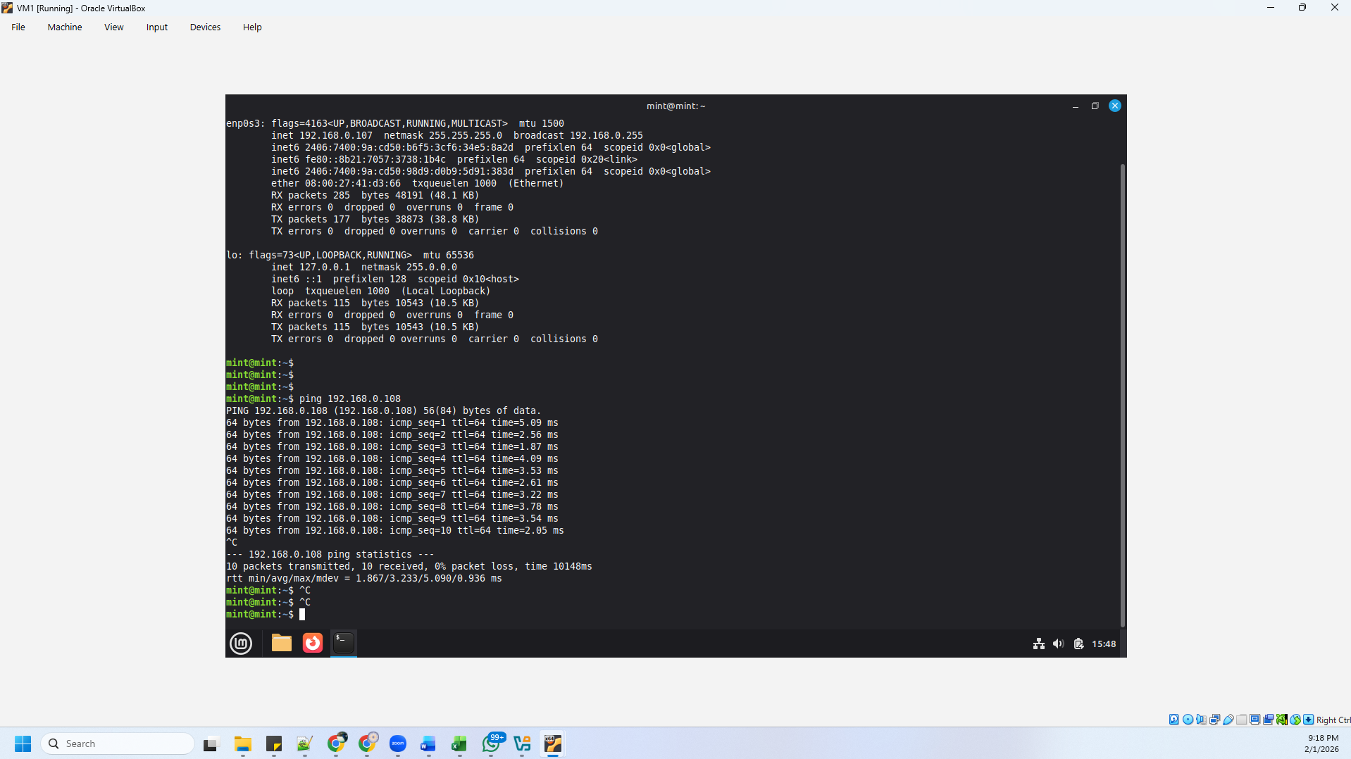
VM2:
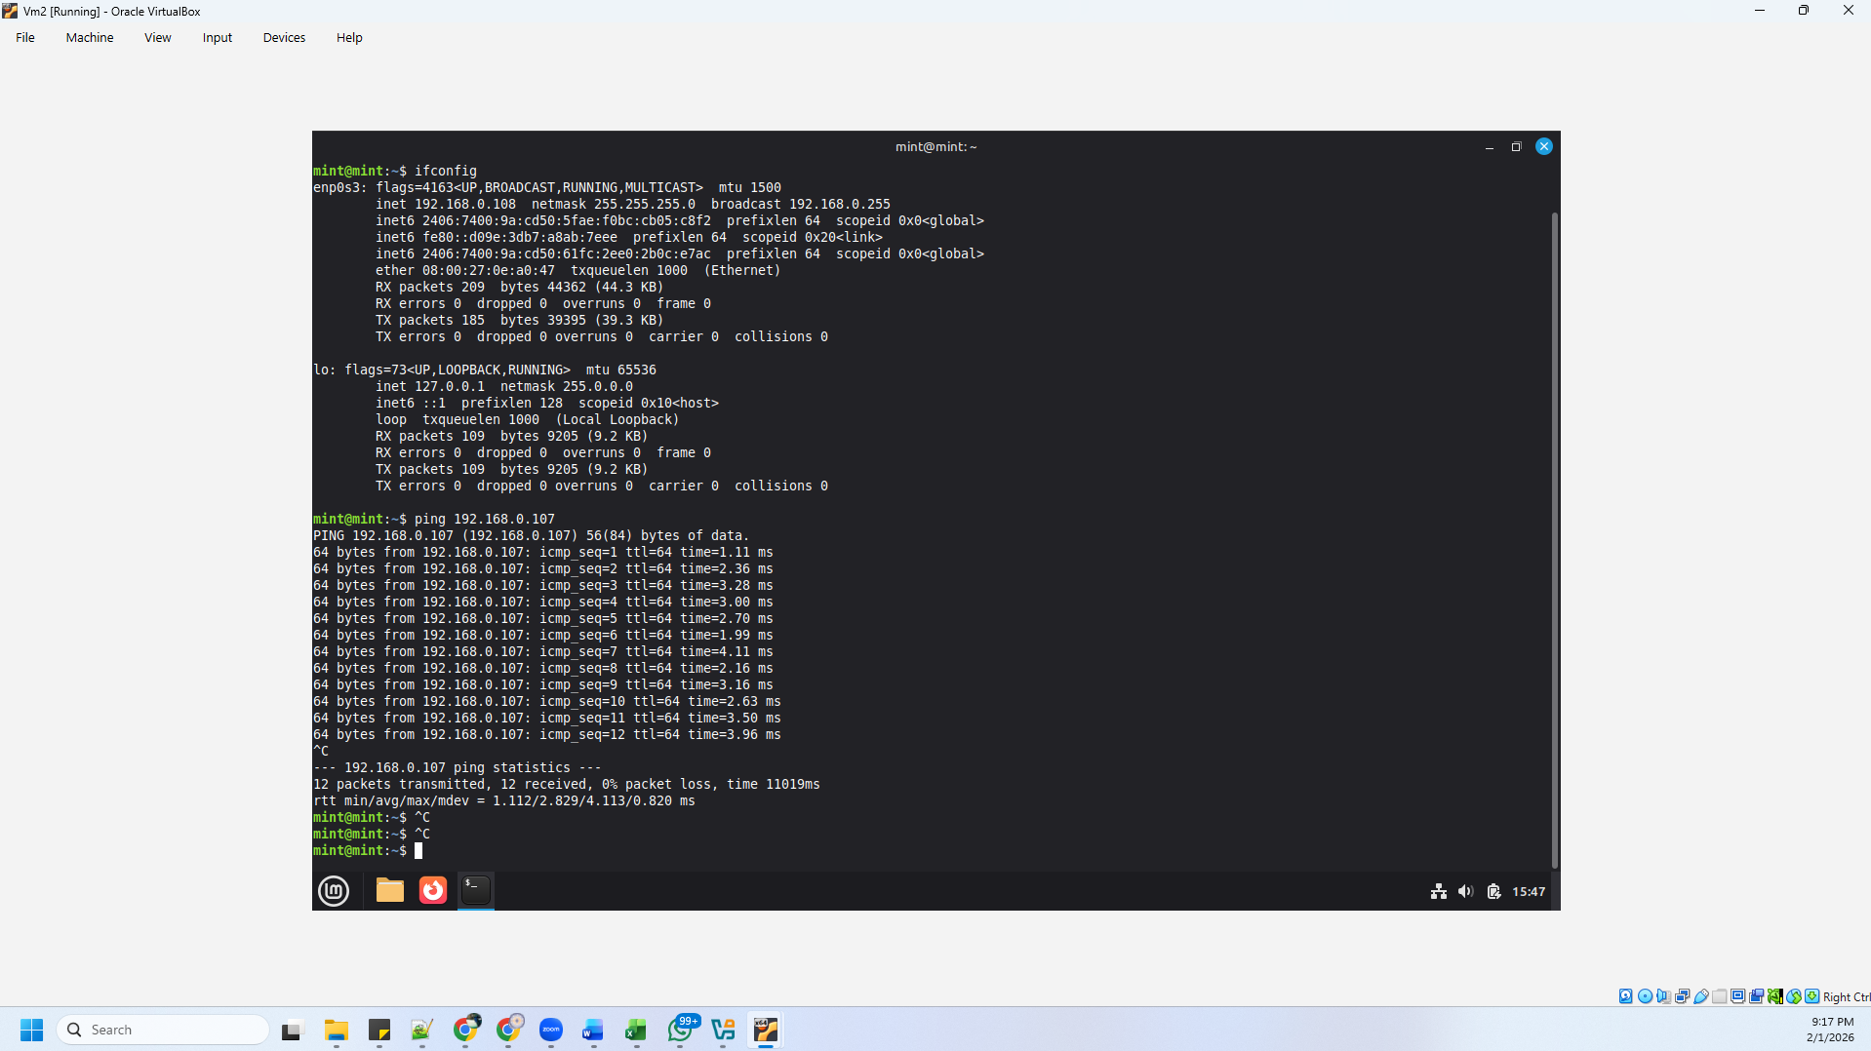

Packet (Massage) check:
VM1:
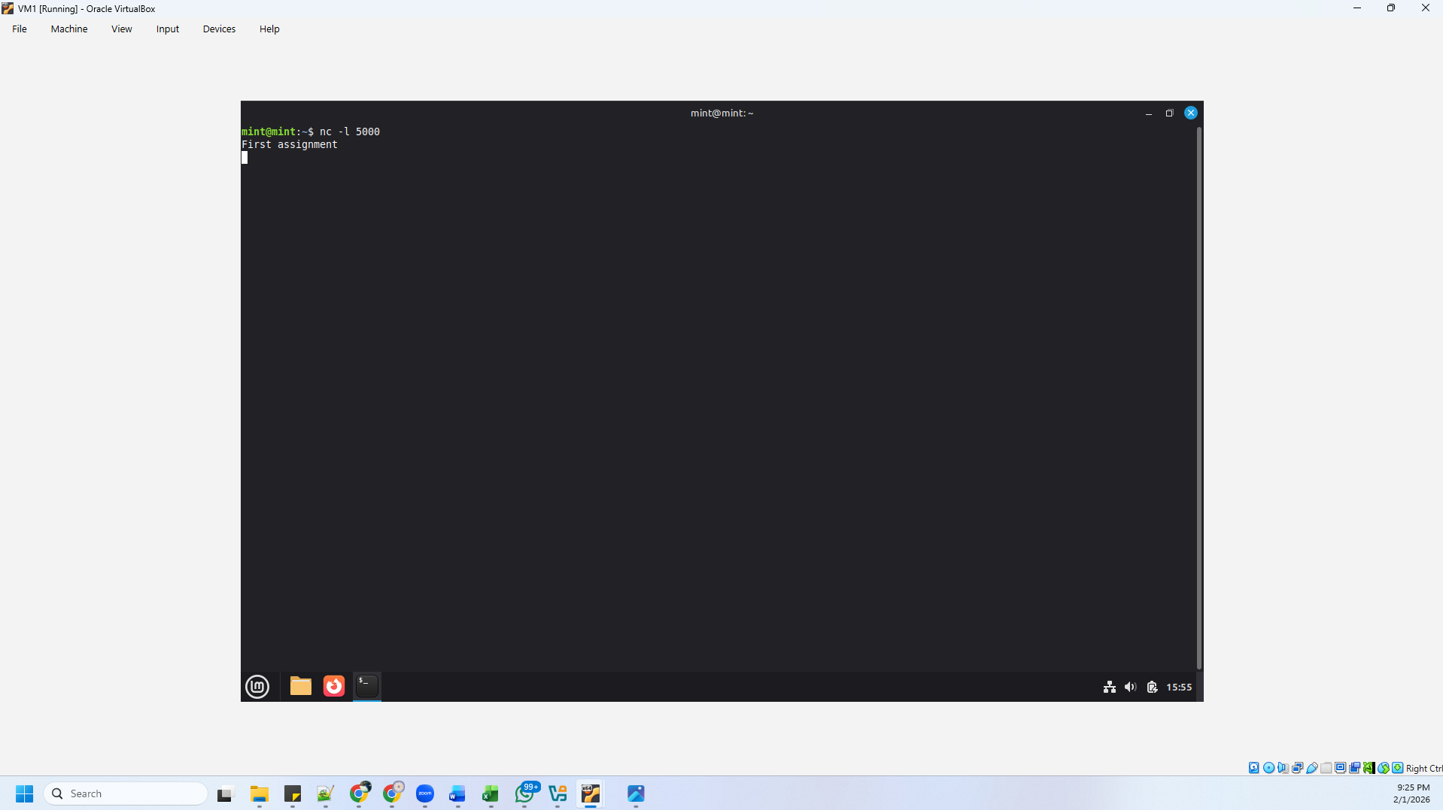

VM2:
