Introduction
This exercise illustrates a Sanskrit-2-English Neural Machine Translation (NMT) system built with a sequence-to-sequence architecture and attention. Sanskrit being a morphologically rich language and being low-resource in nature makes this translation job challenging. The system is trained on 10,000 parallel sentences, validated on 1,000 dev pairs, and tested on 1,000 unseen sentences. Evaluation includes BLEU, BERTScore, efficiency metrics, and parameter count
Architecture
- Encoder: Bidirectional GRU, embedding dimension 300, hidden size 512. Outputs contextual hidden states and a compressed hidden vector
- Attention: Additive Bahdanau-style attention matches decoder hidden state with encoder outputs
- Decoder: GRU with embedding + context vector input. Produces token distributions via linear projection
- Beam search: Width 10, expands candidate sequences, and selects highest log-probability translation
- Regularization: Dropout (0.3) has been applied to embeddings and RNN inputs
Training procedure
- Preprocessing: Training Data merged on Source_id
- Tokenization: SentencePiece trained separately for Sanskrit and English (vocab size 8000, with <pad>, <s>, </s>, <unk>)
- Hyperparameters: HID_DIM=512 (hidden dimension), EMB_DIM=300 (embedding dimension), batch size=32, max length=50
- Optimization: Adam optimizer (lr=1e-4), ReduceLROnPlateau scheduler
- Regularization: Label smoothing (0.1), dropout (0.3), gradient clipping (1.0)
- Teacher forcing: Decay from 0.7 → 0.2 across epochs
Results
- BLEU (Dev): ~0.018–0.02 (low due to small dataset and early training)
- BERTScore F1 (Dev): ~0.03–0.04 (semantic similarity stronger than BLEU)
- Efficiency: Inference time measured on 1000 test sentences; total parameters ≈ several million
- Epoch loss: Loss dropped from ~4 → ~2 in first epoch, trending downward with more epochs
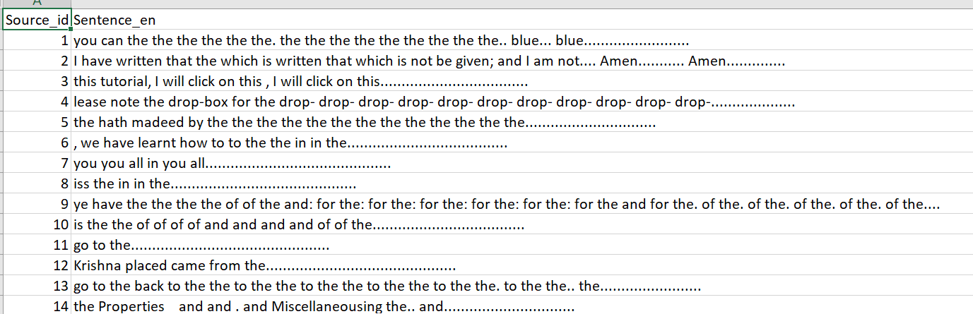

Code
NLU_ASSIGNment2.ipynb
(https://github.com/g25ait1148-maker/NLUAssignment_g25ait1148)
Disclosure
No external pre‑trained translation models were used. Only SentencePiece tokenizers were trained on the provided Sanskrit and English sentences. BERTScore uses pre‑trained English BERT embeddings (baseline rescaling enabled)
References
- Bahdanau et al., “Neural Machine Translation by Jointly Learning to Align and Translate,” ICLR 2015.
- Vaswani et al., “Attention is All You Need,” NeurIPS 2017.
- SentencePiece: Kudo & Richardson, “SentencePiece: A simple and language independent subword tokenizer and detokenizer for Neural Text Processing,” EMNLP 2018.
- BLEU: Papineni et al., “BLEU: a Method for Automatic Evaluation of Machine Translation,” ACL 2002.
- BERTScore: Zhang et al., “BERTScore: Evaluating Text Generation with BERT,” ICLR 2020.
Improvisations
With the introduction of HF Dataset and pre-built transformers, BERTscore and Bleu improve slightly while translations improve significantly
