MLOps Assignment 2: Hugging Face Fine-Tuning, W&B Tracking and Model Deployment
Goodreads Genre Classification using DistilBERT | Kaggle GPU Workflow

Submission Links
Item | Public Link
GitHub Repository | https://github.com/g25ait2016-bot/mlops-assignment2-goodreads-distilbert
Kaggle Notebook | https://www.kaggle.com/code/anukumarkg25ait2016/anukumar-mlops-assn2-final
Hugging Face Model | https://huggingface.co/Aukrk/distilbert-goodreads-genres
W&B Dashboard | https://wandb.ai/anuaussie-prom-iit-rajasthan/mlops-assignment2
W&B Run | https://wandb.ai/anuaussie-prom-iit-rajasthan/mlops-assignment2/runs/l88vnpqs

Evaluation Results
The final model was evaluated on the held-out test set after fine-tuning. The metrics were logged explicitly to Weights & Biases, and the classification report was saved as an evaluation artifact.
Metric | Score
Accuracy | 0.56937
F1 Score | 0.57111
Eval Loss | 2.4409

1. Model Selection Rationale
I selected DistilBERT (distilbert-base-cased) for this text classification task because it provides a practical balance between accuracy, training speed, and compute efficiency. DistilBERT is a compact Transformer model derived from BERT, so it retains useful language understanding while requiring fewer resources than the full BERT model. This was appropriate for Kaggle GPU training because the assignment focuses on building an end-to-end MLOps pipeline rather than achieving the highest possible score. The Goodreads dataset contains natural language review text and genre labels, so a pre-trained language model can reuse general text understanding and only needs fine-tuning for genre prediction. I used the cased version because capitalization in review text, book titles, and named references may carry useful information. Overall, DistilBERT is lightweight, widely supported in Hugging Face, and suitable for a reproducible student-level workflow.

2. Kaggle Training Setup
The starter notebook was imported into Kaggle and executed with GPU acceleration enabled. Internet access was also enabled so that the notebook could install required libraries, download Goodreads review data, access Hugging Face models, log to W&B, and push the final model to Hugging Face Hub. API credentials were not hardcoded in the notebook. Instead, Kaggle Secrets were used to store WANDB_API_KEY and HF_TOKEN securely. This kept the workflow closer to production MLOps practice, where credentials should be externalized and not committed to source control.

3. Training and W&B Tracking Summary
The Goodreads review data was sampled by genre, split into training and test sets, tokenized with the DistilBERT tokenizer, and converted into custom PyTorch Dataset objects. The model was fine-tuned using Hugging Face Trainer for three epochs. TrainingArguments included report_to="wandb", which allowed W&B to capture training loss, validation loss, accuracy, F1 score, runtime statistics, and system metrics. The W&B dashboard was used to confirm that the run was logged successfully. Final metrics were also logged explicitly under final/loss, final/accuracy, and final/f1. The complete classification report was saved as eval_report.json and uploaded as a W&B artifact.
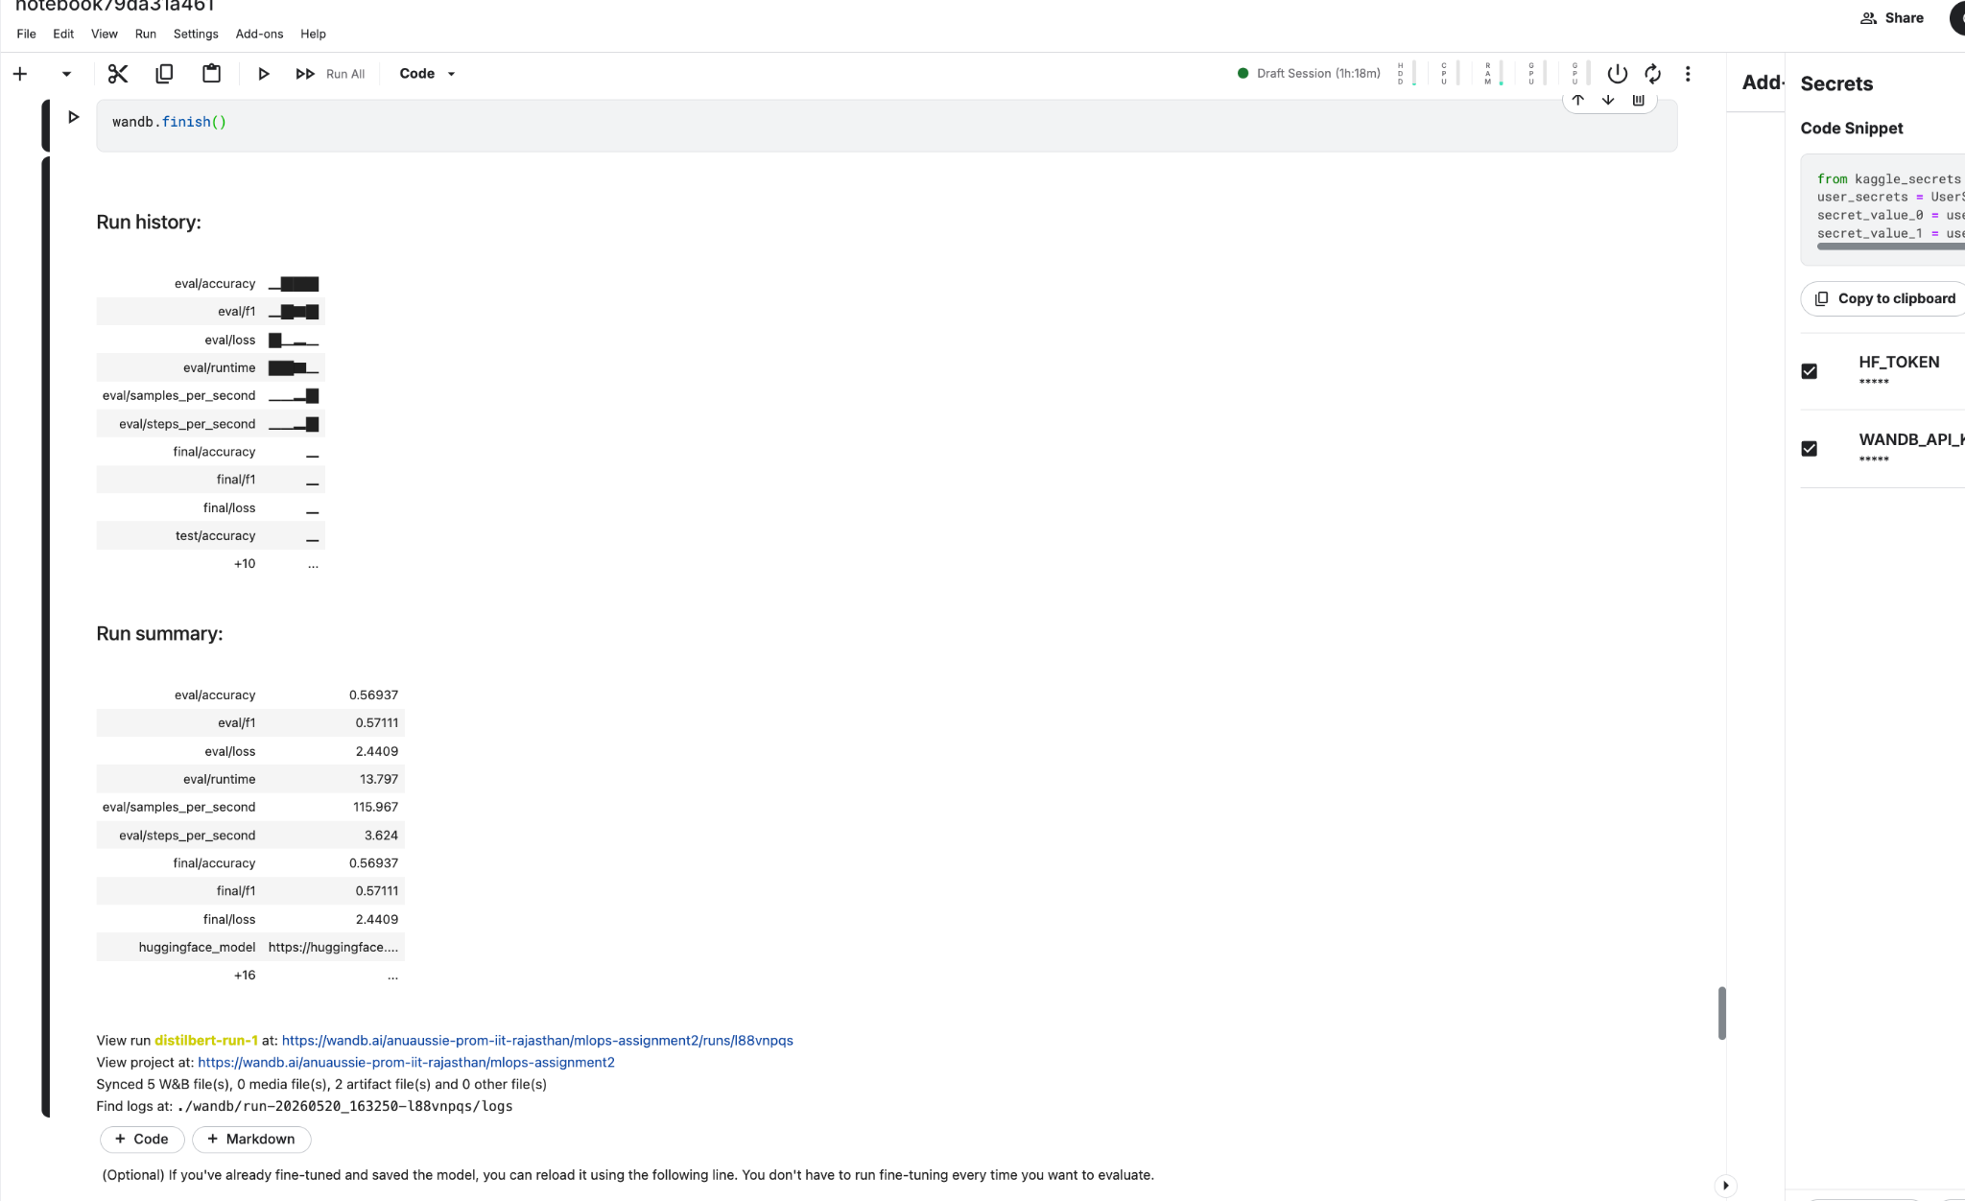
Figure 1. W&B run summary showing final metrics and Hugging Face model link.

4. Evaluation Interpretation
The final evaluation produced an accuracy of 0.56937, a weighted F1 score of 0.57111, and an evaluation loss of 2.4409. These results show that the model learned useful patterns from the Goodreads review text, although the assignment objective was not to maximize accuracy. The F1 score is close to the accuracy value, which suggests that the model performance was reasonably balanced across the genre classes. The main value of this experiment is that it demonstrates the full MLOps lifecycle: secure configuration, reproducible training, metric tracking, artifact logging, and public model deployment.

5. Deployment, Challenges and Learnings
After training and evaluation, the model and tokenizer were pushed to Hugging Face Hub under a public repository. The Hugging Face model URL was also written into the W&B run summary so that the experiment tracking record points to the deployed model. The main challenges were around environment setup, token management, and notebook cleanup. The first W&B token used was incorrect, so a proper API key had to be generated and stored in Kaggle Secrets. The Hugging Face token also required write access before the model could be pushed. Another issue was Kaggle Save Version failing due to notebook output rendering, which was resolved by clearing outputs and using a clean quick save. If I repeated this work, I would create the secrets first, use a smaller trial run for validation, and keep the notebook structure cleaner from the beginning.
Conclusion: This assignment successfully completed the requested MLOps pipeline: model fine-tuning on Kaggle, W&B experiment tracking, evaluation artifact logging, Hugging Face deployment, and public submission links for reproducibility.

