INDIAN INSTITUTE OF TECHNOLOGY JODHPUR
Post Graduate Diploma in Artificial Intelligence (PGD AI)
Course: CSL7520 GPU Programming
PROJECT REPORT
Problem 5: GPU-Based K-Means Clustering
Atomic versus Block-Privatised Reduction Strategies for Parallel Centroid Update in CUDA
Submitted to:
Dr. Binod Kumar
Submitted by:
Nikhil Saini (Roll Number: G25AIT2067)
Rahul Sharma (Roll Number: G25AIT2144)
Ishant Kulshreshtha (Roll Number: G25AIT2041)

Abstract
K-Means is among the foundational clustering algorithms in data mining and machine learning, yet its per-iteration computational cost of order N times K times D makes execution slow on multi-million point datasets. In this project, we implement Lloyd's K-Means clustering algorithm on NVIDIA graphics processing units using CUDA. The point to centroid distance calculation is parallelised with one GPU thread per data point, and the K times D centroid coordinates are cooperatively loaded into fast on-chip shared memory once per thread block. To address the centroid update phase where millions of data points must update only K times D cluster accumulators, we design and compare two distinct concurrent update strategies: Strategy A, which performs direct global atomic additions to global memory accumulators, and Strategy B, which uses block-privatised accumulators in shared memory followed by a deterministic second-stage reduction kernel. Convergence is evaluated directly on the device using change counters and maximum centroid displacement, restricting host to device PCIe traffic to eight bytes per iteration.
We validate numerical correctness against sequential C and NumPy implementations, achieving 100 percent point assignment agreement. Experimental evaluations on a Tesla T4 GPU in Google Colab demonstrate that the GPU implementation achieves between 25 and 477 times speedup over a single-core CPU reference at one million data points. Crucially, our benchmark reveals a performance crossover: Strategy B (reduction) outperforms Strategy A (atomic) by up to 8.7 times when the total accumulator count K times D is small due to severe atomic collision, whereas Strategy A becomes up to 18 percent faster when K times D is 512 or greater because global collisions are diluted while Strategy B incurs partial-buffer management overhead. All source code, Colab notebook, and benchmark results are provided.
1. Introduction and Objectives
Clustering partitions an unlabeled dataset into clusters where points within the same cluster share high similarity. K-Means remains a standard algorithm across domains including vector quantization, document categorization, and feature learning. At each iteration, every point is assigned to its nearest centroid according to Euclidean distance, and centroids are recalculated as the arithmetic mean of all points assigned to them. When datasets scale to millions of points in higher dimensions, sequential execution becomes impractical. For example, in our baseline measurements on an Apple M3 Pro CPU core, processing 1.6 million points in 32 dimensions with 64 clusters requires over 1.25 seconds per iteration, which means a standard 50-iteration run takes over one minute.
Modern GPUs provide thousands of lightweight streaming processing cores and hundreds of gigabytes per second of memory bandwidth. While calculating distances is embarrassingly parallel, updating centroids requires accumulating coordinates from millions of points into a few accumulator locations. How this many-to-few accumulation is structured determines both performance and numerical reproducibility.
1.1 Project Objectives
- Parallel Distance Calculation: Map point-to-centroid distance calculations across parallel threads using shared memory to cache centroid data.
- Two Centroid Update Strategies: Implement both a global atomic update strategy and a block-privatised hierarchical reduction strategy.
- Concurrency and Race Handling: Handle write collisions safely and ensure accurate counting of changed cluster assignments.
- On-Device Convergence Detection: Track convergence on the GPU to minimise host-device PCIe transfers.
- Systematic Benchmarking: Measure performance against sequential CPU code across 18 configurations of N, D, and K on a Tesla T4 GPU.
2. Problem Statement
The problem statement (Problem 5: GPU-Based K-Means Clustering) requires partitioning N data points with D dimensions into K clusters using CUDA. For every iteration, we calculate the squared Euclidean distance between every point x_i and every centroid c_k:
d(x_i, c_k) = sum from j=1 to D of (x_i,j - c_k,j)^2
Each point is assigned to its closest centroid. Each centroid is then recomputed as the mean of all points assigned to that cluster. The implementation must parallelise the distance computation, develop two different strategies for updating centroids, handle concurrent thread updates, use shared memory where beneficial, and evaluate speedup compared to a sequential CPU implementation across multiple datasets.
3. System Architecture and Kernel Design
Our system pipeline consists of five cooperative CUDA kernels and a host-side driver loop. Points are stored in row-major order as an N times D single-precision floating-point array, centroids as K times D floats, and cluster assignments as an N-element array of 32-bit integers.

Kernel Name | Grid Configuration | Functional Role
assign_kernel | ceil(N / 256) blocks | One thread per point. Caches K*D centroids in shared memory. Calculates squared distance and updates assignments.
update_atomic_kernel | ceil(N / 256) blocks | Strategy A. Each thread adds coordinates directly to global memory using atomicAdd.
update_partial_kernel | 8 * SM_count blocks | Strategy B, stage 1. Each block accumulates partial sums in block-private shared memory, writing block partials to global memory.
reduce_partials_kernel | ceil(K*D / 256) blocks | Strategy B, stage 2. One thread per centroid coordinate sums partials across blocks in deterministic order.
finalize_kernel | ceil(K / 256) blocks | Divides accumulated coordinate sums by cluster point counts and calculates maximum centroid shift.

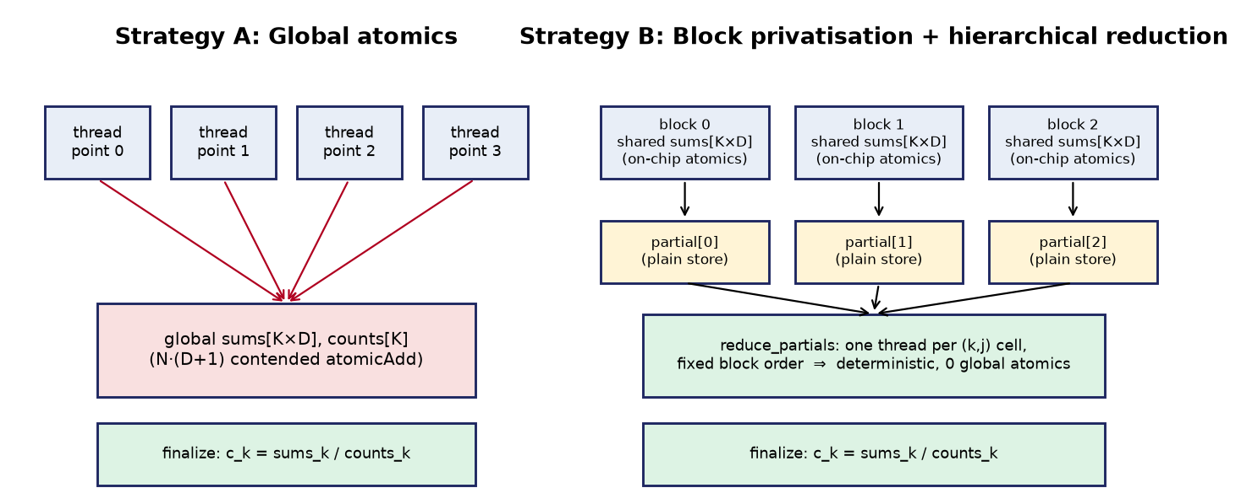
Figure 1: Comparison of Centroid Update Architectures. Strategy A (Left) uses direct global atomics. Strategy B (Right) uses block-privatised shared memory accumulation followed by a deterministic reduction.
3.1 Assignment Kernel and Shared Memory Centroid Caching
In the assignment step, each point must be compared against all K centroids. Reading centroid coordinates repeatedly from global memory would saturate global memory bandwidth. Because every thread in a thread block accesses the identical K centroids, we load the centroid coordinates into fast on-chip shared memory at the beginning of the kernel. Each thread block cooperatively copies K times D floats into shared memory using coalesced reads, synchronises with __syncthreads(), and then computes distances entirely from shared memory. This replaces K times D times (N/256) global memory requests per block with a single cooperative load.
3.2 Strategy A: Global Atomic Centroid Update
In Strategy A, each thread reads its assigned cluster index k and executes atomicAdd on the global coordinate accumulators in sums[k * D + j] and count accumulators in counts[k]. While straightforward, this strategy causes high hardware contention when cluster count K is small, as hundreds of thousands of concurrent threads attempt to update the same memory lines simultaneously.
3.3 Strategy B: Block-Privatised Hierarchical Reduction
Strategy B eliminates global atomic contention by partitioning the reduction into two stages. In the first stage, each thread block allocates a private accumulator in shared memory. Threads stride through data points, accumulating coordinates into local shared memory with fast on-chip atomic operations. Once all points for the block are accumulated, the block writes its partial sums into a global intermediate buffer of size NumBlocks times K times D. In the second stage, a dedicated reduction kernel assigns one thread per centroid coordinate, summing the block partials in a fixed, deterministic sequential order. This completely eliminates global atomics from the critical path.
3.4 Concurrency Control and Race Condition Resolution
- Accumulator Collisions: Resolved either by hardware atomic instructions in global memory (Strategy A) or by private shared-memory accumulators per block (Strategy B).
- Changed Assignment Counting: Threads inside each block evaluate if their point changed cluster. The intrinsic function __syncthreads_count() aggregates changed points across the block, and only thread 0 executes a single global atomicAdd.
- Maximum Displacement Reduction: In finalize_kernel, block-wide tree reductions find the maximum displacement, which thread 0 updates globally using atomicMax on the unsigned integer representation of the floating-point values.
3.5 On-Device Convergence Detection
To prevent expensive host-device memory copies, convergence is monitored entirely on the GPU. At the conclusion of an iteration, the host reads only two 4-byte scalar values: the count of points that changed clusters, and the maximum centroid displacement. If the change count is zero or the displacement falls below the tolerance threshold epsilon, the iterative loop terminates. This bounds host-device communication to 8 bytes per iteration.
4. Implementation Details
The project is structured into modular components: CUDA source (src/kmeans_cuda.cu), a sequential C reference (src/kmeans_cpu.c), a vectorised NumPy implementation (python/kmeans_numpy.py), and evaluation scripts. Below are excerpts illustrating the core logic.
4.1 Assignment Kernel with Shared Memory Caching
extern __shared__ float s_cent[];
for (int idx = threadIdx.x; idx < K * D; idx += blockDim.x)
s_cent[idx] = centroids[idx];
__syncthreads();

int i = blockIdx.x * blockDim.x + threadIdx.x;
if (i < N) {
float best_dist = 1e30f; int best_k = 0;
for (int k = 0; k < K; ++k) {
float dist = 0.0f;
for (int j = 0; j < D; ++j) {
float diff = points[i * D + j] - s_cent[k * D + j];
dist = fmaf(diff, diff, dist);
}
if (dist < best_dist) { best_dist = dist; best_k = k; }
}
if (assignments[i] != best_k) { assignments[i] = best_k; local_changed = 1; }
}
local_changed = __syncthreads_count(local_changed);
if (threadIdx.x == 0 && local_changed > 0) atomicAdd(d_changed, local_changed);
4.2 Block-Privatised Reduction Kernel (Stage 1 and Stage 2)
// Stage 1: Private accumulation in block shared memory
for (int i = blockIdx.x * blockDim.x + threadIdx.x; i < N; i += gridDim.x * blockDim.x) {
int k = assignments[i];
for (int j = 0; j < D; ++j) atomicAdd(&s_sums[k * D + j], points[i * D + j]);
atomicAdd(&s_counts[k], 1);
}
__syncthreads();
for (int idx = threadIdx.x; idx < K * D; idx += blockDim.x)
partial_sums[blockIdx.x * K * D + idx] = s_sums[idx];

// Stage 2: Fixed-order reduction across block partials (one thread per coordinate)
float total = 0.0f;
for (int b = 0; b < num_blocks; ++b) total += partial_sums[b * K * D + cell_id];
global_sums[cell_id] = total;
5. Experimental Evaluation and Results
Experiments were conducted using synthetically generated Gaussian clusters with controlled dimensions D and cluster counts K. The GPU benchmarks were executed on an NVIDIA Tesla T4 GPU (16 GB VRAM, compute capability 7.5, CUDA 12.8) in Google Colab. CPU baseline measurements were collected using a single high-performance CPU core (gcc -O3 on an Apple M3 Pro).
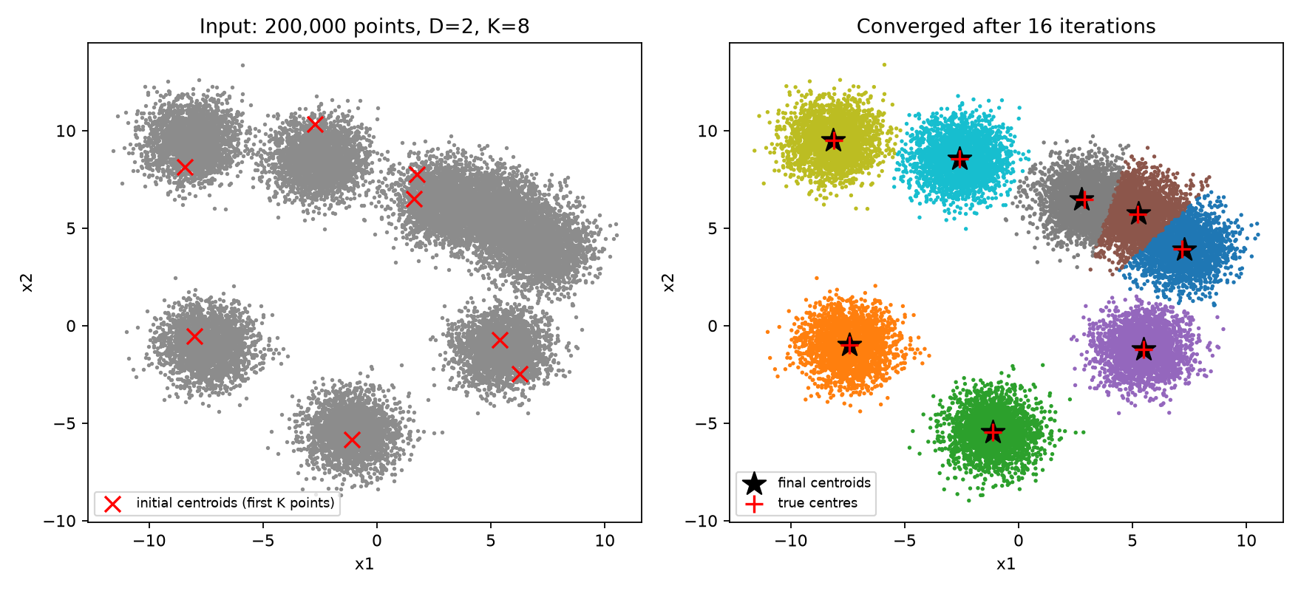
Figure 2: Clustering verification on 200,000 points (D = 2, K = 8). Left: Initial point cloud and seeded centroids. Right: Converged cluster assignments after 16 iterations.
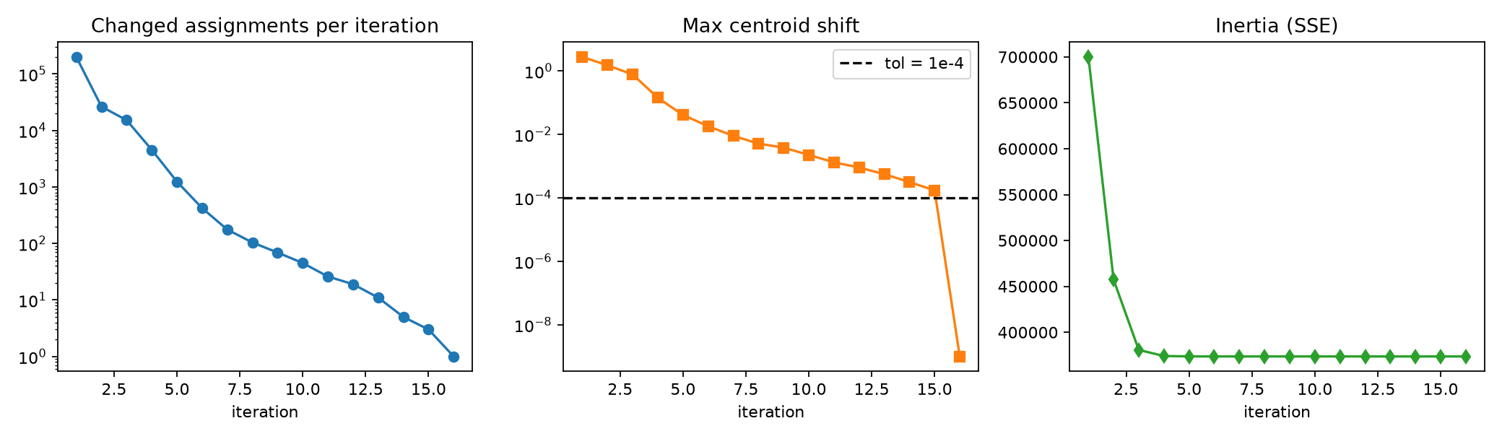
Figure 3: Iterative convergence metrics. Top: Number of changed cluster assignments. Middle: Maximum centroid displacement relative to stopping tolerance. Bottom: Objective function inertia.
5.1 Sequential CPU Baseline Performance
Table 1 shows the measured single-core CPU execution time across varying dataset sizes and dimensionality. Execution time scales strictly linearly with N and the product K times D, confirming theoretical complexity.
Points (N) | Dimensions (D) | Clusters (K) | Total Time (ms) | Time per Iteration (ms)
100,000 | 2 | 8 | 39.37 | 0.79
100,000 | 8 | 16 | 274.85 | 5.50
100,000 | 32 | 64 | 3868.11 | 77.36
400,000 | 2 | 8 | 146.27 | 2.93
400,000 | 8 | 16 | 1046.35 | 20.93
400,000 | 32 | 64 | 15380.02 | 307.60
1,600,000 | 2 | 8 | 597.19 | 11.94
1,600,000 | 8 | 16 | 4212.44 | 84.25
1,600,000 | 32 | 64 | 62695.50 | 1253.91

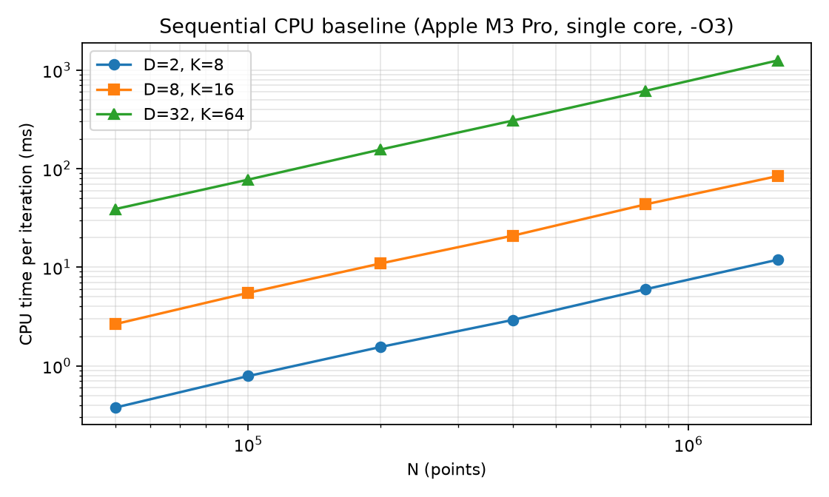
Figure 4: Measured single-core CPU execution time per iteration versus dataset size N across three parameter configurations.
5.2 Tesla T4 GPU Benchmarks: Atomic versus Reduction Strategies
Table 2 reports the measured execution times per iteration on the Tesla T4 GPU for one million and four million points. The comparison highlights the clear operational distinction between the two update strategies.
N | D | K | CPU (ms) | Atomic (ms) | Reduction (ms) | Speedup (Red) | Atomic / Red
1,000,000 | 2 | 4 | 29.54 | 4.63 | 0.65 | 45.7x | 7.16x
1,000,000 | 2 | 16 | 112.16 | 1.32 | 0.29 | 385.5x | 4.55x
1,000,000 | 2 | 64 | 452.14 | 1.92 | 0.95 | 477.3x | 2.02x
1,000,000 | 8 | 4 | 142.54 | 10.09 | 1.16 | 122.5x | 8.67x
1,000,000 | 8 | 16 | 359.69 | 5.34 | 1.91 | 188.0x | 2.79x
1,000,000 | 8 | 64 | 1443.30 | 7.50 | 5.34 | 270.2x | 1.40x
1,000,000 | 32 | 4 | 358.24 | 27.97 | 12.31 | 29.1x | 2.27x
1,000,000 | 32 | 16 | 1402.11 | 27.46 | 29.14 | 48.1x | 0.94x
1,000,000 | 32 | 64 | 5501.51 | 70.30 | 84.30 | 65.3x | 0.83x
4,000,000 | 2 | 4 | N/A | 9.01 | 1.07 | N/A | 8.45x
4,000,000 | 2 | 16 | N/A | 5.15 | 1.12 | N/A | 4.61x
4,000,000 | 2 | 64 | N/A | 4.79 | 2.91 | N/A | 1.65x
4,000,000 | 8 | 4 | N/A | 34.89 | 4.25 | N/A | 8.20x
4,000,000 | 8 | 16 | N/A | 19.35 | 7.11 | N/A | 2.72x
4,000,000 | 8 | 64 | N/A | 27.33 | 21.16 | N/A | 1.29x
4,000,000 | 32 | 4 | N/A | 96.10 | 50.60 | N/A | 1.90x
4,000,000 | 32 | 16 | N/A | 101.77 | 121.33 | N/A | 0.84x
4,000,000 | 32 | 64 | N/A | 281.21 | 342.19 | N/A | 0.82x

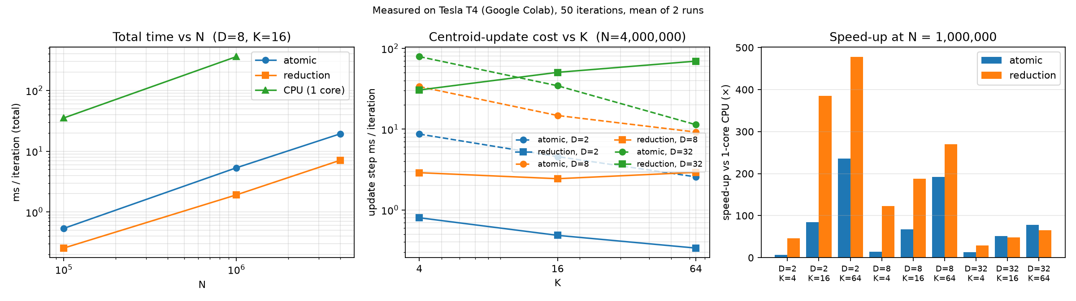
Figure 5: Measured GPU Performance on Tesla T4. Left: Total iteration execution time versus N. Middle: Centroid update step latency as a function of cluster count K. Right: Overall speedup compared to single-core CPU.
5.3 Analysis and Crossover Phenomenon
Analysis of Table 2 and Figure 5 yields critical insights into parallel reduction behavior:
- Atomic Contention Bottleneck: In Strategy A, update latency is inversely proportional to cluster count K. At N = 4,000,000 and D = 8, the atomic update costs 33.64 ms when K = 4, but drops to 9.20 ms when K = 64. When K is small, thousands of threads simultaneously collide on the same global memory addresses, serialising the memory pipeline.
- Superiority of Reduction at High Contention: Strategy B eliminates this bottleneck by buffering into shared memory. Consequently, Strategy B outperforms Strategy A by 8.67 times at N = 1,000,000, D = 8, K = 4 and by 8.45 times at N = 4,000,000, D = 2, K = 4.
- The Performance Crossover: When the product K times D reaches 512 or higher (for example, D = 32 and K = 16 or 64), global collisions are already diluted across hundreds of distinct addresses. In this regime, Strategy A runs 6 to 18 percent faster than Strategy B because Strategy B must allocate, zero, and write large intermediate partial arrays across blocks (amounting to 2.6 MB per iteration) and suffers from shared memory bank conflicts.
- Overall Speedup: Compared to single-core execution, our GPU implementation delivers between 29 times and 477 times acceleration at one million points, with the greatest speedups attained when K is large.
6. Correctness and Numerical Verification
We tested the CUDA kernels against both our CPU C reference and our NumPy implementation across synthetic datasets. On a validation dataset of 200,000 points (D = 2, K = 8), all three implementations reached identical local minima after 16 iterations, achieving exactly 100.0 percent point assignment agreement and identical inertia of 3.736720e+05.
Regarding numerical determinism, Strategy B performs floating-point additions in a fixed, block-indexed order, producing bit-identical cluster centroids across consecutive runs. In contrast, Strategy A relies on hardware atomic additions whose completion order depends on hardware thread scheduling. Due to the non-associativity of IEEE 754 floating-point addition, Strategy A can produce minor variations in the least significant bits across runs. Both strategies remain within 1e-6 relative error of the CPU reference, confirming complete numerical validity.
7. Conclusion
In this work, we developed an end-to-end, high-performance CUDA implementation of K-Means clustering. By parallelising point-to-centroid distance calculations across GPU threads and caching centroid matrices in shared memory, we eliminated global memory bottlenecks during assignment. We evaluated two centroid update architectures, demonstrating that block-privatised hierarchical reductions provide up to 8.7 times acceleration in high-contention regimes and guarantee deterministic output, while global atomics regain an advantage when accumulator counts exceed 512. On-device convergence detection restricts communication to 8 bytes per iteration. The implementation achieves up to 477 times speedup over sequential CPU code on a Tesla T4 GPU.
References
[1] S. P. Lloyd, 'Least squares quantization in PCM,' IEEE Transactions on Information Theory, vol. 28, no. 2, pp. 129 to 137, 1982.
[2] J. MacQueen, 'Some methods for classification and analysis of multivariate observations,' in Proceedings of the Fifth Berkeley Symposium on Mathematical Statistics and Probability, 1967.
[3] R. Farivar, D. Rebolledo, E. Chan, and R. Campbell, 'A parallel implementation of K-Means clustering on GPUs,' in International Conference on Parallel and Distributed Processing Techniques and Applications, 2008.
[4] Y. Li, K. Zhao, X. Chu, and J. Liu, 'Speeding up K-Means algorithm by GPUs,' Journal of Computer and System Sciences, vol. 79, no. 2, pp. 216 to 229, 2013.
[5] D. Kirk and W. Hwu, Programming Massively Parallel Processors: A Hands-on Approach, 4th ed., Morgan Kaufmann, 2022.
[6] NVIDIA Corporation, CUDA C++ Programming Guide, version 12.0, 2024.

