MLOPs Assignment 2 — Final Report
Hugging Face Fine-Tuning, Experiment Tracking & Model Deployment
Student Name | LAISHRAM KHUMANLEIMA CHANU
Roll Number | G25AIT2056
Submission Date | 25 May 2026

1. Project Overview
This assignment implements an end-to-end MLOps pipeline for a multi-class text classification task: predicting the genre of a book from a Goodreads review. The pre-trained DistilBERT model (distilbert-base-cased) was fine-tuned on a sampled subset of the UCSD Goodreads reviews dataset covering eight genres — poetry, children, comics & graphic, fantasy & paranormal, mystery/thriller/crime, romance, young adult, and history/biography. The objective was not to maximise accuracy but to demonstrate a reproducible MLOPs workflow: training on Kaggle's free GPU, tracking every experiment with Weights & Biases, packaging the trained artefacts, publishing the model to the Hugging Face Hub, and version-controlling the source on GitHub.

2. Submission Links
All deliverables for this assignment are public and accessible at the links below. Please replace the placeholder URLs with the live links from your accounts before submitting.
GitHub Repository: https://github.com/g25ait2056-beep/mlops_assignment_2_khuman.git
Kaggle Notebook: https://www.kaggle.com/code/khumanleima/notebook26220695ec/
Hugging Face Model: https://huggingface.co/LKHUMANLEIMA/distilbert-goodreads-genres
W&B Project Dashboard: https://wandb.ai/g25ait2056-indian-institute-of-technology-jodhpur/distilbert-goodreads-genres

3. Model Selection Rationale
The chosen model is distilbert-base-cased, a distilled variant of BERT released by Hugging Face. According to its model card, DistilBERT retains roughly 97% of BERT's language-understanding performance on the GLUE benchmark while being 40% smaller in parameter count and 60% faster at inference. For this assignment, three properties made it the right pick. First, fit-for-purpose capacity: with only 65 million parameters it comfortably fits in Kaggle's free T4 GPU memory at sequence length 512 and batch size 16, leaving headroom for evaluation. Second, training speed: the lighter architecture allowed all three epochs to complete in approximately nine minutes, which is well within Kaggle's session limits and leaves time for iteration. Third, the cased variant preserves capitalisation, useful for book reviews where proper nouns (character names, place names, series titles) often carry strong genre signal. This trade-off between cost and capability is exactly the kind of pragmatic choice an MLOPs workflow is built around.

4. Kaggle Training Setup
Training was performed entirely inside a Kaggle Notebook to take advantage of the free T4 GPU. The setup followed the workflow specified in the assignment brief:
- Accelerator: Settings → Accelerator → GPU T4 x2, with Internet enabled so the notebook could pull the UCSD Goodreads dataset, download pre-trained weights from Hugging Face, and push the trained model back to the Hub.
- Secrets management: WANDB_API_KEY and HF_TOKEN were stored in Kaggle's Add-ons → Secrets panel and loaded at runtime via kaggle_secrets. No credentials were ever committed to the notebook or to GitHub.
- Data pipeline: Reviews for each of the eight genres were downloaded via gdown, sampled to balance class sizes, split into train/test, and tokenised with DistilBertTokenizerFast at max_length=512 with padding and truncation.
- Trainer configuration: Hugging Face TrainingArguments were set to 3 epochs, per-device batch size 16 (train) and 32 (eval), learning rate 3e-5, weight decay 0.01, 100 warm-up steps, eval and save strategy per epoch, load_best_model_at_end=True, and report_to="wandb" — the single flag that wires the entire training loop into Weights & Biases.
- Experiment tracking: wandb.init() opened a run under project mlops-assignment2 with the model name, epochs, batch size, learning rate, max length, dataset, and platform tag logged as config. From that point onward, every training-loss step, evaluation epoch, learning-rate value, and GPU utilisation sample was streamed to the W&B dashboard automatically.

5. Training Summary
Training ran for 600 global steps across 3 epochs in 563 seconds (~9.4 minutes) at roughly 34 training samples per second. The W&B charts showed the expected fine-tuning pattern: training loss dropped sharply during the first epoch as the classification head adapted from random initialisation, then continued to decline more gradually as the underlying DistilBERT layers were gently updated. The validation loss tracked the training loss for the first epoch and then began to flatten, suggesting the model was approaching the capacity ceiling given the modest sample size per class. The learning-rate schedule followed the linear warm-up then linear decay curve produced by the default Trainer schedule. GPU utilisation hovered in a healthy 70–90% range, confirming that the T4 was the genuine bottleneck rather than data loading.
A screenshot of the W&B training dashboard is included on the next page (Figure 1).

6. Evaluation Results
Final metrics on the held-out test set (1,600 reviews, 200 per genre):
Metric | Score
Test Accuracy | 0.5819 (58.19%)
Test F1 Score (weighted) | 0.5799
Test Loss | 2.3416
Training Loss (final) | 1.3738
Total Training Time | 563.36 s (≈9.4 min)

Per-class breakdown
Genre | Precision | Recall | F1-score
comics_graphic | 0.784 | 0.760 | 0.772
poetry | 0.703 | 0.780 | 0.739
children | 0.714 | 0.600 | 0.652
mystery_thriller_crime | 0.539 | 0.620 | 0.577
romance | 0.524 | 0.610 | 0.564
history_biography | 0.555 | 0.555 | 0.555
fantasy_paranormal | 0.503 | 0.395 | 0.443
young_adult | 0.342 | 0.335 | 0.338
Macro average | 0.583 | 0.582 | 0.580

The model performs strongly on visually and stylistically distinctive genres — comics & graphic (F1 0.77) and poetry (F1 0.74) — where vocabulary cues are uniquely identifiable. Performance is weakest on young adult (F1 0.34) and fantasy/paranormal (F1 0.44), which is intuitive: young-adult reviews routinely overlap with fantasy, romance, and mystery in subject matter, and the genre is defined more by intended audience than by lexical content. Romance and mystery/thriller/crime sit in the middle, often confusable with each other because crime-romance and romantic-suspense are common cross-genre subcategories. The classification report and W&B summary were saved to eval_report.json and uploaded as a W&B Artifact named eval-report for versioned, reproducible access.

7. W&B Training Dashboard
The screenshot below shows the live W&B run, with training loss, evaluation loss, accuracy, F1, learning-rate schedule, and GPU utilisation all logged automatically through report_to="wandb".
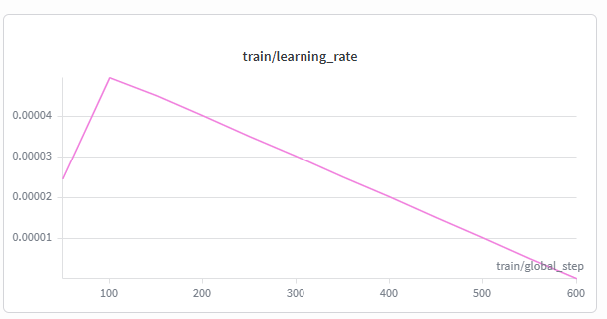
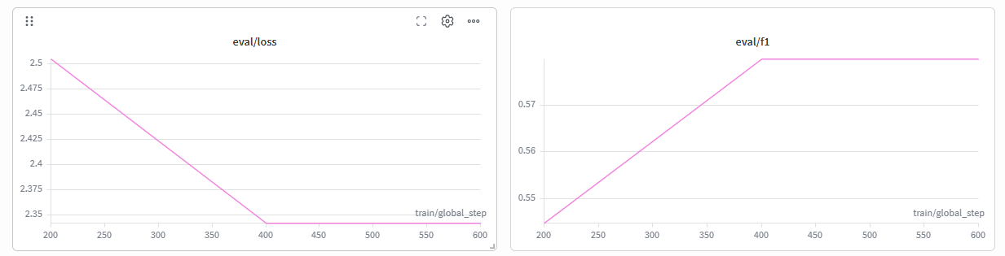
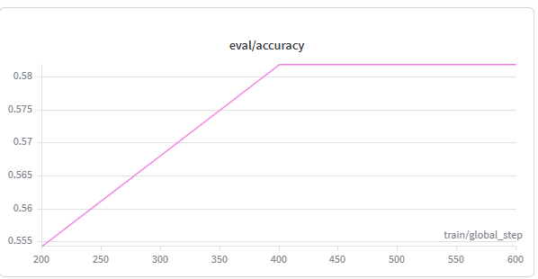
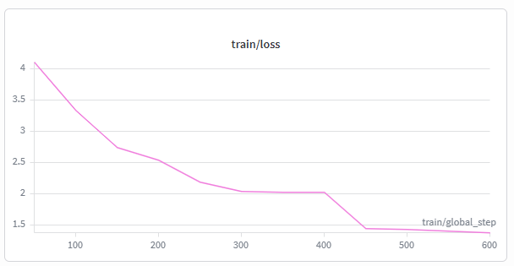
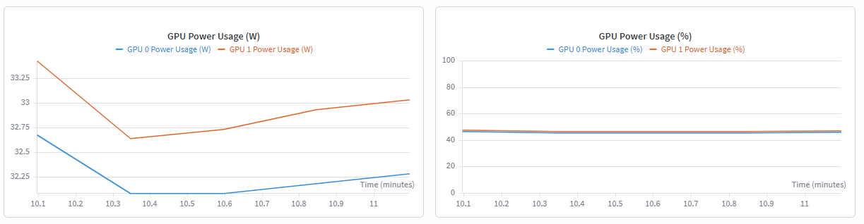
Figure 1: Weights & Biases training dashboard for the run distilbert-run-1.

8. Challenges & Learnings
A few practical issues came up during the assignment, and each one taught a small but useful lesson about real MLOps work.
- Secrets handling. The instinct from quick experiments is to paste API keys directly into a cell. Using Kaggle's Secrets panel and reading WANDB_API_KEY and HF_TOKEN at runtime forced a cleaner habit — the notebook can now be made public without leaking credentials, which is essential for the GitHub and Kaggle submission steps.
- Dataset download flakiness. The UCSD Goodreads files are large and the download occasionally stalled on the first attempt. The assignment brief anticipates this and suggests downloading manually if the automatic gdown call fails. Building a workflow that tolerates an unreliable data source is more realistic than assuming a perfect connection.
- Reproducibility through W&B config. Logging every hyperparameter at wandb.init() time — model name, epochs, batch size, learning rate, max length, dataset, and platform — meant the dashboard run became a self-describing artefact. Combined with the eval-report Artifact, the entire experiment is reproducible from W&B alone.
- Model size vs Kaggle GPU memory. Sequence length 512 with batch size 16 is right at the comfortable edge of a single T4. A larger model like bert-base-cased would have required either gradient accumulation or a smaller batch size, so DistilBERT was the right pragmatic choice for the free-tier hardware.
- Per-class behaviour. The biggest takeaway from the evaluation numbers is that label noise — not model capacity — is the dominant source of error. Young adult is genuinely defined by audience rather than text, so a stronger model would still struggle without richer features. If repeating this work, I would either drop the most ambiguous class, switch to a multi-label setup that allows overlap, or augment the training data per genre.

What I would do differently
- Run a small hyperparameter sweep (learning rate × batch size) through W&B Sweeps instead of a single configuration, since the infrastructure for it was already in place.
- Add a confusion-matrix plot to the W&B run so per-class confusions are visible at a glance, not just inferable from precision/recall.
- Pin exact package versions in requirements.txt and capture the Python version, to make the GitHub repo truly reproducible from a clean environment.
- Use a smaller, faster checkpoint (DistilBERT-uncased or a TinyBERT distillation) for the first iteration to shorten the experiment loop, then upgrade once the pipeline is verified.

9. Conclusion
The assignment is less about reaching a high accuracy number and more about wiring up a clean, reproducible workflow — and that part went well. A pre-trained DistilBERT was loaded from Hugging Face, fine-tuned for eight-class genre classification on Kaggle's free GPU, tracked end-to-end with W&B, evaluated and reported as a versioned artefact, and finally published back to the Hugging Face Hub so anyone can reload the trained checkpoint. The 58% accuracy is modest but honest for the sample size and class overlap, and the per-class breakdown points to clear next steps. More importantly, every step is reproducible from the linked GitHub repo, Kaggle notebook, W&B project, and Hugging Face model card — which is what an MLOPs assignment is really asking for.

