Experimental Report
Multilingual Word Embeddings for Indian Languages
Foundations of Vision and Language · PGDAI, IIT Jodhpur
Author | Roll number | Training corpus | Model | Macro-average ρ
Alok Sahni | G25AIT2138 | rony000013/indiccorpV2-5k | FastText Skip-gram, 300-D | 0.2190

Learning Objectives
Each objective of the assignment is paired with the part of the work where it was exercised.
Objective | How it was met
Train distributional word embeddings from first principles | Seven FastText Skip-gram models trained from random initialisation at exactly 300 dimensions, with no pre-trained vectors at any stage (§2.3).
Understand subword representation for morphologically rich languages | Character n-gram composition used as the primary OOV mechanism; its effect measured in the n-gram ablation and the inflected-form demonstration (§2.4, §4.1, §5).
Design an OOV strategy rather than discard difficult cases | A four-layer resolver guaranteeing a finite, non-zero-norm vector for any input, including blank and malformed strings (§2.4).
Apply correct intrinsic evaluation methodology | Cosine similarity with Spearman rank correlation, p-values, macro-averaging, and rank-based error analysis (§4, §6).
Process multilingual Unicode text across several scripts | NFC normalisation and Unicode-property tokenisation shared by training and evaluation, covering six writing systems in one code path (§2.2).
Handle imperfect real-world data without compromising integrity | Mixed delimiters, BOMs, missing scores and a blank field accommodated while keeping every row in its original position (§2.5).
Investigate hyperparameter sensitivity empirically | A four-configuration ablation on two typologically distinct languages (§5).
Interpret model behaviour and state limitations honestly | Diagnostic analysis of best and worst predictions, with failure modes traced to identifiable causes (§6, §7).

1. Introduction
This report develops and evaluates 300-dimensional word embeddings for seven Indian languages — Gujarati, Hindi, Marathi, Punjabi, Tamil, Telugu and Urdu — spanning six writing systems (Devanagari, Gujarati, Gurmukhi, Tamil, Telugu and Perso-Arabic). All embeddings are trained from random initialisation using only the IndicCorpV2 subset rony000013/indiccorpV2-5k; no pre-trained vectors and no external training corpora are used.
The models are evaluated intrinsically against the human-annotated word-similarity datasets of Akhtar et al. (2017). For each language, the cosine similarity between the two embeddings of every word pair is compared with the human similarity judgement using Spearman's rank correlation, and the per-language correlations are macro-averaged. Across all seven languages the system reaches a macro-average Spearman correlation of ρ = 0.2190.
Two constraints shaped the implementation more than any modelling choice. First, word pairs containing out-of-vocabulary (OOV) words may not be discarded, so every benchmark word — including unseen inflections and malformed strings — must receive a meaningful vector. Second, the exported arrays must preserve the original word-pair order with shape (N, 2, 300), which rules out dropping defective rows from the evaluation files.

2. Methodology

2.1 Training corpus
The dataset rony000013/indiccorpV2-5k was loaded through the Hugging Face datasets library. It contains 118,243 documents in a single train split with the fields language, code and text. Rather than assuming a layout, the pipeline inspects the available columns at runtime and resolves each record's language through an alias table (for example hi, hin, hin_deva and hindi all map to Hindi); in this run the language was read from the code column. The run yields exactly 5,000 documents for each of the seven languages. The pipeline stops with an error if any required language cannot be identified, so no model is ever trained on text of the wrong language.

2.2 Normalisation and tokenisation
Training text and benchmark words pass through an identical preprocessing path, which removes any train/evaluation mismatch. Text is normalised to Unicode NFC and case-folded, then tokenised with the Unicode-property regular expression [\p{L}\p{M}\p{N}]+(?:[-'’][\p{L}\p{M}\p{N}]+)*. Because the pattern matches letters, combining marks and digits by Unicode category rather than ASCII ranges, one code path handles all six scripts and keeps the combining marks that carry vowel information in Indic orthographies. For example, the sentence अच्छा छात्र विद्यालय में पढ़ता है। is tokenised into the six words अच्छा, छात्र, विद्यालय, में, पढ़ता, है, with the danda (।) removed.

2.3 Model and hyperparameters
One independent monolingual Gensim FastText model is trained per language from random initialisation. FastText was chosen for its character n-gram composition, which is what makes principled OOV inference possible. The configuration is identical across languages:
Parameter | Value | Parameter | Value
Architecture | Skip-gram (sg=1) | Negative samples | 10
Vector size | 300 (exact) | Character n-grams | 2–5
Context window | 5 | n-gram buckets | 20,000
Minimum count | 2 | Subsampling | 1e-4
Epochs | 15 | Random seed / workers | 42 / 2

A smoke test (100 documents, 2 epochs) was run first to check imports, training, OOV inference and the (N, 2, 300) export for every language before the full run. Its near-zero correlations (−0.14 to 0.08) are expected for such a tiny budget and are not reported as results.

2.4 Out-of-vocabulary handling
OOV resolution is layered, and every layer is guaranteed to return a finite, non-zero-norm 300-dimensional vector:
1. In-vocabulary words use the learned vector directly.
2. Unseen words are composed from their learned character n-grams — FastText's native subword mechanism. This recovers morphological relationships for inflected forms never seen during training.
3. Multi-token inputs are averaged over the vectors of their tokens.
4. Blank or degenerate inputs — an empty field, or a string whose subword composition yields a near-zero vector — fall back to the frequency-weighted mean of the vocabulary vectors. This is the only layer without word-specific information; it exists so that defective benchmark rows still produce a valid array entry.
The fallback is deliberately narrow: in this run it is reached only by the single Tamil row with a blank word field. No word pair is discarded at any stage.

2.5 Benchmark loading and data integrity
The evaluation files contain genuine formatting irregularities, which are handled rather than repaired. The Hindi file is comma-separated while the others are mostly tab-separated, so the delimiter is detected per line. Files are decoded as utf-8-sig, so byte-order marks are stripped. Missing or non-numeric scores are parsed as NaN instead of raising an error.
No row is removed. All rows stay in the exported (N, 2, 300) arrays in their original order, and a boolean validity mask limits the Spearman computation to rows that have both words and a finite human score:
Language | Rows in file | Scored rows | Excluded from ρ | Reason
Marathi | 253 | 104 | 149 | missing human score
Tamil | 97 | 96 | 1 | blank word field
Other five | 752 | 752 | 0 | —

Evaluation-only guarantee. The benchmark is used only to compute the reported correlations. Human similarity scores never enter training, never contribute gradients, and were not used for model selection or early stopping.

3. t-SNE Visualisation
For each language, the 100 most frequent vocabulary words were projected from 300 to 2 dimensions with t-SNE (perplexity 25, PCA initialisation, seed 42). The reduction is used only for visualisation; all evaluation uses the full 300-dimensional vectors. Points are labelled with numeric IDs rather than the words themselves, because the Colab plotting environment lacks fonts for all six scripts; each figure has a tsne_<Language>_word_labels.csv file that maps every ID to its word and coordinates.
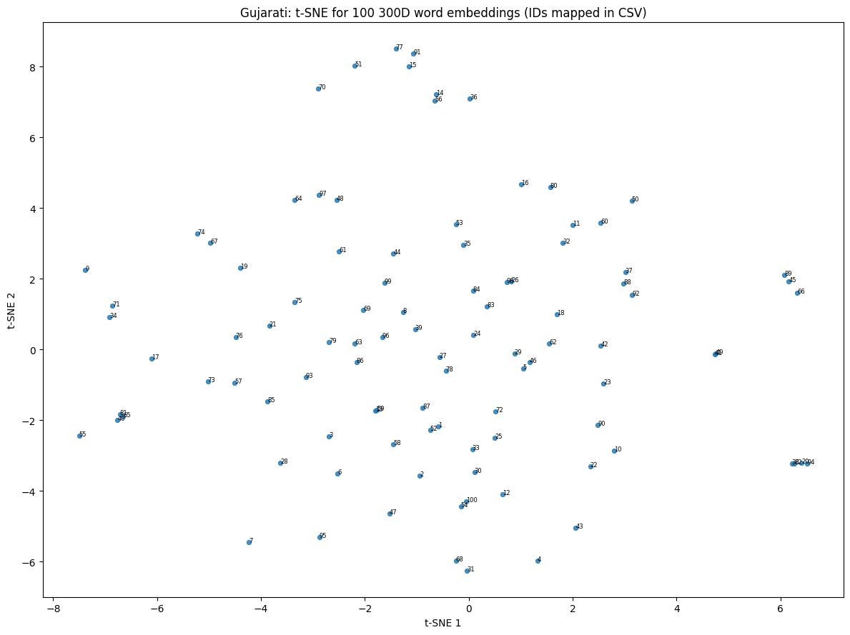  Figure 1 — Gujarati, 100 words | 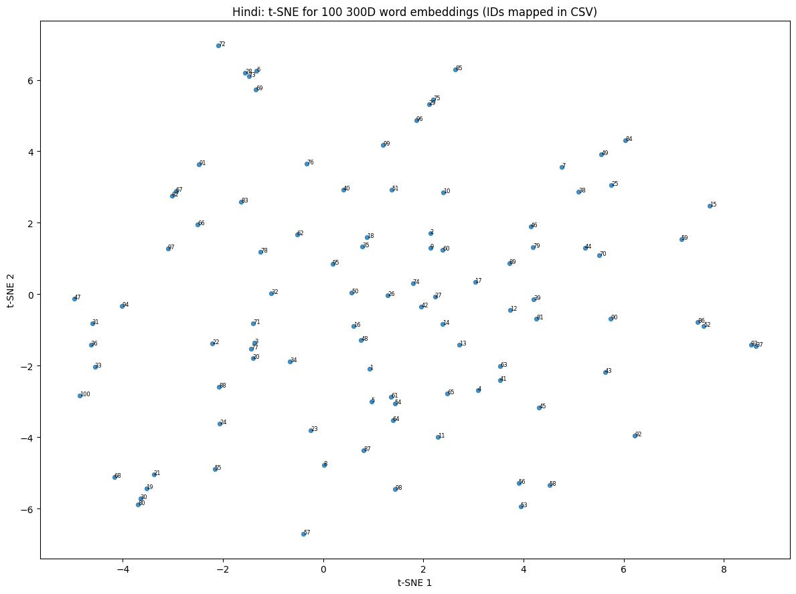  Figure 2 — Hindi, 100 words
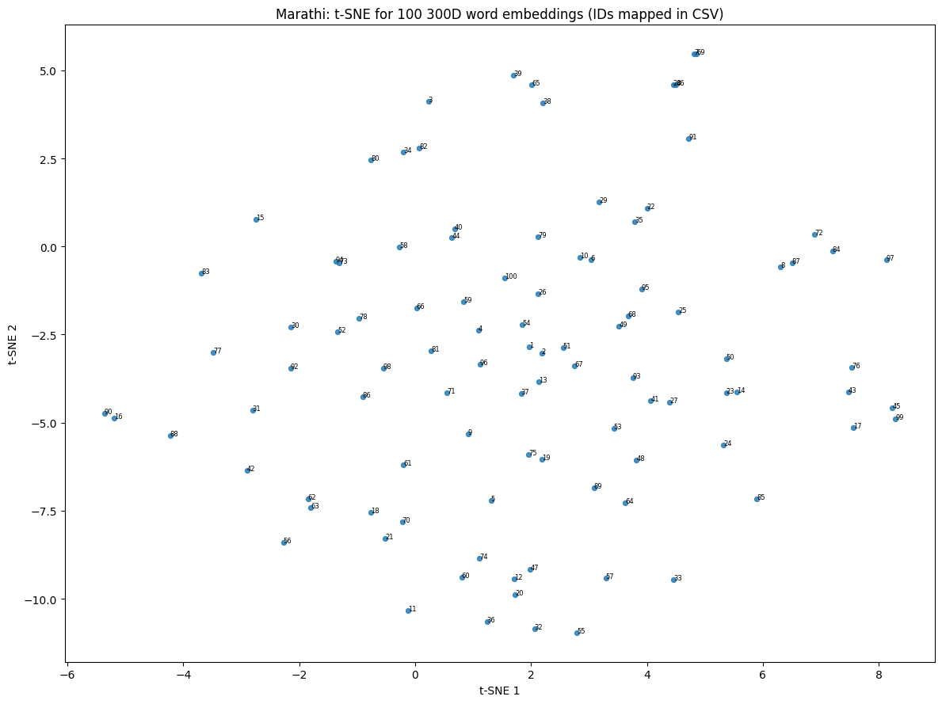  Figure 3 — Marathi, 100 words | 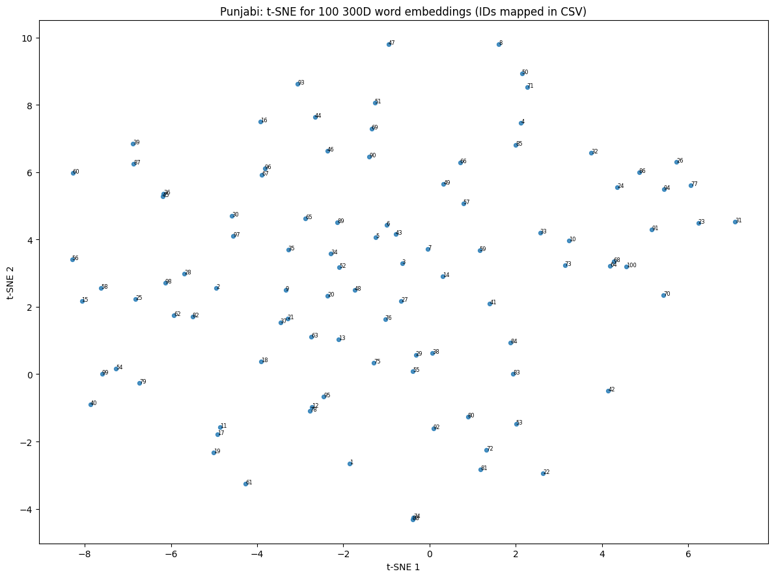  Figure 4 — Punjabi, 100 words
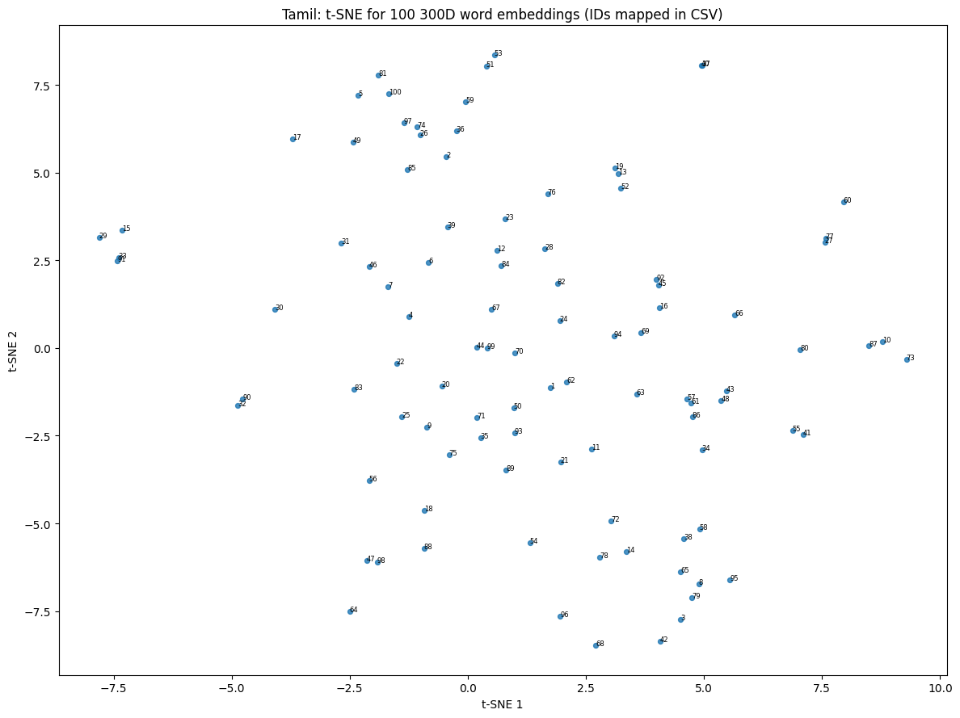  Figure 5 — Tamil, 100 words | 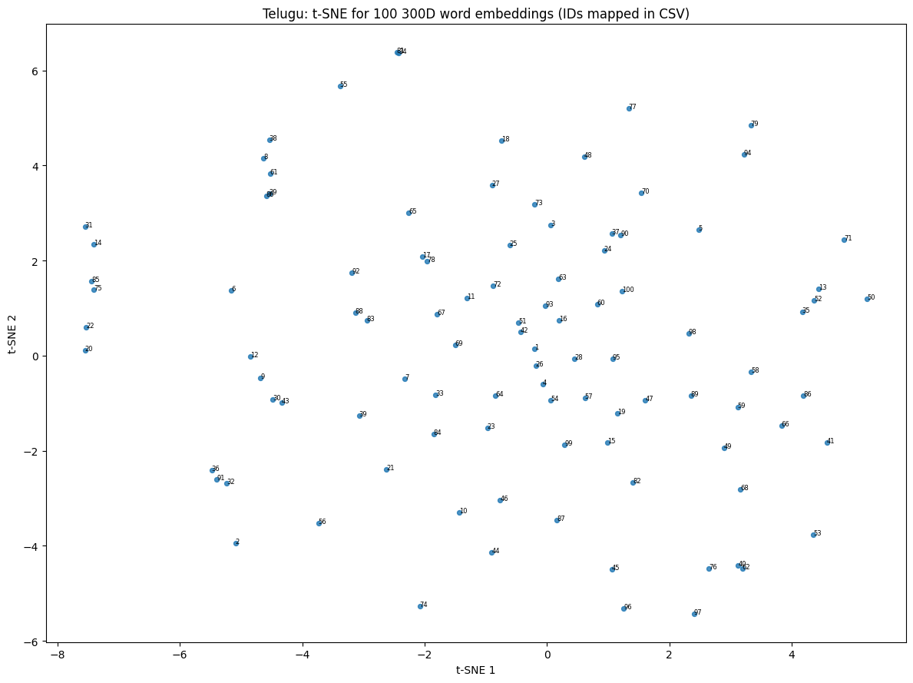  Figure 6 — Telugu, 100 words
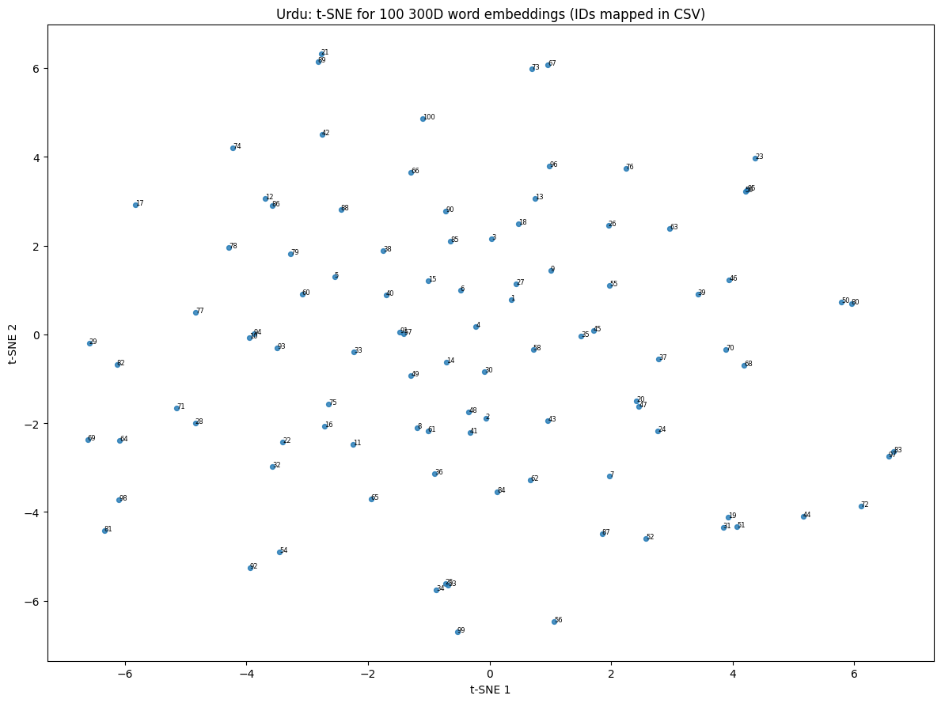
Figure 7 — Urdu, 100 words

The projections are diffuse rather than sharply clustered. This matches the modest correlations reported below and the small corpus: 5,000 documents per language is a thin slice of IndicCorpV2, and distributional methods need much more co-occurrence evidence before clean semantic neighbourhoods appear.

4. Results
For every language the table gives the pairs in the source file, the rows entering the correlation, Spearman's ρ with its p-value, and vocabulary coverage over the unique words in that language's benchmark.
Language | Pairs (N) | Scored | Spearman ρ | p-value | Unique words | In vocab | OOV | Coverage | OOV rate
Gujarati | 163 | 163 | 0.3084 | 0.00006 | 221 | 176 | 45 | 79.6% | 20.4%
Hindi | 235 | 235 | 0.1901 | 0.00344 | 318 | 257 | 61 | 80.8% | 19.2%
Marathi | 253 | 104 | 0.1571 | 0.11113 | 337 | 250 | 87 | 74.2% | 25.8%
Punjabi | 143 | 143 | 0.2540 | 0.00220 | 206 | 170 | 36 | 82.5% | 17.5%
Tamil | 97 | 96 | 0.1846 | 0.07180 | 136 | 102 | 34 | 75.0% | 25.0%
Telugu | 111 | 111 | 0.2258 | 0.01716 | 160 | 108 | 52 | 67.5% | 32.5%
Urdu | 100 | 100 | 0.2125 | 0.03375 | 146 | 126 | 20 | 86.3% | 13.7%
Macro-average / total | 1,102 | 952 | 0.2190 | — | 1,524 | 1,189 | 335 | 78.0% | 22.0%

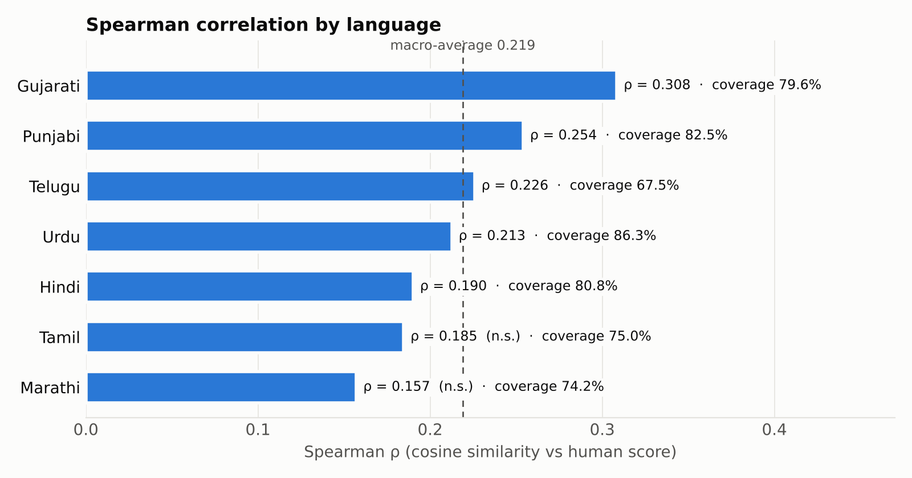
Figure 8 — Spearman correlation by language, with vocabulary coverage. n.s. = not significant at p < 0.05.
The macro-average across all seven languages is ρ = 0.2190. Gujarati performs best at ρ = 0.3084 and Marathi worst at ρ = 0.1571. 5 of the seven correlations are significant at p < 0.05. Marathi (p = 0.111) and Tamil (p = 0.072) are not — and these are exactly the two languages with the fewest scored pairs (104 and 96), so their tests have the least statistical power.
The cosine similarity for every individual pair, with its human score and validity flag, is recorded in tables/<Language>_pair_predictions.csv.

4.1 Coverage and OOV behaviour
Coverage ranges from 67.5% (Telugu) to 86.3% (Urdu), and it is a weak predictor of correlation. Urdu has the highest coverage of any language but ranks only fourth on ρ, while Telugu has the lowest coverage yet ranks third. Across the seven languages, the rank correlation between coverage and ρ is only 0.29. Coverage measures whether a benchmark word was seen during training; it says nothing about whether it was seen in contexts informative enough to place it well.
The demonstration below, run after full training, shows the OOV mechanism on Hindi inputs of increasing difficulty:
Word 1 | Word 2 | Cosine | Case
विद्यालय | स्कूल | 0.6843 | synonyms, both in vocabulary
विद्यालयों | विद्यालय | 0.8966 | inflected plural, OOV at training time
क्ष्यज्ञत्रक | विद्यालय | 0.6239 | malformed string, resolved via subwords

The inflected plural विद्यालयों (vidyālayõ, “schools”), absent from the training vocabulary, scores 0.897 against its base form — higher than the in-vocabulary synonym pair (0.684) — because the two forms share nearly all of their character n-grams. The malformed third string still gets a finite vector, confirming that no input can break the inference path.

5. Experiments
Four configurations were compared on Hindi and Tamil, chosen to represent a moderately inflecting Indo-Aryan language and a strongly agglutinative Dravidian one. Every configuration trains from scratch at 300 dimensions on IndicCorpV2 only; benchmark scores were used only to read off the resulting correlation, never as an optimisation target.
Run | Window | Epochs | n-grams | Hindi ρ | Tamil ρ
E1 baseline | 5 | 15 | 2–5 | 0.1982 | 0.1988
E2 wider window | 10 | 15 | 2–5 | 0.2654 | 0.1847
E3 longer training | 5 | 30 | 2–5 | 0.3181 | 0.1401
E4 larger n-grams | 5 | 15 | 3–6 | 0.1564 | 0.2891

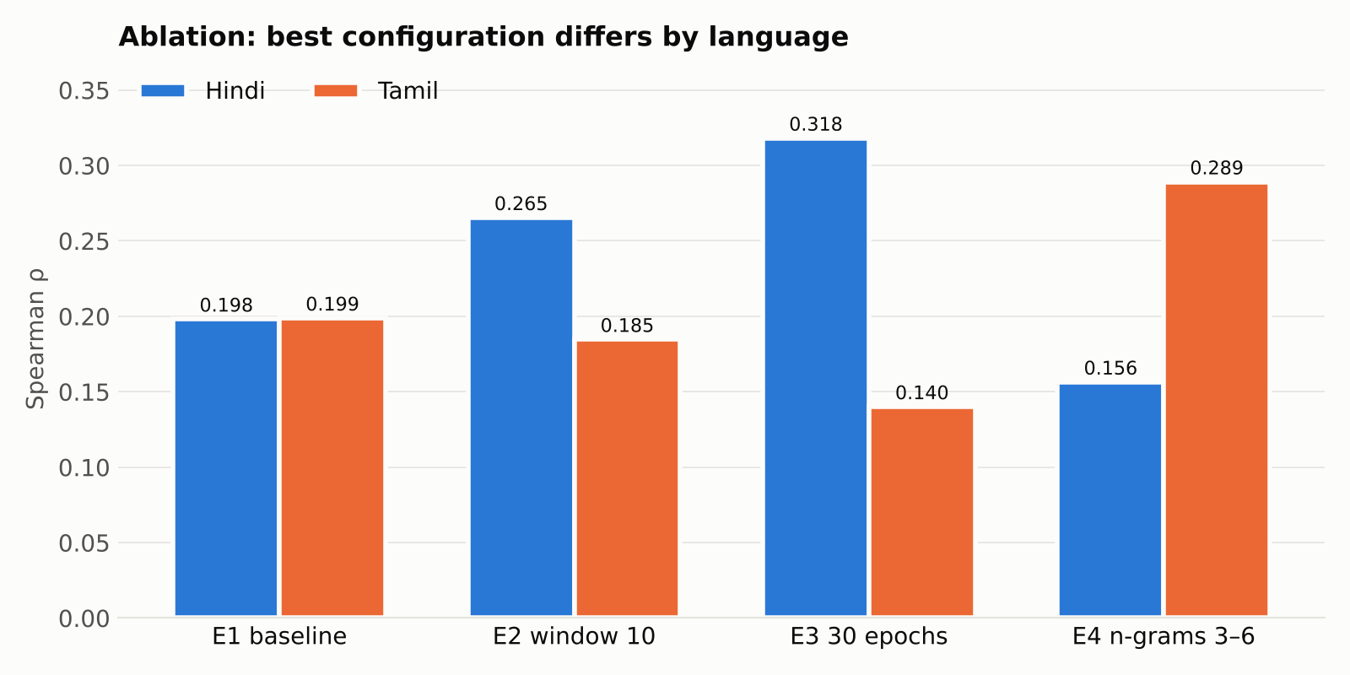
Figure 9 — Ablation results. The best configuration differs by language.
The two languages respond to opposite interventions. Hindi improves from ρ = 0.1982 to 0.3181 when the epoch budget is doubled — a relative gain of 61% — and also benefits from a wider context window (+34%). Tamil gains most from longer character n-grams, improving from 0.1988 to 0.2891 (+45%), while the same change lowers Hindi to 0.1564, its worst result. Conversely, the longer training that helps Hindi most hurts Tamil, dropping it to 0.1401 (-30%), the lowest score in the study; the wider window also slightly hurts Tamil.
This is the clearest finding of the project. Tamil's agglutinative morphology packs more meaning into longer character sequences, so 3–6 character n-grams capture morpheme-sized units that 2–5 n-grams fragment. With the short 2–5 range, extra epochs appear to reinforce short, uninformative fragments rather than add signal. Hindi's shorter affixes are already well served by the 2–5 range, and there the model was clearly still learning at 15 epochs. A single hyperparameter set applied uniformly across Indian languages leaves substantial performance unclaimed.
Run-to-run variance. Training uses 2 worker threads, so repeated runs are not bit-identical. The E1 baseline for Hindi (0.1982) and the identically configured main run (0.1901) differ by about 0.01, which sets the noise floor. The ablation effects (0.05–0.12) are well above it, but each configuration was run only once.

6. Analysis
Human scores lie on a 1–10 scale while cosine similarities lie in [−1, 1], so comparing them directly is misleading. The diagnostic therefore compares rank positions: both columns are ranked within each language and the absolute rank difference is reported. A rank error near zero means the model placed the pair at the same position in its ordering as the annotators did. One closest and one furthest pair are shown per language.
Language | Word 1 | Word 2 | Meaning | Human | Cosine | Rank error
Closest rank agreement
Gujarati | વાઘ | વાઘ | tiger / tiger | 10.00 | 1.0000 | 0.0
Hindi | बाघ | चिड़ियाघर | tiger / zoo | 6.80 | 0.5018 | 0.5
Marathi | वाघ | वाघ | tiger / tiger | 10.00 | 1.0000 | 0.0
Punjabi | ਟਾਈਗਰ | ਟਾਈਗਰ | tiger / tiger | 10.00 | 1.0000 | 0.0
Tamil | பணம் | பணம் | money / money | 10.00 | 1.0000 | 0.5
Largest rank disagreement
Gujarati | સો | ટકા | hundred / percent | 9.00 | 0.0534 | 138.5
Hindi | पैसे | मुद्रा | money / currency | 8.60 | 0.2713 | 203.5
Marathi | टेलिफोन | संवाद | telephone / communication | 9.00 | 0.2250 | 91.0
Punjabi | ਪੈਸਾ | ਨਕਦ | money / cash | 9.00 | 0.3254 | 116.5
Tamil | வங்கி | பணம் | bank / money | 8.75 | 0.0527 | 84.0

Where the model succeeds. Most of the closest agreements are identity pairs — the same word compared with itself, scored 10 by annotators and 1.000 by cosine similarity. They confirm the pipeline is wired correctly but say little about semantics. The substantive success is Hindi बाघ / चिड़ियाघर (bāgh / ciṛiyāghar, “tiger” / “zoo”, human 6.80, cosine 0.502): two different words that co-occur in news text about wildlife and zoos, which the distributional model places at almost exactly the rank the annotators chose.
Where the model fails. The failures share a structure. Hindi पैसे / मुद्रा (paise / mudrā, “money” / “currency”, human 8.60, cosine 0.271) and Punjabi ਪੈਸਾ / ਨਕਦ (paisā / nakad, “money” / “cash”) are near-synonyms from different registers — one colloquial, one formal or Sanskritic. In a 5,000-document corpus these registers rarely share contexts, so the model separates them. Gujarati સો / ટકા (so / ṭakā, “hundred” / “percent”, cosine 0.053) fails similarly: the link is a fixed collocation, not shared context. Tamil வங்கி / பணம் (vaṅki / paṇam, “bank” / “money”) and Marathi टेलिफोन / संवाद (“telephone” / “communication”) are associations that rest on world knowledge, which a small corpus does not supply consistently — the Hindi tiger/zoo pair shows the model can learn such links when the co-occurrence evidence is there.
These are not implementation defects. They are the expected failure mode of a distributional model trained on a small corpus: it learns contextual co-occurrence, and where human judgements rest on register-crossing synonymy or world knowledge instead of shared context, the correlation breaks down.

7. Discussion
Design choices. FastText was selected over Word2Vec and GloVe because the no-discard OOV requirement effectively requires a subword model: with 22.0% of benchmark vocabulary unseen on average, a purely word-level model would have no principled way to embed those tokens. Seven independent monolingual models were trained rather than one multilingual model because the benchmark evaluates each language in isolation, so there is no cross-lingual signal to exploit, and separate models avoid vocabulary interference between scripts. Preprocessing is shared between training and evaluation to eliminate normalisation drift, a common and silent cause of inflated OOV rates.
Limitations. The dominant limitation is corpus size. At 5,000 documents per language the models see far too little text for stable distributional estimates; for Hindi the ablation shows the model still improving at 30 epochs, so the reported correlations are a floor set by data volume, not a ceiling set by the method. The benchmarks are small — 96 to 235 scored pairs — so individual correlations carry wide confidence intervals and two are not statistically significant. Static embeddings assign one vector per word form, so polysemy cannot be resolved by construction. Multi-threaded training makes repeated runs differ by about 0.01 in ρ, and each ablation configuration was run once. Finally, the ablation covers only two languages and four configurations: enough to show that per-language tuning matters, not enough to find optimal settings for the other five.
Future work. In order of expected value: scale the training corpus and re-measure the coverage/correlation relationship; run a per-language hyperparameter search with several seeds, now that the ablation shows the optima diverge; add Word2Vec and GloVe baselines under the same evaluation harness to quantify the subword contribution; and validate the embeddings on a downstream task, since intrinsic similarity correlation is only a weak proxy for usefulness.

Conclusion
This project delivered seven monolingual 300-dimensional FastText models for Gujarati, Hindi, Marathi, Punjabi, Tamil, Telugu and Urdu, trained entirely from scratch on IndicCorpV2 and evaluated against human similarity judgements. The system reaches a macro-average Spearman correlation of ρ = 0.2190, with per-language values from 0.1571 (Marathi) to 0.3084 (Gujarati) and vocabulary coverage between 67.5% and 86.3%. All 1,102 benchmark word pairs are represented in the exported arrays; none was discarded.
Three conclusions follow. First, subword composition is what makes the no-discard requirement satisfiable: the inflected form विद्यालयों, never observed in training, still scored 0.897 against its base form. Second, hyperparameters do not transfer across Indian languages: Hindi gained 61% from a longer epoch budget, which cost Tamil 30%, while Tamil gained 45% from longer character n-grams, which gave Hindi its worst result. Third, vocabulary coverage is not a proxy for embedding quality: the language with the highest coverage ranked only fourth, because coverage counts whether a word was seen, not whether it was seen in informative contexts.
The correlations are modest, and the reason is clear: at 5,000 documents per language the models are corpus-limited rather than method-limited. The pipeline — seeded, smoke-tested, and checked for array shape, dtype, finiteness and word-pair order before export — is built so that re-running it with more text means changing one constant rather than rewriting the experiment.

8. References
1. Bojanowski, P., Grave, E., Joulin, A., & Mikolov, T. (2017). Enriching Word Vectors with Subword Information. Transactions of the ACL, 5, 135–146.
2. Mikolov, T., Chen, K., Corrado, G., & Dean, J. (2013). Efficient Estimation of Word Representations in Vector Space. arXiv:1301.3781.
3. Akhtar, S. S., Gupta, A., Vajpayee, A., Srivastava, A., & Shrivastava, M. (2017). Word Similarity Datasets for Indian Languages: Annotation and Baseline Systems. Proceedings of the 11th Linguistic Annotation Workshop.
4. Doddapaneni, S., Kunchukuttan, A., et al. IndicCorp v2 / IndicNLPSuite — monolingual corpora for Indian languages. Subset used: huggingface.co/datasets/rony000013/indiccorpV2-5k.
5. van der Maaten, L., & Hinton, G. (2008). Visualizing Data using t-SNE. Journal of Machine Learning Research, 9, 2579–2605.
6. Řehůřek, R., & Sojka, P. (2010). Software Framework for Topic Modelling with Large Corpora (Gensim). Proceedings of the LREC 2010 Workshop on New Challenges for NLP Frameworks.

Project resources
Resource | Link
Training corpus — IndicCorpV2-5k | https://huggingface.co/datasets/rony000013/indiccorpV2-5k
Evaluation benchmark — Akhtar et al. (2017) | https://github.com/syedsarfarazakhtar/Word-Similarity-Datasets-for-Indian-Languages
Project source code and artifacts | https://github.com/g25ait2138-collab/word-embeddings-nlp

External-resource disclosure
Training data: rony000013/indiccorpV2-5k only. No pre-trained word embeddings, no external training corpora, and no use of the benchmark's human similarity scores for training or supervised optimisation.
Evaluation data: the Akhtar et al. (2017) word-similarity datasets, used only to compute the reported correlations.
Implementation tools: Python, Gensim (FastText), NumPy, SciPy, Hugging Face datasets, regex, pandas, Matplotlib, scikit-learn (t-SNE).

