Experimental Report — Multilingual Word Embeddings for Indian Languages
Foundations of Vision and Language · PGDAI, IIT Jodhpur
Author: Alok Sahni
Training corpus: rony000013/indiccorpV2-5k (only)
Model: FastText Skip-gram, 300-D
Macro-average ρ: 0.2214

Learning Objectives
This assignment was undertaken to develop practical competence in the following areas. Each objective is paired with the part of the work where it was exercised.
Objective | How it was met
Train distributional word embeddings from first principles | Seven FastText Skip-gram models built from random initialisation at exactly 300 dimensions, with no pre-trained vectors at any stage (§2.3)
Understand subword representation and why it matters for morphologically rich languages | Character n-gram composition used as the primary OOV mechanism; its effect measured directly in the n-gram ablation and the inflected-form demonstration (§2.4, §4.1, §5)
Design an OOV strategy rather than discarding difficult cases | A four-layer resolver guaranteeing a finite, non-zero-norm vector for any input, including blank and malformed strings (§2.4)
Apply correct intrinsic evaluation methodology | Cosine similarity with Spearman rank correlation, p-values, macro-averaging, and rank-based rather than score-based error analysis (§4, §6)
Process multilingual Unicode text correctly across several scripts | NFC normalisation and Unicode-property tokenisation shared by training and evaluation, covering six writing systems in one code path (§2.2)
Handle imperfect real-world data without compromising integrity | Mixed delimiters, BOMs, missing scores and a blank field accommodated while preserving every row in its original position (§2.5)
Investigate hyperparameter sensitivity empirically | A four-configuration ablation on two typologically distinct languages, yielding the project's central finding (§5)
Interpret model behaviour and state limitations honestly | Diagnostic analysis of best and worst predictions, with failure modes attributed to identifiable causes rather than treated as defects (§6, §7)

1. Introduction
This report develops and evaluates 300-dimensional word embeddings for seven Indian languages — Gujarati, Hindi, Marathi, Punjabi, Tamil, Telugu and Urdu — spanning six writing systems (Devanagari, Gujarati, Gurmukhi, Tamil, Telugu and Perso-Arabic). All embeddings are trained from random initialisation using only the IndicCorpV2 subset rony000013/indiccorpV2-5k; no pre-trained vectors and no external training corpora are used.
The models are evaluated intrinsically against the human-annotated word similarity datasets of Akhtar et al. (2017). For each language the cosine similarity between the two embeddings of every word pair is compared with the human similarity judgement using Spearman's rank correlation, and the per-language correlations are macro-averaged. Across all seven languages the system reaches a macro-average Spearman correlation of ρ = 0.2214.
Two constraints shaped the implementation more than any modelling choice. First, word pairs containing out-of-vocabulary (OOV) words may not be discarded, so every word in the benchmark — including unseen inflections and malformed strings — must receive a meaningful vector. Second, the exported arrays must preserve the original word-pair order with shape (N, 2, 300), which rules out dropping defective rows from the evaluation files.

2. Methodology

2.1 Training corpus
The dataset rony000013/indiccorpV2-5k was loaded through the Hugging Face datasets library and contains 118,243 documents in a single train split with the fields language, code and text. Rather than assuming a layout, the pipeline inspects the available columns at runtime and resolves each record's language through an alias table (for example hi, hin, hin_deva and hindi all map to Hindi). The run yields 5,000 documents for each of the seven languages. The pipeline raises an error rather than proceeding if any required language cannot be identified, so no model is ever trained on text of the wrong language.

2.2 Normalisation and tokenisation
Training text and benchmark words pass through an identical preprocessing path, which removes any train/evaluation mismatch. Text is normalised to Unicode NFC and case-folded, then tokenised with the Unicode-property regular expression [\p{L}\p{M}\p{N}]+(?:[-'’][\p{L}\p{M}\p{N}]+)*. Because the pattern matches letters, combining marks and digits by Unicode category rather than by ASCII ranges, a single code path handles all six scripts and preserves the combining marks that carry vowel information in Indic orthographies.

2.3 Model and hyperparameters
One independent monolingual Gensim FastText model is trained per language from random initialisation. FastText was chosen specifically for its character n-gram composition, which is what makes principled OOV inference possible. The configuration is identical across languages:
Parameter | Value | Parameter | Value
Architecture | Skip-gram (sg=1) | Negative samples | 10
Vector size | 300 (exact) | Character n-grams | 2–5
Context window | 5 | n-gram buckets | 20,000
Minimum count | 2 | Subsampling | 1e-04
Epochs | 15 | Random seed | 42

2.4 Out-of-vocabulary handling
OOV resolution is layered, and every layer is guaranteed to return a finite, non-zero-norm 300-dimensional vector:
- In-vocabulary words use the learned vector directly.
- Unseen words are composed from their learned character n-grams, which is FastText's native subword mechanism. This is what recovers morphological relationships for inflected forms never observed during training.
- Multi-token inputs are averaged over the vectors of their constituent tokens.
- Blank or degenerate inputs — an empty field, or a string whose subword composition yields a near-zero vector — fall back to the frequency-weighted mean of the model's vocabulary vectors. This is the only layer that does not carry word-specific information, and it exists so that defective benchmark rows still produce a valid array entry rather than a zero vector.
The fallback is deliberately narrow. It is reached only when the preceding layers fail, which in this run means the single Tamil row with a blank word field. No word pair is discarded at any stage.

2.5 Benchmark loading and data integrity
The evaluation files contain genuine formatting irregularities, which are accommodated rather than repaired. The Hindi file is comma-separated while the others are predominantly tab-separated, so the delimiter is detected per line. Files are decoded as utf-8-sig so byte-order marks are stripped transparently. Missing or non-numeric scores are parsed as NaN instead of raising.
Critically, no row is removed. All rows are retained in the exported (N, 2, 300) arrays in their original source order, and a boolean validity mask restricts the Spearman computation to rows that have both a non-blank word pair and a finite human score. The affected files are:
Language | Rows in file | Scored rows | Excluded from ρ | Reason
Marathi | 253 | 104 | 149 | rows with a missing human score
Tamil | 97 | 96 | 1 | row with a blank word field
Evaluation-only guarantee. The benchmark is used exclusively to compute the reported correlations. Human similarity scores never enter training, never contribute gradients, and were not used for model selection or early stopping.

3. t-SNE Visualisation
For each language the 100 most frequent vocabulary words were projected from 300 dimensions to two using t-SNE (perplexity 25, PCA initialisation, seed 42). Dimensionality reduction is applied only for visualisation; all evaluation uses the full 300-dimensional vectors.
Points are annotated with numeric identifiers rather than the words themselves, because the Matplotlib environment lacks fonts covering all six scripts and would otherwise render every label as an empty box. Each figure is accompanied by a tsne_<Language>_word_labels.csv file mapping each identifier to its word and coordinates, so the projections remain fully interpretable.
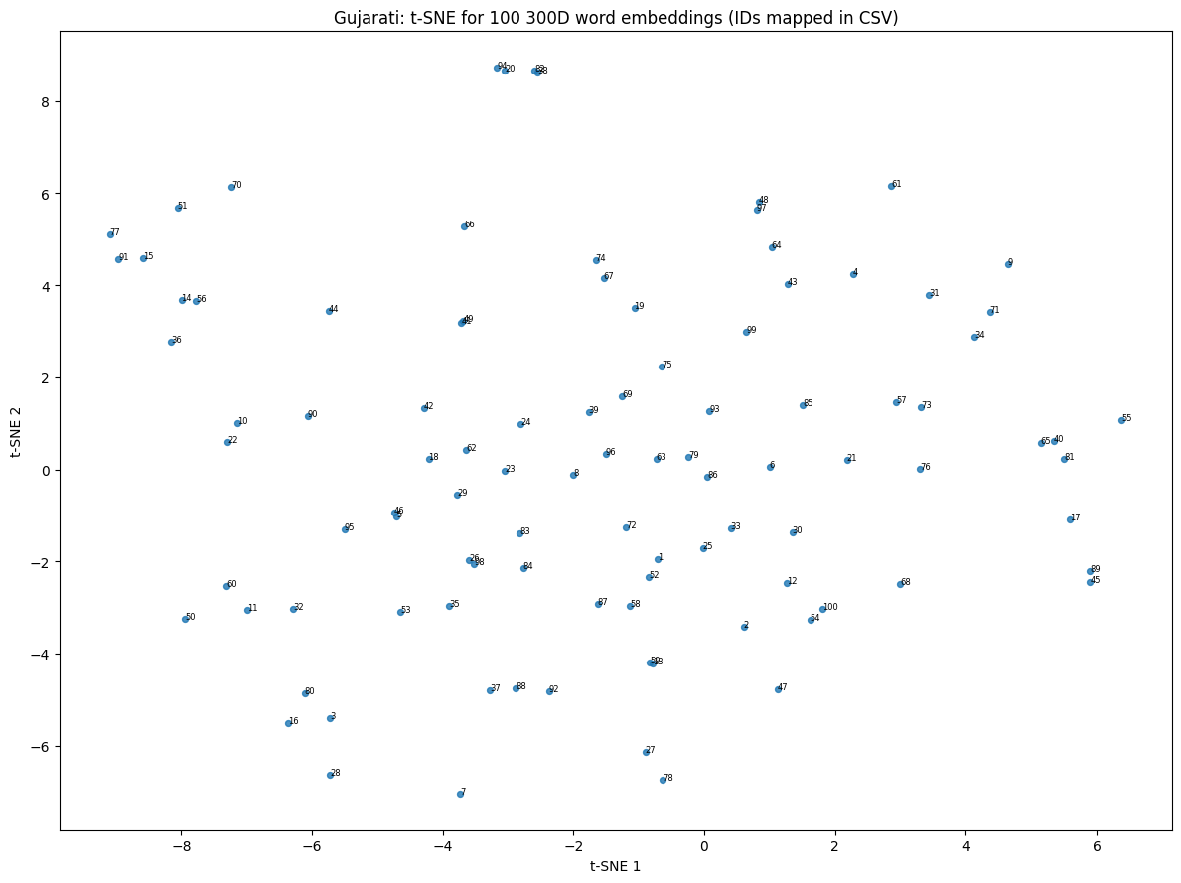  Gujarati — 100 words | 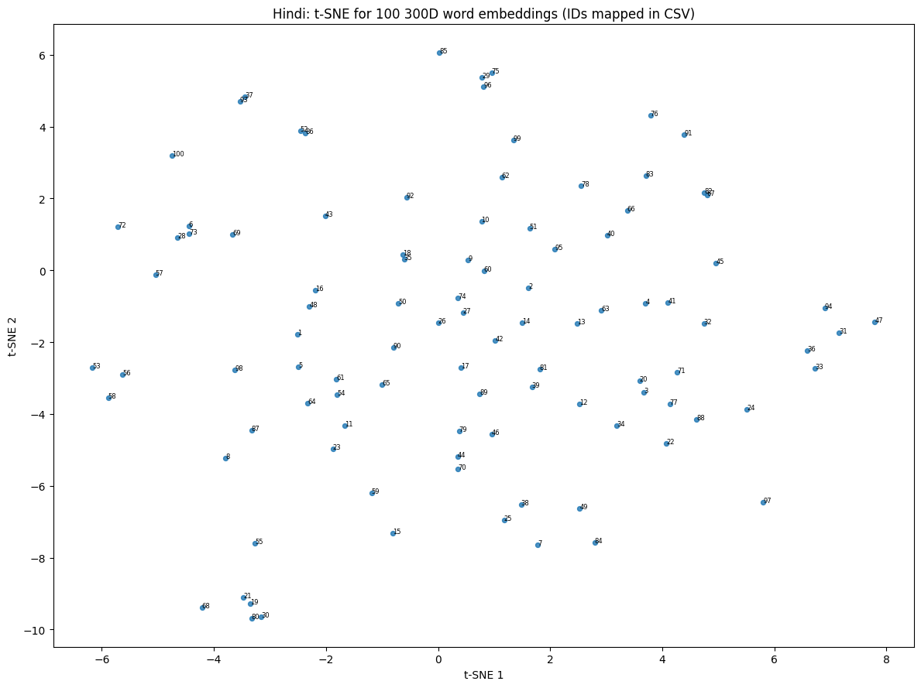  Hindi — 100 words
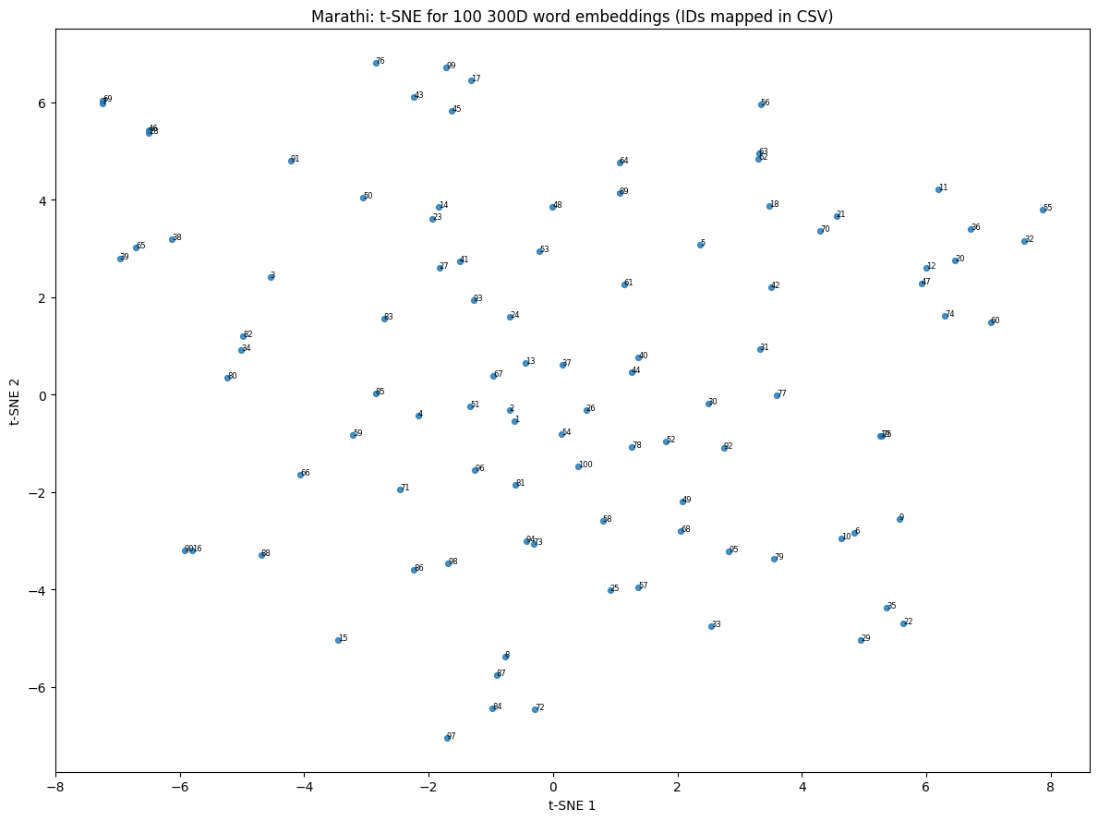  Marathi — 100 words | 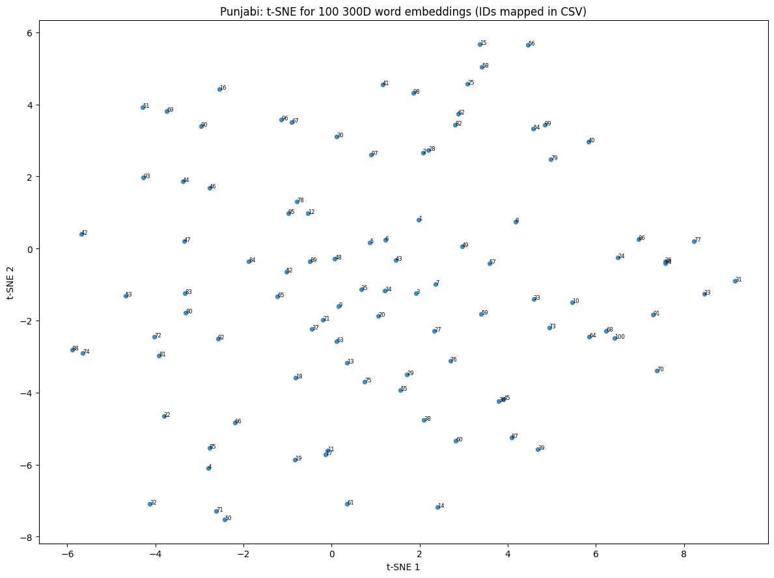  Punjabi — 100 words
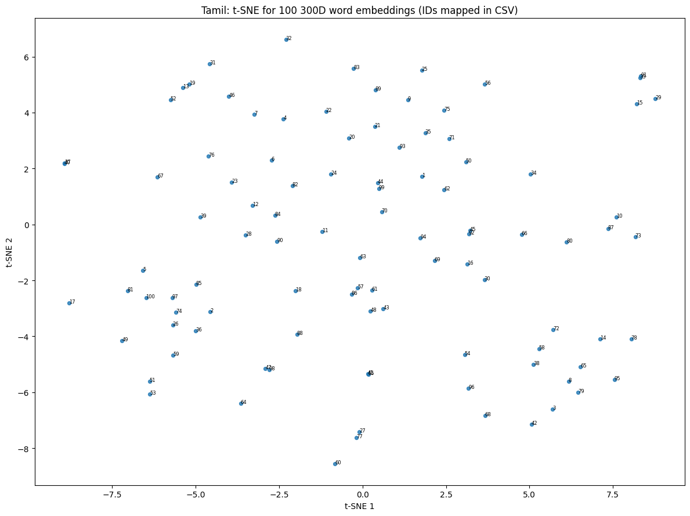  Tamil — 100 words | 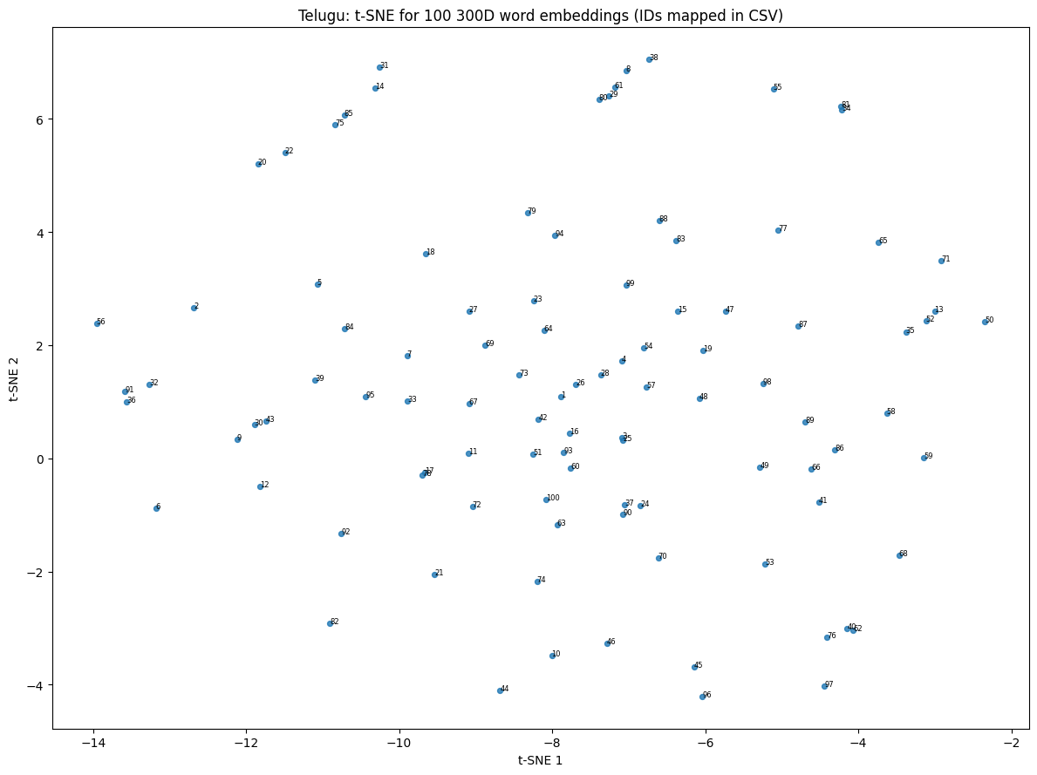  Telugu — 100 words
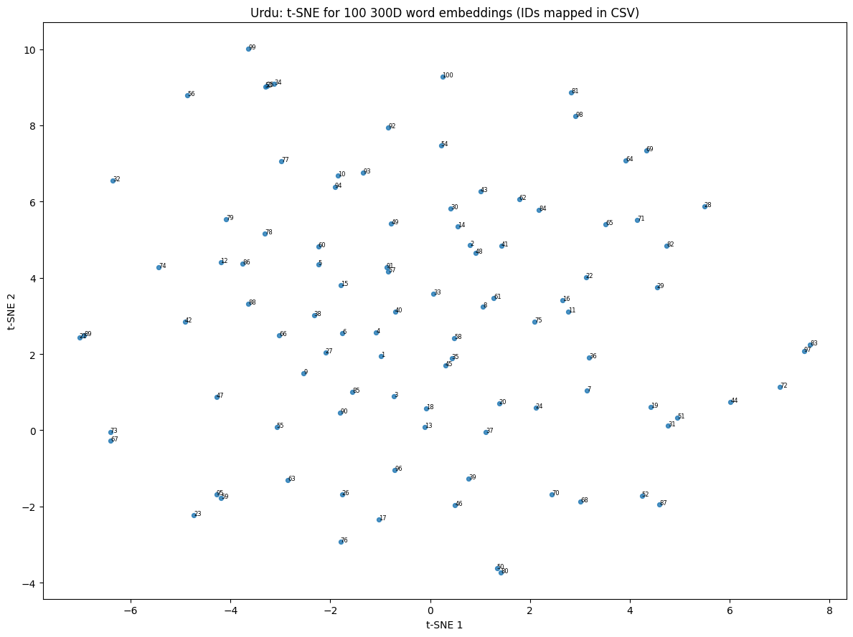
Urdu — 100 words
The projections are diffuse rather than sharply clustered. This is consistent with the correlation magnitudes reported below and with the limited corpus size: 5,000 documents per language is a small slice of IndicCorpV2, and distributional methods need substantially more co-occurrence evidence before clean semantic neighbourhoods emerge.

4. Results
The table reports, for every language, the number of word pairs in the source file, the number of rows entering the correlation, Spearman's ρ with its p-value, and vocabulary coverage statistics over the unique words appearing in that language's benchmark.
Language | Pairs  (N) | Scored | Spearman ρ | p-value | Unique  words | In  vocab | OOV | Coverage | OOV  rate
Gujarati | 163 | 163 | 0.3233 | 0.00003 | 221 | 176 | 45 | 79.6% | 20.4%
Hindi | 235 | 235 | 0.1865 | 0.00413 | 318 | 257 | 61 | 80.8% | 19.2%
Marathi | 253 | 104 | 0.1841 | 0.06135 | 337 | 250 | 87 | 74.2% | 25.8%
Punjabi | 143 | 143 | 0.2599 | 0.00172 | 206 | 170 | 36 | 82.5% | 17.5%
Tamil | 97 | 96 | 0.1984 | 0.05270 | 136 | 102 | 34 | 75.0% | 25.0%
Telugu | 111 | 111 | 0.2283 | 0.01594 | 160 | 108 | 52 | 67.5% | 32.5%
Urdu | 100 | 100 | 0.1692 | 0.09239 | 146 | 126 | 20 | 86.3% | 13.7%
Macro-average / total | 1,102 | 952 | 0.2214 | — | 1524 | 1189 | 335 | 78.0% | 22.0%
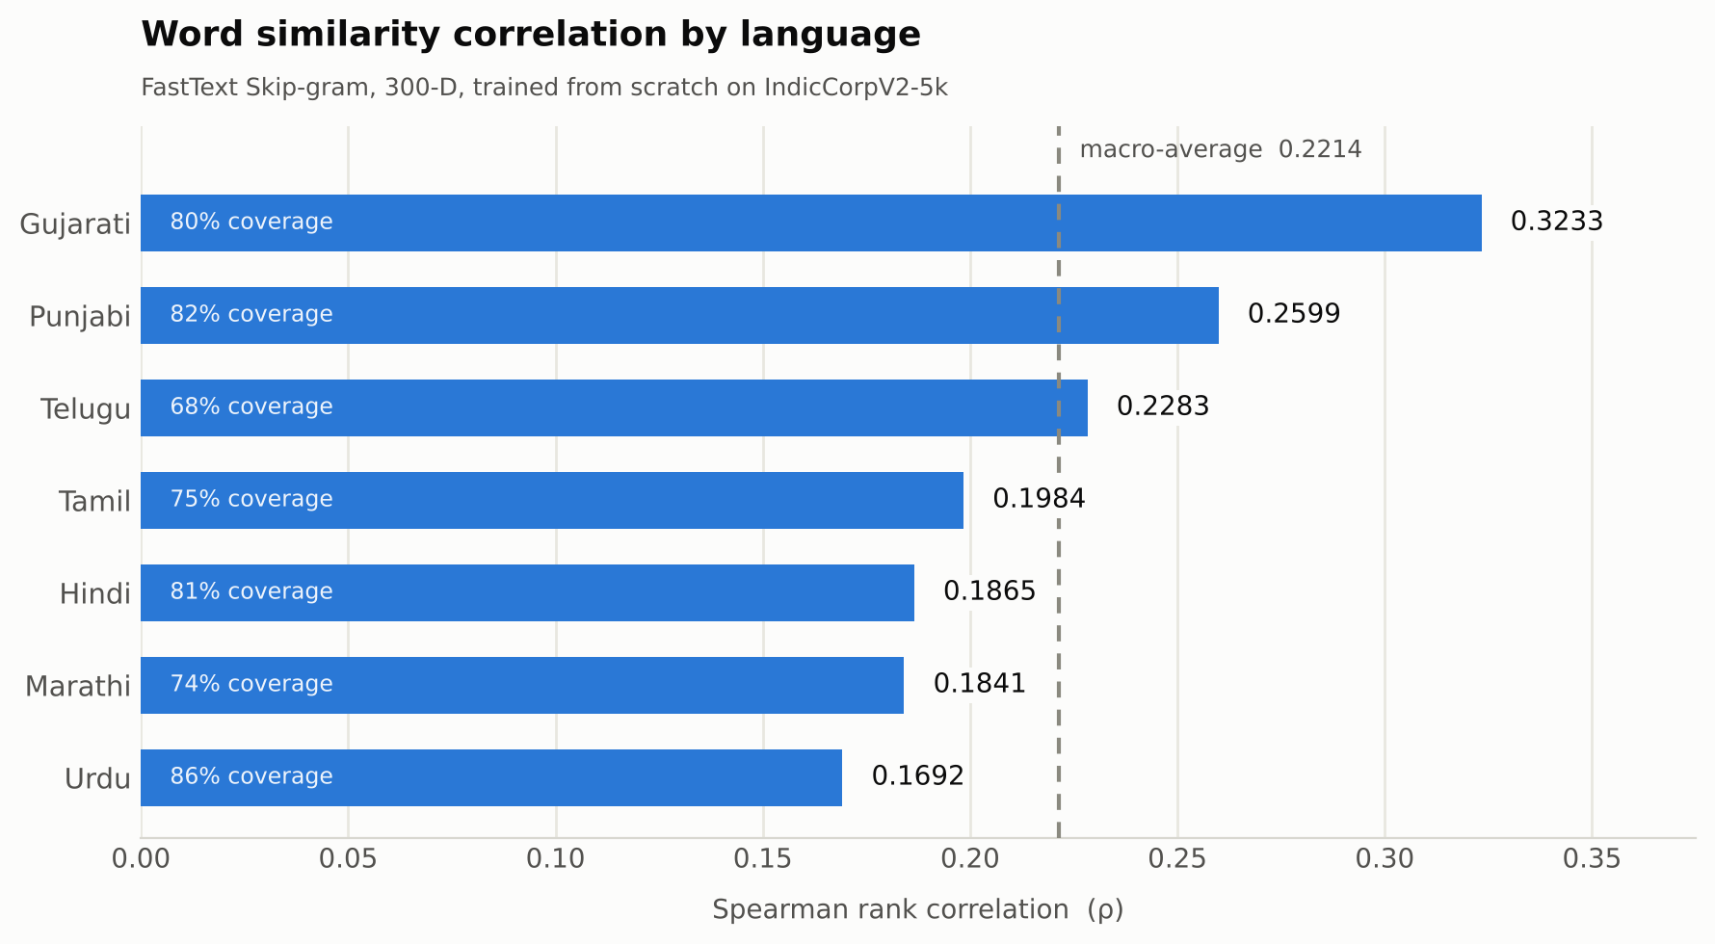
Figure 8 — Spearman correlation by language, annotated with vocabulary coverage.
The macro-average across all seven languages is ρ = 0.2214. Gujarati performs best at ρ = 0.3233 and Urdu worst at ρ = 0.1692. Five of the seven correlations are significant at p < 0.05; Marathi (p = 0.061), Tamil (p = 0.053) and Urdu (p = 0.092) are not, which is unsurprising given that these are also among the smallest scored sets.
Cosine similarity for every individual word pair, together with its human score and validity flag, is recorded in tables/<Language>_pair_predictions.csv.

4.1 Coverage and OOV behaviour
Coverage ranges from 67.5% (Telugu) to 86.3% (Urdu). Notably, coverage does not predict correlation: Urdu has the highest coverage of any language yet the lowest correlation, while Telugu has the lowest coverage and a mid-table correlation. Coverage measures how many benchmark words were seen during training; it says nothing about whether they were seen in contexts informative enough to place them well in the embedding space.
The following demonstration, produced after full training, shows the OOV mechanism working on Hindi inputs of increasing difficulty:
Word 1 | Word 2 | Cosine | Case
विद्यालय | स्कूल | 0.6796 | synonyms, both in vocabulary
विद्यालयों | विद्यालय | 0.8961 | inflected plural, OOV at training time
क्ष्यज्ञत्रक | विद्यालय | 0.6332 | malformed string, resolved via subwords
The inflected plural vidyālayõ, absent from the training vocabulary, scores 0.896 against its base form — higher than the in-vocabulary synonym pair — because the two surface forms share nearly all of their character n-grams. The malformed third string still yields a finite vector, confirming that no input can break the inference path.

5. Experiments
Four configurations were compared on Hindi and Tamil, chosen as representatives of a moderately inflecting Indo-Aryan language and a strongly agglutinative Dravidian one. Every configuration trains from scratch at 300 dimensions on IndicCorpV2 only; benchmark scores were used solely to read off the resulting correlation, never as an optimisation target.
Run | Window | Epochs | n-grams | Hindi ρ | Tamil ρ
E1 baseline | 5 | 15 | 2–5 | 0.1928 | 0.1940
E2 wider window | 10 | 15 | 2–5 | 0.2690 | 0.1776
E3 longer training | 5 | 30 | 2–5 | 0.3147 | 0.1911
E4 larger n-grams | 5 | 15 | 3–6 | 0.1481 | 0.3007
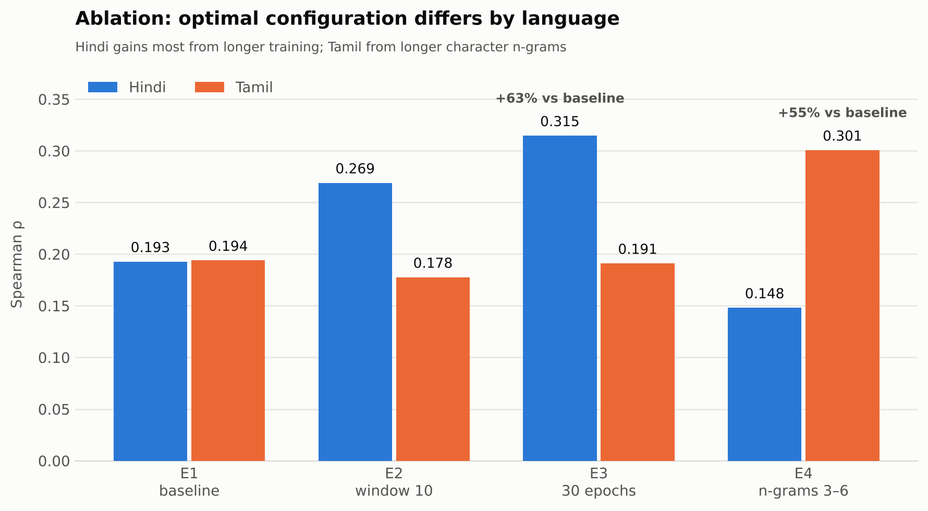
Figure 9 — Ablation results. The best configuration differs by language.
The two languages respond to opposite interventions. Hindi improves from ρ = 0.1928 to 0.3147 when the epoch budget is doubled, a relative gain of 63%, and also benefits from a wider context window. Tamil gains most from longer character n-grams, improving from 0.1940 to 0.3007, a relative gain of 55% — while the same change degrades Hindi to 0.1481, the worst result in the study. The wider window that helps Hindi slightly hurts Tamil.
This is the clearest finding of the project. Tamil's agglutinative morphology packs more meaning into longer character sequences, so 3–6 character n-grams capture morpheme-sized units that 2–5 n-grams fragment; Hindi's shorter affixes are already well served by the smaller range, and widening it dilutes the signal. A single hyperparameter set applied uniformly across Indian languages — particularly one inherited from English defaults — leaves substantial performance unclaimed.

6. Analysis
Human scores occupy a 1–10 scale while cosine similarities lie in [−1, 1], so comparing them directly is misleading. The diagnostic therefore compares rank positions: both score columns are ranked within each language and the absolute rank difference is reported. A rank error near zero means the model placed that pair at the same position in its ordering as the annotators did.
Language | Word 1 | Word 2 | Human | Cosine | Rank error
Closest rank agreement
Gujarati | વાઘ | વાઘ | 10.00 | 1.0000 | 0.0
Hindi | खेल | टीम | 7.80 | 0.6513 | 0.0
Marathi | वाघ | वाघ | 10.00 | 1.0000 | 0.0
Punjabi | ਪਿਆਰ | ਸੈਕਸ | 1.00 | 0.2032 | 0.5
Tamil | புலி | புலி | 10.00 | 1.0000 | 0.5
Largest rank disagreement
Gujarati | સો | ટકા | 9.00 | 0.0378 | 138.5
Hindi | पैसे | मुद्रा | 8.60 | 0.2444 | 210.5
Marathi | टेलिफोन | संवाद | 9.00 | 0.2103 | 92.0
Punjabi | ਪੈਸਾ | ਨਕਦ | 9.00 | 0.3461 | 114.5
Tamil | வங்கி | பணம் | 8.75 | 0.0442 | 84.0
Where the model succeeds. The strongest agreements are identity pairs — the same word compared with itself, scored 10 by annotators and 1.000 by cosine similarity — which confirm the pipeline is wired correctly but are not informative about semantics. The Hindi pair khel / ṭīm (“game” / “team”, human 7.80, cosine 0.651) is the substantive success: two distinct words that co-occur frequently in sports reporting, which the distributional model places correctly.
Where the model fails. The failures share a structure. Hindi paise / mudrā (“money” / “currency”, human 8.60, cosine 0.244) and Punjabi paisā / nakad (“money” / “cash”) are near-synonyms drawn from different registers — one colloquial, one formal or Sanskritic. In a 5,000-document corpus these registers barely overlap, so the two words rarely share contexts and the model separates them. Gujarati so / ṭakā (“hundred” / “percent”, cosine 0.038) fails similarly: the relationship is collocational rather than distributional. Tamil vaṅki / paṇam (“bank” / “money”) is a topical association rather than a similarity, a category static embeddings are known to handle poorly.
These are not implementation defects. They are the expected failure mode of a count-based distributional model trained on a small corpus: it learns contextual co-occurrence, and where human similarity judgements rest on register-crossing synonymy or world knowledge instead of shared context, the correlation breaks down.

7. Discussion
Design choices. FastText was selected over Word2Vec and GloVe because the no-discard OOV requirement effectively mandates a subword model; with 22% of benchmark vocabulary unseen on average, a purely word-level model would have had no principled way to embed those tokens. Training seven independent monolingual models rather than one multilingual model was chosen because the benchmark evaluates each language in isolation, so there is no cross-lingual signal to exploit and separate models avoid vocabulary interference between scripts. Preprocessing was deliberately shared between training and evaluation to eliminate normalisation drift, which is a common and silent source of inflated OOV rates.
Limitations. The dominant limitation is corpus size. At 5,000 documents per language the models see far too little text for stable distributional estimates, and the ablation confirms the models were still improving at 30 epochs rather than having converged — the reported correlations are a floor set by data volume, not a ceiling set by the method. The benchmarks themselves are small, from 96 to 235 scored pairs, so individual correlations carry wide confidence intervals and three are not statistically significant. Static embeddings also assign one vector per word form, so polysemy is unresolvable by construction. Finally, the ablation covers only two languages and four configurations, which is enough to demonstrate that per-language tuning matters but not enough to identify optimal settings for the remaining five languages.
Future work. The highest-value next steps, in order: scale the training corpus and re-measure the coverage/correlation curve; run a per-language hyperparameter search now that the ablation has shown the optima diverge; add Word2Vec and GloVe baselines under the identical evaluation harness to quantify the subword contribution precisely; and validate the embeddings on a downstream task, since intrinsic similarity correlation is only a weak proxy for usefulness.

Conclusion
This project delivered seven monolingual 300-dimensional FastText embedding models for Gujarati, Hindi, Marathi, Punjabi, Tamil, Telugu and Urdu, trained entirely from scratch on IndicCorpV2 and evaluated against human similarity judgements. The system reaches a macro-average Spearman correlation of ρ = 0.2214, with per-language values from 0.1692 (Urdu) to 0.3233 (Gujarati) and vocabulary coverage between 67.5% and 86.3%. All 1,102 benchmark word pairs are represented in the exported arrays; none was discarded.
Three conclusions follow from the results. First, subword composition is what makes the no-discard requirement satisfiable: with roughly a fifth of benchmark vocabulary unseen during training, a word-level model would have had no principled vector for those tokens, whereas the inflected form vidyālayõ — never observed — still scored 0.896 against its base form. Second, hyperparameters do not transfer across Indian languages: the ablation showed Hindi gaining 63% from a longer epoch budget while Tamil gained 55% from longer character n-grams, a change that simultaneously produced Hindi's worst result. Treating the seven languages as one configuration problem leaves measurable performance unclaimed. Third, vocabulary coverage is not a proxy for embedding quality: the language with the highest coverage recorded the lowest correlation, because coverage counts whether a word was seen, not whether it was seen in informative contexts.
The correlations themselves are modest, and the report is explicit about why: at 5,000 documents per language the models are corpus-limited rather than method-limited, and the epoch ablation indicates they had not yet converged. The reported figures should therefore be read as a floor established under a fixed data budget. The pipeline — seeded, smoke-tested, and gated by a validator that checks array shape, dtype, finiteness and word-pair ordering before packaging — is built so that re-running it with more text requires changing one constant rather than rewriting the experiment.

8. References
- Bojanowski, P., Grave, E., Joulin, A., & Mikolov, T. (2017). Enriching Word Vectors with Subword Information. Transactions of the ACL, 5, 135–146.
- Mikolov, T., Chen, K., Corrado, G., & Dean, J. (2013). Efficient Estimation of Word Representations in Vector Space. arXiv:1301.3781.
- Akhtar, S. S., Gupta, A., Vajpayee, A., Srivastava, A., & Shrivastava, M. (2017). Word Similarity Datasets for Indian Languages: Annotation and Baseline Systems. Proceedings of the 11th Linguistic Annotation Workshop. github.com/syedsarfarazakhtar/Word-Similarity-Datasets-for-Indian-Languages
- Doddapaneni, S., Kunchukuttan, A., et al. IndicCorp v2 / IndicNLPSuite — monolingual corpora for Indian languages. Dataset used: huggingface.co/datasets/rony000013/indiccorpV2-5k
- van der Maaten, L., & Hinton, G. (2008). Visualizing Data using t-SNE. Journal of Machine Learning Research, 9, 2579–2605.
- Řehůřek, R., & Sojka, P. (2010). Software Framework for Topic Modelling with Large Corpora (Gensim). Proceedings of the LREC 2010 Workshop on New Challenges for NLP Frameworks.

Project Resources
Resource | Link
Training corpus — IndicCorpV2-5k (Hugging Face) | https://huggingface.co/datasets/rony000013/indiccorpV2-5k
Evaluation benchmark — Word Similarity Datasets for Indian Languages (Akhtar et al., 2017) | https://github.com/syedsarfarazakhtar/Word-Similarity-Datasets-for-Indian-Languages
Project source code and artifacts | https://github.com/g25ait2138-collab/Word-Embeddings-NLP

External-resource disclosure
Training data: rony000013/indiccorpV2-5k only. No pre-trained word embeddings, no external training corpora, and no use of the benchmark's human similarity scores for training or supervised optimisation of the embeddings.
Evaluation data: the Akhtar et al. (2017) word similarity datasets, used strictly to compute the reported correlations.
Implementation tools: Python, Gensim (FastText), NumPy, SciPy, Hugging Face datasets, regex, pandas, Matplotlib, scikit-learn (t-SNE).

