MLOps Assignment 2
Fine-Tuning DistilBERT for Goodreads Genre Classification

Student ID | PGD AI Programme | Indian Institute of Technology Jodhpur
Field | Details
Student Name | Alok Sahni
Roll Number | G25AIT2138
Programme | PGD AI
Institute | Indian Institute of Technology Jodhpur
Training Platform | Kaggle Notebook (NVIDIA Tesla T4 GPU)
Submission Type | Individual Assignment

Submission Resources
Resource | Link
GitHub Repository | https://github.com/g25ait2138-collab/distilbert-goodreads-genres
Kaggle Notebook | https://www.kaggle.com/code/aloksahnig25ait2138/notebook8d09f3f76d/script
Hugging Face Model | https://huggingface.co/ALOK2026/distilbert-goodreads-genres
W&B Dashboard | https://wandb.ai/g25ait2138-iitj/mlops-assignment2/workspace?nw=nwuserg25ait2138

Key Highlights
Accuracy | Weighted F1 | Best Class F1 | Baseline Lift
56.19% | 56.73% | 0.81 | +3 pts

1. Project Overview
This project implements a complete end-to-end MLOps workflow for transformer-based Natural Language Processing using the UCSD Goodreads Reviews Dataset. The objective is to fine-tune DistilBERT for multi-class book genre classification across eight literary categories while applying production-grade engineering practices.
The work demonstrates the following operational capabilities:
- Modular Python code organisation for maintainability
- Cloud GPU training executed on Kaggle
- Secure API credential handling through Kaggle Secrets
- Live experiment tracking with Weights & Biases (W&B)
- Artifact versioning and run reproducibility
- Automated evaluation and metric logging
- Public model deployment to the Hugging Face Hub
The starter notebook was reorganised into four production-style scripts:
- data.py — data loading, sampling, train/test split, label encoding
- train.py — model loading, Trainer setup, training loop, W&B logging, HF Hub push
- eval.py — final evaluation, metrics, classification report uploaded as W&B Artifact
- utils.py — shared helpers (label maps, Dataset class, compute_metrics)
This architecture improves readability, maintainability, and reproducibility of the pipeline. All experiments, metrics, hyperparameters, checkpoints, and artifacts are logged through W&B, allowing any run to be inspected and reproduced from its dashboard entry.

2. Model Selection Rationale
The chosen transformer is distilbert-base-cased, a distilled variant of BERT developed by Hugging Face. It retains approximately 97% of BERT's language-understanding capability while being roughly 40% smaller and 60% faster at inference. The cased version was selected deliberately because Goodreads reviews contain proper nouns, book titles, and author names where capitalisation carries semantic signal that the uncased model would discard.
DistilBERT also fits comfortably on the free Kaggle Tesla T4, supports a 512-token sequence length, and integrates natively with the Hugging Face Trainer, AutoTokenizer, and Hub — making post-training deployment a single function call.

Trade-off Summary
Feature | Benefit
Accuracy | Strong NLP understanding (~97% of BERT-base)
Speed | Roughly 60% faster training and inference
Memory | Fits on free-tier Kaggle T4 GPU
Deployment | Lightweight and easy to host
Integration | Native Hugging Face ecosystem support

3. Kaggle Training Environment
The full workflow ran inside a Kaggle Notebook with GPU acceleration enabled under Settings → Accelerator → GPU → Tesla T4. Internet access was turned on to allow dataset streaming, dependency installation, W&B synchronisation, and Hugging Face model publishing.
Sensitive credentials (WANDB_API_KEY and HF_TOKEN) were stored as Kaggle Secrets and accessed at runtime through kaggle_secrets.UserSecretsClient, so they never appear in the notebook source.

Environment Configuration
Component | Value
Platform | Kaggle Notebook
GPU | NVIDIA Tesla T4 (free tier)
Framework | PyTorch + Hugging Face Transformers
Python Version | 3.10+
Tracking Tool | Weights & Biases (W&B)
Model Hosting | Hugging Face Hub

Hyperparameter Configuration
Hyperparameter | Value
Epochs | 3
Learning Rate | 3e-5
Train Batch Size | 16
Eval Batch Size | 32
Max Sequence Length | 512
Warmup Steps | 100
Weight Decay | 0.01
Optimizer | AdamW
Best-Model Strategy | load_best_model_at_end=True (lowest val loss)

4. Dataset and Data Pipeline
The UCSD Goodreads 'by genre' review dumps were streamed directly from the McAuley Lab repository. Eight literary genres were used, with approximately 1,000 reviews sampled per genre and a deterministic 800/200 train/test split, producing a balanced corpus across all classes.

Target Genres
- Children
- Comics & Graphic
- Fantasy & Paranormal
- History & Biography
- Mystery / Thriller / Crime
- Poetry
- Romance
- Young Adult

Dataset Statistics
Split | Samples
Training Set | 6,400
Test Set | 1,600
Reviews per Genre | ~1,000
Total Genres | 8

Tokenization Strategy
Tokenisation was performed with DistilBertTokenizerFast using truncation=True, padding=True, and max_length=512. Labels were encoded using sorted(set(labels)) rather than insertion order, ensuring the integer-to-genre mapping remains stable across runs — a small but critical detail for inference reproducibility.

5. Training Workflow and W&B Tracking
Fine-tuning was driven by the Hugging Face Trainer with report_to="wandb", which automatically captures training and validation loss, accuracy, weighted precision/recall/F1, the learning-rate schedule, gradient norms, GPU utilisation, and the complete hyperparameter configuration. Model checkpoints were saved at the end of each epoch.

A Screenshot of W & B Training Dashboard
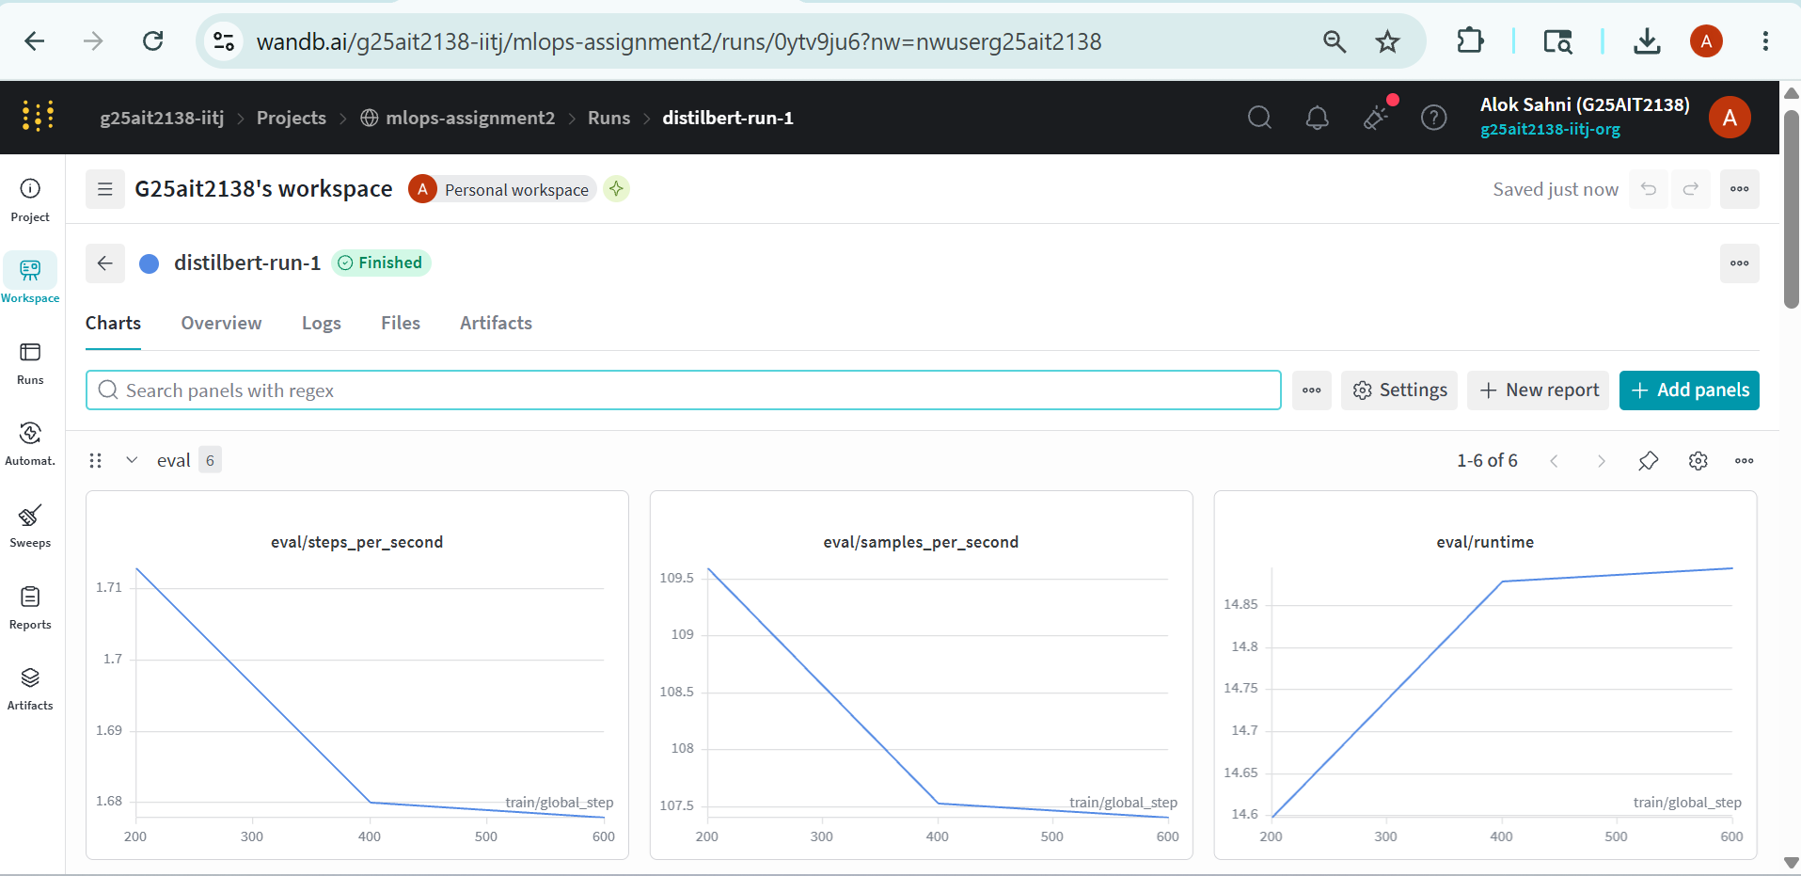
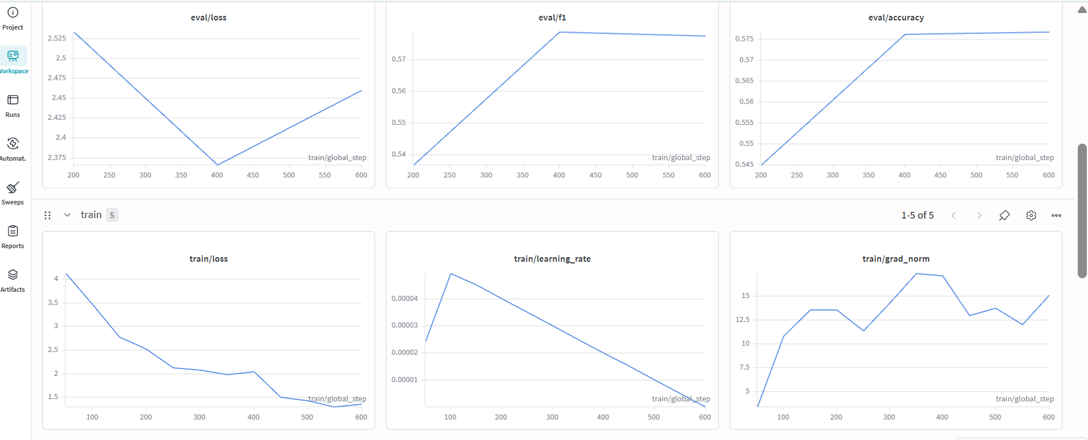
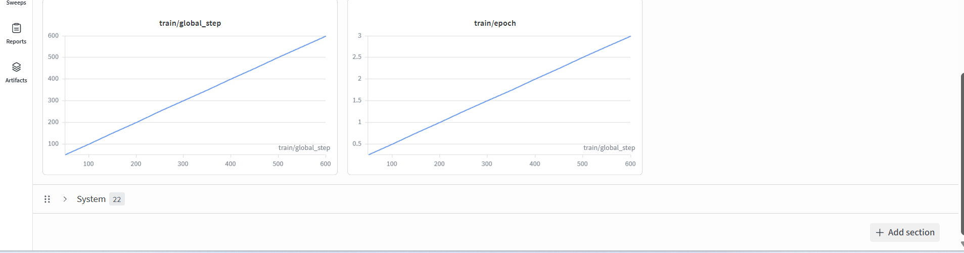

Per-Epoch Training Results
Epoch | Train Loss | Val Loss | Accuracy | F1
1 | 1.0665 | 2.8248 | 0.5619 | 0.5673
2 | 0.9481 | 3.0193 | 0.5625 | 0.5674
3 | 0.5708 | 3.1652 | 0.5713 | 0.5747

Training loss decreased steadily across epochs, indicating successful learning. Validation loss reached its minimum at epoch 1 and rose thereafter — an early sign of overfitting. The load_best_model_at_end=True flag automatically restored the epoch-1 checkpoint as the final deployable model.

6. Evaluation Results
The selected best checkpoint was evaluated on the held-out test set of 1,600 reviews (200 per genre). The classification report was saved as eval_report.json and uploaded to W&B as a versioned Artifact named eval-report.

Final Test-Set Metrics

Metric | Score
Accuracy | 56.19%
Weighted F1 Score | 56.73%
Weighted Precision | 57.81%
Weighted Recall | 56.19%
Evaluation Loss | 2.8248

Per-Class Classification Report
Genre | Precision | Recall | F1 Score
Children | 0.64 | 0.60 | 0.62
Comics & Graphic | 0.88 | 0.75 | 0.81
Fantasy & Paranormal | 0.36 | 0.34 | 0.35
History & Biography | 0.54 | 0.53 | 0.53
Mystery / Thriller / Crime | 0.55 | 0.59 | 0.57
Poetry | 0.71 | 0.76 | 0.73
Romance | 0.64 | 0.52 | 0.57
Young Adult | 0.31 | 0.41 | 0.35
Weighted Average | 0.58 | 0.56 | 0.57

Result Interpretation
The model significantly outperforms random guessing on eight balanced classes (random baseline = 12.5%). The strongest categories are Comics & Graphic (F1 = 0.81) and Poetry (F1 = 0.73), whose vocabularies are highly distinctive — terms such as panel, artwork, stanza, and verse rarely appear elsewhere.
The weakest categories are Young Adult (F1 = 0.35) and Fantasy & Paranormal (F1 = 0.35). This is unsurprising: these genres share substantial thematic overlap with Romance and Children, so their reviews are linguistically ambiguous rather than under-represented.

Baseline Comparison
Model | Accuracy | Weighted F1
Logistic Regression (TF-IDF) | 0.53 | 0.53
DistilBERT (fine-tuned) | 0.56 | 0.57
The transformer approach delivers a measurable improvement of approximately three percentage points on both accuracy and weighted F1 over the traditional TF-IDF baseline.

7. Hugging Face Deployment
After training, the final model weights and tokenizer were pushed to the public repository ALOK2026/distilbert-goodreads-genres via model.push_to_hub() and tokenizer.push_to_hub(). The HF model URL was also recorded in the W&B run summary, linking the experiment record to the deployed artifact.

Any user can load and run the deployed model with a few lines of code:
from transformers import AutoTokenizer, AutoModelForSequenceClassification

repo_id = "ALOK2026/distilbert-goodreads-genres"
tokenizer = AutoTokenizer.from_pretrained(repo_id)
model = AutoModelForSequenceClassification.from_pretrained(repo_id)

inputs = tokenizer("A thrilling whodunit set in Victorian London.",
return_tensors="pt", truncation=True, max_length=512)
pred_id = model(**inputs).logits.argmax(-1).item()
print(model.config.id2label[pred_id])
This illustrates end-to-end deployment automation: raw text reviews flow through training and emerge as a publicly downloadable, versioned model usable in just a handful of lines.

8. Challenges and Learnings

Issues Encountered
Kaggle Internet configuration. The first run failed silently because the Internet toggle was off in the session, blocking dataset download and W&B / HF authentication. Enabling it under Notebook → Settings resolved both problems at once.
GPU memory constraints. With batch_size=16 and max_length=512, the Tesla T4 approached its 16 GB memory limit. The mitigation is to reduce batch size to 8 or max_length to 256 should an OOM event occur.
Validation loss instability. Validation loss rose after epoch 1 while accuracy continued to improve marginally. The load_best_model_at_end flag combined with save_strategy="epoch" handled this automatically by restoring the lowest-val-loss checkpoint.
Reproducibility of label IDs. Building the label map using sorted(set(labels)) — rather than relying on insertion order — keeps the integer-to-genre mapping stable across runs. Without this, the same model file could produce different predictions on a re-run.

Key Takeaways
This assignment showed that modern MLOps practice is broader than model training alone. The practical lessons include:
- Run reproducibility through deterministic seeds and sorted label maps
- Artifact management and versioning via W&B Artifacts
- Cloud GPU orchestration using free-tier resources
- Live experiment tracking with rich dashboards
- Secure credential handling through Kaggle Secrets
- Modular ML engineering for long-term maintainability
- Public deployment with a two-line consumption API
The most important insight is that operational scalability and reproducibility often outweigh marginal accuracy gains. A single reproducible artifact that anyone can load from Hugging Face delivers more practical value than weeks of hyperparameter tuning.

9. Future Improvements
Several extensions would strengthen the system further:
Improvement | Expected Benefit
Stratified K-Fold Cross Validation | More stable per-class evaluation metrics
W&B Hyperparameter Sweeps | Systematic learning-rate and sequence-length optimisation
Class-Weighted Cross-Entropy | Better minority-class handling
Focal Loss | Improved learning on difficult and overlapping classes
Confusion Matrix Logging | Visual diagnosis of off-diagonal errors (e.g. YA ↔ Fantasy)
CI/CD Pipelines | Automated retraining on data updates
Production Model Monitoring | Drift detection and alerting in deployed environments

10. Conclusion
This project delivers a complete production-oriented MLOps pipeline for transformer-based NLP classification. It integrates cloud GPU training on Kaggle, modular Python engineering, live experiment tracking with Weights & Biases, versioned evaluation artifacts, secure credential management, and public deployment to the Hugging Face Hub into a single coherent workflow.
The fine-tuned DistilBERT model achieved a measurable lift over the TF-IDF + Logistic Regression baseline while remaining lightweight enough to train and serve on free-tier infrastructure. The cased variant proved particularly well-suited to Goodreads reviews, where author names, book titles, and proper nouns carry meaningful classification signal.
Beyond the model itself, the assignment establishes a transferable engineering pattern: every run is reproducible, every artifact is versioned, every credential is secure, and the trained model is one function call away from any downstream user. This workflow is directly applicable to industrial AI systems involving continuous training, automated deployment, drift monitoring, and scalable NLP pipelines, and it provides a solid foundation for more advanced MLOps work such as CI-driven retraining and automated rollbacks.

Final Submission Links
Platform | Link
GitHub | https://github.com/g25ait2138-collab/distilbert-goodreads-genres
Kaggle | https://www.kaggle.com/code/aloksahnig25ait2138/notebook8d09f3f76d/script
Hugging Face | https://huggingface.co/ALOK2026/distilbert-goodreads-genres
W&B | https://wandb.ai/g25ait2138-iitj/mlops-assignment2/workspace?nw=nwuserg25ait2138

— End of Report —

