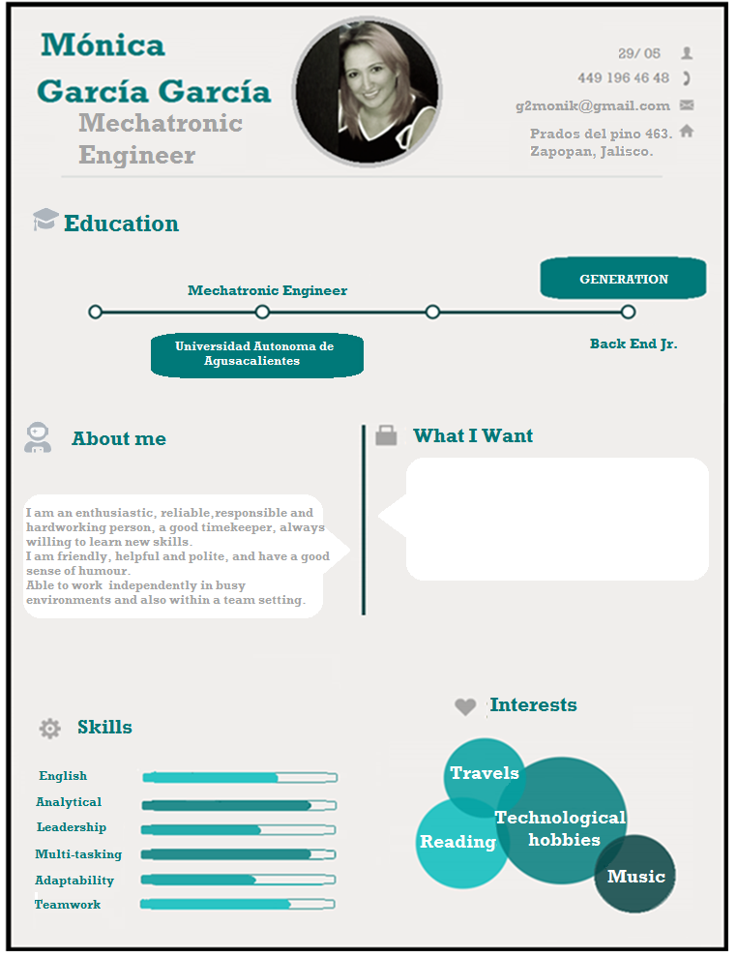

I need a place where measure and reward success, and where value each individual employee’s contributions.

I would like to work for a workplace that has a viable business plan, so that I know I am helping the company succeed in both the short and long term.