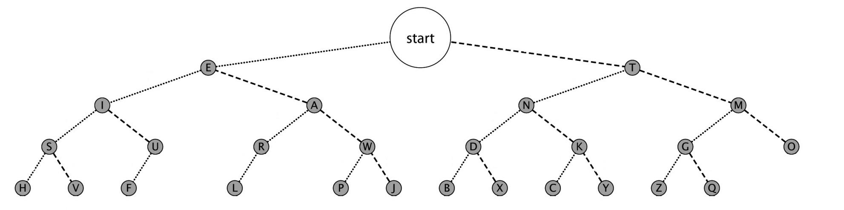

* “Morse code is usually received as a medium-pitched audio tone (600-1000 Hz)” [http://en.wikipedia.org/wiki/Morse_code]
  + - using frequency ~830.61(Ab 5)
* Using the conventions of airway beacons it will be “0.5 second for a dot, 1.5 second for a dash with a 0.5 second between each dot or dash. A pause of 1.5 seconds separates each letter” [http://en.wikipedia.org/wiki/Airway_beacon]
* To extend standardized conventions, a word break will be 3.5 seconds long
* For the user’s accuracy of transcribing Morse Code, two lights will be used to display 0.5 and 1 second intervals.

Relative duration of Morse Code

A Dash is three times longer than a Dot  
There is a dot’s duration of space between Dashes and Dots within a character  
A pause between characters is three Dots long  
A pause between words is seven dots long

*Based upon a 50 dot duration standard word such as PARIS, the time for one dot duration or one unit can be computed by the formula:*

*T = 1200 / W* [W is speed in wpm]

*T = 6000 / C* [C is speed in cpm]

[T is in milliseconds]

|  |  |  |
| --- | --- | --- |
| **State** | **Input** | **Next State** |
| START | dot | E |
| START | dash | T |
| A | dot | R |
| A | dash | W |
| D | dot | B |
| D | dash | X |
| E | dot | I |
| E | dash | A |
| G | dot | Z |
| G | dash | Q |
| I | dot | S |
| I | dash | U |
| K | dot | C |
| K | dash | Y |
| M | dot | G |
| M | dash | O |
| N | dot | D |
| N | dash | K |
| R | dot | L |
| S | dot | H |
| S | dash | V |
| T | dot | N |
| T | dash | M |
| U | dot | F |

|  |  |  |
| --- | --- | --- |
| W | dot | P |
| W | dash | J |

The 50 MHz clock will be regulated to count intervals of the new dot duration (0.5 s) and after every other interval (since there is a dot’s duration between each character) it will shift the recorded value into a (8-bit) register. Three consecutive dots will constitute a dash, three dot durations of pause will constitute a letter break, and seven dot durations of pause will constitute a word break.