Download Terraform from **Hasicorp “**<https://www.terraform.io/downloads.html>” select the package based on the OS version

Once downloaded extract to a location and then set the path

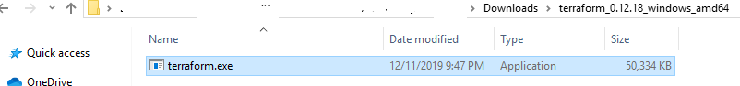

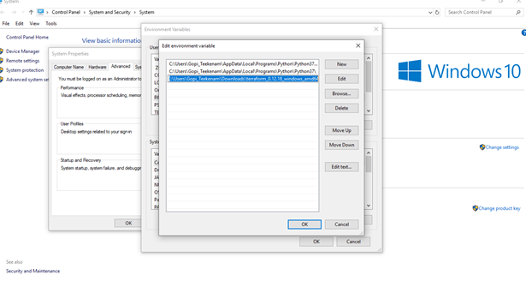

Create a S3 bucket with right permissions to store terraform state



Terraform recommends enabling versioning to recover from any failure

**aws2 s3api put-bucket-versioning --bucket terraform-artifacts-bucket --versioning-configuration Status=Enabled**

Once bucket is created, we can use the bucket for storing Terraform artifacts

Create a file with name terraform.tf in the root of the project, and then write the following script in it

|  |
| --- |
| **terraform {**  **backend "s3" {**  **bucket = "terraform-bucket-19122019"**  **key = "cloudwatch-demo/terraform.tfstate"**  **region = "us-east-1"**  **}**  **}** |

Run the following command to initialize the backend storage

**terraform init**

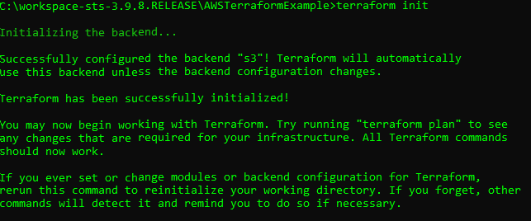

As an outcome of above command “**.terraform”** folder is create in the project

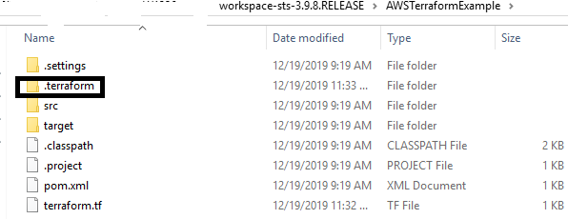

Add the following script in terraform.tf file in the project

provider "aws" {

access_key = "${var.access_key}"

secret_key = "${var.secret_key}"

region = "${var.region}"

}

Define another file “**varilables.tf”** to provide access_key and secret_key

variable "access_key" {}

variable "secret_key" {}

variable "region" {

default = "us-east-1"

}

variable "alarms_email" {}

create a file **“teffaform.tfvars”** with following contents

access_key = "your-aws-access-key-here"

secret_key = "your-aws-secret-key-here"

alarms_email = "your@email.here"

Provide you AWS access key and secret key for access_key and secret_key

Run terraform init

If you get an error message saying provider.aws no suitable version installed, download terraform aws provider and then configure in path variables

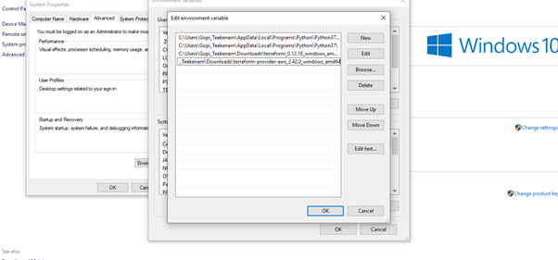

Run terraform.init

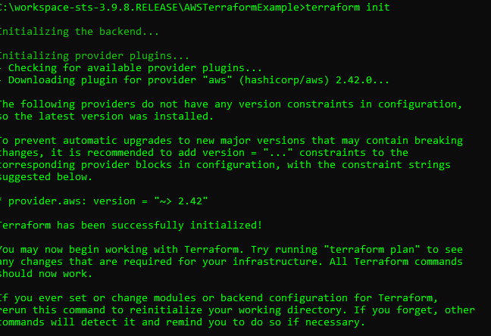

application.tf

|  |
| --- |
| resource "aws_key_pair" "ssh" {  key_name = "default"  public_key = "${file("~/.ssh/id_rsa.pub")}"  }  resource "aws_security_group" "examplesg" {  ingress {  from_port = 22  to_port = 22  protocol = "tcp"  cidr_blocks = ["0.0.0.0/0"]  }  }  resource "aws_instance" "ec2_instance" {  ami = "ami-00068cd7555f543d5"  instance_type = "t2.micro"  vpc_security_group_ids = ["${aws_security_group.examplesg.id}"]  key_name = "${aws_key_pair.ssh.id}"    tags = {  Name = "my-test-server"  }  }  output "web_public_dns" {  value = "${aws_instance.ec2_instance.public_dns}"  } |

Commands

terraform validate – To validate the file

terraform fmt – To format all the files

terraform plan – To set up the provision

terraform apply – To execute the plan

terraform destroy – To display the existing instances (need to be careful in applying this command)