Charlie Geisler
Professor Clayton
CYB-3900-001
OSINT 3
31 October, 2025

1A. Face Page
Zillow: Pick a random home and find all relevant info on previous owners.
The chosen random house is 1710 Nw Woodland Dr, Corvallis, OR. I found information about the previous owners of the home via the property assessor records, which appears to be a family with the last name Christy, specifically the names Erik Emil Christy and Mei Tak Goretti Christy. The home was built in 1971, and there are no records listing a different last name besides “Christy” since 1971. Both names are followed by “TR”, which verifies that they are the individual trustees of this property.
1B. Narrative
Property records search via the Google Dorks method "1710 NW Woodland DR Corvallis, OR 97330” + "Benton County" + "Property Records" returned the assessor’s office link for Benton County (1C Appendix A). The Zillow listing verifies that the house is currently up for sale, so these are the previous owners. I also conducted a search for the owners names via Freepeoplesearch and it implied that their name now is connected to a home in CA. However, I could not verify this because the assessment of their supposed new property did not list their name as a owner under a CA governance law (1C Appendix B).

1C. Appendix/Analysis
A. Screenshot 2025-10-30 at 3.41.48 PM MDT
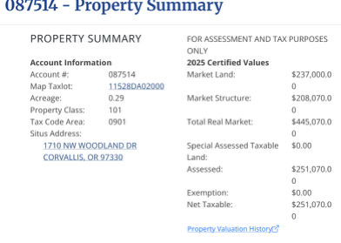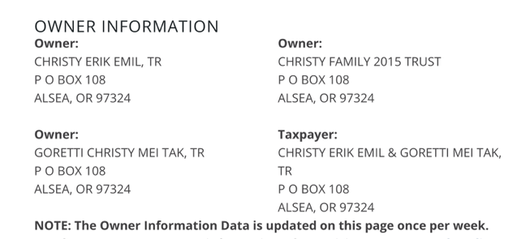
https://assessment.bentoncountyor.gov/property-account-search/
B. Screenshot 2025-10-30 at 4.14.23 PM MDT
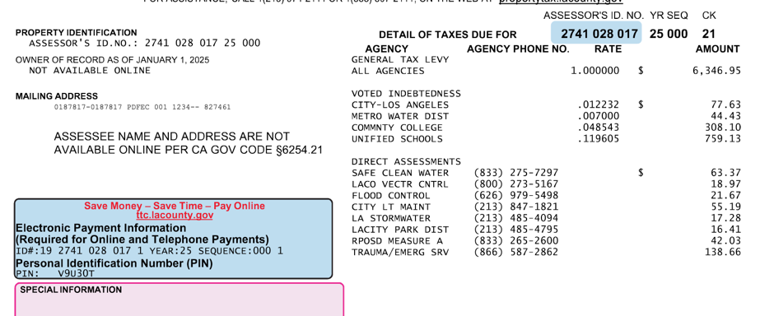
https://latapi.estreamone.com
My confidence is low that these are all accurate previous owners in this search, as the data I collected on the Christy family contradicts itself in some areas. FreePeopleSearch returned several different addresses and possible owners of the property, and so did Spokeo but I chose to include only the common Christy names on FreePeopleSearch. I determined this was the best way to verify some correlation between the property owners.

2A. Face Page
Wrong number (incoming) or spam calls: Reverse-search it, provide their details.
The number I chose to research is (719)752-2467. This number appeared with a “scam likely” footer. I was able to find the carrier is Twilio and the city is Colorado Springs/Trinidad (this is not much, because I already could tell that from the area code).
2B. Narrative
To research this number I used Whitepages, USPhonebook, and 411 all of which returned no results. I believe the main reason for this is that it came from a temporary, untraceable, or spoofed line, which is common for scammers (www.fcc.gov).
2C. Appendix/Analysis
- Screenshot 2025-10-30 at 17.06.59
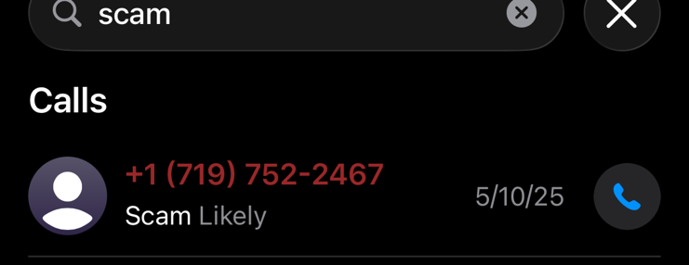
- Screenshot 2025-10-30 at 17.09.51
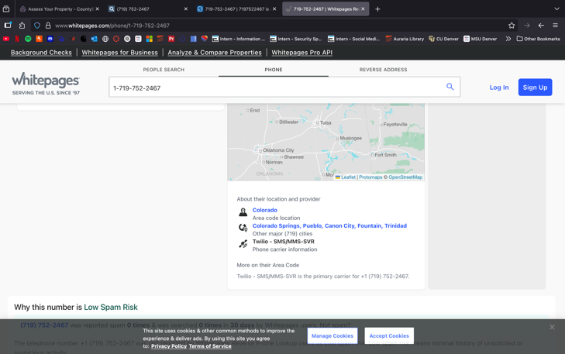
- https://www.whitepages.com/phone/1-719-752-2467?hasNoResults=true
Since I was able to find very little data on this number I have low confidence on the background of this information. If it was a temporary line, it is extremely difficult to trace.

3A. Face Page
Reviews: Find 5 people that have patronized a local business and locate their
home address.
- Desiree Martinez - 13457 W Purdue Dr Morrison, CO
- Dylan Hillestad - 208 E Lotta St Sioux Falls, SD 57105
- Jacob Ott - 13706 W Grand Dr Morrison, CO 80465
- Charles Cox - 1410 S Kendall St T Lakewood, Colorado 80232
- Jaimee Maher - 3450 W Mountain Rd Englewood, Colorado 80110

3B. Narrative
I chose a random shop near me called Bardo Coffee House to dig in the reviews.
- Desiree Martinez’s address was found via Truepeoplesearch.com. After looking through her other Google reviews, (Appendix A) and by triangulating the locations of her reviews I verified that the general area was most likely South Littleton or Morrison. One detail was a greater giveaway—Desiree had left a review for a heating company contractor who fell through the roof of her house and provided a picture (B). This gave me enough information to determine her home color was like what TruePeopleSearch returned. Confidence: Medium
- Dylan Hillestad’s address was found using TruePeopleSearch. I found multiple results in South Dakota and a review in Littleton that he said he grabbed coffee before his “leaving town.” (Appendix C). Confidence: High
- Jacob Ott’s address was the only result returned for his name on TruePeopleSearch (TPS) and it is in the Morrison area. The Bardo coffee shop is a common place for residents of Morrison. His other reviews were also in the Morrison area, another giveaway was a pet food shop review which is the closest pet food location to this home (D). Confidence: High
- Charles Cox mentioned in a review that he lives 200 yards away so this is a dead giveaway (E ). A search query on TPS returned an address that is indeed 200 yards away. Confidence: Very High
- Jaimee Maher’s address (F) was found with a search query on TruePeopleSearch and unfortunately, I could not gather much information on this person. She is the only one with location around the Englewood/South CO area, so I assumed this is the same person.
3C. Appendix/Analysis
- Screenshots 10.30.2025 18:00.28
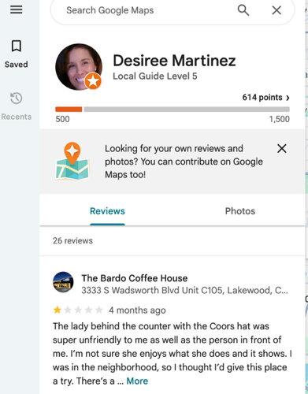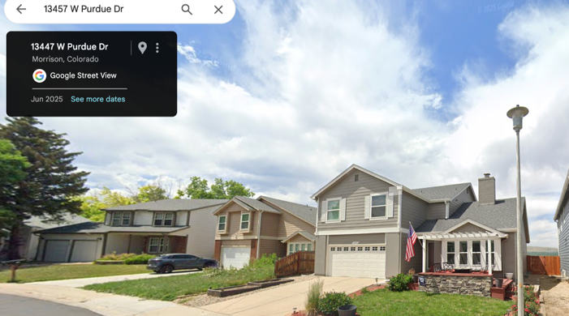
- Screenshots 10.30.2025 18:03.21
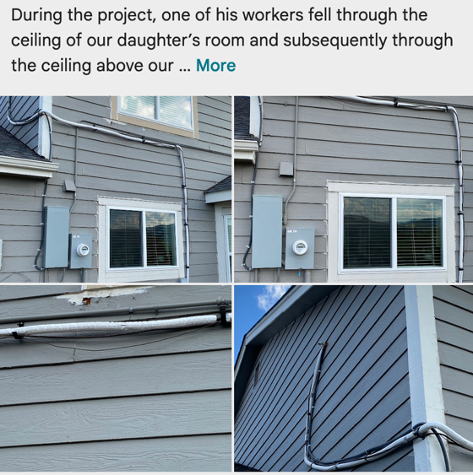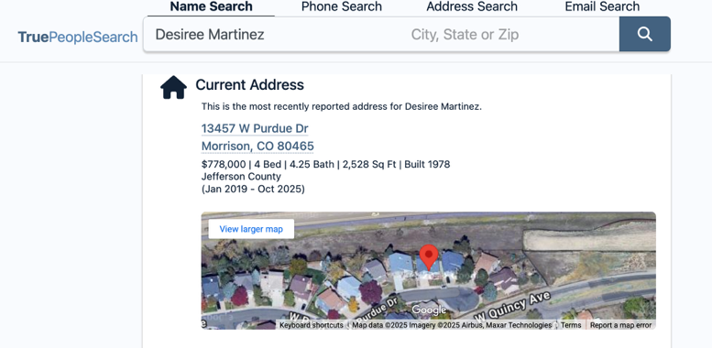
- Screenshots 10.30.2025 18:04.32
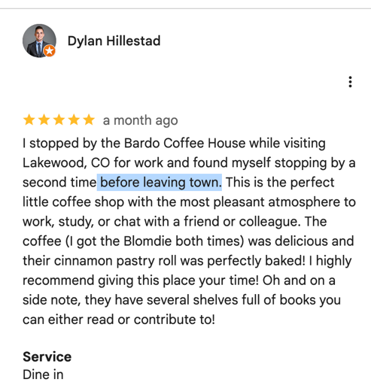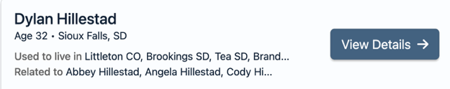
- Screenshots 10.30.2025 18:03.58
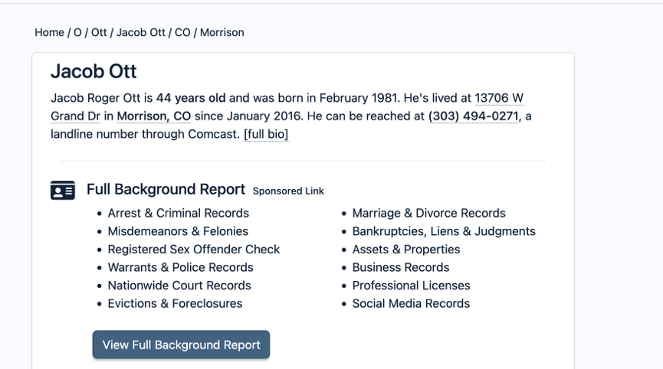
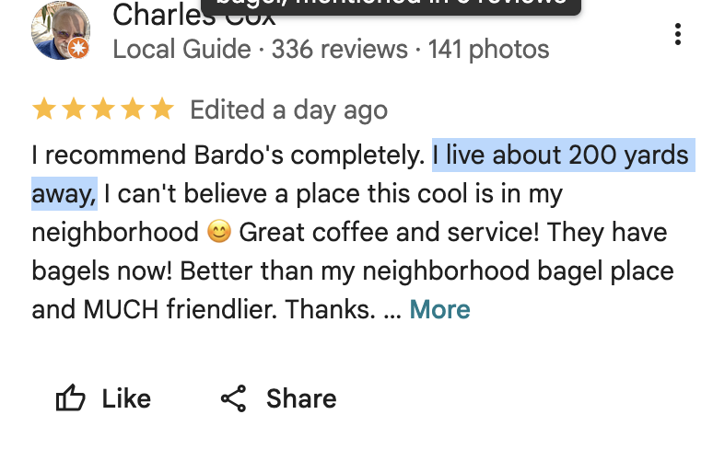
- Screenshot 10.30.2025 18:16.32

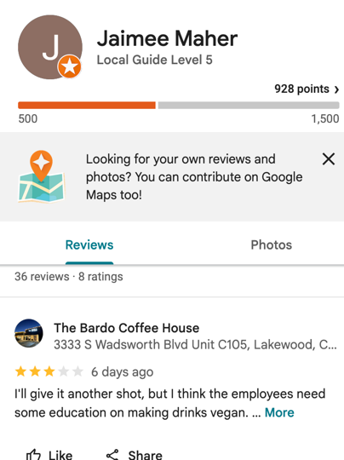
- Screenshots 10.30.2025 18:48.32

4A. Face Page
Newspaper: Choose a person quoted in a recent newspaper article and identify
their social networks.
I chose to research Tanya Towles (Appendix A) in a news story about how a tree company recently saved her cat from a tree in Colorado. Her Facebook handle is Tonya Towles with her Instagram being @tonyamariee.
4B. Narrative
I searched her name on Facebook to find her profile, and verified it was her because she had reposted the same cat story, and her profile also said she is from Colorado Springs.
4C. Appendix/Analysis
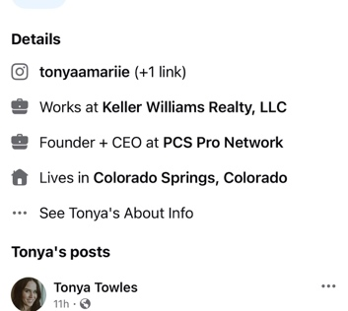
- Screenshots 10.30.2025 19:46.09
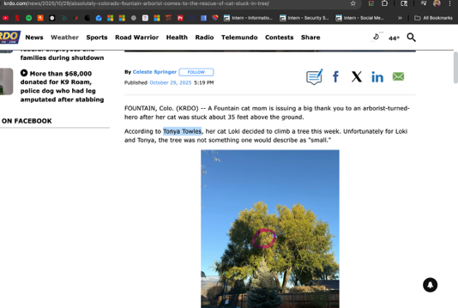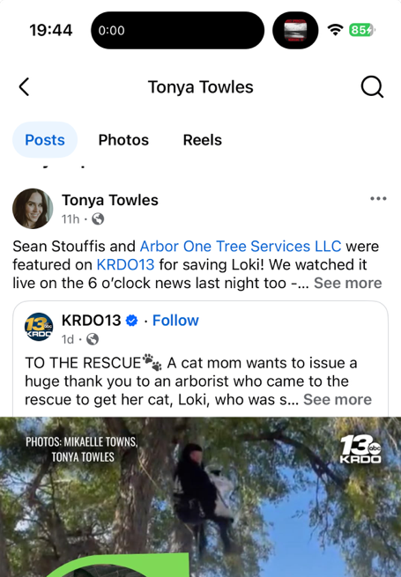

5A. Face Page
Yearbook: Dust off an old yearbook and locate someone from your graduating
class.
I chose to research someone named Brayden Ford from my graduating class. I found that he is attending University of Arizona and is graduating this semester, a semester before me. He lives in Tucson and is studying Management Information Systems.
5B. Narrative
All this information was available when I searched up his name on Linkedin, and he included where he is for school in his bio (A).
5C. Appendix/Analysis
- Screenshot 10.30.25 17:59.29
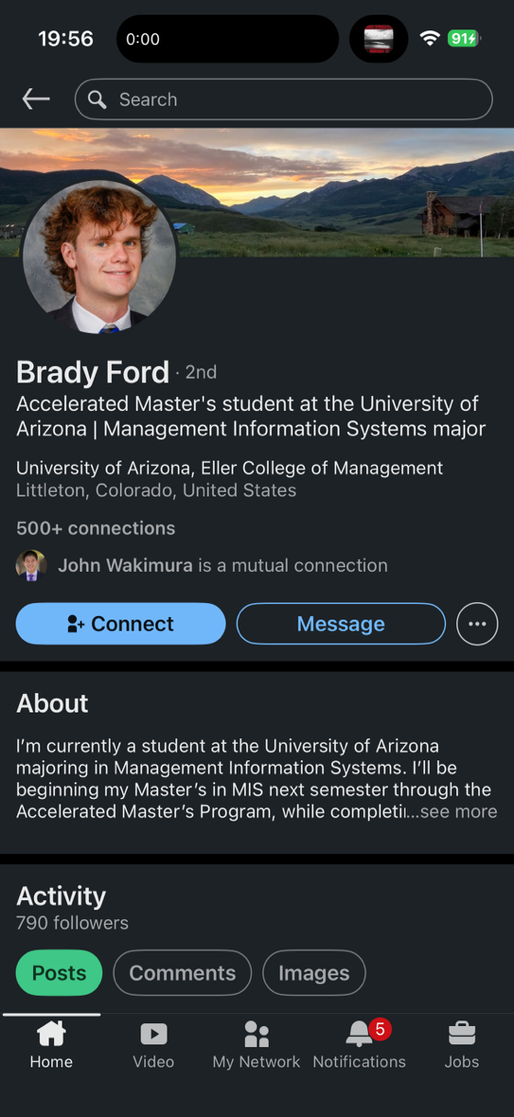
Since I know him I can have high confidence in the search result.

