2024-2025 ICT HKDSE SBA
Elective B - Web Application Development
Homework Completion Checking Website
By Del Mundo Giuliana Sero S6B (11)

Table of Contents
Table of Contents 2
1. Introduction 3
1.1 Situation 3
1.2 Purpose 3
1.3 Analysis & Planning 3
1.3.1 Users 3
1.3.2 Development Software & Language 4
1.3.3 Sitemap & Structure 4
2. Design & Implementation 6
2.1 UI 6
2.2 Database Structure 7
2.2.1 Present Database Structure 7
2.2.2 Other Considerations 9
2.3 Functions 10
2.3.1 Login 10
2.3.2 Uploading Assignments (Teacher) 12
2.3.3 Uploading Assignments (Class Monitor) 14
2.3.4 Submitting Completed Homework 16
2.3.5 Viewing Completion Status 21

Introduction

Situation
The Student Affairs Committee in a secondary school has developed a homework completion checklist website. Teachers or class monitors can input homework for the day through the homework input interface, and students can record completed homework through the completion interface. The teacher can check the completion status of the students’ homework using the checking interface.

Purpose
The purpose of this website is to provide a homework checklist website for teachers and students. Teachers will be able to upload homework, and check its respective completion status, while students are able to verify their completion of homework.

Analysis & Planning

Users
This website will be used mainly by 3 types of users: teachers, regular students, and class monitors. After signing in to their account, users will be designated to their respective permissions.
For teachers, their main features will be able to upload assignments, including the due date, subject, assignment name, and instructions. They will also be able to check submissions by students according to their student ID.
For regular students, they will be able to see homework that were assigned to them. Additionally, they will be able to see their homework’s completion status, and submit homework accordingly to update its status.
For class monitors, their user accounts are similar to that of regular students except that they will also be able to upload assignments to their respective monitor subject.

Development Software & Language
- Visual Studio Code was used for programming and debugging.
- Xampp was used to provide a free local webserver and test the program.
- Photoshop 2018 was used to create miscellaneous icons, such as the school logo.
- HTML, CSS and PHP were used to develop the website.

1.3.3 Sitemap & Structure
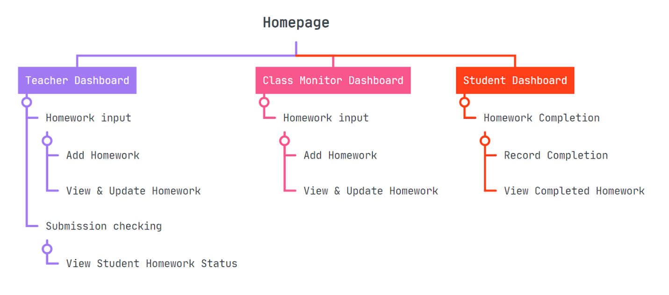
Figure 1: 1st version of sitemap
The premise of the first version of the sitemap is to categorise webpages into 3 categories: the teacher dashboard, the class monitor dashboard and the student dashboard. Later, it was updated into a teacher, class monitor, and student homepage directly for better organisation.

Design & Implementation

2.1 UI

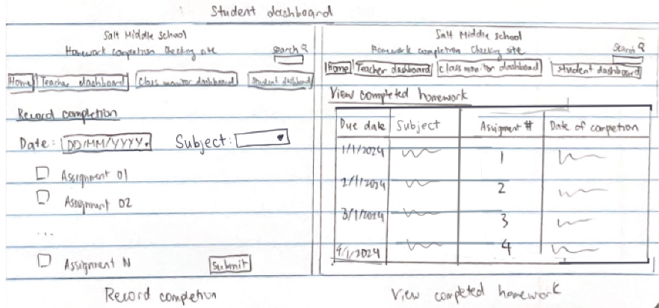
Figure 2: UI draft
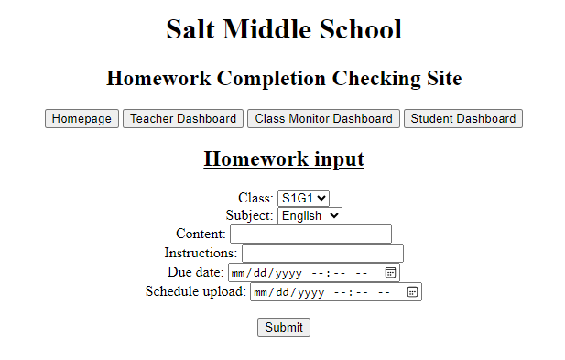
Figure 3: Basic UI

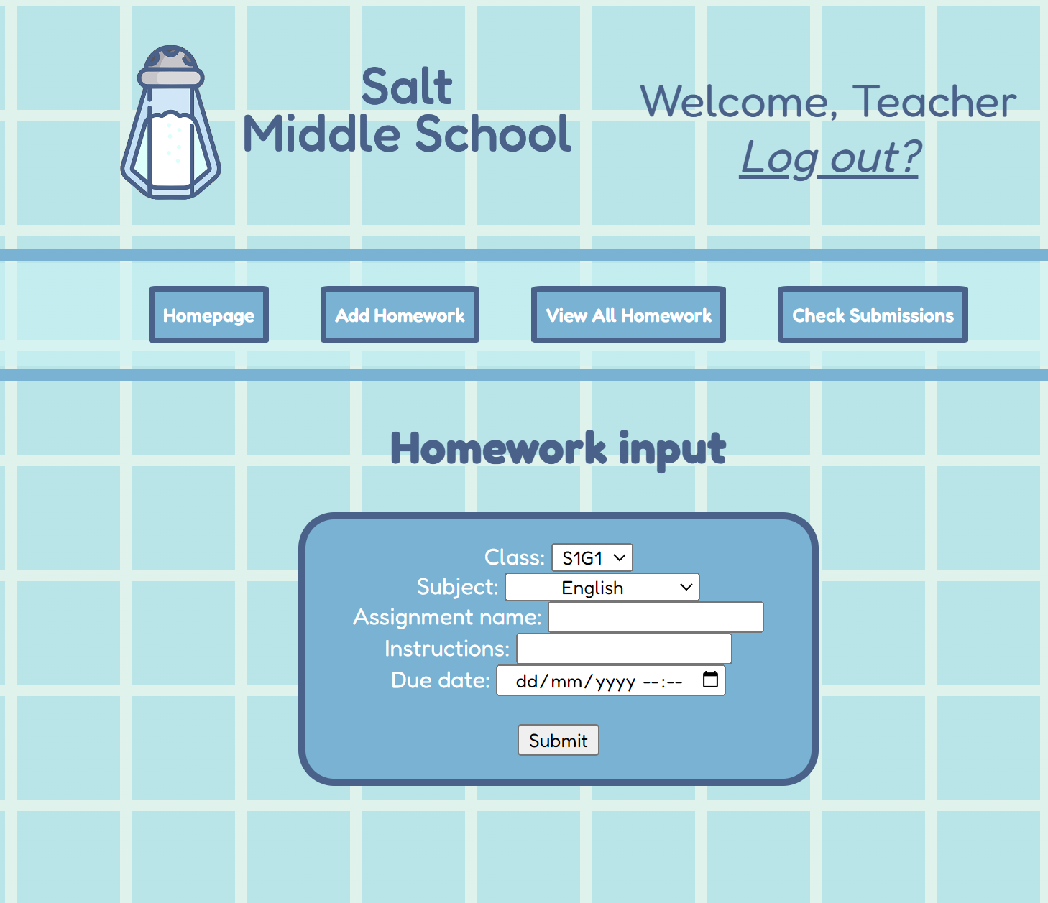
Figure 4: Final UI

In order to establish a consistent look across webpages, one CSS file, styles.css, was used for global formatting and convenience.

Design choices
For readability, a simple font named Fredoka was used throughout the website.
Additionally, for this website, I aimed for a clean look with pastel blues to avoid too much eyestrain, and to make the website easy to navigate.
In the login page, a CSS animation was used for the background, made by Temani Afif.

2.2 Database Structure

2.2.1 Present Database Structure
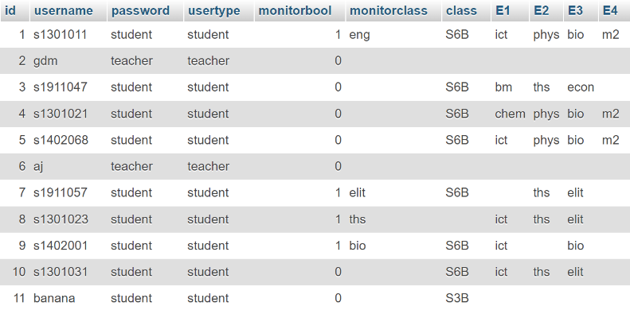
Figure 5: login table, as seen on phpMyAdmin

The login table is structured with 11 columns, which include:
- id: Serves as the primary key for the table.
- username: Contains the unique identifier for each user.
- password: Stores the encrypted password for authentication.
- usertype: Indicates the role of the user, which is either student or teacher.
- monitorbool: A Boolean value that designates whether the user serves as a class monitor (1 for yes, 0 for no).
- monitorclass: Specifies the subject associated with the class monitor.
- class: Identifies the class to which the user belongs.
- E1, E2, E3, E4: Columns designated to determine which assignments are displayed on a student's feed.

This structure allows for efficient user management and tailored content delivery based on user’s respective roles.
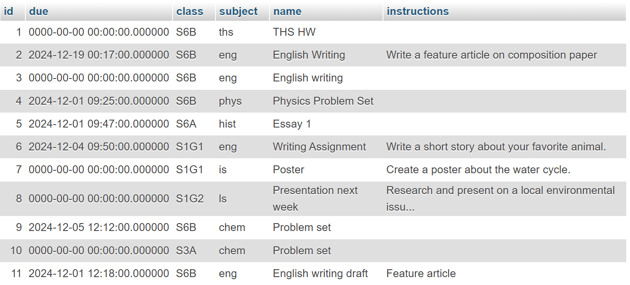
Figure 6: homework table, as seen on phpMyAdmin

The homework table consists of 6 columns, including:
- id: Serves as the primary key of the table.
- due: Indicates the due date of the homework.
- class: Specifies the class that the assignment was assigned to.
- subject: Indicates the subject that the assignment was assigned to.
- name: Holds the assignment name.
- instructions: Contains the instructions of the assignment (optional).
This table holds all information about assignments.

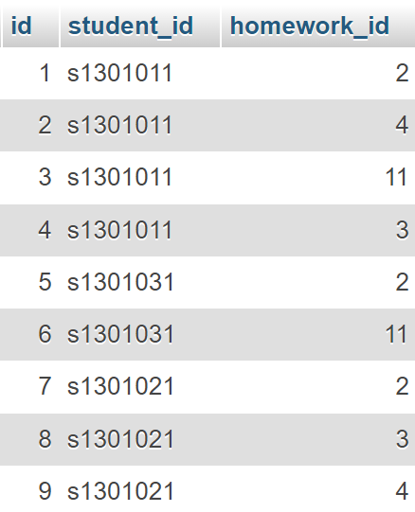
Figure 7: submission table, as seen on phpMyAdmin
For the submission table, it is only composed of 3 columns.
- id: Serves as the primary key of the table.
- student_id: Holds the student id of the homework that was completed.
- homework_id: Consists of the homework id that was completed.

2.2.2 Other Considerations
One consideration was creating a table for every new homework that is uploaded, with every student account added as a row in that homework’s class. However, it would have been too resource-intensive and difficult to keep track of all of the new tables that are created.
Another consideration was making a separate table for students who are class monitors, but it was instead added as a Boolean column in the login table for convenience.

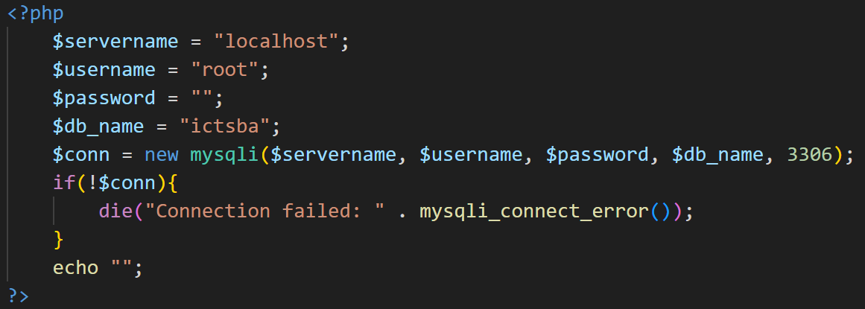
2.3 Functions
Figure 8: connection.php

2.3.1 Login
Upon submission, the POST data is directed to the login.php script. This script establishes a connection with the web server with connection.php (refer to Fig. 8) and subsequently executes a query to verify the provided user credentials against the entries in the login table of the ictsba database. If the connection fails with if(!conn), an error message is displayed and the script is terminated with die(“Connection failed: “ . mysqli_connect_error());.

The authentication process involves the following steps:
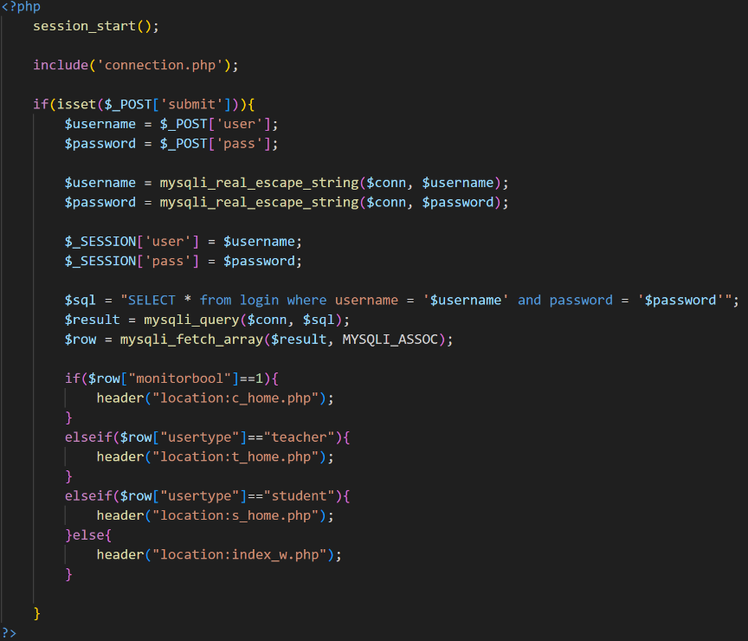
Figure 9: Credential verification & monitor status checking
Credential Verification (refer to Fig. 9): All of the accounts from the login table are fetched using a query, shown in line $sql = “SELECT * from login where username = ‘$username’ and password = ‘$password’”;. The system checks whether the provided username and password correspond to an existing account in the database by using an if condition. If not, the user is redirected to the homepage again via header(“location:index_w.php”) and requested to input a valid username and password. mysqli_real_escape_string is used to sanitise the input username and password strings.

Monitor Status Check (refer to Fig. 9): Once a valid account is identified, the system assesses the value of the monitorbool field through if($row[“monitorbool”] == 1):
If monitorbool is set to 1, the user is redirected to the designated class monitor page.
If monitorbool is set to 0, the system further distinguishes the user type (teacher or student) and redirects them to their respective pages.
Furthermore, the inputted username and password is saved as the variables $username and $password through $_SESSION[‘user’] and $_SESSION[‘pass’] to ensure that the username and password is saved.

2.3.2 Uploading Assignments (Teacher)
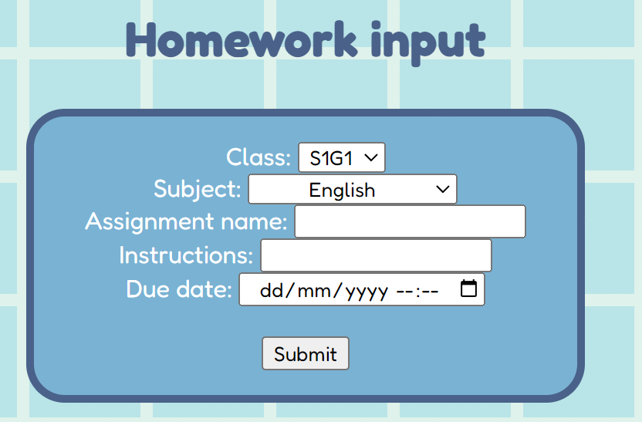
Figure 10: Homework uploading form for teachers
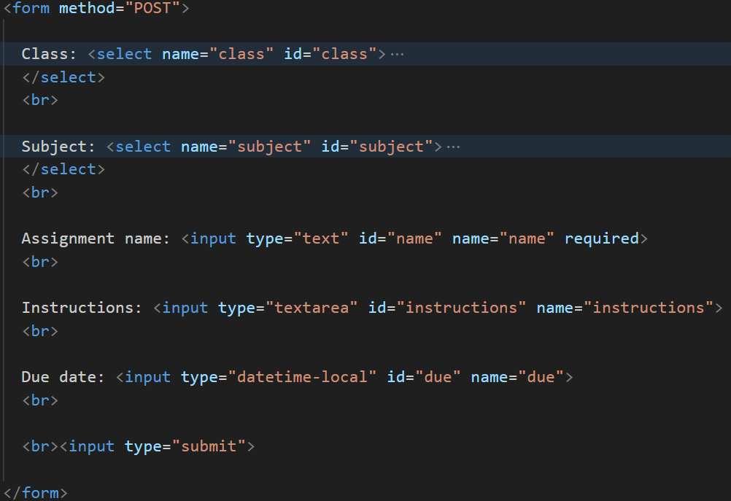
Figure 11: HTML behind adding assignment form
The homework uploading form is composed of a simple HTML form, consisting of a dropdown for class and subject, a textbox for assignment name, a text are for instructions, a date-time picker for due date, and a submit button. The submitted information is then uploaded via POST to the webserver through <form method=“POST”>.
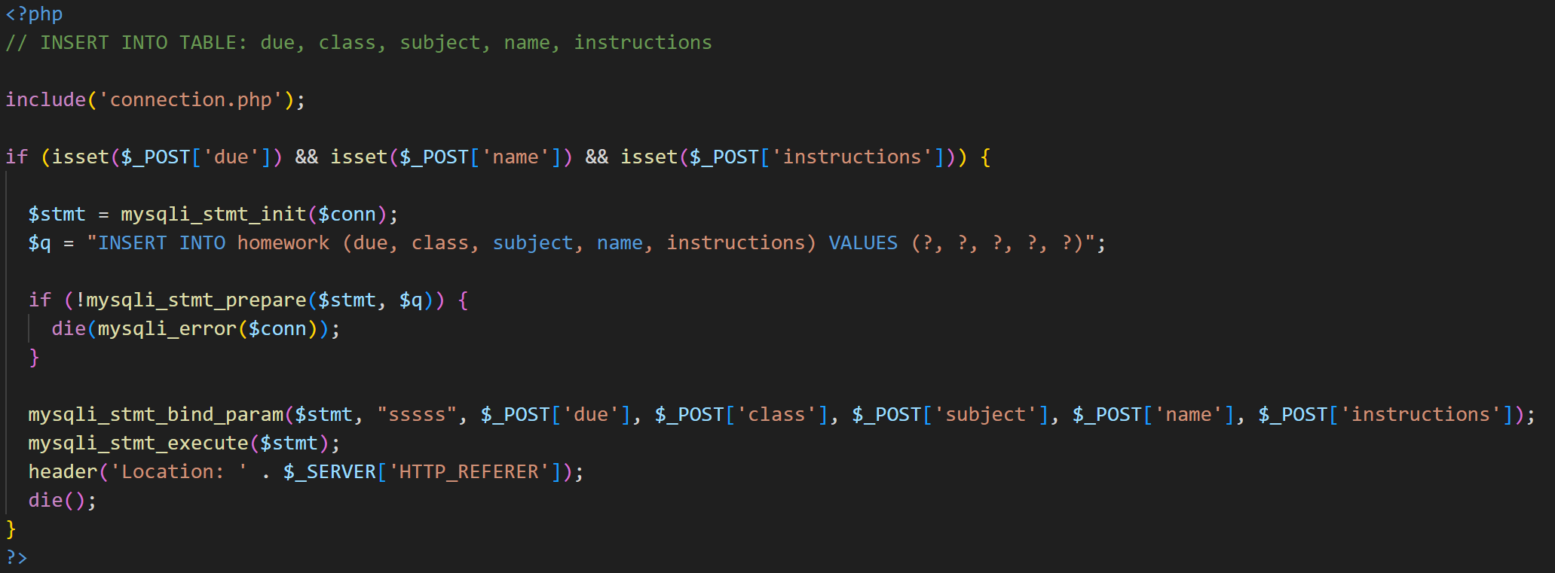
Figure 12: Code that uploads added assignments to the homework table for teachers
Once the POST request is sent, the webpage connects to the database through include(‘connection.php’). If the connection fails, as shown by if(!mysqli_stmt_prepare($stmt, $q)), it sends an error message with mysqli_error($conn)and terminates the script with the die function.
A query is then sent to the database to insert values into the due, class, subject, name, and instructions column using the line $q = “INSERT INTO homework (due, class, subject, name, instructions) VALUES (?, ?, ?, ?, ?)”;.
Afterwards, the POST values are bound to the parameter markers of the statement with mysqli_stmt_bind_param($stmt, "sssss", $_POST['due'], $_POST['class'], $_POST['subject'], $_POST['name'], $_POST['instructions']);. In other words, it inserts the variables into VALUES (?, ?, ?, ?, ?) located in the query in the same order.

Furthermore, header('Location: ' . $_SERVER['HTTP_REFERER']); was added to prevent the query from running again and inserting the values onto the table every time the webpage is reloaded.

2.3.3 Uploading Assignments (Class Monitor)
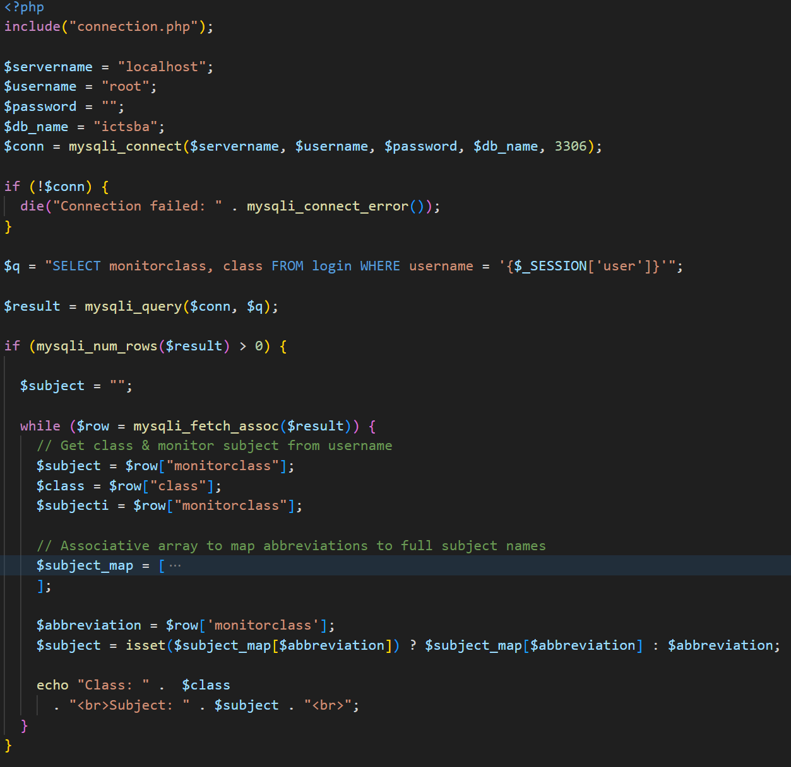
Figure 13: Automatic assignment of class monitor class and subject when adding assignments
For a class monitor, the subject that they are a subject monitor in and their class should be automatically assigned to the class monitor user. This is done by fetching monitorclass and class from the login table and filtering it by the row where the account username matches with the inputted username. This line is presented through $q = “SELECT monitorclass, class FROM login WHERE username = ‘{$_SESSION[‘user’]}’”;. Afterwards, the query is run through $result = mysqli_query($conn, $q);. If the query runs successfully and outputs at least one row, it fetches the respective class and monitor subject as $subject and $subjecti, like how it is displayed below (Figure 14).
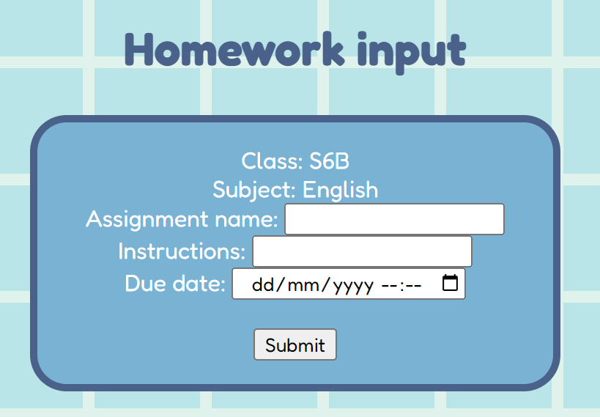
Figure 14: Homework uploading form for class monitors
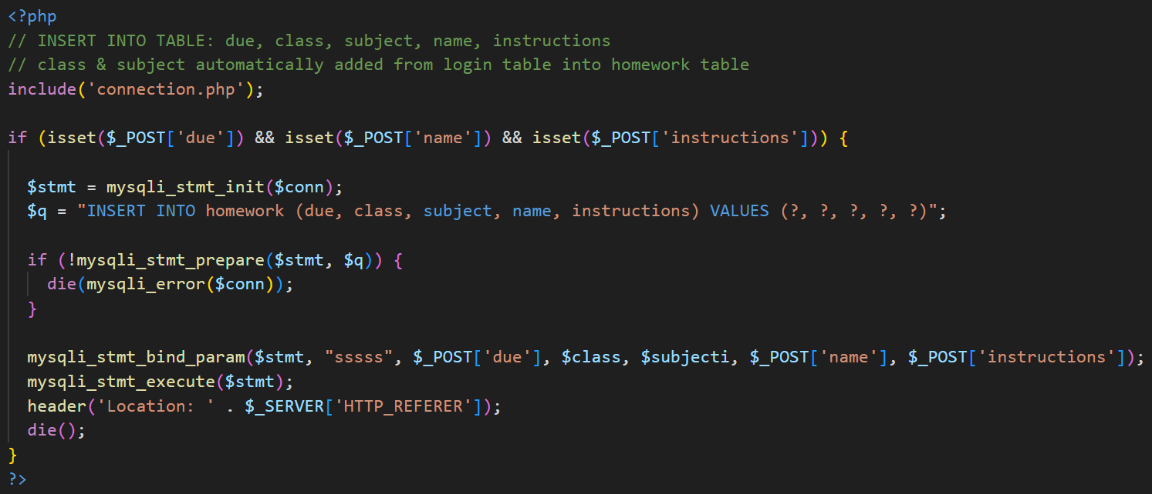
Figure 15: Code that uploads added assignments to the homework table for class monitors
As for adding assignments for class monitors, the general code (refer to Fig. 15) is similar to that of adding assignments for teachers (refer to Fig. 12). However, the only difference is with mysqli_stmt_bind_param, where the respective values for class and subject are automatically set by the class monitor’s subject and class, with $class and $subjecti.

2.3.4 Submitting Completed Homework
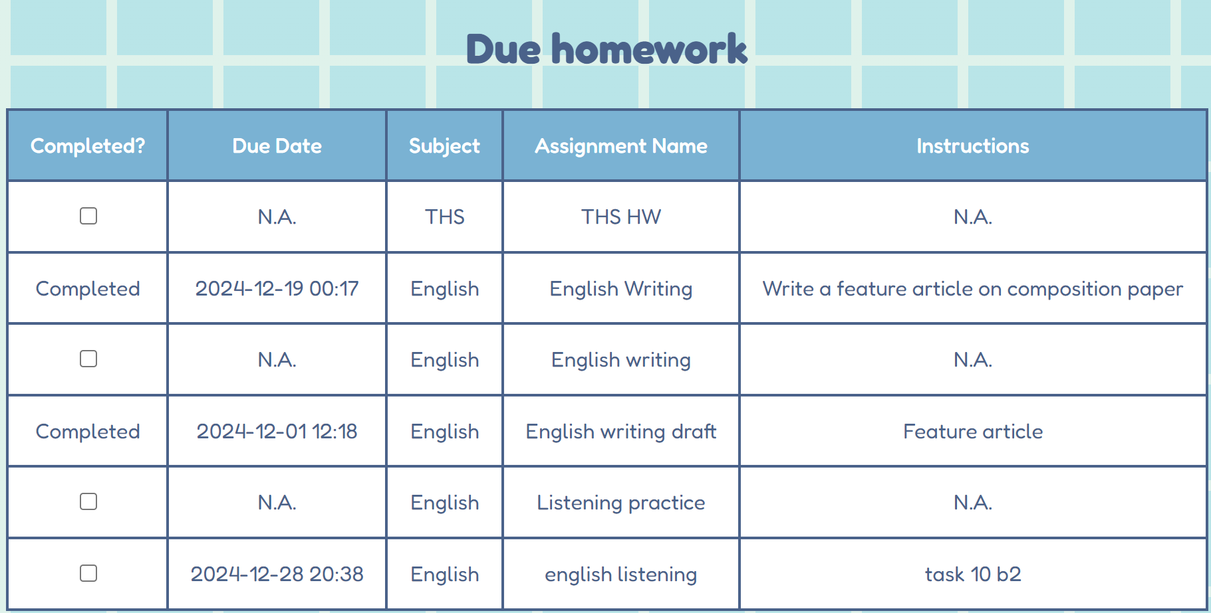
Figure 13: Table that displays due homework
Displaying due homework
First, a connection with the database is established through include(“connection.php”);.
Next, a few things must be set up. First, an associative array named $subject_map is set, with abbreviations for subjects and their respective full names. For instance, $subject_map[0] contains the string ‘English’ with the index ‘eng’.
Moreover, 2 queries will be run at once. In $homework_query, homework information from the homework table and a user’s electives are fetched from the login table filtered by the account’s username. This will retrieve all homework and its information based on a user’s class. As for $submission_query, this fetches homework_id from the submission table filtered by the user’s username.
Afterwards, an array named $submitted_hwids is created. When the $submission_query is run, all of the submitted homework ids based on the user is added to the array. This compiles all submitted homework ids of a user.
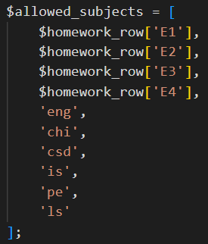
Figure 14: $allowed_subjects array
Subsequently, another array called $allowed_subjects is set. The values in the array are electives that are taken from $homework_row, as well as the abbreviations for core subjects. That way, this array can be used to filter by electives that the user actually has, as well as core subjects. This is done by using if(in_array($homework_row[‘subject’], $allowed_subjects)).
Once all of the checks and filtering are done, the next step is formatting.
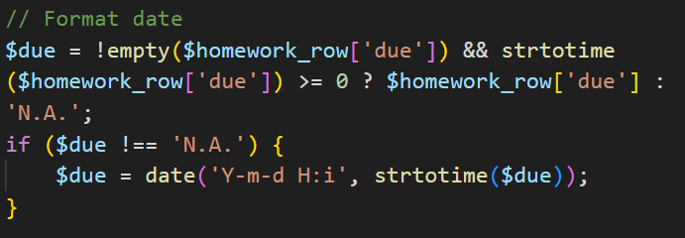
Figure 15: Setting date format
First, the format for date is set. The date is set in the format YYYY-MM-DD HH-ii by using date(‘Y-m-d H:I’, strtotime($due));. If the due date is empty, the table displays the due date as ‘N.A.’. Both conditions are done using the code above (refer to Fig. 14).
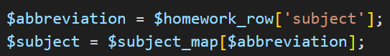
Figure 16: Abbreviations with subject map
Using the $subject_map array set earlier, the full name of the subject is retrieved from its abbreviation.
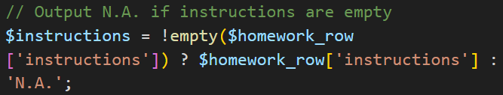
Figure 17: Formatting for instructions
If the instructions row is empty, the table will output ‘N.A’.
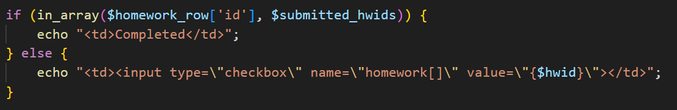
Figure 18: Formatting for checkboxes
Most importantly, as mentioned earlier, if the homework id is found in the $submitted_hwids array, the table will display the homework as completed. Otherwise, the table will show a checkbox with the value of its homework id.
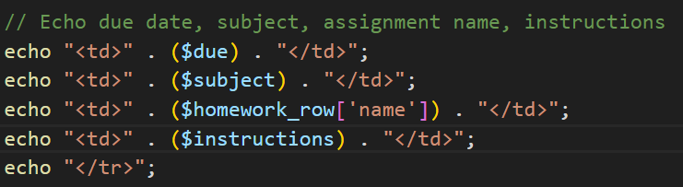
Figure 19: Displaying table rows
Finally, all of the variables are outputted as a row for each homework.

Submitting completed homework
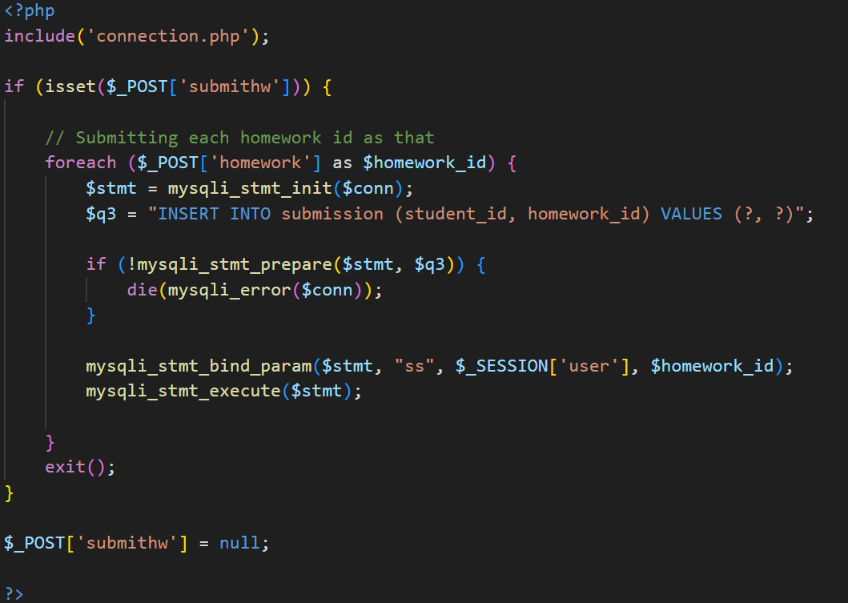
Figure 20: Code that inserts finished homework into submission table
When a class monitor or student toggles the checkbox and submits the homework submission form, for each homework that is completed, a query is run. This query is $q3 = “INSERT INTO submission (student_id, homework_id VALUES (?, ?)”; which inserts the user’s student id and homework id into the submission table. Afterwards, mysqli_stmt_bind_param($stmt, “ss”, $_SESSION[‘user’], $homework_id); is run to bind the variables needed, the homework id and student id, into the query. If there are multiple checkboxes ticked, multiple queries will run for each homework.

2.3.5 Viewing Completion Status

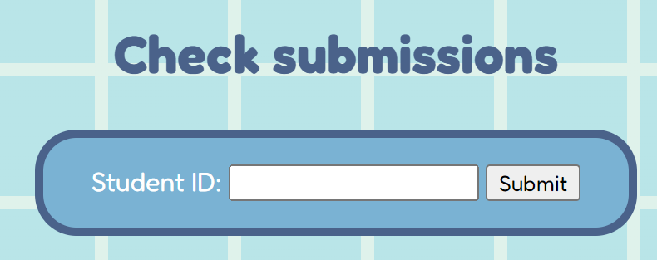
Figure 21: Searching submissions by Student ID
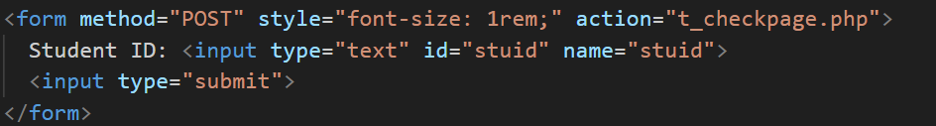
Figure 22: HTML form for searching students by Student ID
When a teacher wants to check a student’s submissions, they can first enter the student’s student id into the textbox. Once submitting the form through POST, the POST data is sent to t_checkpage.php.
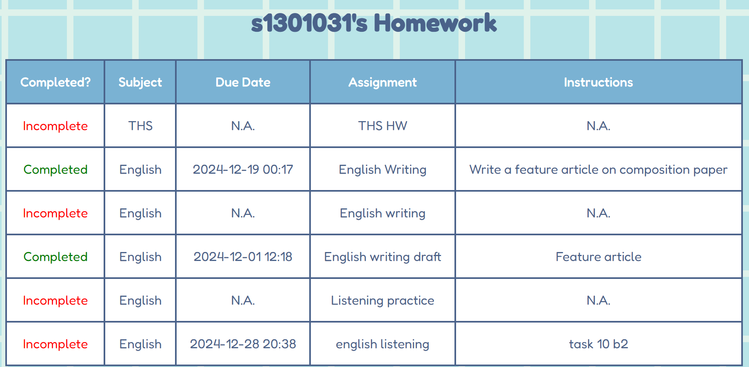
Figure 23: Table displaying incomplete and completed homework for teachers
In t_checkpage.php, the student’s assignments and their completion status is displayed on the webpage.
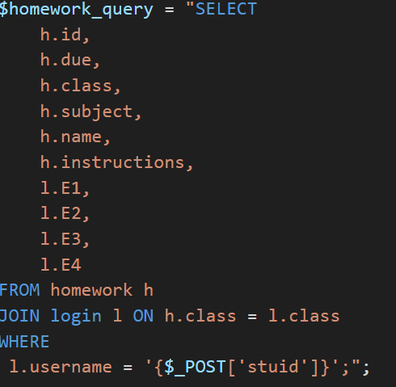
Figure 24: $homework_query
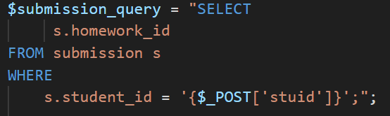
Figure 25: $submission_query

In order to display the table, 2 queries are run. In $homework_query, this fetches the student’s homework and elective information based on their student id from the homework table and the login table. In $submission_query, this fetches the homework id of the student’s completed homework from the submission table.
The process of displaying a student’s homework is similar to that of a student or class monitor viewing their due assignments. The only difference in particular is that the status ‘Completed’ or ‘Incomplete’ is displayed correspondingly, instead of a checkbox.
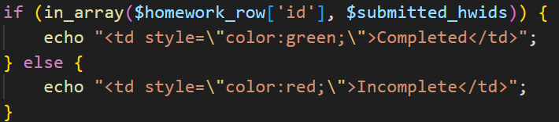
Figure 26: Code for checking submissions
If the homework id is found in the $submitted_hwids array, using an if-statement, the table outputs a ‘Completed’ status under the ‘Completed?’ column. Otherwise, the status will be labelled ‘Incomplete’. Therefore, teachers will be able to see which assignments were submitted by a particular student.

