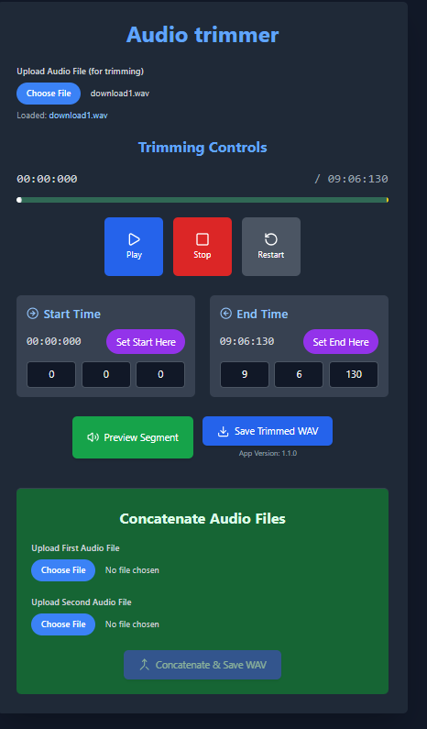

MP3Trim — Quick User Guide
MP3Trim lets you trim a selected part of an audio file or join two audio files into one WAV file.

Trim Fragment
- Tap Select next to Source to choose an MP3, WAV, M4A, or AAC file.
- Use the range slider, time values, or Start / Set and End / Set buttons to choose the part you want to keep.
- Use Play, Stop, Restart, and Preview to listen to the selected part.
- Enter an output filename if needed.
- Tap Save WAV.
The app exports the selected fragment as a WAV file and opens the Android save dialog. Choose a folder, edit the filename if desired, and save. After success, the app shows:
Saved to <folder name>

Concatenate Files
- Tap Select next to File 1 and choose the first audio file.
- Tap Select next to File 2 and choose the second audio file.
- Tap Concatenate & Save WAV.
The app combines File 1 followed by File 2 into one WAV file. The Android save dialog lets you choose the destination folder and change the filename. After success, the app shows:
Saved to <folder name>

Notes
- If a filename does not include .wav, the app adds it when possible.
- If you cancel the save dialog, the app shows Save canceled.
- If both files are not selected for concatenation, the app shows Choose both files.
- During export or concatenation, the button shows progress.
Вывел краткое руководство на экран.
Worked for 58s

