NFL Players Analytics: Local Database Prototype
Ishaan Parikh | John Zhao | Victor Prosekov
Point of contact: iparikh4@vt.edu | techzjc@vt.edu | Vprosekov@vt.edu
CS 5614, Dr. Nizamani
Fall 2026

Table of Contents

The table of contents is a Word field. Update it in Word if page numbers are not populated.

1. Introduction

NFL Players Analytics is a local, database-backed prototype for exploring fictional football teams, athletes, games, statistics, and standings. It demonstrates a normalized relational schema, integrity rules, a FastAPI service, and browser-based CRUD; authentication and production imports are out of scope.
The sample contains one fictional football league and synthetic records. The schema is relational and can represent multiple sports, while the current user interface focuses on football.
Target scenarios:
S1. Search teams, athletes, and games by name and filters; inspect related rosters, results, statistics, and standings.
S2. Add a team to an existing league using a database-backed league selector.
S3. Edit a team using its current values, preserving valid league relationships.
S4. Delete an individual performance statistic with a confirmation step while retaining its game and subject records.

2. Technology Stack

DBMS and version: SQLite 3.53.1 (local file database).
Programming languages: Python 3.12.15 and TypeScript/TSX.
Frontend: React 18, Ant Design 5, React Router, and Vite 7.3.7.
Backend and database library: FastAPI 0.143.1, Pydantic 2.14.1, SQLAlchemy 2.1.4, and Python sqlite3.
Other tools: uv 0.13.1, Node.js 24.21.0, npm 11.19.0, Swagger UI, VS Code, and GitHub.
Repository: https://github.com/g497813927/NFLPlayersAnalytics

3. Final ER Diagram and Changes from Phase 3

Figure 1. Final ER diagram generated from the implemented SQLite schema and its foreign-key metadata.
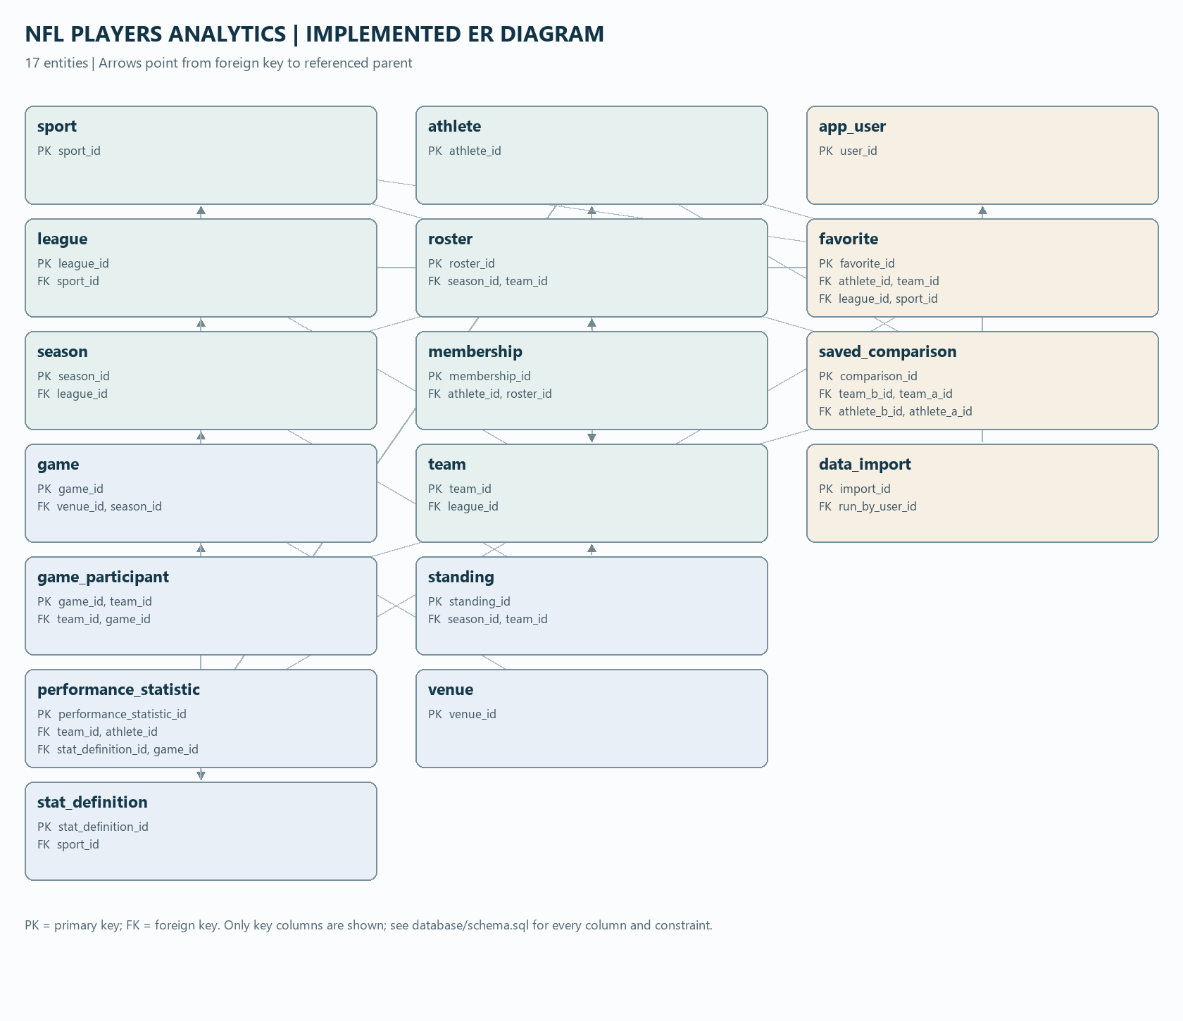

Changes from Phase 3: No changes. The implemented entity relationships follow the Phase 3 design.

Phase 3 design | Implementation result
ER entities and relationships | No changes from Phase 3, per the project team.

4. Database Initialization
4.1 Initialization Scripts

Order | File/command | What it does
1 | backend/scripts/init_db.py; optionally database/schema.sql | Create the empty schema using --method orm or --method sql. The SQL file is the alternate SQLite path.
2 | backend/scripts/seed.py | Populate an empty initialized schema with deterministic fictional records.

Verified rebuild output: Created 17 tables using ORM; loaded deterministic fictional data with seed 5614. The initialization and seed commands completed successfully on the newly created empty database. A terminal screenshot still needs to be added for submission.

SQLite schema excerpt from database/schema.sql (roster references team and season, restricts parent deletion, and enforces one roster per team and season):

CREATE TABLE roster (
roster_id INTEGER NOT NULL,
team_id INTEGER NOT NULL,
season_id INTEGER NOT NULL,
CONSTRAINT pk_roster PRIMARY KEY (roster_id),
CONSTRAINT fk_roster_season_id_season FOREIGN KEY(season_id)
REFERENCES season (season_id) ON DELETE RESTRICT,
CONSTRAINT fk_roster_team_id_team FOREIGN KEY(team_id)
REFERENCES team (team_id) ON DELETE RESTRICT,

4.2 Data Population

SELECT 'team' AS table_name, COUNT(*) AS row_count FROM team
UNION ALL SELECT 'athlete', COUNT(*) FROM athlete
UNION ALL SELECT 'game', COUNT(*) FROM game
UNION ALL SELECT 'roster', COUNT(*) FROM roster
UNION ALL SELECT 'membership', COUNT(*) FROM membership
UNION ALL SELECT 'game_participant', COUNT(*) FROM game_participant
UNION ALL SELECT 'performance_statistic', COUNT(*) FROM performance_statistic
UNION ALL SELECT 'standing', COUNT(*) FROM standing
UNION ALL SELECT 'favorite', COUNT(*) FROM favorite
UNION ALL SELECT 'saved_comparison', COUNT(*) FROM saved_comparison
UNION ALL SELECT 'app_user', COUNT(*) FROM app_user
UNION ALL SELECT 'sport', COUNT(*) FROM sport
UNION ALL SELECT 'league', COUNT(*) FROM league
UNION ALL SELECT 'venue', COUNT(*) FROM venue
UNION ALL SELECT 'season', COUNT(*) FROM season
UNION ALL SELECT 'stat_definition', COUNT(*) FROM stat_definition
UNION ALL SELECT 'data_import', COUNT(*) FROM data_import;

Verified SQLite result (2026-10-15):
team 20 | athlete 100 | game 100 | roster 100 | membership 500
game_participant 200 | performance_statistic 1,260 | standing 100
favorite 20 | saved_comparison 20 | app_user 5 | sport 1 | league 1
venue 10 | season 5 | stat_definition 6 | data_import 5
All core/major tables have at least 20 rows. Sport and league are intentionally singletons for this football-only sample. Row-count screenshots and per-table screenshots still need to be captured in a SQLite DBMS/viewer.

Data generation: backend/scripts/seed.py uses Python random.Random(5614) to create reproducible fictional cities, teams, athletes, schedules, scores, memberships, statistics, and derived standings for seasons 2022-2026. The seed is synthetic, includes no real people or public data, and refuses to populate non-empty tables.

Major-table evidence to capture in a SQLite viewer: table name, PRAGMA table_info columns, and first rows for team, athlete, game, roster, membership, game_participant, performance_statistic, and standing. The verified counts are included above; screenshots are not embedded yet.

5. Integrity in Action

Test | SQL attempted | DBMS result / screenshot | Business rule protected
(a) Foreign key | INSERT INTO membership (roster_id, athlete_id, position, start_date) VALUES (999999, 1, 'QB', '2022-08-01'); | Rejected on a disposable database copy: FOREIGN KEY constraint failed. DBMS screenshot still needed. | Every membership must reference an existing roster and athlete.
(b) CHECK | UPDATE season SET end_date='2022-01-01' WHERE season_id=1; | Rejected on a disposable copy: CHECK constraint failed: ck_season_date_order. DBMS screenshot still needed. | A season end date cannot precede its start date.
(c) UNIQUE | INSERT INTO sport (sport_name) VALUES ('American Football'); | Rejected on a disposable copy: UNIQUE constraint failed: sport.sport_name. DBMS screenshot still needed. | Sport names must be unique.
(d) Referential action | DELETE FROM roster WHERE roster_id=1; | On disposable copy: 5 membership child rows before; 0 after ON DELETE CASCADE. DBMS screenshot still needed. | Memberships have no meaning after their roster is deleted; the test left the normal demo database untouched.

Referential action justification: deleting roster 1 cascaded to its five membership rows in the disposable copy. The athlete and team records remain; a membership has no meaning without the roster that connects an athlete to a team-season.

(e) Application rejection: the management form attempted to add an existing team name. The API returned HTTP 409 and the form displayed the readable error shown below; no record was written.

Figure 2. Duplicate team submission rejected in the Data Management form: ?A team with this name already exists in the selected league.?
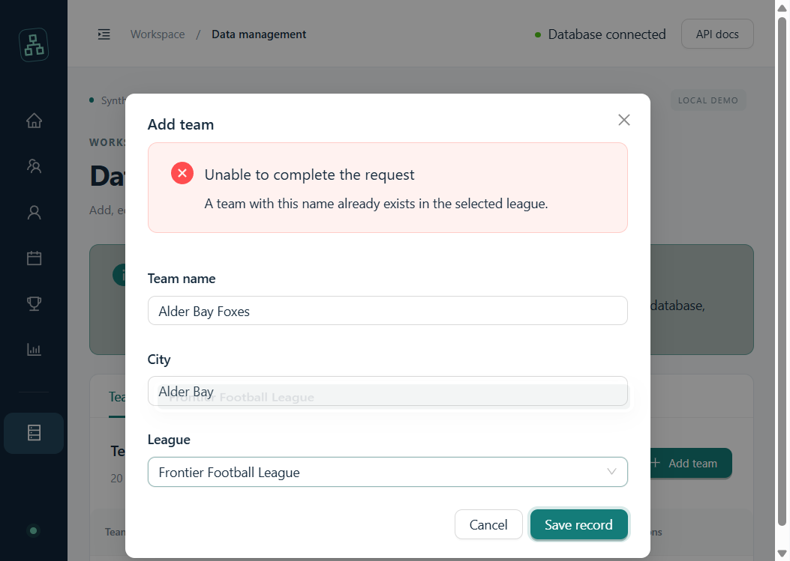

6. User Interface and Database Connection
6.1 User Interface Overview

Figure 3. Application overview with navigation and database-backed dashboard.
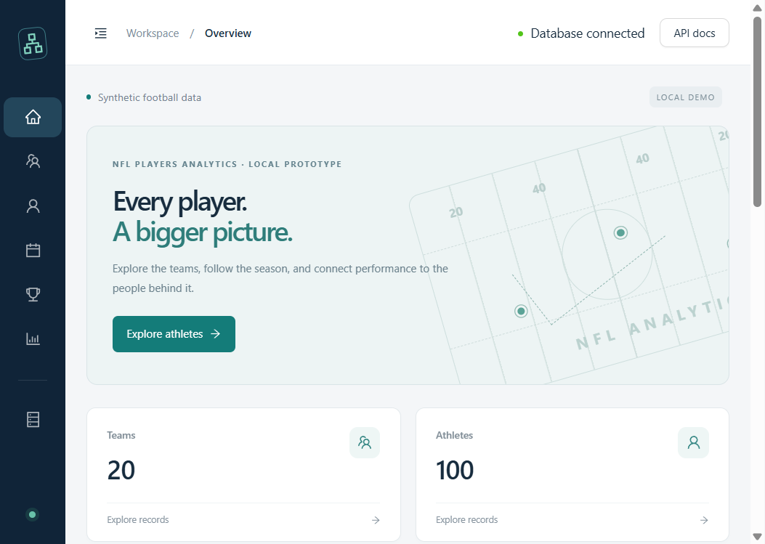
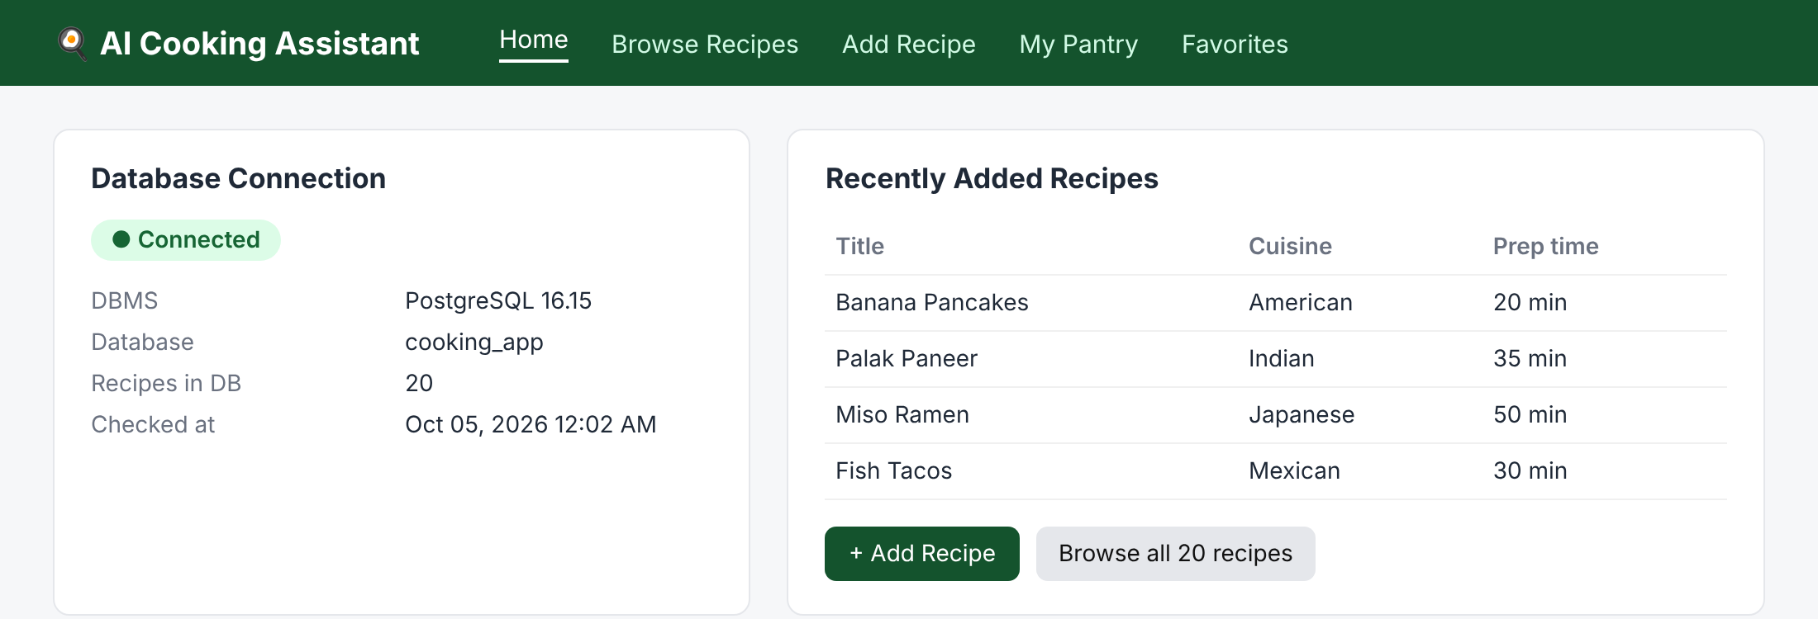

Screen | What the user can do | Scenario
Overview | See database connection status, record counts, recent games, and app navigation. | S1
Teams | Search by team/city, filter by league, and inspect seasonal roster history. | S1
Athletes | Search athlete records and inspect membership/statistic history. | S1
Games | Browse schedules/results and filter by team, season, status, and date. | S1
Standings | Review derived season records and ranks. | S1
Statistics | Browse performance statistics and their athlete/team subjects. | S1
Data Management | Create, edit, or delete teams, athletes, rosters, memberships, games, and statistics. | S2-S4

Connection confirmation: the live home page and management page displayed ?Database connected?; GET /api/overview returned HTTP 200 with the seeded counts. Figure 3 above shows the home-page connection indicator.

The connection indicator is visible in the embedded Overview screenshot (Figure 3).
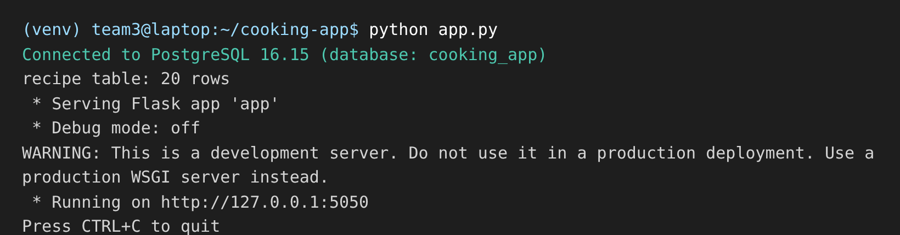

7. Application Operations

7.1 Read / Search
Scenario: S1. Search teams by a team-name or city keyword and inspect the returned database-backed records.
Form in use: Teams search filtered to ?Cedar?; the result is Cedar Reach Bears.
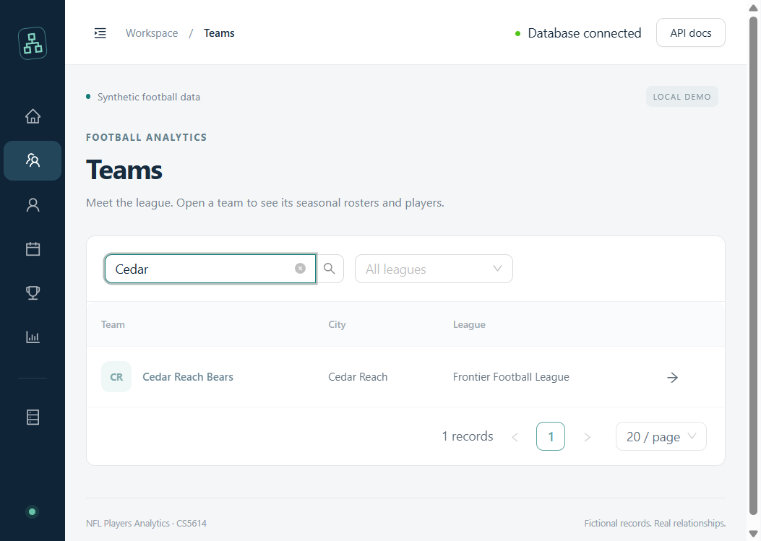
SQL executed by the app (SQLAlchemy uses bound values):
SELECT t.team_id, t.team_name, t.city, l.league_name
FROM team AS t JOIN league AS l ON l.league_id = t.league_id
WHERE lower(t.team_name) LIKE lower(:pattern)
OR lower(t.city) LIKE lower(:pattern)
ORDER BY t.team_name, t.team_id
LIMIT :page_size OFFSET :offset;

Database evidence (disposable copy): binding pattern ?%Cedar%? returned team_id 3, Cedar Reach Bears, Cedar Reach, Frontier Football League. Capture this query/result in the DBMS for the final evidence package.

7.2 Insert
Scenario: S2. Add a fictional team to the existing Frontier Football League using the database-backed League selector.
Form in use: completed Add team form with Harbor City Owls, Harbor City, and Frontier Football League selected; the form was not submitted to preserve the seeded database.
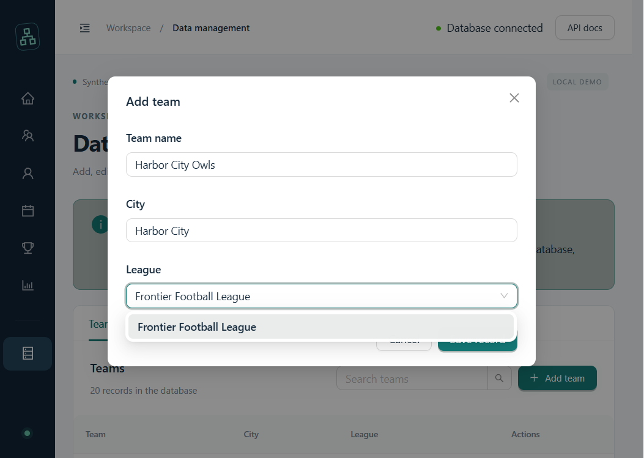
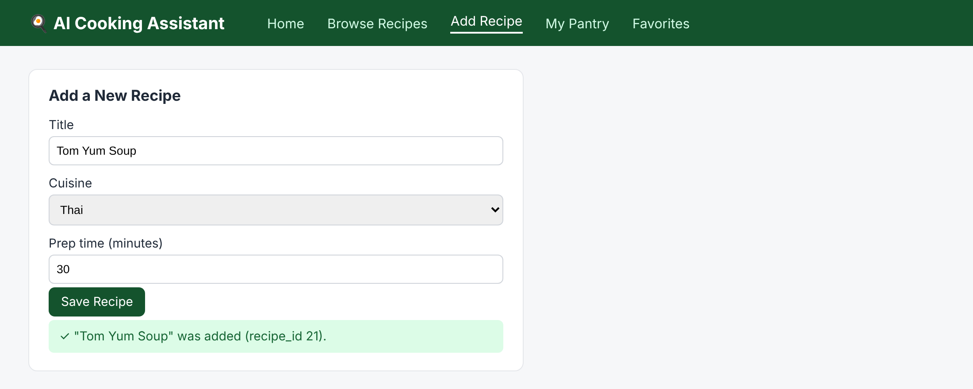
SQL executed by the app (bound parameters; ID is generated by SQLite):
INSERT INTO team (team_name, city, league_id) VALUES (?, ?, ?);

Database evidence (disposable copy): inserting Harbor City Owls / Harbor City / league 1 returned row (team_id 21, team_name Harbor City Owls, city Harbor City, league_id 1). Capture the INSERT and SELECT result in the DBMS for submission.

7.3 Update
Scenario: S3. Edit a team name and city while keeping its league relationship valid.
Form in use: edit form pre-filled from the selected current team record; no changes were saved.
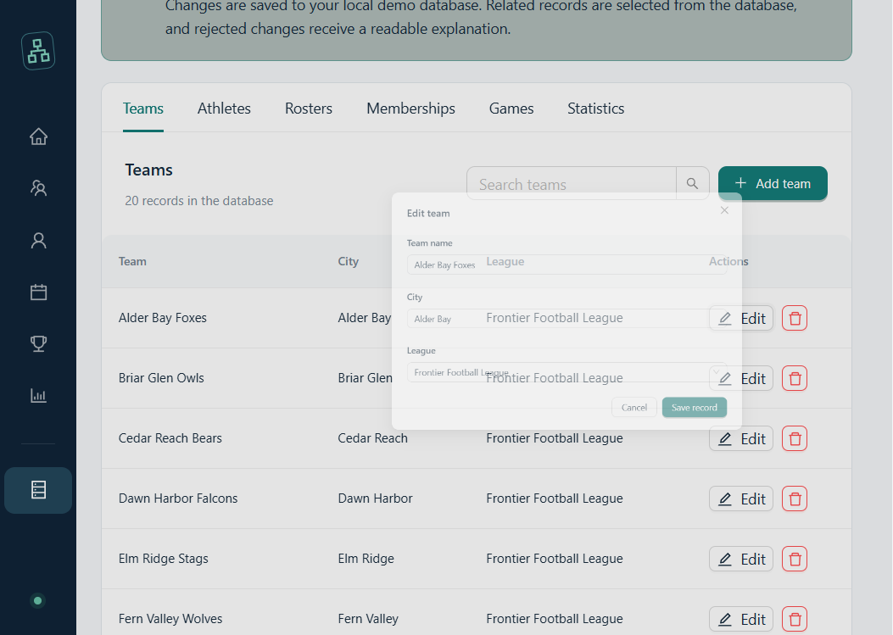
SQL executed by the app (full replacement of editable values):
UPDATE team SET team_name=?, city=?, league_id=? WHERE team_id=?;

Database evidence (disposable copy): before: (21, Harbor City Owls, Harbor City); after updating: (21, Harbor City Hawks, Harbor Heights). Capture both SELECT results in the DBMS for submission.

7.4 Delete
Scenario: S4. Delete one performance statistic while retaining the game, definition, and athlete/team subject.
Form in use: performance-statistic deletion confirmation; it was cancelled without deleting the seeded record.
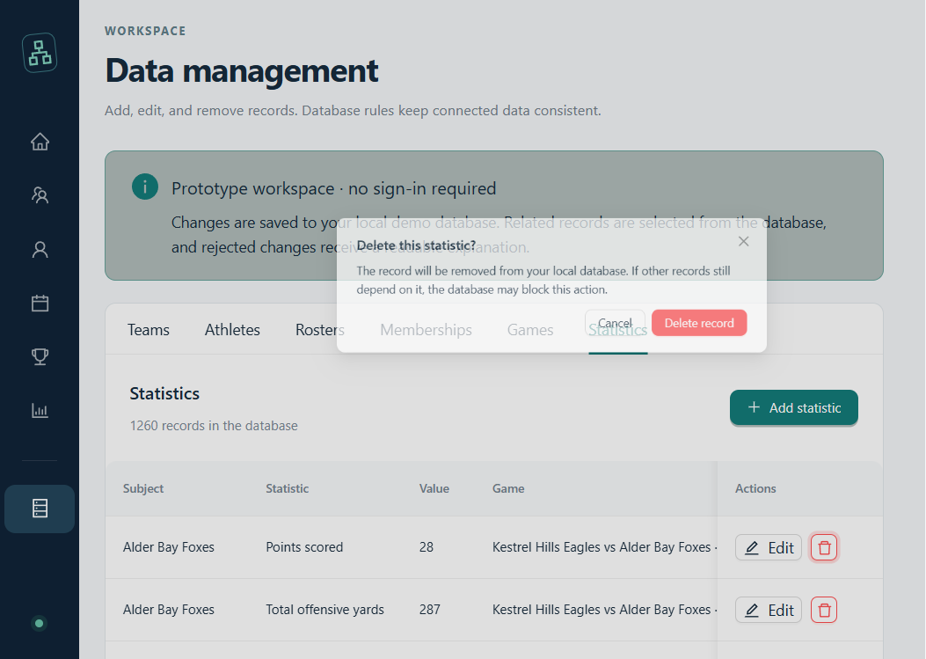
SQL executed by the app after confirmation:
DELETE FROM performance_statistic WHERE performance_statistic_id=?;

Database evidence (disposable copy): statistic_id 1 existed before deletion as (1, game 1, definition 1, value 14.0); SELECT returned no row after deletion. Capture the before/after query results in the DBMS for submission.

8. Team Roles and Generative AI Use

Team Member 1: Ishaan Parikh - database design, schema, and seed-data responsibilities.
Team Member 2: John Zhao - frontend implementation (React, TypeScript, and Ant Design).
Team Member 3: Victor Prosekov - backend implementation (FastAPI, SQLAlchemy, and API).

Generative AI tools used and purpose: ChatGPT was used for project planning and coding assistance (shared project conversation: https://chatgpt.com/s/cx_6ad139b1aa0c8191b9a91170c7e56a29). GitHub Copilot was used for local setup assistance and this report draft. All generated code and content require team review.
Example checked: the AI-assisted deterministic seed implementation was run against a fresh SQLite database. The team verified its row counts and relationship constraints, including 20 teams, 100 athletes, 500 memberships, 100 games, and 1,260 performance statistics. Invalid foreign-key, CHECK, and UNIQUE writes were also tested against a disposable copy and rejected. No real-person data is used.

Submission Evidence Checklist
Embedded in this draft: home/connection, filtered team search, team insert form, prefilled team update form, statistic delete confirmation, and the readable duplicate-team rejection.
Still required by the template: screenshots of the empty-database rebuild; row-count query; each major table with its columns and first rows; DBMS responses for integrity tests (a)-(d); and direct DBMS query evidence for each CRUD operation, including before/after for update and delete.
All successful CRUD and destructive integrity checks reported above were run against a temporary copy of the seeded SQLite database. The working demo database was not changed by those checks.

