23cm LDMOS Driver board – Assembly notes
This kit contains the components required to build a G4BAO 23cms driver amplifier as described in the January 2013 issue of Scatterpoint, and includes any updates since publication. Note that in the original article, the two of the component values on the circuit and component list are incorrect. C9 is shown as 12pF should be 6p8, C11 shown as 6p8 should be 4p7.
You may find that you get slightly more output power if you do not fit C12

This document is correct for the issue 1.0 PCB.

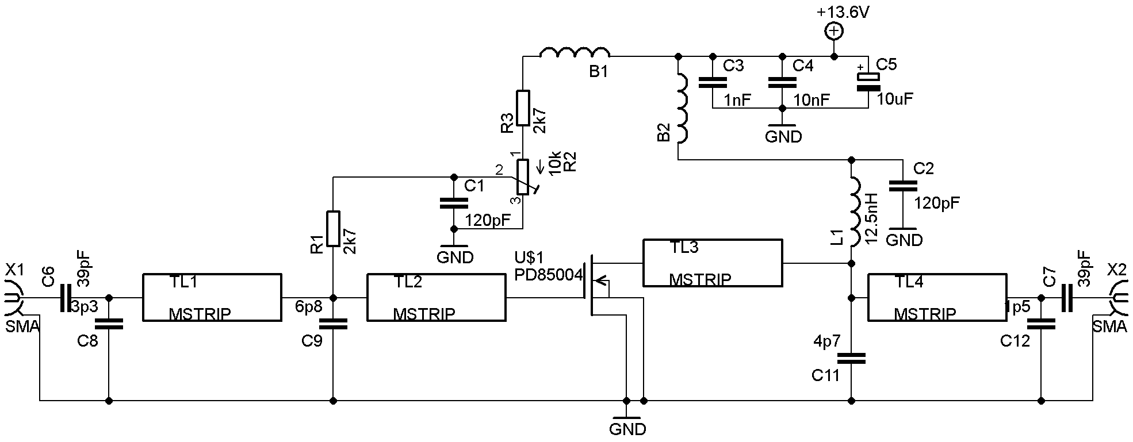
Figure 1 Circuit diagram

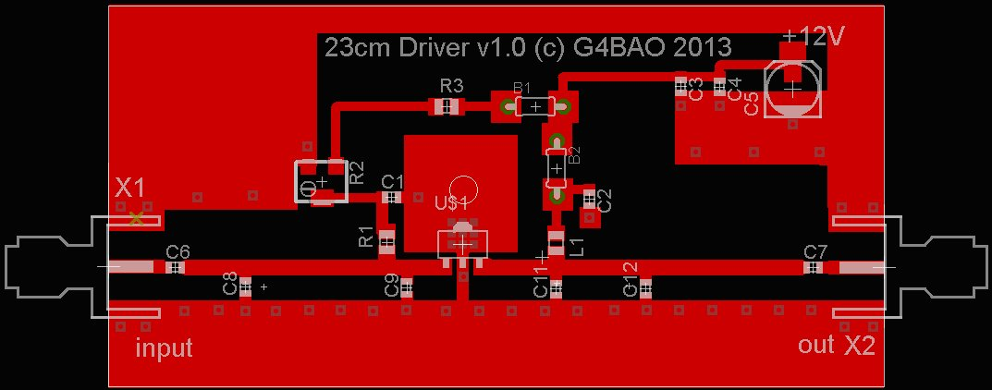
Figure 2 PCB layout

Antistatic precautions
Note that the LDMOS power FET device fitted to the PCB is still susceptible to static damage until the board has been assembled. Do not remove from the packaging without wearing an antistatic wrist strap or at minimum before having first touched something grounded.

Component list
Component | Value | Type | Colour code/packaging
R1, R3 | 2k7 | SMD 0805 | Black card
R2 | 10k | SMD preset | Trimmer in clear plastic
C1, C2 | 120pF | ceramic 0603 | Yellow card
C3 | 1nF | ceramic 0603 | White card
C4 | 10nF | Ceramic 0805 | Black plastic
C5 | 10uF 35V | SMD electrolytic | Obvious!
C6,C7 | 39pF | ceramic 0603 | Green and blue card
C8 | 3p3 | ceramic 0603 | Green card
C9 | 6p8 | ceramic 0603 | Blue card
C11 | 4p7 | ceramic 0603 | Orange card
C12 | 1p5 | ceramic 0603 (see note on p1) | Purple card
U$1 | PD85004 | LDMOS power | Black Plastic
L1 | 12.5nH | Coilcraft 0805 | Clear plastic
B1, B2 | Dual ferrite bead | Panasonic EXCELDRC35 or 25 | Obvious!

Check that all the components and the PCB are present in the kit, and email john@g4bao.com immediately if there is anything missing.

Tools
Use a small (1mm bit or smaller) temperature controlled, earthed soldering iron, and thin (28swg) solder.
A pair of small sharp side cutters
Small SMD tweezers

Assembly
This kit contains very small 0603 components that all look the same or similar. The packaging is colour coded as above. BE VERY CAREFUL not to "ping" them across your bench when removing them from the packaging, as I will not support the kits if replacement components are fitted that are not supplied by me. Never remove a component from the packaging until you are about to fit it so as not to mix them up.

To fit the board in a recommended standard Schuberth box (not supplied) small notches need to be taken out of two corners with a small file to allow the overlap of the tinplate. Do this before assembly.

- Fit the two resistors R1 and R3.
- Fit the eleven 0603 ceramic capacitors C1-C4, C6-C12. (see note on p1)
- Fit the 0805 inductor L1.
- Fit the Preset R2
- Fit C5. Observe polarity. The black end is ground This fits OVER the pads provided so solder it in with care.
- Fit the ferrite beds B1 and B2 soldered under the board.Take care as the gap from the pad to the ground plane is VERY small

DO NOT FIT THE LDMOS DEVICE U$1 YET

Initial check
RE-CHECK THAT YOU HAVE NOT FITTED THE DEVICE YET.
If you have, remove R1 and place it to one side until after the initial voltage checks, when you can replace it!

Make sure that the cut leads of the beads do not short to ground.

Check for shorts to ground on the +13.6V rail

Rotate R2 fully ANTICLOCKWISE and using a thin wire, apply a regulated +13.6 volts to +ve end of C5 and ground to the ground plane. Measure the voltage at the junction of R1 and C9 where it connects to the gate of the device. It should be 10.5 volts +/- 0.2

Rotate R2 fully CLOCKWISE Measure the voltage at the junction of R1 and C9 where it connects to the gate of the device. It should be 0V

Leave the preset at this setting and remove the 13.6 volt supply.

Fitting the LDMOS device U$1
Note carefully the position of the device in Fig 2 and place it carefully and solder the centre pin.
Check again that the device is square on the board and the Tab covers the small plated through holes.
Solder the other two leads.
Solder the tab making sure that the solder flows under and round it, and turn the board over and make sure that solder has gone down the tiny plated through holes.
To make sure, melt some solder on the underside of the board on the tab area.

Recommended Test equipment

Equipment | Example
Digital Multimeter | Any DMM that can measure up to 15 Volts and 1 Ampere
100mW Drive source with adjustable | Signal Generator or Low power
13.6V regulated power supply | Any
1.3GHz Power meter | HP 435A, HP436 plus 30 dB attenuator.  Bird Thruline or Diamond SX1000 plus 5Watt dummy load.
Drive source
Ammeter
Amplifier under test
Power meter
Attenuator
13.6V regulated PSU

Alignment
No RF alignment is required, you just need to set the DC bias on the device to give a drain current of 50mA without drive
Connect the input from your 1.3GHz 100mW source transmitter to the amplifier input. Connect the amplifier output to a power meter/ dummy load capable of dissipating at least 5 Watts. If you are using “flying coax leads” to connect rather than a box and connectors, there should be NO braid tail, not even 1mm. Use thin PTFE coax so that the inner does not melt and solder the braid directly to the convenient ground point close to the input and output pads.

DO NOT CONNECT ANY DRIVE POWER YET

Be careful with R2, it is possible to increase the bias enough to destroy the device Turning the pot ANTI clockwise INCREASES the Bias current/voltage
Connect the 13.6 volt supply via an ammeter on a low range such as 100mA. Starting with R2 set fully clockwise with minimum volts on the gate, VERY carefully increase the gate voltage (remember, ANTI clockwise) until the device begins to take drain current. This onset is very sharp, so be very careful, as the drain current can easily swing up to many Amperes if you are not. Set the drain current to 50mA +/-1mA. This may rise by some 10-20mA as the device warms up, this is normal. Switch off both supplies and then switch the ammeter to the 1 Amp range. Switch back on.
Check all your connections, take a deep breath and apply the 100mW drive. You should see around 2.5 Watts out with around 300mA of drain current. Increasing the drive any further will just cause the device to saturate.

Fault finding
There are only few components on the board, so there is little to go wrong, and fault finding is relatively easy. If you fail to achieve something close to the values in the previous paragraph, carefully inspect all your solder joints, and check that you have not cracked or damaged any of the surface mount components or the FET. If you can get access to a microscope to do this, all the better! Recheck the bias current with no drive (standing current) It should not have changed by more than about 10mA. Measure the gate voltage and it should be around 3.6 volts.

