Cardiovascular Care Deserts in Pará, Brazil: A Clustering Analysis of Regional Health Disparities (2019–2023)
Gabriel Fernando
Parauapebas, Pará, Brazil
Correspondence: g4bfernandoo@gmail.com
Data availability: All data are publicly available via DATASUS and IBGE. Analysis code: github.com/g4bfernandoo/regional-health-disparities-brazil

ABSTRACT
Background. Cardiovascular disease is the leading cause of death in Brazil, yet access to diagnostic and interventional procedures remains geographically concentrated. The state of Pará presents a particularly severe case of spatial inequality: a vast territory with dispersed populations, limited infrastructure, and a single dominant metropolitan center. The within-state distribution of cardiovascular care access and mortality burden across Pará's 144 municipalities has not been characterized using machine learning methods applied to public health data.
Methods. We analyzed cardiovascular mortality (ICD-10 I20–I25), cardiac catheterization procedures (SIH-SUS), population estimates, and gross domestic product data for all 144 municipalities in Pará between 2019 and 2023, obtained from DATASUS and the Brazilian Institute of Geography and Statistics (IBGE). Municipalities with catheterization infrastructure (Belém and Ananindeua) were classified a priori as regional cardiac reference centers and excluded from cluster analysis. K-Means clustering (k=4) was applied to the remaining 142 municipalities using three features: cardiovascular mortality rate per 100,000 inhabitants, log-transformed GDP per capita, and smoothed five-year mortality growth trend. Cluster validity was assessed by silhouette score, internal stability across 30 runs (Adjusted Rand Index), and one-way ANOVA.
Results. Two municipalities (1.4% of the state total) performed all 5,324 cardiac catheterization procedures recorded over the study period, concentrating 100% of procedural access while 142 municipalities recorded zero. The 142 remaining municipalities clustered into four distinct profiles: Structural Care Deserts (n=67, mean cardiovascular mortality rate 129.8 per 100,000), characterized by chronic poverty and stable mortality; Rapidly Deteriorating Access (n=18, mean smoothed growth trend 132.7%), marked by sharply rising mortality despite rates initially below the state mean; High-Mortality Economic Corridors (n=21, mean rate 203.3 per 100,000), exhibiting high mortality alongside above-average GDP driven by mineral extraction; and Critical Mortality Burden (n=36, mean rate 260.7 per 100,000), the highest-mortality cluster in the state, with moderate GDP and no accelerating trend. Cluster separation was statistically significant for mortality rate (F=53.3, p<0.001), GDP per capita (F=12.6, p<0.001), and mortality growth trend (F=24.2, p<0.001). K-Means internal stability was moderate-to-high (mean ARI=0.886 across 30 independent runs, minimum=0.772).
Conclusions. Cardiovascular care access in Pará is structurally absent for 98.6% of municipalities. Among those without access, four heterogeneous mortality profiles indicate that a single policy response is insufficient. The Critical Mortality Burden cluster — highest mortality in the state without structural economic or temporal explanation — represents the most important target for future individual-level investigation. These findings provide an evidence base for tiered resource allocation in Amazonian health policy.
Keywords: cardiovascular disease; health disparities; clustering; machine learning; Brazil; DATASUS; Pará; ischemic heart disease; health geography

INTRODUCTION
Ischemic heart disease kills more Brazilians than any other single cause, accounting for approximately 90,000 deaths per year in a country of 215 million people [1, 4]. The Unified Health System (SUS) provides universal coverage in principle, but cardiovascular care — particularly diagnostic catheterization and percutaneous coronary intervention — depends on physical infrastructure that does not follow demographic need. Referral centers cluster in state capitals and larger cities, leaving broad territories without meaningful access to time-sensitive cardiac procedures [2].
Pará illustrates this problem in an extreme form. The state spans 1.25 million km² — larger than France and Germany combined — with a 2021 population of approximately 8.1 million distributed across 144 municipalities. The state capital, Belém, is a metropolitan area of roughly two million people; the interior includes riverine communities reachable only by boat for weeks at a time. The contrast in healthcare infrastructure between the capital and the interior is correspondingly stark.
Existing analyses of cardiovascular disparities in Brazil have largely focused on inter-state comparisons or national trends, with limited characterization of within-state heterogeneity at the municipality level. Where municipal-level data have been examined, analyses have typically described access or mortality in isolation rather than profiling municipalities by their combined health and economic characteristics.
We address this gap using unsupervised machine learning applied to publicly available data from DATASUS and IBGE. K-Means clustering groups Pará's municipalities by their cardiovascular mortality burden, economic development, and mortality trajectory simultaneously — revealing subpopulations that aggregate statistics obscure. The approach is fully reproducible from publicly available administrative data, with no requirement for primary data collection or institutional data-sharing agreements.
Two questions motivate this analysis. First, how concentrated is catheterization access within Pará, and which municipalities bear the highest mortality burden in its absence? Second, among the municipalities without catheterization infrastructure, are there structurally distinct profiles that call for different policy responses? The answers have implications not only for Pará but for other Brazilian states with comparable geographic and demographic structures.

METHODS

Data Sources and Study Period
We used four publicly available datasets covering all 144 municipalities in Pará for the period January 2019 through December 2023. Cardiovascular mortality data were obtained from the Sistema de Informação sobre Mortalidade (SIM) via DATASUS, restricted to ICD-10 codes I20–I25 (ischemic heart disease, including angina pectoris, acute myocardial infarction, subsequent infarction, and other chronic ischemic forms). Cardiac catheterization procedure data were obtained from the Sistema de Informação Hospitalar (SIH-SUS) via DATASUS, using procedure codes corresponding to cardiac catheterization approved as Hospital Admission Authorizations (Autorizações de Internação Hospitalar, AIH) [5]. Municipal population estimates for 2021 were obtained from IBGE (Table 6579, Estimativas de População). Municipal GDP for 2019–2023 was obtained from IBGE (municipal GDP series) [3]. All data are publicly available under Brazil's Lei de Acesso à Informação (Law 12,527/2011).
The study period was selected to capture both a pre-pandemic baseline (2019) and the full COVID-19 disruption cycle through 2023, allowing characterization of medium-term mortality trajectories rather than a single cross-sectional snapshot.
Data were accessed from publicly available DATASUS and IBGE repositories in June–July 2025. At no point did the authors have access to information that could identify individual participants; all data were obtained as aggregate municipality-level statistics.

Feature Construction
Four features were constructed. The mortality growth trend was operationalized using a two-year block comparison rather than single-year endpoints, to mitigate the small-numbers effect in low-population municipalities. We calculated the mean deaths in 2019–2020 as the baseline and the mean of 2022–2023 as the endpoint, with Laplace smoothing (+1) in the denominator: crescimento_suavizado = (mean₂₀₂₂₋₂₀₂₃ − mean₂₀₁₉₋₂₀₂₀) / (mean₂₀₁₉₋₂₀₂₀ + 1) × 100.

Exclusion of Reference Centers
Belém and Ananindeua — the only municipalities with recorded catheterization procedures — were excluded from clustering and classified a priori as regional cardiac reference centers. Including them produced a trivial two-group solution (one group containing only Belém) driven entirely by procedure volume rather than revealing health profile heterogeneity among underserved municipalities. This exclusion is stated explicitly so that readers can assess its appropriateness; the two reference centers are described separately in the Results section. The cluster analysis characterizes the 142 municipalities with no catheterization infrastructure.

Clustering Procedure
We initially constructed four features for clustering analysis. However, because catheterization procedures were entirely absent across all 142 non-reference municipalities, the procedure rate variable (taxa_proc_100k) exhibited zero variance within this analytical subset. A zero-variance feature produces a null vector after StandardScaler normalization, contributing no information to K-Means Euclidean distance calculations while introducing a logical inconsistency between the Methods and Results sections. The variable was therefore excluded from the clustering model and is described separately in the Results as a descriptive characteristic of the study population. Three features were used in the final model: cardiovascular mortality rate, log-transformed GDP per capita, and a smoothed five-year mortality growth trend.

Statistical Validation
One-way ANOVA tested whether cluster means differed significantly across mortality rate, GDP per capita, and smoothed mortality growth trend (the three active features used in the model, measured in original units). Procedure rate was excluded from ANOVA because all 142 clustered municipalities had values of zero — a constant yields an undefined F-statistic. A significance threshold of p<0.05 was applied. This clustering approach is consistent with methodological frameworks applied in previous health geography literature. [7,8]
K-Means internal stability was assessed by re-fitting the algorithm 30 times with different random seeds and computing the Adjusted Rand Index (ARI) between each solution and the reference clustering (random_state=42). ARI quantifies agreement between two partitions without requiring label alignment (range: 0 = random, 1 = perfect agreement). Mean ARI across 30 runs was 0.886 (minimum: 0.772), indicating moderate-to-high stability and confirming that the k=4 solution is consistently recovered across initializations rather than dependent on a specific random seed. Supplementary geometric validation included the Davies-Bouldin index (1.056; values ≤1.5 indicate acceptable separation) and the Calinski-Harabasz index (57.7; higher values indicate denser, more separated clusters).

Ethical Considerations
This study uses exclusively publicly available, aggregate, de-identified municipal-level data from DATASUS (Brazilian Ministry of Health) and IBGE (Brazilian Institute of Geography and Statistics), released under Brazil's Lei de Acesso à Informação (Law 12,527/2011). No individually identifiable data were accessed, and no interaction with human subjects occurred at any stage. As the dataset is aggregated at the municipal level and publicly available, formal approval from an Institutional Review Board or Ethics Committee was not required, consistent with Brazil's General Data Protection Law (Lei Geral de Proteção de Dados Pessoais, LGPD, Law No. 13,709/2018).

RESULTS

Procedure Concentration
Between 2019 and 2023, SUS recorded 5,324 cardiac catheterization procedures in Pará at a total expenditure of R$29.7 million. These procedures were performed exclusively in two municipalities: Belém (n=5,260; 98.8% of the state total) and Ananindeua (n=64; 1.2%). The remaining 142 municipalities — home to the majority of Pará's population outside the metropolitan area — recorded zero cardiac catheterizations over the entire five-year period.
Over the same period, 16,677 cardiovascular deaths (ICD-10 I20–I25) were recorded across all 144 municipalities. The mean cardiovascular mortality rate across municipalities was 178.6 deaths per 100,000 inhabitants (SD 74.8), with a range from 48.7 (Aveiro) to 399.7 (Curionópolis). There was no correlation between procedure access and mortality burden: the municipalities with the highest mortality rates had no catheterization access, and Belém — which performed 98.8% of procedures — was not among the highest-mortality municipalities in the state.
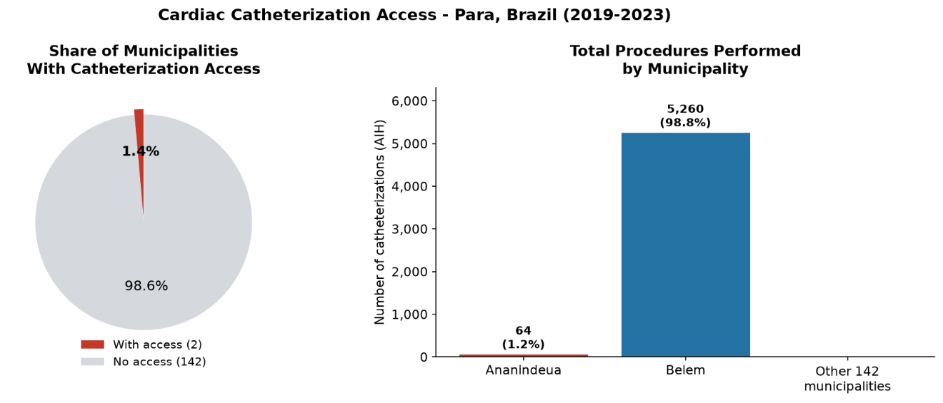
Fig 1. Cardiac catheterization access in Pará, Brazil (2019–2023). Left: proportion of municipalities with and without catheterization access. Right: total SUS-funded cardiac catheterization procedures by municipality. All 5,324 procedures were concentrated in two municipalities.

Temporal Trends
Cardiovascular mortality in Pará increased over the study period. Deaths rose from 3,073 in 2019 to 3,564 in 2023, a net increase of 16.0% over five years. The steepest year-on-year rise occurred between 2019 and 2021, coinciding with the peak of COVID-19 in Brazil. This trajectory is consistent with documented pandemic-era disruption of elective and urgent cardiovascular care nationally, including cancellations of catheterization procedures [6] and reduced hospital-seeking behavior among patients with acute coronary syndromes.
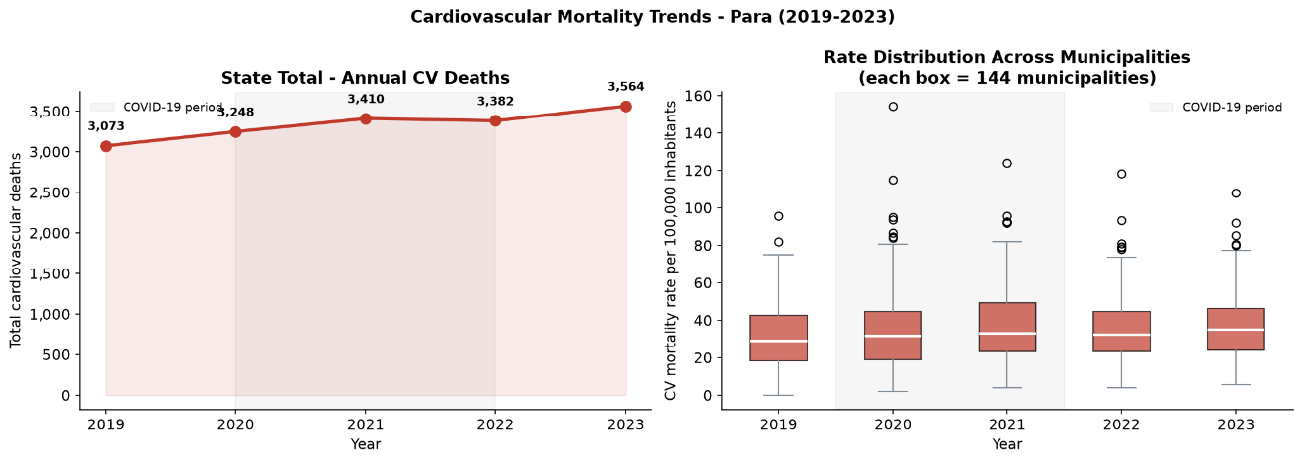Fig 2. Cardiovascular mortality trends in Pará, Brazil (2019–2023). Left: state-level annual cardiovascular deaths. Right: distribution of per-municipality mortality rates by year. Shaded area indicates the COVID-19 disruption period (2020–2022).

Cluster Profiles
K-Means clustering (k=4, silhouette score=0.305, mean internal ARI=0.886 across 30 independent runs) partitioned the 142 non-reference municipalities into four groups with distinct cardiovascular profiles.
Table 1. Cluster profiles (mean ± SD)
 | Variable |  | Structural Care Desert (n=67) |  | Rapidly Deteriorating (n=18) |  | High-Mortality Corridor (n=21) |  | Critical Mortality Burden (n=36) |  | p-value (ANOVA)
CV mortality rate (per 100k) |  | 129.8 ± 40.5 |  | 159.5 ± 58.9 |  | 203.3 ± 64.6 |  | 260.7 ± 57.0 |  | <0.001
GDP per capita (R$) |  | 117221.9 ± 48851.3 |  | 129501.5 ± 38369.7 |  | 693863.9 ± 1017958.7 |  | 139767.6 ± 67230.7 |  | <0.001
Mortality growth (%) |  | 10.8 ± 32.3 |  | 132.7 ± 60.0 |  | 14.7 ± 33.9 |  | -13.0 ± 24.1 |  | <0.001
Mean population (2021) |  | 47,180 |  | 37,679 |  | 83,834 |  | 31,402 |  | —

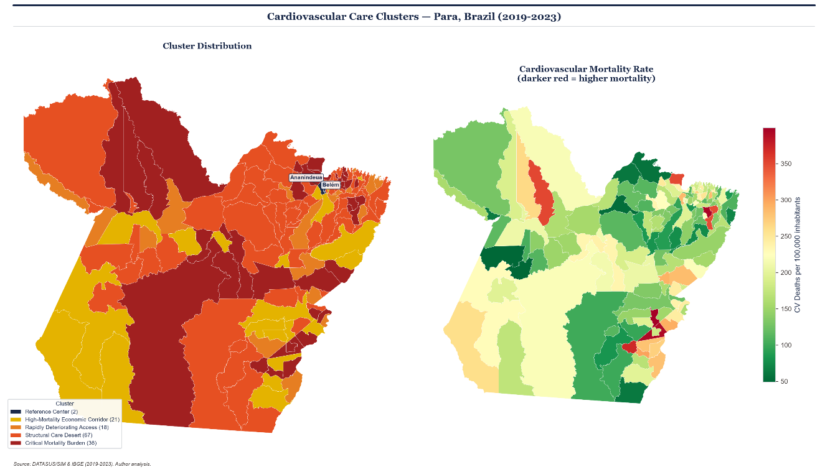
Fig 3. Cardiovascular care clusters in Pará, Brazil (2019–2023). Left: K-Means cluster assignments (k=4) across 144 municipalities. Reference centers (Belém and Ananindeua) shown in navy. Right: cardiovascular mortality rate choropleth (darker red = higher mortality).
Cluster 0 — High-Mortality Economic Corridor (n=21). Twenty-one municipalities had above-average cardiovascular mortality (203.3 per 100,000) alongside the highest mean GDP per capita in the analysis (R$693,864) — a figure inflated by Canaã dos Carajás (S11D iron ore complex, GDP per capita R$4.7M) and Parauapebas, but the mortality elevation persists even when these outliers are excluded. Stable growth trend (14.7%) indicates that high mortality is structurally embedded rather than recently worsening. Economic activity in this corridor is concentrated in mineral extraction and commercial agriculture — industries associated with large male working-age populations at elevated cardiovascular risk whose occupational health programs are typically not integrated into SUS.
Cluster 1 — Rapidly Deteriorating Access (n=18). Eighteen municipalities showed a mean smoothed mortality growth trend of 132.7% over the study period despite mortality rates initially below the state mean (159.5 per 100,000). This trajectory indicates municipalities that were not the worst performers at the start of the period but experienced structural collapse in cardiovascular outcomes during it, likely amplified by COVID-19 disruption in health systems with limited pre-existing resilience. Conceição do Araguaia, Bragança, Salinópolis, and Inhangapi are among the most extreme cases. The small cluster size (n=18) warrants caution in generalization, but the trajectory is statistically robust (F=24.2, p<0.001) and represents the most urgent intervention target in the analysis.
Cluster 2 — Structural Care Desert (n=67). The largest cluster (47.2% of analyzed municipalities) had the lowest mean cardiovascular mortality rate (129.8 per 100,000) and the lowest mean GDP per capita (R$117,222). This cluster encompasses the most economically marginal municipalities in the state, including riverine communities in the Marajó archipelago — Chaves, Afuá, Melgaço, Aveiro — accessible primarily by river and with severely limited healthcare infrastructure. The stable mortality growth trend (mean 10.8%) indicates chronically inadequate care rather than acute deterioration.
Cluster 3 — Critical Mortality Burden (n=36). The highest-mortality cluster in the state (mean 260.7 per 100,000, 46% above the state mean of 178.6) is characterized by moderate GDP (R$139,768, close to state median) and slightly declining smoothed growth trend (-13.0%). Unlike Cluster 0, this profile cannot be explained by economic activity or industrial demographics; unlike Cluster 1, it shows no temporal acceleration. Municipalities include Irituia, Xinguara, Bannach, Monte Alegre, Soure, and Capitão Poço. The absence of a structural economic or temporal explanation — with high mortality persisting at moderate economic levels and stable rates — suggests that unmeasured local health system factors (physician density, primary care coverage, hospital bed availability, treatment quality) are the primary drivers. This cluster represents the most important target for future individual-level investigation using linked SIH-SUS and SIM records. Notably, the smoothed growth trend of -13.0% indicates a slight downward trajectory, the only cluster showing declining mortality, which further distinguishes this profile from both the Rapidly Deteriorating and stable-but-high clusters and reinforces the interpretation that these municipalities represent a structurally embedded rather than dynamic mortality burden.

DISCUSSION

Principal Findings
This analysis makes three contributions. First, it quantifies the extreme concentration of cardiac catheterization capacity in Pará: two municipalities performed every recorded SUS catheterization between 2019 and 2023, while 142 municipalities recorded none. This is not a statistical artifact — it reflects the physical absence of catheterization laboratories, trained interventional cardiologists, and the supply chains required to sustain them across most of the state's territory.
Second, the analysis demonstrates that municipalities without catheterization access are not a homogeneous group. The four clusters identified here require different responses. The 67 municipalities in the Structural Care Desert cluster face chronic, stable underdevelopment of cardiovascular care — a long-term infrastructure problem. The 21 municipalities in the High-Mortality Economic Corridor face a different paradox: economic activity has not translated into health protection, possibly because the workforce health programs of major extractive operations are not integrated into SUS and do not reach the broader population. The 18 municipalities in the Rapidly Deteriorating Access cluster require immediate epidemiological investigation to identify reversible causes of the mortality acceleration. The 36 municipalities in the Critical Mortality Burden cluster — with the highest mortality in the state and no structural economic or temporal explanation — represent the most important target for individual-level clinical investigation.
Third, the finding that high GDP does not protect against cardiovascular mortality in the extractive corridor challenges a common assumption in Brazilian health policy — that economic development is sufficient to improve health outcomes. The Pará data suggest that the type of economic activity matters as much as its scale, and that resource extraction GDP does not reliably fund or attract the health infrastructure needed to serve the communities around it.

COVID-19 and the Mortality Trajectory
The 2019–2023 period captures an unusually disruptive interval for cardiovascular care globally. COVID-19 reduced catheterization volumes, disrupted primary care follow-up for hypertension and diabetes — both major cardiovascular risk factors — and caused excess cardiovascular deaths through both direct viral mechanisms and indirect care disruption. The Rapidly Deteriorating cluster's extreme mortality growth (mean 132.7%) may partly reflect these dynamics concentrated in municipalities that entered the pandemic with the least resilient health systems. Disentangling pandemic effects from pre-existing structural trends is beyond the scope of this analysis but represents an important next step.

The Critical Mortality Burden cluster as an Unexplained Residual
The fourth cluster — 36 municipalities with cardiovascular mortality 46% above the state mean, at moderate GDP and without accelerating trends — does not fit the explanatory frameworks applied to the other profiles. It is not impoverished, not deteriorating rapidly, and not concentrated in extractive industries. This "unexplained residual" is scientifically important: it identifies municipalities where aggregate data available in DATASUS and IBGE are insufficient to explain the mortality burden. Resolving it requires individual-level linkage of patient comorbidity profiles, care pathway reconstruction, and local health system capacity indicators — the direct methodological extension of this work.

Limitations
Several limitations apply. First, the analysis is ecological: the unit of analysis is the municipality, not the individual. We cannot determine the cardiovascular risk profile, comorbidities, or care-seeking behavior of the people who died. Municipality-level mortality rates reflect aggregate exposure; individual-level confounders are uncharacterized.
Second, population data are from 2021 IBGE estimates; exact values for 2022 and 2023 were unavailable, introducing modest denominator imprecision for later years of the study.
Third, the SIH-SUS procedure data reflect only SUS-funded catheterizations. Private-sector procedures are not captured. In municipalities with more developed private healthcare — primarily the economic corridor cluster — some residents may have accessed private cardiac care not reflected in these data, which would lead us to overestimate the true access gap in those municipalities specifically.
Fourth, the silhouette score of 0.305 indicates moderate but not strong cluster separation. This is expected in health geography applications where municipalities exist on a continuum rather than in discrete health categories; it does not invalidate the clustering but indicates that cluster boundaries are gradients rather than sharp divisions. Fifth, this analysis is limited to one state. Generalizability to other Brazilian states or to other large countries with similar geographic structures requires replication.
The mortality growth metric, despite two-year block averaging and Laplace smoothing, remains sensitive to the small-numbers effect in the lowest-population municipalities. Future iterations should incorporate empirical Bayes smoothing or spatial empirical priors to provide more stable epidemiological trajectories in low-density regions, particularly within the Rapidly Deteriorating cluster.
Municipal population estimates from 2021 were used as fixed denominators for the full 2019–2023 period. In municipalities experiencing rapid demographic change — particularly those in the High-Mortality Economic Corridor affected by extraction-driven migration — the 2021 estimate may not accurately represent the population at risk in earlier or later years, potentially introducing modest bias in mortality rates for those municipalities specifically.

Implications for Cardiovascular Surgery Training and Research
From a clinical research perspective, the cluster profiles identified here generate testable hypotheses for outcomes research. The High-Mortality Economic Corridor presents an opportunity to examine whether occupational cardiovascular risk in extractive industries — documented in global literature for mining and agricultural workers — is detectable at the population level in Brazilian data. The Rapidly Deteriorating cluster raises questions about specific system failures: whether they reflect collapse of primary prevention, loss of key personnel, or infrastructure deterioration. Both questions are addressable with individual-level SUS data linkage, representing natural extensions of this work.

CONCLUSIONS
Cardiac catheterization access in Pará, Brazil is geographically absent for 98.6% of municipalities. Among those without access, four structurally distinct profiles emerge from K-Means clustering: chronically underserved low-income communities, municipalities experiencing rapid mortality deterioration, an economic corridor where high GDP coexists with high mortality, and a high-mortality group with no structural economic or temporal explanation whose drivers remain to be characterized. These profiles call for differentiated policy responses rather than uniform infrastructure investment. The analysis is fully reproducible from publicly available DATASUS and IBGE data; the code is available at github.com/g4bfernandoo/regional-health-disparities-brazil.

Data and Code Availability
All analysis code is publicly available at github.com/g4bfernandoo/regional-health-disparities-brazil. Raw data are publicly available from DATASUS and IBGE under Brazil's Lei de Acesso à Informação (Law 12,527/2011).

Funding
This research received no external funding.

Conflicts of Interest
The author declares no conflicts of interest.

SUPPORTING INFORMATION
S1 Figure. Elbow method and silhouette analysis for cluster number selection.
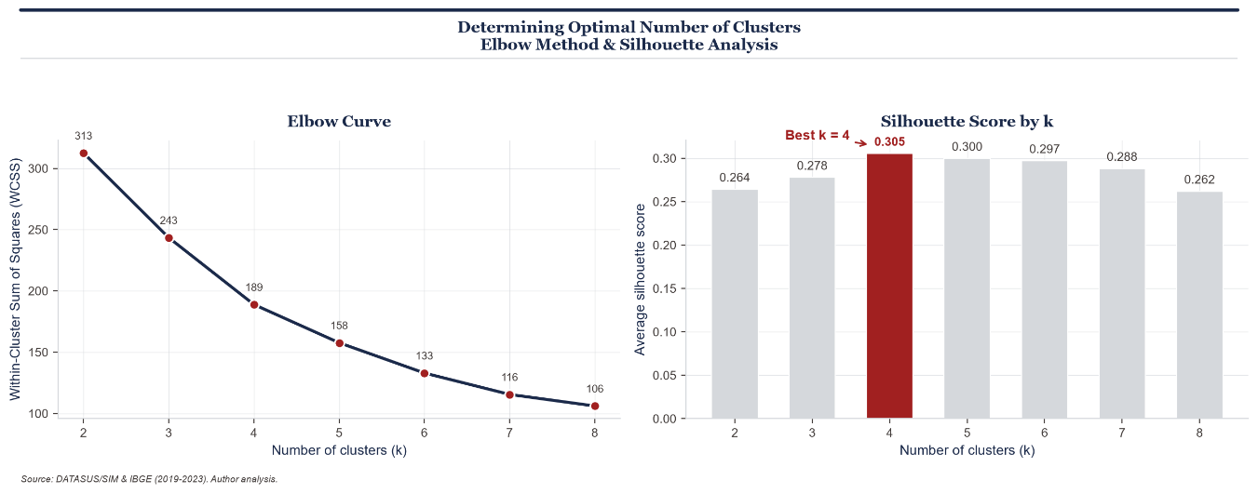
S2 Figure. Cardiovascular mortality rate distribution across municipalities.
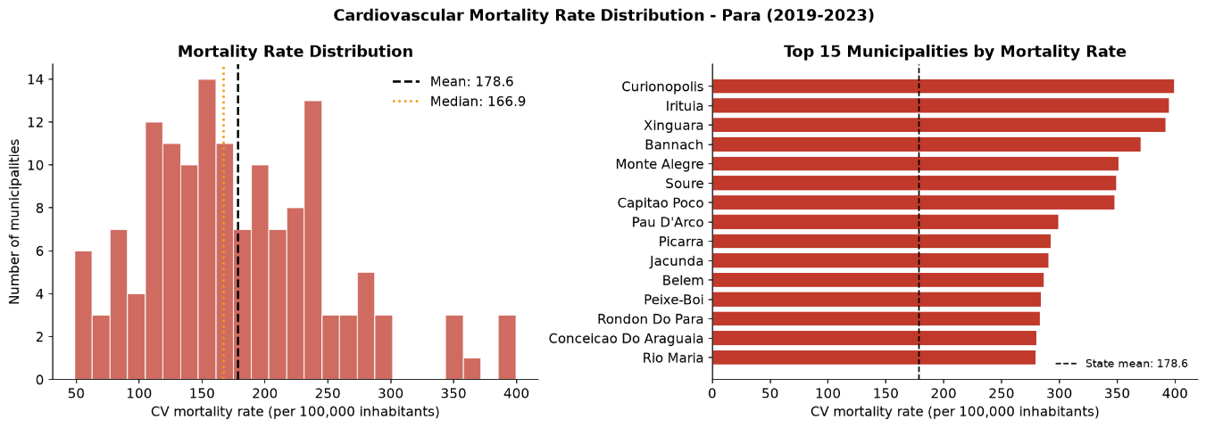

S3 Figure. Cluster profiles — mean feature values by cluster.
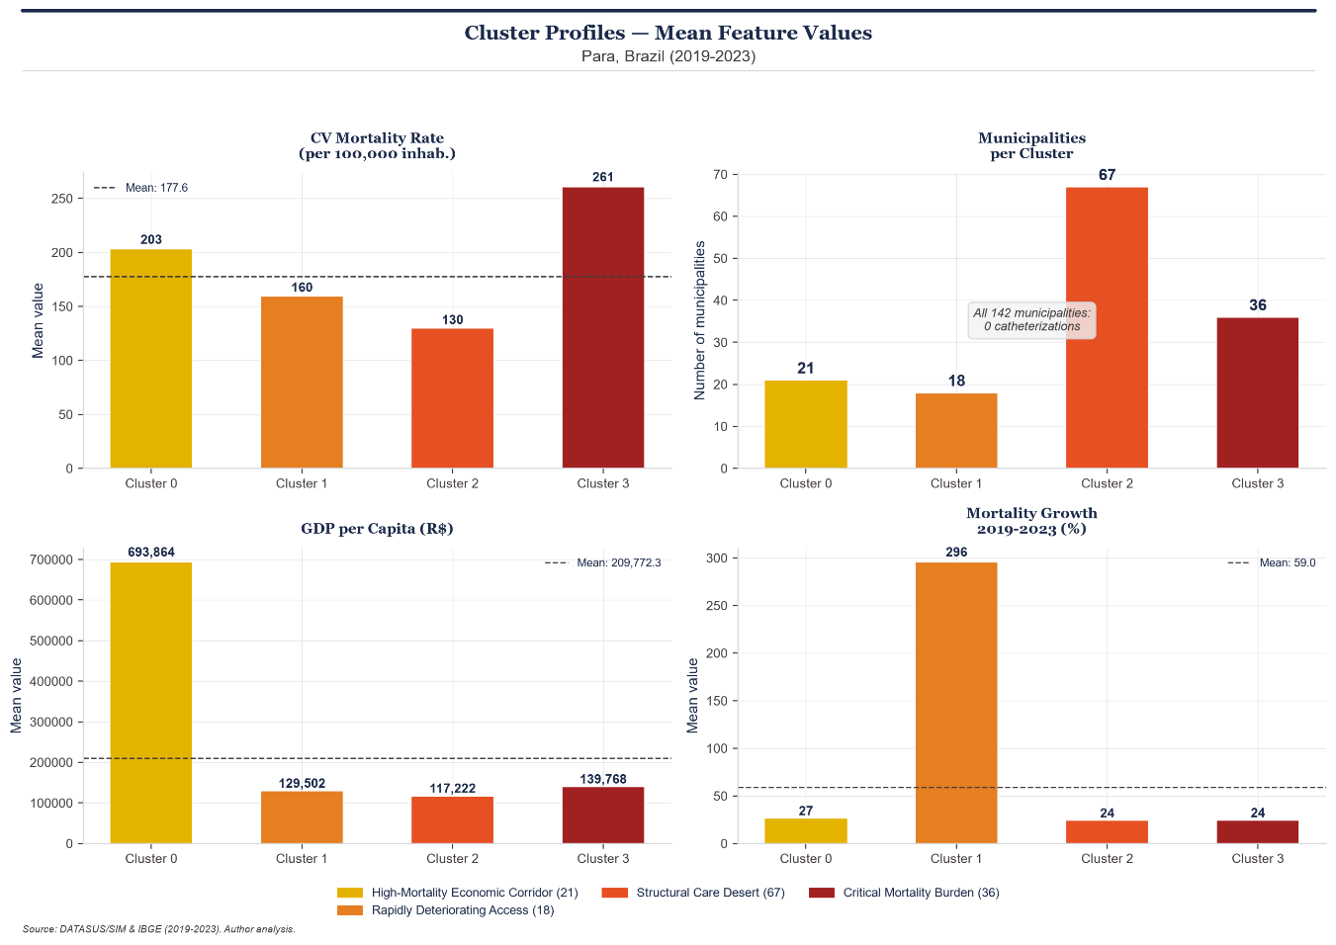
S4 Figure. Economic gradient — GDP per capita versus cardiovascular mortality rate.
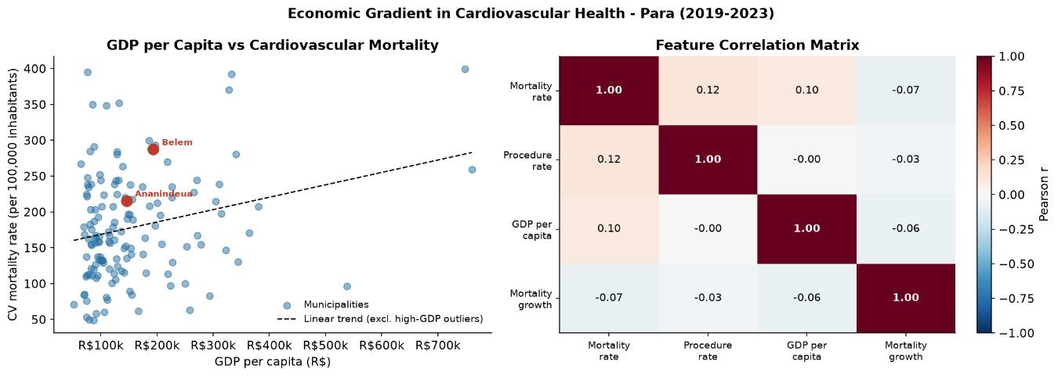

S5 Figure. Inter-cluster distance heatmap.
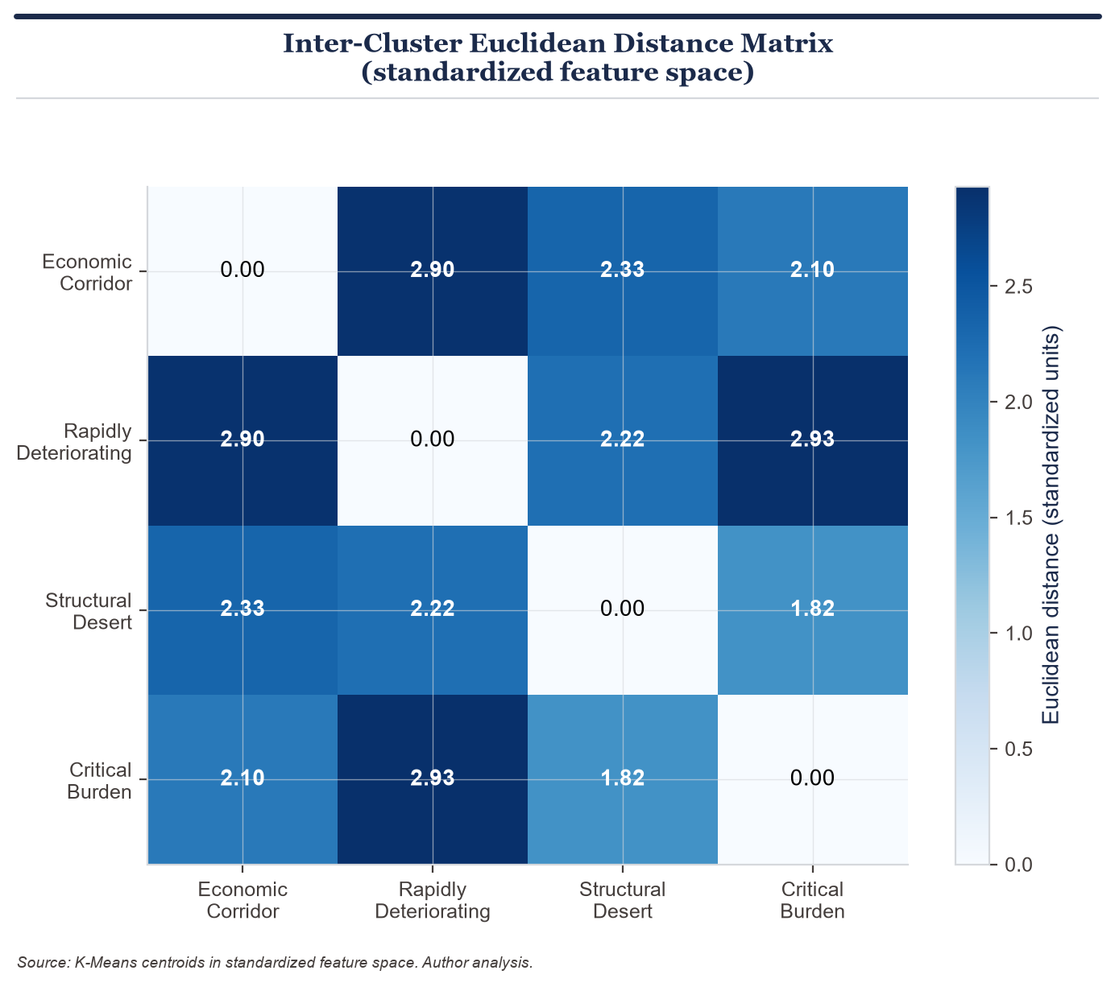

REFERENCES
[1] GBD 2021 Causes of Death Collaborators. Global burden of 369 diseases and injuries in 204 countries and territories, 1990–2021: a systematic analysis for the Global Burden of Disease Study 2021. Lancet. 2022;400(10356):1135–1191. https://doi.org/10.1016/S0140-6736(22)02185-7
[2] Ribeiro ALP, Duncan BB, Brant LCC, Lotufo PA, Mill JG, Barreto SM. Cardiovascular Health in Brazil: Trends and Perspectives. Circulation. 2016;133(4):422–433. https://doi.org/10.1161/CIRCULATIONAHA.114.008727
[3] Instituto Brasileiro de Geografia e Estatística (IBGE). Estimativas de População 2021. Rio de Janeiro: IBGE; 2022. Available from: https://www.ibge.gov.br
[4] Nascimento BR, Brant LCC, Marino BCA, et al. Cardiovascular Disease Epidemiology in Portuguese-Speaking Countries: data from the Global Burden of Disease, 1990 to 2016. Arq Bras Cardiol. 2018;110(6):500–511. https://doi.org/10.5935/abc.20180092
[5] Ministério da Saúde (Brasil). DATASUS: Sistema de Informações sobre Mortalidade e Sistema de Informações Hospitalares. Brasília: Ministério da Saúde; 2024. Available from: https://datasus.saude.gov.br
[6] Garcia S, Albaghdadi MS, Meraj PM, et al. Reduction in ST-Segment Elevation Cardiac Catheterization Laboratory Activations in the United States During COVID-19 Pandemic. J Am Coll Cardiol. 2020;75(22):2871–2872. https://doi.org/10.1016/j.jacc.2020.04.011
[7] Grubesic TH. On the application of fuzzy clustering for crime hot spot detection. Journal of Quantitative Criminology. 2006;22(1):77–105. https://doi.org/10.1007/s10940-005-9003-6
[8] Rocha TAH, Silva NC, Amaral PV, et al. Access to emergency care services: a spatial analysis of primary care sensitive conditions in Brazil. BMC Health Services Research. 2017;17(1):362. https://doi.org/10.1186/s12913-017-2283-z

