**Details about the assignment work :**

* I have a Spring Boot Application which I am trying to Dockerize.
* I have created Jenkins pipeline which is SCM based picking up the source to build from GitHub. Which successfully getting pulled up and while dockerize the image for the application getting some issues as I am using Docker for windows. Docker deamon running issues on windows 10 also there are some limitations for me as I am using organization system which limits me to have admin rights for some of the cases.

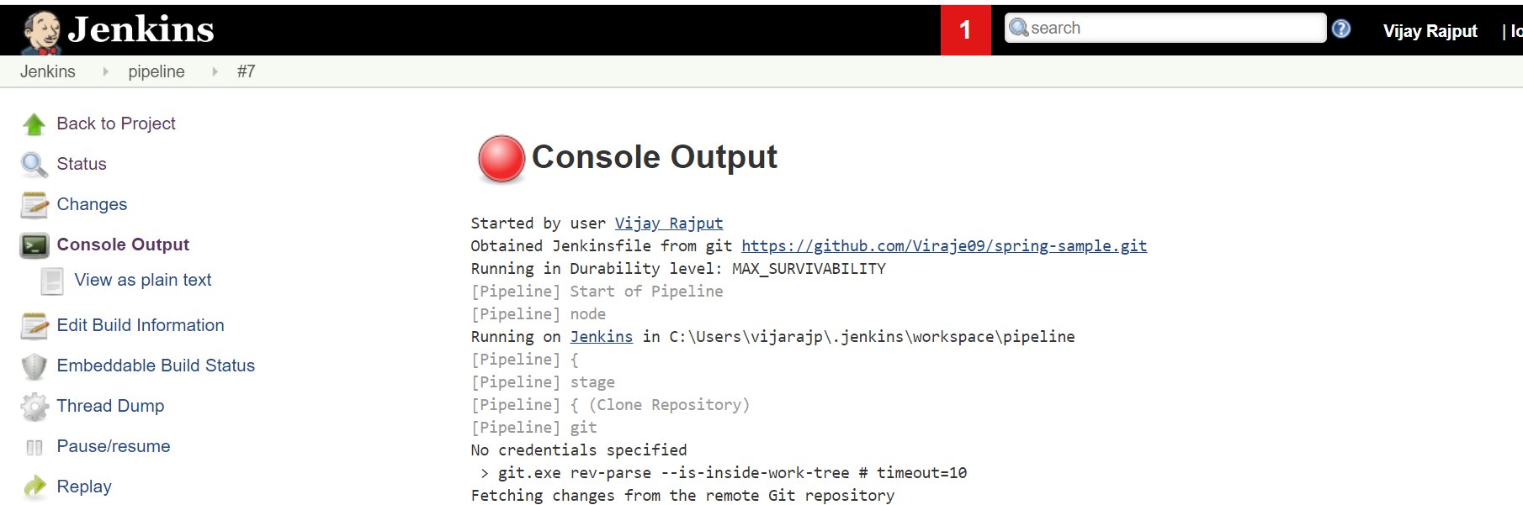

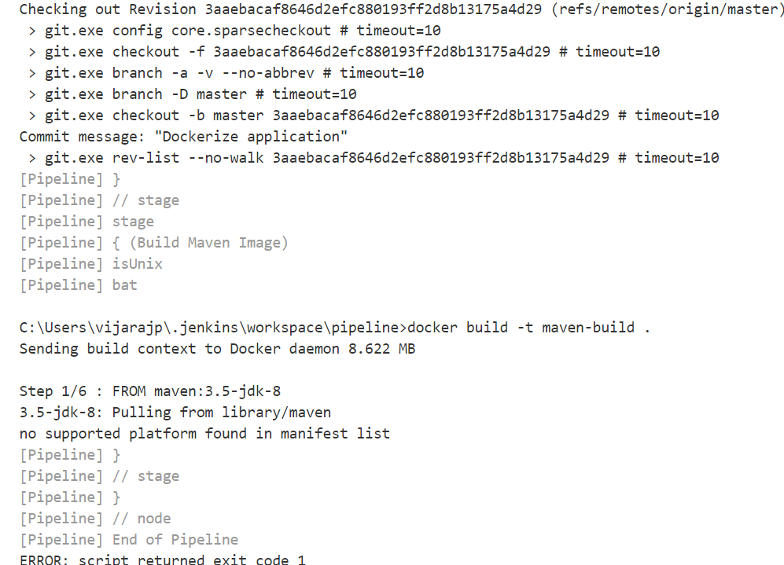

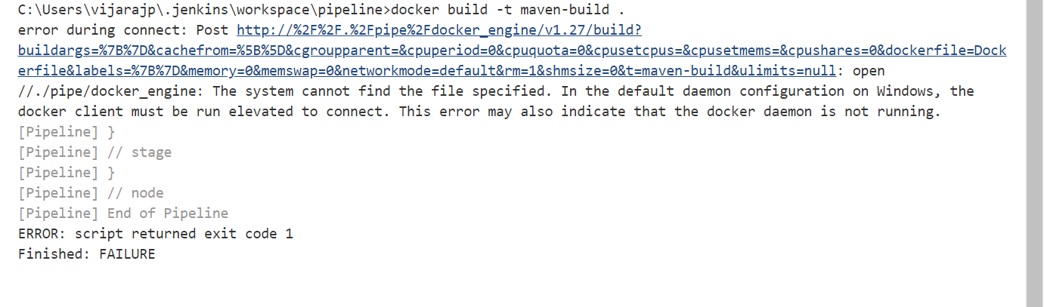

* Running Jenkins using Jenkins.war file.

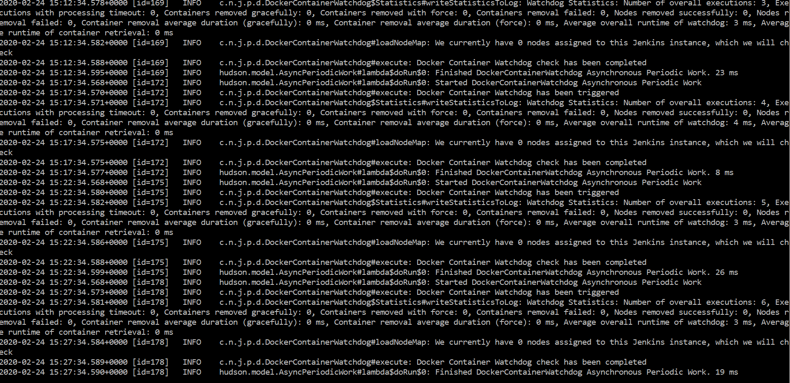

* Meanwhile please find source written for Jenkinsfile, Dockerfile etc.

|  |
| --- |
| **Jenkinsfile :**  node {  stage('Clone Repository') {  // Get some code from a GitHub repository  git 'https://github.com/viraje09/spring-sample.git'    }  stage('Build Maven Image') {  docker.build("maven-build")  }  stage('Run Maven Container') {    //Remove maven-build-container if it exisits  sh " docker rm -f maven-build-container"    //Run maven image  sh "docker run --rm --name maven-build-container maven-build"  }  stage('Deploy Spring Boot Application') {    //Remove maven-build-container if it exisits  sh " docker rm -f java-deploy-container"    sh "docker run --name java-deploy-container --volumes-from maven-build-container -d -p 8080:8080 vijay/spring-sample-deploy"  }  } |

|  |
| --- |
| **Dockerfile :**  FROM maven:3.5-jdk-8  RUN mkdir -p /deploy/application  VOLUME ["/deploy/application"]  WORKDIR /deploy/application  ADD . .  ENTRYPOINT ["mvn","clean","package"] |

* I have configured role based user access in Jenkins as below.

