**2.2 c)**

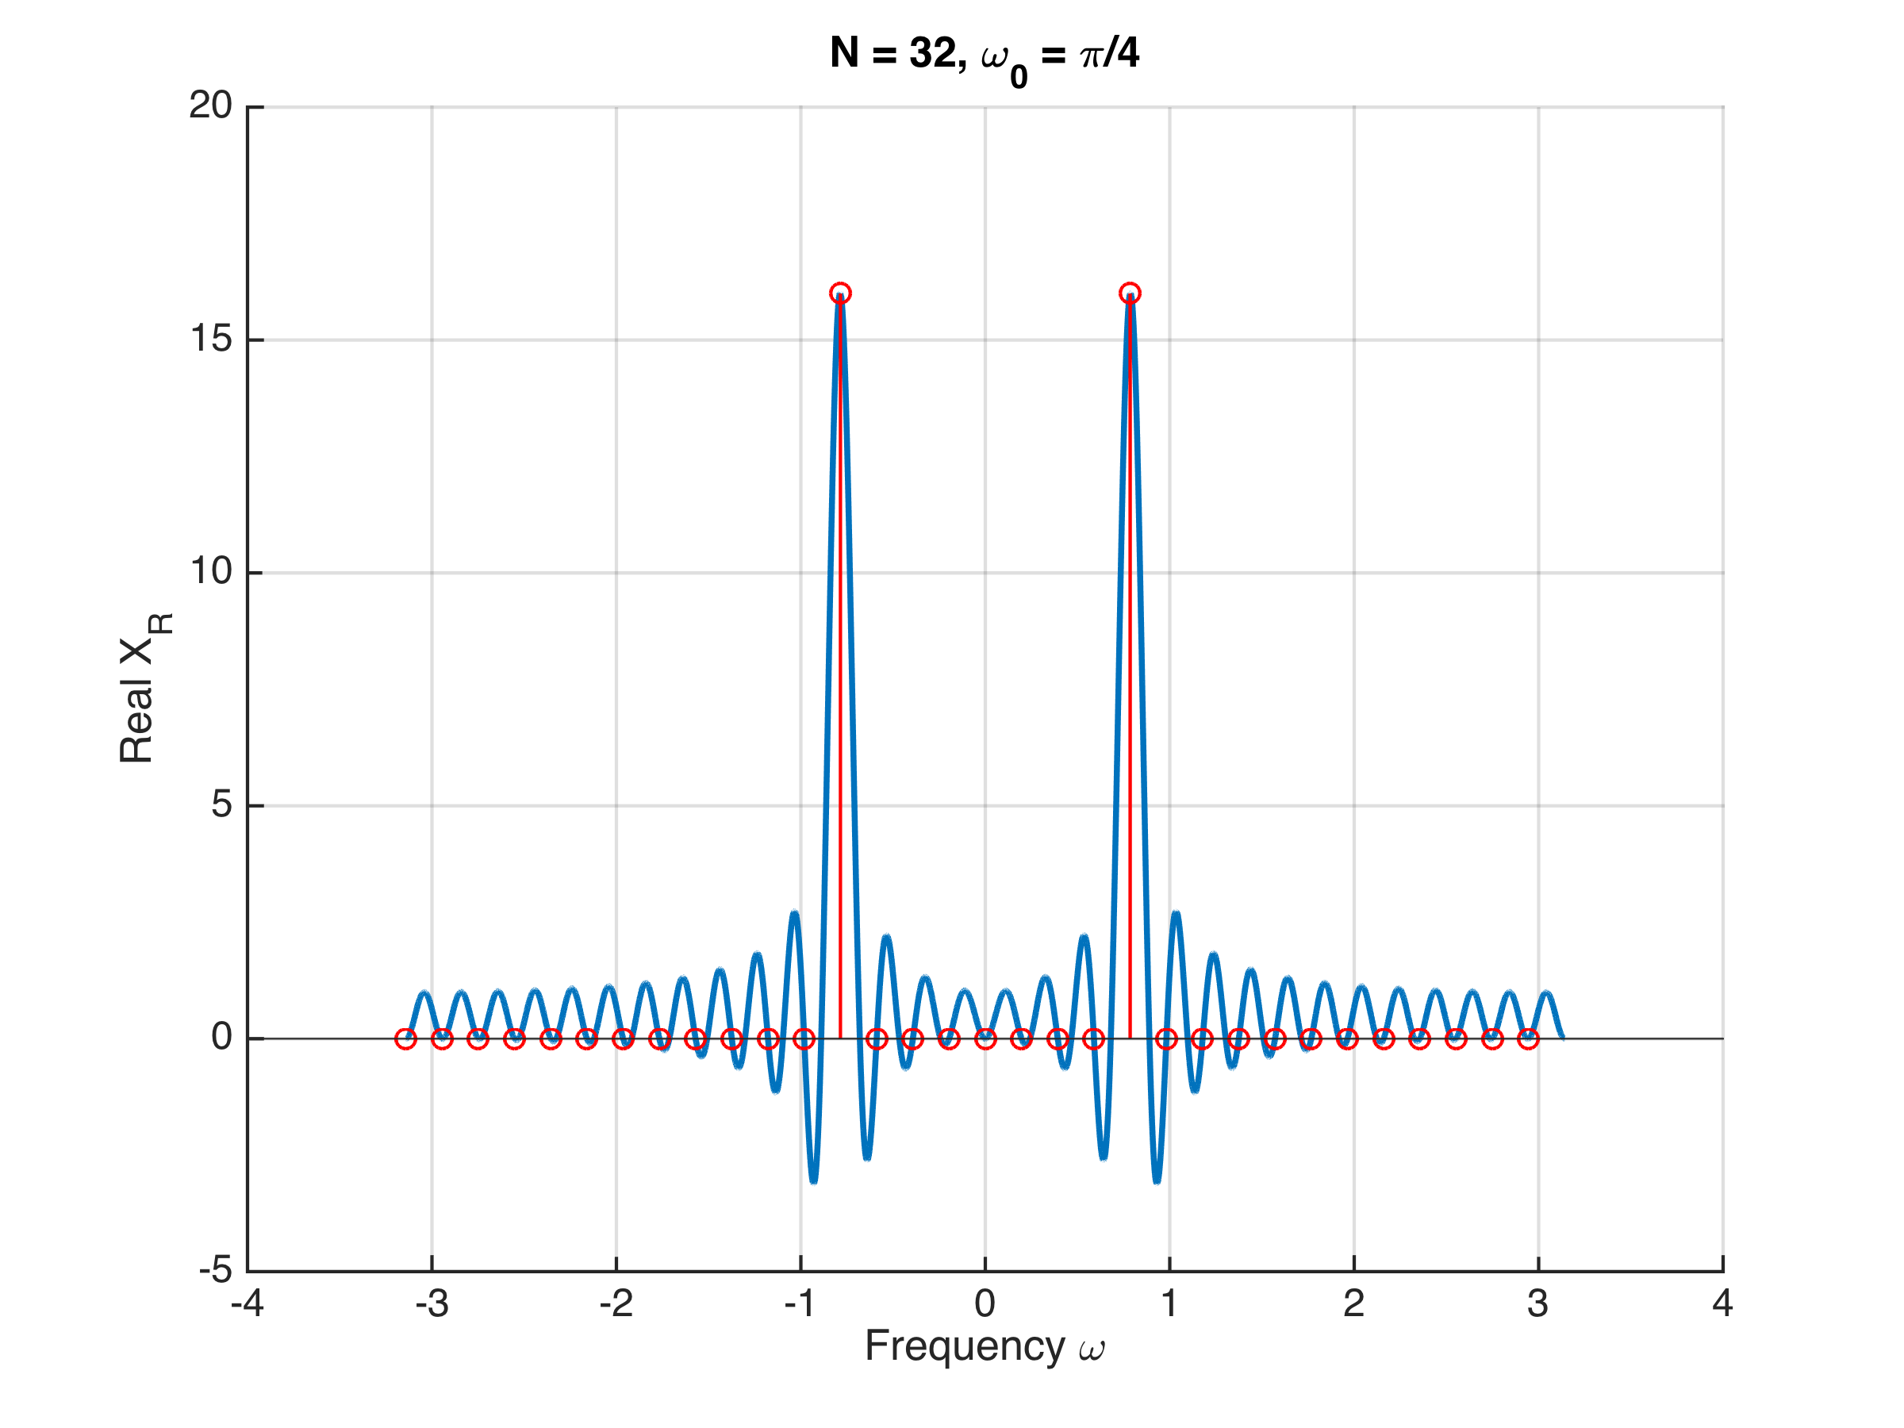

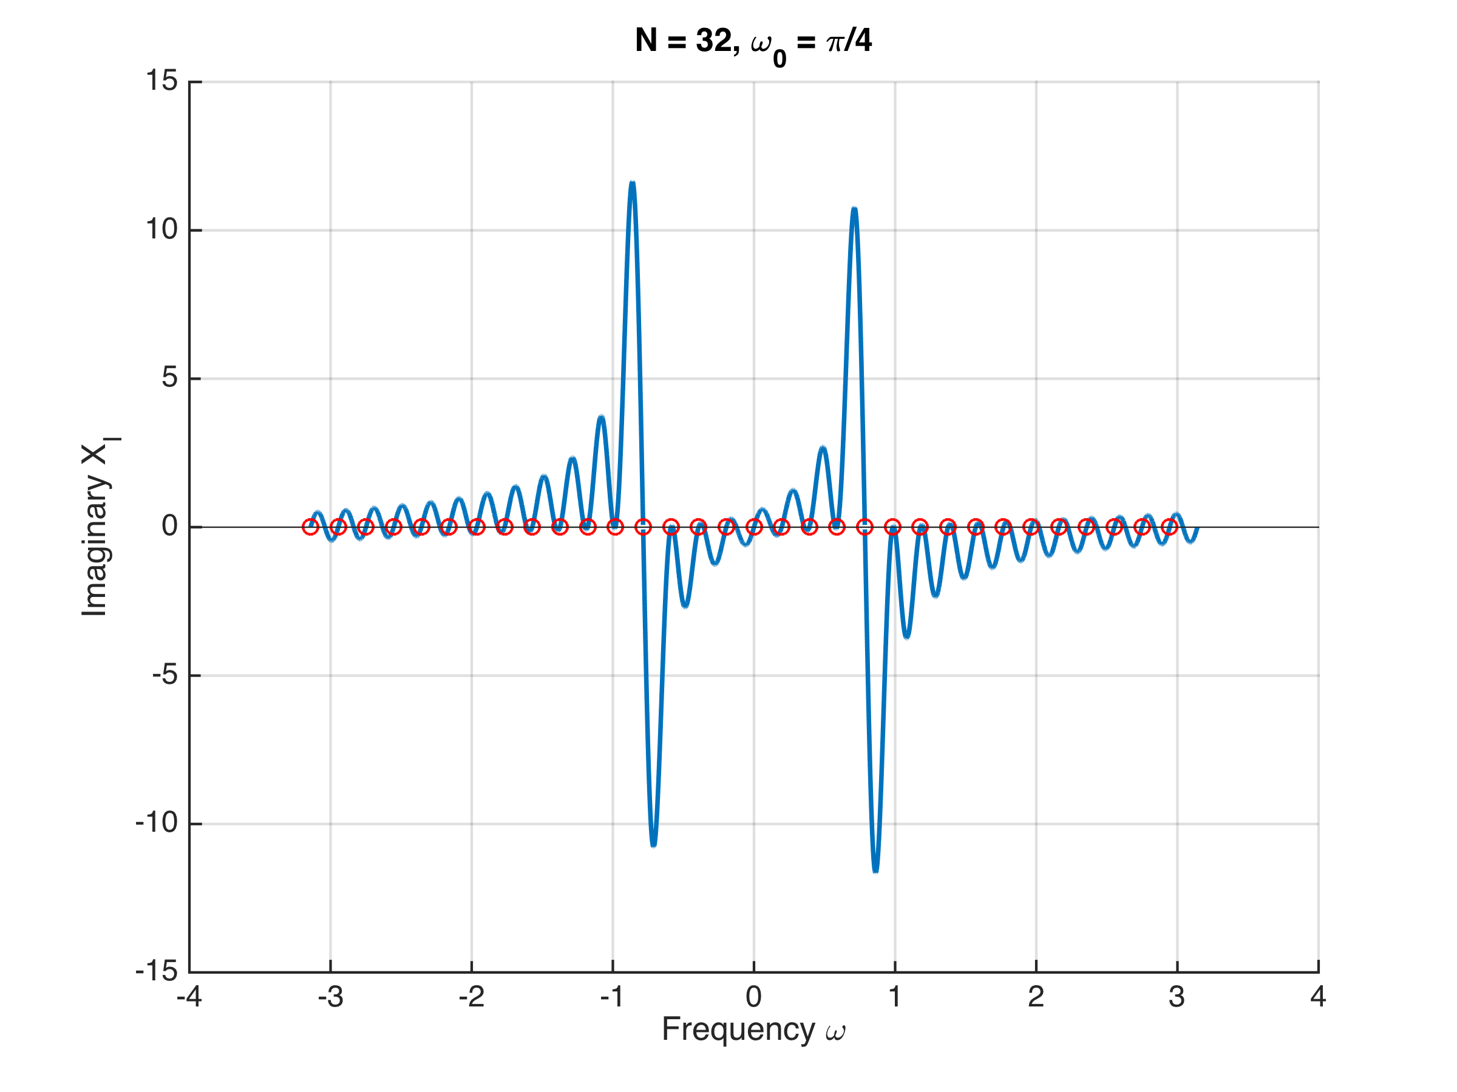

The 32-point DFT is the periodic representation of the signal x(n) and thus represents the periodic signal cos(ω0n) as opposed to the spectrum of the windowed signal given by the DTFT. As expected, because the 32-point DFT encompasses complete cycles of the sinusoid when ω0 = π/4, the resulting DFT spectrum consists of two impulse functions representing a sinusoid of frequency ω0 i.e. π/4.

**2.2 d)**

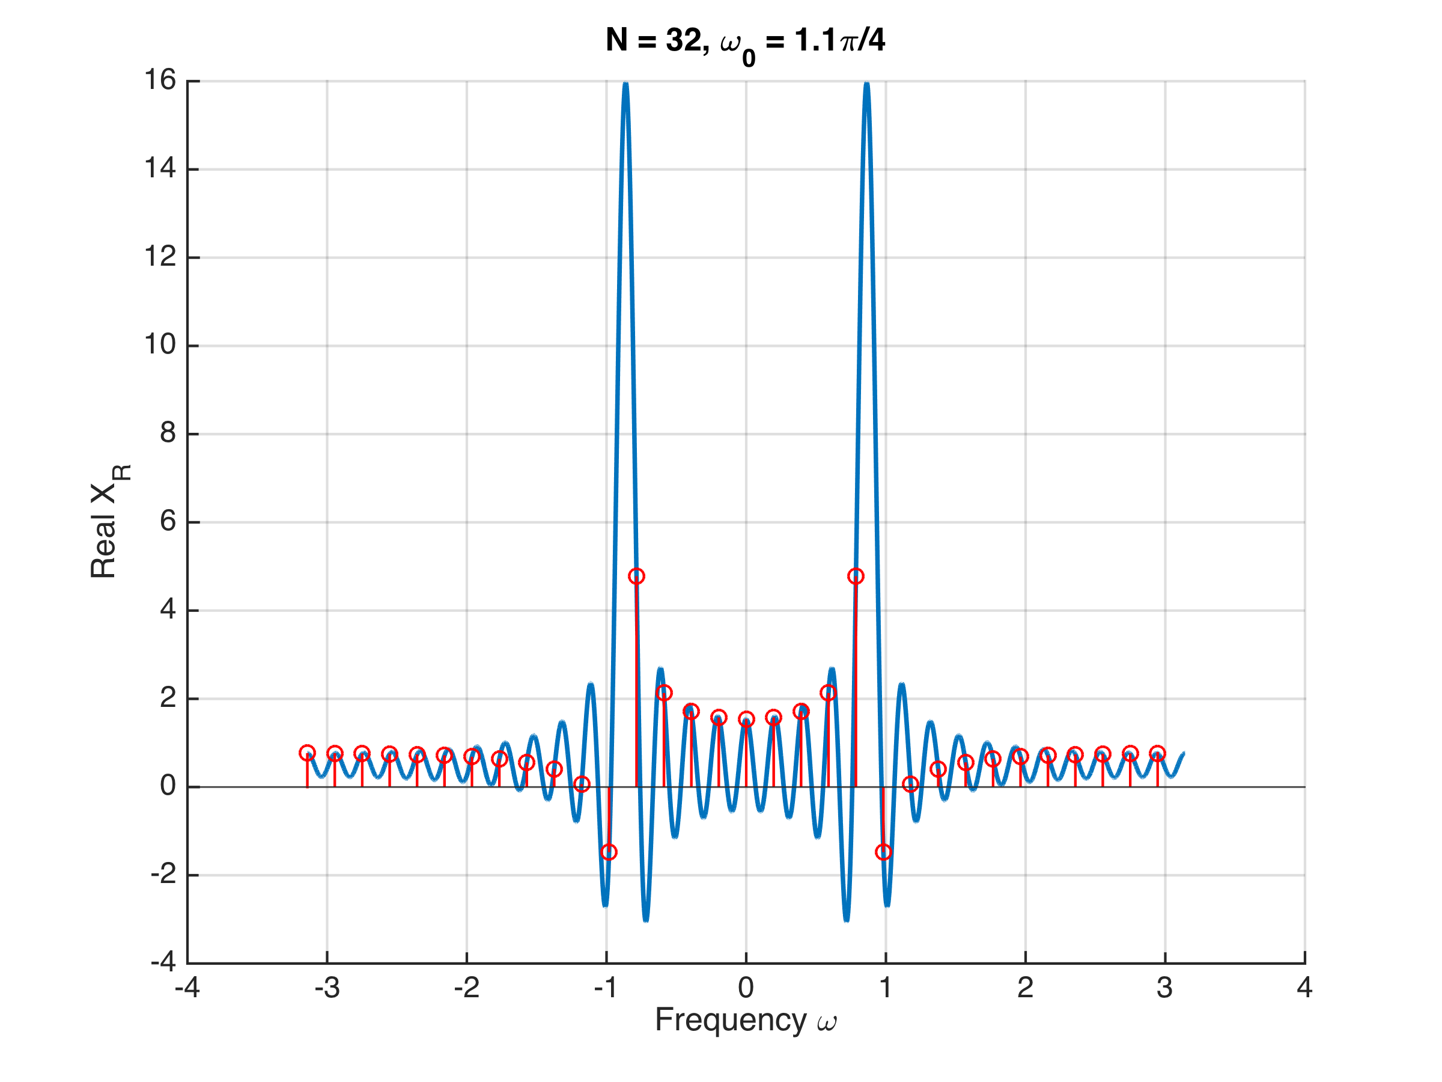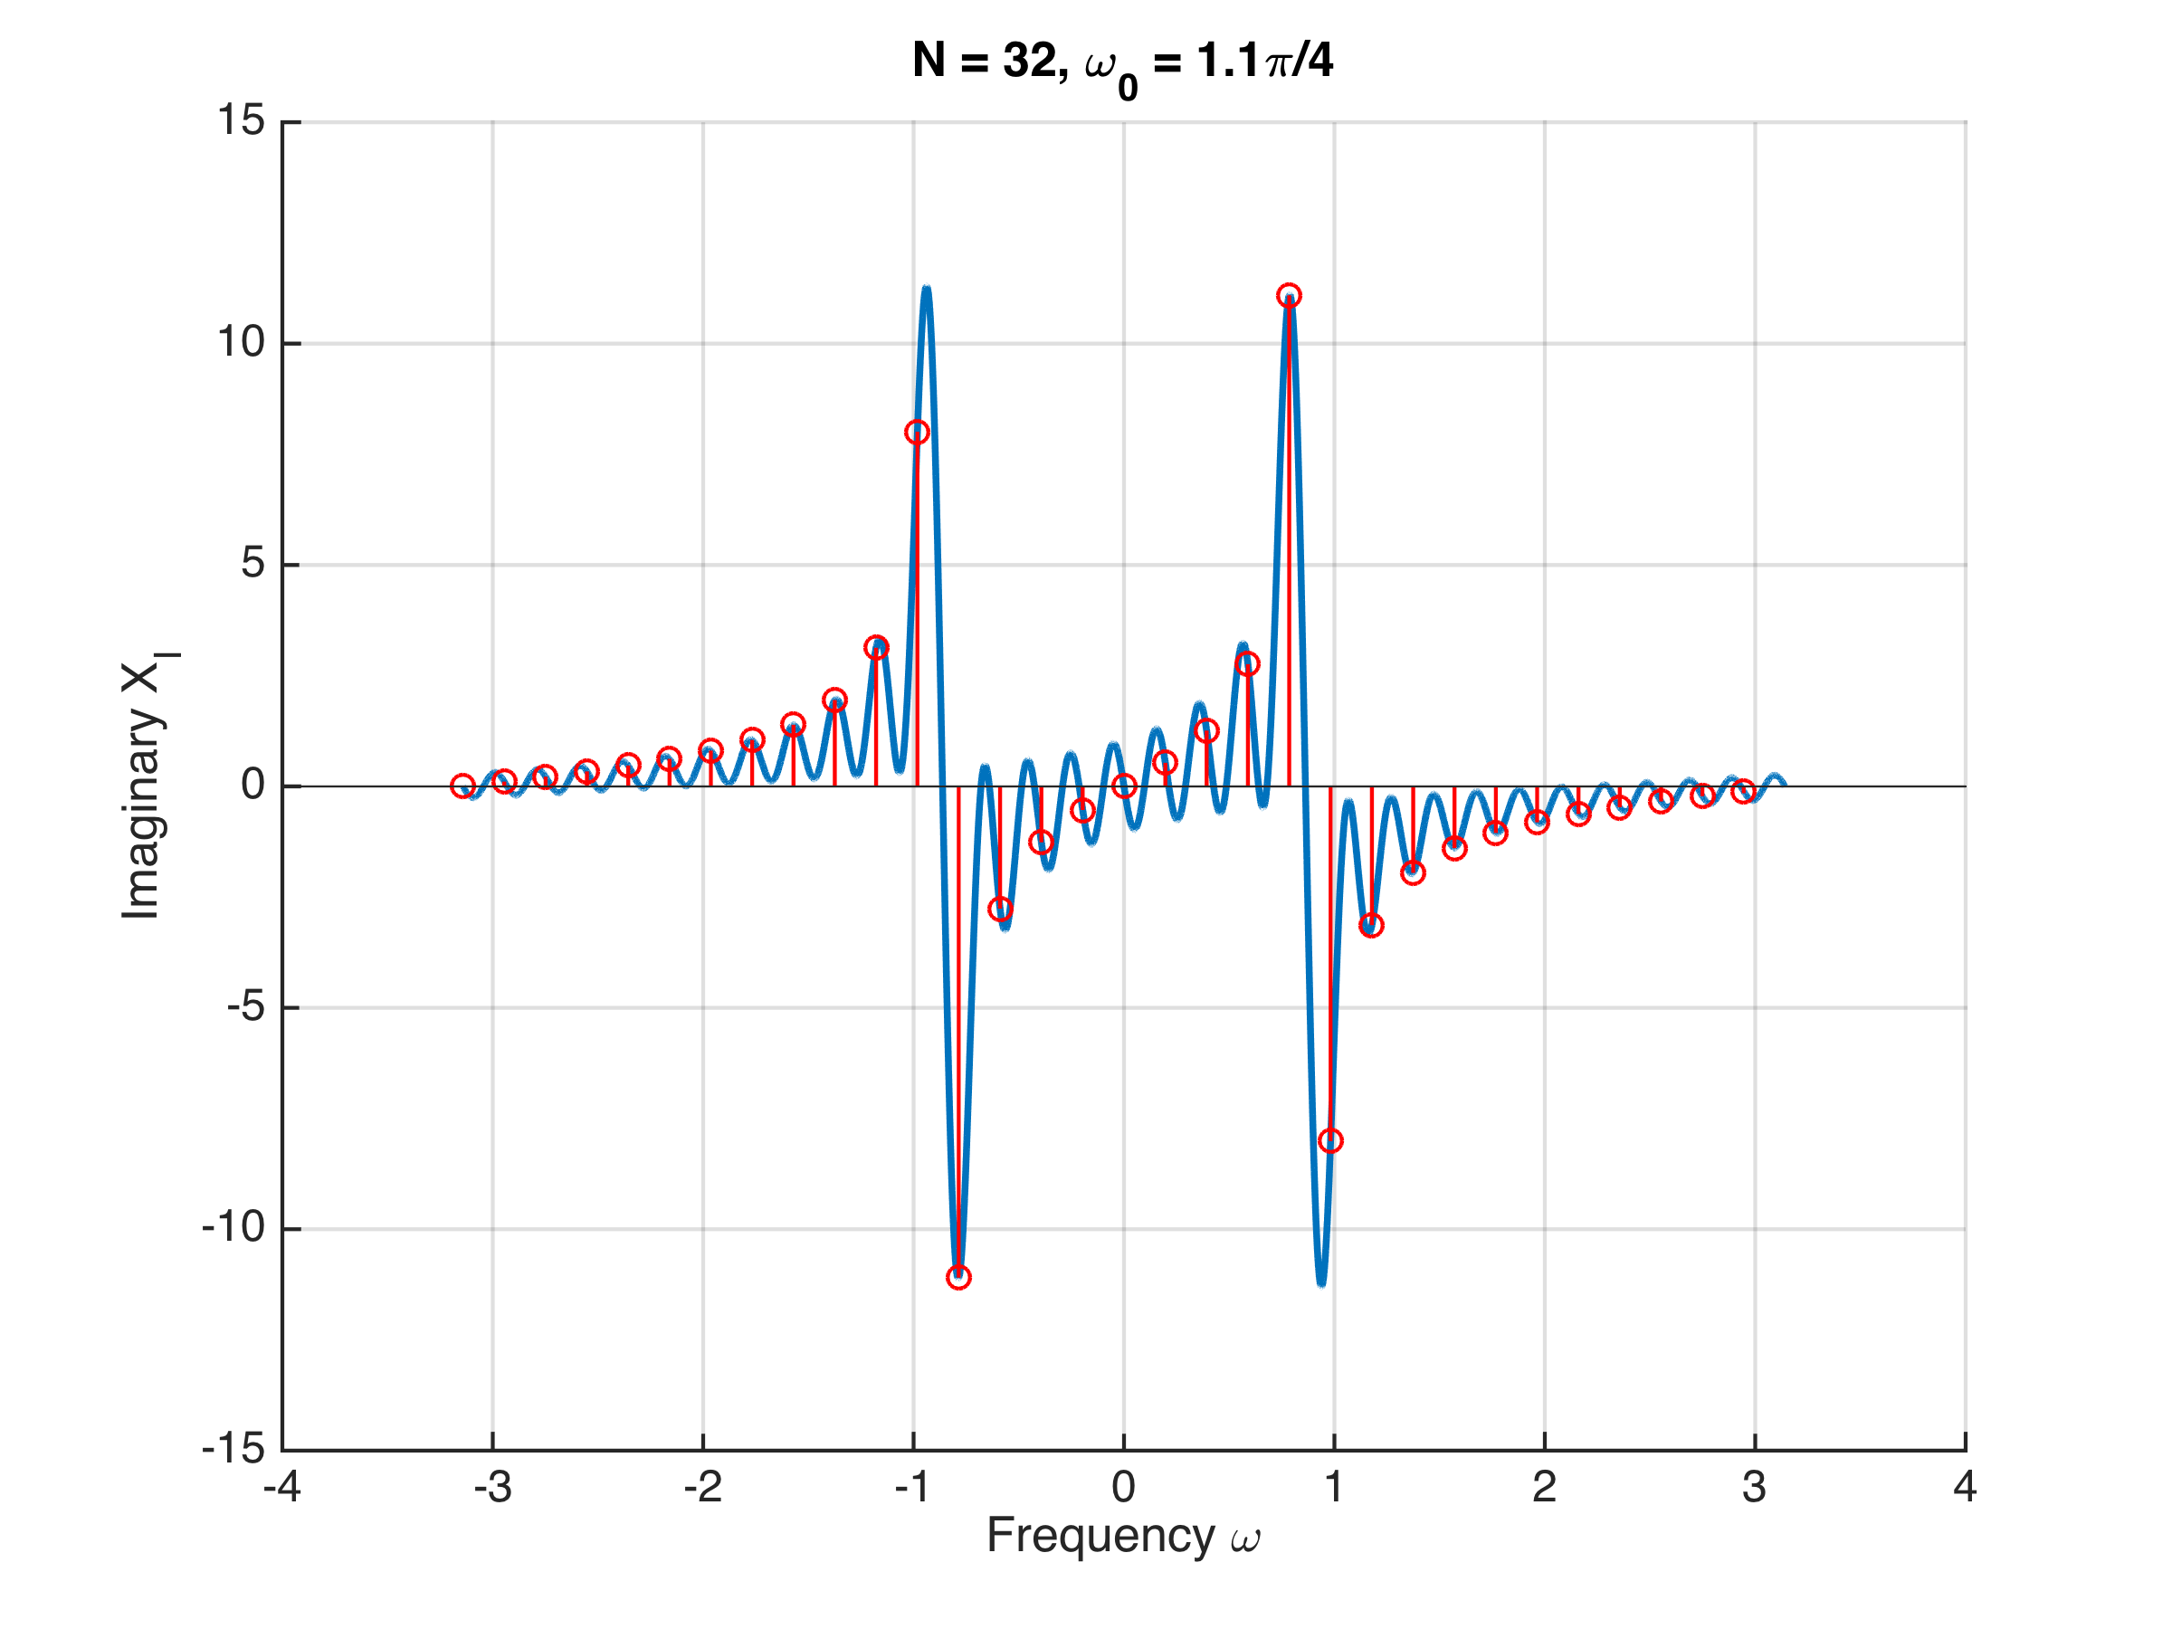

When the digital frequency is increased to ω0 = 1.1 π/4, the points sampled for the 32-point DFT no longer represent complete cycles of the windowed sinusoid, i.e. the last cycle is incomplete. Therefore, the periodic representation of the signal does not fully represent a sinusoid and has sharp discontinuities where the 32-point sequences are stitched together. As a result, we observe frequency content beyond just the two impulses that were seen in the ω0 = π/4 condition.

**2.5 a)**

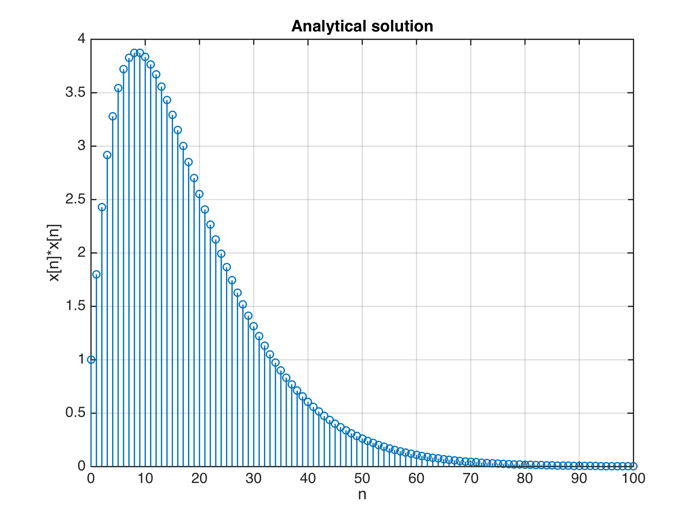

**2.5 b)**

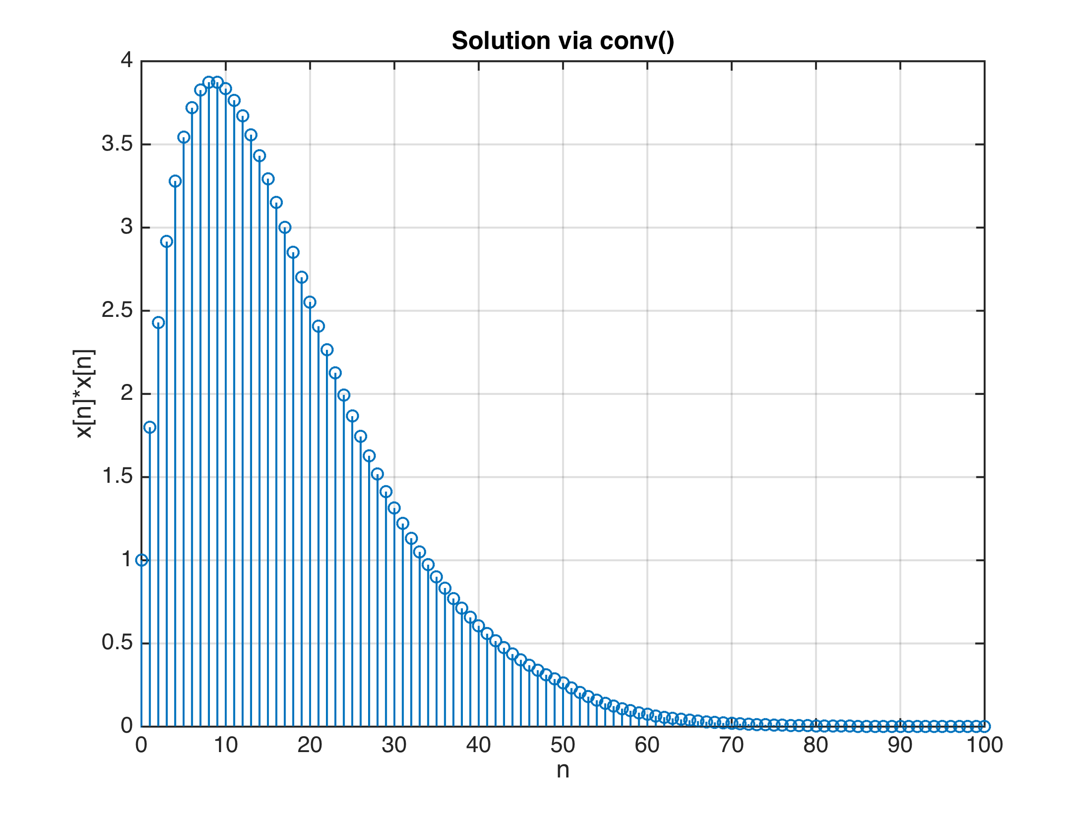

**2.5 c)**

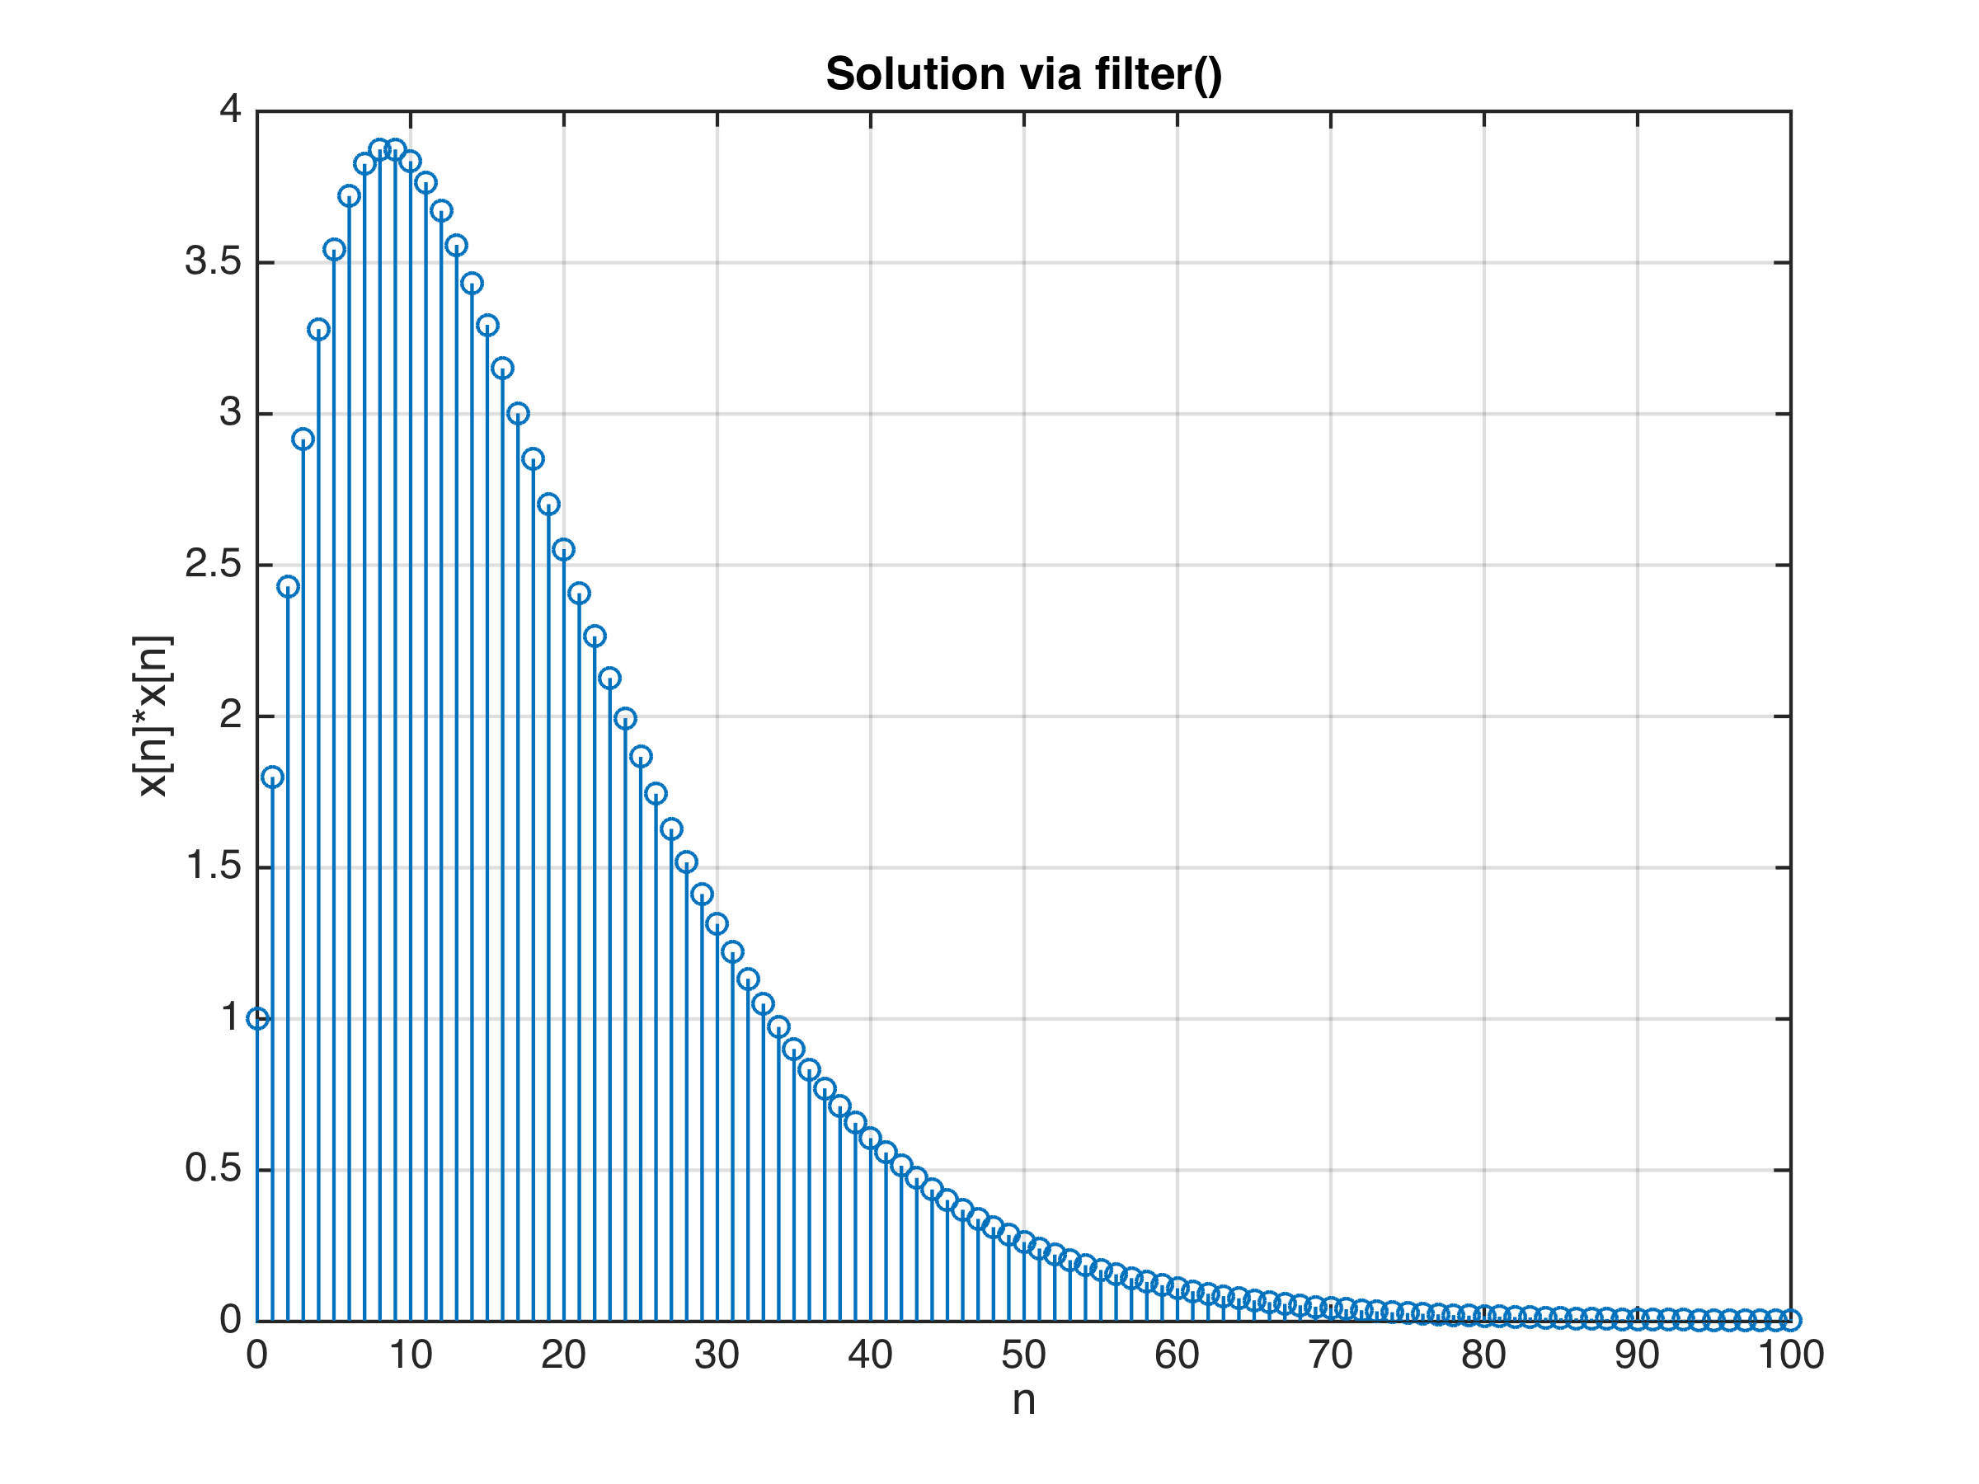

**2.5 d)**

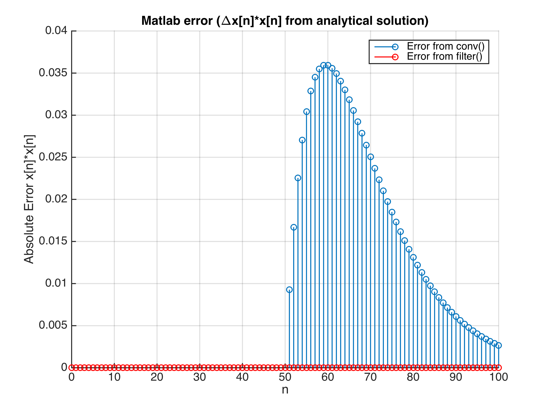

Solutions generated from both the conv() and filter() Matlab functions very closely resemble the expected analytical solution. However, when plotting the absolute error of both methods, the differences in accuracy between the two methods can be observed. Because the conv() requires a signal to be truncated, we can see an increase in error for higher values of n where the signal is truncated. On the other hand, because the filter() method is able to represent the impulse response of a system via coefficients that describe the system in its entirety, this method does not lose significant accuracy with larger signals. Thus, the filter() approach is best suited for infinite length signals since conv() requires both input signals to be truncated.