Analytics Specializations and Applications

Coursework 1
2025

Student ID: 20595117
Executive Summary:

In this customer analytics case study, the goal is to conduct a customer segmentation analysis. Using a transactional dataset provided by a national convenience store chain, the goal is to identify five to seven distinct customer segments in order to provide the company with the tools to better understand their existing consumers’ behavior and to act as a guide for future marketing strategies. The data provided consists of general spending behavior of 3,000 customers over a period of six months. Data provided includes typical transactional data available at a convenience chain on multiple transactional levels; category level, basket level, and customer level, and transaction line level data were all made available for further analysis.

To accomplish this task the following techniques were implemented. The raw data was analyzed in order to examine generalized trends. The data was then cleaned in order to address any missing or errant values present. Next, new data features were engineered to analyze customer behavior more deeply. As per the Chief Data Officer’s request, recency, frequency, and monetary value were the emphasis of the newly engineered features. Basket composition, time trend shopping patterns, and category spend aggregation was also performed. Additionally, all of the individual categorical spending data were consolidated into three spending groups: fresh foods, processed foods, and non-food items. The purpose of this exercise was to group many of the items frequently bought together, instead of the alternative approach of deleting highly correlated items. This way, wer were able to include all of this valuable data into our analysis.

The next step was to create clusters of customers with strong relation based on both the raw data and engineered features, but first dimensionality reduction was performed in order to extract the most critical customer traits while reducing the overall noise of the dataset. Principal component analysis and non-negative matrix factorization were the two approaches deemed most fit to handle this dataset. The final steps for analysis were creating the clusters and providing customer profiling based on these clusters. K-means clustering was used to create five distinct groups based on the aforementioned behavioral traits. Silhouette score analysis was used to analyze which methods would produce the most well-separated groups that produced the most informative customer segmentation. The two most high-priority customer segments are analyzed in detail at the end of this report.

Our results showed that there are many different types of customers shopping at your store. Categories of customers include high value frequent shoppers that are driving the bulk of your revenue, budget conscious buyers, single- category specialists, and infrequent bulk buyers. All of these groups could benefit from different types of marketing strategies including customer loyalty programs, targeted promotions, and category-based marketing.

Feature Description:

The following sections will describe the features selected and engineered for the customer segmentation analysis. Features were chosen based on their perceived relevance their relevance to customers’ shopping patterns, spending habits, and behavioral traits; as per request of the CDO. The features fall into four main categories: transactional behavior features that show how frequently customers shop and how much they spend, basket-level features that portray a customers basket size and contents of their baskets, category level features that show what types of products customers are buying, and time-preference features that show time of day and weekend vs. weekday buying trends at the customer level.

Category Level Features
Feature Name | Definition | Description
fresh_foods | Merged spend data from: fruit_veg, dairy, grocery_food_meat, discount_bakery, & bakery | Merged raw data from all product categories related to fresh food
processed_foods | Merged spend data from: confectionary, prepared_meals, soft_drinks, drinks, frozen, deli, & world_foods | Merged raw data from all product categories related to processed food and drink
non_food_items | Merged spend data from: newspapers_magazines, tobacco, lottery, cashpoint, seasonal_gifting, practical_items, grocery_health_pets | Merged raw data from all product categories related to non-food items

The decision to aggregate the eighteen categorical features into three, broad categories was both deliberate and effective. By doing so, the model was not overcomplicated with an unruly number of features, but it still retained all of the vital information provided by the raw dataset. Additionally, many of the categories were highly correlated (dairy and fruit_veg > 60% correlation, soft_drinks and confectionary > 50%, frozen and prepared_meals >45%) so merging them was the most logical way to keep the dataset complete while also getting rid of the correllation problem.

Basket Level Features
Feature Name | Definition | Description
Total_spend | Sum of the total number of line-items in all baskets for each unique customer number | The total number of items purchased by each customer
Average_item_count | Total_quantity / Total_baskets | The average number of items purchased, per basket, by each customer
Category_  specialization | Average number of unique product categories per basket | High number indicates a varied basket

Basket level features allow us to gain valuable insight on both the size and contents of the basket. This type of categorization allows for great insight tailored towards both quantity and type. The marketing team will surely find interest in these features; offering wholesale deals to bulk buyers will lead to increased revenue and customer retention, and giving category specific discounts leads to increased spend and frequency of visits.

Temporal Features
Feature Name | Definition | Description
Recency_last_  purchase | The number of days since the customer’s last reported purchase | Higher recency suggest active engagement from custoemr
Weekend_shopper | % of total visits made on weekends | High % indicates weekend shopper, which gives insight into customer behavior
Morning_shopper | % of total visits made before 12 noon | Differentiates between morning shoppers and evening shoppers
Avg_visits_monthly | Takes the average number of monthly visits | Shows how frequently each shopper is shopping.

Understanding when a customer shops allows us to create much stronger, well defined clusters. It helps paint a picture of the type of shopper we are dealing with. Habitual weekend spenders are likely busy professionals who only have time to make a big weekly shop, whereas someone who comes in and gets a single basket item every morning is someone coming in for a coffee or snack before work.

Transactional Behavior Features
Feature Name | Definition | Description
Total_spend | Sum of all spending across six months for each unique customer_number | Identified the total amount spent over the 6 month period for each customer
Average_basket_  spend | Total_spend / Number_of_baskets | Identifies the amount each customer spends per trip, separating high-spend and low-spend customers
Spend_  concentration | Percentage of total_spend attributed to top 3 product categories | Identifies customers who have a high spend concentration on any single category, which lends itself to targeted marketing

Understanding a customer’s purchasing behavior and spending habits allows the grocer to identify and target its most high value customers and make an effort to keep their most loyal customers. Additionally, it allows for budget conscious shoppers to be targeted for additional discounts, which will inevitably increase loyalty and spending habits.

All together, these features allow for the K-means model implemented to create meaningful customer groups that are ripe for targeted marketing opportunities. This combination of variables allows for both flexibility and robustness with the model, while maintaining all important features from the raw data.

A correlation heatmap of the features can be seen below. It exhibits some mildly high correlation between a few of the selected features, especially total_spend. The goal of our clustering is to identify customer similarities, so some correlation between important features can actually help provide key insights as to how our customers behave, and total_spend is an incredibly inciteful feature that should not be omitted, despite its correlation. Additionally, in the next steps prior to clustering, measures were taken to mitigate the effect of the features’ correlation prior to clustering.

Real world data, such as customer spending data, is multifaceted and often correlated since many purchasing decisions are interconnected. The final correlation matrix is acceptable, as any further reduction of data points would strip our model of useful information. The correlated features we kept provide distinct behavioral insights.

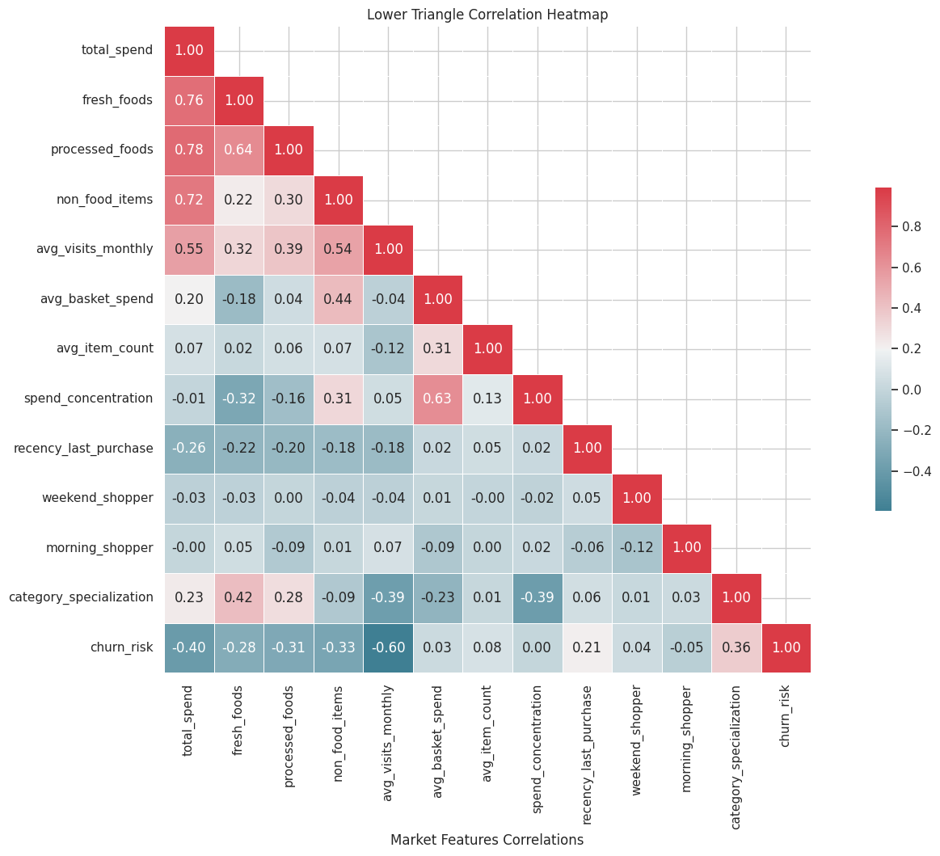
Customer Base Summary:

With all of the features generated, a brief exploratory analysis of the customer base can provide some key insights into what features may be important for clustering, and beyond that provide actionable details for the marketing team to work off of for future projects.

It was found that the majority of customers make small, frequent purchases with an average basket spend hovering around under 2 pounds. Spending power is also highly concentrated. Total spending is right skewed, with the majority of customers spending between 200 and 800 pounds over the six-month period, with a few high value customers exceeding 2,500 pounds. Interestingly, the distribution of purchase patterns was quiet equal between fresh foods, processed foods, and non-food items with fresh foods only having a slightly higher average spend over the period. Temporally, many customers have irregular visit patterns, but many of the highest spenders are at a very low risk of churning. Additionally, weekend shopping is significant, but not dominant.
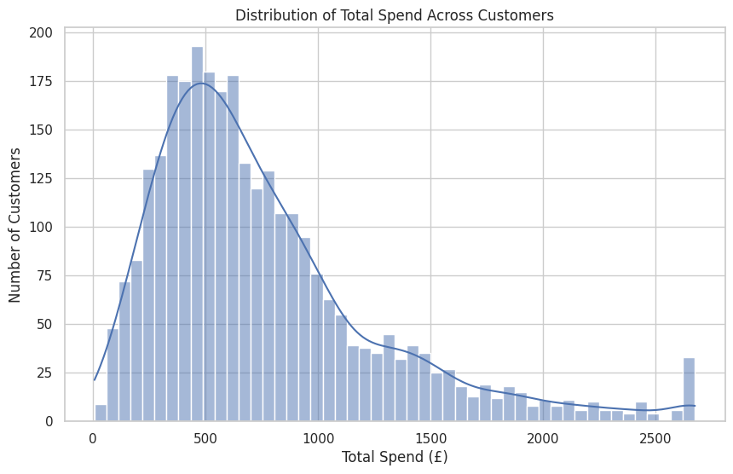 | 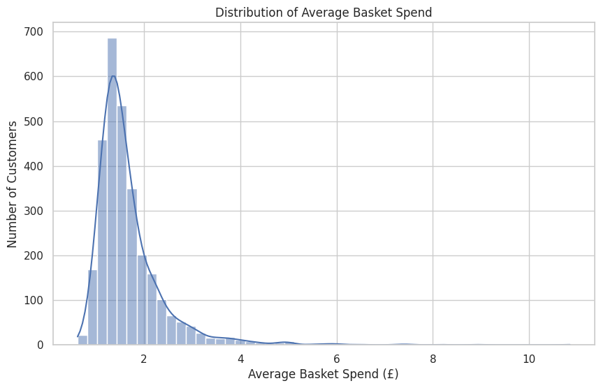
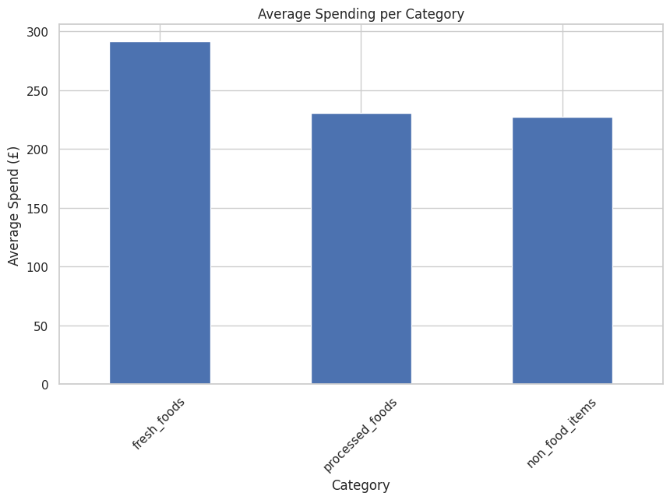 | 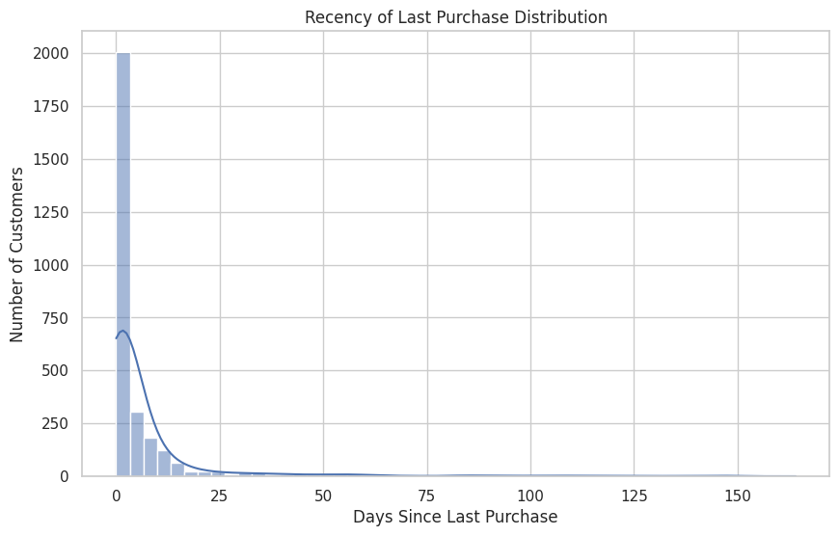
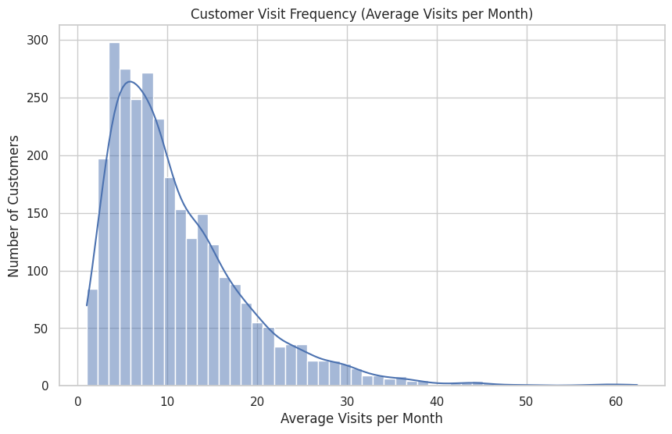 | 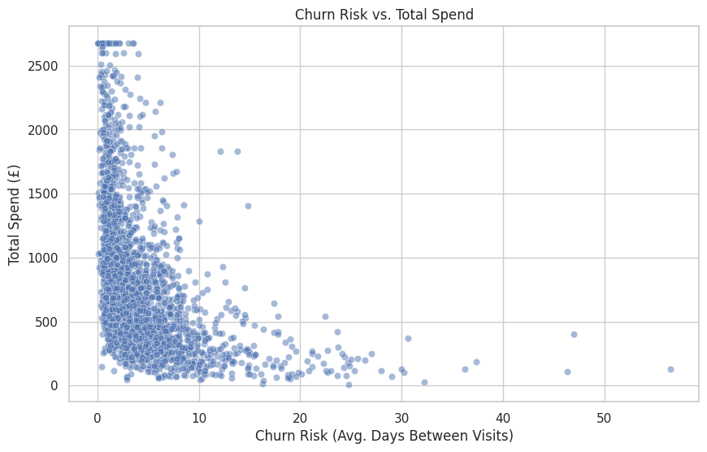
Figure 1: Graphics Displaying Customer Base Analytics
Segmentation Methodology:

In order to form segmented customer clusters, K-means clustering was performed after applying Non-negative Matrix Factorization (NMF) and Principal Component Analysis (PCA). NMF and PCA were used in order to reduce dimensionality of the data and to improve feature separation. Though both PCA and NMF were tested, only NMF components were used in the final K-means cluster model, as NMF produced much more separable clusters with a higher silhouette score.

NMF ended up providing a better score and more robust analysis for a multitude of reasons. In contrast to PCA, NMF was able to capture customers’ behavioral patters better, which is the main goal of this project. It was able to identify distinct customer groups based on key behavioral patters.

In order to run the NMF model effectively, we had to normalize our data to ensure that all features contributed equally, despite being on different scales (such as total spend and morning shopper). Though these datapoints are very different in how they are describing the customer (one is a percentile between 0 and 1 and the other is a sum total somewhere between 0 and 2,500+) normalization allows for the magnitude of the differences to still influence the clusters without allowing the difference in scale to cause the clusters to be widely varied. It changed the varying values into a common scale, without misrepresenting the differences in the ranges or values. Through running the NMF model multiple times with varying number of components, it was found that 2 components was the optimal amount to achieve the most distinct customer clusters.

The data was normalized using Min-Max scaling method. This ensured that all values remained non-negative (between 0 and 1 which is required for and NMF model). In addition it ensured that our clusters were not dominated only by high value features like total spend.

K-means was chosen as the appropriate clustering approach because it is generally suitable for datasets of this size, it uses Euclidean distance to generate spherical segments (which our data lent itself to), and because it able to create well defined clusters that are easily analyzed and translate well to creating marketing strategies and actionable insight.

The optimal number of clusters using this method was five. This is no arbitrary number, rather this optimal number of clusters was found through robust testing of the model. Both the elbow method and Silhouette score revealed that five was the minimum number of clusters that explained the maximum amount of variance (around 90%) before hitting a point of diminishing returns with increased clusters. This number of clusters intuitively makes sense as well, as our number of components would likely produce only a few distinct types of shoppers. Any more and our data would likely be overfitting, showing categories of shoppers that were much too distinct that provide little insight, (ex: customers that shop on the weekend for fresh food) and any less and our clusters would have been much too broad.

Results:

What follows are the results of our K-Means clustering analysis. Five distinct customer groups were found, and each are able to provide some meaningful insight on the type of customers shopping at your store. Each customer cluster will be briefly described statistically and through a brief vignette of what a customer belonging to that group might act like as it relates to your store.

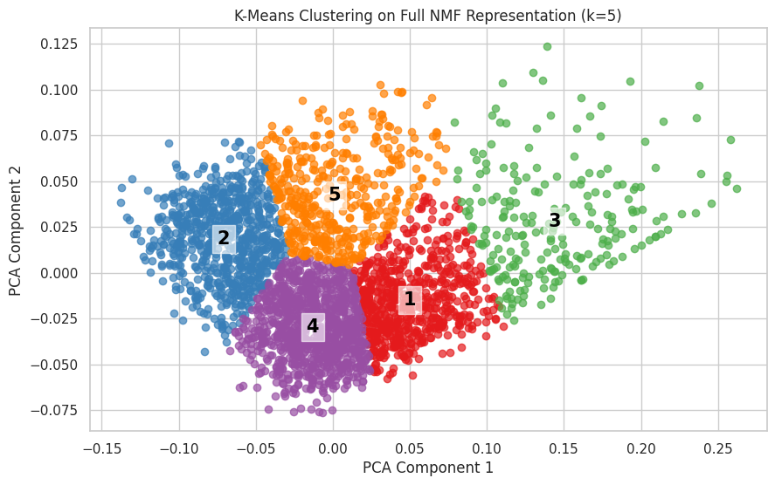

Cluster 1: High Value Shoppers
This cluster is dominated by the most loyal, highest spending customers. They average a total spend of 2,000 pounds, which is the highest among all clusters, visit the most frequently, and have the lowest churn rate. These customers visit often and spend good money whenever they do.

High Value Shopper Profile: Eddy is a working professional who does his weekly shopping at this store. He spares no expense and uses you as a one-stop-shop to pick up everything he needs, fresh fruits, vegetables, meats, frozen meals for the lazy days, and all of his household essentials. He does not worry about the price of goods and goes for the top of the line. Since Eddy shops so frequently here, he would appreciate a rewards program and personalized discounts based on his weekly shop.

Cluster 2: Quick Morning Stop Shoppers

This cluster has the highest morning shop rate (around 85%) of all of the clusters but has the second lowest total spend and does not shop here frequently.

Quick Morning Stop Shopper Profile: Nancy is a blue-collar worker, and she stops at the store whether she needs a pick me up or forgets her lunch on the way to work. She does not buy much, perhaps a coffee and a morning pastry, but that is usually all. She knows this store but prefers to do her bulk weekly shop elsewhere. We should incentive her to come back to do her main shop here after work by enrolling her in a rewards program.

Cluster 3: Morning Mission Bulk Buyer

This cluster has the highest morning shop rate of all the clusters (78%) and has the second highest total spend out of all of the groups, which much of their spending concentrated on non-food items in comparison to the other groups.

Morning Mission Bulk Buyer Shopper Profile: Greg does not mess around. When he needs to get his shopping done, he writes a list the night before and gets up early the next day to get it done. He picks up the household essentials and grabs whatever food stuff he needs for the day while he is there. He probably does the bulk of his food shopping elsewhere, but he loves to come to us for his non-food essentials.

Cluster 4: One Item, Random Stop Shoppers

This cluster has the lowest total spend out of all of the groups at 449 pounds, as well as touting the lowest frequency of all of the groups. Their average basket is only 1.5 pounds, which means that they do not come in frequently, they do not come in to pick up much, and they are not buying anything expensive.

One Item, Random Stop Shopper Profile: Shirley knows about our store, but she prefers to shop elsewhere. She lives quite close by, so whenever she gets home from her weekly shop and realized “OH NO! I forgot the peanut butter” she might stop by our store to grab it quickly. How can we get her to choose us as her new main convenience store? Perhaps some good discounts and targeted advertising could do the trick!

Cluster 5: The Moderate Shopper

This cluster is the middle of the road shopper. They scored moderately in all of the categories. They come relatively frequently and have a moderately low churn risk, but in general nothing expectational stands out without them. It is incredibly important that we keep this customer base though, without them we would not be in business! This is our average shopper.

The Moderate Shopper Profile: Dave shops with us frequently, and only picks up what he needs when he needs it. He is cost conscious and looks for the stuff on the cheaper side, but gets everything he needs when he visits. He is a loyal customer, and though he does not break the bank when he comes to our store, we need to keep him around.

Summary:

The results of the clustering prove a roadmap for how to approach certain groups of customers. You now have clearly defined segments of high-value, convenience, bulk, and unloyal customers that you can use marketing strategies to real in. The clustering data provides data-driven actionable insight that will allow your company to focus on customer retention and growth through personalized marketing. It will also aid in operational efficiency, seeing when peak shopping hours are, basket sizes, and product category preferences. Additionally, it can help maximize revenue by identify the highest value customers to target to maximize your return on investment into marketing.

The two segments we recommend you focus on are the High Value Shoppers and the One Item, Random Stop Shoppers.

Keeping and incentivizing high value shoppers to stay is incredibly important, as these customers are the ones driving your profit margins. Creating robust loyalty programs is incredibly important, and perhaps inviting them to a ‘platinum’ tier rewards program that offers special deals and discounts could be a good way to keep them coming back.

We believe you should focus on the One Item, Random Stop Shoppers for because these shoppers know about your store but choose to do the bulk of their shopping elsewhere. They come in a few times a month, but only buy one or two low value items each time. What makes them prefer other stores to yours for the bulk of their purchases? Perhaps for further analysis, we could look into these specific customers’ shopping patterns and see what exactly is bringing them in and try to see any patterns that indicate what they choose to pick up from you and infer where they might be going for their other shopping needs. Targeted marketing and discounts could get these customers to shop more frequently and buy more with you. This group contains a large number of customers and turning them over into loyal customers could be exactly the revenue boost you are looking for.

