**Hardware platform and Sensors Deployed**

1. Raspberry Pi 2
2. Grove Pi+
3. EOUP Wifi Dongle
4. Grove 3-Axis Accelerometer
5. Grove Ultrasonic Sensor
6. Blue LED
7. Buzzer

**Hardware Setup**

Figure 1 shows the various components connected to the Grove Pi+ which is attached to the Raspberry Pi 2. Figure 2 shows architecture diagram of the hardware setup

The setup is powered by a portable power bank. The steps are as shown below.

1. Attach Grove Pi+ to Raspberry Pi 2
2. Insert Wifi Dongle to an available USB port
3. Connect Grove Accelerometer to port I2C-2
4. Connect Grove Ultrasonic Sensor to port D2
5. Connect Blue LED to port D4
6. Connect Buzzer to port D8

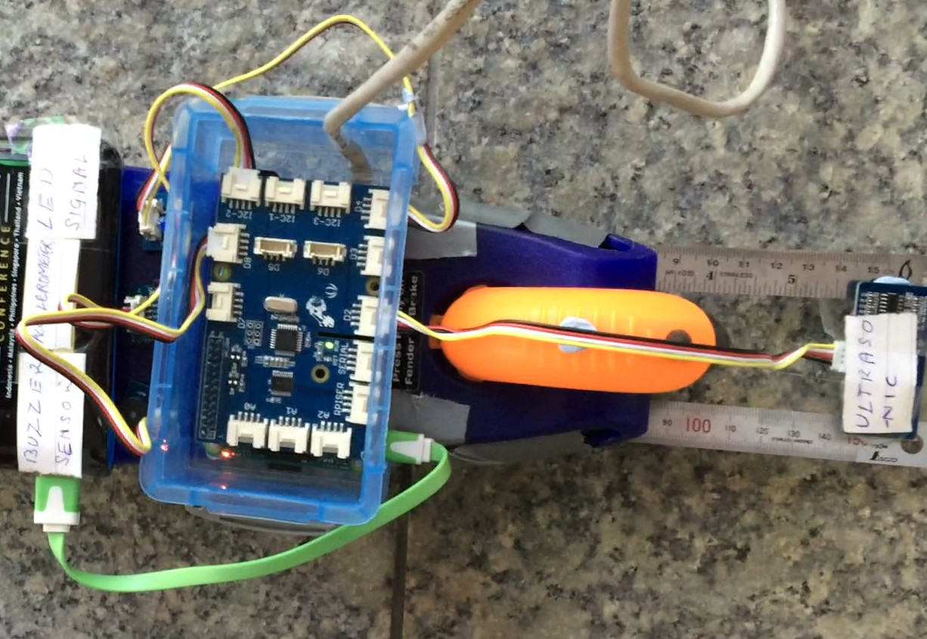

**Figure 1 Hardware Setup**

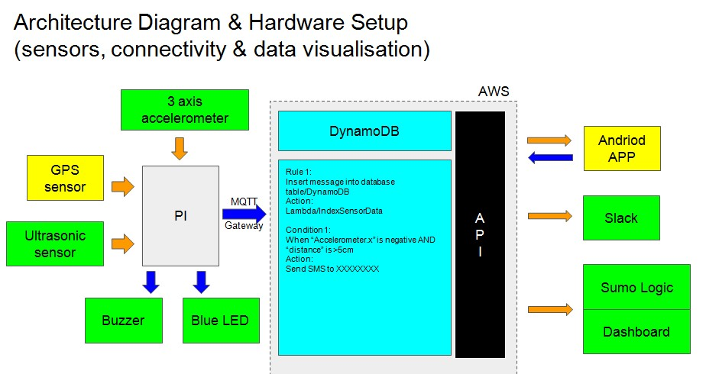

**Figure 2 Architecture Diagram**