Integrating with the G6 Offers Android SDK

SDK Setup

Download
To install the G6Pay SDK, first download the latest G6SDK package. After unzipping the download archive, you will see the following directories:

G6SDK/src/
G6SDK/samplesrc/
G6SDK/doc/

The src directory contains the Java source files that need to be copied into your application. The contents of this directory should be copied into the src/ directory of your Android application.
The doc directory contains Javadocs with detailed information on usage.

Application Setup
After copying the contents of G6SDK/src to your src/ directory, you'll need to update your AndroidManifest.xml file.
Under the <manifest> tag, you'll need to add:
<uses-permission android:name="android.permission.READ_PHONE_STATE" />
<uses-permission android:name="android.permission.INTERNET"/>
<uses-permission android:name="android.permission.ACCESS_NETWORK_STATE"/>

Notes:
- READ_PHONE_STATE – Required to read the UDID of the Android device
- INTERNET – Required to access G6 servers
- ACCESS_NETWORK_STATE – Required to access G6 servers

Under the <application> tag, you'll need to add:

<activity android:name="com.g6pay.sdk.OffersWebView"
android:configChanges="keyboardHidden|orientation" />
<meta-data android:name="G6_APP_ID" android:value="YOUR_APP_ID_HERE"/>
<meta-data android:name="G6_SECRET_KEY"
android:value="YOUR_SECRET_KEY_HERE"/>
Notes:
- activity com.g6pay.sdk.OffersWebView – Required to show offer wall
- G6_APP_ID – This should be replaced with the value of the APP_ID as specified on your G6 account page
- G6_SECRET_KEY – This should be replaced with the value of the SECRET_KEY as specified on your G6 account page

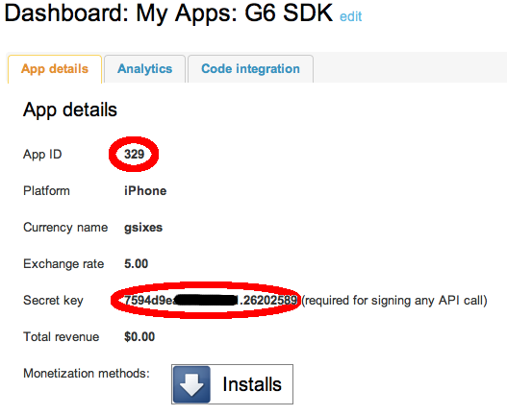
If more help is required, please refer to G6SDK/samplesrc/AndroidManifest.xml for a sample.

SDK Usage

Showing the Offer Wall
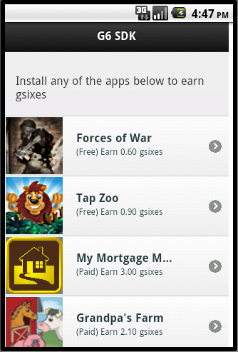
Showing the offer wall is made available easily with a single call. If you would like to be notified of offer completion, implement the G6OfferListener interface to receive a callback upon offer completion.

G6Pay sdk = G6Pay.getG6PayInstance(this.getApplicationContext());

G6OfferListener listener = new G6OfferListener() {
public void offerWasCompleted(OfferDTO offer) {
// This is a method you implement
handleOfferCompletion(offer);
}
};

sdk.showOffers(this.getApplicationContext(), "UNIQUEUSERID", listener);

Crediting User

G6Pay sdk = G6Pay.getG6PayInstance(this.getApplicationContext());

G6UserAccountListener listener = new G6UserAccountListener() {
public void creditUserSuccess(String userId, String transactionId, float amount) {
// This is a method you implement
handleUserCredited(amount);
}
public void creditUserFailure(String userId, String transactionId, float amount) {
// This is a method you implement
callFailed();
}
};

sdk.creditUser("TRANSACTIONID", "UNIQUEUSERID", amount,
listener);

Debiting User

G6Pay sdk = G6Pay.getG6PayInstance(this.getApplicationContext());

G6UserAccountListener listener = new G6UserAccountListener() {
public void debitUserSuccess(String userId, String transactionId, float amount) {
// This is a method you implement
handleUserDebited(amount);
}
public void debitUserFailure(String userId, String transactionId, float amount) {
// This is a method you implement
callFailed();
}
};

sdk.creditUser("TRANSACTIONID", "UNIQUEUSERID", amount,
listener);

Getting User Balance

G6Pay sdk = G6Pay.getG6PayInstance(this.getApplicationContext());

G6UserAccountListener listener = new G6UserAccountListener() {
public void getUserBalanceSuccess(String userId, float balance) {
// This is a method you implement
handleUserBalance(balance);
}
public void getUserBalanceFail(String userId) {
// This is a method you implement
callFailed();
}
};

sdk.getUserBalance("UNIQUEUSERID", listener);

Getting User Transactions

G6Pay sdk = G6Pay.getG6PayInstance(this.getApplicationContext());

G6TransactionListener listener = new G6TransactionListener() {
public void getAllTransactionsSuccess(String userId, ArrayList<TransactionDTO> transactions) {
// This is a method you implement
handleUserTransactions(transcations);
}

public void getAllTransactionsFail(String userId) {
// This is a method you implement
callFailed();
}
};

sdk.getAllTransactions("UNIQUEUSERID", listener);

