Integrating with the G6 Pay Per Install Android SDK

SDK Setup

Download
To install the G6Pay SDK, first download the latest G6SDK package. After unzipping the download archive, you will see the following directories:

G6SDK/src/
G6SDK/samplesrc/
G6SDK/doc/

The src directory contains the Java source files that need to be copied into your application. The contents of this directory should be copied into the src/ directory of your Android application.
The doc directory contains Javadocs with detailed information on usage.

Application Setup
After copying the contents of G6SDK/src to your src/ directory, you'll need to update your AndroidManifest.xml file.
Under the <manifest> tag, you'll need to add:
<uses-permission android:name="android.permission.READ_PHONE_STATE" />
<uses-permission android:name="android.permission.INTERNET"/>
<uses-permission android:name="android.permission.ACCESS_NETWORK_STATE"/>

Notes:
- READ_PHONE_STATE – Required to read the UDID of the Android device
- INTERNET – Required to access G6 servers
- ACCESS_NETWORK_STATE – Required to access G6 servers

Under the <application> tag, you'll need to add:

<meta-data android:name="G6_APP_ID" android:value="YOUR_APP_ID_HERE"/>
<meta-data android:name="G6_SECRET_KEY"
android:value="YOUR_SECRET_KEY_HERE"/>
Notes:
- G6_APP_ID – This should be replaced with the value of the APP_ID as specified on your G6 account page
- G6_SECRET_KEY – This should be replaced with the value of the SECRET_KEY as specified on your G6 account page

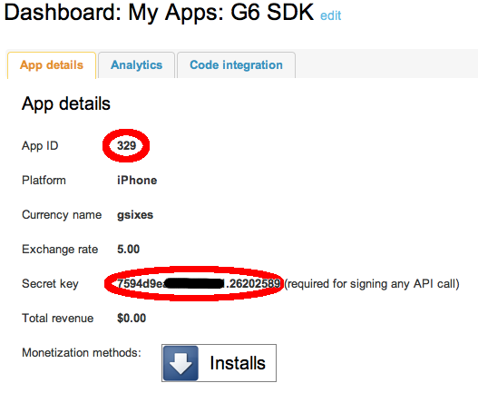
If more help is required, please refer to G6SDK/samplesrc/AndroidManifest.xml for a sample.

SDK Usage

Install Confirmation

Confirming install involves the following code. This code should be added to the onCreate() method of your Android application.

G6Pay sdk = G6Pay.getG6PayInstance(this.getApplicationContext());

sdk.installConfirm();

